Supplementary information for
Signal Propagation in Resettable Mechanical Logic Circuits
Robert M. Panas¹, Frederick Sun², Amin Farzaneh³, John Cortes², Logan Bekker², Hilary A. Johnson^{2*}, Julie Mancini², Andrew J. Pascall², and Jonathan B. Hopkins³
¹Bright Silicon Technologies LLC ²Lawrence Livermore National Laboratory, Livermore, CA. ³Department of Mechanical and Aerospace Engineering, University of California Los Angeles, Los Angeles, CA

Supplementary Information

Layered design of bistable elements
The bistable element (Fig. S1) is designed with two conceptual layers: kinematics and energetics as described in Methods, section ‘Bistable element design’. The axial stiffness bearing as well as the preload mechanism are also included in the kinematics layer. (Fig. S1a)

The kinematics layer is composed of two physical layers to generate the stacked cross-pivot bearing. These cross-pivot bearings determine the Rb rolling effect and set the kinematics of the bistable element. Cross-pivots were chosen as they provide superior range per size while retaining the capability to handle high compressive loads as are required to create bistability. Conventional blade flexures tend to buckle under these combined requirements of large range and high compressive load, resulting in unreliable behavior^{1,2}. See section ‘Cross-pivot rolling radius’ for details.

The Y-axis compliance was placed in series with the motion stage using the 4-bars topology to decouple design requirements and simplify the design rather than within the motion stage itself, as has been done with other designs. The symmetric distribution of the Y-axis compliance on both sides of the motion stage suppresses shuttle parasitic Y-axis displacement during operation. Furthermore, the 6 degree of freedom (DOF) coupling linkages decouples bistable element orientations from one another by passing only force only without constraining motion. The coupling linkage is made as a separate part to facilitate easy assembly for reconfigurable systems.

The energetics layer contains non-motion-constraining 6 DOF compliance elements that fine-tune each element’s unique compliance values required by the chain PEM modification. The energetics layer is laid above the kinematics layer and is composed of additional flexible elements that stack in parallel with the kinematics bearings, providing additional stiffness without constraint. The under-constrained coupling linkage is included in the energetics layer.

Both kinematics and energetics layer designs are compatible with layer-based fabrication methods on the macro- and micro-scale.

Preload design trade-offs
Selection of preload design strategies focused on micro-scale additive manufacturing compatibility. The preload is printed in series with the bistable element, with either a latch or a bistable structure. Post-fabrication the preload is actuated and secured to engage the bistable behavior. The latch design (Fig. S1a) uses a nonlinear ratchet that restricts return motion of a slider which compresses the bistable element axial spring. The latch provides a high stiffness approach with easy tunability to set the required displacement and is manufacturable for both micro- and macro-scale structures.

A bistable structure (Fig. S5a) could be used instead of the latch to produce displacement. This design is relatively straightforward to tune, but requires a large footprint and results in low axial stiffness of the preload structure, which modifies the bistable element performance. Alternately, substrate strain (Fig. S5b) compresses the printed structures after fabrication. While this approach is compact and does not alter the compliance of the bistable element substructure, it requires all compression to occur in one direction, severely limiting design complexity. It is also difficult to finely tune the strain within the structure due to the substrate compliance.

Cross-pivot rolling radius
Cross-pivots, as shown in Fig. S4, have a single axis around which they allow motion, to first order analysis. A simple model of this behavior is a pin joint. However, the location of this instant center is not actually fixed since the flexures distort and shift the instant center under large displacements. This instant center can be thought of as ‘rolling’ with a horizontal translation that is dependent on the scale of the bearing.

The scale of the pin joint rolling effect is captured by an effective radius rb, where rb = 0 means bearing rotation produces no translation. Any bistable element bearing that can be reduced to a model of rigid bodies linked via pin joints can be modified with rolling behavior. The function defining the rolling radius for cross-pivot bearings has previously determined by Van Eijk¹, and is included in Eq. (S1) below, where lbf is the length, a is the location of the axis normalized to the flexure length (a = ½ describes the typical mid-point crossing) and θbf is the angle between the cross-pivot flexures.
. | (S1)
The model of a rigid link pinned at either end is replaced by a rigid link of length lb-2rb with rolling contacts of radius rb added at either end, shown in Fig. S4b, and a total separation between the rolling surfaces of lb. The shuttle translation, x, in this model is the combination of the rotation of the rigid body and the rolling on the two edge surfaces. The addition of the rolling effect alters the elasto-mechanics of the bistable element slightly, modifying the force and energy profiles.

Potential energy map calculation
A potential energy map (PEM) is defined for the pulse propagation through a single node (Fig. 1d). This is captured by tracking the potential energy of a steady state pulse profile as the center node n shifts from the unstable equilibrium state where the n node is at Xb = 0, to the stable equilibrium state, and back to the unstable equilibrium state where the n node is off center at the next unstable equilibrium displacement, Xue1, and now it is the n+1 node which is at Xb = 0. This represents the transition of the pulse center from the n to the n+1 node. Insight is gained by tracking the dynamic energy flows through the pulse with each step of the n’th node across the profile surface. The change in kinetic energy [ek] per step is balanced by the energy dissipated per step [ed] and the potential energy [ep] change per step, shown in Eq. (S2). This calculation is carried out for each step as the center node of the pulse is moved from Xb = 0 out to Xb = Xbe in incremental steps of dx.
(S2)
The potential energy is calculated using the unstable equilibrium pulse profile, where there is a single node at Xb = 0. While the pulse profile shifts from the unstable to stable and back to unstable equilibrium, it is simpler to approximate as a single profile energy value as the profiles produce nearly identical results. The pulse profile does not have uniformly velocity as the center shifts from node i to i+1. Rather, the nodes at the center have higher velocity than those at the edge. The velocity along the profile during propagation can be defined via ‘ΔX per node’ advance of the pulse and measured by finding the distance each node must traverse to move from its position at location n in the profile to reach the n+1 position, [dxp]_{i} as shown in Eq. (S3).
(S3)
The velocity profile is normalized to the maximum velocity per node advance, which is the step taken by the node at the center, out to the next location in the profile, xue1. The normalized velocity profile now provides a scaling factor for each node’s velocity relative to the velocity of the center node, a value which is set by [vp] for each step. The assumption that the tracked node location is always at the peak velocity is acceptable since the PEM is analyzed for small displacements around Xb = 0 where the tracked node is on the plateau of high velocity at the center of the pulse profile. The kinetic energy is then the sum of all i of these velocities for the n’th step, as shown in Eq. (S4).
(S4)
The dissipated energy is a product of the damping coefficient bb, the average nodal velocity over the course of the step from n-1 to n and the distance traveled by each node over the course of the step as shown in Eq. (S5). Both the velocity and distance must be normalized by the pulse velocity profile.
(S5)
The pulse potential energy as a function of center node location is extrapolated as a sinusoidal variation with the unstable equilibrium set at relative energy 0 and the stable equilibrium at lower energy dese. While this is a simplification of the actual profile, the scale of energy variation was found to be small and locally flat around the equilibria, so the sinusoidal profile worked well as an approximation. A linear slope was added to the approximation to capture the slight decrement in nodal energy by estep per node down the chain, shown in Eq. (S6).
(S6)
All terms are gathered using Eq. (S2) and rearranged around the unknown parameter, vp, into a second order polynomial shown in Eq. (S7) which can be solved using the quadratic formula for the pulse velocity at each location. The threshold of pulse propagation is defined as emin, the minimum value of estep at which vp > 0 over the full range of the PEM. The threshold is a complex combination of kinetic and potential effects so does not lend itself to a simple analytical expression.
(S7)

Alternate Circuit Designs
Other circuits can be created using the basic elements described in this work. Several addition elements are presented in Fig. S3 to aid in circuit development, including 90° turns in Fig. S3a, 180° turns in Fig. S3b, and a NOT gate in Fig. S3c. The AND and NOT gate are a logically complete set of gates, meaning all possible logical operations are formed from these elements.

Microfabrication
Two-photon lithography (TPL)^{3,4} is a microscale additive manufacturing method that enables rapid prototyping of micro mechanisms. TPL occurs when two photons are absorbed at the same time to activate a photo-initiator molecule and it requires a high flux of photons both locally and temporally: the photons should be focused tightly by a high numerical aperture objective lens and be compressed in ultra-short pulses using a femto-second pulsed laser. By satisfying these two conditions the non-linear TPL process takes place with higher resolution comparing with the conventional laser lithography methods.

The TPL system (Fig. S7) used to fabricate the microscale structures is composed of a tunable wavelength femtosecond pulsed laser (fs laser, SpectraPhysics MaiTai eHP DS), an acousto-optic modulator (AOM, IntraAction ATM-802DA2) combined with a mirror (M) and beam block (BB), which act as a high speed beam shutter and also a power controller, a beam expander system (BE), 2D mirror galvanometers (Galvo, Thorlabs GVS012) that scan the beam in the x-y plane at the fabrication site, a 4-F telescope relay, a dichroic mirror (DM), a 100X microscope objective (MO, Olympus Plan Apo Lambda, NA = 1.45), a dichroic filter (DF), a z-axis piezo objective scanner with 600µm travel range (MO scanner, Thorlabs PFM450E), a 3-axis micro positioning stage (Stage, Thorlabs RB13M), a light emitting diode source (LED, Thorlabs M617L3), and a camera (40X cam, Basler ace acA1300-75gm) connected to a custom 40X magnification imaging tube including a tube lens (TL) and two lenses (L).

To overcome low adhesion of polymer to the glass substrate, a chemical functionalization procedure has been conducted by following these steps: 1) O2 plasma treatment for three minutes on the substrate. 2) Substrate immersion in a solution of anhydrous ethanol (93 vol%), deionized water (5 vol%), and 3-acryloxypropyl trimethoxysilane (2 vol%) for 16 hours. 3) Substrate immersion in anhydrous ethanol for 1 hour. 4) Baking at 95°C for 1 hour.
Nanoscribe IP-Dip is used as the photocurable polymer to fabricate the structures. In this work, the average laser scanning speed was 1 mm/s and the beam power was set to be 90 mW at 780 nm (measured before the objective).

Since a single working area of our TPL system is 250 µm by 250 µm, to fabricate the AND gate and the chain of gates (Fig. 3b & 4b), neighboring elements are printed individually and then stitched together, while their spacing is precisely controlled with alignment marks. Post processing of the printed structures to wash away the uncured photopolymer is done by propylene glycol methyl ether acetate (PGMEA) immersion for 13 minutes followed by isopropyl alcohol (IPA) immersion. Throughout the testing procedure, the structures are kept submerged in IPA to avoid the undesired effects of surface tension forces on the microstructures, caused by evaporation.

All microscale designs are mechanically supported by the three grounded regions on the glass substrate (Fig. S8). The out of plane thickness of the elements in Fig. S8 is 36µm, and the overhanging structures are printed at 12 µm clearance from the substrate.

While the polymer structures lay the groundwork for micro-scale gates, there are some limitations related to poor mechanical properties that must be addressed before these devices can be used in more demanding applications. One of these solutions could be using ceramic-based resins to manufacture the gates using the same TPL system as outlined above. In this case, the resin is based on preceramic monomers, also known as polymer-derived ceramics (PDCs). These resins can be converted into ceramics by pyrolysis in an oven in a nitrogen atmosphere at temperatures of 250° C, 400° C, 600° C and 1000° C, each step for an hour. The samples are then allowed to cool down to room temperature at a rate of 5° C per min. This process removes species such as water and hydrocarbons to produce silicon oxycarbide, or SiOC. Aside from the pyrolysis step, the printing and immediate post-processing is very similar to that of conventional polymer structures (including laser settings and PGMEA/IPA post-print development).

The current drawback with ceramic-based resins is the large amount of shrinkage that results from pyrolysis. This shrinkage, though isotropic, can be as much as 30-35%, which results in highly warped structures, as shown in Fig. S9. We believe this can be addressed with more development of the printing process so that the individual voxels are properly energized, and thus properly cross-linked. Additionally, we are experimenting with the use of strain-relief structures which can accommodate the shrinking of the gate structure without adding additional stresses which can cause it to warp and distort as it shrinks. Though more development is necessary, we believe this path is quite promising and can eventually deliver high-quality, reliable, and functional micro-scale logic structures.

Supplementary information figures

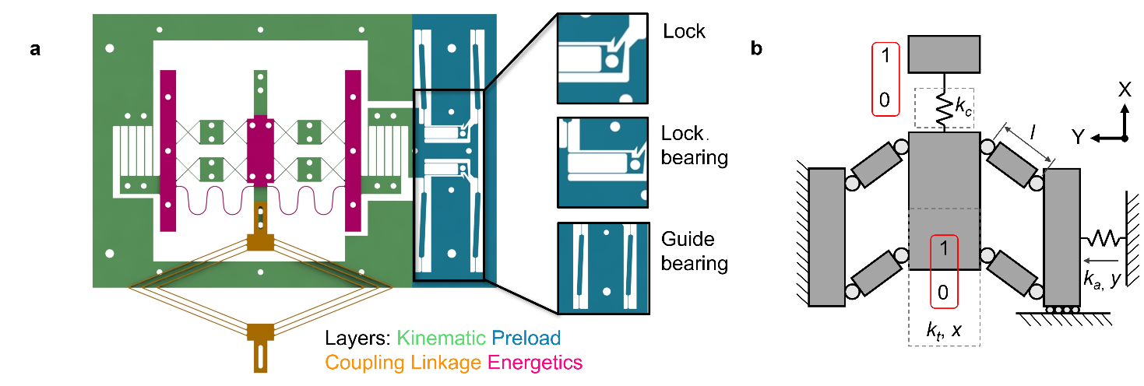
Fig. S1| Bistable element layers and functional components. a, Bistable element topology and coupling linkage. Detail elements show structure fabrication in stress free condition unlocked, then the lock is permanently compressed to a loaded and energized state. d, Detailed schematic of bistable element, showing parameters mapped onto the generalized structure.

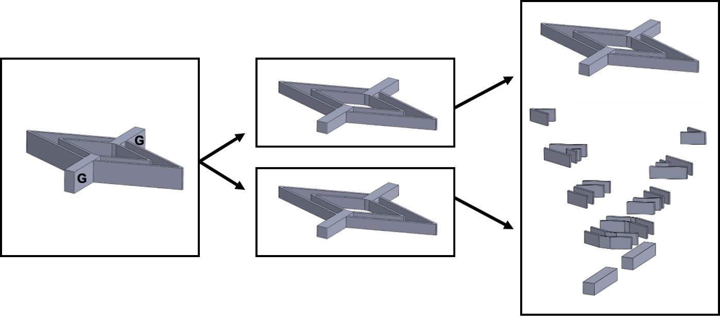
Fig. S2| Sequential printing approach. A linkage connector with long and thick overhanging features is decomposed into five substructures with shorter features. For thick overhanging features, sequential printing is used for the initial layers until a secure underlying structure is printed for subsequent layers. The “G” tabs are grounded, all other features are overhung.

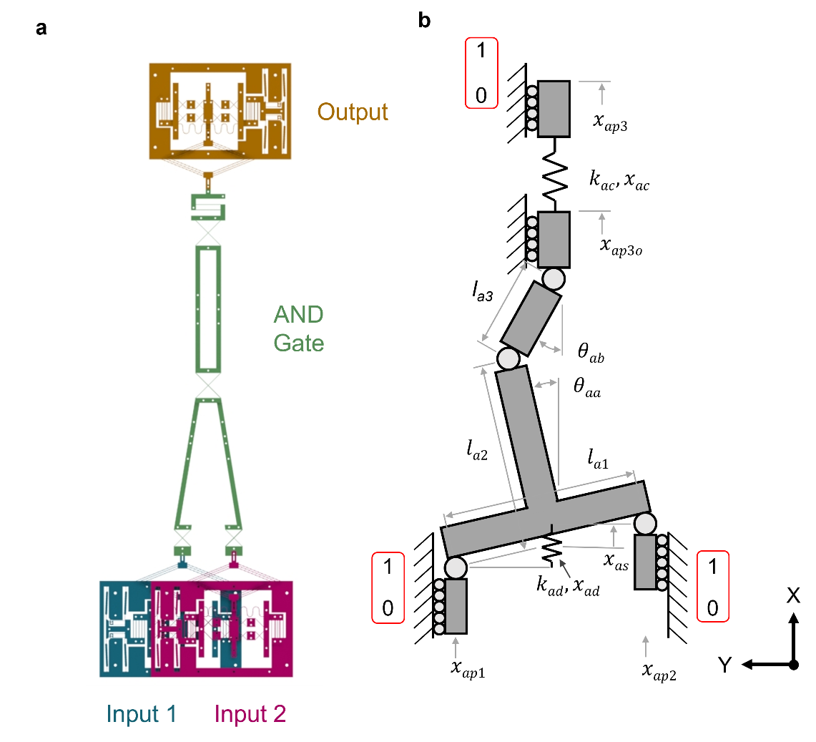
Fig. S3| a, AND gate topology linked to two input and one output bistable elements. b, Isometric view of CAD showing overlapping inputs 1 and 2. c, AND gate parameters mapped to generalized structure.

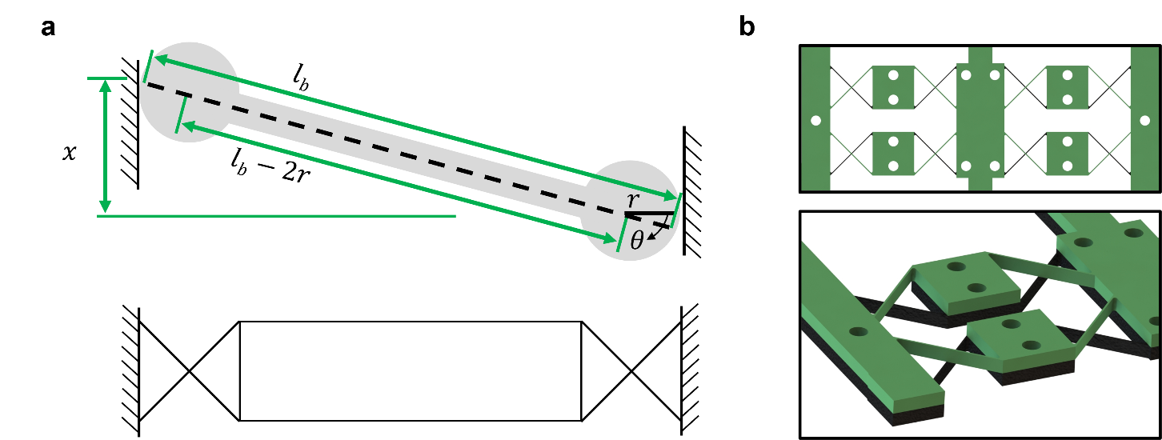

Fig. S4 | Cross-pivot flexures. a, Bearing kinematics. b, Bearing layers and combinations.

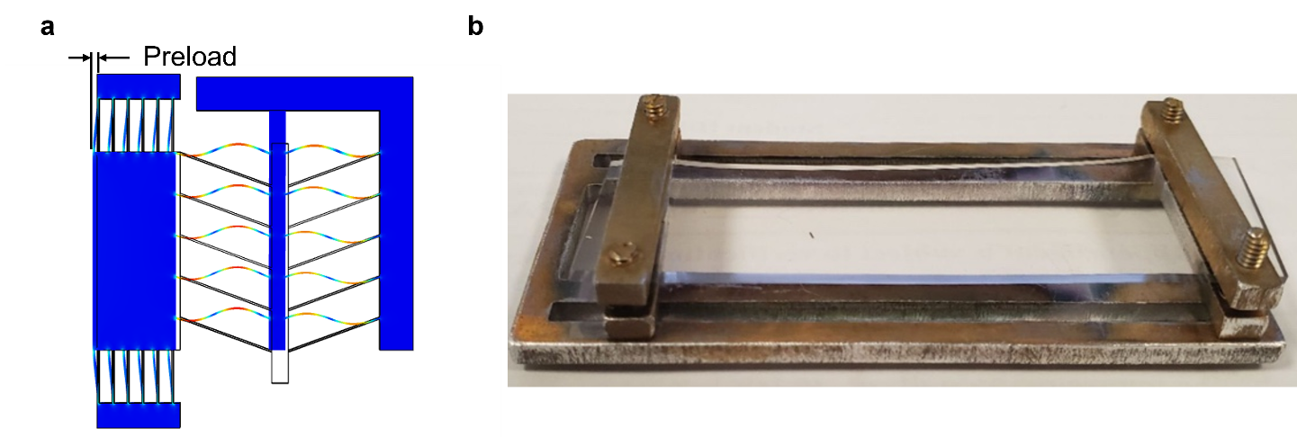
Fig. S5 | A bistable element is charged with stored energy to initiate bi-stability. a, A flexural preload structure is one charging method. b, Straining the microscale structure substrate pre-print and then relaxing the substrate after manufacturing to charge the elements.

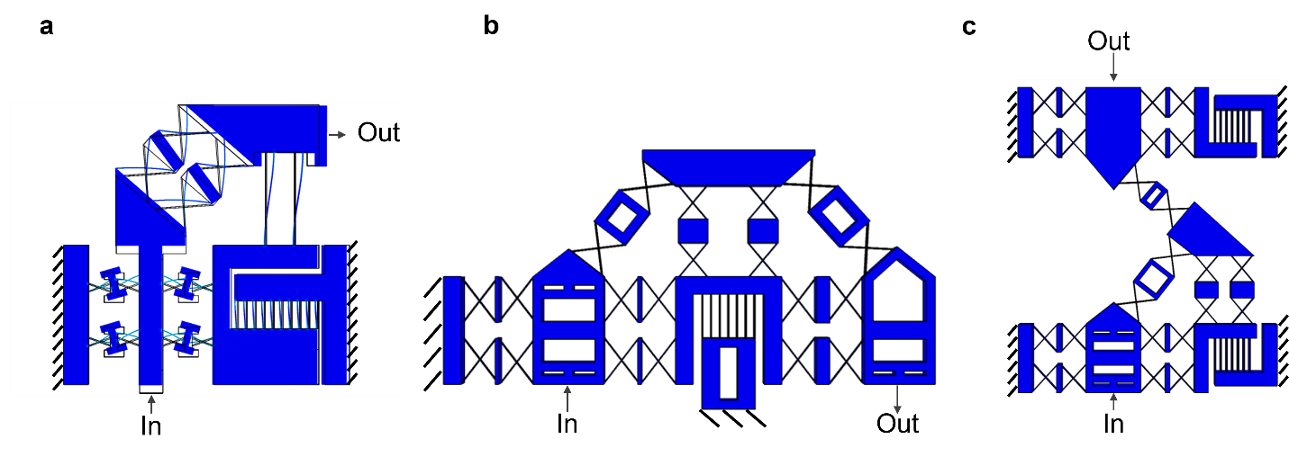
Fig. S6 | Complex circuits require combinations of logic elements. a, A 90º turn enables circuit routing. b, A 180° element enables a full turn. c, A NOT gate enables access to a complete set of logical operations when paired with an AND gate

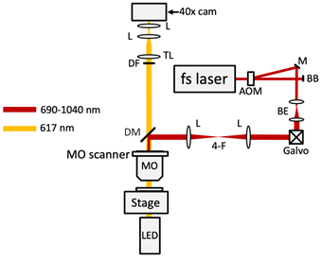

Fig. S7 | A schematic of the two photon lithography system setup.
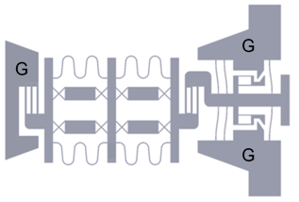

Fig. S8 | Top view of a single bistable design. The tabs shown with “G” are grounded to substrate. All other features are overhanging.

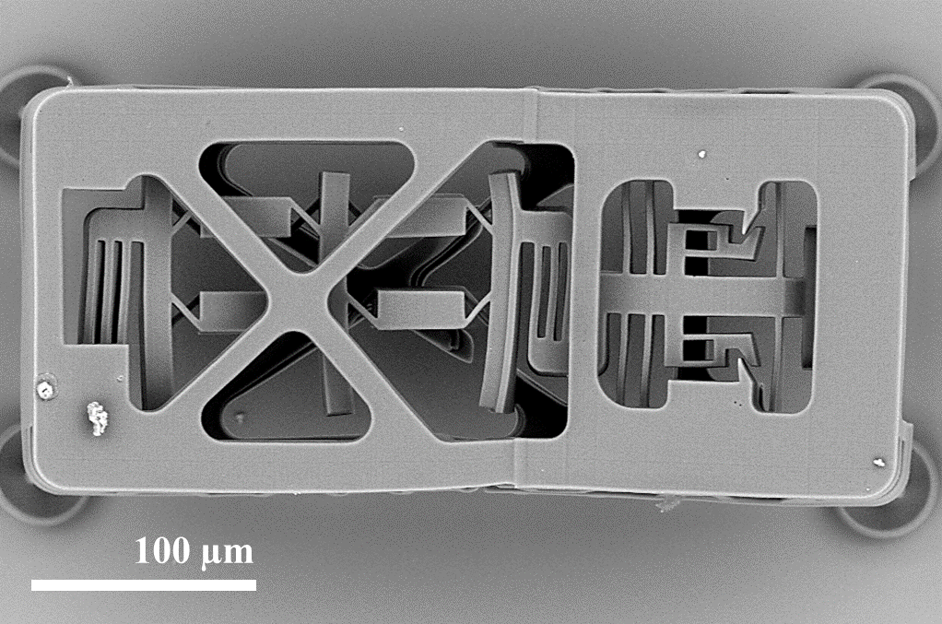

Fig. S9 | A SEM image of a warped silicon oxy-carbide logic gate. Warpage occurred due to material shrinkage during high-temperature post-processing.

Supplementary information references

1. Van EijK, J. On The Design of Plate-Spring Mechanisms. (TU Delft, 1985).
2. Howell, L. L. Compliant mechanisms. in 21st century kinematics 189–216 (Springer, 2013).
3. Farsari, M. & Chichkov, B. N. Two-photon fabrication. Nat. Photonics 3, 450–452 (2009).
4. Zhou, X., Hou, Y. & Lin, J. A review on the processing accuracy of two-photon polymerization. AIP Adv. 5, 030701 (2015).

