Title: Trajectories of Sleep Disturbance and Self-Management of Chronic Conditions during COVID-19 among Middle-aged and Older Adults

Online-only Supplement

List of elements included in the documents:
Table S1. C3 Study
Table S2. C3 Study Measures Included in the Analysis
Table S3. Sample Characteristics by Inclusion in the Analysis
Figure S1. Trajectory of Likelihood of Sleep Disturbance (Sensitivity Analysis where sleep was dichotomized as PROMIS Sleep Disturbance T-score >45 vs ≤45)

Table S1. C3 Study
Survey Wave | Date Range | COVID-19 Timeline | Completed | Eligible | Response rate (%)
W1 | 3/13/20 – 3/20/20 | Week 1 of the initial outbreak in Chicago | 672 | - | -
W2 | 3/27/20 – 4/3/20 | Stay-at-home order(3/20/20 – 5/29/20) | 625 | 672 | 93.0
W3 | 5/1/20 – 5/22/20 | Peak of surge #1 | 600 | 672 | 89.3
W4 | 7/15/20 – 8/21/20 | Plateau phase (6/4/20-), with 7-day rolling average positive rate < 10% | 557 | 672 | 82.9
W5 | 11/30/20 – 3/3/21 | Surge #2, Initial vaccine rollout | 544 | 672 | 81.0
W6 | 4/12/21 – 7/16/21 | Rapid decrease in cases and deaths; vaccination available for anyone ≥16y; beginning of surge #3 in July ’21 | 511 | 672 | 76.0
W7 | 9/8/21 – 12/16/21 | Peak of surge #3 (Delta; July-Oct ‘21) followed by gradual decrease in cases | 502 | 672 | 74.7
W8 | 2/17/22 – 5/23/22 | Post-surge #4 (Omicron; Dec ’21- Feb ’22) | 480 | 672 | 71.4

Table S2. C3 Study Measures Included in the Analysis
Variable | Instrument or Measure | Number of Responses
Variable | Instrument or Measure | W3 | W4 | W5 | W6 | W7 | W8
Sleep Disturbance¹ | PROMIS Sleep Disturbance | - | 485 | 541 | 511 | 500 | 478
Perceived Stress | Perceived Stress Scale | - | 483 | 536 | 509 | 498 | 479
Physical Health | PROMIS Physical Function | - | - | 542 | - | 501 | -
Mental Health | PROMIS Anxiety | 508 | 487 | 542 | 509 | 501 | 445
Mental Health | PROMID Depression | 508 | 487 | 542 | 511 | 501 | 479
Medication Adherence | ASK-12 medication survey | - | - | - | - | 495 | -
Cognitive Concerns | Everyday Cognition (ECog)  4-item scale | - | - | - | 510 | - | 480
Self-Efficacy | Lorig Self-Efficacy for Managing Chronic Disease 6-item Scale | - | - | - | 510 | - | 480
PROMIS, Patient-Reported Outcomes Measurement Information System
¹Sleep disturbance data were available at 5 survey waves in 393 participants, 4 waves in 99 participants, 3 waves in 40 participants, and 2 waves in 17 participants.

Table S3. Sample Characteristics by Inclusion in the Analysis
Characteristic | Overall, N = 672¹ | Excluded, N = 123¹ | Included, N = 549¹ | p-value²
Age Group |  |  |  | 0.2
< 60 | 236 (35%) | 45 (37%) | 191 (35%)
60 - 69 | 240 (36%) | 36 (29%) | 204 (37%)
≥ 70 | 196 (29%) | 42 (34%) | 154 (28%)
Female | 405 (60%) | 67 (54%) | 338 (62%) | 0.15
Race/ethnicity |  |  |  | 0.9
Hispanic/Latino | 135 (21%) | 22 (19%) | 113 (22%)
Non-Hispanic/Latino White | 302 (48%) | 54 (48%) | 248 (48%)
Non-Hispanic/Latino Black | 198 (31%) | 37 (33%) | 161 (31%)
Living below Poverty Level | 192 (29%) | 37 (31%) | 155 (28%) | 0.6
Education |  |  |  | 0.3
High School Grad or Less | 165 (25%) | 30 (24%) | 135 (25%)
Some College | 181 (27%) | 40 (33%) | 141 (26%)
College Degree or Higher | 326 (49%) | 53 (43%) | 273 (50%)
Health Literacy |  |  |  | 0.6
Low | 153 (23%) | 31 (25%) | 122 (22%)
Marginal | 155 (23%) | 30 (24%) | 125 (23%)
Adequate | 364 (54%) | 62 (50%) | 302 (55%)
Number of Chronic Conditions |  |  |  | 0.3
1 | 144 (21%) | 24 (20%) | 120 (22%)
2 | 107 (16%) | 15 (12%) | 92 (17%)
3 or more | 421 (63%) | 84 (68%) | 337 (61%)
¹n (%)
²Pearson's Chi-squared test

Figure S1. Trajectory of Sleep Disturbance (Sensitivity Analysis where sleep was dichotomized as PROMIS Sleep Disturbance T-score >45 vs ≤45)

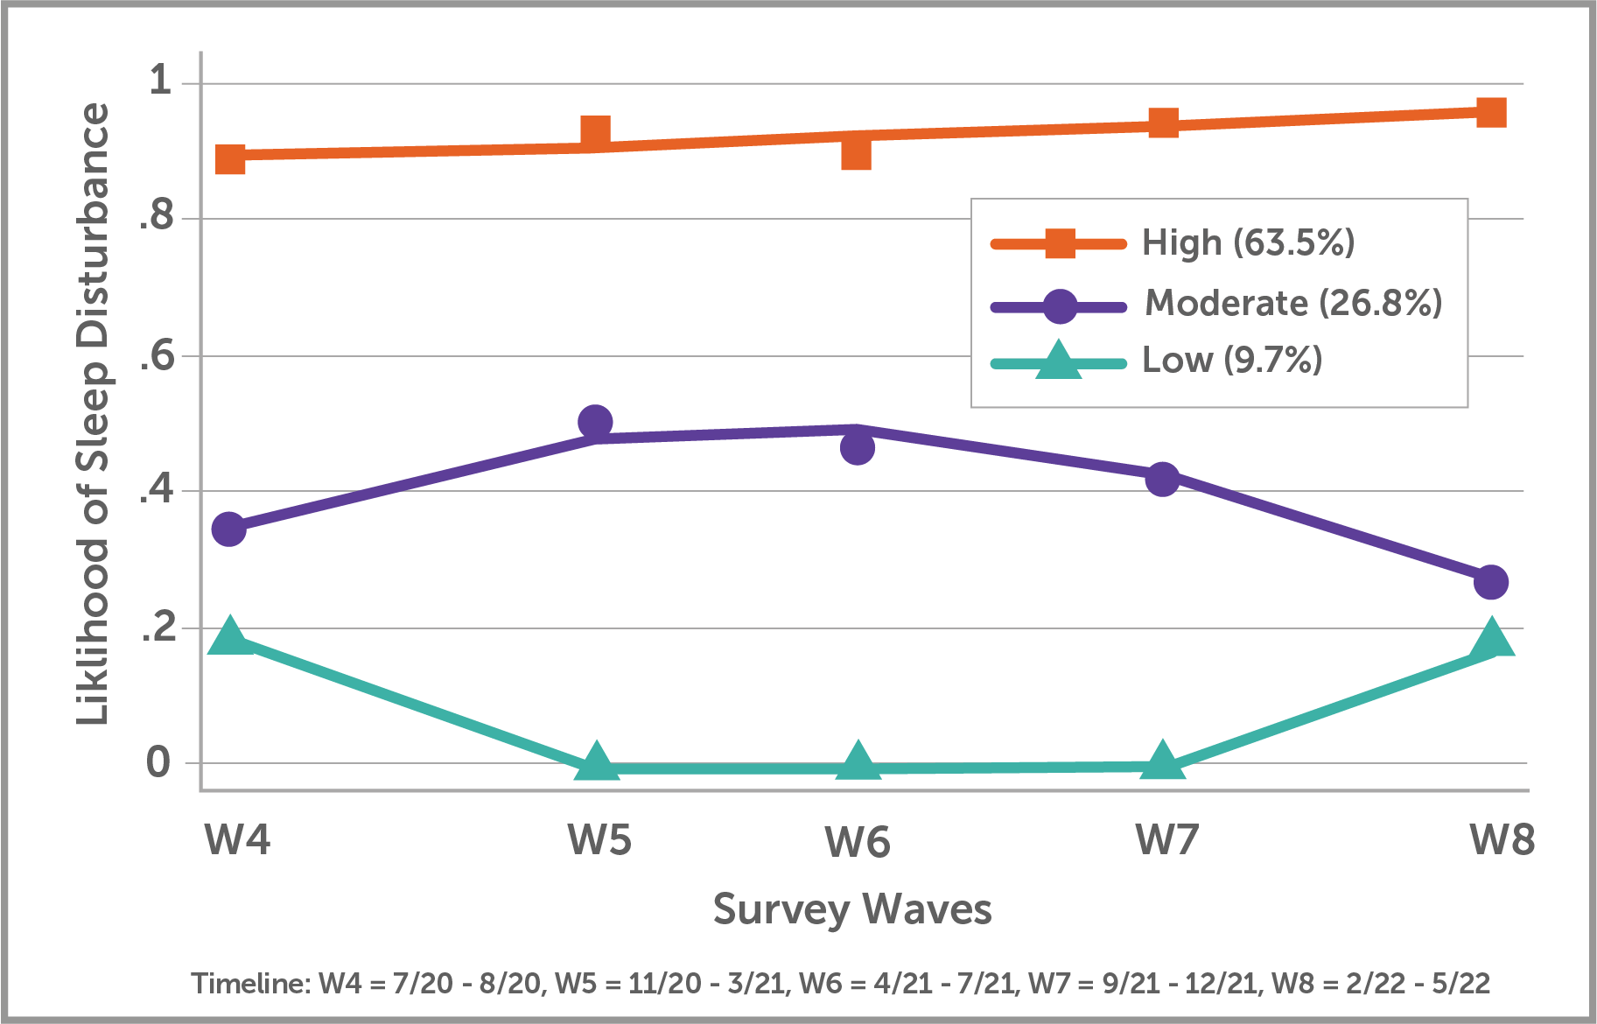

Figure S1 Legend:
Using an alternative PROMIS Sleep Disturbance T-score threshold (>45; equivalent to Pittsburgh Sleep Quality Index >5) to define sleep disturbance, three distinct trajectories of likelihood of sleep disturbance were estimated between July 2020 and May 2022.

