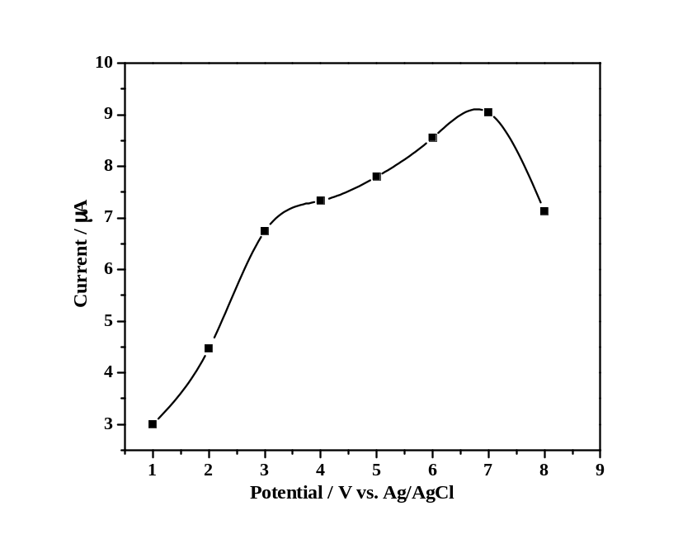

Figure S1. Plot of peak current vs. amount of suspension
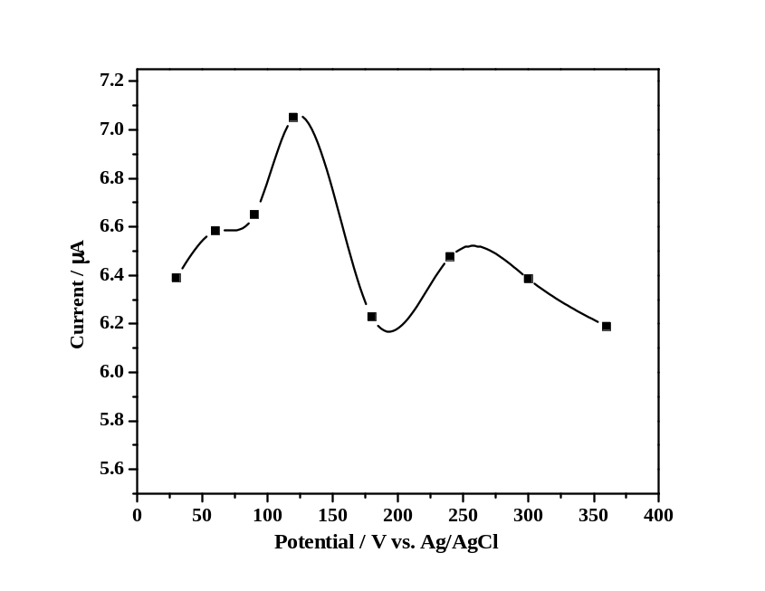

Figure S2. Plot of peak current vs. accumulation time

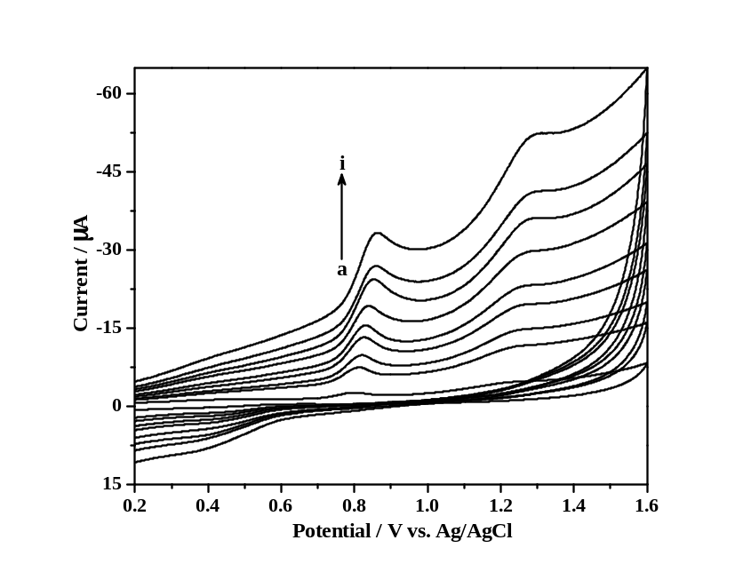

Figure S3. Cyclic voltammograms of 10 μM HES (pH 4.0) at the scan rate range of 10–300 mV s⁻¹

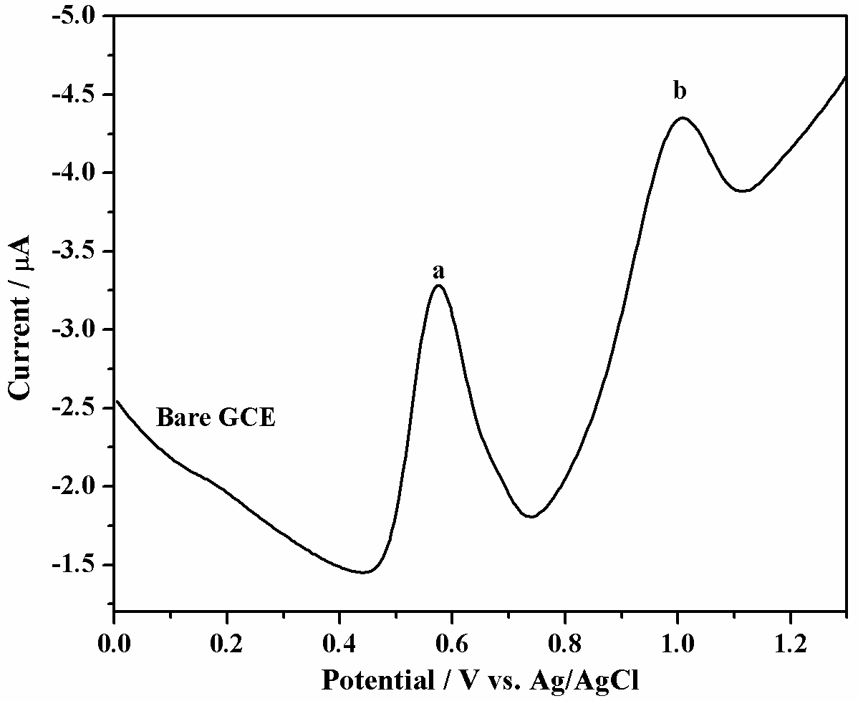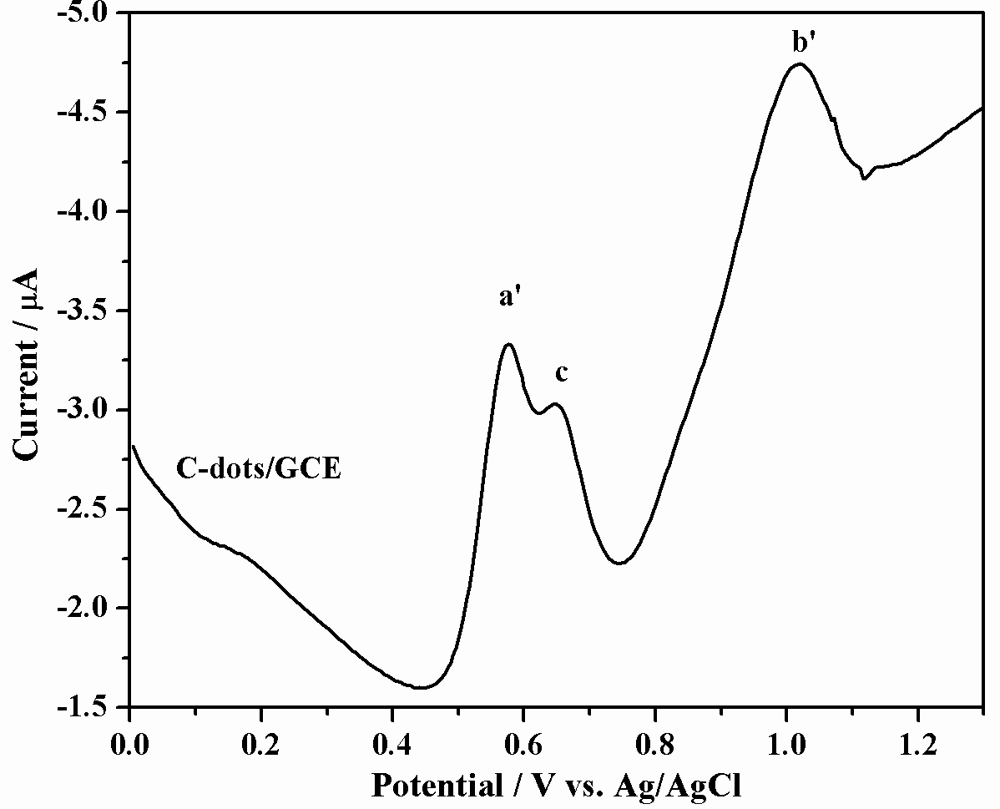
A
B

Figure S4. Differential pulse voltammograms of a mixture containing 10 μM HES and 30 μM genestein in phosphate buffer of pH-4 at bare GCE (A) and C-dots/GCE (B).

