Electronic Supplementary Information for
A new pyridine-dicarbohydrazide-based turn-off fluorescent and colorimetric chemosensor for selective recognition of Cu²⁺
Ali Zamani, Mahmood Tajbakhsh*, Yaghoub Sarrafi
Department of Organic Chemistry, Faculty of Chemistry, University of Mazandaran, Babolsar, Iran
*E-mail: tajbaksh@umz.ac.ir

Fig. S1. ¹H NMR Spectrum of P1.
Fig. S2. ¹³C NMR Spectrum of P1.
Fig. S3. FT-IR Spectrum of P1.
Fig. S4. ¹H NMR Spectrum of P2.
Fig. S5. ¹³C NMR Spectrum of P2.
Fig. S6. FT-IR Spectrum of P2.
Fig. S7. ¹H NMR Spectrum of P3.
Fig. S8. ¹H NMR Spectrum of P3.
Fig. S9. ¹³C NMR Spectrum of P3.
Fig. S10. FT-IR Spectrum of P3.
Fig. S11. Mass Spectrum of P3.
Fig. S12. Calibration curve of P3.
Fig. S13. Mass Spectrum of P3-Cu²⁺.
Fig. S14: Visual color change of paper strips.

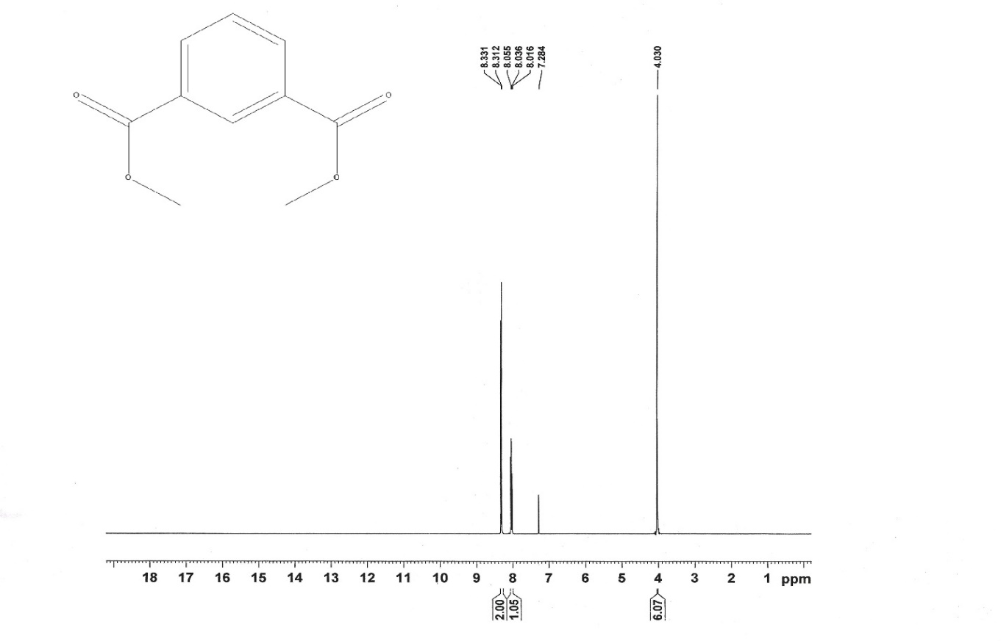
Figure S1: ¹H NMR (400MHz in CDCl3) of P1.
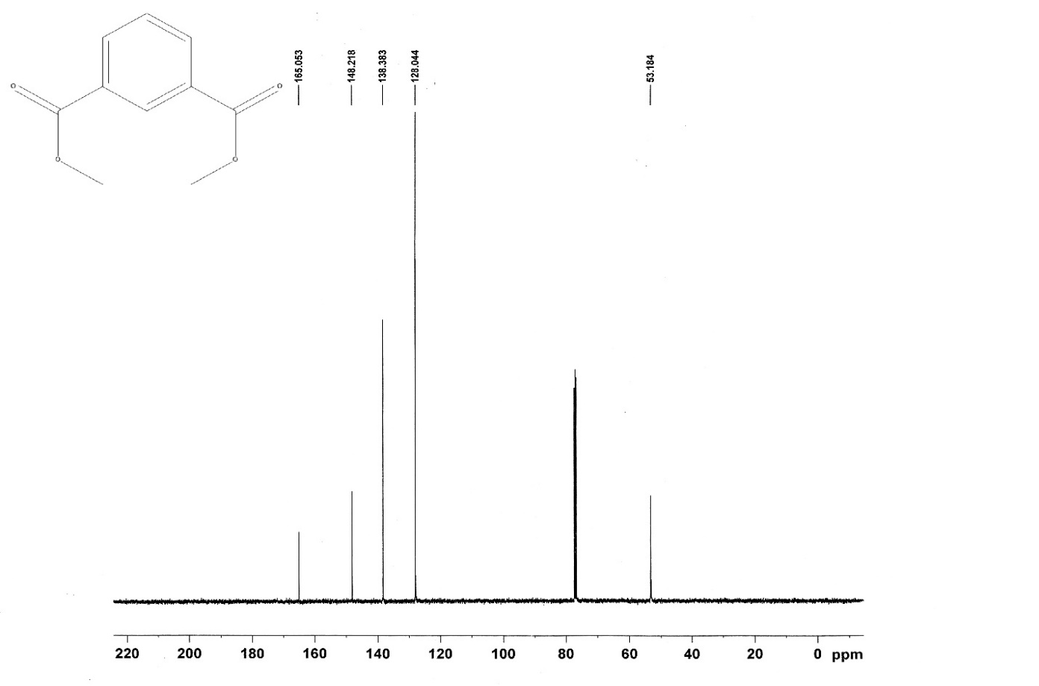
Figure S2: ¹³C NMR (100 MHz in CDCl3) of P1.
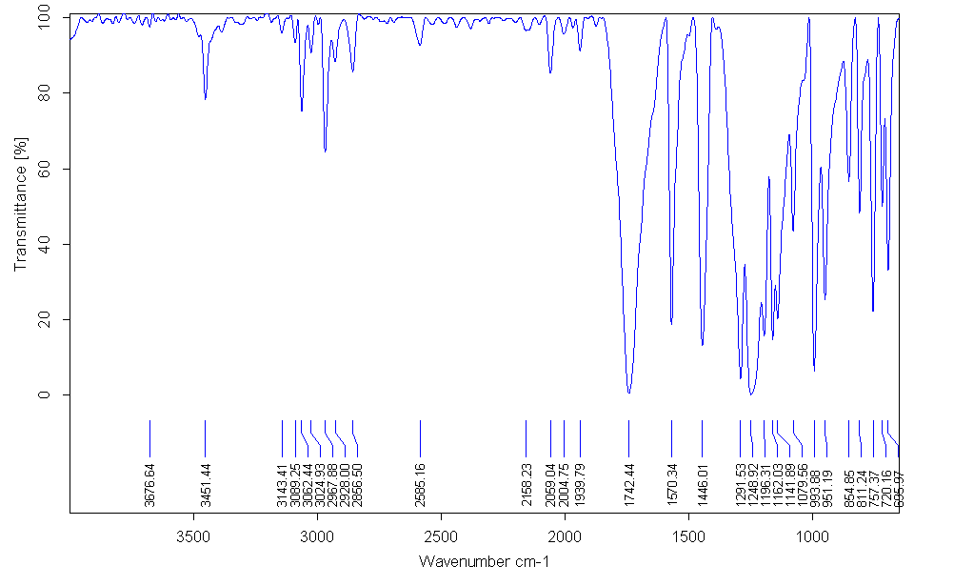
Figure S3: FT-IR spectrum of P1.
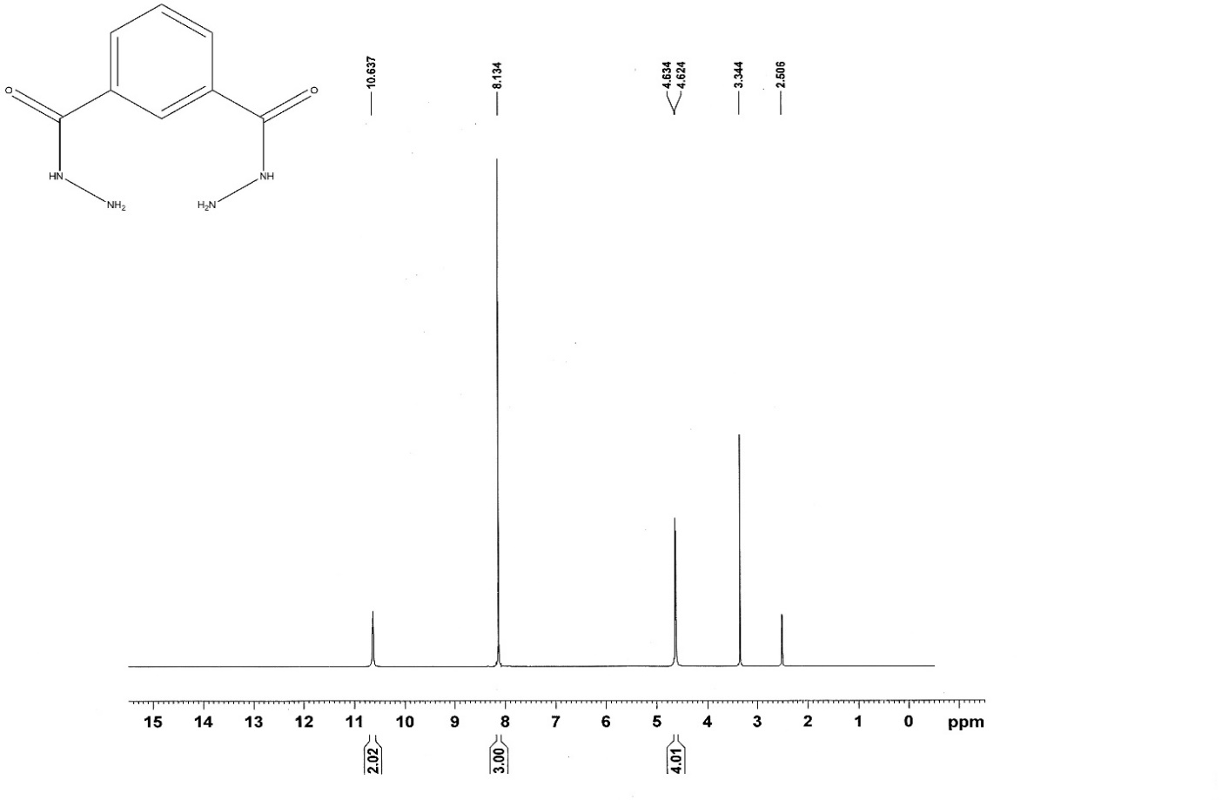
Figure S4: ¹H NMR (400 MHz in DMSO-d6) of P2.
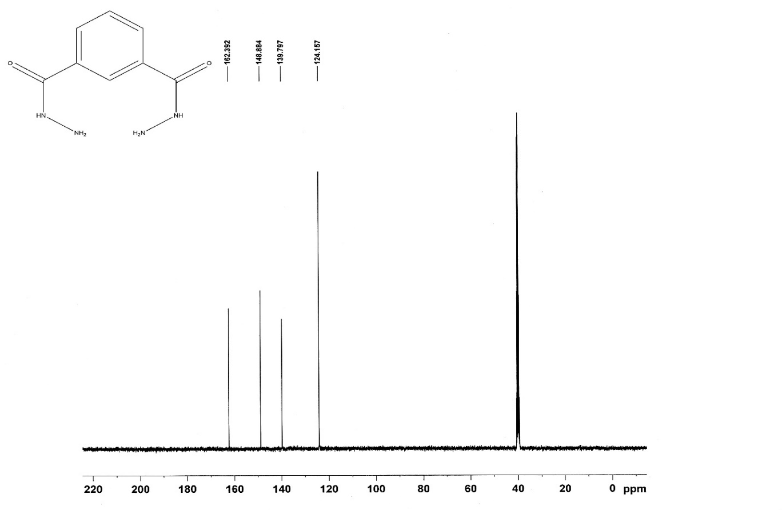
Figure S5: ¹³C NMR (100 MHz in DMSO-d6) of P2.
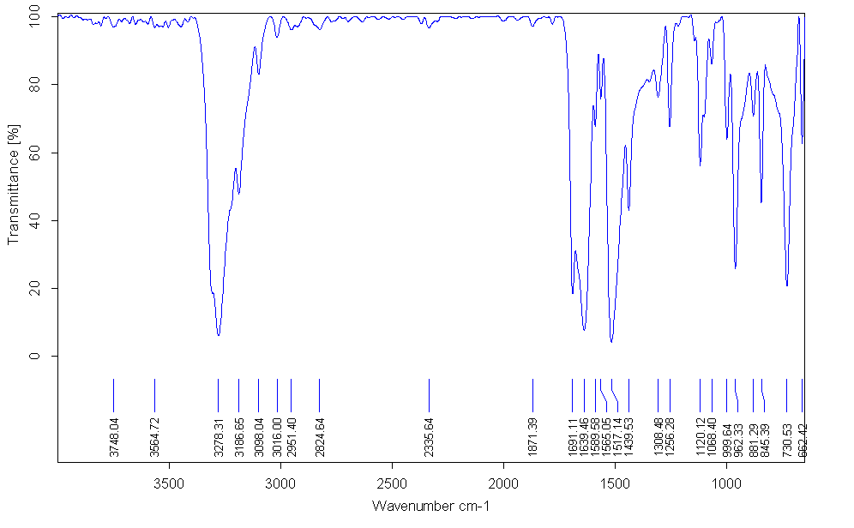
Figure S6: FT-IR spectrum of P2.
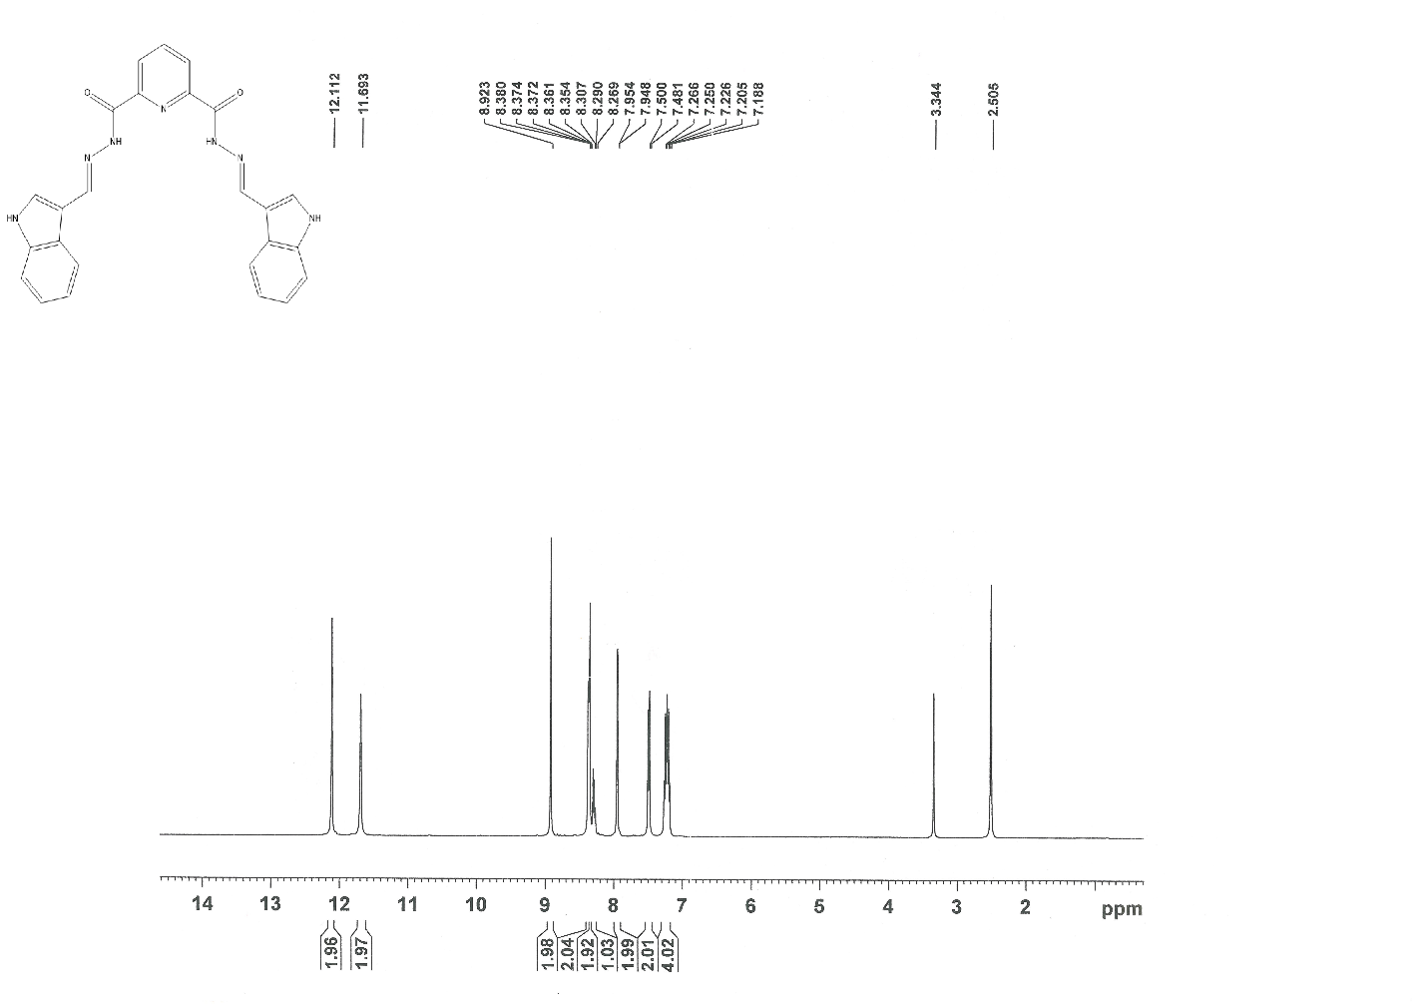
Figure S7: ¹H NMR (400 MHz in DMSO-d6) of P3.
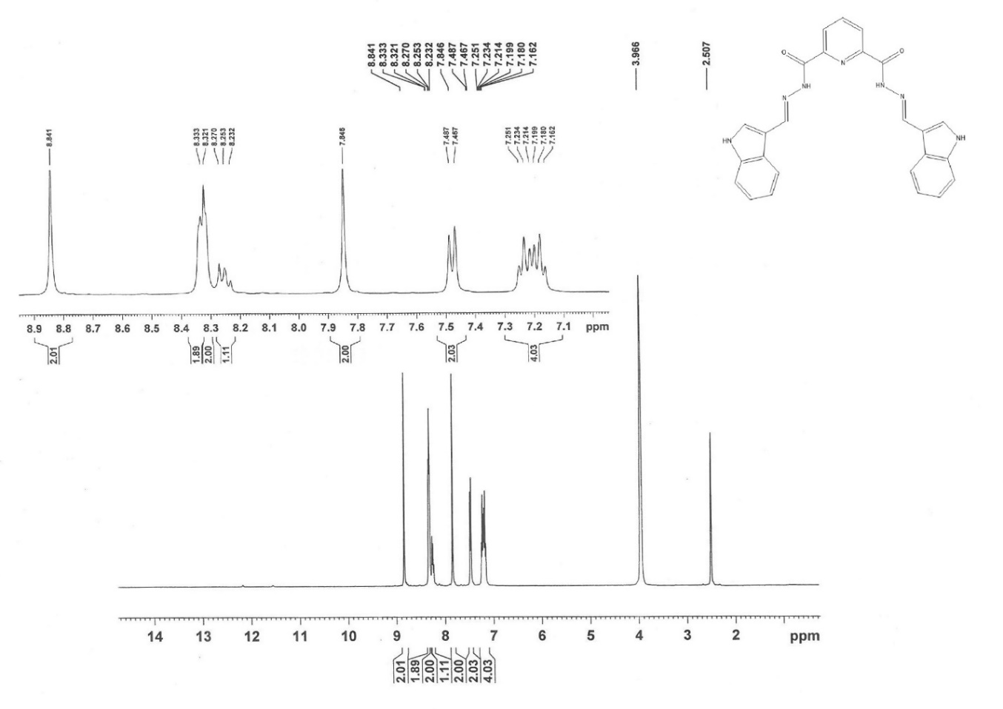
Figure S8: ¹H NMR (400 MHz in D₂O) of P3.
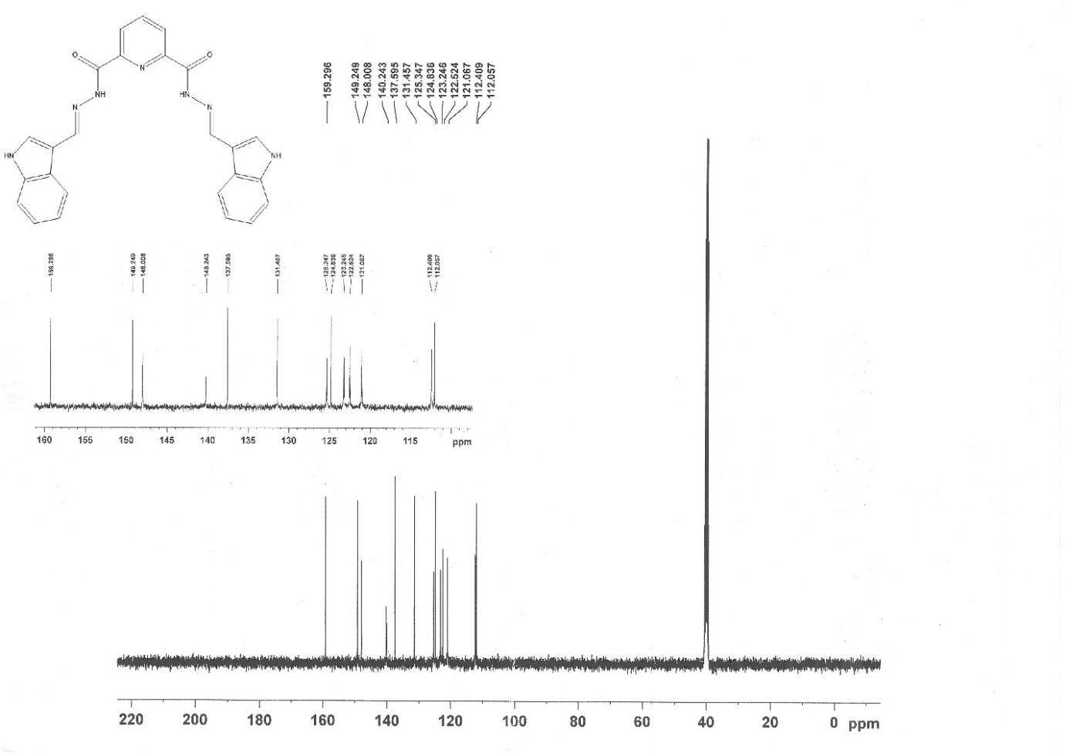
Figure S9: ¹³C NMR (100 MHz in DMSO-d6) of P3.
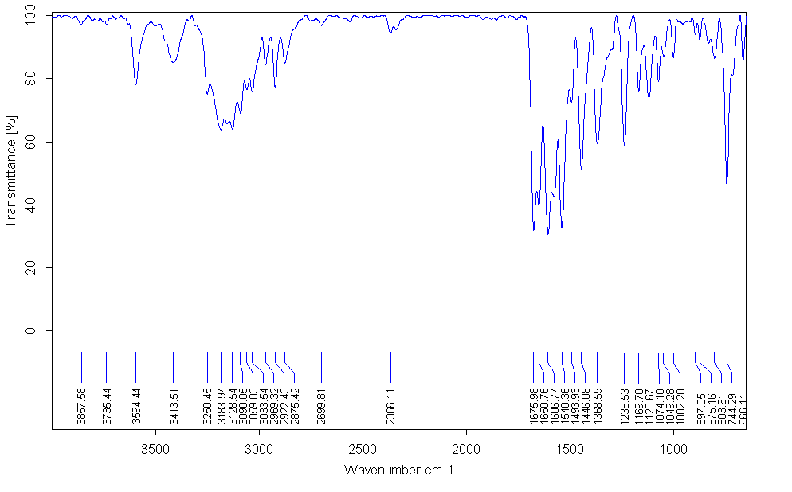
Figure S10: FT-IR spectrum of P3.
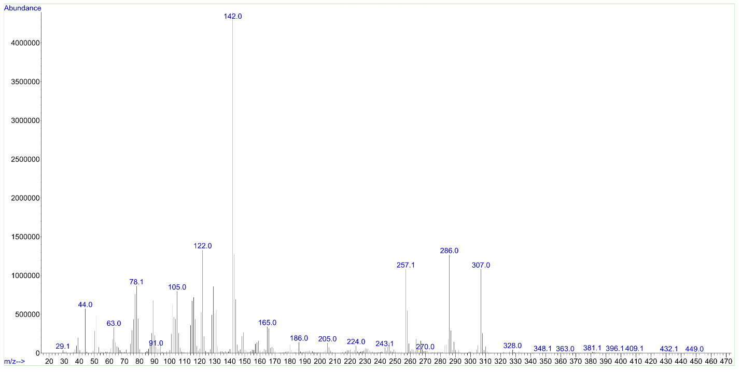
Figure S11: Mass Spectrum of P3.
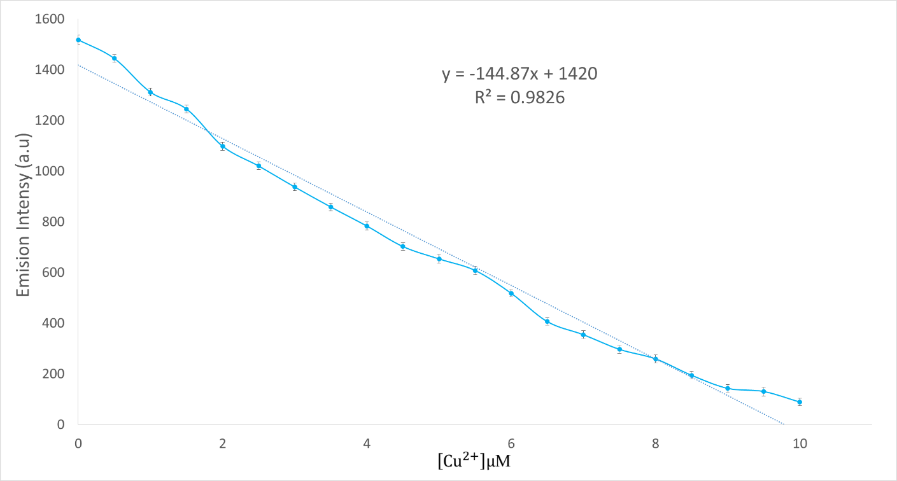
Figure S12: Calibration curve of fluorescence intensity of receptor P3 ($5.0 × {10}^{-6 }M)$ with Cu²⁺ ion concentrations.
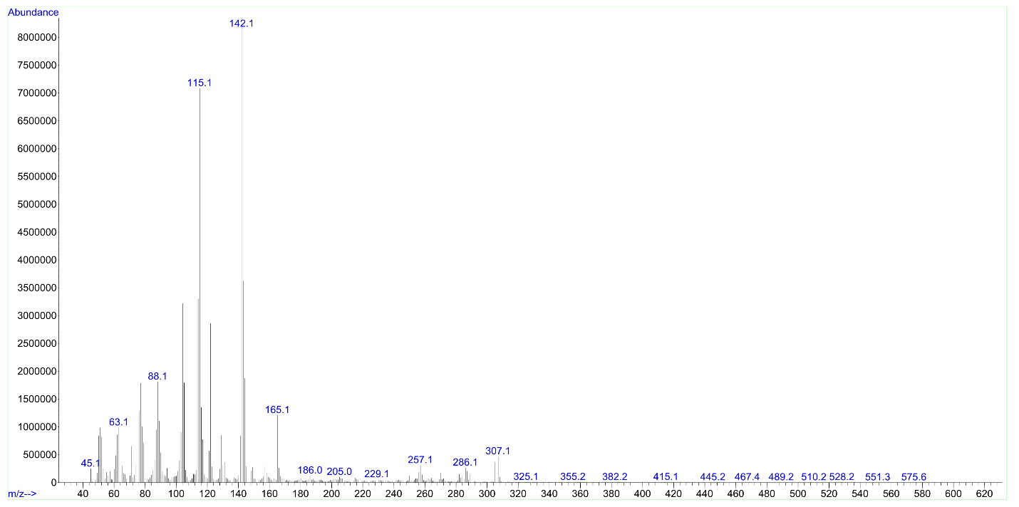
Figure S13: Mass Spectrum of P3-Cu²⁺.
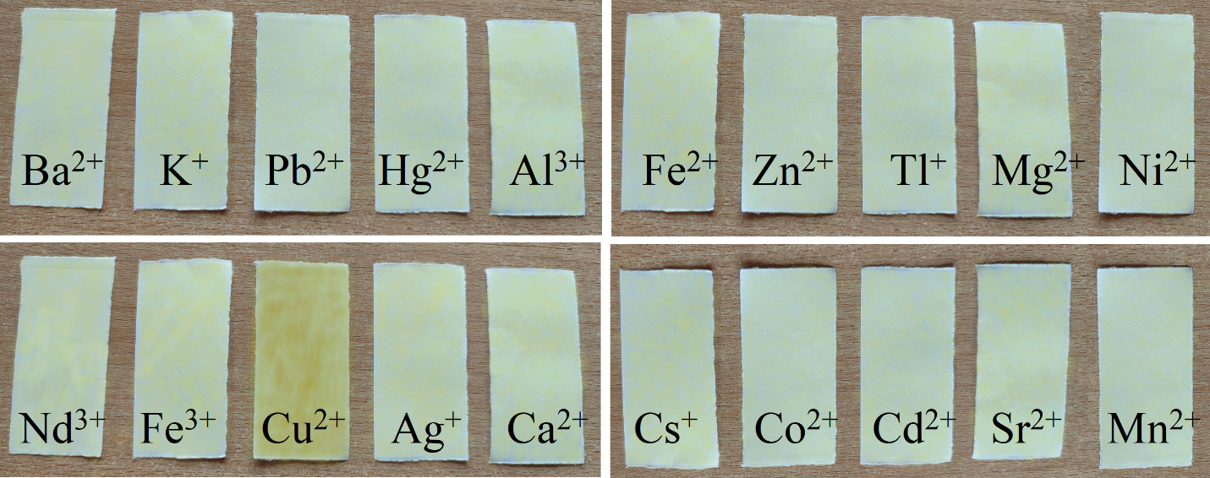
Figure S14: The Visual color change of paper strips with various cations.

