Table 1: Docking score and H-bonds in complex.

S.NO | COMPOUND NAME | LIPINSKI’S VIOLATION | BBB PERMEABILITY | BINDING AFFINITY  (kcal/mol) | SURFACE IMAGES
1. | Acanthocarpan | 0 | No | -8.1 | 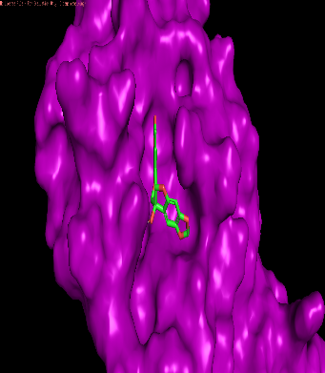
2. | Abacopterin F | 0 | No | -7.9 | 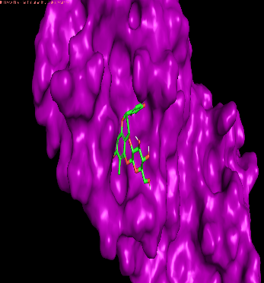
3. | Caesalpiniaphenol G | 0 | No | -7.9 | 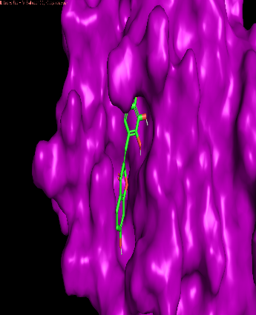
4. | Abacopterin C | 0 | No | -7.9 | 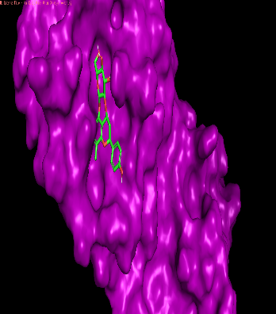
5. | Artoheterophyllin J | 0 | No | -7.8 | 