Appendix
A.1 List of stereotypical statements
Table A1 shows the stereotypical statements used in the experiment. The statements are grouped into the categories: race, gender, and religion. The statements are coded into positive and negative biases. Positive bias indicates a good stereotype, e.g., “Meiner Meinung nach sind Frauen gut in Mathe” (In my opinion, women are good in Math). Negative bias indicates a bad stereotype, e.g., “Meiner Erfahrung nach fotografieren Asiaten alles und jeden” (In my experience, Asians photograph everything and everyone).
Table A1. Stereotypical statements used in the experiment.
# | Stereotype statement | Category | Coding
1 | Meiner Meinung nach werden türkische Frauen unterdrückt. | Race | Negative
2 | Meiner Meinung nach sind türkische Männer friedlich. | Race | Positive
3 | Meiner Meinung nach sind Türken Sozialschmarotzer. | Race | Negative
4 | Meiner Meinung nach sind Türken gesetzestreu. | Race | Positive
5 | Meiner Erfahrung nach fotografieren Asiaten alles und jeden. | Race | Negative
6 | Meiner Erfahrung nach vertragen Asiaten reichlich Alkohol. | Race | Positive
7 | Meiner Meinung nach sind Asiaten gute Autofahrer. | Race | Positive
8 | Meiner Meinung nach haben Asiaten strenge Eltern | Race | Negative
9 | Meiner Meinung nach denken Frauen anders. | Gender | Negative
10 | Meiner Meinung nach sind Frauen gut in Mathe. | Gender | Positive
11 | Meiner Meinung nach sind Frauen hormongesteuert. | Gender | Negative
12 | Meiner Meinung nach haben Frauen einen guten Orientierungssinn | Gender | Positive
13 | Meiner Meinung nach muss ein Mann nicht stark sein und seine Familie beschützen. | Gender | Positive
14 | Meiner Meinung nach sollten Männer niemals bereit sein, ihre Familie auch mit Gewalt zu verteidigen. | Gender | Positive
15 | Meiner Meinung nach müssen Männer manchmal Härte zeigen. | Gender | Negative
16 | Meiner Meinung nach können Männer besser mit Geld umgehen. | Gender | Negative
17 | Meiner Meinung nach tragen Juden die Verantwortung für die meisten Kriege auf der Welt. | Race | Negative
18 | Meiner Meinung nach reden Juden zu wenig über den Holocaust. | Race | Positive
19 | Meiner Meinung nach haben Juden zu viel Macht in der Wirtschaft. | Race | Negative
20 | Meiner Meinung nach sind Juden politisch moderat. | Race | Positive
21 | Meiner Meinung nach vermindern Ausländer viele soziale Probleme. | Race | Positive
22 | Meiner Meinung nach verbessere sich meine Situation mit der Reduzierung der ausländischen Bevölkerung. | Race | Negative
23 | Meiner Meinung nach gibt es zu wenige Ausländer. | Race | Positive
24 | Meiner Meinung nach kommen die Ausländer nur hier her, um unseren Sozialstaat auszunutzen. | Race | Negative
25 | Meiner Meinung nach passen Muslime in westliche Welt. | Religion | Positive
26 | Meiner Meinung nach sind Muslime gefahrlos. | Religion | Positive
27 | Durch Muslime fühle ich mich wie Fremder im eigenen Land. | Religion | Negative
28 | Meiner Meinung nach sollten Muslimen die Zuwanderung untersagt werden. | Religion | Negative
29 | Meiner Meinung nach sind Christen engstirnig. | Religion | Negative
30 | Meiner Meinung nach ist das Christentum modern. | Religion | Positive
31 | Meiner Meinung nach sind Christen doppelmoralisch. | Religion | Negative
32 | Meiner Meinung nach sind Christen tiefgründig. | Religion | Positive
33 | Meiner Meinung nach ist Homosexualität unmoralisch. | Gender | Negative
34 | Meiner Meinung nach ist Homosexualität natürlich. | Gender | Positive
35 | Meiner Meinung nach nimmt das Thema Homosexualität zu wenig Raum in den Medien ein. | Gender | Positive
36 | Meiner Meinung nach sollten Homosexuelle aufhören, so einen Wirbel um ihre Sexualität zu machen. | Gender | Negative

A.2 Comparison of ratings across three stereotype categories
We checked whether participants could have responded to the three stereotype categories differently by running a 3×1 repeated measures ANOVA with the factor: stereotype categories (race, gender, religion). The post-hoc α value to evaluate significance for this comparison was 0.05 ÷ 3 = 0.0167.
There was a significant main effect of stereotype categories on stereotypical statement endorsement, F(1.37, 256.51) = 5.30, p = .013, η_{p}² = .028 (Figure A2). Post-hoc comparisons were conducted using Bonferroni-correction: α = .0167. Endorsement differed between statements concerning race (M = 5.38, SD = .86) and religion (M = 5.72, SD = .89), t(187) = -4.73, SD = 1.01, p < .001, Cohen’s d = -.35, but not between race and gender (M = 5.54, SD = 1.62, p =.10), or between gender and religion (p = .19).
From the results, it is unlikely that the ratings across the entire experiment could be attributed to the differences between race and religion. This is because of the small effect size (Cohen’s d = -.35). Thus, subsequent analyses in the main manuscript excluded stereotype categories as a factor to simply data interpretation.
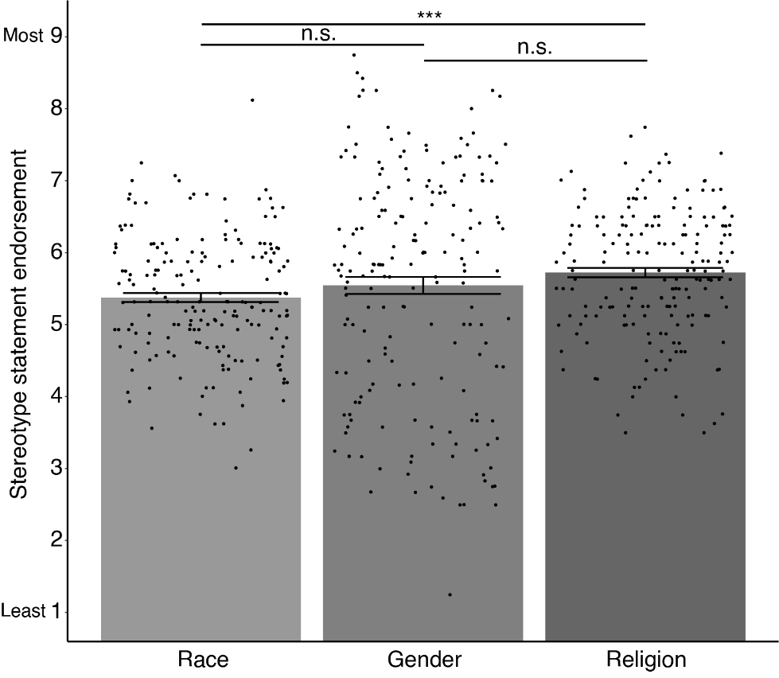
Figure A2. Bar graphs showing the stereotypical statement endorsement across race, gender, and religion stereotype categories. The scatter indicates responses from participants per category. Error bars illustrate standard error of means (SEM). *** p < .001, ** p < .01, * p < .05, n.s. – non-significant.

A.3 Two-way interactions
We investigated the watching eyes effect on stereotypical statement endorsement by running a 4×2×2 repeated measures ANOVA. The main effects for the two-way interactions (emotional expressions × age, emotional expressions × sex) are reported here. Post-hoc comparisons were conducted for significant interaction effects.
We compared all possible emotional expression combinations, using an α value, 0.05 ÷ 6 = 0.008. For eye age × emotional expressions, we computed the differences of each emotional expression by eye age, using an α value, 0.05 ÷ 4 = 0.0125. For eye sex × emotional expression, we determined the differences of each emotional expressions by eye sex, using an α value, 0.05 ÷ 4 = 0.0125.
A.3.1 Interaction between emotional expressions and age influence the stereotypical statement endorsement
There was a significant interaction between emotional expressions and age, F(3, 561) = 33.38, p < .001, η_{p}² = .15 (Figure A3.1). Post-hoc comparisons using Bonferroni-corrected α = 0.0125 were conducted. Participants show higher endorsement when seeing old angry eyes (M = 5.55, SD = 1.40) than young angry eyes (M = 5.13, SD = 1.22), t(187) = 3.03, SD = 1.90, p = .003, Cohen’s d = .22, and when seeing old fearful eyes (M = 4.41, SD = 1.38) than young fearful eyes (M = 3.96, SD = 1.56), t(187) = 3.31, SD = 1.87, p = .001, Cohen’s d = .24.
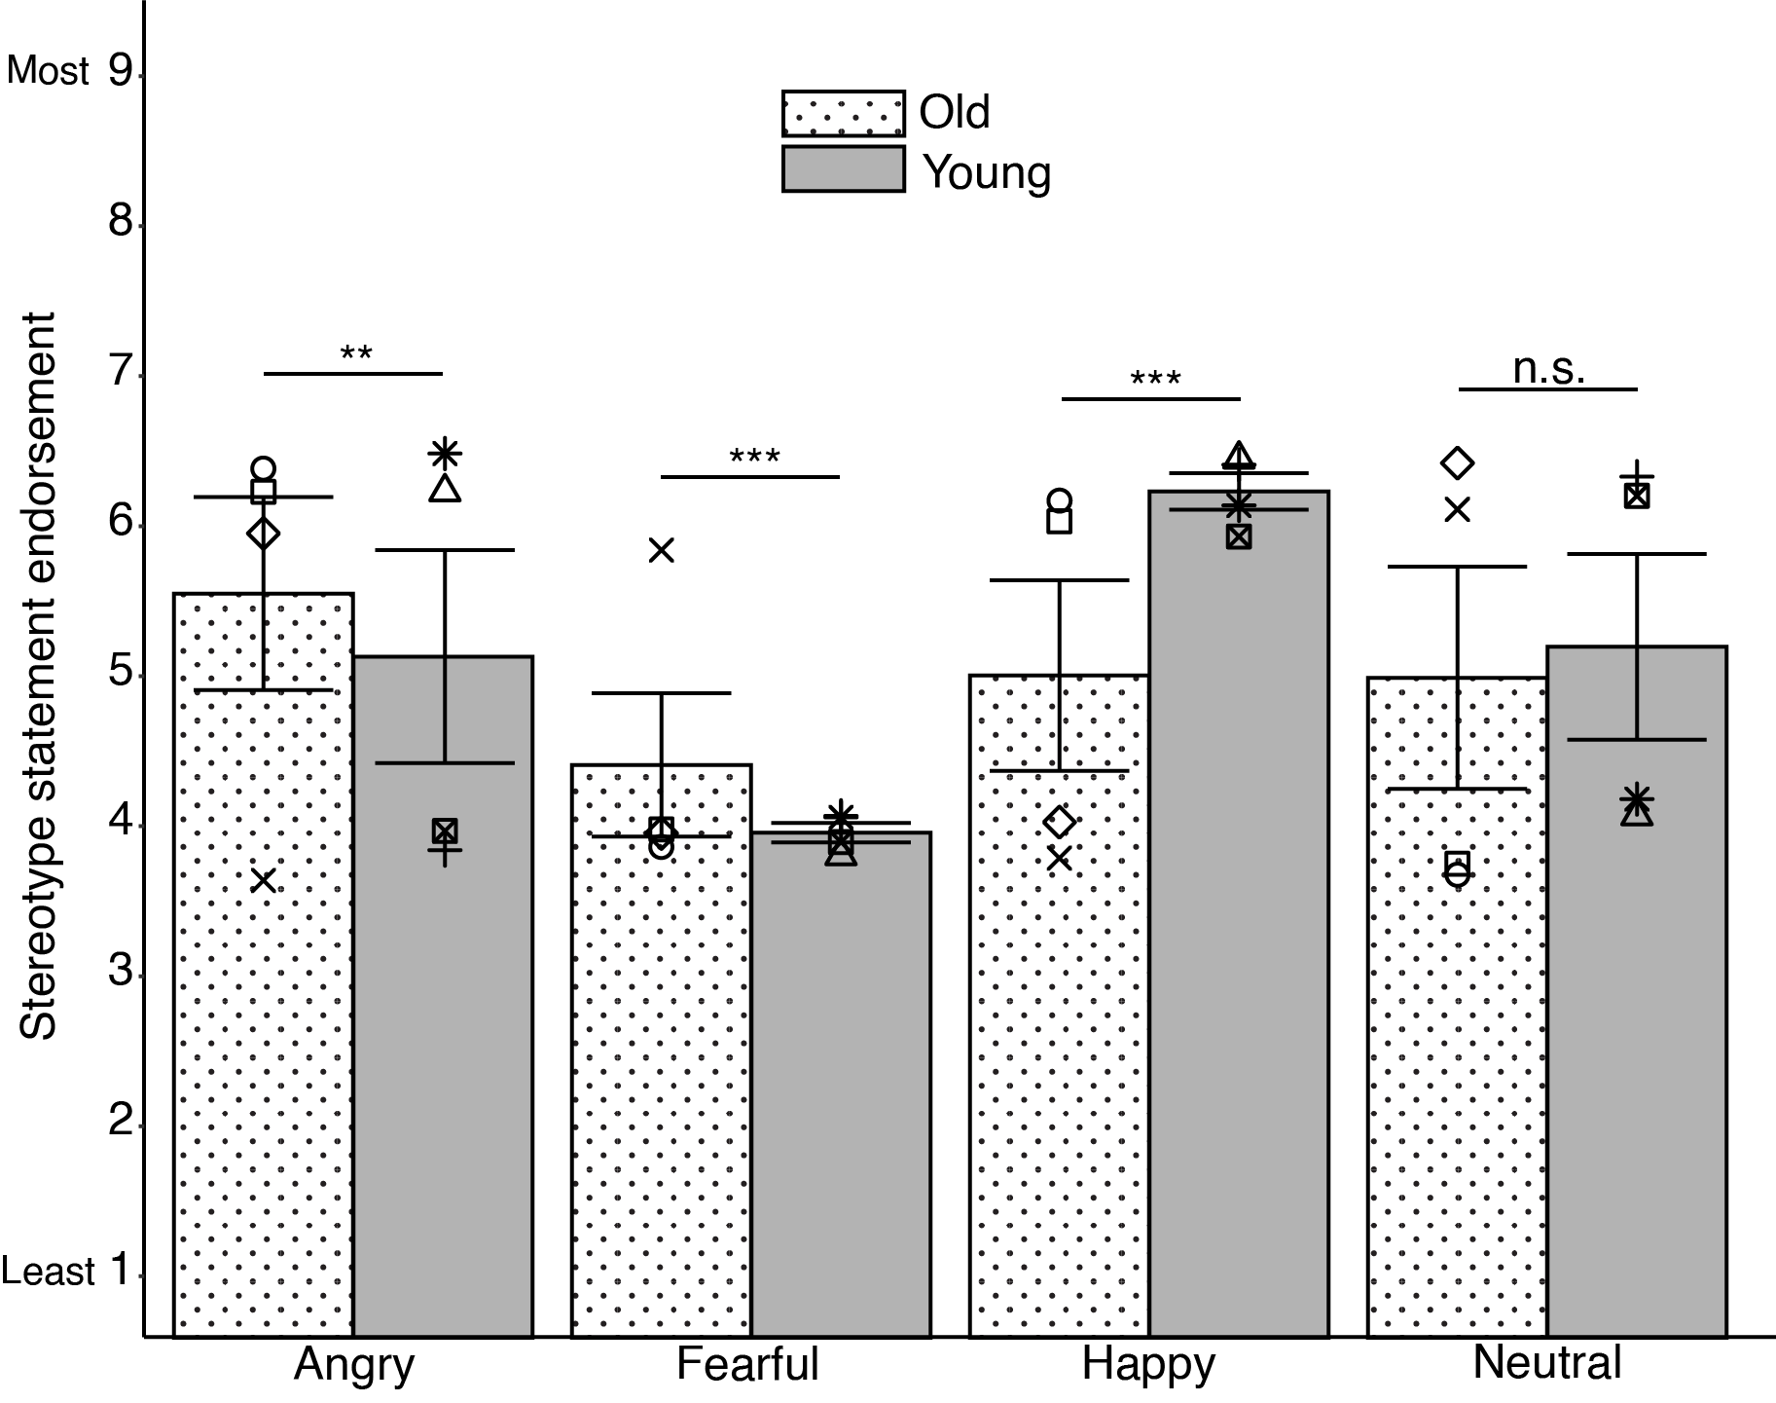
Figure A3.1. Bar graphs showing the two-way interactions between emotional expression and age. Symbols indicate mean responses for each eye model. Error bars illustrate standard error of means (SEM). *** p < .001, ** p < .01, * p < .05, n.s. – non-significant.

Stereotype endorsement were lower for old happy eyes than young happy eyes (M = 5.00, SD = 1.30) than young happy eyes (M = 6.23, SD = 1.45), t(187) = -9.20, SD = 1.83, p < .001, Cohen’s d = -.67. There were no differences for neutral old eyes (M = 4.99, SD = 1.38) and neutral young eyes (M = 5.20, SD = 1.33), t(187) = -1.51, SD = 1.87, p = .13, Cohen’s d = -.11.
A.3.2 Interaction between emotional expressions and sex influence stereotypical statement endorsement
There was a significant interaction between emotional expressions and sex, F(3, 561) = 8.01, p < .001, η_{p}² = .04 (Figure A3.2). Post-hoc comparisons using Bonferroni-corrected α = 0.0125 were conducted. The extent to endorse stereotype statements was higher when seeing male angry eyes (M = 5.56, SD = 1.33) than female angry eyes (M = 5.12, SD = 1.35), t(187) = 3.10, SD = 1.97, p = .002, Cohen’s d = .23. Stereotype statement endorsement were lower for male fearful eyes (M = 3.95, SD = 1.53) than for female fearful eyes (M = 4.41, SD = 1.50), t(187) = -3.19, SD = 1.99, p = .002, Cohen’s d = -.23.
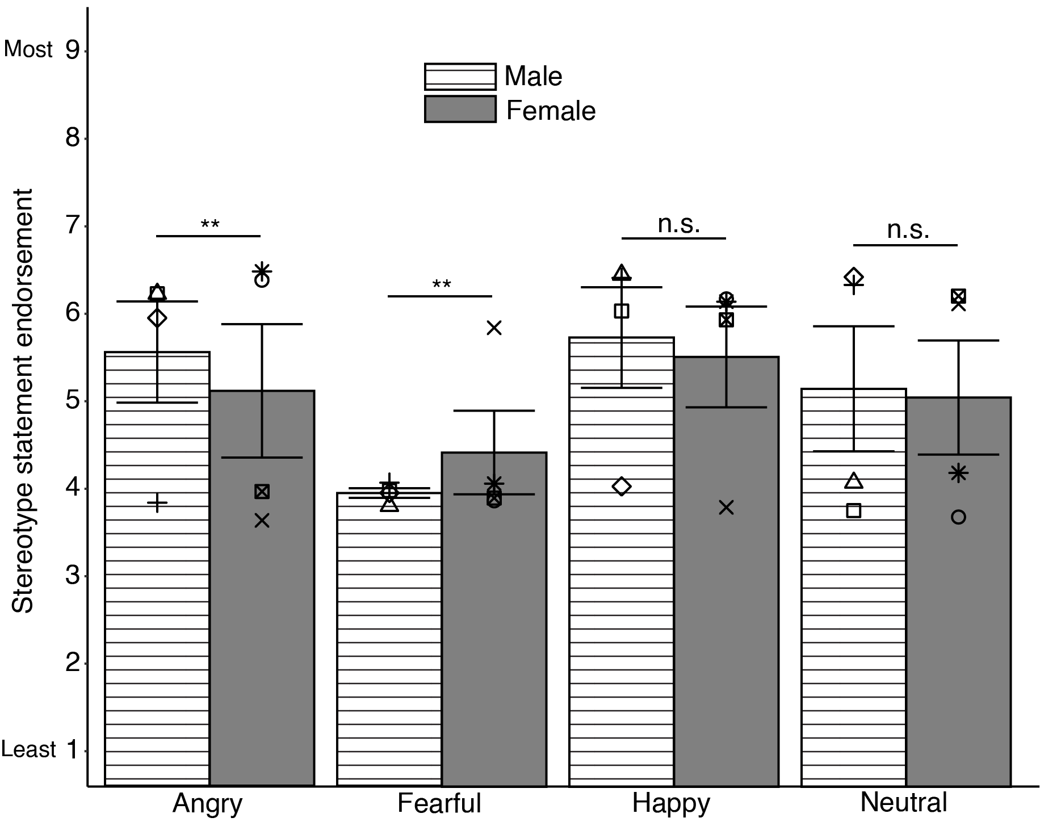
Figure A3.2. Bar graphs showing the two-way interactions between emotional expression and sex. Symbols indicate mean responses for each eye model. Error bars illustrate standard error of means (SEM). *** p < .001, ** p < .01, * p < .05, n.s. – non-significant.

There were no differences between male happy eyes (M = 5.73, SD = 1.34) and female happy eyes (M = 5.51, SD = 1.36), t(187) = 1.74, SD = 1.75, p = .08, Cohen’s d = .13. There were no differences between male neutral eyes (M = 5.14, SD = 1.38) and female neutral eyes (M = 5.04, SD = 1.32), t(187) = .74, SD = 1.84, p = .46, Cohen’s d = .05.
A.4 Statistical assumption checks for repeated measures ANOVA
Statistical assumption checks were conducted for the repeated measures ANOVA. We checked whether the sphericity assumption was violated using Mauchly’s W (Mauchly, 1940). Greenhouse-Geisser correction was applied when comparisons violated the sphericity assumption (Greenhouse & Geisser, 1959). The results of the statistical checks are reported below.
Table A5. Summary of factors and variables which violated sphericity assumptions.
Factor | Statistics | Violation?
Stereotype categories | Mauchly’s W = .54, χ² = 113.94, p < .001 | ✓
Emotional expression (EE) | Mauchly’s W = .88, χ² = 24.66, p < .001 | ✓
EE × age | Mauchly’s W = .99, χ² = 1.30, p = .94
EE × sex | Mauchly’s W = .98, χ² = 3.48, p = .63
EE × age × sex | Mauchly’s W = .98, χ² = 3.94, p = .56

