Supplementary information for
A processing paradigm for loose varved sediments in Anthropocene strata research: An example from the Sihailongwan maar Lake

The file includes:
The principle of freeze coring and the detailed coring process
Pretreatment of element scanning
Figures S1-S3;

The principle of freeze coring and the detailed coring process
The freezing corer works as follows: The wedge is inserted into the sediment, and the refrigerant in the device rapidly lowers the temperature of the wedge, causing the sediment to freeze a layer on the wedge. 30 L anhydrous ethanol was first added into the corer chamber (Figure S1A), then the liquid nitrogen is passed into the coil of the chamber. As the liquid nitrogen flows through the coil, it takes away the heat from the anhydrous ethanol, the temperature of the anhydrous ethanol drops to -100 °C after 2.5 hours. (Storing absolute ethanol in the freezer ahead of time can effectively reduce the amount of liquid nitrogen used and is time saving.) Then the freeze corer was released and sunk to the water bottom. The freeze wedge (1 m long, 15 cm wide, and 1 cm thick (Figure S1A) was inserted into the sediment approximately 50-90 cm and kept steady. Then, the electromagnetic switch (Figure S1A) was automatically triggered, and the -100°C ethanol in the holding tank began to circulate in the freezing wedge driven by an electric pump (Figure S1A). About 20 minutes later, 2 pieces of frozen sediment (approximately 2 cm thick, 15 cm wide, 50-90 cm long) were rapidly condensed on the periphery of the freezing wedge (Figure S1B). Lift the equipment out of water, clean up unfreeze sediment on the frozen cores and inject warm ethanol into the freezing wedge to lightly separate the cores from the wedge. The cores were wrapped with aluminum foil, plastic wrap, and foaming paper to prevent core contamination, water evaporation, and core breakage. It took about 1.5 hours to collect a core. Then, it was stored in a -36°C refrigerator and transported to our institution.

Pretreatment of element scanning
A core strip (20 × 2 × 2 cm) was cut from the freeze core, and then it was placed in an aluminium box (22 × 2.5 × 2.5 cm), freeze-dried in a freeze drier, and impregnated in mixture of epoxy resin (epoxy resin-128, Yueyang Petrochemical) and triethanolamine (Macklin). Here we tried heating the resin mixture at different temperatures to melt it and found that 120 ° C for 20 minutes was the best. After impregnating the core strip with resin, it was placed in a vacuum machine to completely impregnate the resin into the sample under negative pressure. By trying different pressures, it was found that -30 kPa is the best. The impregnated strip was hardened in an oven at 50°C for 24 hours and then polished with 30, 10, 5, 1 micron sandpaper in sequence on a grinder and polisher. The polished core strip was scanned at 0.1-cm resolution using an Avaatech XRF core scanner (Avaatech, the Netherlands) at the Institute of Earth Environment, Chinese Academy of Sciences (IEECAS).

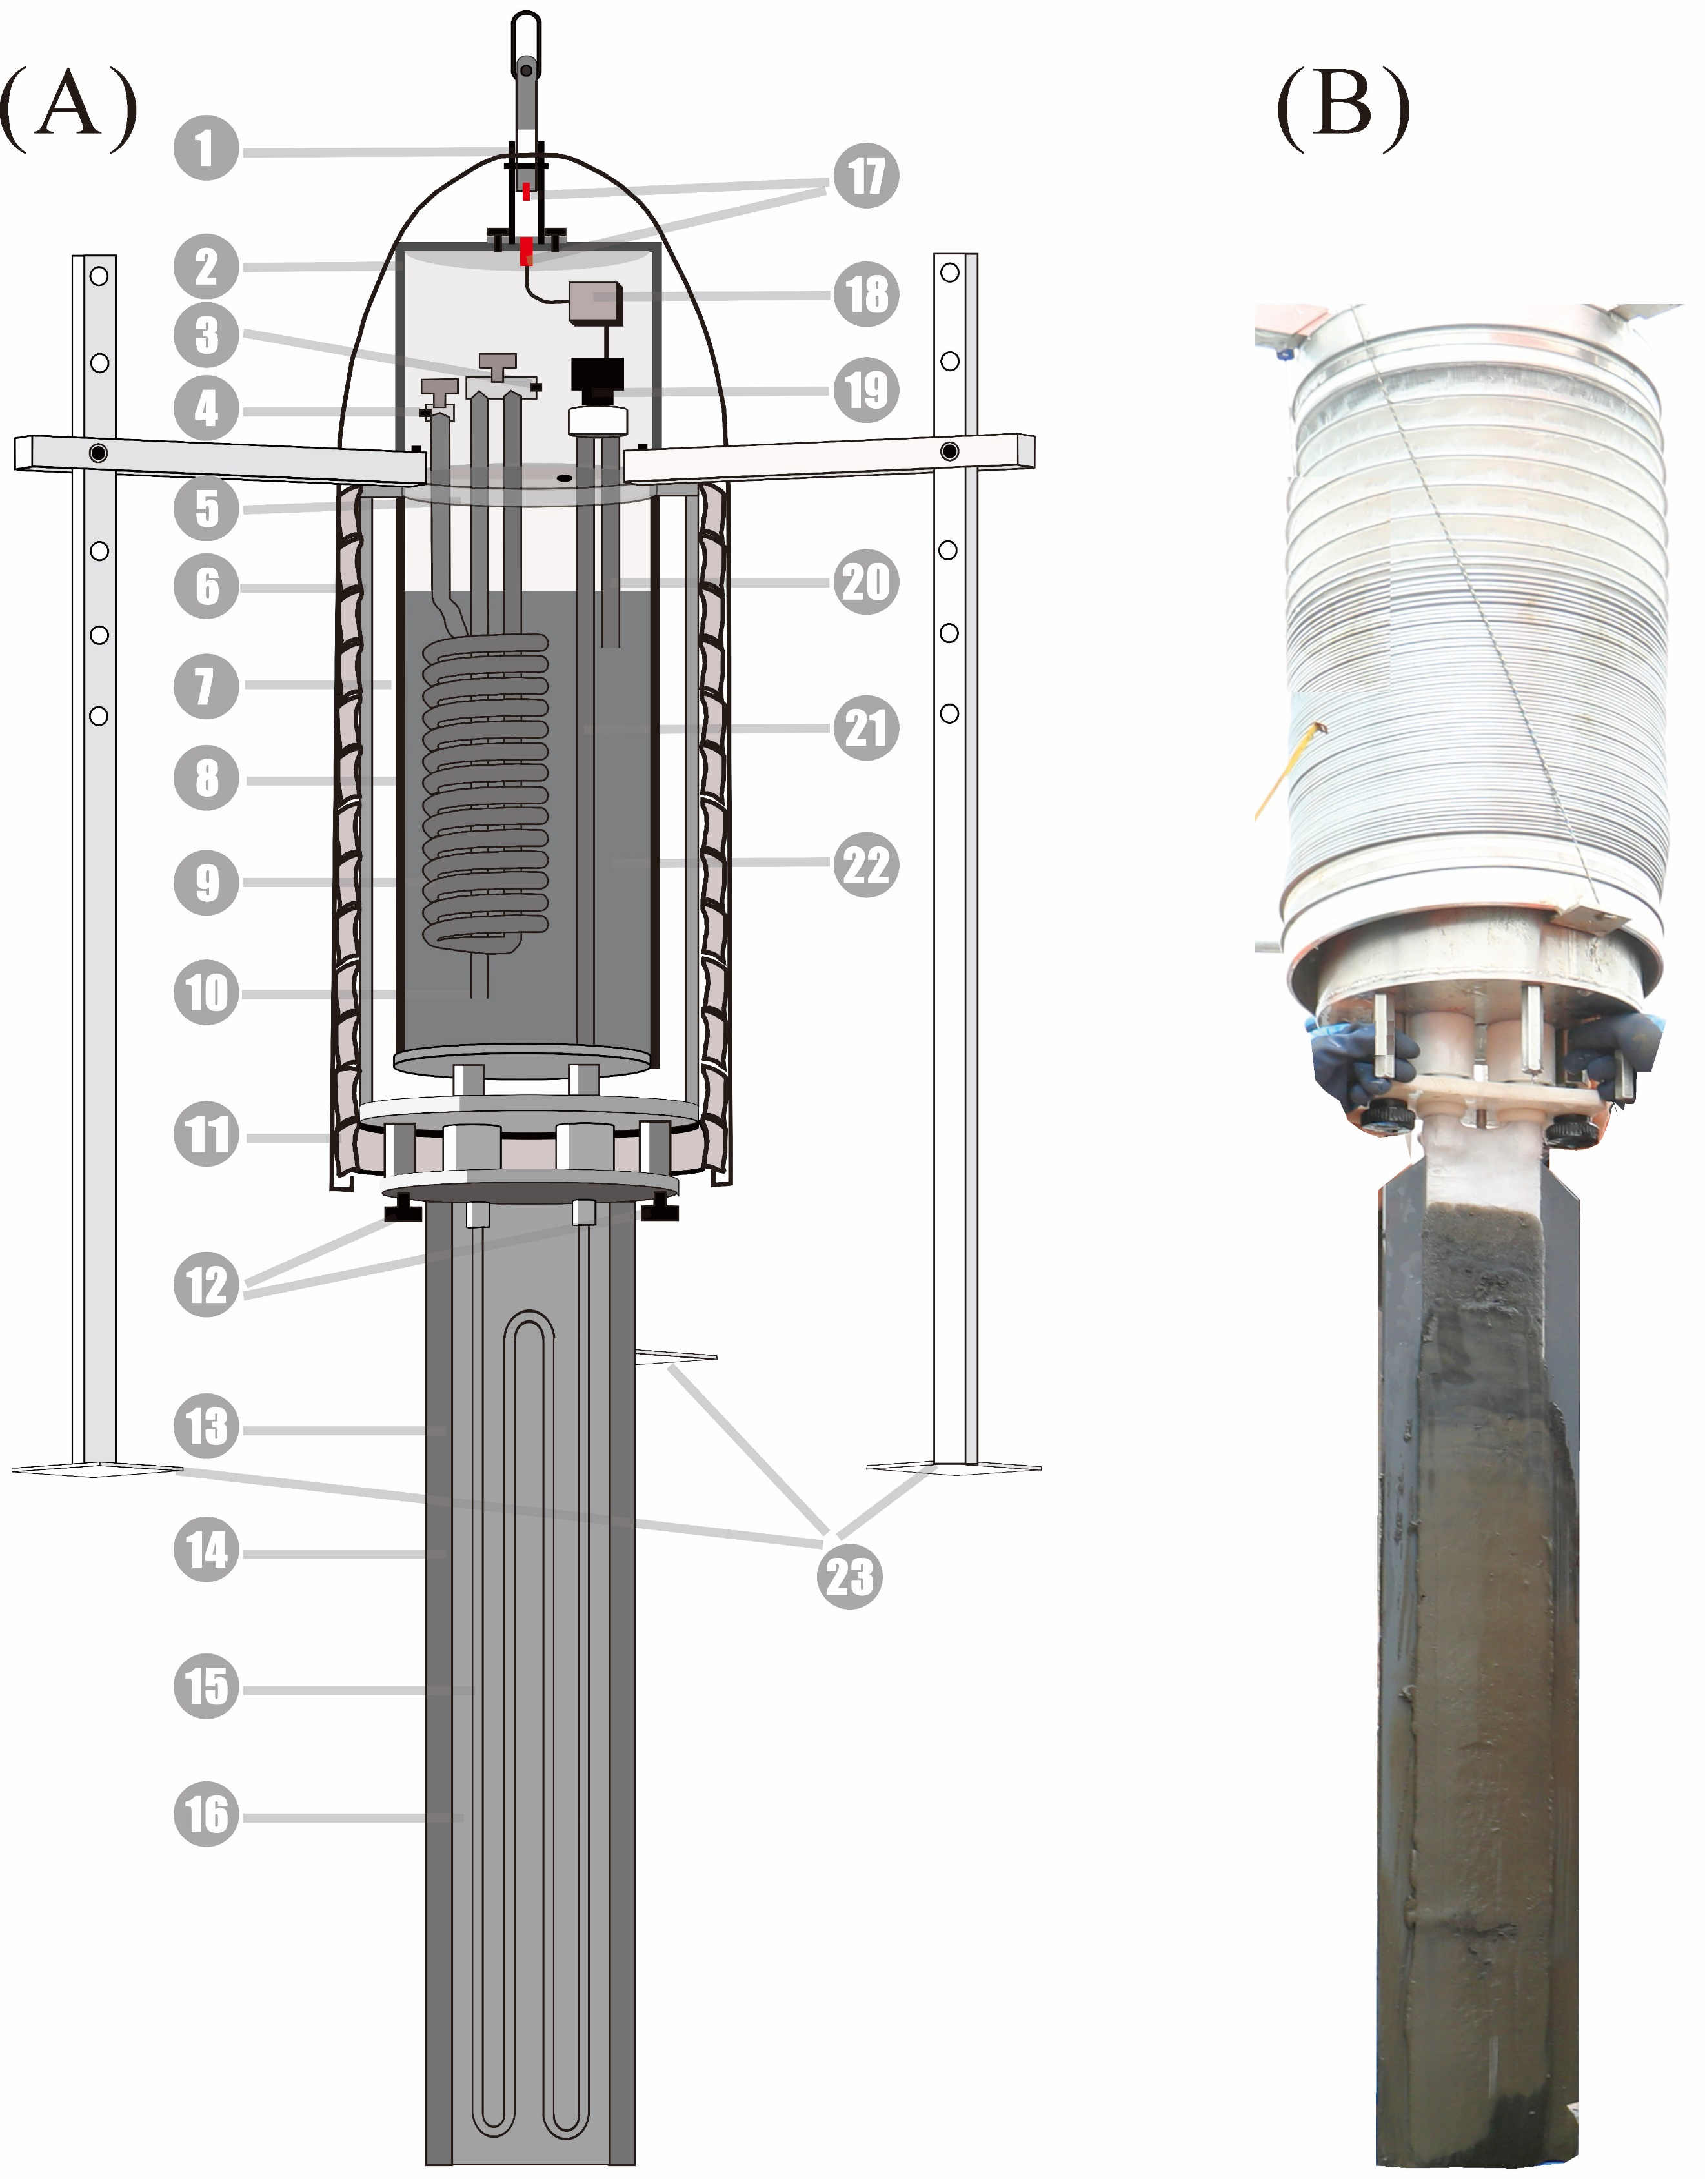
Figure S1. Freeze corer and coring. (A) Schematic diagram of freeze corer (Modify according to Thomas, et al., 2003). (B) Freeze coring in the field.

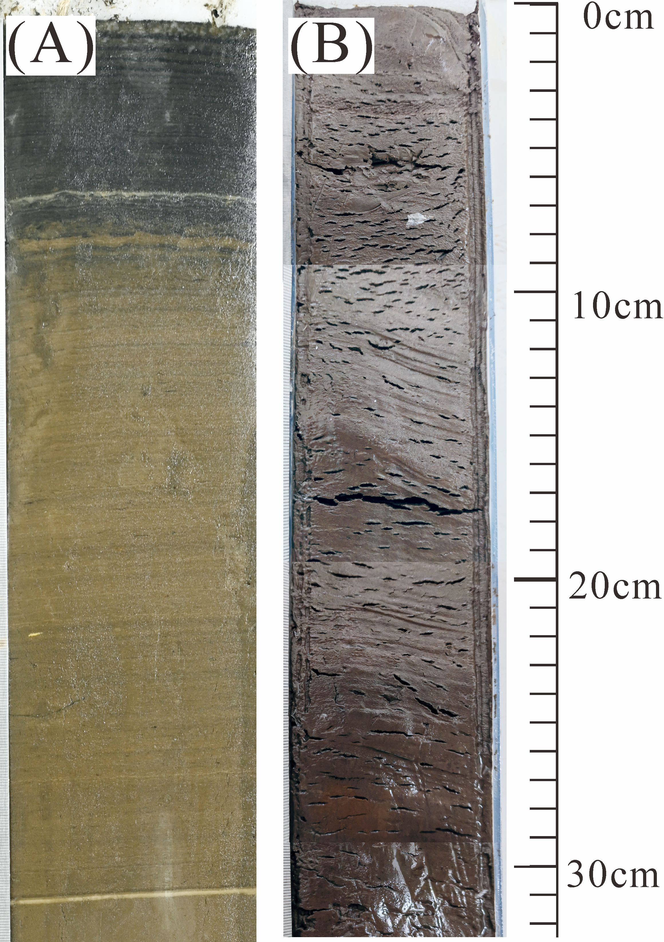
Figure S2. Comparison of freeze core and gravity core. (A) Freeze core image, clear varve layers in the freeze core. (B) gravity core image. There are full of voids in the core and the varve layers were mostly broken, and the core color turn brown and black when exposed to air.

Figure S3. Part of the parallel cores and with their varve age marked. There are several distinct marker layers that connect the parallel cores and their ages. The age uncertainty can be greatly reduced by cross-checking the marker layer.

