Supplementary material for
The Preventive and Treatment of the Alzheimer’s disease in Sorokdo National Hospital.

Section 1. Calculation 3
Supplementary Table 1. AD Prevalence rate in the Dapsone (+/-) group. 3
One-Way ANOVA Calculator, 4
T-Test Calculator for DDS (+)/AD(+/-) Independent Means 5
T-Test Calculator for 2 Independent Means Site 6
T Test Calculator for DDS (+)/AD(+/-) Dependent Means 7
T Test Calculator for 2 Dependent Means Site 7
T-Test Calculator for DDS (-)/AD(+/-) Independent Means 8
T-Test Calculator for DDS (-)/AD(+/-) Dependent Means 10
Section 2. STROBE Statement 11
Discussion 20
References 21

Section 1. Calculation

Supplementary Table 1. AD Prevalence rate in the Dapsone (+/-) group.
Year | Dapsone (+) | Dapsone (-) | AD (+)  Total | Dapsone (+) | Dapsone (-) | AD (-)  Total | P-value* | Rate:  DDS (+) AD (+) | Rate:  DDS (+) AD (-) | Rate:  DDS (-) AD (+) | Rate:  DDS (-) AD (-)
2005 | 18 | 19 | 37 | 290 | 417 | 707 | .3583 | 0.4865 | 0.4102 | 0.5135 | 0.5898
2006 | 20 | 37 | 57 | 302 | 363 | 665 | .1324 | 0.3509 | 0.4541 | 0.6491 | 0.5459
2007 | 22 | 51 | 73 | 317 | 332 | 649 | .0024** | 0.3014 | 0.4884 | 0.6986 | 0.5116
2008 | 22 | 58 | 80 | 310 | 312 | 622 | .00028** | 0.2750 | 0.4984 | 0.7250 | 0.5016
2009 | 19 | 66 | 85 | 300 | 283 | 583 | < .00001** | 0.2235 | 0.5146 | 0.7765 | 0.4854
2010 | 25 | 82 | 107 | 270 | 286 | 556 | < .00001** | 0.2336 | 0.4856 | 0.7664 | 0.5144
2011 | 35 | 98 | 133 | 255 | 268 | 523 | < .00001** | 0.2632 | 0.4876 | 0.7368 | 0.5124
2012 | 39 | 135 | 174 | 238 | 241 | 479 | < .00001** | 0.2241 | 0.4969 | 0.7759 | 0.5031
2013 | 34 | 172 | 206 | 195 | 248 | 443 | < .00001** | 0.1650 | 0.4402 | 0.8350 | 0.5598
2014 | 25 | 190 | 215 | 172 | 236 | 408 | < .00001** | 0.1163 | 0.4216 | 0.8837 | 0.5784
2015 | 26 | 242 | 268 | 167 | 168 | 335 | < .00001** | 0.0970 | 0.4985 | 0.9030 | 0.5015
2016 | 33 | 255 | 288 | 154 | 149 | 303 | < .00001** | 0.1146 | 0.5083 | 0.8854 | 0.4917
2017 | 37 | 268 | 305 | 143 | 115 | 258 | < .00001** | 0.1213 | 0.5543 | 0.8787 | 0.4457
2018 | 45 | 292 | 337 | 132 | 87 | 219 | < .00001** | 0.1335 | 0.6027 | 0.8665 | 0.3973
2019 | 46 | 334 | 380 | 114 | 40 | 154 | < .00001** | 0.1211 | 0.7403 | 0.8789 | 0.2597
2020 | 32 | 352 | 384 | 109 | 4 | 113 | < .00001** | 0.0833 | 0.9646 | 0.9167 | 0.0354

One-Way ANOVA Calculator,
Treatment 1: DDS (+) AD (+) Treatment 2: DDS (+) AD (-) Treatment 3: DDS (-) AD (+) Treatment 4: DDS (-) AD (-)
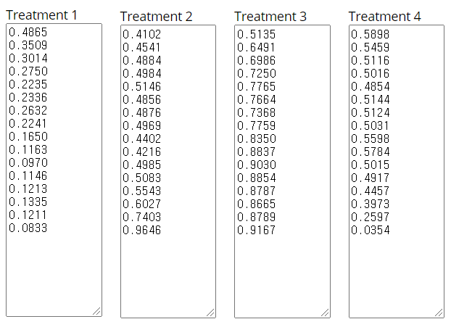

Summary of Data
 | Treatments
 | 1 | 2 | 3 | 4 |  | Total
N | 16 | 16 | 16 | 16 |  | 64
∑X | 3.3103 | 8.5663 | 12.6897 | 7.4337 |  | 32
Mean | 0.2069 | 0.5354 | 0.7931 | 0.4646 |  | 0.5
∑X² | 0.8677 | 4.8741 | 10.2471 | 3.7415 |  | 19.7304
Std.Dev. | 0.1104 | 0.1385 | 0.1104 | 0.1385 |  | 0.2433
Result Details
Source |  | SS | df | MS
Between-treatments |  | 2.7892 | 3 | 0.9297 | F = 59.27206
Within-treatments |  | 0.9412 | 60 | 0.0157
Total |  | 3.7304 | 63
The f-ratio value is 59.27206. The p-value is < .00001. The result is significant at p < .05.

T-Test Calculator for DDS (+)/AD(+/-) Independent Means
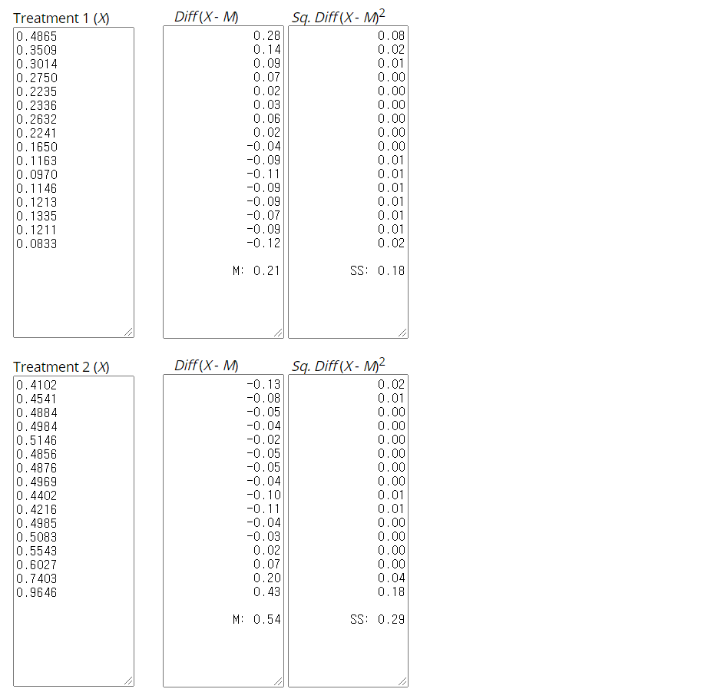
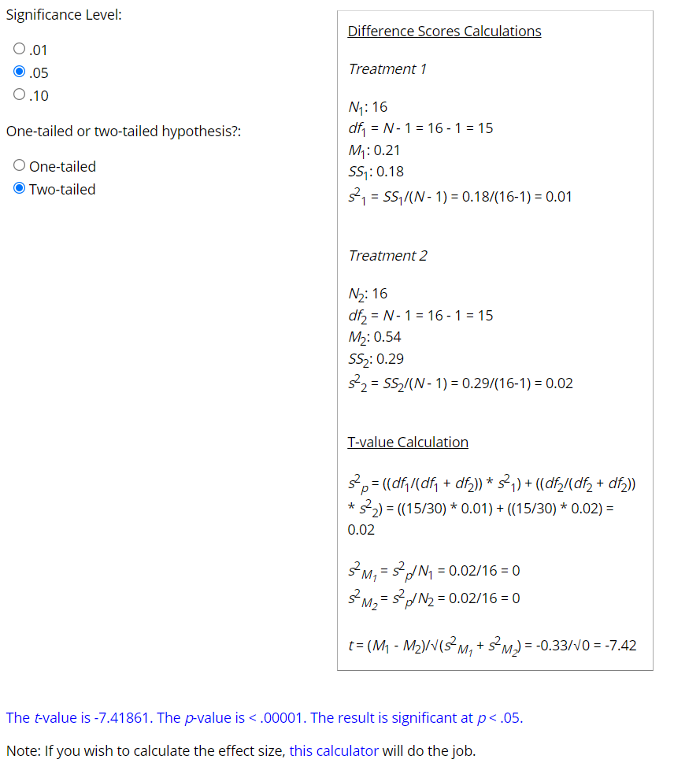

T-Test Calculator for 2 Independent Means Site
https://www.socscistatistics.com/tests/studentttest/default.aspx

T Test Calculator for DDS (+)/AD(+/-) Dependent Means
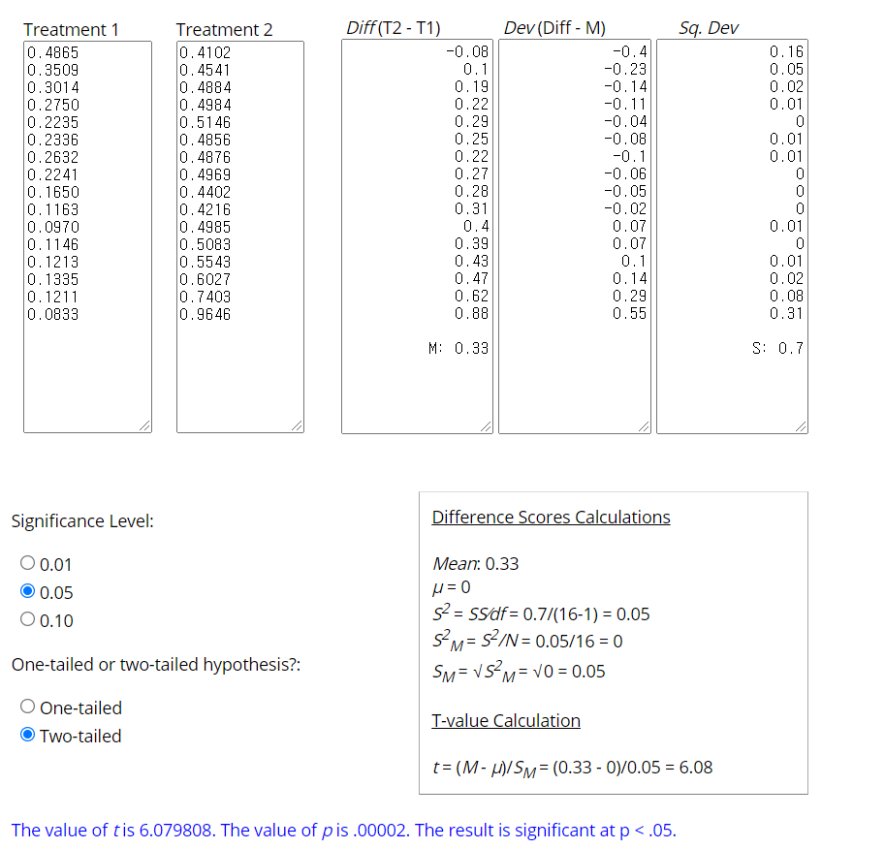

T Test Calculator for 2 Dependent Means Site
https://www.socscistatistics.com/tests/ttestdependent/default.aspx

T-Test Calculator for DDS (-)/AD(+/-) Independent Means
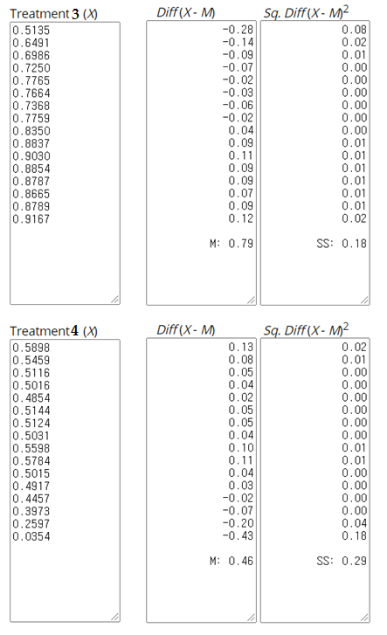

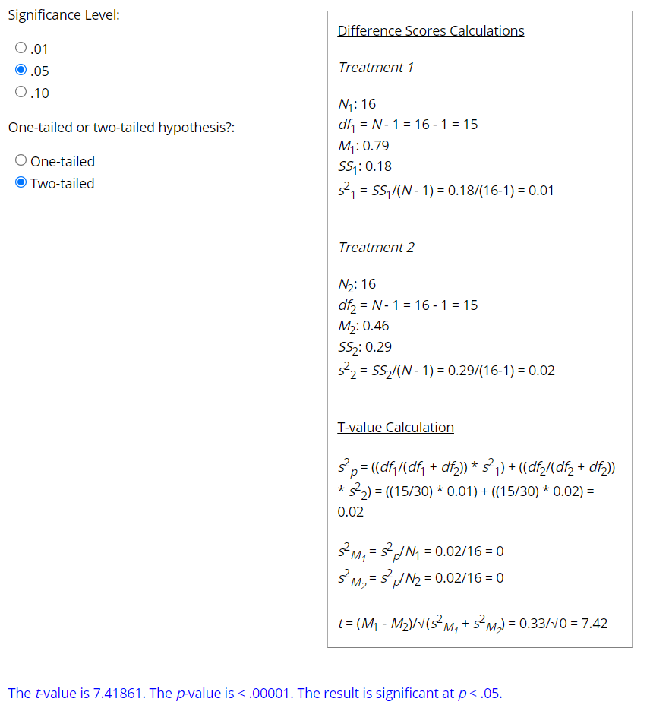

T-Test Calculator for DDS (-)/AD(+/-) Dependent Means
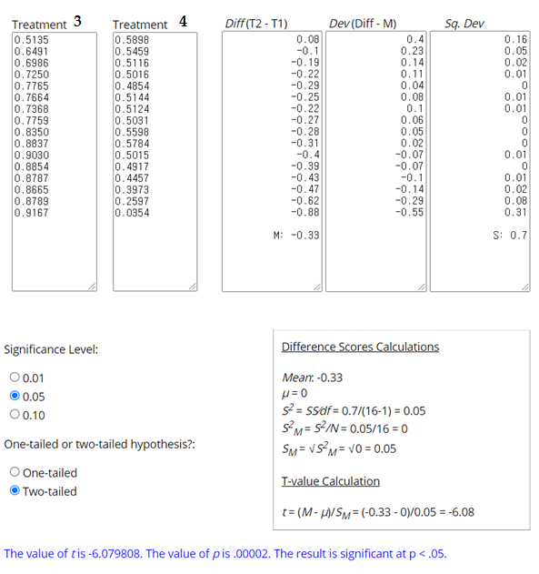

Section 2. STROBE Statement
STROBE Statement—Checklist of items that should be included in reports of case-control studies
 | Item No |  | Recommendation |  |  | Page No
Title and abstract | 1 |  | (a) Indicate the study's design with a commonly used term in the title or the abstract :  According to the Official Information Disclosure Act in Korea, the Seoul study analyzed AD and anti-Alzheimer's disease drug (AAD) use in Hansen subjects. The Seoul study analyzed AD and anti-AD drugs (AADs) in the Sorokdo National Hospital's EDI database archived from January 2005 to June 2020 through the ICD-9 and -10 codes. |  |  | 2
Title and abstract |  |  | (b) Provide in the abstract an informative and balanced summary of what was done and what was found :  We analyzed AD in HD patients at Sorokdo National Hospital. The HD patients in Sorokdo National Hospital have lived only on Sorokdo (an island for HD patients) all their lives. Korean HD patients continue to take DDS throughout their lives. Based on the relative prevalence of AD in patients who have been prescribed DDS and those who have not, this drug appears to have a preventive effect against AD. (Table 2) It shows that DDS's action as a neuro-inflammasome competitor¹ can be conjectured by comparing the AD prevalence in HD patients who have been prescribed DDS and those who have not. Thus, DDS appears to be a neuro-inflammasome competitor. |  |  | 3, 4
Introduction
Background/rationale |  | 2 |  | Explain the scientific background and rationale for the investigation being reported:  The Seoul study analyzed the causes of low AD prevalence of Hansen's disease (HD) patients at the Sorokdo National Hospital. We have also analyzed infectious respiratory diseases of HD at Sorokdo National Hospital². The Korean Hansen Welfare Association reported that HD patients had no known outbreaks of four respiratory infectious diseases (SARS-CoV (2002), influenza A virus subtype H1N1 (2009), MERS (2015), and SARS-CoV-2 (2020)) between 2002 and 2020.6¹. DDS approved for HD has potent antimicrobial effects, even at a small dose³. This study shows that DDS is also a neuro-inflammasome competitor because of the preventive effects of AD or infectious diseases.
Objectives |  | 3 |  | State-specific objectives, including any prespecified hypotheses  We hypothesized that the deterioration of MCI to AD should be prevented by NLRP3 inflammasome inhibitors⁴, such as DDS. The DDS tablets had been produced by the local pharmaceutical company, which stopped the production of DDS. Since then, the Korea Food and Drug Administration has designated DDS as an anti-retraction drug and produced it only for HD. The Korea Orphan & Essential Drug Center imported it from Germany. After administering the two types of DDSs to patients, we found a large difference in clinical effectiveness empirically. DDS from the local pharmaceutical company had one-third the effective dose (ED₅₀) of Germany's drugs. So DDS efficacy is also a very significant factor to prevent AD.
Methods
Study design |  | 4 |  |  | Present critical elements of study design early in the paper  According to the Official Information Disclosure Act in Korea, the Seoul study analyzed AD and anti-Alzheimer's disease drug (AAD) use in Hansen subjects. We searched all medical records of the National Health Insurance Service (NHIS) in Korea and the Sorokdo National Hospital from the time when the International Classification of Diseases (ICD)-9 code and Electronic Data Interchange (EDI) were computerized. The Sorokdo National Hospital was established in May 1916 to treat leprosy. We connected to the medical record database of the Sorokdo National Hospital and archived it from January 2005 to June 2020. With the ICD-9 and -10 codes, medical data on the correlation between DDS and AD were then analyzed.
Setting |  | 5 |  |  | Describe the environment, locations, and relevant dates, including periods of recruitment, exposure, follow-up, and data collection  Korea's Dementia Management Act came into effect on 05 February 2012. It was amended by Act No. 15649, 12 June 2018. The purposes of this Act are to mitigate personal pain and damage from dementia; to lighten its burden on society, and to help enhance national health by establishing and implementing a comprehensive policy on the prevention of dementia, protection of and support for dementia patients, and research for the eradication of dementia. Korea government help HD patient's AD treatment freely and supply AAD for free.  We utilize Object-Relational DBMS and SPSS. According to the Official Information Disclosure Act in Korea, we also requested and analyzed the entire ICD 9 and 10 code data (from 2010 to 2019) of AD and AAD from the Health Insurance Review & Assessment system.
Participants |  | 6 |  |  | (a) Give the eligibility criteria and the sources and methods of case ascertainment and control selection. Give the rationale for the choice of cases and controls  The HD patients in Sorokdo National Hospital have lived only on Sorokdo (an island for HD patients) all their lives. Korean HD patients continue to take DDS throughout their lives.  Protocol for administration: For HD patients, doctors perform standard treatment based on AD diagnosis and test results. Our research does not intervene at all.
(b) For matched studies, give matching criteria and the number of controls per case\
The relation between DDS and AD in the Sorokdo National Hospital from January 2005 to June 2020.

Matching criteria – Only HD patient and (AD (+) OR AD (-)) and (DDS (+) OR DDS (-))

Year | AD(+) |  |  | AD(-)
Year | DDS (+) | DDS (-) | Total | DDS (+) | DDS (-) | Total
2005 | 18 | 19 | 37 | 290 | 417 | 707
2006 | 20 | 37 | 57 | 302 | 363 | 665
2007 | 22 | 51 | 73 | 317 | 332 | 649
2008 | 22 | 58 | 80 | 310 | 312 | 622
2009 | 19 | 66 | 85 | 300 | 283 | 583
2010 | 25 | 82 | 107 | 270 | 286 | 556
2011 | 35 | 98 | 133 | 255 | 268 | 523
2012 | 39 | 135 | 174 | 238 | 241 | 479
2013 | 34 | 172 | 206 | 195 | 248 | 443
2014 | 25 | 190 | 215 | 172 | 236 | 408
2015 | 26 | 242 | 268 | 167 | 168 | 335
2016 | 33 | 255 | 288 | 154 | 149 | 303
2017 | 37 | 268 | 305 | 143 | 115 | 258
2018 | 45 | 292 | 337 | 132 | 87 | 219
2019 | 46 | 334 | 380 | 114 | 40 | 154
2020 | 32 | 352 | 384 | 109 | 4 | 113

Variables |  | 7 |  |  | Clearly define all outcomes, exposures, predictors, potential confounders, and effect modifiers. Give diagnostic criteria, if applicable  Outcomes: It shows that DDS's action as a neuro-inflammasome competitor can be conjectured by comparing the AD prevalence in HD patients who have been prescribed DDS and those who have not. Thus, DDS appears to be a neuro-inflammasome competitor because of low AD prevalence.  Exposure: There are only standard diagnosis and treatment for AD. Doctors prescribe dapsone and AAD for AD (+) HD patients or AD (-) HD patients.  Predictors: The Hansen people have a long lifespan. If there is no significant impact on Hansenin's lifespan, it is determined that there is no significant risk factor.  Potential confounders: Korean doctors sometimes replace military service with public health doctors. Since the period is 3 years, new doctors sometimes make new diagnoses and medications every 3 years. However, the standard for dementia management was clear and could be overcome.  Effect modifiers: The risk of AAD in patients with dementia is well known. Doctors who benefit from increasing AAD prescriptions can skew the results. However, since it was a public institution, the doctors were thoroughly audited.  Diagnostic criteria: including Geriatric depression scale (GDS), Korean modified Mini Mental Status Exam (k-mMMSE), and Global Deterioration Scale (GDS).
Data sources/ measurement |  | 8* |  |  | For each variable of interest, give sources of data and details of assessment methods (measurement). Describe comparability of assessment methods if there is more than one group  According to the Official Information Disclosure Act in Korea, we also requested data from the Health Insurance Review & Assessment system. Additionally, we requested data from the Health Insurance Review & Assessment system, according to Korea's Official Information Disclosure Act. From 2010 to 2019, all ICD 9 and 10 code data on AD and AAD were analyzed. We connected the Sorokdo National Hospital's EDI database archived from January 2005 to June 2020 and searched it using the ICD-9 and -10 codes. Hansen's disease patients were evaluated for DDS or AAD prescriptions at Sorokdo National Hospital, dedicated to treating patients with this disease.
Bias |  | 9 |  |  | Describe any efforts to address potential sources of bias  For HD patients, doctors perform standard treatment according to AD diagnosis and test results, but AD misdiagnosis is also possible. However, there are no misdiagnoses since the tests have been repeatedly conducted.
Study size |  | 10 |  |  | Explain how the study size was arrived at  In Korea, leprosy patients have been quarantined for long years. Freedom of movement was guaranteed around 2000, but they still live as a living place. The Sorokdo National Hospital was established as a hospital dedicated to HD patients, and public health doctors were employed to enable various diagnosis and management.
Quantitative variables |  | 11 |  |  | Explain how quantitative variables were handled in the analyses. If applicable, describe which groupings were chosen and why  From 2010 to June 2020, the diagnosis of patients with MCI and AD in Korea increased dramatically. (Table 1)  AAD prescriptions for leprosy patients have increased in Korea. In the past, there were no doctors, so HD patients took dapsone without stopping. As more doctors increased, more patients did not take dapsone. Such changes in the medical environment could form a comparative control group.
Statistical methods |  | 12 |  |  | (a) Describe all statistical methods, including those used to control for confounding  We tried the chi-square test in Table 2. The p-value and statement of significance appear beneath the Table. Above all, it was a study of HD patients living in the same area in the same hospital for 15 years, which was a factor in reducing confounding.
(b) Describe any methods used to examine subgroups and interactions

The chi-square statistic, p-value and statement of significance for 15 years were of the utmost importance and consistent with the medical staff's patient management and the Sorokdo Cathedral Sisters' patient management.
(c) Explain how missing data were addressed
There are no missing data.
(d) If applicable, explain how matching of cases and controls was addressed

We define the Korean Standard Classification of Diseases (KCD) disease code for "Alzheimer's disease."

1. Mental and behavioural disorders, F00-F09, G30

2. Korea Drug Code Medicine
First Group: For symptomatic relief of Alzheimer’s disease
[donepezil hydrochloride]
[rivastigmine]
[galantamine]
[N-methyl-D-aspartate (NMDA) receptor antagonist]

Second Group: For psychologic symptoms of Alzheimer’s disease
[haloperidol]
[Risperidone]
[Quetiapine]
[Olanzapine]
[Aripiprazole]
[Oxcarbazepine]
[fluvoxamine]
[Escitalopram]
[Trazodone]
[sertraline]
[Escitalopram]
[Fluoxetine]

(e) Describe any sensitivity analyses

It was sensitive to medical data because medical experts examined full inspections, according to the Dementia Act.

Results
Participants |  | 13* |  |  | (a) Report numbers of individuals at each stage of study—e.g. numbers potentially eligible, examined for eligibility, confirmed eligible, included in the study, completing follow-up, and analyzed
  Year | AD(+) |  |  | AD(-)
  Year | DDS (+) | DDS (-) | Total | DDS (+) | DDS (-) | Total
  2005 | 18 | 19 | 37 | 290 | 417 | 707
  2006 | 20 | 37 | 57 | 302 | 363 | 665
  2007 | 22 | 51 | 73 | 317 | 332 | 649
  2008 | 22 | 58 | 80 | 310 | 312 | 622
  2009 | 19 | 66 | 85 | 300 | 283 | 583
  2010 | 25 | 82 | 107 | 270 | 286 | 556
  2011 | 35 | 98 | 133 | 255 | 268 | 523
  2012 | 39 | 135 | 174 | 238 | 241 | 479
  2013 | 34 | 172 | 206 | 195 | 248 | 443
  2014 | 25 | 190 | 215 | 172 | 236 | 408
  2015 | 26 | 242 | 268 | 167 | 168 | 335
  2016 | 33 | 255 | 288 | 154 | 149 | 303
  2017 | 37 | 268 | 305 | 143 | 115 | 258
  2018 | 45 | 292 | 337 | 132 | 87 | 219
  2019 | 46 | 334 | 380 | 114 | 40 | 154
  2020 | 32 | 352 | 384 | 109 | 4 | 113
(b) Give reasons for non-participation at each stage
In Korea, patients with HD are compulsory for medical tests according to the Disease Control Act. No non-participation
(c) Consider the use of a flow diagram

It is a distinct dataset for 2010-2019.
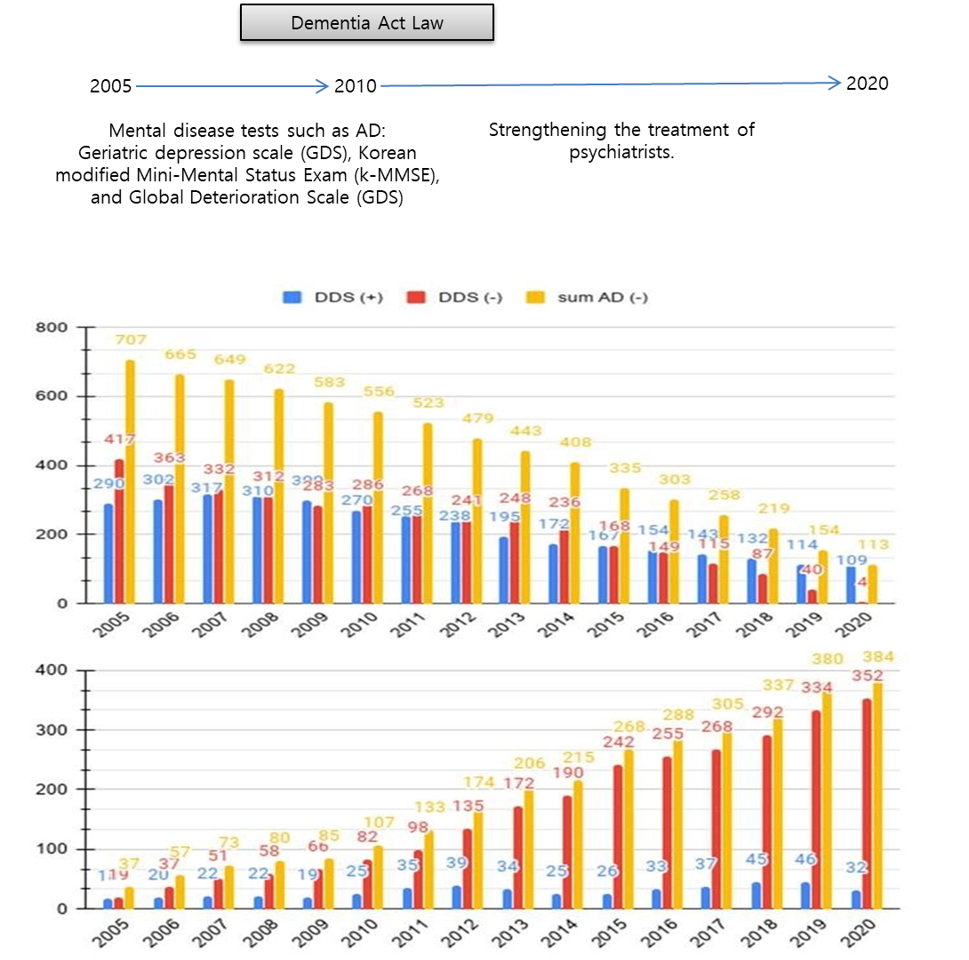

Descriptive data |  | 14* |  |  | (a) Give characteristics of study participants (e.g. demographic, clinical, social) and information on exposures and potential confounders  Korea Centers for Disease Control and Prevention (KCDC) is supplying DDS to Hansen's patients. KCDC reported that DDS was supplied free for all (DDS 100 mg–1000 tablet/bottle to 3814 of 9134 Hansen's patients). With a bottle, each of three people can take one tablet per day for one year.  We also analyzed infectious respiratory diseases among Hansen's patients at Sorokdo National Hospital. The data shows that the patients of Sorokdo National Hospital are responsible for the development of respiratory infectious diseases according to the occurrence of SARS-CoV (2002), Influenza A virus subtype H1N1 (2009), MERS (2015), and SARS-CoV-2 (2020). There is no significant change and no statistical correlation. After President Dae-Jung Kim came to power in 1998, Hansen's patients were given freedom. Many were devout Christians, but as more and more became smokers, as in a typical rural village, RIS increased. Sorok-do became a tourist destination, and travellers have come and gone freely, but SARS-CoV (2002), influenza A virus subtype H1N1 (2009), MERS (2015), and SARS-CoV-2 (2020) have not occurred. All patients have continued to take DDS after they were leprosy-diagnosed. The proportion of the oldest demographic group (80 years and over) is still 38.5% (2019), higher than for all Koreans¹  From 2010 to June 2020, the diagnosis of patients with MCI and AD in Korea increased dramatically. (Table 1) AAD prescriptions for leprosy patients have increased in Korea. In the past, there were no doctors, so HD patients took dapsone without stopping. As more doctors increased, more patients did not take dapsone. Such changes in the medical environment could form a comparative control group.
(b) Indicate the number of participants with missing data for each variable of interest

There are no missing data because HD patients live their life until death.
Outcome data |  | 15* |  |  | Report numbers in each exposure category, or summary measures of exposure  2. Korea Drug Code Medicine  First Group: [donepezil hydrochloride]148603ATB 148602ATD 148602ATB 148601ATD 148601ATB 643401ATD 643402ATD [rivastigmine]224501ACH 224503ACH 224504ACH 224505ACH 224506CPC 224507CPC 24508CPC[galantamine]385203ACR 385203ATR 385204ACR 385204ATR 385205ACR 385205ATR[N-methyl-D-aspartate (NMDA) receptor antagonist]190031ALQ 190001ATB 190003ATD 190004ATB 190004ATD  Second Group: [haloperidol]167903ATB 167904ATB 167905ATB 167906ATB 167908ATB 167908ATB 168030BIJ[Risperidone]224201ATB 224201ATD 224202ATB 224202ATD 224203ATB 224204ATB 224205BIJ 224206BIJ[Quetiapine]378601ATB 378602ATB 378603ATB 378604ATB 378605ATB 378605ATR 378606ATR 378607ATR 378608ATR 378608ATR 378610ATB[Olanzapine]204001ATB 204001ATD 204002ATB 204002ATD 204004ATB 204005ATB[Aripiprazole]451501ATB 451501ATD 451502ATB 451502ATD 451503ATB 451504ATB 451505ATB 451506BIJ 451507BIJ[Oxcarbazepine]206330ASS 206301ATB 206302ATB 206303ATB  [fluvoxamine]162501ATB 162502ATB[Escitalopram]474801ATB 474802ATB 474803ATB 474804ATB[Trazodone]242901ACH 242901ATB 242902ATB 242903ATR  [sertraline]227001ATB 227002ATB 227003ATB[Escitalopram]474801ATB 474802ATB 474803ATB 474804ATB[Fluoxetine]161501ACH 161501ATB 161502ACH 161502ATB 161502ATD
  year | 2005 | 2006 | 2007 | 2008 | 2009 | 2010 | 2011 | 2012 | 2013 | 2014 | 2015 | 2016 | 2017 | 2018 | 2019 | 2020
  AD (+) | 37 | 57 | 73 | 80 | 85 | 107 | 133 | 174 | 206 | 215 | 268 | 288 | 305 | 337 | 380 | 384
  AD (+) DDS EXPOSURE | 18 | 20 | 22 | 22 | 19 | 25 | 35 | 39 | 34 | 25 | 26 | 33 | 37 | 45 | 46 | 32
  AD (-) | 707 | 665 | 649 | 622 | 583 | 556 | 523 | 479 | 443 | 408 | 335 | 303 | 258 | 219 | 154 | 113
  AD (-) DDS EXPOSURE | 290 | 302 | 317 | 310 | 300 | 270 | 255 | 238 | 195 | 172 | 167 | 154 | 143 | 132 | 114 | 109
  We use the Korean Standard Classification of Diseases (KCD) disease code for "Alzheimer's disease."
  1. Mental and behavioural disorders, F00-F09, G30
  [F00] [F01] [F02] [F03] [F04] [F05] [F06] [F07] [F09] [G30]

Main results |  | 16 | (a) Give unadjusted estimates and, if applicable, confounder-adjusted estimates and their precision (e.g., 95% confidence interval). Make clear which confounders were adjusted for and why they were included  The relation between DDS and AD each year was analyzed using the chi-square test. A P-value < .05 was considered significant. ** indicates a P-value < 0.05.
  Year | 2005 | 2006 | 2007 | 2008 | 2009 | 2010 | 2011 | 2012 | 2013 | 2014 | 2015 | 2016 | 2017 | 2018 | 2019 | 2020
  P-value | 0.3583 | 0.1324 | .0024** | .0002** | < .00001** | < .00001** | < .00001** | < .00001** | < .00001** | < .00001** | < .00001** | < .00001** | < .00001** | < .00001** | < .00001** | < .00001**
 |  | 16 | (b) Report category boundaries when continuous variables were categorized  To remove diverse confounding factors, we searched all medical records of the National Health Insurance Service (NHIS) in Korea and the Sorokdo National Hospital from the time when the International Classification of Diseases (ICD)-9 code and Electronic Data Interchange (EDI) were computerized by medical staffs. With the ICD-9 and -10 codes, medical data on the correlation between DDS and AD were then analyzed.  - AD group with DDS (+)  - AD group with DDS (-)  - AD free group with DDS (+)  - AD free group with DDS (-)
 |  | 16 | (c) If relevant, consider translating estimates of relative risk into absolute risk for a meaningful period  Depending on the 15-year analysis, the diagnosis and treatment of AD are precise according to medical standards.
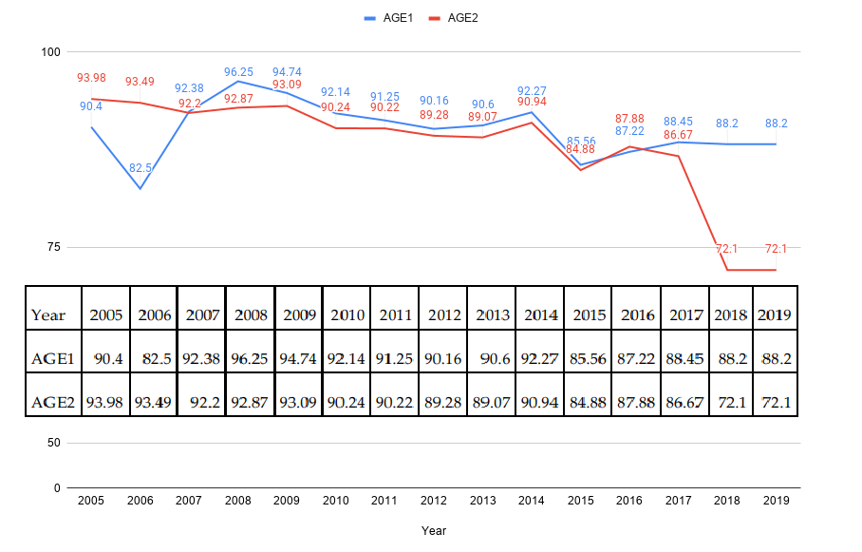  Other analyses | 17 | Report other analyses are done—e.g. analyses of subgroups and interactions and sensitivity analyses  1. Mortality study by ADD the second group.

Discussion
Key results | 18 | Summarise key results concerning study objectives  We analyzed AD in HD patients at Sorokdo National Hospital. The HD patients in Sorokdo National Hospital have lived only on Sorokdo (an island for HD patients) all their lives. Korean HD patients continue to take DDS throughout their lives. Based on the relative prevalence of AD in patients who have been prescribed DDS and those who have not, DDS appears to have a preventive effect against AD.
Limitations | 19 | Discuss the limits of the study, taking into account sources of potential bias or imprecision. Discuss both direction and magnitude of any potential bias  As a long-term study of HD patients living in Sorok Island for 15 years, the relationship between AD and dapsone is clear.  In 1992, an AD research team published a method of preventing and treating human AD dementia with DDS, its didextrose sulfonate derivative, and other closely related sulfones (sulfetrone and thiazolsulfone)⁵⁻⁷. It is the same results. However, it is not a study of inflammation but a study of the inflammasome.
Interpretation | 20 | Give a cautious overall interpretation of results considering objectives, limitations, the multiplicity of analyses, results from similar studies, and other relevant evidence  If people who have been prescribed dapsone and then did not receive it are reflected in the statistical data, the effects of dapsone as an inflammasome competitor are mixed. It is essential to distinguish them. It is why further investigations by Japanese Sanatorium autopsy studies^{8, 9} did not detect any differences in AD prevalence among HD patients treated with DDS and failed to demonstrate that it had any protective effects against Aβ neurotoxicity.  Furthermore, because of the validation study that denied the AD prevention effect of dapsone as an experimental study corresponding to the null hypothesis, dapsone did not even have a proper cohort study^{10, 11}.
Generalisability | 21 | Discuss the generalisability (external validity) of the study results  This study is for HD patients have been taking dapsone consistently under the nursing oSorokdo Cathedral's sisters for a long time (over 30 years) without medical doctors. The only change factors were doctor's prescription (i.e. stop dapsone) and introduction of dementia management law. This is a fantastic scientific result that is different from the works of other researchers. We searched individual identified medical records of the National Health Insurance Service (NHIS) in Korea and the Sorokdo National Hospital from the time when the International Classification of Diseases (ICD)-9 code and Electronic Data Interchange (EDI) were computerized. It is only objective researches for DDS and Dementia relationships.
Other information
Funding | 22 | Give the source of funding and the role of the funders for the present study and, if applicable, for the original study on which the present article is based  No funding.

References
1 Lee, J. H., An, H. K., Sohn, M. G., Kivela, P. & Oh, S. 4,4′-Diaminodiphenyl sulfone (DDS) as an inflammasome competitor. Int. J. Mol. Sci. 21, 5953 (2020).
2 Ahn, Y. H., Park, H. & Kweon, S. S. Causes of death among persons affected by leprosy in Korea, 2010–2013. Am. J. Trop. Med. Hyg. 102, 42-47 (2020).
3 Zhu, Y. I. & Stiller, M. J. Dapsone and sulfones in dermatology: overview and update. J. Am. Acad. Dermatol. 45, 420-434 (2001).
4 Ismael, S., Zhao, L., Nasoohi, S. & Ishrat, T. Inhibition of the NLRP3-inflammasome as a potential approach for neuroprotection after stroke. Sci. Rep. 8, 5971 (2018).
5 McGeer, P. L., Harada, N., Kimura, H., McGeer, E. G. & Schulzer, M. Prevalence of dementia amongst elderly Japanese with leprosy: apparent effect of chronic drug therapy. Dement. Geriatr. Cogn. Disord. 3, 146-149 (1992).
6 McGeer, P. L., Harada, N., Kimura, H., McGeer, E. G. & Schulzer, M. Dapsone and promin for the treatment of dementia (Google Patents, 1996).
7 McGeer, P. L., Klegeris, A., Walker, D. G., Yasuhara, O. & McGeer, E. G. Pathological proteins in senile plaques. Tohoku J. Exp. Med. 174, 269-277 (1994).
8 Namba, Y., Kawatsu, K., Izumi, S., Ueki, A. & Ikeda, K. Neurofibrillary tangles and senile plaques in brain of elderly leprosy patients. Lancet 340, 978 (1992).
9 Kimura, T. & Goto, M. Existence of senile plaques in the brains of elderly leprosy patients. Lancet 342, 1364 (1993).
10 Endoh, M., Kunishita, T. & Tabira, T. No effect of anti-leprosy drugs in the prevention of Alzheimer's disease and beta-amyloid neurotoxicity. J. Neurol. Sci. 165, 28-30 (1999).
11 Lee, J. H., Choi, S. H., Lee, C. J. & Oh, S. S. Recovery of dementia syndrome following treatment of brain inflammation. Dement. Geriatr. Cogn. Dis. Extra 10, 1-12 (2020).

