Supplementary materials
The R markdown file for these plots are available at https://osf.io/szcpt/.

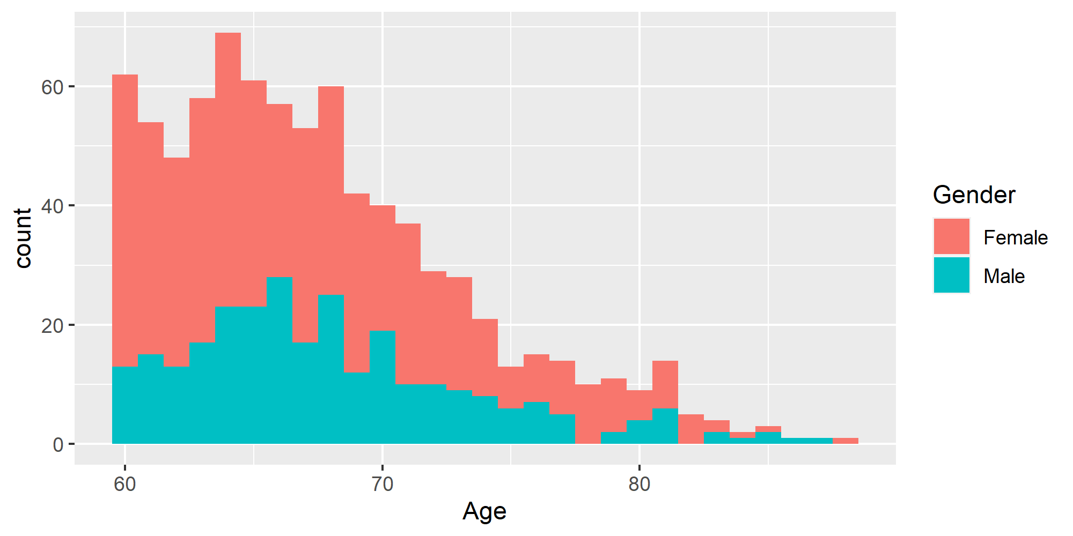
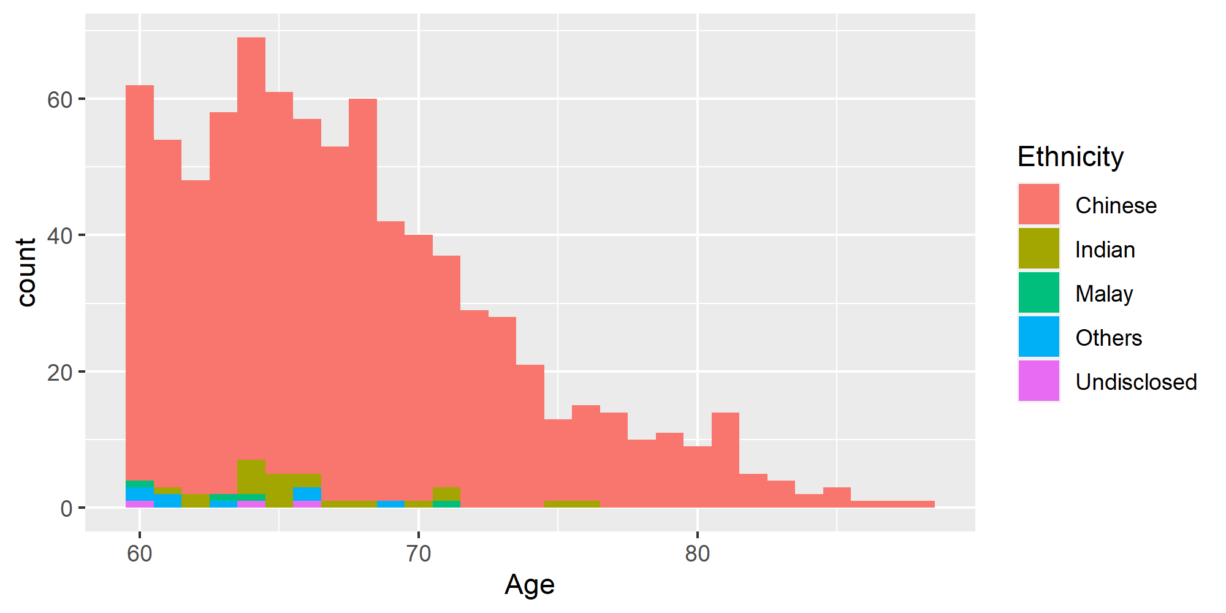 Fig. S1 Histograms of age distribution by gender and ethnicity

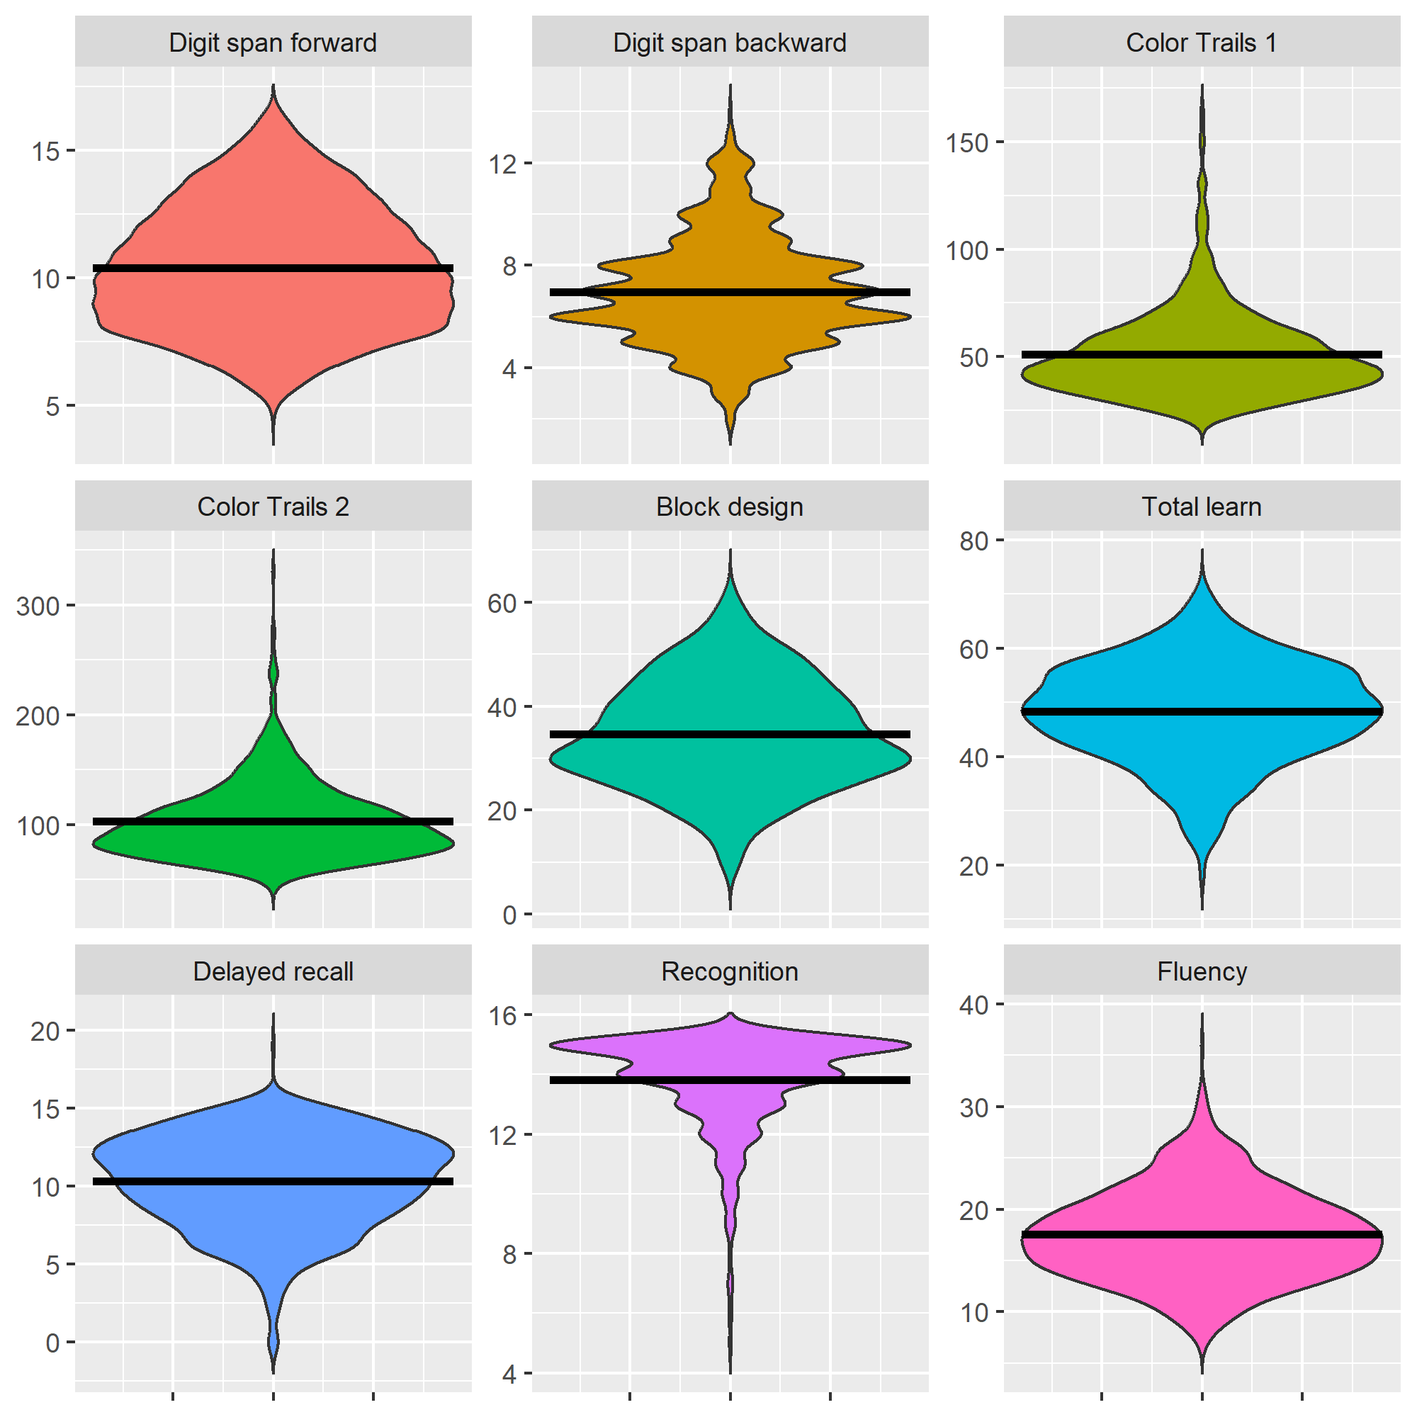
Fig. S2 Violin plots of all cognitive predictors. The means of these distributions are represented as horizontal lines embedded within the violin plots
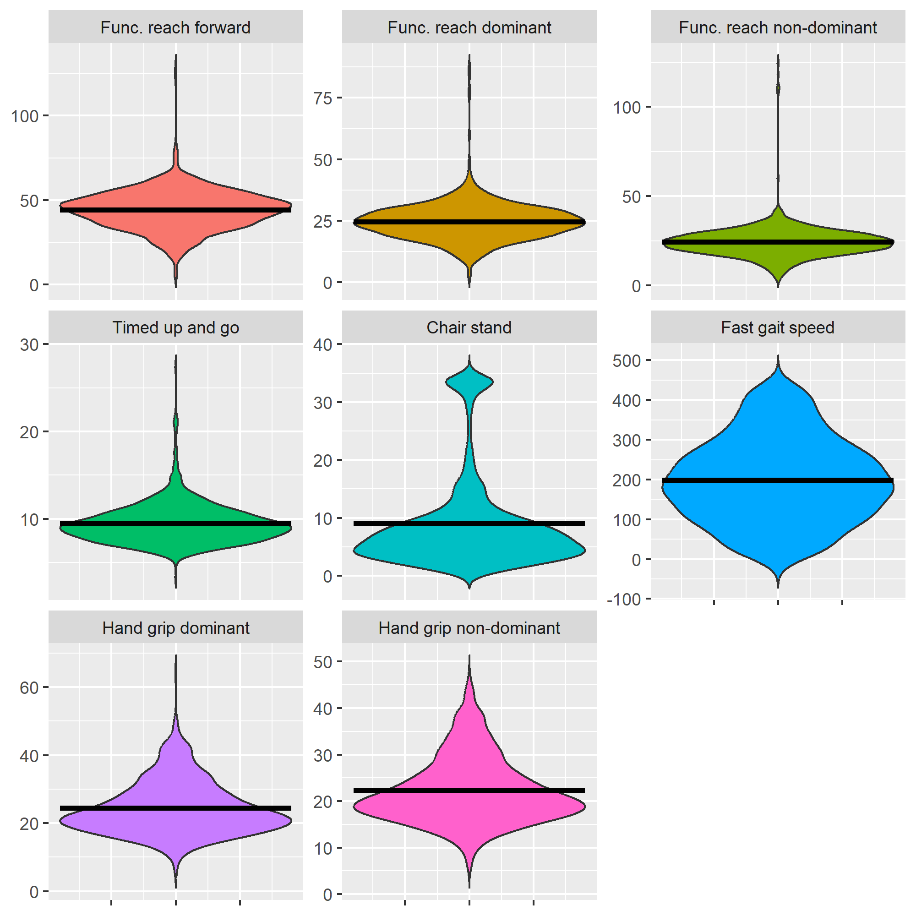
Fig. S3 Violin plots of all physical fitness predictors. The means of these distributions are represented as horizontal lines embedded within the violin plots
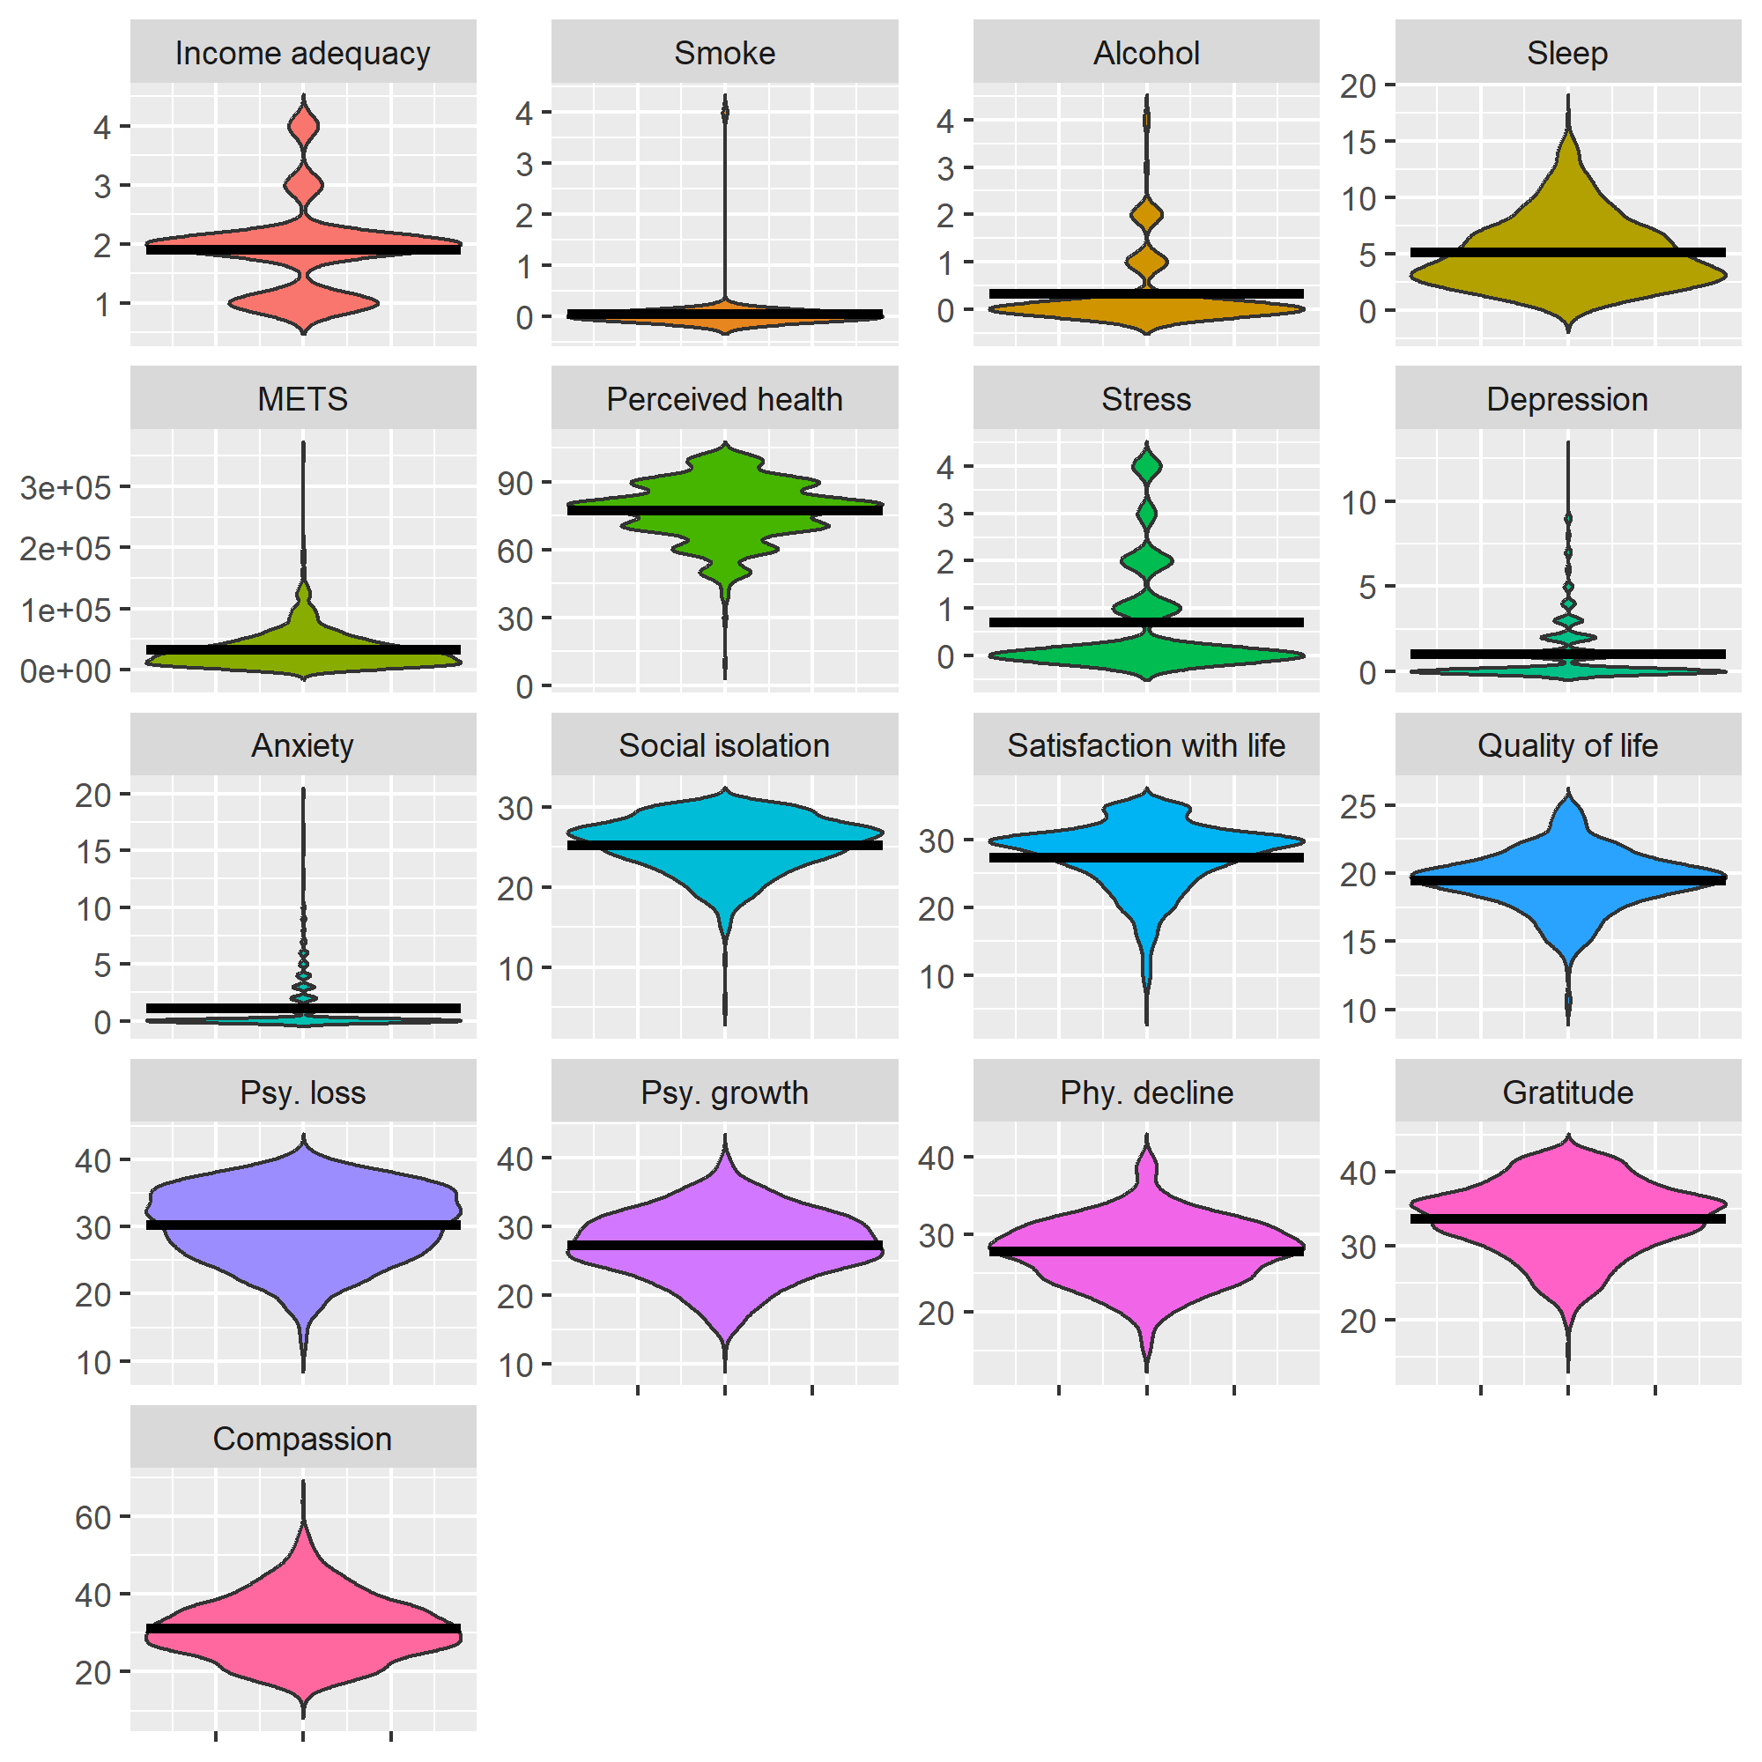
Fig. S4 Violin plots of all lifestyle, well-being and attitude-related outcomes. The means of these distributions are represented as horizontal lines embedded within the violin plots
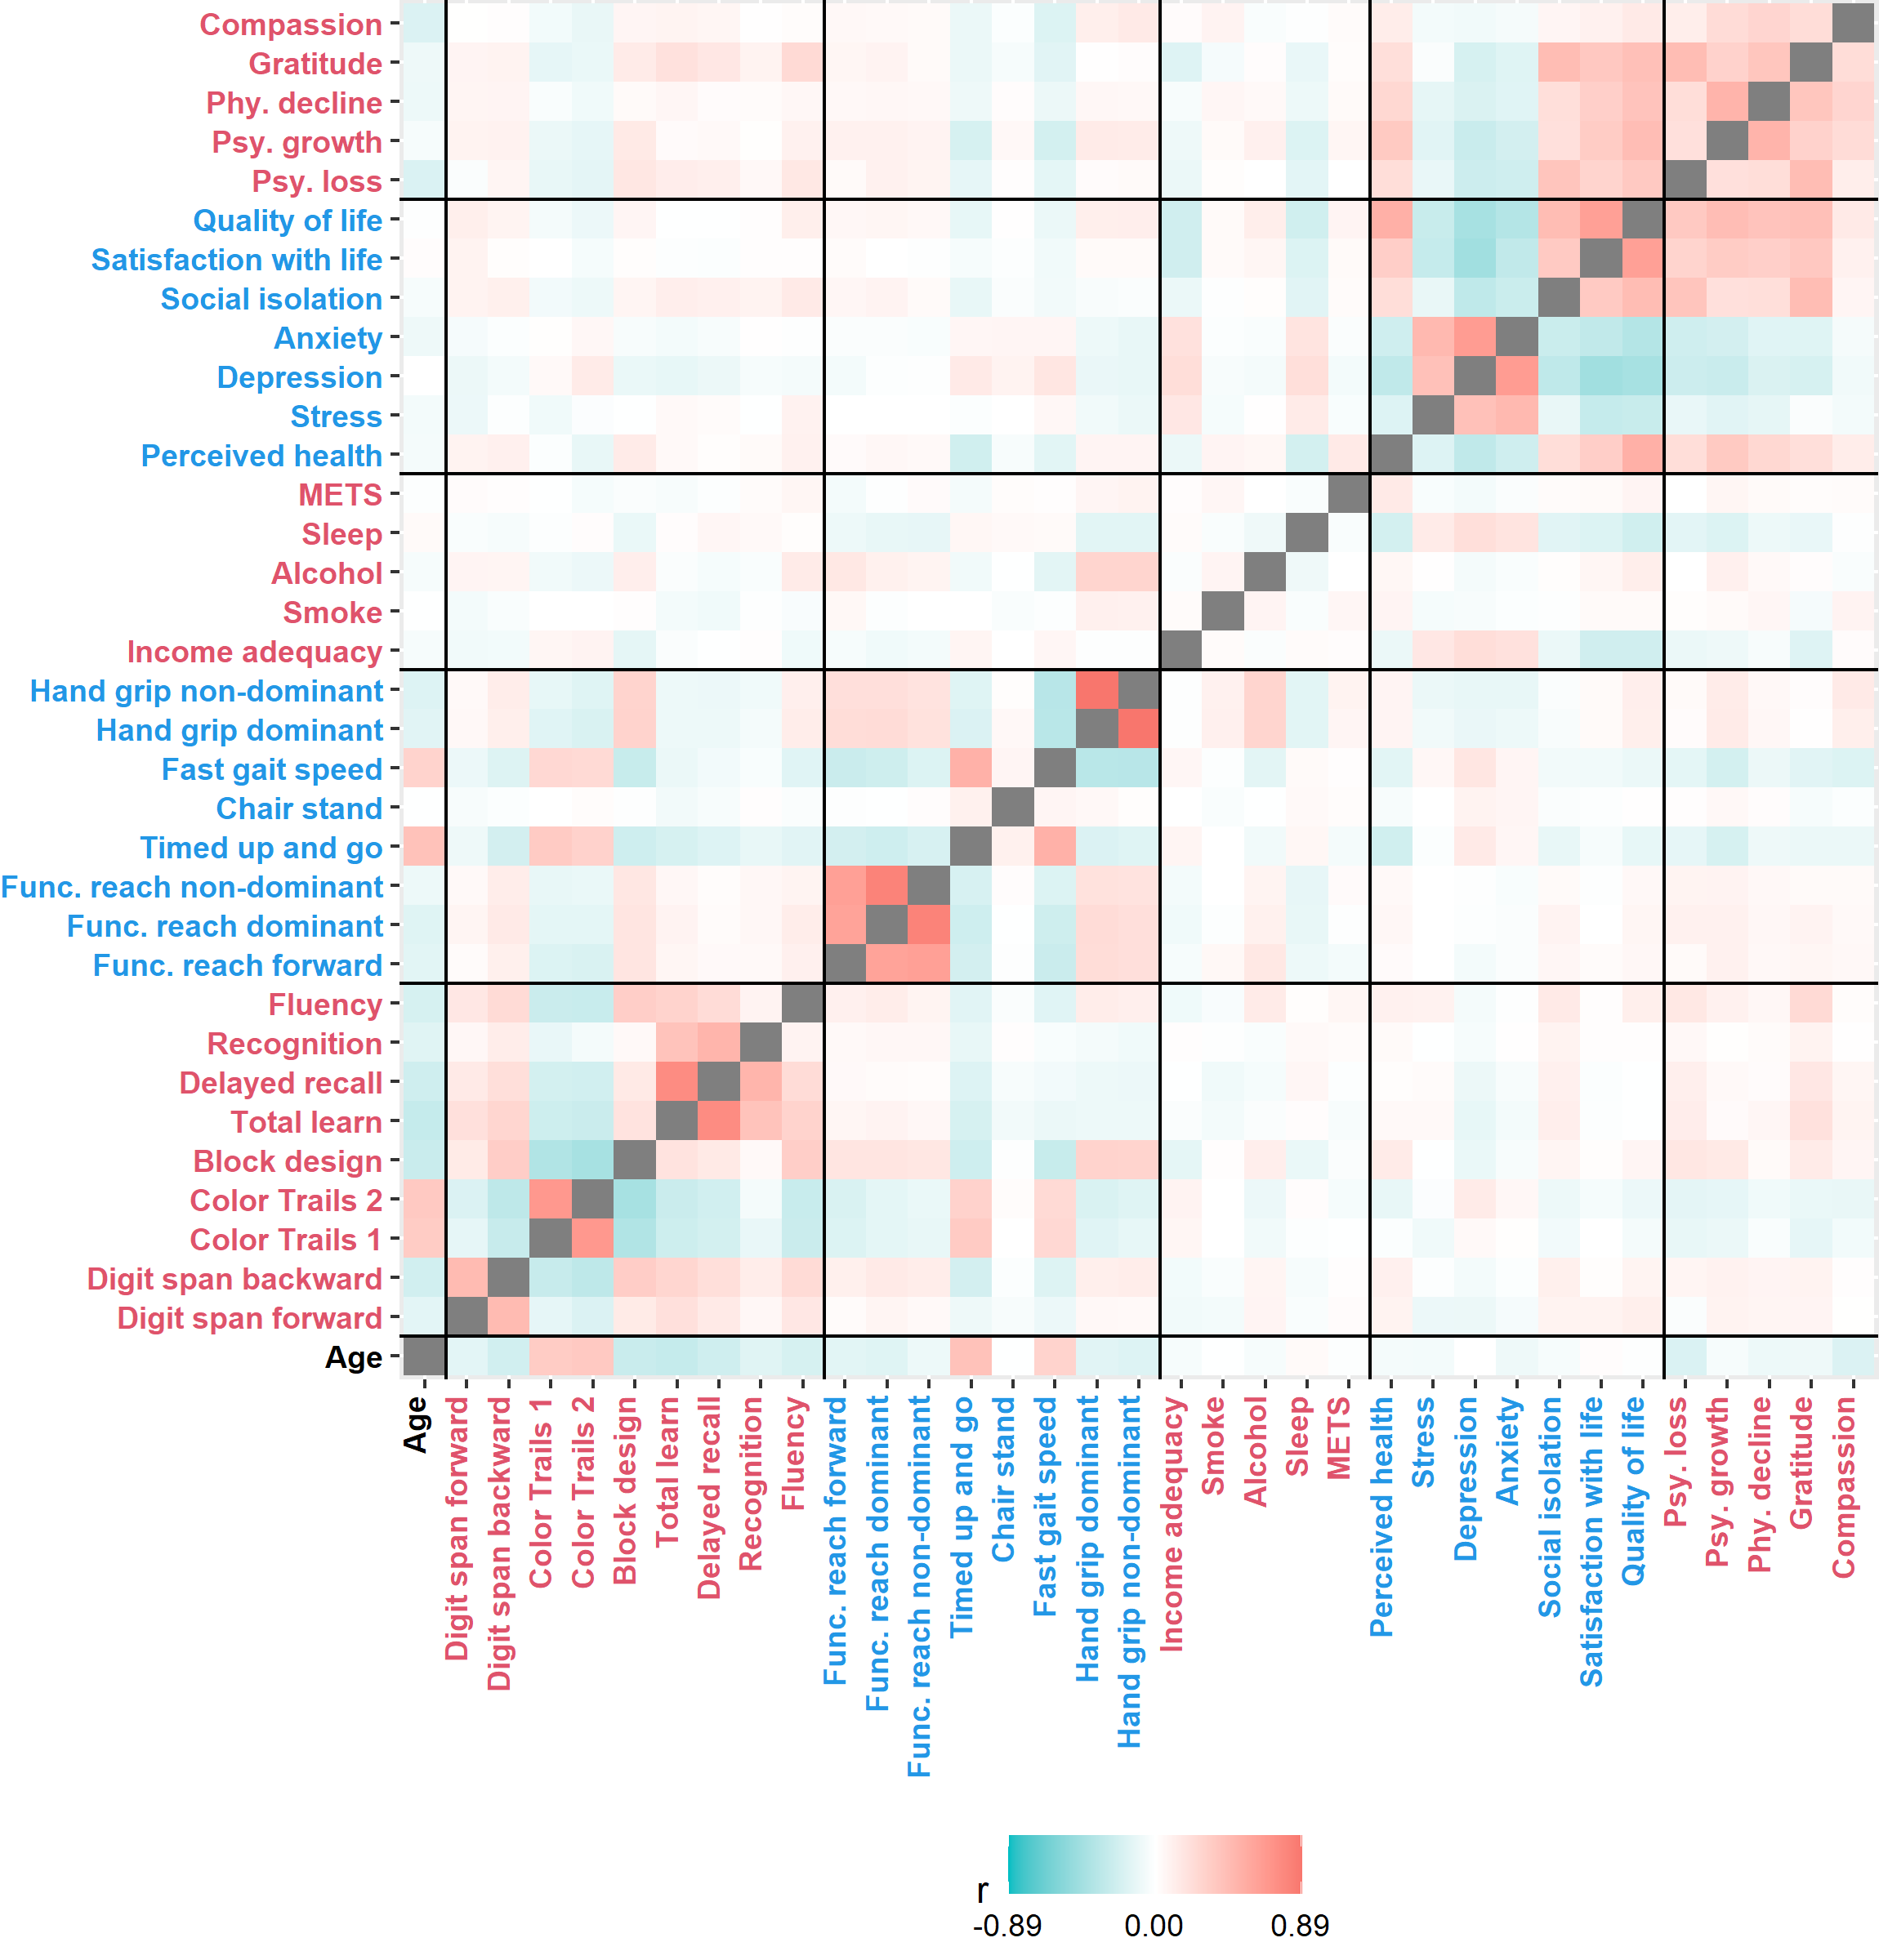Fig. S5. Correlation heatmap of all studied variables

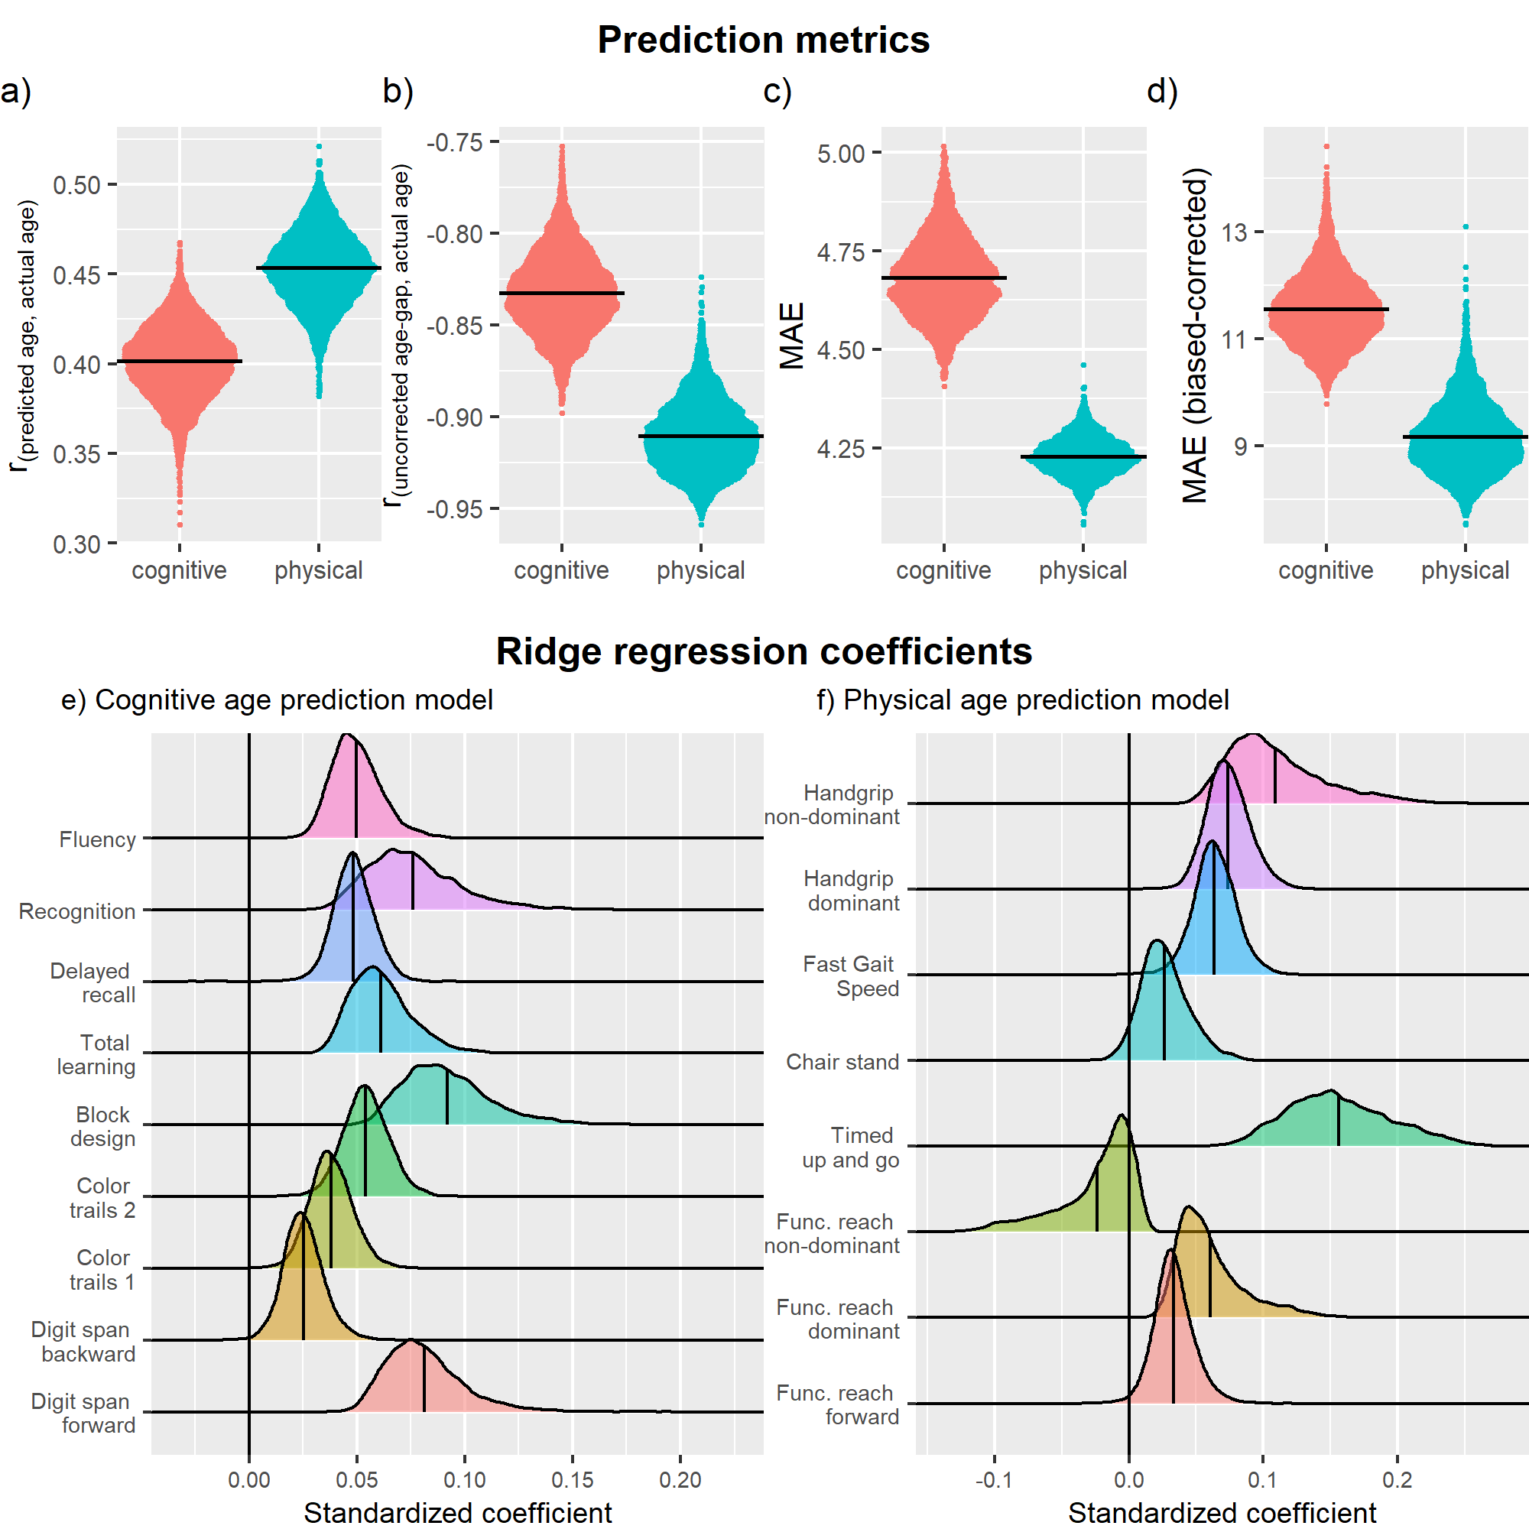
Fig. S6. The top panel illustrates the distribution of prediction metrics of the age-prediction models across 5000 random train-test split iterations: a) Correlation between predicted and actual age. b) Age-prediction bias. c) Mean absolute error. d) Mean absolute error after correcting for the age-prediction bias. The bottom panel depicts the distribution of ridge regression coefficients in the e) cognitive age-prediction and f) physical age-prediction models across 5000 random train-test split iterations. To facilitate interpretations, some of the coefficients for the predictors were sign-flipped (i.e., multiply by -1), such that for all predictors, a positive coefficient would suggest poorer performance corresponding to increasing age. The means of the distributions are illustrated as horizontal and vertical lines in the top and bottom panels, respectively.

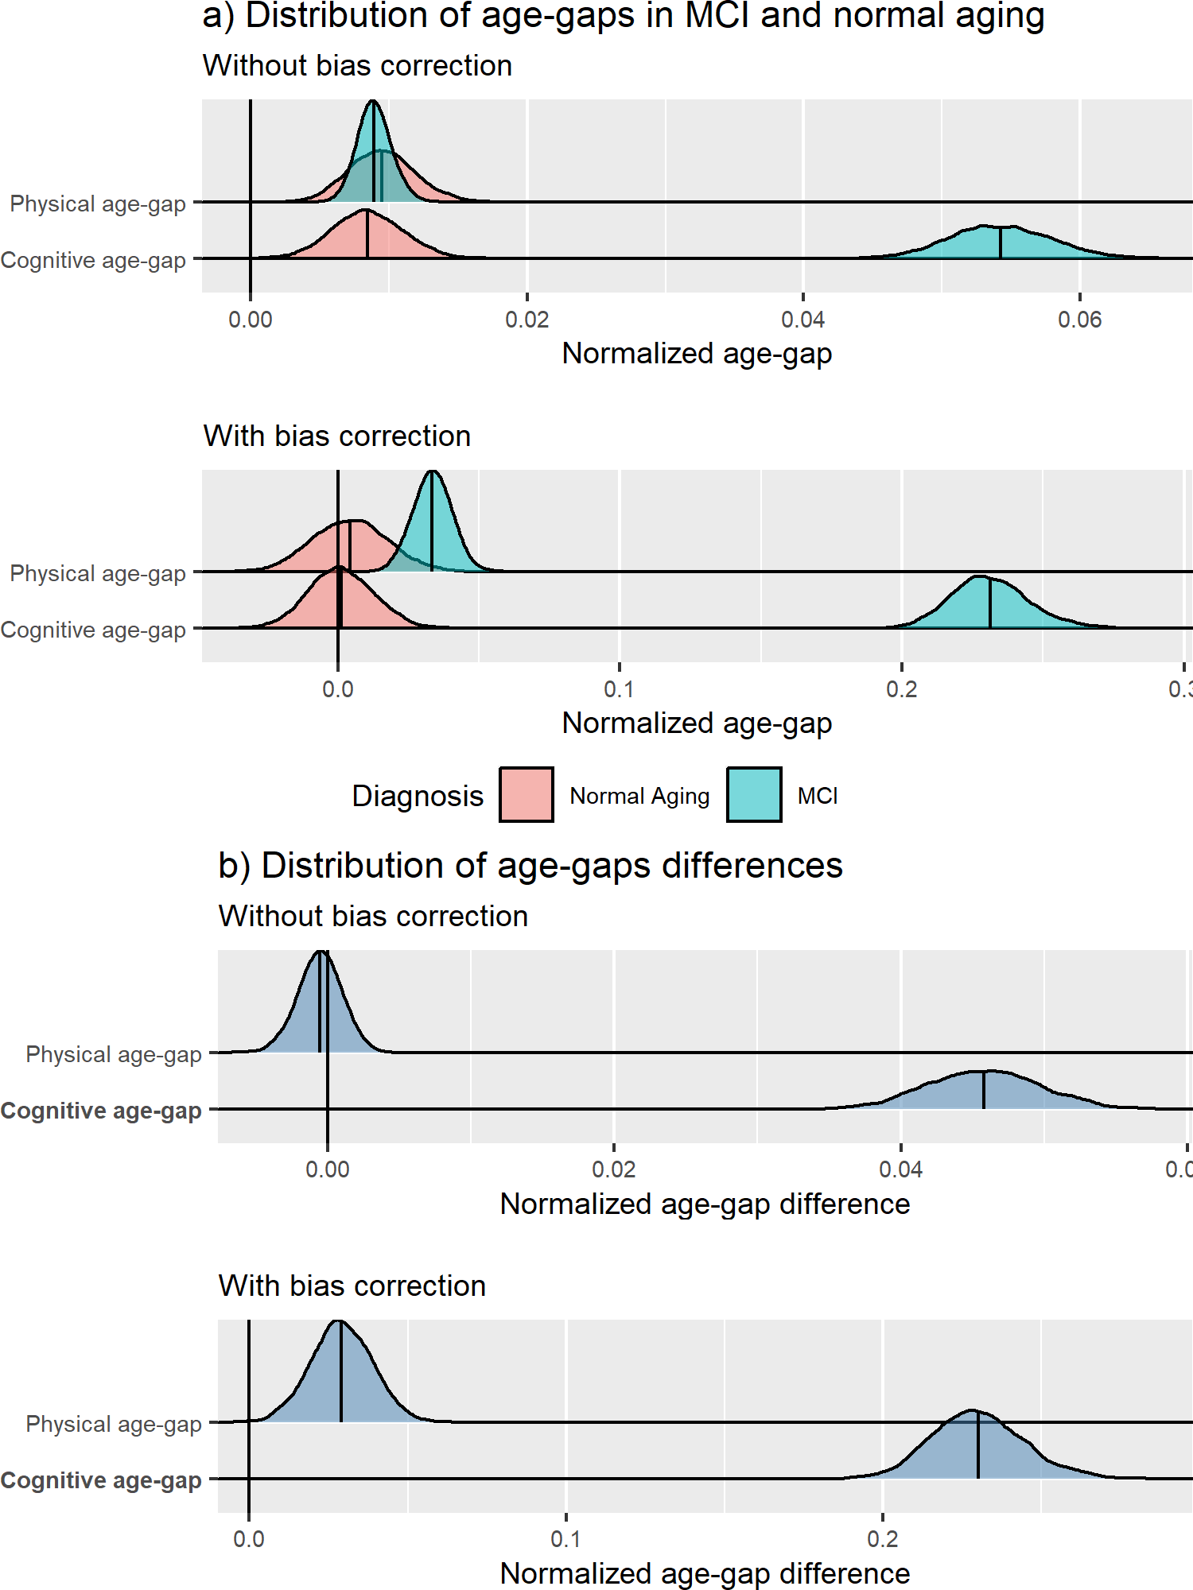
Fig. S7. a) distribution of age-gaps in MCI and normal aging, b) distribution of age-gap. Bot distributions are obtained across 5000 random train-test split iterations. Larger normalized age-gap differences in b) suggest older age-gaps in the MCI group. The labels in bold on the left of their respective ridgeline plots indicate that its normalized age-gap difference is significant at the FDR-corrected (four tests) p<.05 level. The means of the distributions are illustrated as vertical lines embedded within the ridges.
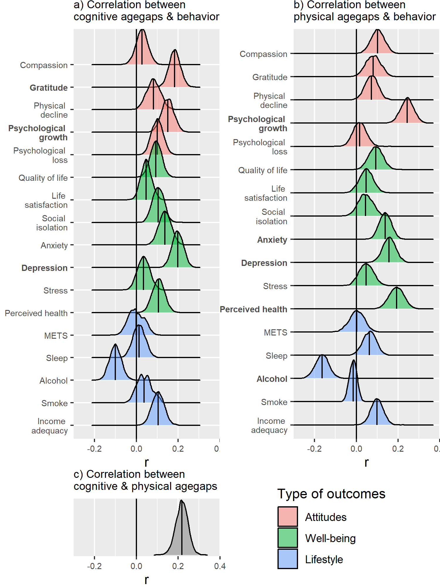
Fig. S8. Distribution of correlation coefficients a) between cognitive age-gaps and behavioral phenotypes, b) physical age-gaps and behavioral phenotypes, c) cognitive and physical age-gaps across the 5000 random train-test split iterations. All correlations were controlled for age. To facilitate interpretations, some of the correlation coefficients were sign-flipped (i.e., multiply by -1), such that for all these outcomes, a positive coefficient would suggest worse outcomes corresponding to increasing age. The labels in bold on the left of their respective ridgeline plots (top panel) indicate that its mean correlation coefficient is significant at the FDR-corrected (17 tests) p<.05 level. The means of the distributions are illustrated as vertical lines in the middle of the ridges.

