Electronic Supporting Information

Benzene sulfonyl linked tetrasubstituted Thiacalix[4]arene for selective and sensitive fluorometric sensing of Sulfosulfuron along with Theoretical studies.

Priyanka Kashyap^{a*}, Dushyantsingh Rajpurohitª, Krunal Modi^{b*} Hinaly Bhasinª, Patrick Fernandesª, Divya Mishra^{a*}

ªDepartment of Chemistry, School of Sciences, Gujarat University, Ahmedabad-380009, Gujarat, India
^{b}Department of Humanity and Science, School of Engineering, Indrashil University, Mehsana-382740, Gujarat, India
*Corresponding Authors: Priyanka Kashyap, Krunal Modi, and Divya Mishra.
Email: pkashyap@gujaratuniversity.ac.in, kmodi5033@gmail.com, pandey.divyamishra@gmail.com.

Table of Content:
Sr. No. | Content | Page No.
1 | Material and Method | S3
1 | 1.1 Synthesis of TC | S4
1 | 1.2 Synthesis of PK¹ | S4
1 | 1.3 Synthesis of PK² | S5
1 | 1.4 Sample Preparation for MALDI-TOF | S6
1 | 1.5 Quantum Yield Determination | S7
2 | Characterization. | S8-S14
3 | Photophysical studies | S15
4 | Determination of LOD and Ks. | S16-S17
5 | Docking studies | S18
6 | Association constant | S19
7 | MALDI-TOF data | S20-S21
8 | Interference studies | S22
9 | Probable Binding Mechanism | S23
10 | Recyclability studies | S24
11 | Comparison Table | S24
12 | References | S25

- Materials and Methods:
4-Isopropylbenzene sulfonyl chloride, 2,4-Dimethylbenzenesulfonyl chloride, sulfur powder, potassium iodide, and silica gel were purchased from Sigma-Aldrich while p-tert butyl phenol was procured from TCI chemicals India. Anhydrous potassium carbonate and sodium hydroxide were obtained from SRL, India. Diphenyl ether was obtained from Spectrochem, India. All metal chloride salts were purchased from commercially available sources. Solvents were procured from Finar and were used directly without any additional purification. All reactions and photophysical studies were carried out in HPLC-UV spectroscopic grade solvent, obtained from SRL, India. Mass-spectrometric analysis was carried out on a Q-TOF Micro TM LC-Ms instrument/ (Micromass Q-TOF micro mass spectrometer using a capillary voltage of 3000 V and a source temperature of 120ºC—instrument detail copied from a paper for reference, write according to your instrument) by electron ionization spray (ESI) technique. MALDI-TOF (Matrix-Assisted Laser Desorption Ionization- Time of Flight) data were collected on Bruker Daltonics flex analysis Instrument using Acetonitrile and Water matrix. ¹H NMR and ¹³C NMR data were collected at 500 MHz on Bruker Ascend 500 in CDCl₃ using TMS as the internal standard. The UV-visible spectra were recorded on a Jasco V-750 UV-Visible spectrophotometer (Tokyo, Japan) with EHCS-750 in the 200-800 nm range whereas the fluorescence spectra were measured utilizing HORIBA FLUOROMAX-4 spectrofluorometer. IR spectra were recorded using Perkin Elmer (Model Name: Spectrum Two) equipped with ATR diamond crystal. DFT data were calculated using B3LYP in Gaussian 16 program.

  - Synthesis of Thiacalix[4]arene (TC):
TC was prepared according to the following literature [S1]. It was purified using column chromatography and further confirmed using mass spectrometry. LCMS (ESI) m/z 720.24 cal; [TCA - H] ⁺ found 719.23 m/z. MF: C₄₀H₄₈O₄S₄.
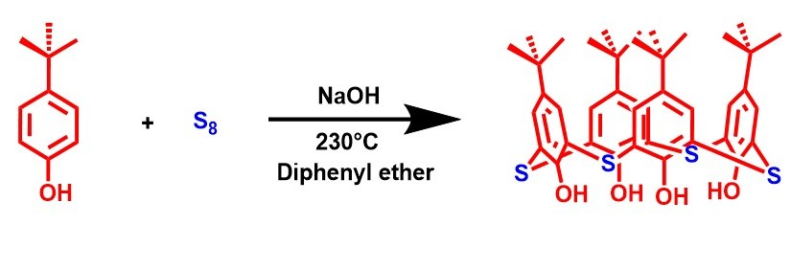
Figure S1: General synthetic procedure of Thiacalix[4]arene (TC).

  - Synthesis of PK¹:
In a 50ml RBF (round bottom flask) containing 10 ml anhydrous Acetonitrile, Potassium carbonate (15.84 mM) and Potassium iodide (15.84 mM) were added along with Thiacalixarene (3.25 mM) and were refluxed for 1 hour and then on slow addition of 2,4-dimethyl benzene sulfonyl chloride (14.08 mM) into it and refluxed for next 24 hours result in the formation of PK¹. The crude was purified using column chromatography. Yield: 0.59 g (60.2%). ¹H-NMR (500 MHz, CDCl₃, ppm) δ 1.03 (s J =1.0 Hz, 36H, CH₃), 2.42 (s, J=2.4 Hz, 12H, CH₃), 2.85 (s, J=2.8 Hz, 12H, CH₃), 7.04 (d, J= 7.0 Hz, 4H, CH₂), 7.19 (s, J=7.1 Hz, 8H, CH₂) 7.33 (s, J=7.3 Hz, 4H, CH₂) 7.42 (s, J=7.4 Hz, 4H, CH₂). ¹³C NMR (500 MHz, CDCl₃, ppm): δ 149.27, 147.66, 144.98, 141.50, 134.16, 132.22, 131.34, 130.78, 126.52, 34.47, 31.11, 29.72, 22.12, 21.60.; LCMS (ESI) m/z 1392.34 cal; [PK¹ + Na]⁺ found 1415.33; MF: C₇₂H₈₀O₁₂S_{8.}
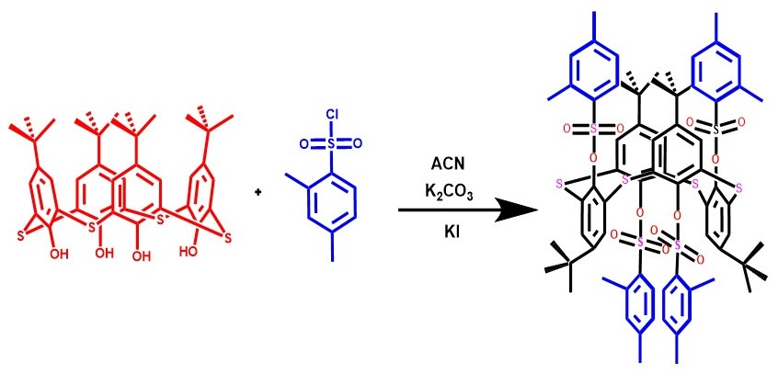
Figure S2: General synthetic procedure of P₂ (1⁵,3⁵,5⁵,7⁵-tetra-tert butyl-2,4,6,8-tetrathia-(1,3,5,7-(1,3)-tetrabenzenacyclooctaphane-1²,3²,5²,7²-tetrayltetrakis (2,4-dimethylbenzene sulfonate).
  - Synthesis Of PK²:
In a 50ml RBF (round bottom flask) containing 10 ml Anhydrous Acetonitrile, Potassium carbonate (15.84 mM) and Potassium iodide (15.84 mM) were added along with Thiacalixarene (3.25 mM) and were refluxed for 1 hour and then on slow addition of 4-isopropyl benzene sulphonyl chloride (14.08 mM) into it and refluxed for next 24 hours result in the formation of PK². The crude was purified using column chromatography. Yield: 0.67 g (65.7%). ¹H-NMR (500MHz, CDCl₃, ppm) δ 1.06 (s J =1.0 Hz, 36H, CH₃), 1.33 (d, J=1.3 Hz, 24H, CH₃), 3.04 (m, J= 3.0 Hz, 4H, CH). 7.25 (s, J=7.2 Hz, 8H, CH₂) 7.45 (s, J=7.4 Hz, 8H, CH₂) 7.90 (s, J=7.9 Hz, 8H, CH₂) ¹³C NMR (125MHz, CDCl3, ppm): δ 154.37, 148.29, 146.64, 133.41, 130.03, 128.88, 126.22, 33.26, 29.97, 22.50.; LCMS (ESI) m/z 1448.40 cal; [PK² + Na]⁺ found 1471.38; [PK² + K]⁺ found 1487.36. MF: C₇₆H₈₈O₁₂S₈.
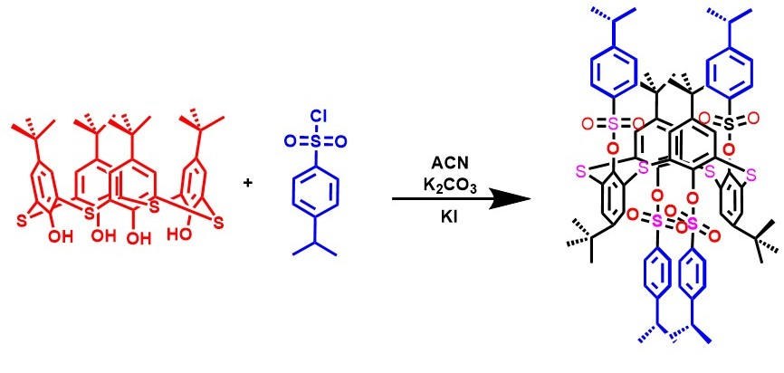
Figure S3: General synthetic procedure of P₁ (1⁵,3⁵,5⁵,7⁵-tetra-tert butyl-2,4,6,8-tetrathia-(1,3,5,7-(1,3)-tetrabenzenacyclooctaphane-1²,3²,5²,7²-tetrayltetrakis (4-isopropylbenzene sulfonate).

  - Sample preparation of PK¹⁻² with Sulfosulfuron for MALDI-TOF analysis:
The reaction of PK^{1/2} with Sulfosulfuron were performed in an ACN-Water system (9:1). Sulfosulfuron was taken in a stoichiometric ratio of 1:1 with respect to the receptor (PK¹⁻²) and the reaction mixture was stirred and refluxed for next 1 hour. The filtrate obtained was filtered, dried in a rotavapory evaporator, and characterized to be [PK¹ + SS], MALDI-TOF (+): 1863.445 m/z, and [PK² + SS], MALDI-TOF (+): 1919.483 m/z.

  - Quantum Yield determination:
The Quantum yield for Ligand P₁₋₂ was determined using the following equation:
Φ= Φ_{std} I A_{std} n²
I_{std} A n²_{std}
where, I and I_{std} are the areas under the fluorescence intensity curves of receptors (PK¹⁻²) and the standard tryptophan. n and n_{std} are the refractive indices of solvent ACN (Acetonitrile) used for ligand and standard respectively. A and A_{std} are relative absorbance of receptors and standard (tryptophan) respectively.

(2) Characterization:
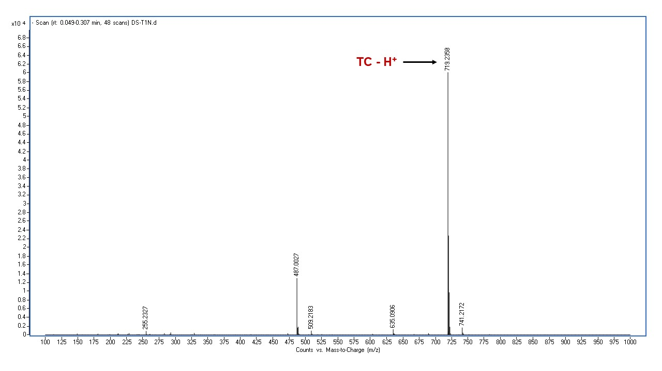
Figure S4: ESI-MS spectra of Thiacalix[4]arene (TC).

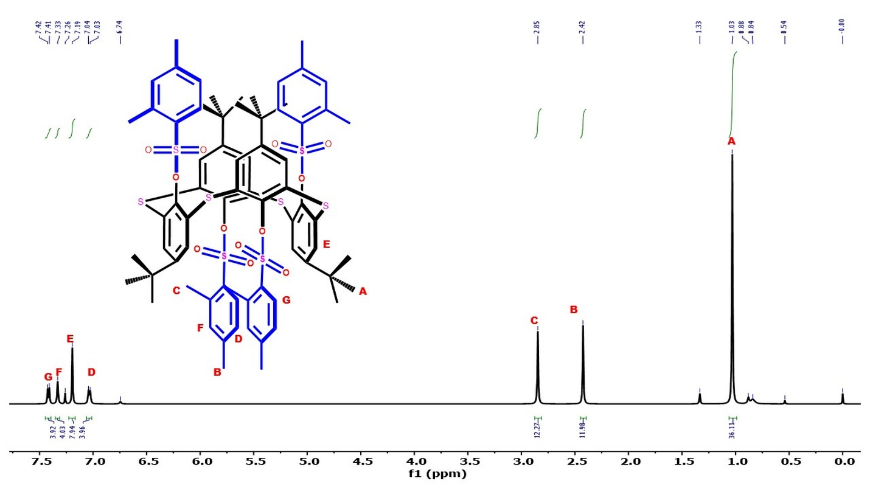
Figure S5: ¹H-NMR spectra of receptor PK¹ (CDCl₃ 500MHz).

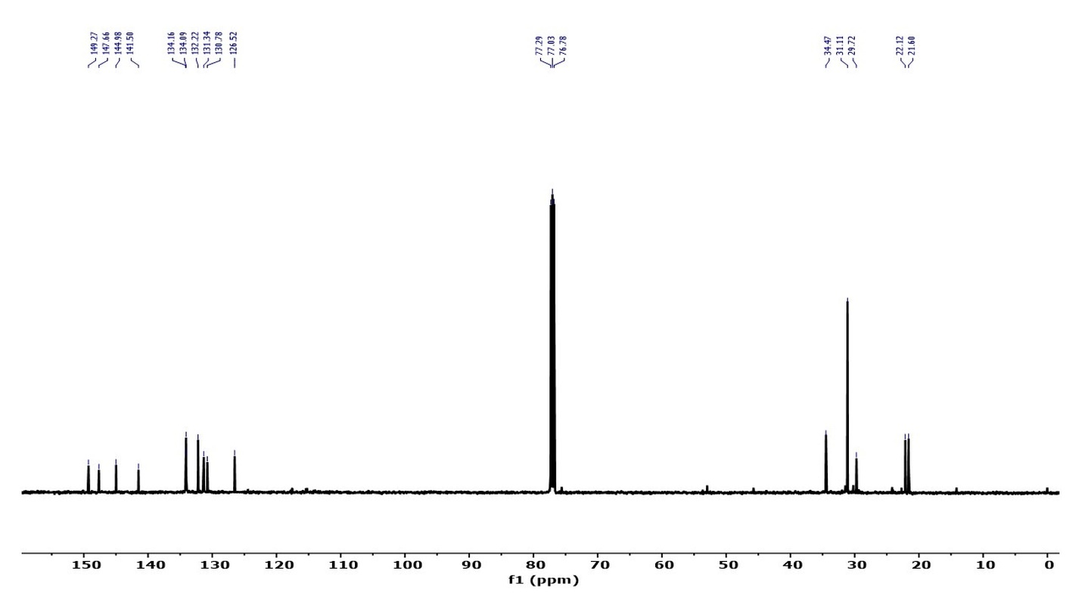Figure S6: ¹³C-NMR spectra of receptor PK¹ (CDCl₃ 500MHz).
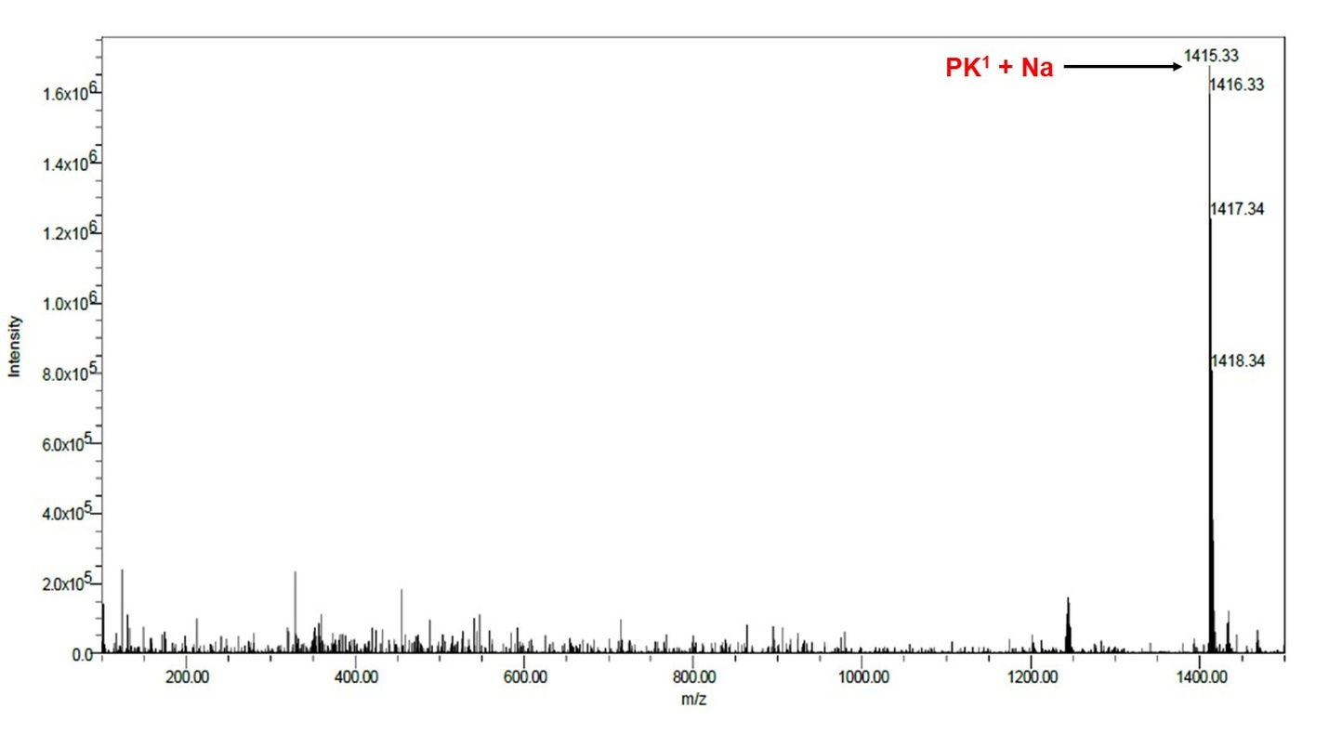
Figure S7: ESI-MS spectra of receptor PK¹.

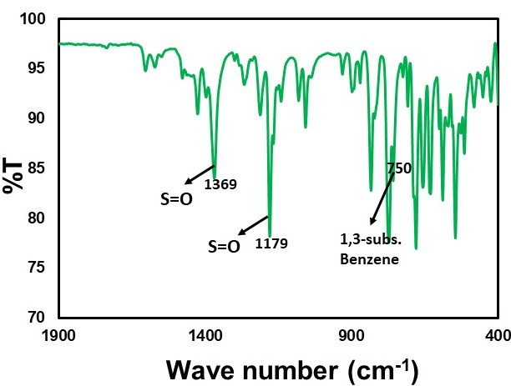

Figure S8: FT-IR spectra of receptor PK¹.

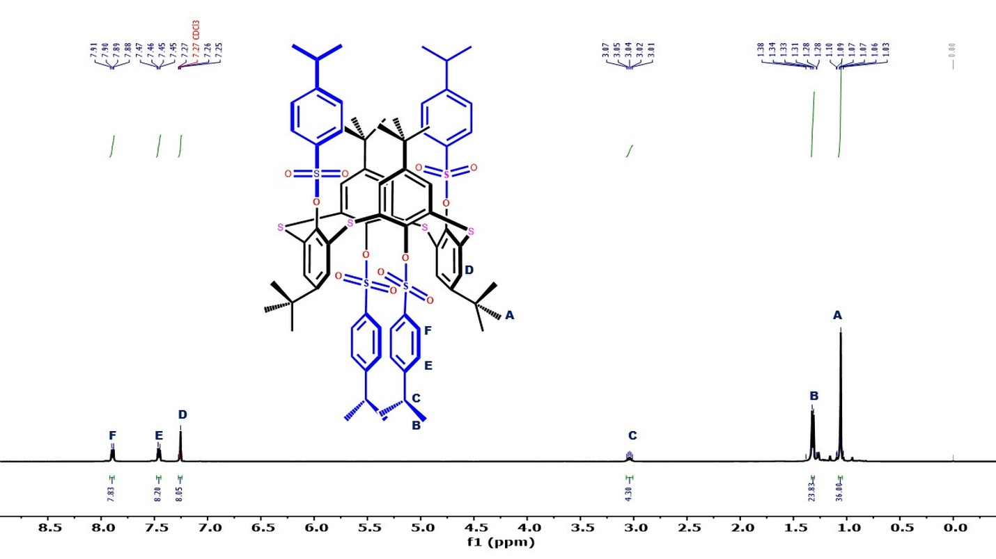
Figure S9: ¹H-NMR spectra of receptor PK² (CDCl₃ 500MHz).
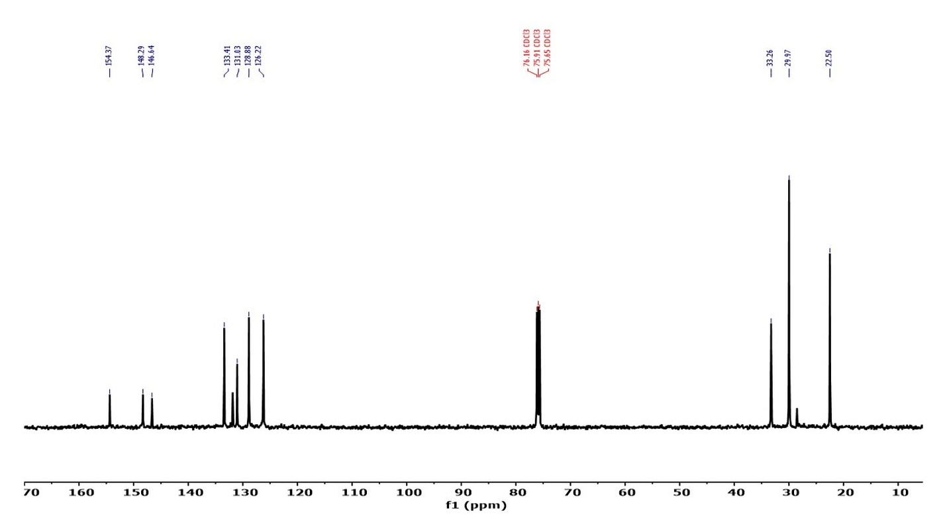
Figure S10: ¹³C-NMR spectra of receptor PK² (CDCl₃ 500MHz).
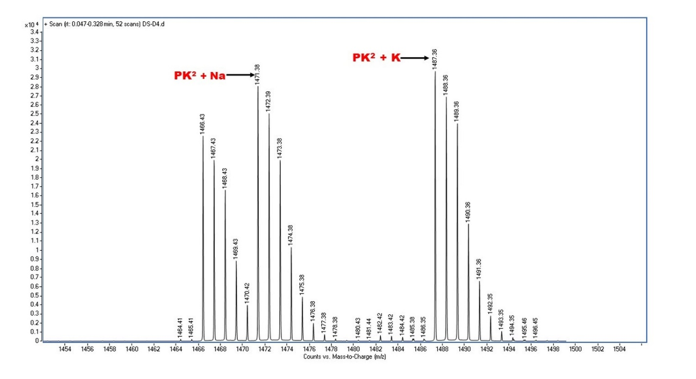

Figure S11: ESI-MS spectra of receptor PK².

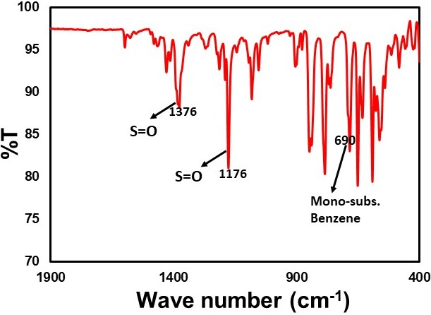
Figure S12: FT-IR spectra of receptor PK².

(3) Photophysical Data:
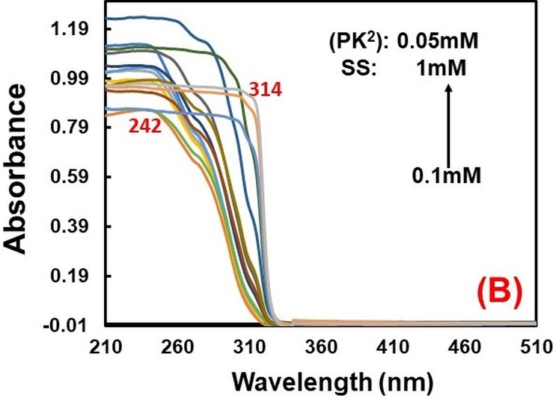
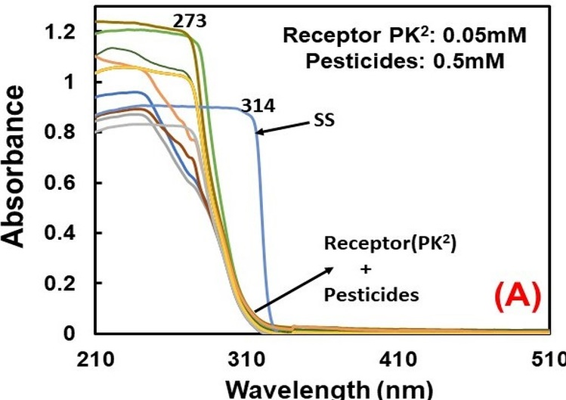

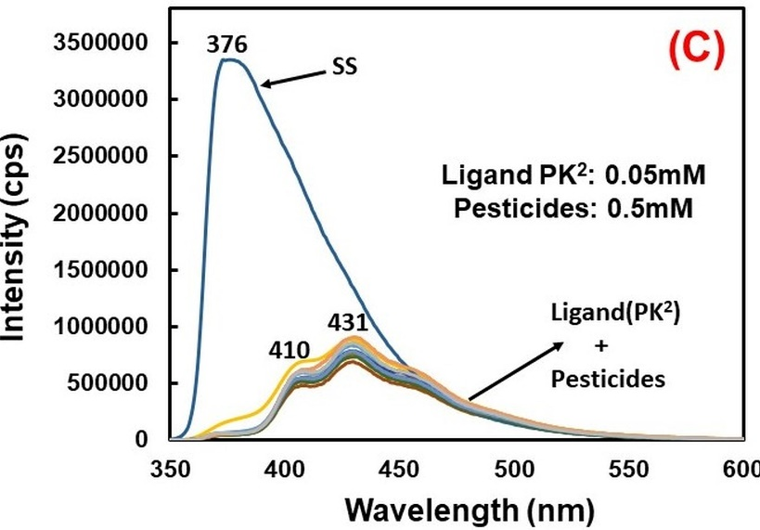

Figure S13: (A) Competitive Absorption spectra of PK² along with Pesticides. (B) UV-Visible titration of PK² with an incremental concentration of Sulfosulfuron. (C) Competitive Emission spectra of PK² with various Pesticides. (D) Fluorescence Titration of PK² with an incremental concentration of Sulfosulfuron.

(4) Determination of LOD (Detection limit) and Enhancement constant (Ks):
The detection limit and Enhancement constant (K_{S}) for Cu²⁺ were calculated using fluorescence titration. For LOD calculation, the concentration ranges from 0.1mM to 0.3 mM was considered for Sulfosulfuron. The plot of Fluorescence Intensity vs concentration of Sulfosulfuron was obtained, revealing a linear relationship between S (Slope) and R² (Correlation factor).
Similarly, the Enhancement constants (K_{S}) for PK¹⁻² were calculated while maintaining the same concentration of Sulfosulfuron mentioned above. As shown earlier, PK1-2 shows strong raise in Fluorescence intensity in the presence of Sulfosulfuron. A linear fitting analysis of emission titration data results in an enhancement constant value which was obtained using the following equation:
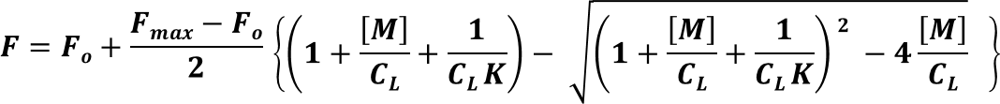

F₀ & F are the emission intensities of receptor PK^{1/2} in the absence and presence of Sulfosulfuron, respectively & F_{max} is the fluorescence intensity of PK^{1/2} at the same emission wavelength in the presence of an excess amount of Sulfosulfuron.
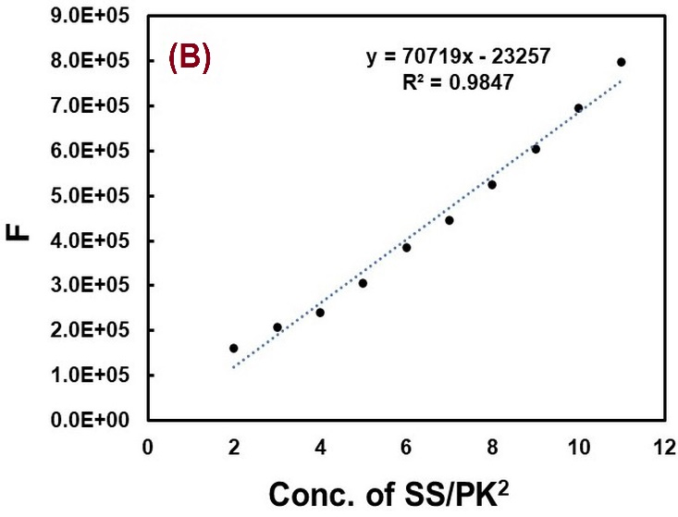
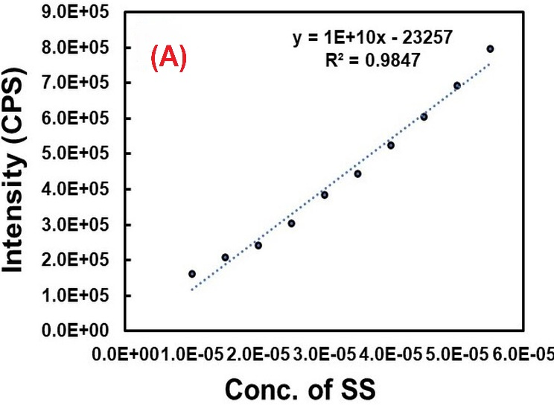

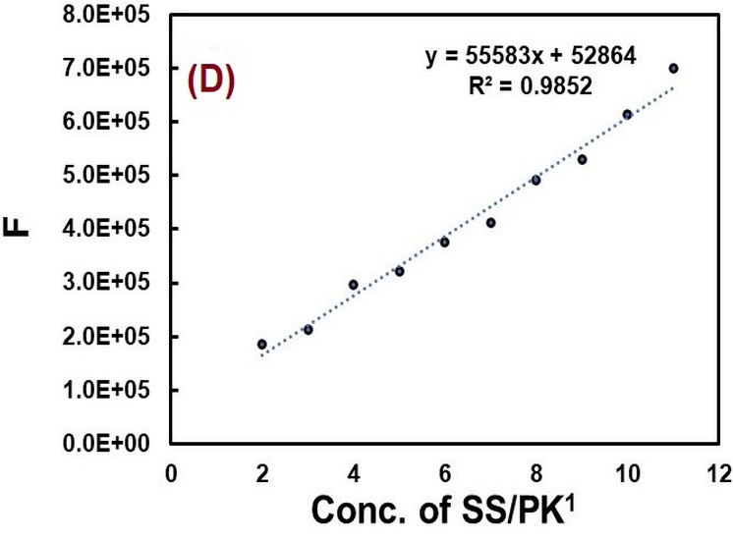
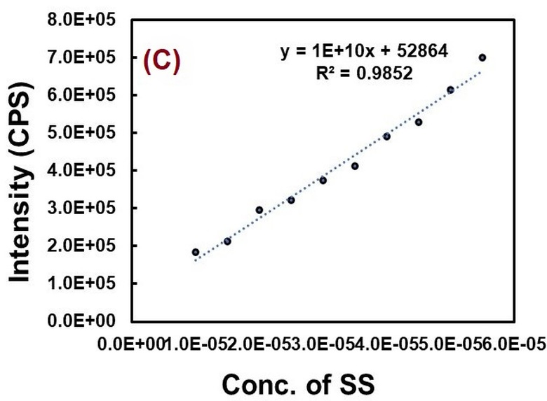

Figure S14: (A and C) Plot of Intensity (Fluorescence) vs Concentration of Ligand PK¹⁻² with Sulfosulfuron for LOD calculation respectively and (B-D) Linear plot of Intensity (F) -vs- Conc. of SS/PK1/2 for determination of Enhancement constant (Ks).

(5) Docking Studies:

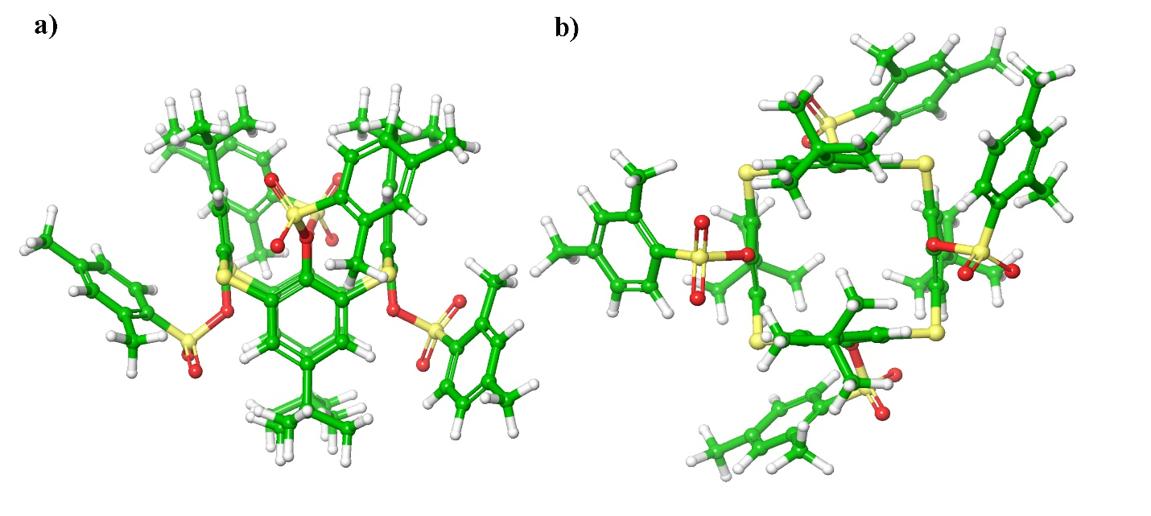
Figure S15: Geometry optimization Structure of PK¹ (a) Side view; (b) top View
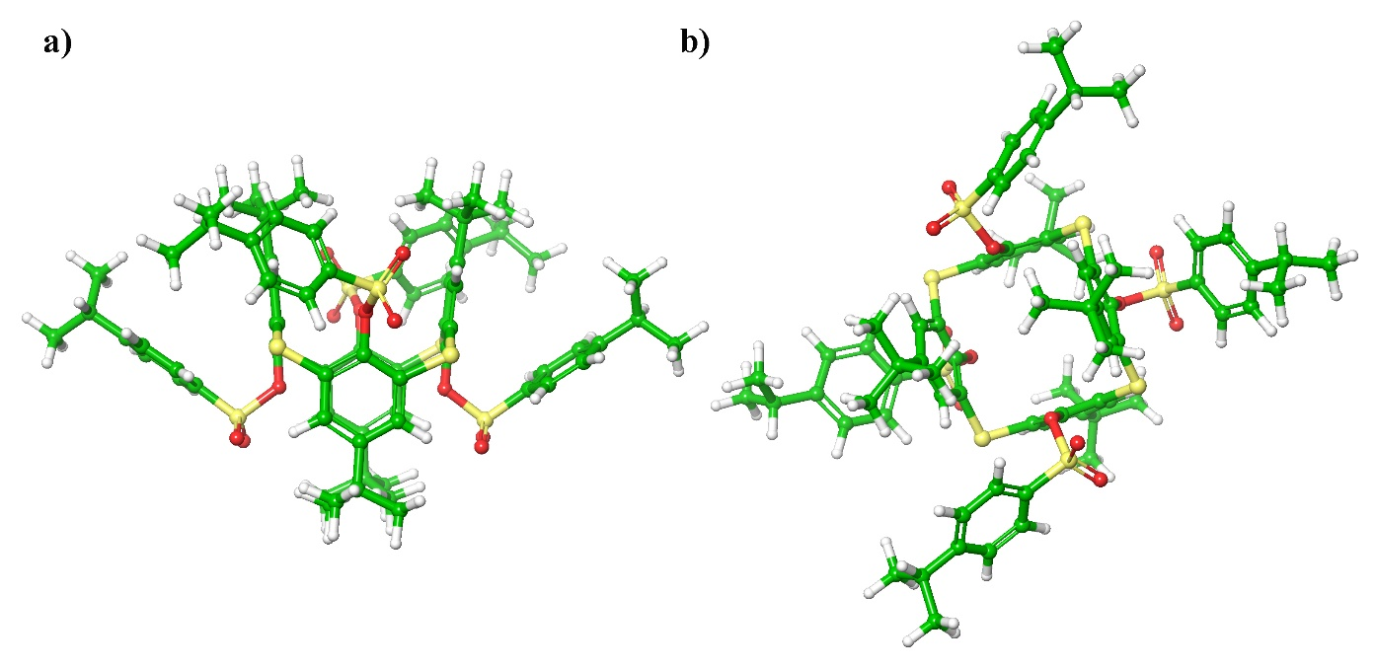
Figure S16: Geometry optimization Structure of PK² (a) Side view; (b) top View.

(6) Association Constant:
Ligand | Binding Model | Experiment No. | Direct Link for Association constant data files available on Supramolecular.org
PK¹ | 1:1 | Experiment 1 | http://app.supramolecular.org/bindfit/view/c26a233c-c0e7-4c8f-9455-0dd6ff20827c
PK¹ | 1:1 | Experiment 2 | http://app.supramolecular.org/bindfit/view/f9c9abf7-ab97-4702-8f1b-5322de53267f
PK¹ | 1:1 | Experiment 3 | http://app.supramolecular.org/bindfit/view/68203374-20d8-447d-ba35-3a76052c53ef
PK² | 1:1 | Experiment 1 | http://app.supramolecular.org/bindfit/view/836201f5-07f5-4638-a18b-df854cb2b1d1
PK² | 1:1 | Experiment 2 | http://app.supramolecular.org/bindfit/view/d38c8f98-c92c-4863-8c4f-c4ae9b4bb84e
PK² | 1:1 | Experiment 3 | http://app.supramolecular.org/bindfit/view/bf05d31b-3ca6-4984-8a1c-4c481ad52584

Table S1: Direct link of Binding constant data obtained using non-linear regression plot via free online software (Supramolecular.org).

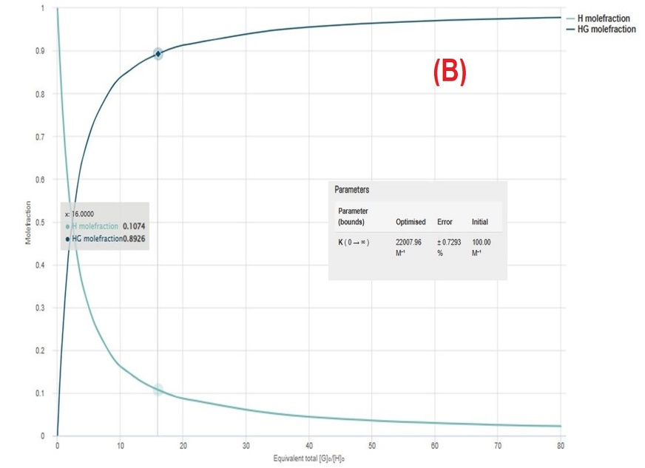
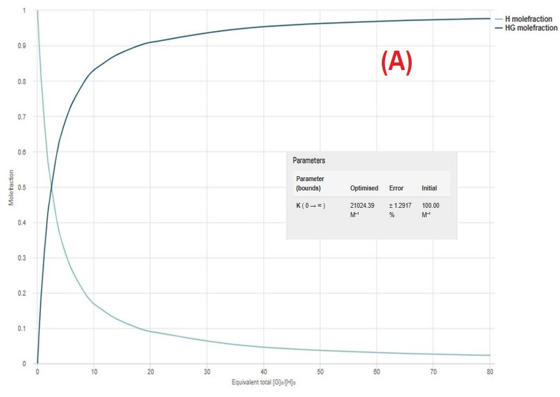
Figure S17: (A-B) Plot of Mole fraction vs Equivalent (G_{o}/H_{o}) for PK¹⁻² + Sulfosulfuron. [G_{o} is Guest concentration and H_{o} is Host concentration]

(7) MALDI-TOF Data:
m/z | S/N | Quality Fac. | Res. | Intens. | Area
684.920 | 23 |  | 571 | 1677 | 4917
700.514 | 3 |  | 396 | 261 | 680
739.927 | 6 |  | 493 | 826 | 2982
747.881 | 5 |  | 296 | 392 | 1410
923.223 | 8 |  | 242 | 395 | 1420
938.852 | 6 |  | 289 | 327 | 1364
1106.337 | 7 |  | 361 | 212 | 899
1122.800 | 9 |  | 271 | 254 | 1113
1332.587 | 6 |  | 326 | 112 | 514
1525.650 | 9 |  | 735 | 276 | 821
1668.268 | 11 |  | 671 | 322 | 511
1697.798 | 12 |  | 521 | 112 | 400
1847.988 | 11 |  | 478 | 113 | 339
1863.445 | 17 |  | 497 | 194 | 566

Table S2: MALDI-TOF single peak analysis for PK¹-SS adduct.

m/z | S/N | Quality Fac. | Res. | Intens. | Area
492.487 | 25 |  | 1219 | 36002 | 3366
508.485 | 58 |  | 4327 | 34545 | 19713
514.496 | 48 |  | 1142 | 41504 | 9839
531.512 | 80 |  | 97.2 | 13304 | 20350
564.805 | 44 |  | 459 | 4810 | 7511
760.322 | 3 |  | 3005 | 1873 | 406
1001.930 | 13 |  | 278 | 807 | 413
1122.162 | 3 |  | 315 | 1989 | 359
1305.250 | 5 |  | 202 | 7276 | 751
1488.272 | 9 |  | 137 | 4176 | 978
1724.699 | 20 |  | 218 | 5460 | 424
1759.277 | 25 |  | 189 | 5177 | 3300
1898.389 | 29 |  | 1323 | 2204 | 3441
1919.483 | 33 |  | 808 | 2415 | 4789

Table S3: MALDI-TOF single peak analysis for PK²-SS adduct.

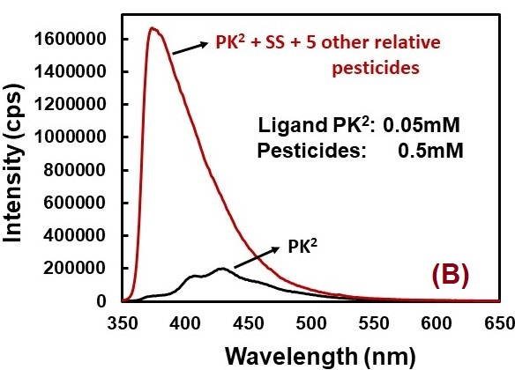
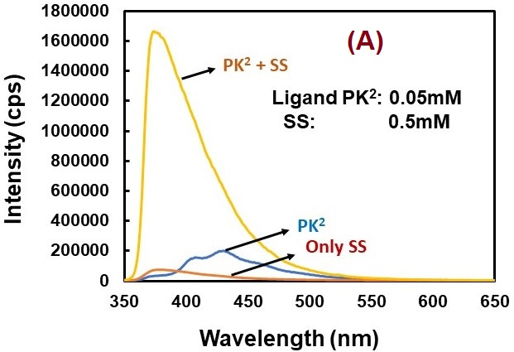
(8) Interference Studies:

Figure S18: (A)Emission spectra of PK2 with in presence and absence of Sulfosulfuron and only Sulfosulfuron when excited at 325 nm wavelength (B) Emission spectra of PK2 with Sulfosulfuron and excess of other herbicides.

(9) Probable Binding Mechanism:

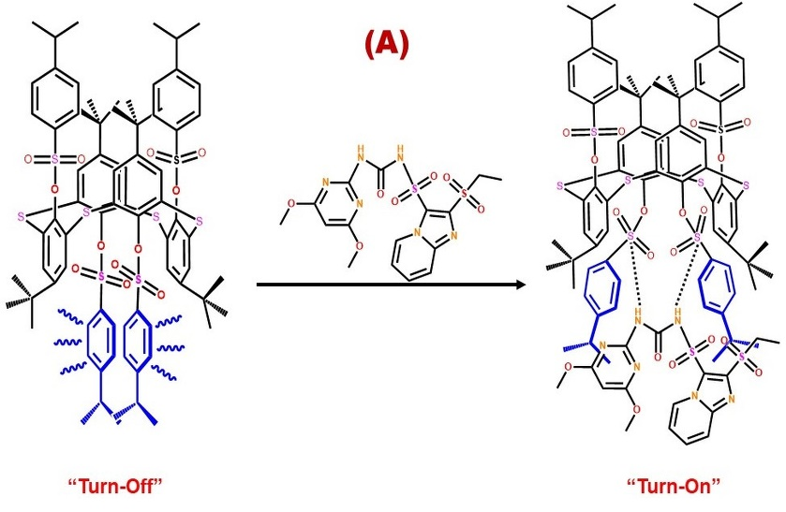
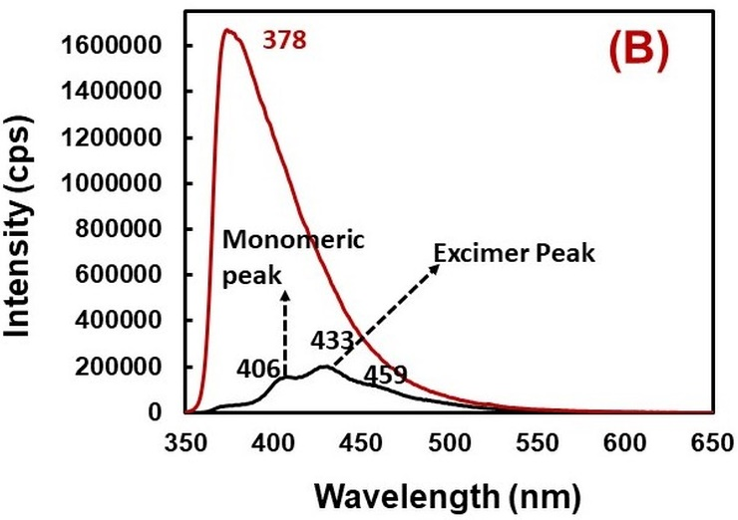

Figure S19: (A) Schematic representation of the “Excimer OFF- Excimer ON” mechanism. (B) Emission spectra showing rise in Excimer and Monomeric peak in the presence of Sulfosulfuron.

(10) Recyclability test:
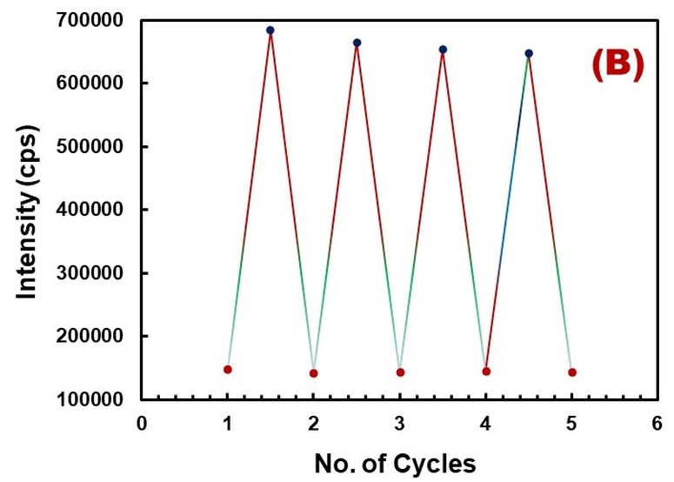
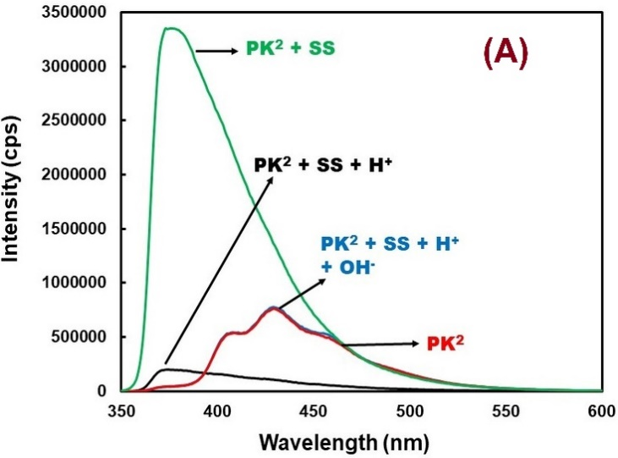

Figure S20: (A) Presentation of Recyclability of receptor PK2 using simple Acid-Base treatment, (b) Variation in Fluorescence intensity at 375 nm on incremental addition of Sulfosulfuron.

(11) Comparison Table:
Methods applied | Detection Limit | References.
HPLC-UV based technique | 0.01 μg/ml | [2]
Adsorption Technique | 0.001 μg/g | [3]
Accelerated Microbial Degradation technique | 2.7 ng/g | [4]
Organic Quenchers | 0.002 mg/kg | [5]
Degradation method | 2.7 ng/g | [6]
Deep eutectic solvents | 0.010 μg/L | [7]
MOF-based adsorbent | 0.04-0.84 μg/L | [8]
Photophysical Techniques | - 0.21 ppm  - 0.35 ppm | THIS WORK

Table S4: Comparison table of methods employed for the determination of Sulfosulfuron with their Detection limit reported.

(12) References:
S1. Kumar R, Lee YO, Bhalla V, et al (2014) Recent developments of thiacalixarene based molecular motifs. Chem Soc Rev 43:4824–4870
S2. Mehdizadeh M, Alebrahim MT, Roushani M (2017) Determination of Two Sulfonylurea Herbicides Residues in Soil Environment Using HPLC and Phytotoxicity of These Herbicides by Lentil Bioassay. Bull Environ Contam Toxicol 99:93–99. https://doi.org/10.1007/s00128-017-2076-8
S3. Maheswari ST, Ramesh A (2007) Adsorption and degradation of sulfosulfuron in soils. Environ Monit Assess 127:97–103. https://doi.org/10.1007/s10661-006-9263-0
S4. Paporisch A, Laor Y, Rubin B, Eizenberg H (2020) Effect of repeated application of sulfonylurea herbicides on sulfosulfuron dissipation rate in soil. Agronomy 10:. https://doi.org/10.3390/agronomy10111724
S5. Joshi V, Suyal A, Srivastava A, Srivastava PC (2019) Role of organic amendments in reducing leaching of sulfosulfuron through wheat crop cultivated soil. Emerg Contam 5:4–8. https://doi.org/10.1016/j.emcon.2018.12.002
S6. Paporisch A, Laor Y, Rubin B, et al (2018) Application Timing and Degradation Rate of Sulfosulfuron in Soil Co-affect Control Efficacy of Egyptian broomrape (Phelipanche aegyptiaca) in Tomato. Weed Sci 66:780–788. https://doi.org/10.1017/wsc.2018.49
S7. Wang DD, Zhao Y, Ou yang MN, et al (2019) Magnetic polydopamine modified with deep eutectic solvent for the magnetic solid-phase extraction of sulfonylurea herbicides in water samples. J Chromatogr A 1601:53–59. https://doi.org/10.1016/j.chroma.2019.05.011
S8. Yang JH, Cui CX, Qu LB, et al (2018) Preparation of a monolithic magnetic stir bar for the determination of sulfonylurea herbicides coupled with HPLC. Microchemical Journal 141:369–376. https://doi.org/10.1016/j.microc.2018.05.049

