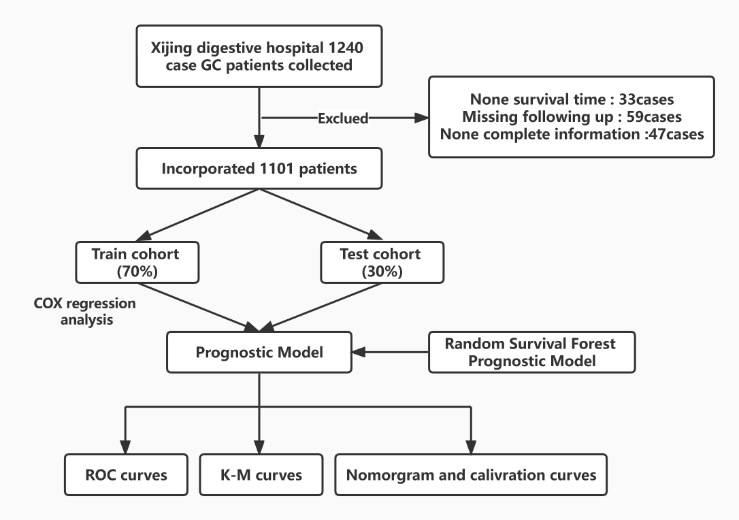
Supplementary Figure S1 Selection criteria and workflow of the study
Supplementary Figure S2 ROC Curves of the included variables and TNM staging system.
ROC curves for (A) cachexia, (B) CEA level, (C) CA19-9 level, (D) serum albumin level and (E) TNM stage.
CEA, carcinoembryonic antigen; CA19-9, carbohydrate antigen 199; TNM stage: AJCC/UICC eighth edition TNM staging system.
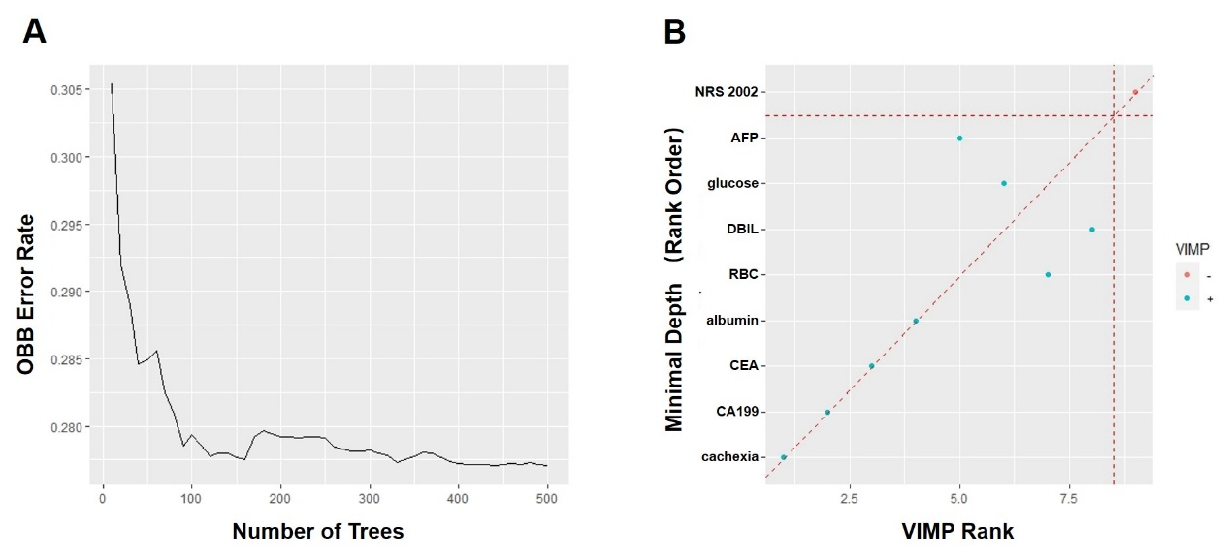
Supplementary Figure S3 Random Survival Forest Model
(A) Model prediction error rates for different numbers of survival trees.
(B) Scatter plots of random survival forest model determined using the VIMP and Minimal Depth methods.

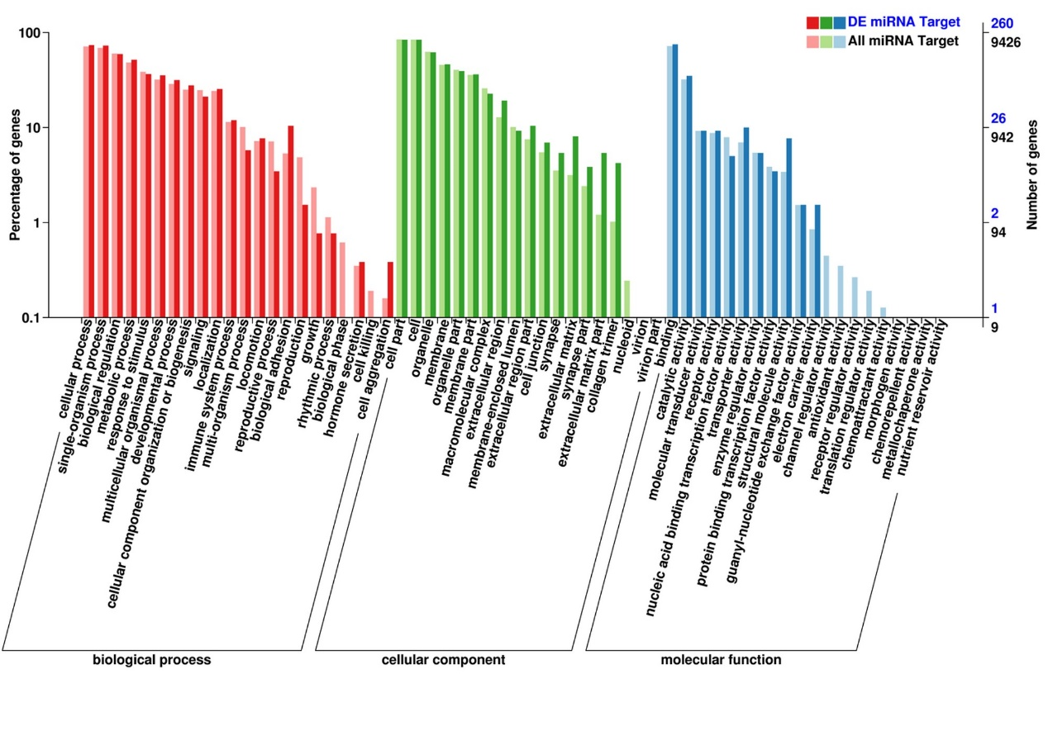 Supplementary Figure S4 GO annotation classification statistics of differentially expressed miRNA target genes
The horizontal axis represents the GO classification, the left side of the vertical axis represents the percentage of the number of genes, and the right side represents the number of genes. This figure shows the gene enrichment of each secondary function of GO in the backgrounds of differentially expressed miRNA target genes and all genes. GO, gene ontology.
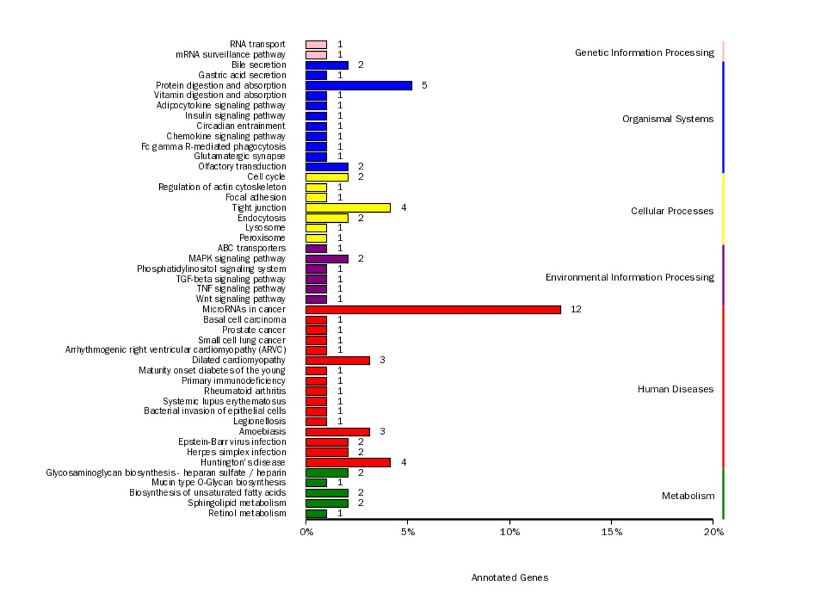 Supplementary Figure S5 KEGG classification statistics of differentially expressed miRNA target genes
The ordinate represents the name of the KEGG metabolic pathway, and the abscissa represents the number of genes annotated to the pathway as well as the ratio of the number to the total number of genes annotated. KEGG, Kyoto Encyclopedia of Genes and Genomes.

Supplementary Table S1 Baseline data of the population
No. of case | N=1101 |  | N=1101
Survival status (%) |  | T stage (%)
Alive | 769 (69.8%) | 1 | 277 (25.16%)
Dead | 332 (30.2%) | 2 | 150 (13.62%)
Survival time（month） | 37.38 (17.34) | 3 | 274 (24.89%)
Sex (%) |  | 4 | 400 (36.33%)
Male | 826 (75.0%) | N stage (%)
Female | 275 (25.0%) | 0 | 469 (42.60%)
Age (year) | 57.80 (10.78) | 1 | 184 (16.71%)
BMI  Cachexia (%)  Yes  No | 22.85 (3.17)  330 (29.97%)  771 (70.03%) | 2  3  M stage (%)  0 | 157 (14.26%)  291 (26.43%)  1060 (96.28%)
Marriage (%) |  | 1 | 41 (3.72%)
Yes | 1091 (99.09%) | NRS2002
No | 10 (0.91%) | ≥3 | 744 (67.57%)
Blood type (%) |  | ＜3 | 357 (32.43%)
A | 334 (30.34%) | CEA | 4.52 (7.45)
B | 322 (29.25%) | CA19-9 | 22.29 (29.10)
AB | 105 (9.54%) | albumin | 37.55 (6.10)
O | 340 (30.88%)
BMI, body mass index; CEA，carcinoembryonic antigen;
CA19-9, carbohydrate antigen 19-9; NRS2002, nutritional risk screening scale-2002;

