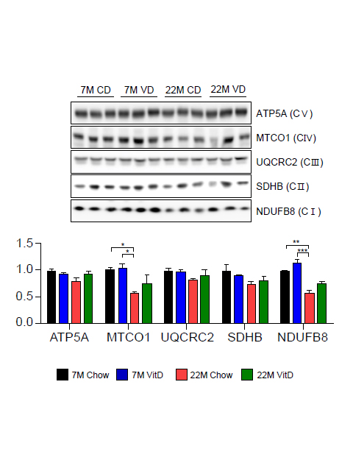
Supplementary Fig. 1. Altered protein levels of OXPHOS in aged liver. OXPHOS protein levels in liver from young and old mice fed the chow and Vitamin D₃-supplemented diet (n=3/group). The reduction of OXPHOS in aged mice partially restored by Vitamin D_{3.}

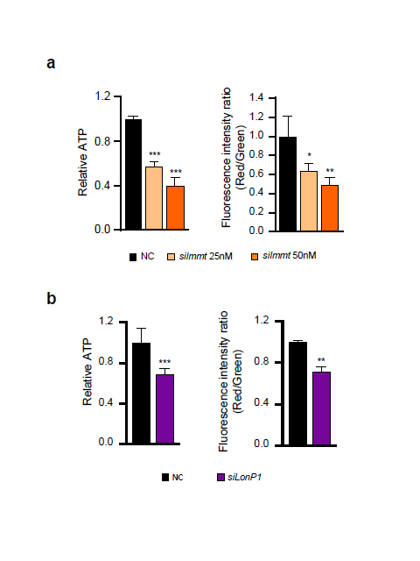
Supplementary Fig. 2 The cellular ATP production level and mitochondrial membrane potential were decreased in Immt or LonP1-depleted HepG2 cells. Specific depletion of both genes equally induced the reduction of the cellular ATP production level and mitochondrial membrane potential.
Supplementary Table 1. The Primers used in this study
Primer Name | Sequence (5’ to 3’)
mβ-actin | Sense | CACAGCTTCTTTGCAGCTCCT
mβ-actin | Anti-Sense | GTCATCCATGGCGAACTGG
mIMMT (MIC60) | Sense | AGGGAGACACTCCAGCTTCA
mIMMT (MIC60) | Anti-Sense | GACGAGCTGCAACTTCTTCG
mAPOOL (MIC27) | Sense | GCGGCCTTTAGGATGGGAAA
mAPOOL (MIC27) | Anti-Sense | GATCCGGTCTCACTAGCTGC
mCHCHD3 (MIC19) | Sense | TGAAGACAAAGCTCGGCAG
mCHCHD3 (MIC19) | Anti-Sense | GCTTGAACTTGGCTTCCACC
mMINOS1 (MIC10) | Sense | GAACATCCCAGCGGGAGAAA
mMINOS1 (MIC10) | Anti-Sense | ACTGATGGCACTGTCACAGGA
mL-CPT1α | Sense | CTCAGTGGGAGCGACTCTTCA
mL-CPT1α | Anti-Sense | GGCCTCTGTGGTACACGACAA
mPPARα | Sense | TGCAAACTTGGACTTGAACG
mPPARα | Anti-Sense | GATCAGCATCCCGTCTTTGT
mFAS | Sense | AAGCCGTTGGGAGTGAAAGT
mFAS | Anti-Sense | CAATCTGGATGGCAGTGAGG
mPPARγ | Sense | ACAGGACTGTGTGACAGACA
mPPARγ | Anti-Sense | TATGGGTGAAACTCTGGGAG
mCIDEA | Sense | CCAGAGTCACCTTCGACCTATACA
mCIDEA | Anti-Sense | CATCGTGGCTTTGACATTGAGA
m FSP27 | Sense | TCCAGGACATCTTGAAACTT
m FSP27 | Anti-Sense | GGCTTGCAAGTATTCTTCTGT
mGPAT | Sense | TTCCGCCTCTGGGCATT
mGPAT | Anti-Sense | AGAATCGGCCCACAATCCA
mDGAT | Sense | TTCCGCCTCTGGGCATT
mDGAT | Anti-Sense | AGAATCGGCCCACAATCCA
mMGAT1 | Sense | CTGGTTCTGTTTCCCGTTGT
mMGAT1 | Anti-Sense | TGGGTCAAGGCCATCTTAAC
mMGAT2 | Sense | GAGCAAAGCCCGTGTGTAGA
mMGAT2 | Anti-Sense | AAGGTCTGTAACCTGCGCTC
mCD36 | Sense | TGCACCACATATCTACCAAA
mCD36 | Anti-Sense | TTGTAACCCCACAAGAGTTC
mVLDLR | Sense | GCCATATGAGAACATGCCGC
mVLDLR | Anti-Sense | AGGACACGGGGATACACTGA
mLDLR | Sense | TGACTCAGACGAACAAGGCT
mLDLR | Anti-Sense | ATCTAGGCAATCTCGGTCTC
hGAPDH | Sense | GTCTCCTCTGACTTCAACAGCG
hGAPDH | Anti-Sense | ACCACCCTGTTGCTGTAGCCAA
hIMMT1 | Sense | CACCTGCACTTTCAGAAGCA
hIMMT1 | Anti-Sense | CTTGCAGTTTGCCTCAGAGC
hLonP1 | Sense | CGGGAAGATCATCCAGTGTT
hLonP1 | Anti-Sense | ACGTCCAGGTAGTGGTCCAG
hPPARα | Sense | GGATGTCACACAACGCGATTC
hPPARα | Anti-Sense | GGTGGATTGTTACTGGCCTTTC
hL-CPT1a | Sense | GCAGAGGTTCAAGCTGTTCAA
hL-CPT1a | Anti-Sense | CATGGCTCAGACAGTACCTCCT
hCD36 | Sense | CAGGTCAACCTATTGGTCAAGCC
hCD36 | Anti-Sense | GCCTTCTCATCACCAATGGTCC
hVLDLR | Sense | CAAGGATGGCAGTGATGAGGTC
hVLDLR | Anti-Sense | CTCGGATACCATTACACTGCCTG
hLDLR | Sense | GAATCTACTGGTCTGACCTGTCC
hLDLR | Anti-Sense | GGTCCAGTAGATGTTGCTGTGG
hFAS | Sense | GGACCCAGAATACCAAGTGCAG
hFAS | Anti-Sense | GTTGCTGGTGAGTGTGCATTCC
hPPARγ | Sense | GCAATCAAAGTGGAGCCTGC
hPPARγ | Anti-Sense | TCTCCGGAAGAAACCCTTGC
hCIDEA | Sense | CGGGACTATGCAGGAGCC
hCIDEA | Anti-Sense | GAGGGCATCCAGAGTCTTGC
hFSP27 | Sense | AAGCGTGAGGAAGGGCATCATG
hFSP27 | Anti-Sense | CAGTTGTGCCATCTTCCTCCAG
hSREBP1 | Sense | ACTTCTGGAGGCATCGCAAGCA
hSREBP1 | Anti-Sense | AGGTTCCAGAGGAGGCTACAAG
hSCD1 | Sense | CCTGGTTTCACTTGGAGCTGTG
hSCD1 | Anti-Sense | TGTGGTGAAGTTGATGTGCCAGC
hDGAT2 | Sense | GCTACAGGTCATCTCAGTGCTC
hDGAT2 | Anti-Sense | GTGAAGTAGAGCACAGCGATGAG
hMGAT1 | Sense | CCTATGACCGAGATTTCCTCGC
hMGAT1 | Anti-Sense | TGAAGCTGTCCCTGCCCGTATA
hMGAT2 | Sense | CCAGGGAATTGACAACGTCCTC
hMGAT2 | Anti-Sense | AGGGTCACTACCTGGAAACTCG
hCDKN1A | Sense | AGGTGGACCTGGAGACTCTCAG
hCDKN1A | Anti-Sense | TCCTCTTGGAGAAGATCAGCCG
hCDKN2A | Sense | CTCGTGCTGATGCTACTGAGGA
hCDKN2A | Anti-Sense | GGTCGGCGCAGTTGGGCTCC
hp53 | Sense | CCTCAGCATCTTATCCGAGTGG
hp53 | Anti-Sense | TGGATGGTGGTACAGTCAGAGC
hIGFBP7 | Sense | GCCATCACCCAGGTCAGCAAG
hIGFBP7 | Anti-Sense | GGATTCCGATGACCTCACAGCT
hIL1A | Sense | TGTATGTGACTGCCCAAGATGAAG
hIL1A | Anti-Sense | AGAGGAGGTTGGTCTCACTACC
hIL6 | Sense | AGACAGCCACTCACCTCTTCAG
hIL6 | Anti-Sense | TTCTGCCAGTGCCTCTTTGCTG
R1 (-3986~-3203) | Sense | ATTCAATGTCATCTGCCGGGT
R1 (-3986~-3203) | Anti-Sense | ATGACTCCCGTTGCCAATTC
R2 (-3157~-2323) | Sense | AAGGCTTGAGTGCAGTGGTG
R2 (-3157~-2323) | Anti-Sense | GCAGACTGAGGTGGGAGGAT
R3 (-2312~-1724) | Sense | TCAGTCTGCCAAAATGCCGGG
R3 (-2312~-1724) | Anti-Sense | GCTTCAGTCATGTGGTGCCCGT
R4 (-1845~-1159) | Sense | AGGCGCAAGTTGTGGCTGTG
R4 (-1845~-1159) | Anti-Sense | ACGCCATTGCACTCCAGCCT
R5 (-1179~-550) | Sense | AGGCTGGAGTGCAATGGCGT
R5 (-1179~-550) | Anti-Sense | ACACTGTGGGGACCCTTGTGCT
R6 (-574~115) | Sense | TTAGCACAAGGGTCCCCACA
R6 (-574~115) | Anti-Sense | GCGGTCACACCCGATAACTG

