Supplementary Text 1
Clue of delay effect on West Antarctic ice loss by strong El Niño
During the 41-year period from 1979–2019, strong El Niño events greater than 1.5 standard deviation occurred three times in 1982/1983, 1997/1998, and 2015/2016, which is equivalent to once every 13.7 years. Unfortunately, GRACE satellites measuring the Antarctic ice mass change began observation in 2002 and includes only one strong El Niño event of 2016 (Fig. 1a). The data stands as reliable evidence that strong El Niño-induced extreme precipitation temporarily prevents decrease in ice mass over West Antarctica. Meanwhile, ERA-5 data having longer record shows that all strong El Niño events in 1979–2019 led to extreme West Antarctic precipitation (although 1982/1983 El Niño causes weaker precipitation than the others) (Fig. 1a), and it can be a clue regarding the delay effect of ice mass. Gained total mass by precipitation (including climatological precipitation) in AM 1998 and AM 2016 are 245.8 and 208.4 Gton, respectively. Therefore, one clear evidence from the GRACE satellite data and the clue from the ERA5 suggest that the temporary delay effect on West Antarctic ice loss by strong El Niño is occurring in the present climate.

Supplementary Text 2
Advantage in using all models to show the non-linear migration of the ASL response
The use of all models yields broad sight in the migration, because individual analysis of models, divided into better and worse groups by ability of simulation of the ASL response, explains only a part of them. In a result of the division, the MME of the residual models shows an eastward and ‘poleward’ shift of El Niño-driven ASL anomaly with global warming (upper panel in Supplementary Fig. 5), while the adopted models exhibits an eastward and ‘equatorward’ shift. In addition, the residual models present the weaker polar jet than that in the adopted models (upper panel in Supplementary Fig. 5 and Fig. 3a). Unintentionally, the division informs a nonlinearity of the migration of the ASL response with jet extension. The polar jet extension with weak intensity shifts the ASL anomaly southward, whereas with strong intensity it induces the anomaly to migrate northward. To elucidate the nonlinearity in the movement, we should involve a broad range in the degree of jet extension by using all models and all projections.
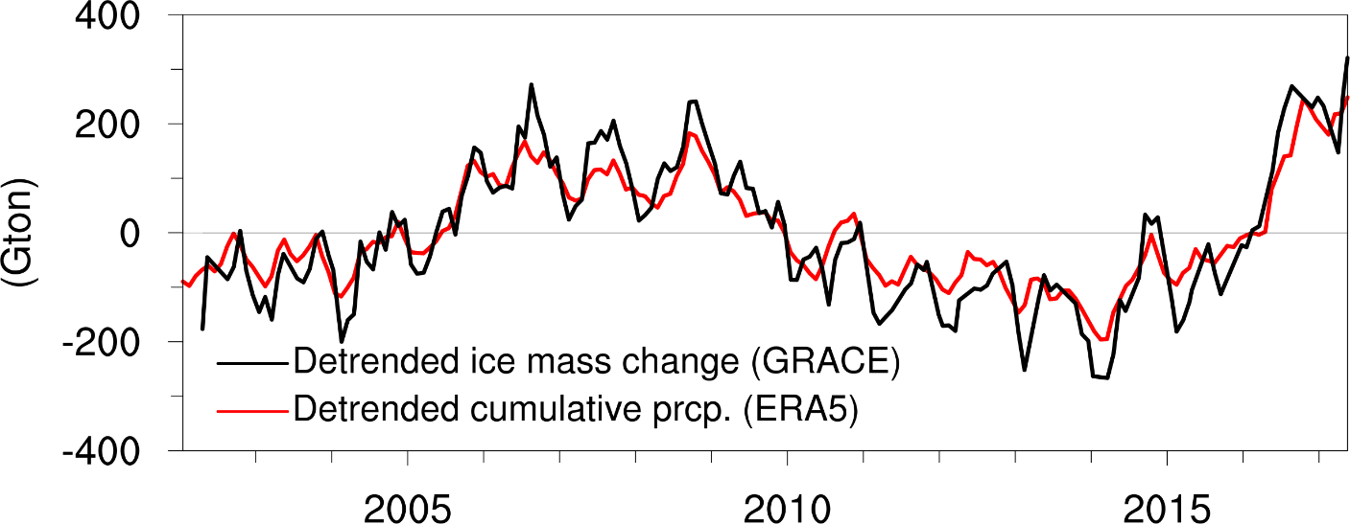
Supplementary Fig. 1 | Detrended ice mass change and detrended cumulative precipitation over West Antarctica. In both, quadratic trend was removed to eliminate long-term trend associated with global warming, so they can be deemed surface mass balance.

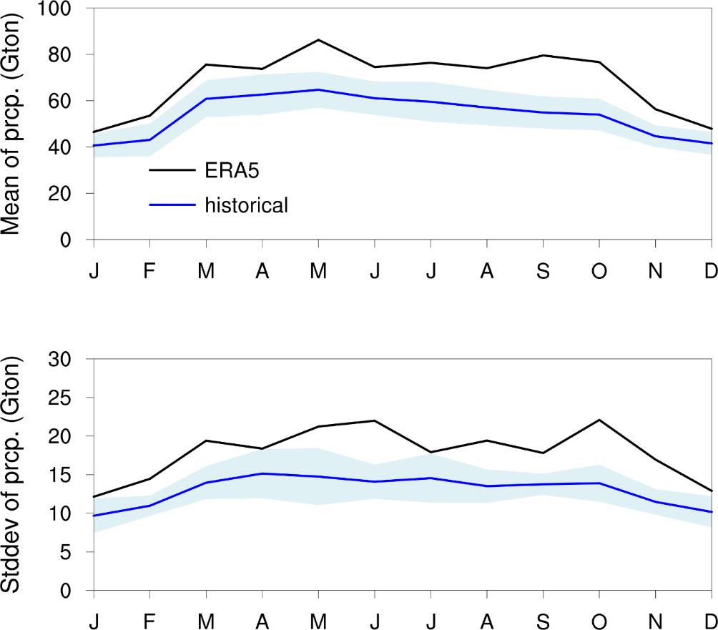

Supplementary Fig. 2 | Mean and standard deviation of monthly West Antarctic precipitation. Black line is of ERA5 (1979−2019) and blue line is of MME in the historical projection (1974–2014) with adopted models. Shaded area represents inter-model spread estimated with one inter-model standard deviations. Mean and standard deviation in AM are 159.9 and 30.2 Gton, respectively, in ERA5 and 127.3 and 22.4 Gton, respectively, in the MME.

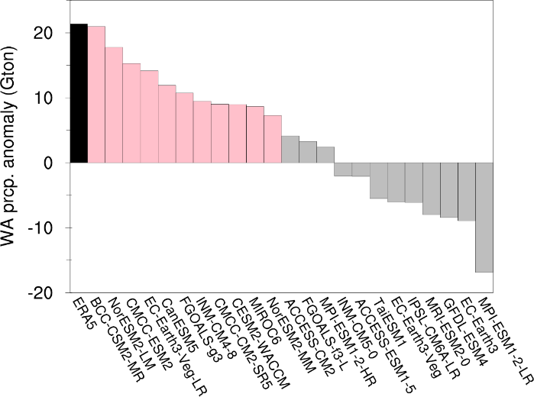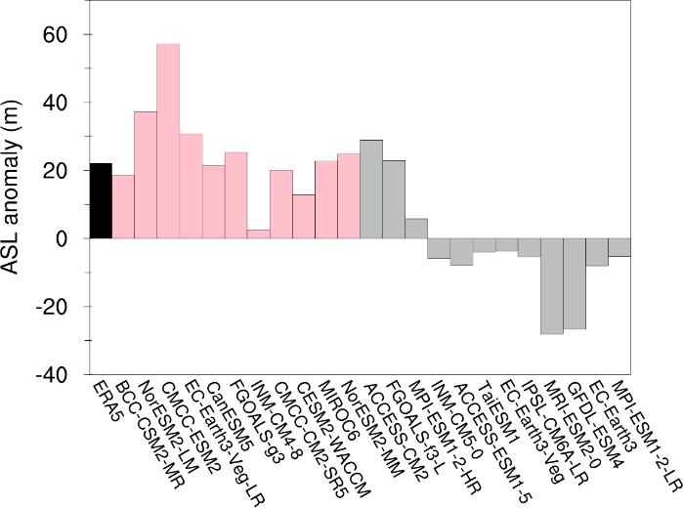
Supplementary Fig. 3 | Capability of CMIP6 models in simulating El Niño-driven West Antarctic precipitation and ASL anomalies. Regression coefficients of West Antarctic precipitation (left) and ASL (right) anomalies against Niño3 index in ERA5 (1979−2019) and CMIP6 models (2014−2014). The ASL anomaly was defined by averaging 500-hPa geopotential height anomaly within the domain of 80°−60°S and 90°−50°W. Based on model ability in simulating West Antarctic precipitation response, 11 models were chosen (pink bar) in which the regression coefficients have positive value and statistical significance at the at least 70% confidence level. The adopted models are BCC-CSM2-MR, CanESM5, CESM2-WACCM, CMCC-CM2-SR5, CMCC-ESM2, EC-Earth3-Veg-LR, FGOALS-g3, INM-CM4-8, MIROC6, NorESM2-LM, and NorESM2-MM

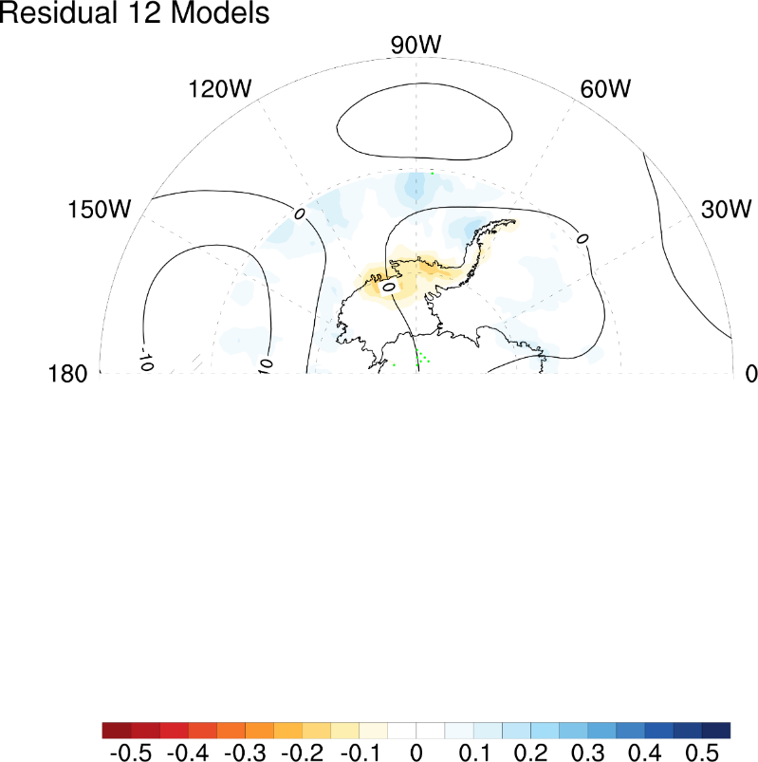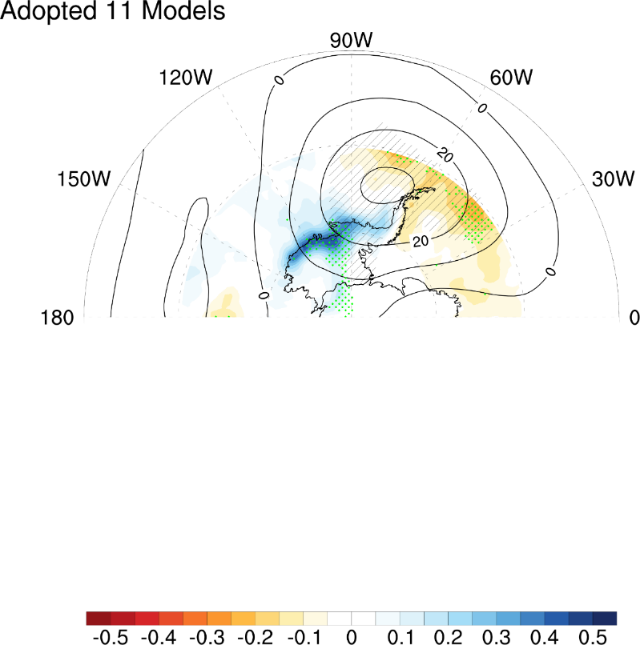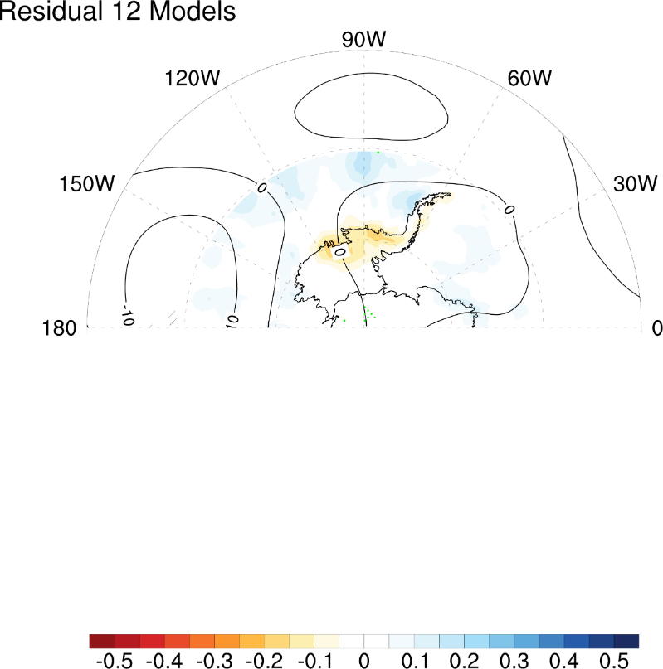

Supplementary Fig. 4 | Horizontal structure of simulated El Niño-driven ASL and West Antarctic precipitation anomalies. MME of regression maps of 500-hPa geopotential height (contour; at 10-m intervals) and precipitation (shaded, m) anomalies onto Niño3 index with adopted 11 models (upper) and residual 12 models (lower) for the period of 1974–2014. Hatched and green dotted patterns indicate areas where more than 90% of the models agree on the sign of geopotential height and precipitation anomalies, respectively.

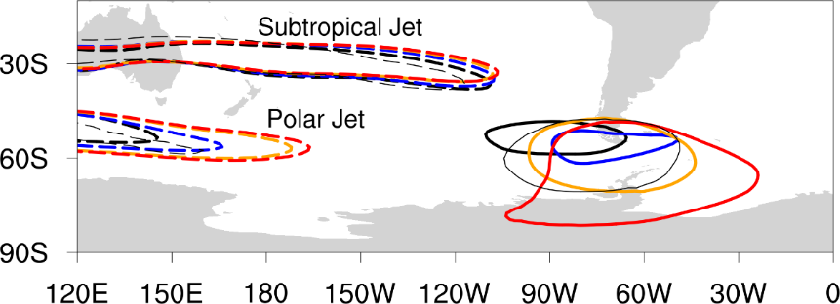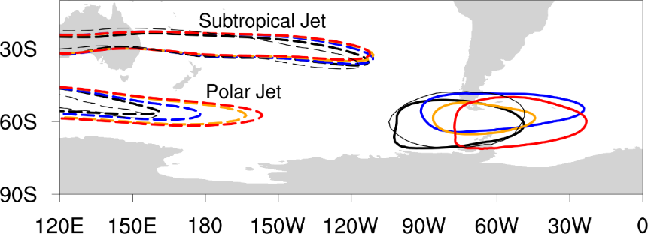

Supplementary Fig. 5 | Jet stream and El Niño-driven ASL anomaly. Same as Fig. 3a, but for the MMEs of 12 residual models (upper) and the MMEs of 23 total models (lower).
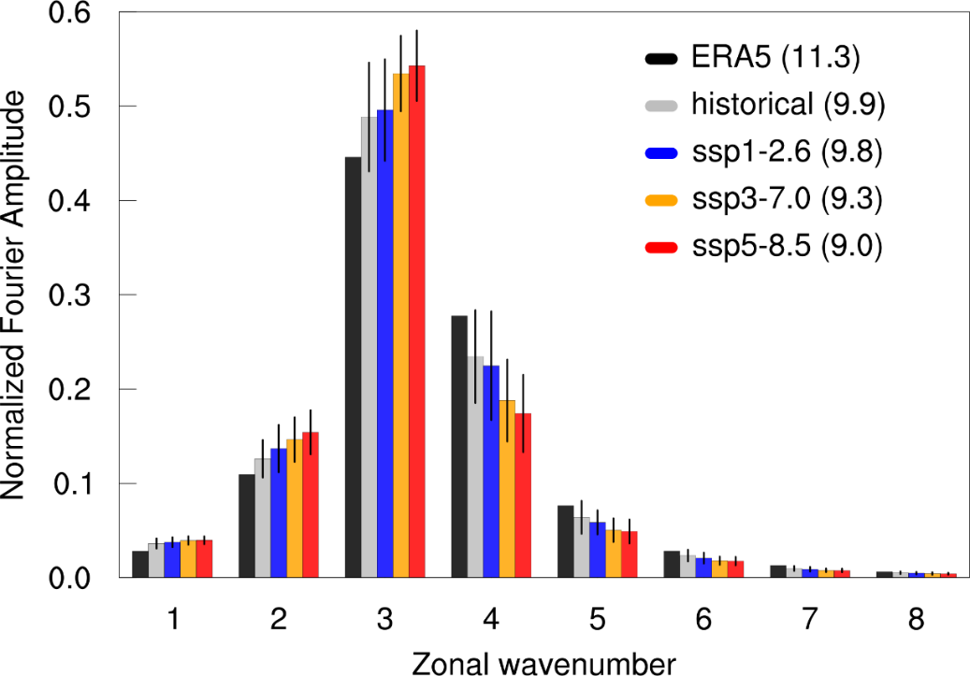
Supplementary Fig. 6 | Normalized Fourier spectrum magnitude of 500-hPa meridional wind anomaly averaged over 70–40°S as a function of zonal wavelength. Bar is MME of the CMIP6 projections and line above bar is one inter-model standard deviations. ERA5 is represented by black bar. Historical projection and ERA5 are calculated for 1974–2014 and 1979–2019, respectively, and future projections are calculated for 2059–2099. Before calculating, mean and trend were removed, and the number inside of the parenthesis indicates total variance.

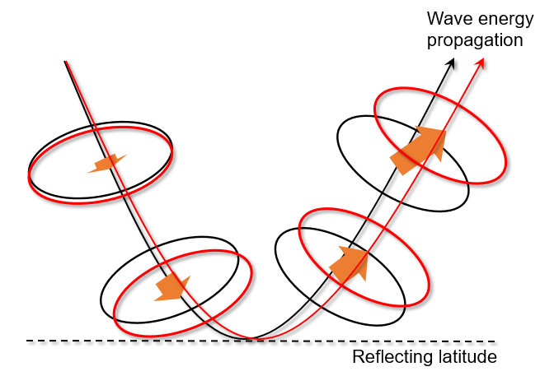
Supplementary Fig. 7 | Idealized schematic of change in tropics-driven teleconnection by the longer zonal wavelength in warmer climate. Black solid line denotes a normal case and red solid line represents a case with the longer zonal wavelength. Dashed line indicates the reflecting latitude. Note that future changes in the reflecting latitude by global warming is not considered here.

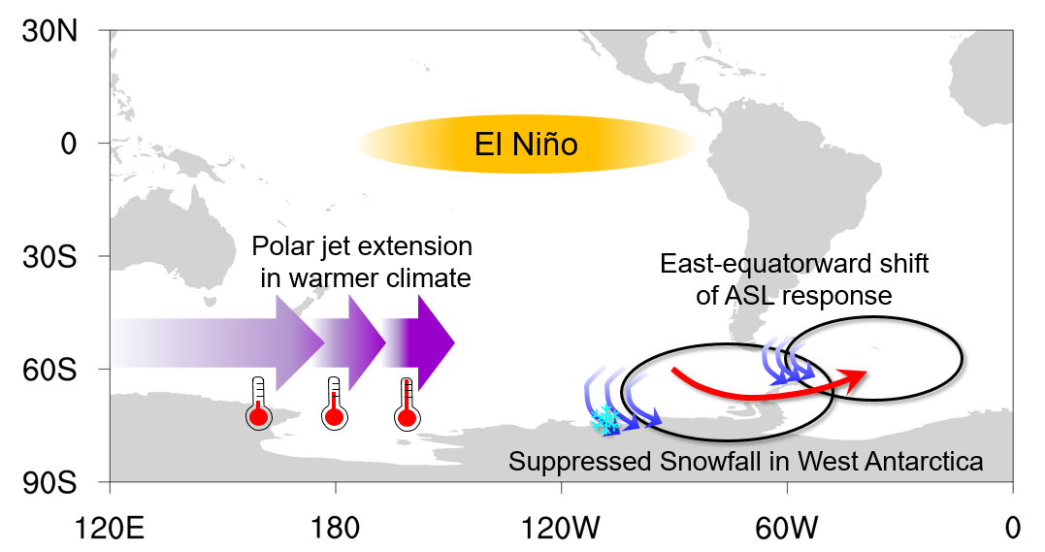
Supplementary Fig. 8 | Summarized process of suppressing El Niño-driven West Antarctic snowfall owing to polar jet extension by global warming.

Supplementary Table 1 | Correlation coefficients of DJF Niño3 index and West Antarctic precipitation in following months.
 | West Antarctic precipitation
 | DJ | FM | AM
DJF Niño 3 | 0.09 | 0.04 | 0.46**
DJF Niño 3 in El Niño years |  |  | 0.53*
DJF Niño 3 in La Niña years |  |  | 0.33

Correlation coefficient was calculated over 41 years (1979−2019) in the first row. To confirm ENSO asymmetry, correlation coefficients in 17 El Niño years and 24 La Nina years were presented in second and third rows, respectively. Asterisk and double asterisk denote statistically significant values at p < .05, p < .01, respectively.

