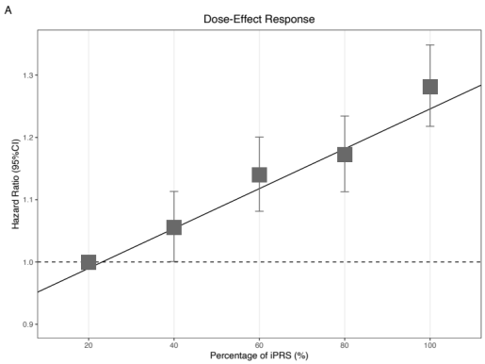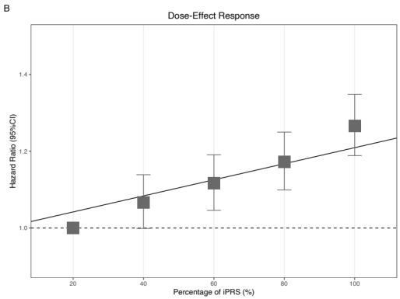
Figure Supplementary 2. The dose-response response between quantile groups of iPRS. The iPRS was divided into five equal parts according to the quantiles. The gray dotted line indicates HR of 1.00. The Bottom (0 to 20%) iPRS group was the reference. The solid black line means the fitted linear regression line between the quantile and HR. iPRS, integrated PRS. CI, confidence interval. (A) For Male. (B) For Female.
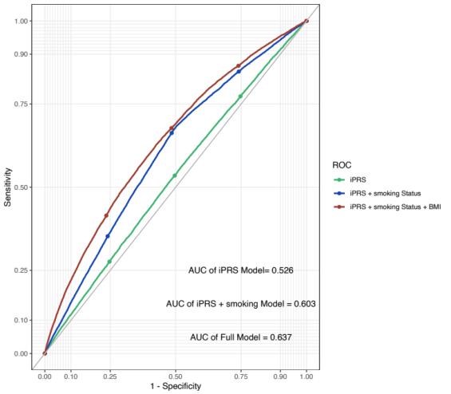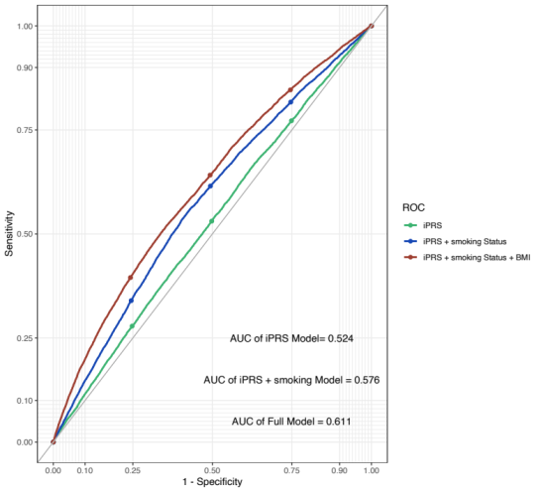
Figure Supplementary 3. The AUROC of the iPRS for all-cause mortality from 10-fold cross-validation.

