Supporting Information
3D plasmonic SERS aptasensor for rapid detection of aflatoxin B₁ combined with Au@Ag bimetallic nanostars and Fe₃O₄@MoS₂ magnetic nanoflowers
Peifang Chen ^{a, b, c, d, 1}, Caiyun Jiang ^{e, 1}, Zhouping Wang ^{a, b, c, d}, Hong-zhen Lian ^{f, *} and Xiaoyuan Ma ^{a, b, c, d, *}

ª State Key Laboratory of Food Science and Technology, Jiangnan University, Wuxi 214122, China
^{b} School of Food Science and Technology, Jiangnan University, Wuxi 214122, China
^{c} International Joint Laboratory on Food Safety, Jiangnan University, Wuxi 214122, China
^{d} Collaborative Innovation Center of Food Safety and Quality Control in Jiangsu Province, Jiangnan University, Wuxi 214122, China
^{e} Department of Health, Jiangsu Engineering and Research Center of Food Safety, Jiangsu Vocational Institute of Commerce, Nanjing 211168, China
^{f} State Key Laboratory of Analytical Chemistry for Life Science, School of Chemistry & Chemical Engineering and Center of Materials Analysis, Nanjing University, Nanjing 210023, China

* Corresponding author: hzlian@nju.edu.cn (H.L.); maxy@jiangnan.edu.cn (X.M.)
¹ These authors contributed equally to this work.
Figure Captions
Fig. S1. (A) The SERS spectra, and (B) curve chart of Au NSs with different volumes (0.2 μL, 0.4 μL, 0.6 μL, 0.8 μL, and 1.0 μL) of 4-MBA (1 mM).
Fig. S2. (A) SERS spectra, (B) curve chart, and (C) UV-Vis spectra of Au-4MBA@Ag NSs with different volumes (0.5 μL, 1 μL, 2 μL, 3 μL and 4 μL) of AgNO₃ (0.1 M) added in Au-4MBA (100 μL) (inset: optical image); (D) TEM image of Au-4MBA@Ag NSs with 3 μL AgNO₃.
Fig. S3. (A) UV-Vis spectra of Au-4MBA@Ag NSs and AFB₁apt before and after incubation; (B) Zeta potential measurements of Au-4MBA@Ag NSs and Au-4MBA @Ag NSs-AFB₁apt.
Fig. S4. TEM images of (A) MoS₂ NSs, and (B) Fe₃O₄@MoS₂ NFs.
Fig. S5. TEM images of Au-4MBA@Ag NSs-AFB₁apt-Fe₃O₄@MoS₂ NFs (A) without AFB₁, and (B) with AFB₁.
Fig. S6. (A) The corresponding RSD result of I₁₅₈₁ for 15 random sites on the assemblies; (B) SERS intensity of the assemblies on the different storage time.
Fig. S7. SERS intensity at 1581 cm⁻¹, and the corresponding RSD values for the detection of 10 ng/mL AFB₁ on (A) the same batch, and (B) six different batch.

Fig. S1.
Fig. S2.
Fig. S3.
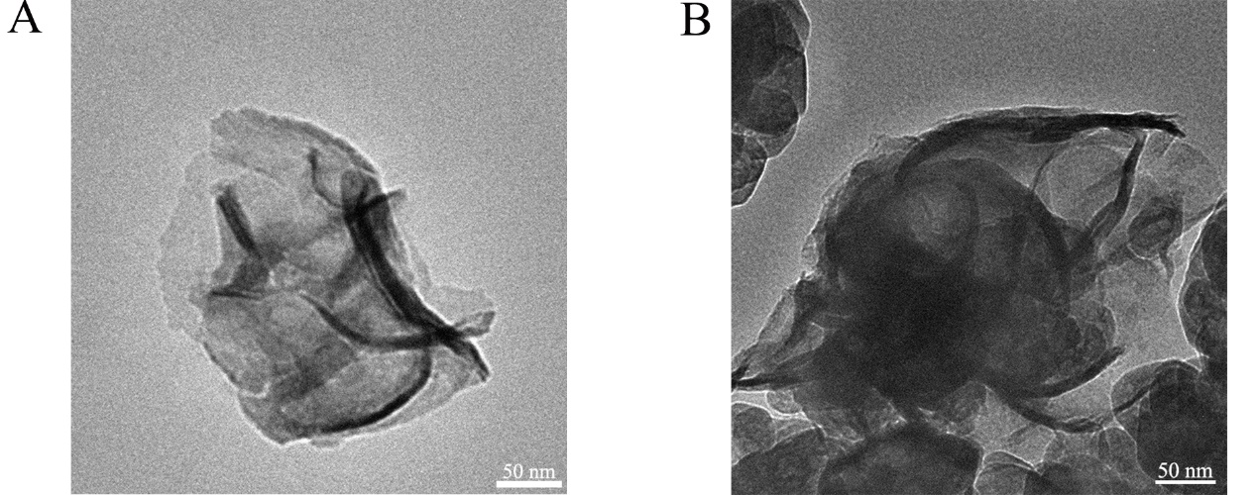
Fig. S4.
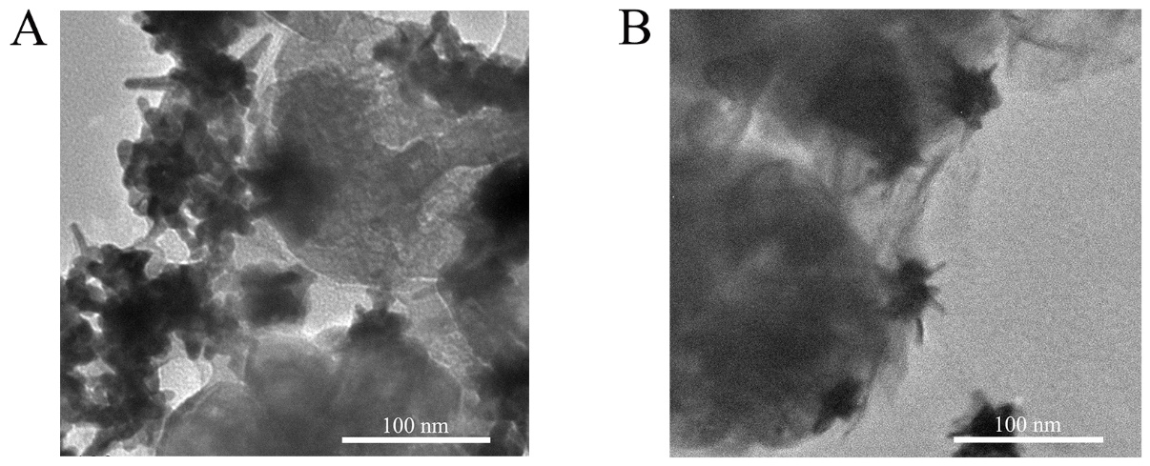
Fig. S5.

Fig. S6.

Fig. S7.

Table S1. Comparison of currently available methods for the AFB₁ detection.
Method | Material | Detection limit  (ng/mL) | Linear range  (ng/mL) | References
Fluorescence | Quantum dot NBs | 1 | 1-19 | (Jia et al. 2021)
Pressure/colorimetric | Dendritic platinum NPs | 0.03 | 0.05-10 | (Jiang et al. 2021)
Fluorescence | Phycocyanin fluorescent NSs | 0.16 | 0.2-48 | (Li et al. 2021)
Colorimetric | Au NPs | 0.36 | 1-10 | (Lerdsri et al. 2020)
SERS | Ag coating magnetic NPs | 0.00045 | 0.001–1000 | (He et al. 2023)
Fluorescence | Fluorescent dye | 1 | 0.2-200 | (Li et al. 2019)
Electrochemistry | Graphene oxide | 0.13 | 1-20 | (Mo et al. 2018)
SERS | Ag nanocluster | 5 | 5-100 | (Chen et al. 2020)
SERS | Fe₃O₄@MoS₂ NFs and Au-4MBA@Ag NSs | 0.0589 | 0.1-1000 | This work

References
Chen Q, Jiao T, Yang M, et al (2020) Pre etched Ag nanocluster as SERS substrate for the rapid quantification of AFB1 in peanut oil via DFT coupled multivariate calibration. Spectrochimica Acta Part A: Molecular and Biomolecular Spectroscopy 239: 118411. https://doi.org/10.1016/j.saa.2020.118411
He H, Sun DW, Pu H, Wu Z. (2023) A SERS-Fluorescence dual-signal aptasensor for sensitive and robust determination of AFB1 in nut samples based on Apt-Cy5 and MNP@ Ag-PEI. Talanta 253: 123962. https://doi.org/10.1016/j.talanta.2022.123962
Jia B, Liao X, Sun C, Fang L, Zhou L, Kong W (2021) Development of a quantum dot nanobead-based fluorescent strip immunosensor for on-site detection of aflatoxin B1 in lotus seeds. Food Chemistry 356. https://doi.org/10.1016/j.foodchem.2021.129614.
Jiang S, Zhang L, Li J, Ouyang H, Fu Z (2021) Pressure/colorimetric dual-readout immunochromatographic test strip for point-of-care testing of aflatoxin B1. Talanta 227. https://doi.org/10.1016/j.talanta.2021.122203.
Lerdsri J, Chananchana W, Upan J, Sridara T, Jakmunee J (2020) Label-free colorimetric aptasensor for rapid detection of aflatoxin B1 by utilizing cationic perylene probe and localized surface plasmon resonance of gold nanoparticles. Sensors and Actuators B: Chemical 320: 128356. https://doi.org/10.1016/j.snb.2020.128356
Li S, Zhong X, Xu Y, et al (2021) Smartphone-based reading system integrated with phycocyanin-enhanced latex nanospheres immunoassay for on-site determination of aflatoxin B1 in foodstuffs. Food Chemistry 360. https://doi.org/10.1016/j.foodchem.2021.130019.
Li Y, Wang J, Zhang B, He Y, Wang J, Wang S (2019) A rapid fluorometric method for determination of aflatoxin B1 in plant-derived food by using a thioflavin T-based aptasensor. Microchimica Acta 186: 1-7. https://doi.org/10.1007/s00604-019-3325-9
Mo R, He L, Yan X et al (2018) A novel aflatoxin B1 biosensor based on a porous anodized alumina membrane modified with graphene oxide and an aflatoxin B1 aptamer. Electrochemistry Communications 95: 9-13. https://doi.org/10.1016/j.elecom.2018.08.012

