Protease secretions by the invading blastocyst induce calcium oscillations in endometrial epithelial cells via the protease activated receptor-2

Aurélie Hennes^{1,2,#} Johanna Devroe^{1,2,3, #}, Katrien De Clercq^{1,2}, Martina Ciprietti^{1,2}, Katharina Held^{1,2}, Katrien Luyten¹, Nele Van Ranst², Nina Maenhoudt⁴, Karen Peeraer^{1,3}, Hugo Vankelecom⁴, Thomas Voets² and Joris Vriens^{1,*}

Supplementary Information

SUPPLEMENTARY FIGURES

Supplementary figure 1
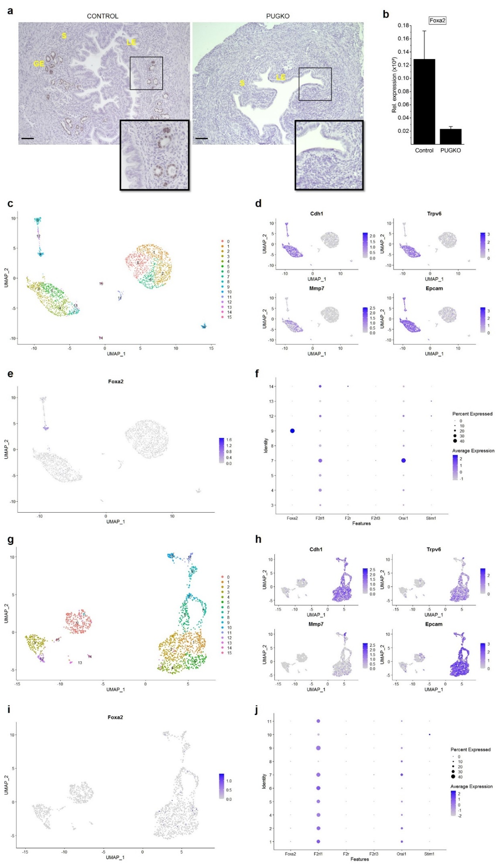
Supplementary Figure 1: Progesterone-induced uterine gland knock-out model
(A) Representative images of FOXA2 staining in uterine sections derived from control or PUGKO animals. The boxes in the lower right corner are magnifications of the indicated areas. Scale bar: 50 µm. LE: luminal epithelium, GE: glandular epithelium, S: stroma. (B) RT-qPCR expression levels for Foxa2 in isolated control or PUGKO epithelial cells. Expression is relatively quantified compared to geometric mean of the housekeeping genes Tbp and Pgk1. Data is shown as mean ± SEM. (C, G) Uniform manifold approximation and projection (UMAP) of the distinct epithelial populations within isolated mEEC from control (C) or PUGKO (G) animals. (D, H) Expression of different epithelial markers, Cdh1 (E-cadherin), Trpv6, Mmp7 and Epcam, in UMAP space in the cell population described under (C) and (G) respectively. (E, I) Evaluation of Foxa2 expression in UMAP space for the cell population described under (C) and (G) respectively. (F, J) Dot plot representing the average expression and expression percentage of several genes in the isolated mEEC from control (F) and PUGKO (J) animals.

Supplementary figure 2
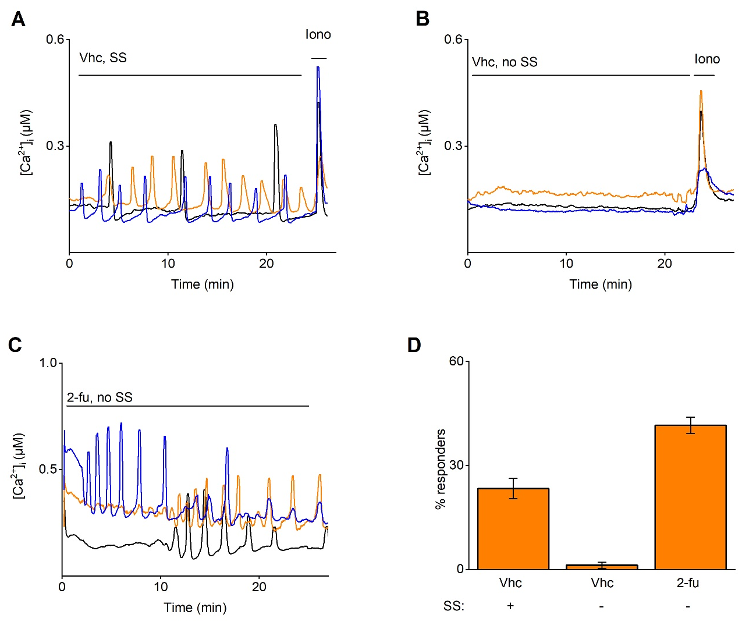
Supplementary Figure 2. Trypsin induced calcium oscillations in endometrial epithelial cells
Ca²⁺ microfluorimetry. (A-B) depict representative traces of mouse EEC subjected to the bath solution without additional compounds (vehicle), in the presence (A) or absence (B) of shear stress. In (C) representative traces are shown of 2-furoyl-LIGRLO-NH₂ stimulation without shear stress. (D) Percentage of oscillating cells (≥ 2 intracellular Ca²⁺ peaks) to stimulation in Ca²⁺ microfluorimetric experiments with vehicle, 2-furoyl-LIGRLO-NH₂ (5 µM) in the presence (+) or absence (-) of shear stress. Responders are shown as mean ± SEM. Three representative traces are shown in each graph. Ionomycin (2 µM) was added as a positive control at the end of each experiment. n = at least independent 3 experiments with a total minimum of 200 cells per condition.
Tryp = trypsin, Iono = ionomycin, 2-fu = 2-furoyl-LIGRLO-NH₂, SS = shear stress, vhc = vehicle.

Supplementary figure 3

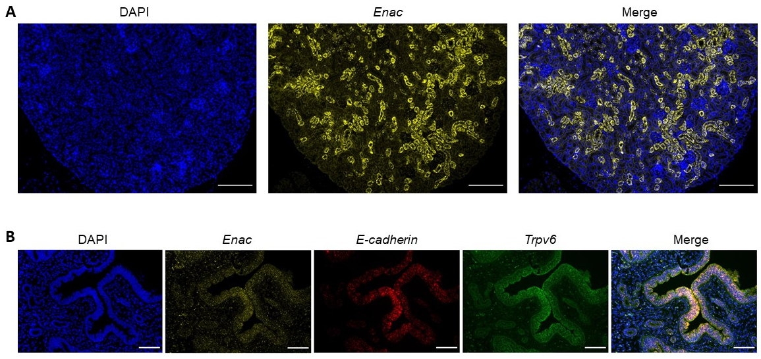
Supplementary Figure 3. Expression of Enac in mEEC
(A) In situ hybridization RNAscope images of kidney tissue sections. Positive signals were detected for the EnaC. Scale bar: 100 µm. (B) In situ hybridization RNAscope images of uterine tissue sections. Modest signals were detected for the epithelial markers E-cadherin and Trpv6. Limited signals could be observed for Enac. Scale bar: 50 µm.

Supplementary figure 4
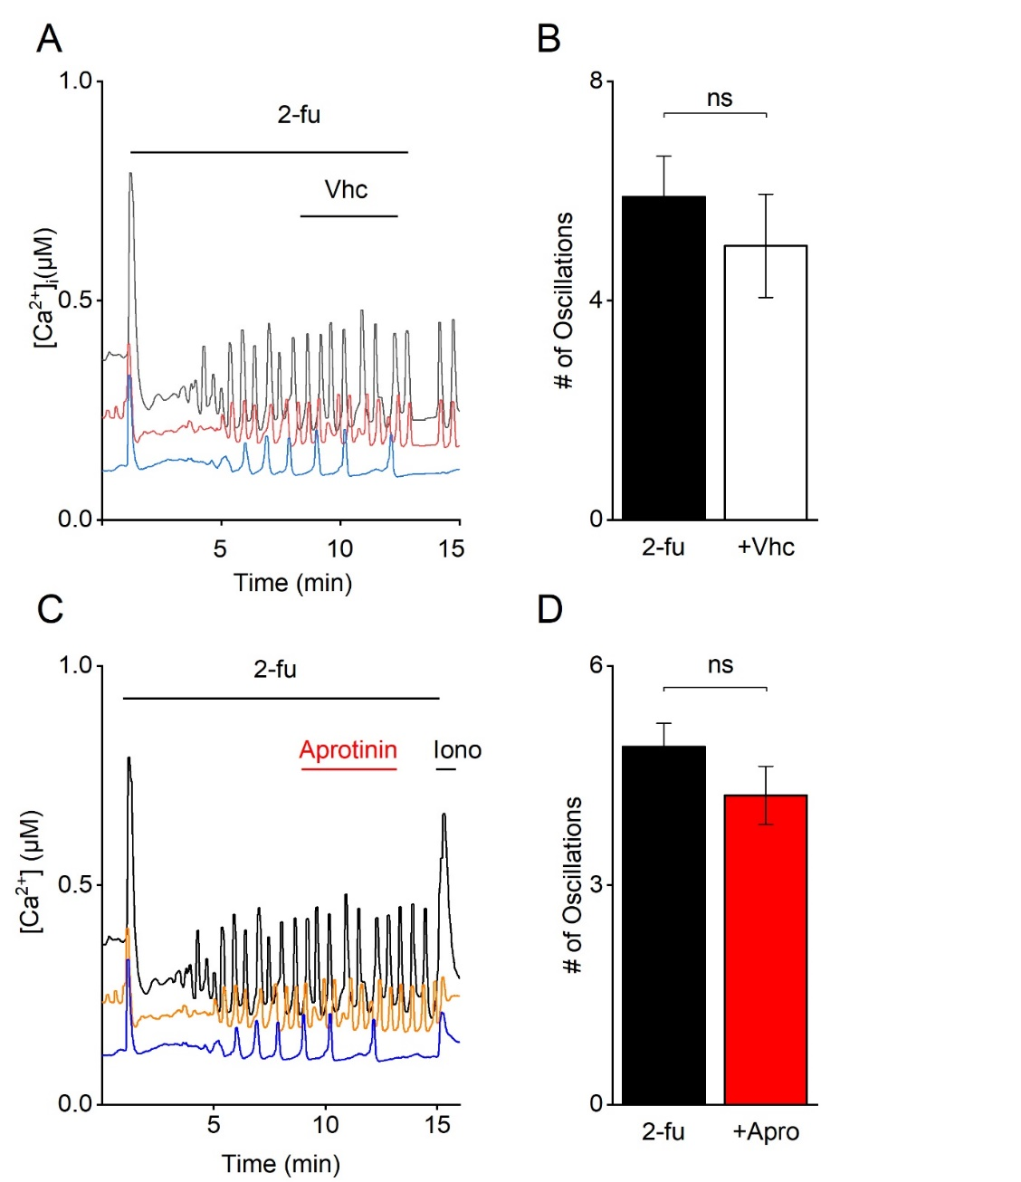
Supplementary Figure 4. Aprotinin has no effect on the 2-fu induced [Ca²⁺]_{I} oscillations
Ca²⁺ microfluorimetry. (A) representative traces of mEEC stimulated with 2-fu (5 µM) in the absence (vhc) of presence (C) of aprotinin (20 µg/ml). (B) en (D) represent the number of oscillating cells (≥ 2 intracellular Ca²⁺ peaks) for the experiments performed under (A) en (C) respectively. Responders are shown as mean ± SEM. Ionomycin (2 µM) was added as a positive control at the end of each experiment. n = at least independent 3 experiments with a total minimum of 200 cells per condition.
Apro = aprotinin, Iono = ionomycin, 2-fu = 2-furoyl-LIGRLO-NH₂, Vehicle (vhc) = bath solution without additional compounds, ns = not significant.

Supplementary figure 5

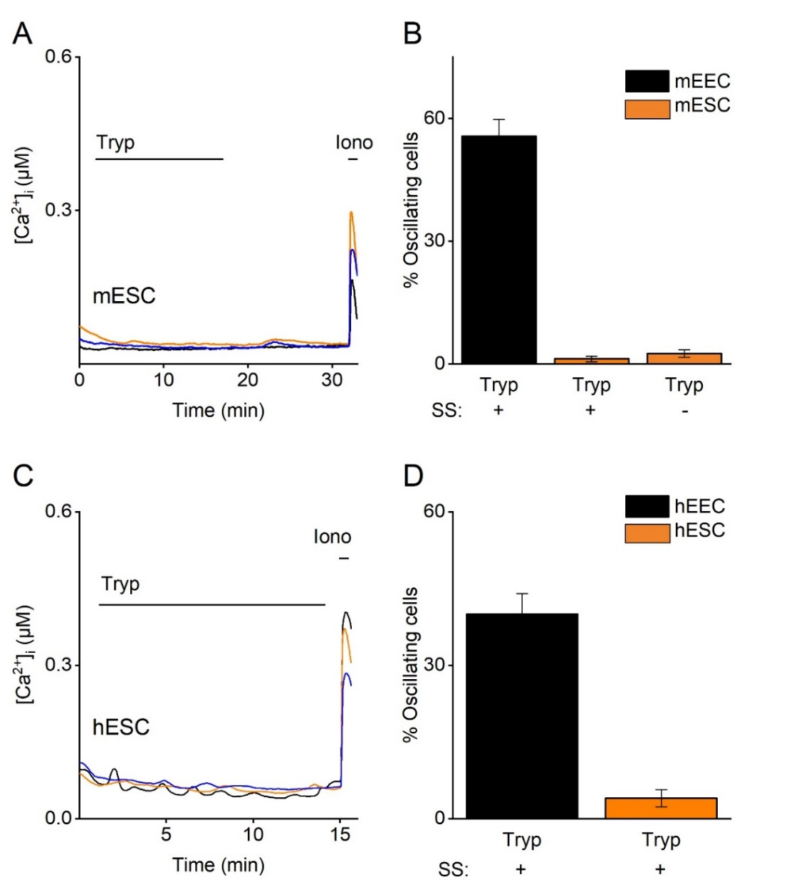
Supplementary Figure 5: Stromal cells do not show [Ca²⁺]_{I} oscillations after stimulation by trypsin.
Ca²⁺ microfluorimetry. (A) Three representative traces of mESC subjected to trypsin. (B) Percentage of oscillating cells (≥ 2 intracellular Ca2+ peaks) of mEEC and mESC to stimulation with trypsin (2 µg/ml) in the presence (+) or absence (-) of shear stress. Responders are shown as mean ± SEM.(C) Three representative traces of hESC subjected to trypsin. (D) Percentage of oscillating cells (≥ 2 intracellular Ca2+ peaks) of hEEC and hESC to stimulation with trypsin (2 µg/ml). Responders are shown as mean ± SEM. Ionomycin (2 µM) was added as a positive control at the end of each experiment. n = at least 3 independent experiments with a total minimum of 200 cells per condition.
Tryp = trypsin, Iono = Ionomycin

Supplementary figure 6
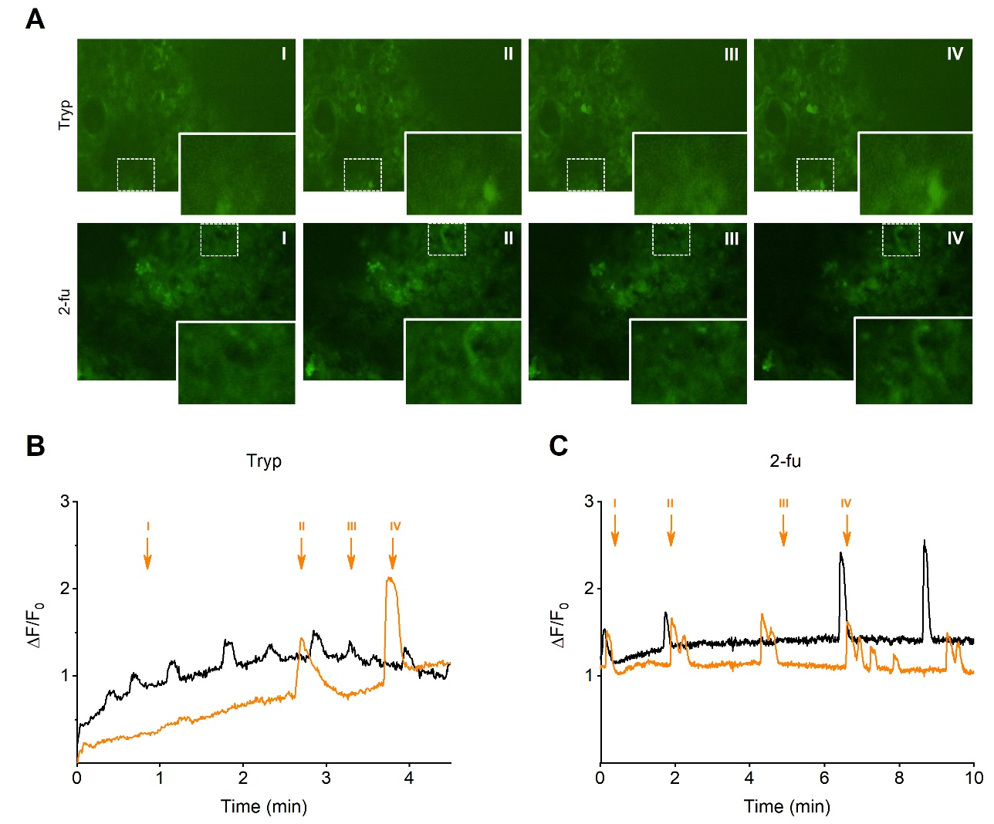
Supplementary Figure 6. Ex vivo Ca²⁺ imaging in excised uterine tissue
(A) Still frame pictures extracted from ex-vivo Ca²⁺ imaging on excised uterine tissues. Stimulation with trypsin (2 µg/ml) (top panels) or 2-furoyl-LIGRLO-NH₂ (5 µM) (bottom panels) is shown. Dotted boxes indicate a specific cell of which the intracellular Ca²⁺ concentration was shown in (B) or (C). The area represented by the dotted box is enlarged in the lower right panels. (B, C) depict two representative intracellular Ca²⁺ traces when stimulated with trypsin or 2-furoyl-LIGRLO-NH₂. The trace in orange corresponds with the frames in (A). Arrows indicate the time points when the frames were extracted. Tryp = trypsin, 2-fu = 2-furoyl-LIGRLO-NH₂

SUPPLEMENTARY MOVIES

Supplementary Movie 1
https://youtu.be/lL7mc-1Fr0k
Supplementary Movie 2
https://youtu.be/pC9-dABf75Y
Supplementary Movie 3
https://youtu.be/DE-dF9u9pG8
Supplementary Movie 4
https://youtu.be/fRaO3LN4fNw

SUPPLEMENTARY TABLE
RNAscope probes
Product | Company | Product number
Human CDH1 | ACDBio | 311091
Human F2RL1 | ACDBio | 319861
Mouse F2rl1 | ACDBio | 417541
Mouse Cdh1 | ACDBio | 408651
Mouse TrpV6 | ACDBio | 539131
RT-qPCR gene expression assays
Product | Company | Assay ID
Mouse F2rl1 | Life Technologies | Mm00433160_m1
Mouse Orai1 | Life Technologies | Mm00774349_m1
Mouse Stim1 | Life Technologies | Mm01158413_m1
Mouse Tbp | Life Technologies | Mm01277042_m1
Mouse Pgk1 | Life Technologies | Mm00435617_m1
Mouse Foxa2 | Life Technologies | Mm01976556_s1
Mouse Scnn1a | Life Technologies | Mm00803386_m1
Mouse Cacna1c | Life Technologies | Mm01188812_m1
Mouse Cacna1d | Life Technologies | Mm01209927_g1
Mouse Cacna1f | Life Technologies | Mm01352612_m1
Human F2RL1 | Life Technologies | Hs00608346_m1
Human ORAI-1 | Life Technologies | Hs03046013_m1
Human STIM1 | Life Technologies | Hs00963373_m1
Human PGK1 | Life Technologies | Hs00943178_g1
Human HPRT1 | Life Technologies | Hs02800695_m1

Supplementary table 1: overview of used RNAscope probes and RT-PCR assays.

