Interfacial Disordering and Heterojunction Enabling Fast Proton Conduction
Muhammad Yousaf^{1, #}, Yuzheng Lu^{2, #}, Enyi Hu¹, Muhammad Akbar³, M.A.K Yousaf Shah¹, Naveed Mushtaq¹, Senlin Yan², Chen Xia^{3,4**}, Bin Zhu^{1,5*}
¹Energy Storage Joint Research Center, School of Energy and Environment, Southeast University, No.2 Si Pai Lou, Nanjing 210096, China
²School of Electronic Engineering, Nanjing Xiaozhuang University, Nanjing 211171, P.R. China
³School of Microelectronics and Faculty of Physics and Electronic Science, Hubei University, Wuhan, Hubei 430062, P. R. China
⁴Hubei Yangtze Memory Laboratories, Wuhan 430205, China
⁵State Key Laboratory of Multiphase Flow in Power Engineering, School of Energy and Power Engineering, Xi’an Jiaotong University, Xian 710049, China

*Correspondence: zhu-bin@seu.edu.cn; chenxia@hubu.edu.cn

#Muhammad Yousaf and Yuzheng Lu contributed equally to this work.

Figures

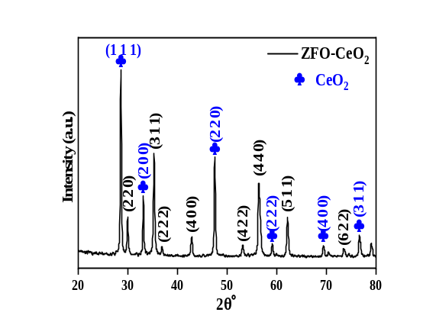

Fig. S1: XRD pattern of ZFO-CeO₂ sample.

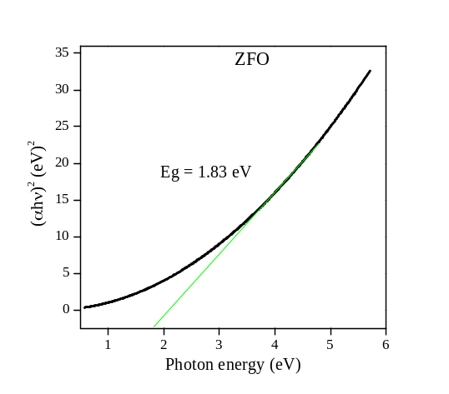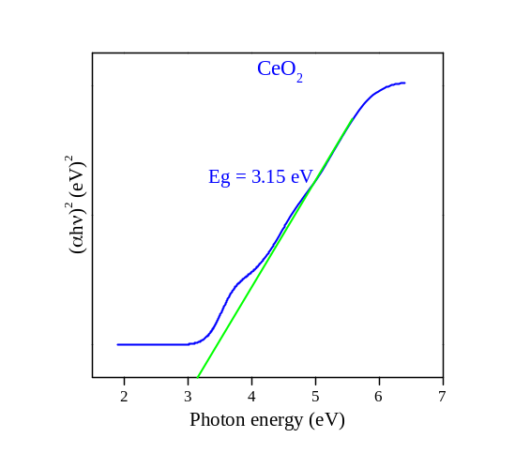

Fig. S2: Tuac’s plots of UV-Vis absorption spectra of pure ZFO and CeO₂ samples.

Before OG After OG

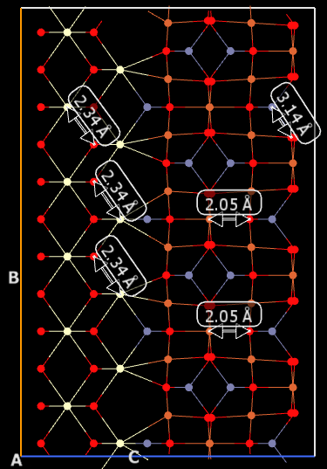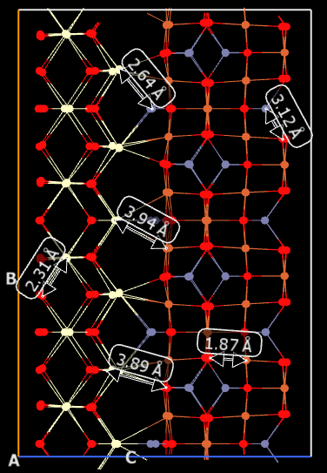

Fig. S3: Lattice disorder and different site radii in ZFO-CeO₂ sample interface before and after optimization geometry (OG)

Fig. S4: (a)ZnFe₂O₄ (ZFO) crystal structure with their basic information i.e., space group, space group number, (b) CeO₂ crystal structure information, i.e., space group, space group number, (c) ZFO-CeO₂ interfacial structural disorder transformed to another phase.

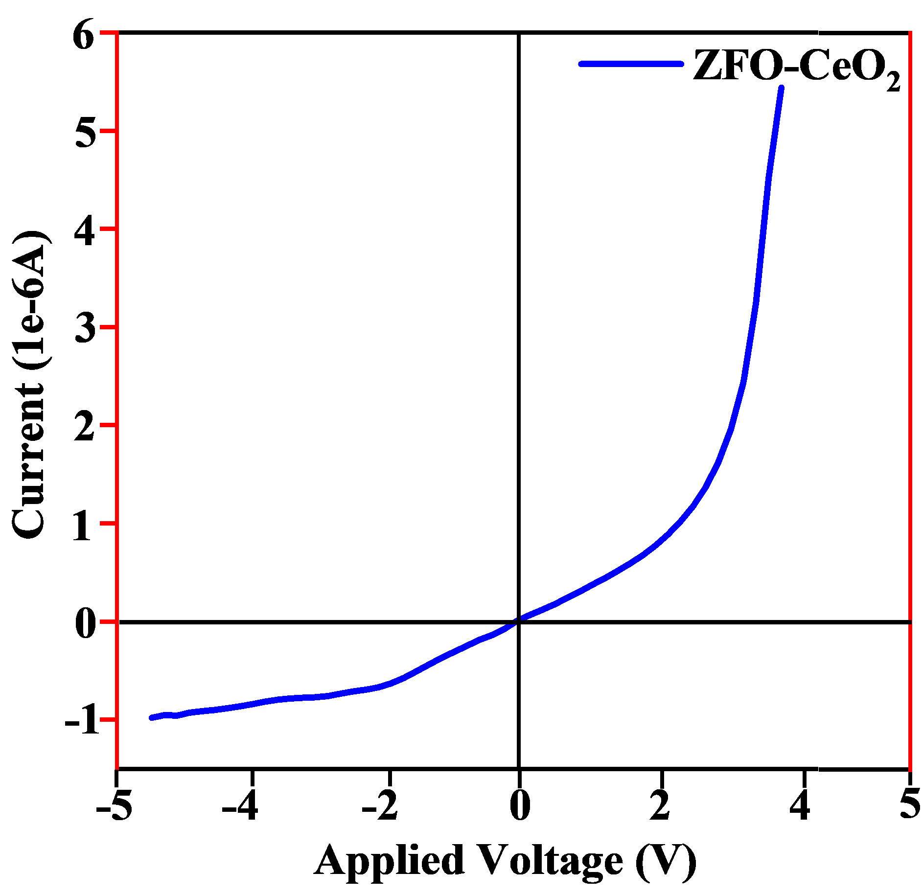

Fig. S5: Ag/ZFO/CeO₂/Ag layered structure under N₂ gas atmosphere at 550 °C

To further distinguish chemical states and heterostructure components, Ce 3d and O 1s core level spectra of both prepared samples are deconvoluted Gaussian functions and Shirley background. Moreover, the deconvolution of Ce⁴⁺ to Ce³⁺ ions at the heterostructure surface was detected and presented in supplementary Fig. S6. The Ce³⁺ existence can be attributed due to the mutual diffusion of Fe and Ce at the ZFO/CeO₂ interface.

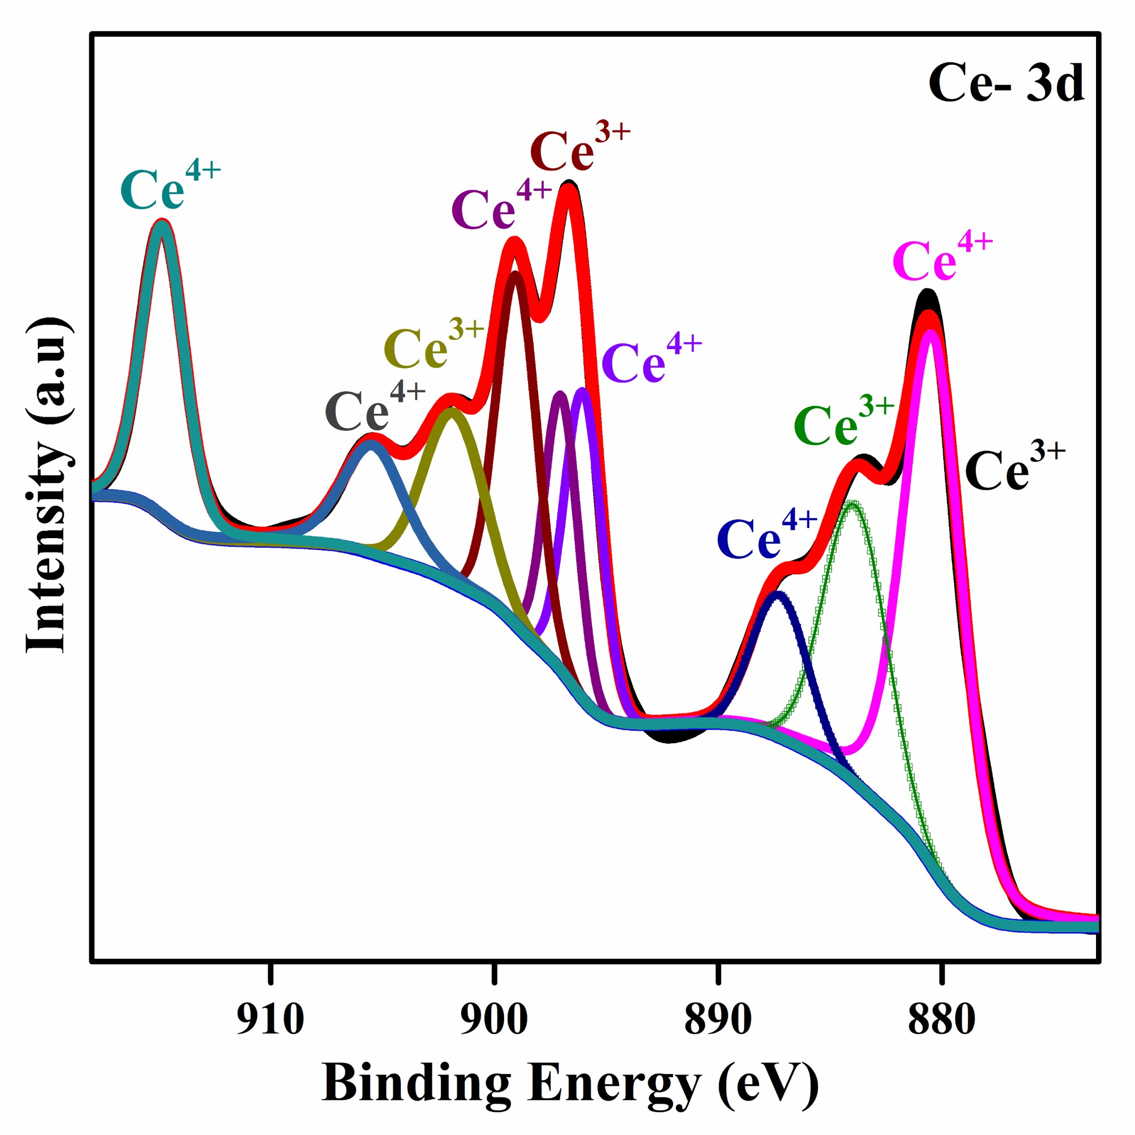

Fig. S6: XPS core level spectra of Ce 3d from ZFO-CeO₂ sample.

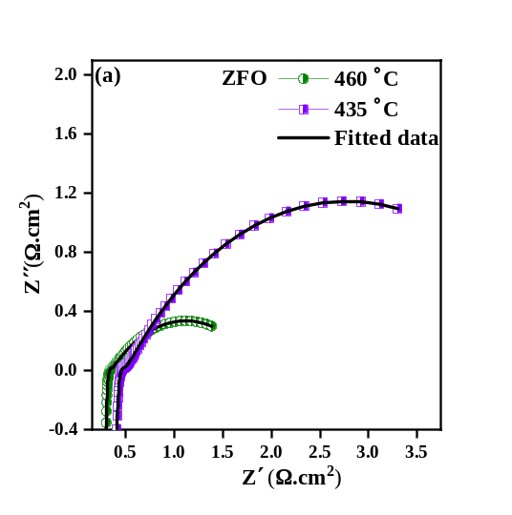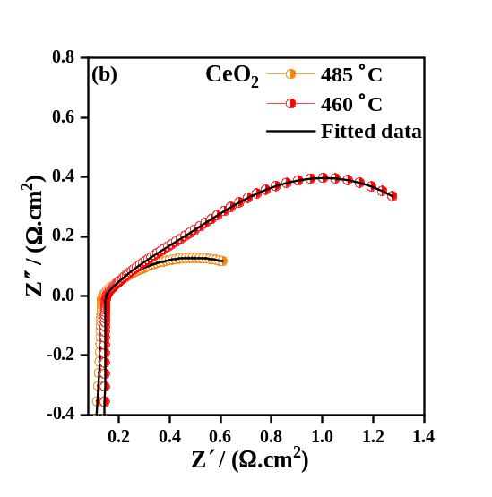
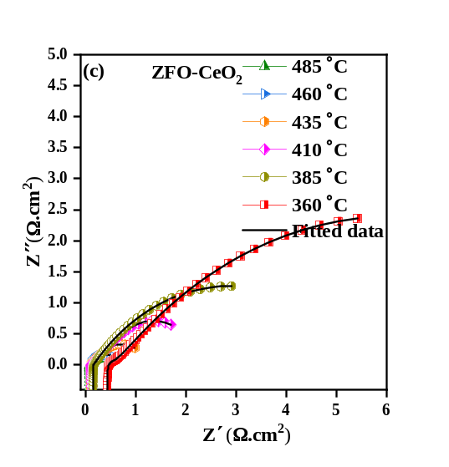

Fig S7: (a, b and c) EIS measurements of ZFO, CeO₂ and ZFO-CeO₂ at different operational temperature (485 °C to 360 °C) under H₂ and air.

Supplementary Table S1: EIS fitting parameters of ZFO-CeO₂ sample using ZSIMPWIN software, where R represents to the resistance and Q is constant phase elements (CPE). The R and Q have the units of Ω.cm² and F cm⁻², respectively.

Temperature (℃) | $$R_{o}$$ | $$R_{1}$$ | $$Q_{ct}$$ | $$N_{1}$$ | $$C_{1}$$ | $$R_{mt}$$ | $$Q_{mt}$$ | $$N_{2}$$ | $$C_{2}$$ | $$R_{P}$$
510 | 0.071 | 0.06 | 0.28 | 0.39 | 4.6E-04 | 0.19 | 0.17 | 0.796 | 0.070532 | 0.25
485 | 0.076 | 0.09 | 0.128 | 0.51 | 1.75E-3 | 0.27 | 0.35 | 0.64 | 0.092843 | 0.36
460 | 0.082 | 0.12 | 0.08 | 0.669 | 8.03E-2 | 0.36 | 0.343 | 0.7 | 0.139952 | 0.48
435 | 0.091 | 0.16 | 0.912 | 0.8 | 5.64E-01 | 0.74 | 0.54 | 0.8 | 0.429339 | 0.9
410 | 0.11 | 0.24 | 1.035 | 0.88 | 8.55E-01 | 1.37 | 0.63 | 0.98 | 0.628 | 1.61
385 | 0.16 | 0.39 | 2.4 | 0.55 | 2.273 | 2.54 | 0.8 | 0.88 | 0.881 | 2.93
360 | 0.44 | 1.2 | 2.3 | 0.56 | 5.106 | 3.86 | 1.2 | 1 | 1.20 | 5.06

Supplementary Table S2: EIS fitting parameters of ZFO sample using ZSIMPWIN software, where R represents to the resistance and Q is constant phase elements (CPE). The R and Q have the units of Ω.cm² and F cm⁻², respectively.

Temperature (℃) | $$R_{o}$$ | $$R_{1}$$ | $$Q_{ct}$$ | $$N_{1}$$ | $$C_{1}$$ | $$R_{mt}$$ | $$Q_{mt}$$ | $$N_{2}$$ | $$C_{2}$$ | $$R_{P}$$
510 | 0.25 | 0.06 | 0.21 | 0.28 | 2.73E-06 | 0.53 | 0.404 | 0.532 | 0.104126 | 0.53
485 | 0.32 | 0.1 | 0.270 | 0.26 | 9.26E-06 | 1.06 | 0.71 | 0.9 | 0.687928 | 1.06
460 | 0.45 | 0.38 | 0.002 | 0.8 | 3.32E-4 | 2.47 | 0.920 | 0.77 | 1.1802 | 2.85

Supplementary Table S3: EIS fitting parameters of CeO₂ sample using ZSIMPWIN software, where R represents to the resistance and Q is constant phase elements (CPE). The R and Q have the units of Ω.cm² and F cm⁻², respectively.

Temperature (℃) | $$R_{o}$$ | $$R_{1}$$ | $$Q_{ct}$$ | $$N_{1}$$ | $$C_{1}$$ | $$R_{mt}$$ | $$Q_{mt}$$ | $$N_{2}$$ | $$C_{2}$$ | $$R_{P}$$
510 | 0.13 | 0.07 | 0.086 | 1 | 0.086 | 0.419 | 0.88 | 0.42 | 0.221 | 0.489
485 | 0.14 | 0.19 | 0.40 | 0.8 | 0.210 | 0.99 | 0.41 | 0.62 | 0.235 | 1.18
460 | 0.17 | 0.26 | 0.31 | 0.8 | 0.165 | 1.13 | 0.62 | 0.44 | 0.394 | 1.39

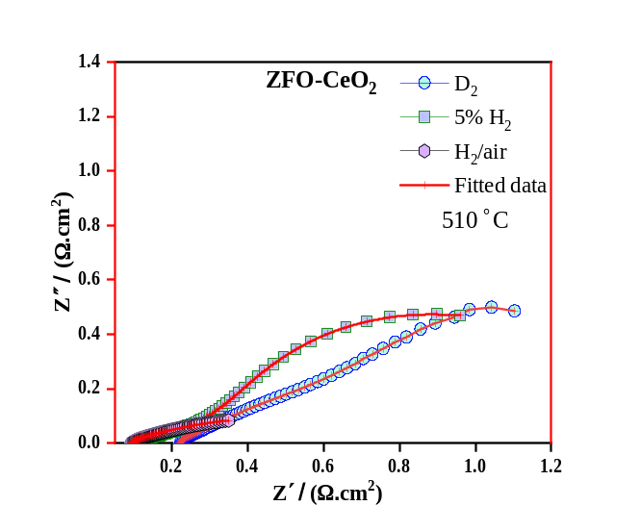

Fig. S8: Electrochemical impedance spectra ZFO-CeO₂ electrolyte measured in H₂ (5%), D₂, pure H₂(95%) and H₂/air atmosphere at 510 °C.

Fig. S9: I-V and I-P curves of pure ZFO fabricated fuel cell device.

Fig. S10: I-V and I-P curves of pure CeO₂ fabricated fuel cell device.

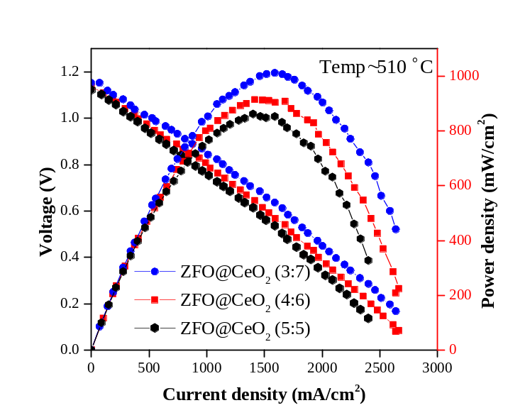

Fig. S11: I-V and I-P curves of ZFO-CeO₂ with different mass ratios of 3:7, 4:6 and 5:5 constructed electrolytes.

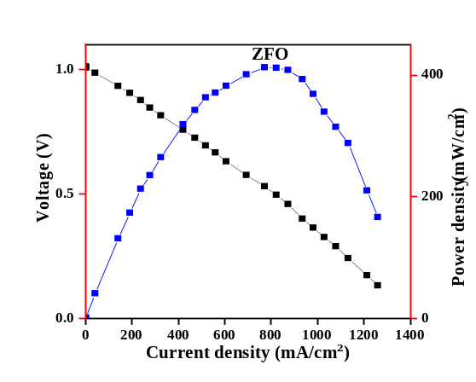

Fig. S12: I-V and I-P curves of Ni-NCAL/BZY/ZFO/BZY/Ni-NCAL device at 510 °C.

