Supplementary Materials
Chiral Dirac fermion in a collinear antiferromagnet
Ao Zhang^{1†}, Ke Deng^{1†}, Jieming Sheng^{1,2†}, Pengfei Liu^{1†}, Shiv Kumar³, Kenya Shimada³, Zhicheng Jiang⁴, Zhengtai Liu⁴, Dawei Shen⁴, Jiayu Li¹, Jun Ren¹, Le Wang¹, Liang Zhou¹, Yoshihisa Ishikawa⁵, Qiang Zhang⁶, Garry McIntyre⁷, Dehong Yu⁷, Enke Liu⁸, Liusuo Wu^{1*}, Chaoyu Chen^{1*} and Qihang Liu^{1*}
¹Shenzhen Institute for Quantum Science and Technology and Department of Physics, Southern University of Science and Technology, Shenzhen, 518055, China
²Academy for Advanced Interdisciplinary Studies, Southern University of Science and Technology, Shenzhen, 518055, China
³Hiroshima Synchrotron Radiation Centre, Hiroshima University, Higashi-Hiroshima, Hiroshima 739-0046, Japan.
⁴State Key Laboratory of Functional Materials for Informatics and Center for Excellence in Superconducting Electronics, Shanghai Institute of Microsystem and Information Technology, Chinese Academy of Sciences, Shanghai 200050, China.
⁵Neutron Science and Technology Center, Comprehensive Research Organization for Science and Society, Tokai, Ibaraki 319-1106, Japan
⁶Neutron Science Division, Oak Ridge National Laboratory, Oak Ridge, Tennessee 37831, USA
⁷Australian Nuclear Science and Technology Organisation, Locked bag 2001, Kirrawee DC, New South Wales 2232, Australia
⁸State Key Laboratory for Magnetism, Institute of Physics, Chinese Academy of Sciences, Beijing 100190, China
†These authors contributed equally to this work.
*Correspondence should be addressed to L.W. (wuls@sustech.edu.cn), C.C. (chency@sustech.edu.cn) and Q.L. (liuqh@sustech.edu.cn)

Contents
S1. Dirac-like field with chirality 3
S2. Single crystal X-ray diffraction refinement 6
S3. Magnetic structure analysis 7
S4. Magnetization measurements 10
S5. Symmetry analysis of CoNb₃S₆ 11
S5.1. Doubly degenerate bands of CoNb₃S₆ 11
S5.2. Chern number and robust Fermi-arc surface states 13
S5.3. The electronic structure and fermi surface of nonmagnetic CoNb₃S₆ 14
S6. Momentum distribution curves of $β$at E_{F} 14
S7. ARPES spectra taken with different polarization light 15
S8. Anomalous hall conductivity tensors of bulk and slab CoNb₃S₆ 15
S9. Electric transport measurements 17
Supplementary references 19

S1. Dirac-like field with chirality
First, we briefly review the Dirac field. Its field operators furnish a 4D irreducible representation of the Lorentz group. After that, we considered the symmetry condition supporting the flavor Weyl field. The Lorentz group is the group of Minkowski space-time symmetries obeying the principle of relativity. Such a group can be written as a combination of two disconnected pieces—$O\left(3,1\right)=SO\left(3,1\right)+P SO\left(3,1\right)$, where $SO\left(3,1\right)$ is a connected subgroup of $O\left(3,1\right)$. Any irreps of $SO\left(3,1\right)$ can be labeled by the irreps of two su(2) algebras, denoted as $\left(j^{+},j^{-}\right)$, with $j^{±}=0, 1/2, 1, 3/2,…$, because the Lie algebra of $SO\left(3,1\right)$ consists of six generators forming two individual su(2) algebras commuting with each other. Weyl fields—the simplest fields for spin-½ fermions—furnish the irrep $(0,1/2)$ or $(1/2,0)$ for right or left-handedness, satisfying two-component massless Weyl equations when P is broken. The reducible representation of $SO\left(3,1\right)$, i.e., $(0,1/2)⨁(1/2,0)$, in the presence of P, becomes irreducible for the Lorentz group $O(3,1)$, giving rise to the Dirac fields.
The Dirac fields obey the famous Dirac equation, $(-iα^{i}∂_{i}+mβ)ψ(x)=i∂_{0}ψ(x)$, where $α^{i}=τ_{x}⨂σ_{i}$ and $β=τ_{z}⨂σ_{0}$. It explains several new phases and phenomena such as antimatter, SOC, and Zeeman effect. However, seldom considered is the possibility of elementary spin-1/2 particles described by four-component fields having $\left(1/2,0\right)⨁{\left(1/2,0\right)}$ (or equivalently, $\left(0,1/2\right)⨁{\left(0,1/2\right)}$). To achieve such fields, P should be broken, reducing the corresponding symmetry group to $SO\left(3,1\right)$. Therefore, $\left(1/2,0\right)⨁{\left(1/2,0\right)}$ would become a reducible representation, corresponding to a field that naturally decomposes into two Weyl fields. Second, additional internal symmetries need to be assumed to elevate the symmetry hierarchy of the system, rendering $\left(1/2,0\right)⨁{\left(1/2,0\right)}$ representation irreducible. Internal symmetry operations are required to decouple the space-time operations according to the Coleman–Mandula theorem¹. Furthermore, we selected them to form an $SU(2)$ group connecting two Weyl fields with the same chirality, analogous to the $SU(2)$ flavor symmetry in high-energy physics. Specifically, it is analogous to the isospin symmetry proposed by Heisenberg, pairing a proton and a neutron forming an $SU\left(2\right)$ doublet².
Such isospin symmetry can stabilize free and causal quantum fields that follow the representation $\left(1/2,0\right)⨁{\left(1/2,0\right)}$ (and $\left(0,1/2\right)⨁{\left(0,1/2\right)}$). The corresponding fields are called flavor Weyl fields, described by the following massless Dirac-like equation:
$iα^{i}∂_{i}ψ(x)=±i∂_{0}ψ(x)$, (1)
where $ψ(x)$ denotes a four-component free field operator and $α^{i}=τ_{i}⨂σ_{0}$. Furthermore, the energy spectrum of equation (1) is doubly degenerate owing to the protection of the additional $SU\left(2\right)$ group, resembling the role of P in the Dirac equation.
To construct such flavor Weyl field, we firstly assume that inversion symmetry is broken such that left-handed Weyl field and right-handed Weyl field could exist individually. Then, we further assume a four component Dirac field can be written as the form $ψ=\left(\begin{matrix}ψ_{L}^{1} \\ ψ_{L}^{2}\end{matrix}\right)$ where $ψ_{L}^{1}$ and $ψ_{L}^{2}$ are two left-handed and 2-component Weyl fields following the irreducible representation $(1/2,0)$ of the proper orthochronous Lorentz transformation. Then the representation matrices of the angular momentum operators and boost operators of proper orthochronous Lorentz transformation are $J=\frac{1}{2}τ_{0}⊗σ, K=-\frac{i}{2}τ_{0}⊗σ$, where $τ_{i}$ and $σ_{j}$ (i=0,x,y,z) are Pauli matrices.
Such field is reducible under proper orthochronous Lorentz transformation, to stabilize this field, we further assumes that there is an internal $SU(2)$ symmetry group with generators represented as $I=\frac{1}{2}τ⊗σ_{0}$, which implies that the elements of $SU(2)$ group transform on $ψ=\left(\begin{matrix}ψ_{L}^{1} \\ ψ_{L}^{2}\end{matrix}\right)$ by $exp(-iθ⋅\frac{1}{2}τ)\left(\begin{matrix}ψ_{L}^{1} \\ ψ_{L}^{2}\end{matrix}\right)$, identical to the transformation properties of $SU(2)$ isospin symmetry on two quantum fields in standard model. Then, it is obvious that such field describe one particle formed by two Weyl fields connected by the internal $SU(2)$ symmetry group.
From quantum field theory, the field operator can be written as the following form
$ψ_{l}\left(x\right)=κψ_{l}^{+}\left(x\right)+μψ_{l}^{c-}\left(x\right)$, (2)
$ψ_{l}^{+}\left(x\right)=\sum_{s_{1}, s_{2}}{∫}\frac{d^{3}p}{{(2π)}^{3/2}} u_{l}\left(p, s_{1}, s_{2}\right) a\left(p, s_{1}, s_{2}\right) e^{ipx}$, (3)
$ψ_{l}^{c-}\left(x\right)=\sum_{s_{1}, s_{2}}{∫\frac{d^{3}p}{{(2π)}^{3/2}} v_{l}\left(p, s_{1}, s_{2}\right) a^{c†}\left(p, s_{1}, s_{2}\right)e^{-ipx}}$, (4)
where $l$ labels the 4 components of the field operator, $a\left(p, s_{1}, s_{2}\right)$ and $a^{c†}\left(p, s_{1}, s_{2}\right)$ are the annihilation operator of a spin-1/2 particle and creation operator of the antiparticle, with eigenvalue of momentum operator to be $p$ , helicity $s_{1}$ ($s_{1}=±1/2$) and eigenvalue of third component of the internal $SU\left(2\right)$ symmetry $I_{z}$ to be $s_{2}$ ($s_{2}=±1/2$). $u_{l}\left(p, s_{1}, s_{2}\right)$ and $v_{l}\left(p, s_{1}, s_{2}\right)$ are components of $4×1$ column vectors, that are complex functions of $p, s_{1}$ and $s_{2}$.
Then, by assuming the operation of internal $SU\left(2\right)$ symmetry group on $a\left(p, s_{1}, s_{2}\right)$ to be $\sum_{\overline{s_{2}}}{{exp(-iθ⋅\frac{1}{2}σ)}_{s_{2} \overline{s_{2}}}a\left(p, s_{1}, \overline{s_{2}}\right)}$ and follow the process of constructing field operator provided in Ref. ³, we can see that $ψ$ can be constructed for describing massless spin-1/2 particles following the causal relation ${\left[ψ_{l}\left(x\right),ψ_{\overline{l}}^{†}\left(y\right)\right]}_{∓}=0$for $x-y$space like. It could also be shown that this field obeys the following equation
$\left(-∂_{0}+α^{i}∂_{i}\right)ψ\left(x\right)=0$, (5)
where $α^{i}=σ_{0}⨂σ_{i}$. This 4-component field have 4 independent variables, however, when we do not assume internal $SU\left(2\right)$ symmetry group, the field operator will reduce to operators with two independent variables, which is actually the Weyl field. Thus, this $SU\left(2\right)$ symmetry group helps to stabilize the flavor Weyl field.

S2. Single crystal X-ray diffraction refinement
Single crystals of CoNb₃S₆ were grown using chemical vapor transport method. The crystal structure of CoNb₃S₆ was characterized using a Bruker D8 Quest diffractometer with Mo-K𝛼 radiation (𝜆 = 0.71069 Å). The data integration and reduction were performed with the commercial Bruker APEX2 software suite. The refined lattice parameters and the atomic occupations are presented in Tables S1 and S2. It is worthy to note that the ratio of the refined atomic occupations for Co:Nb:S is about to 0.995:2.975:6, nearly equal to the nominal stoichiometric composition 1:3:6, indicating the single crystal is high quality.
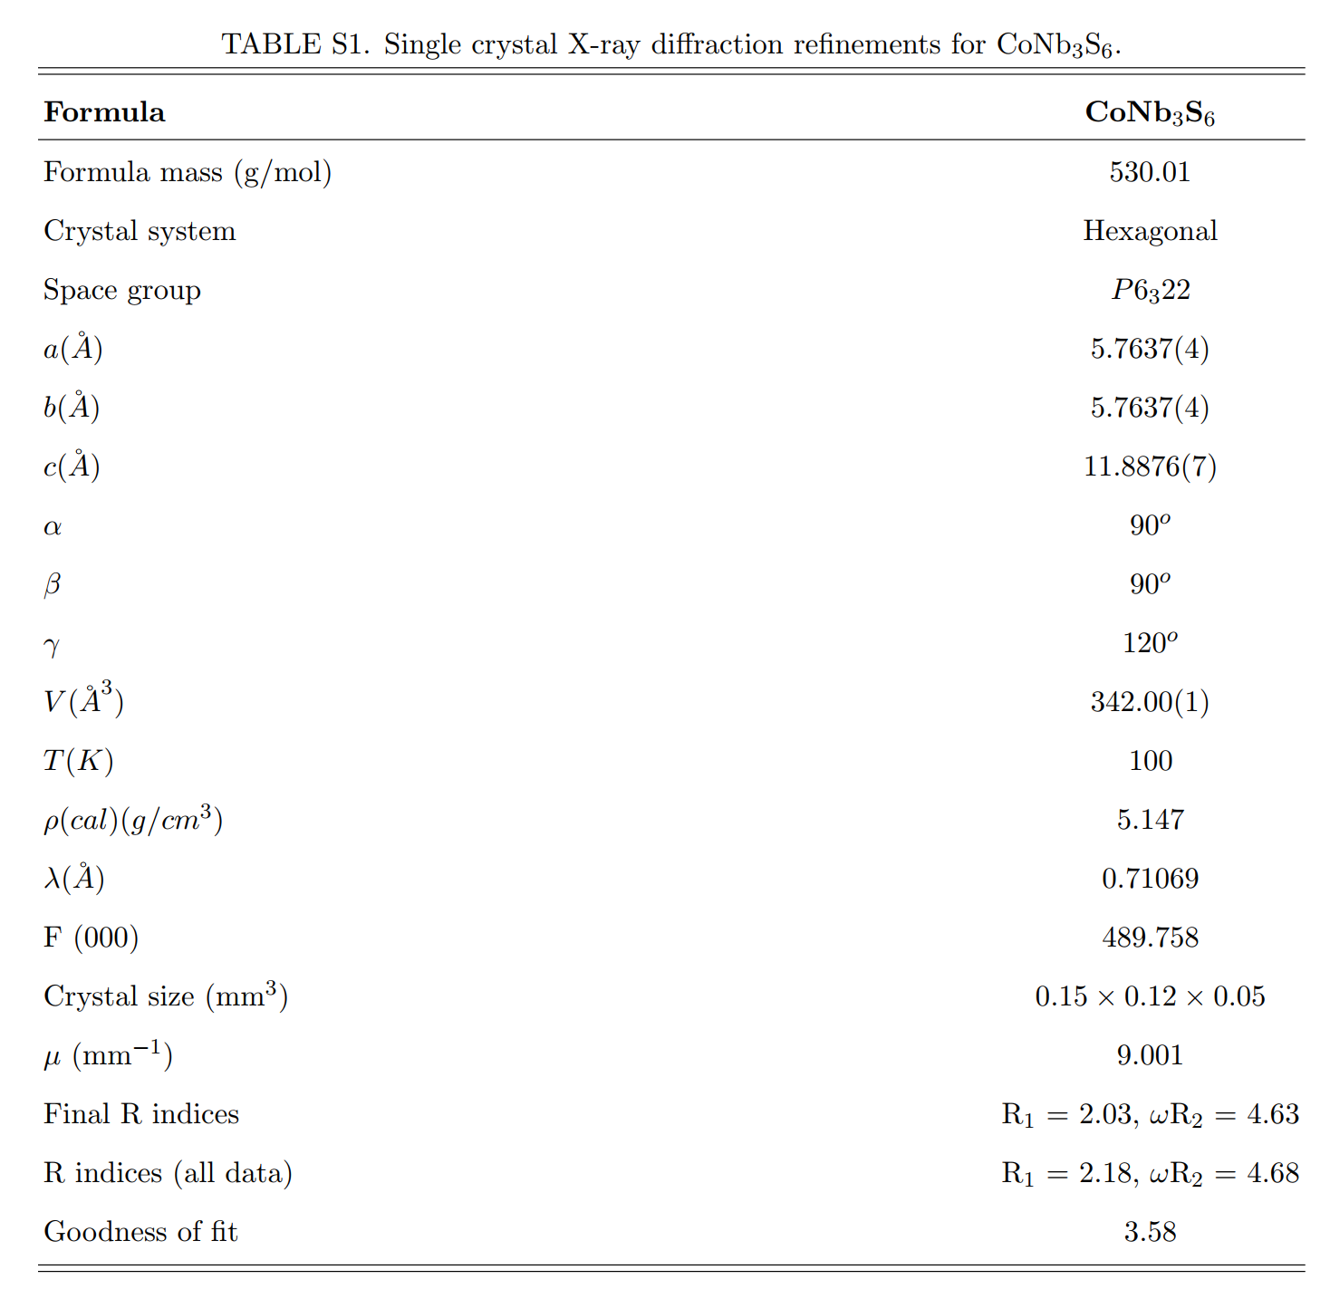

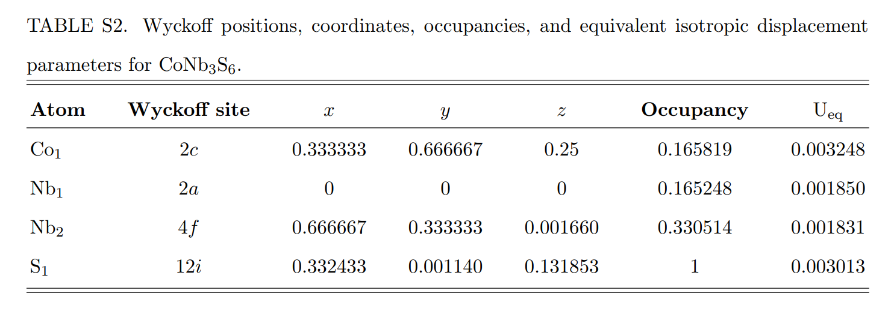

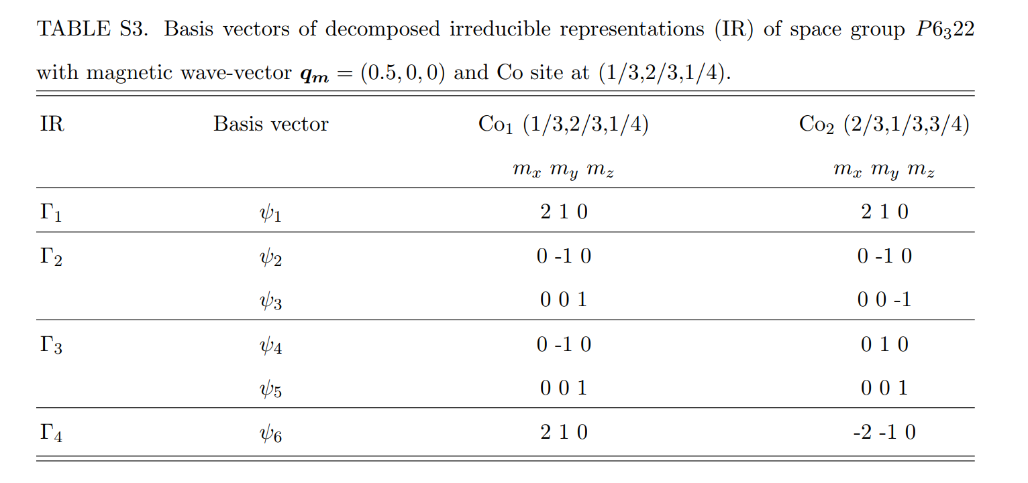

S3. Magnetic structure analysis
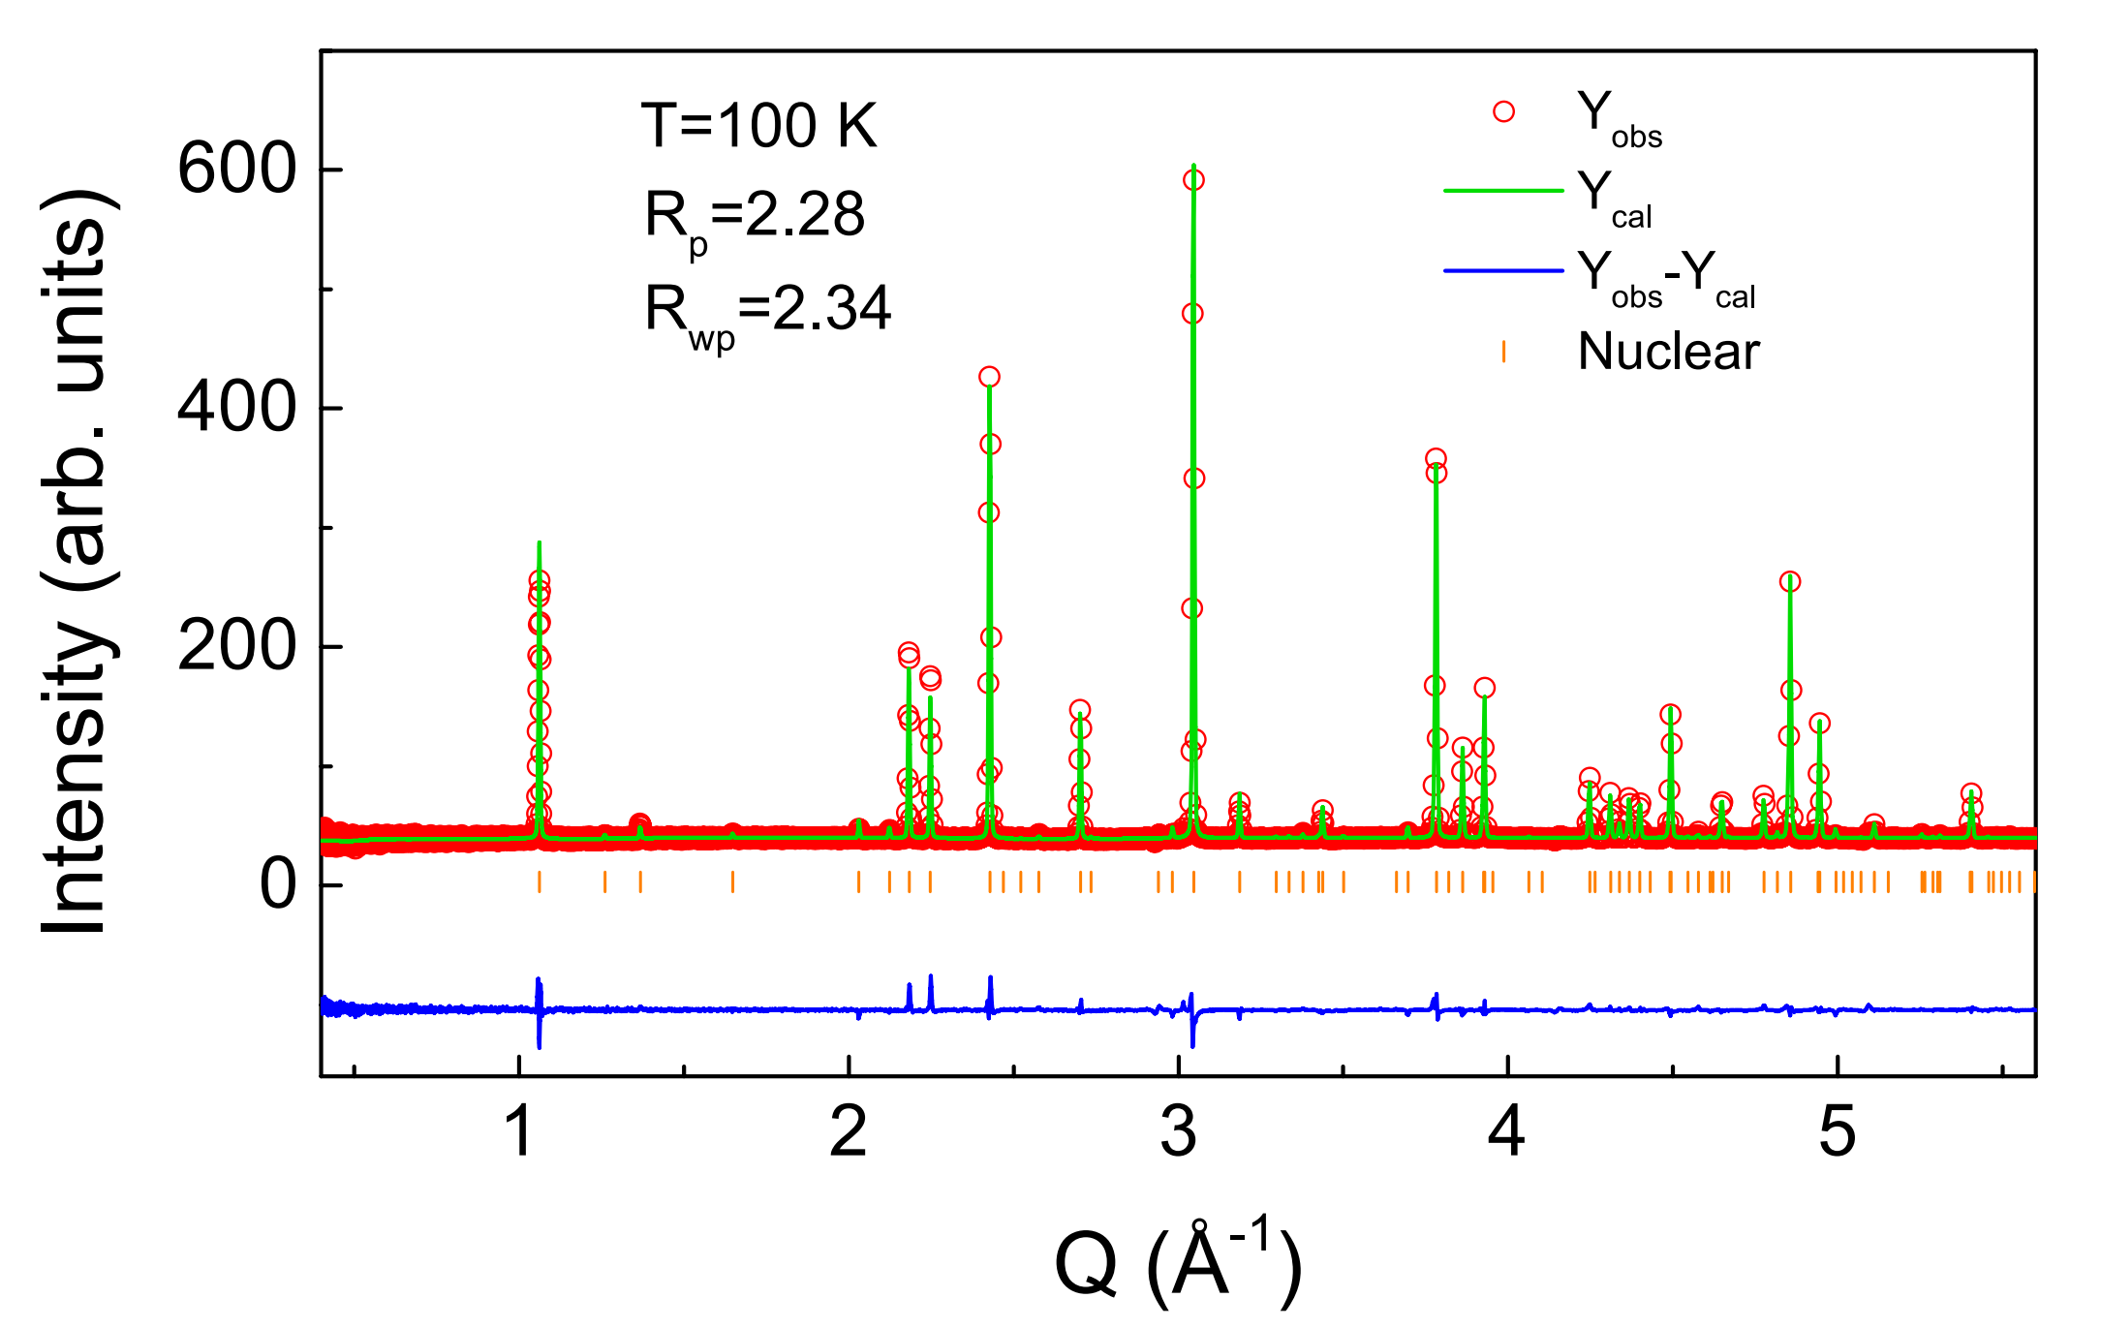
Fig. S1. Powder neutron diffraction pattern of CoNb₃S₆ with Rietveld refinement fit at 100 K.

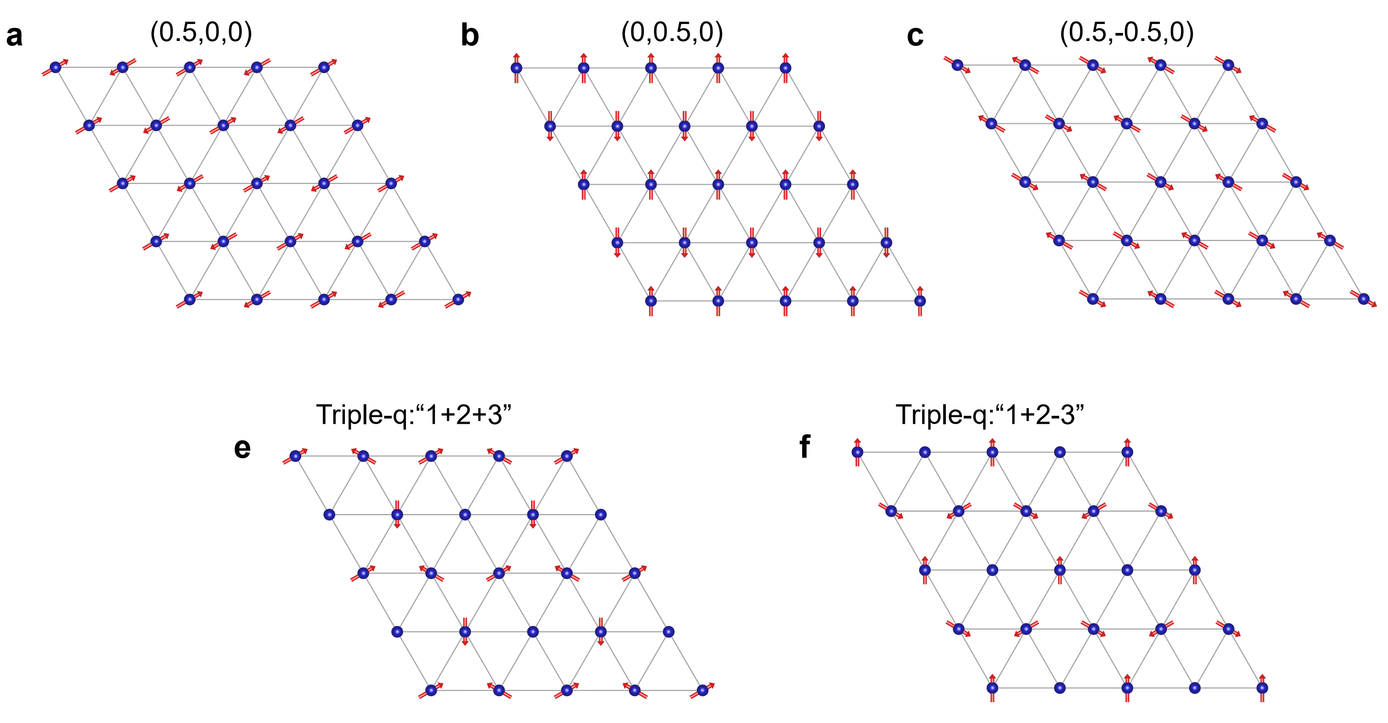
Fig. S2. The in-plane spin configurations for three equivalent magnetic propagation vectors a, q_{m1}= (0.5,0,0), b, q_{m2}= (0,0.5,0) and c, q_{m3}= (0.5,-0.5,0). e and f are the schematics of the triple-q magnetic order with a vector sum of three magnetic domains “1+2+3” and “1+2-3”, respectively. The bule circles have no moments. A total of four domains could be expected for the triple-q magnetic order with different combination of the“1,2,3” three magnetic structures.
By our single crystal neutron diffraction measurements, three magnetic domains with different magnetic propagation vectors (0.5, 0, 0), (0, 0.5, 0) and (0.5, -0.5, 0) were identified. However, due to the limited magnetic reflections of the single crystal neutron diffraction experiment, an additional powder neutron diffraction experiment was performed to determine the magnetic structure of CoNb₃S₆. Fig. S1 and Fig. 1(c) of the main text present the powder neutron diffraction patterns measured at 100 K and 10 K, respectively. Consistent with our single crystal X-ray diffraction results, the Rietveld refinement of the neutron diffraction data at 100 K confirms the Hexagonal structure of CoNb₃S₆ with space group P6₃22. For T = 10 K, a new set of reflections emerge around the low-Q region of the diffraction pattern, and can be indexed by (0.5, 0, 0), (0, 0.5, 0) or (0.5, -0.5, 0) magnetic propagation vectors, indicating the magnetic origin. Here, we chose q_{m} = (0.5, 0, 0) as the magnetic propagation vector. The magnetic structure of CoNb₃S₆ was analyzed by representation theory. For space group P6₃22 (No.182) with Co site at (1/3, 2/3, 1/4), the spin configuration can be described by four different irreducible representations (IRs). Table S3 lists the basis vectors for IRs Γ₁, Γ₂, Γ₃ and Γ₄, respectively. For Γ₁ and Γ₄, the moments are constrained in the ab plane. The spin arrangement between Co₁ and Co₂ is ferromagnetic for Γ₁ and antiferromagnetic for Γ₄. For Γ₂ and Γ_{3,} the moments are allowed to lie in the bc plane. The spin components align ferromagnetically along the b axis and antiferromagnetically along the c axis between Co₁ and Co₂ for Γ₂, while Γ₃ shows the opposite arrangement. By Rietveld refinement, we found that Γ₄ could give the best fit with R_{p} = 2.88 and R_{wp} = 3.68 for powder neutron diffraction data at 10 K, as shown in Fig. 1(c) of the main text.
Due to the in-plane C₃ symmetry, besides the possibility of three equivalent magnetic domains, the compound could also have a triple-q magnetic order. However, diffraction from three magnetic domains with equal populations would in principle be indistinguishable from a triple-q magnetic order. As shown in Fig.S2 a-c are the schematics of the magnetic structures for three different magnetic domains. A triple-q magnetic order can be understood as a vector sum of the above three magnetic domains (Fig.S2 e and f).

S4. Magnetization measurements
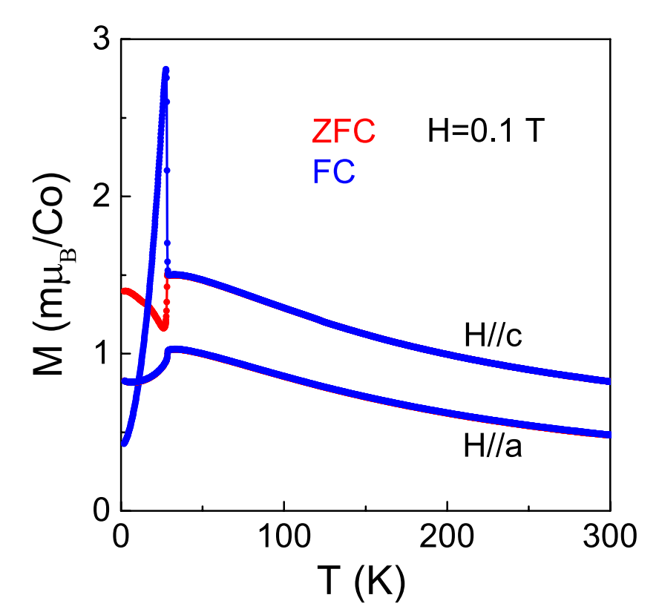
Fig. S3. Temperature dependence of the magnetization measured at H=0.1 T with field along the a and c axis. The bule and red lines represent the field cooled (FC) and zero field cooled (ZFC) measurements, respectively.
Fig. S3 shows the temperature evolution of the magnetization M(T) measured at H=0.1 T with field along the a and c axis. For H//a, the zero-field cooled (ZFC) and field cooled (FC) measurements show identical behaviors. Both the M(T) curves exhibit a broad peak around T=30 K and a sharp decrease at T=28.3 K, suggesting antiferromagnetic (AFM) phase transition in CoNb₃S₆. For H//c, M(T) curves show an irreversible behavior between the FC and ZFC measurements below T_{N}. The ZFC magnetization initially increases on cooling and reaches the maximum at 28.5 K, followed by an abruptly decrease around T_{N}=28.3 K. Further lowering the temperature, it shows an additional upturn feature below 26.1 K. As a comparison, the FC magnetization shows an abruptly increase around T_{N,} reaches a maximum at 27.6 K and decreases on further cooling. These irreversible behaviors observed in M(T) indicate the presence of ferromagnetic component along the c axis.
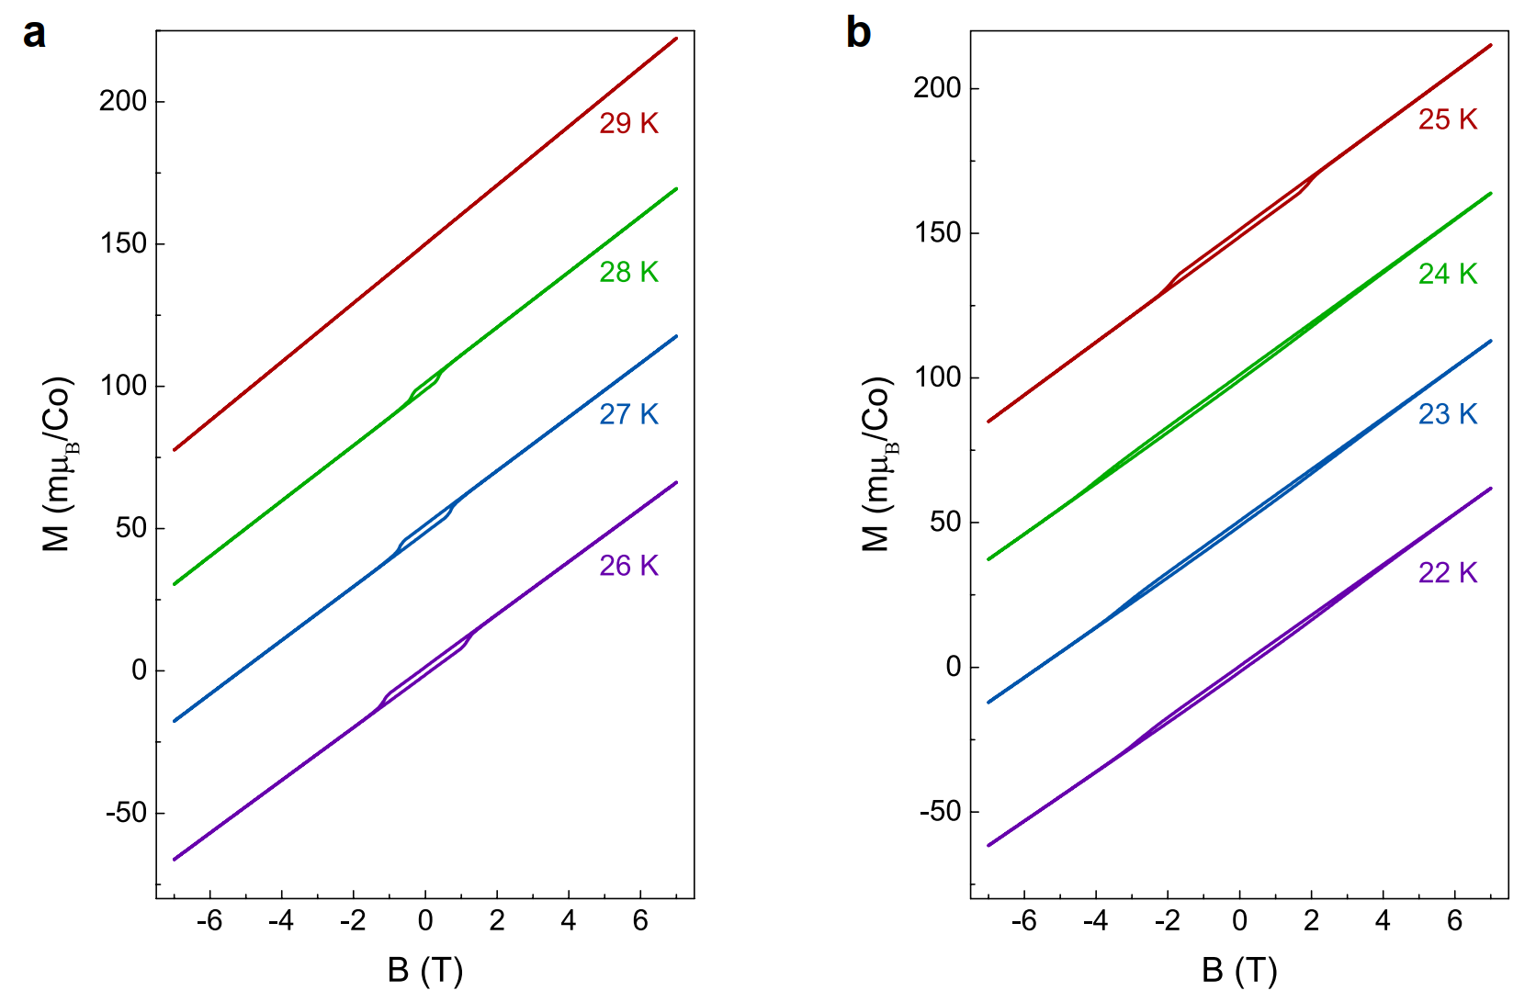
Fig. S4. Field dependence of the magnetization measured from 22 K to 29 K with field along the c axis.
The isothermal magnetization M (H) curves, measured from 22 K to 29 K with H//c, are shown in the Fig. S4. For T=29 K>T_{N}, nearly linear M (H) curves were observed between 7 T and -7 T, while, for T<T_{N}, a small ferromagnetic hsyteresis loop gradually began to emerge, implying the ferromagnetic component was accompanied by the AFM phase transition. As lowering the temperature, the hysteresis loop gradually becomes larger due to the increase of the ferromagnetic coercive field. When the temperature is below 24 K, the coercive field becomes larger than 7 T, beyond the limit of our experimental MPMS magnet, which results in the incomplete hysteresis loops, as shown in Fig. S4 b.

S5. Symmetry analysis of CoNb₃S₆

S5.1. Doubly degenerate bands of CoNb₃S₆
CoNb₃S₆ belongs to space group P6₃22 (No. 182). It is a collinear antiferromagnet with magnetic moments oriented along a crystal axis within the a-b plane. This magnetic structure corresponds to the magnetic space group P_{B}2₁2₁2 (No. 18.22) and the spin space group $P_{B}{}_{ }^{1}{2_{1}}{}_{ }^{1}{2_{1}}{}_{ }^{1}{2_{ }}{}_{ }^{∞m}1$. According to previous work⁴, the elements of this spin space group are listed in Table S4. From Table S4, we can prove that the element $\{U_{z}(π)||E|τ_{(a+b)/2}\}$ is included in the spin space group without SOC. In addition, the $\{U_{z}(π)||E|τ_{(a+b)/2}\}$ preserve double degeneracy in the whole Brillouin zone.
In fact,$\{U_{z}(π)||E|τ_{(a+b)/2}\}$is an symmetry keeping the Hamiltonian invariant, $\{U_{z}(π)||E|τ_{(a+b)/2}\}ε(s,\vec{k})=ε(s,\vec{k})$. At the same time, we apply this element on the spin and momentum-dependent energy band $ε(s,\vec{k})$. Since all spins point along x direction in CoNb₃S₆ (Fig 1d), $U_{z}(π)$ will reverse the good quantum number of spin, $\{U_{z}(π)||E|τ_{(a+b)/2}\}ε(s,\vec{k})=ε(-s,\vec{k})$. Hence $ε(s,\vec{k})=ε(-s,\vec{k})$. The band structure is at least double-degenerate everywhere in the whole Brillouin zone.

Table S4. Group elements of the magnetic space group and spin group describing CoNb₃S₆.
 | Spin space group | Group elements
w/ SOC | $$P_{B}{}_{ }^{2}{2_{1}}{}_{ }^{2}{2_{1}}{}_{ }^{2}2$$ | H: $\{E||E|0\}, \{U_{x}(π)||C_{x}(π)|0\},$  $$\{U_{y}(π)||C_{y}(π)|τ_{(b+c)/2}\}, \{U_{z}(π)||C_{z}(π)|τ_{(b+c)/2}\}$$  M: $\{T|\left|E\right|τ_{(a+b)/2}\},\{TU_{x}(π)||C_{x}(π)|τ_{(a+b)/2}\},$  $$\{TU_{y}(π)||C_{y}(π)|τ_{(a+c)/2}\}, \{TU_{z}(π)||C_{z}(π)|τ_{(a+c)/2}\}$$
w/o SOC | Nontrivial:  $$P_{B}{}_{ }^{1}{2_{1}}{}_{ }^{1}{2_{1}}{}_{ }^{1}2$$ | H: $\{E||E|0\}, \{E||C_{x}(π)|0\},$  $$\{E||C_{y}(π)|τ_{(a+c)/2}\}, \{E||C_{z}(π)|τ_{(a+c)/2}\}$$  M: $\{T|\left|E\right|τ_{(a+b)/2}\},\{T|\left|C_{x}(π)\right|τ_{(a+b)/2}\},$  $$\{T||C_{y}(π)|τ_{(b+c)/2}\}, \{T||C_{z}(π)|τ_{(b+c)/2}\}$$
w/o SOC | Trivial:  $${}_{ }^{∞m}1$$ | $$\{TU_{n}(π)||E||0\} (n=cosφ\hat{y}+sinφ\hat{z}, φ∈(0,π])$$  $$\{U_{x}(θ)||E||0\} (θ∈(0,2π])$$
$τ_{(a+b)/2}=(1/2,1/2,0), τ_{(b+c)/2}=(0,1/2,1/2),τ_{(a+c)/2}=(1/2,0,1/2)$;
H/M: elements without/with time-reversal symmetry.

S5.2. Chern number and robust Fermi-arc surface states
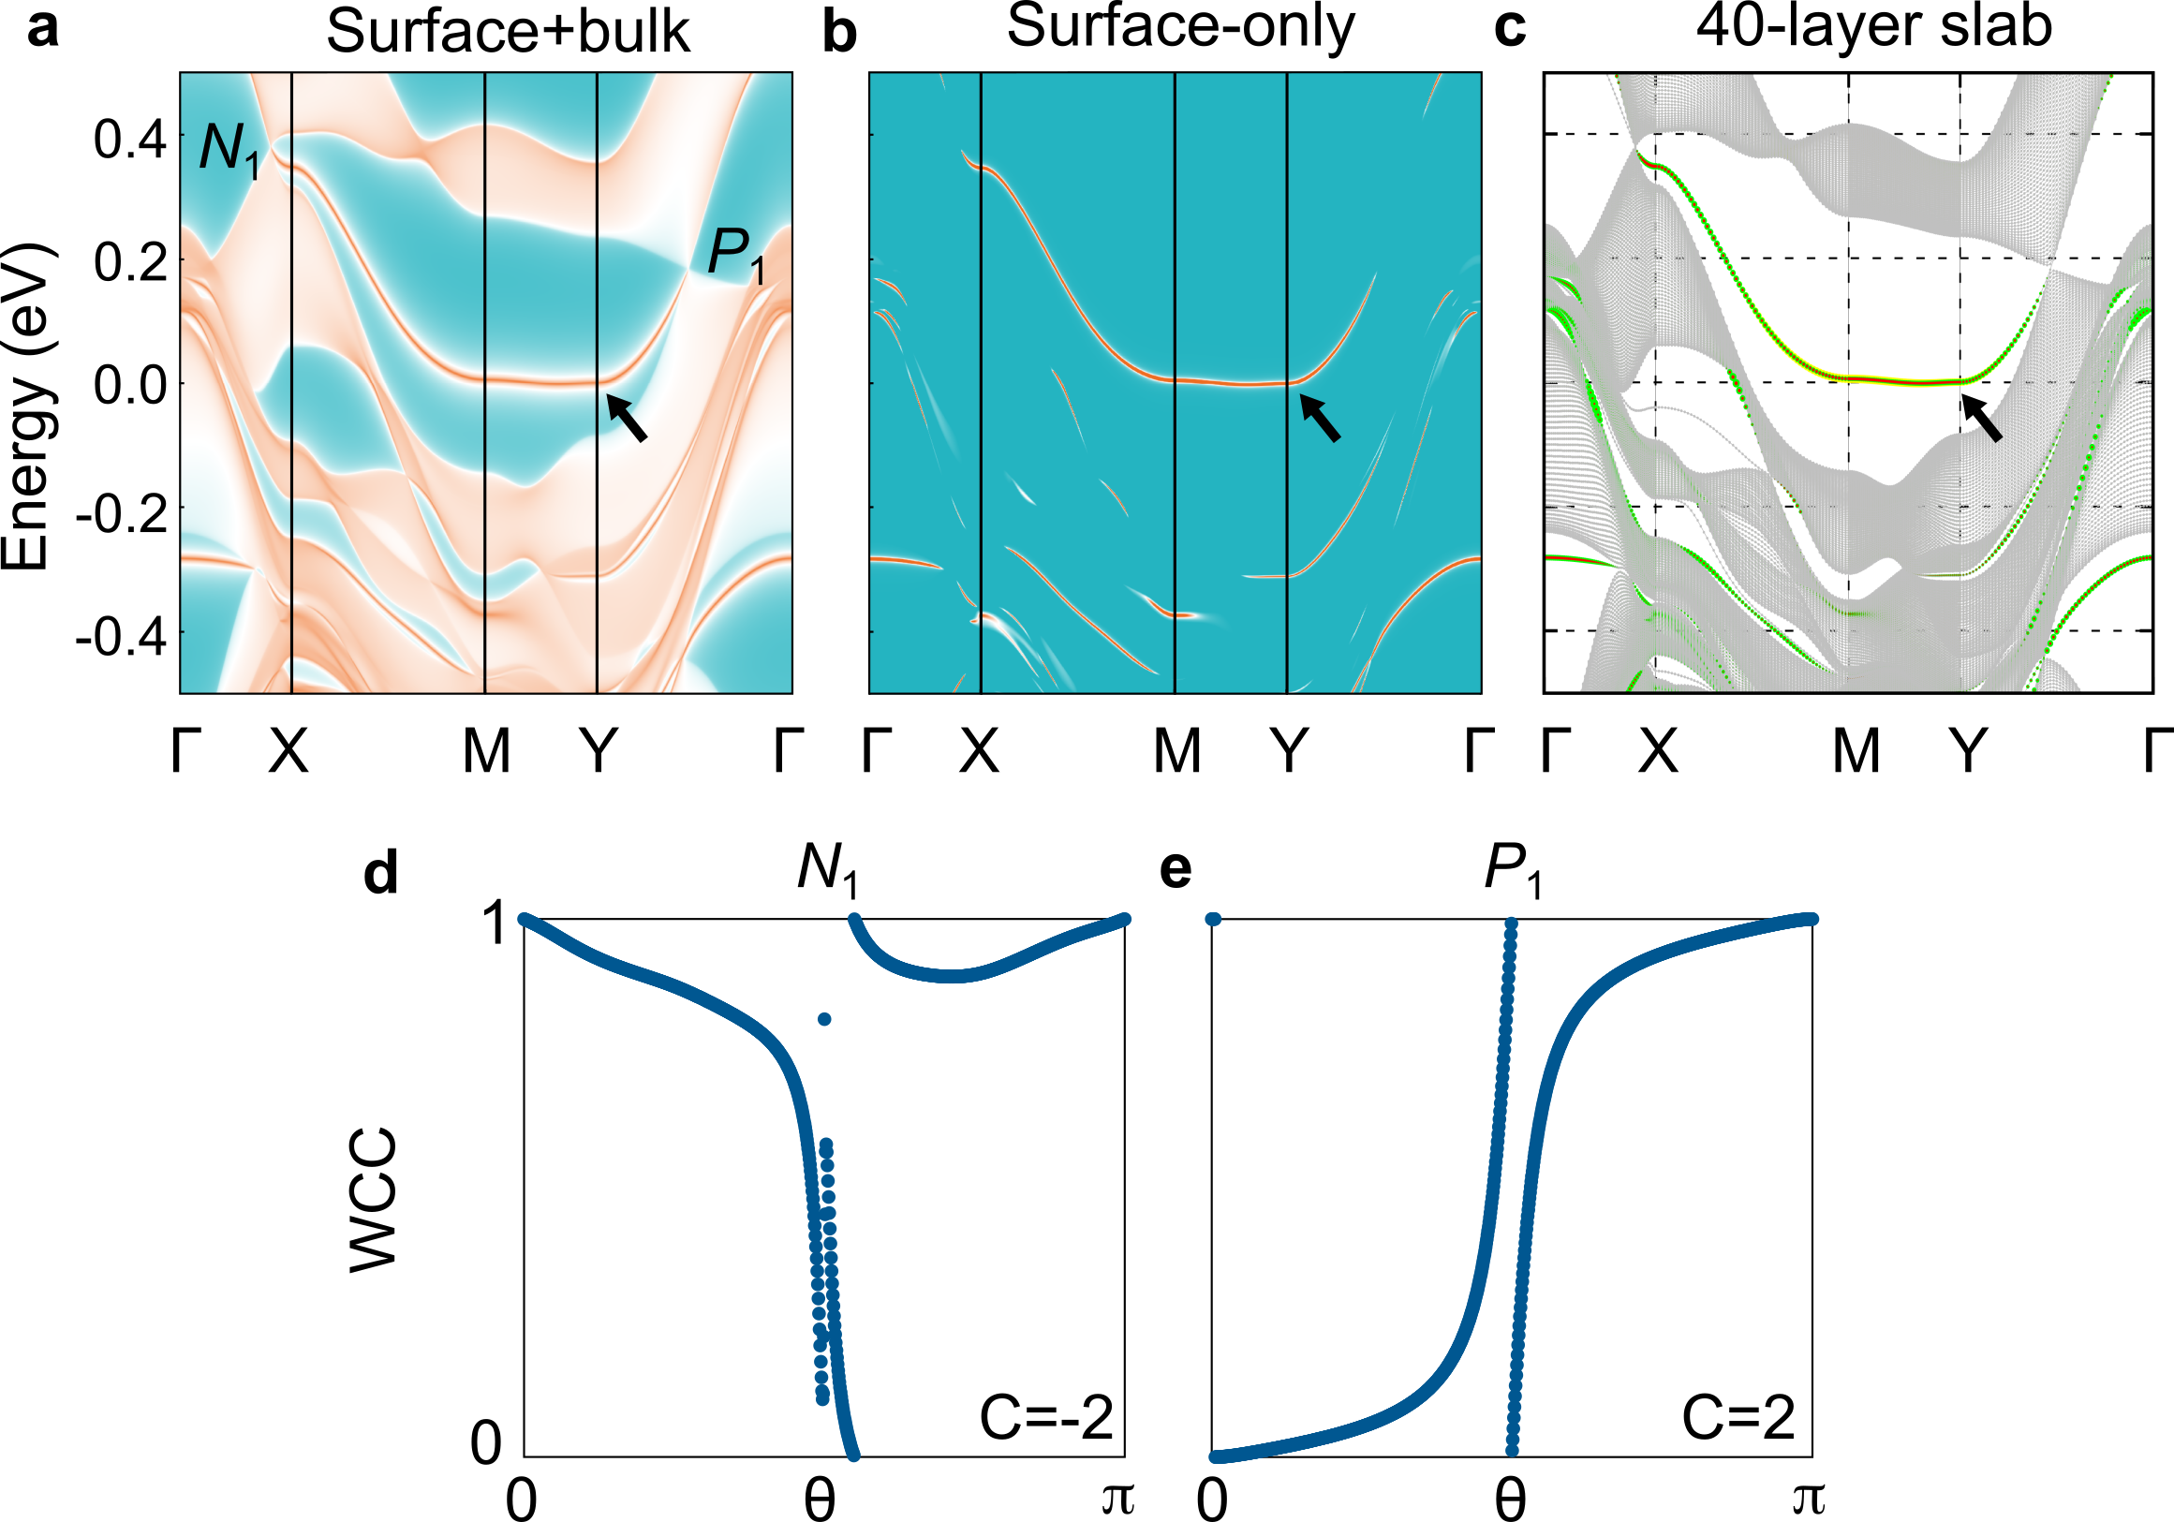
Fig. S5. The Fermi-arc surface states and Chern number of CoNb₃S₆. a, The Fermi-arc surface states of CoNb₃S₆ contain both bulk and surface contribution. b, Fermi-arc surface states of CoNb₃S₆ with only surface contribution. c, The 40-layer slab bands calculation with projection on Co-3d (yellow), Nb-4d (green) and S-3p (red) orbitals in the first unit cell of NbS₂ surface. Fermi-arc surface states are denoted by black arrows. d, e The Wannier charge centers (WCCs) of the flavor Weyl points (N₁ and P₁) and their Chern numbers. N₁(0.40793, 0.00008, 0.00002), P₁(0.00001, 0.26514, 0.00003).

S5.3. The electronic structure and fermi surface of nonmagnetic CoNb₃S₆
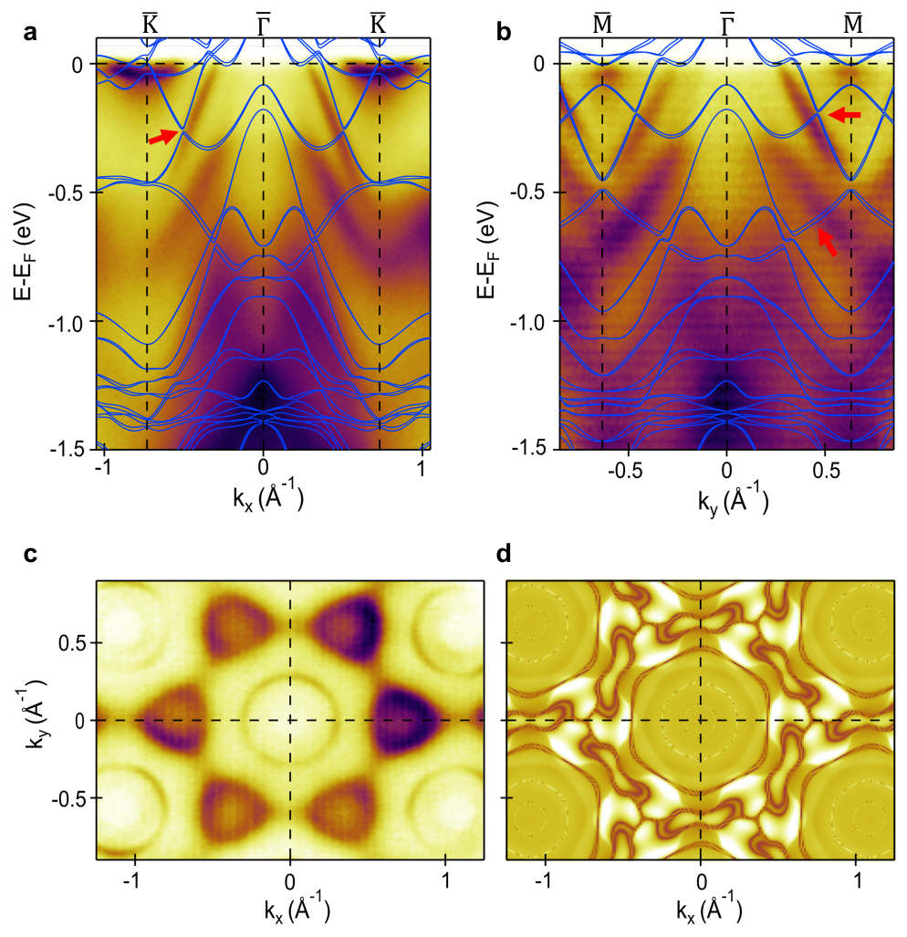
Fig. S6. The electronic structure and Fermi surface of nonmagnetic CoNb₃S₆. a and b ARPES spectra taken with 123 eV photons along the $\overline{K}-\overline{Γ}-\overline{K}$ and $\overline{M}-\overline{Γ}-\overline{M}$, respectively. The DFT calculation of nonmagnetic CoNb₃S₆ along the above two k-paths with SOC are overlaid on top of ARPES Data. The red arrows indicate the main mismatch between APRES measurement and DFT calculation. c and d denote the ARPES Fermi surface mapping and DFT calculated Fermi surfaces with only surface state spectral weight for nonmagnetic CoNb₃S_{6,} respectively.

S6. Momentum distribution curves of $β$at E_{F}
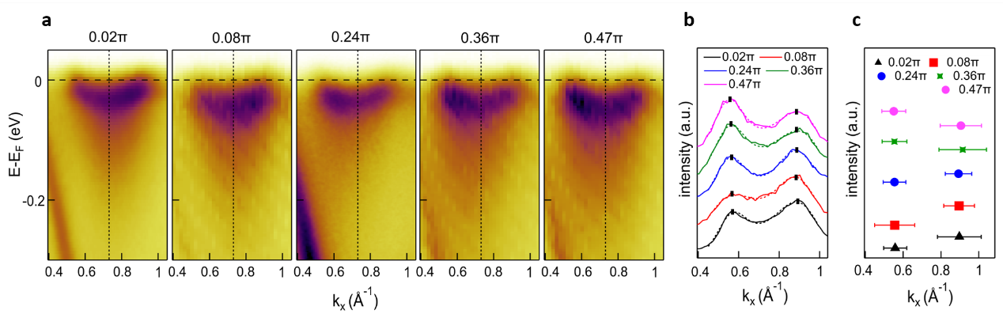
Fig. S7. The ARPES spectra and momentum distribution curves (MDCs) at E_{F} of $β$. a, ARPES spectra cuts of $β$ at different $k_{z}$ value along $\overline{K}-\overline{Γ}-\overline{K}$ direction, black dashed lines denote $\overline{K}$ points. b, Corresponding MDCs at E_{F} for $β$ in a (solid lines), appended with two Lorentzian peak fitting (dashed lines). c, Fitted peak positions for $β$ at E_{F} ($k_{F}$), with the error bars defined by FWHM of the fitted curves.

S7. ARPES spectra taken with different polarization light
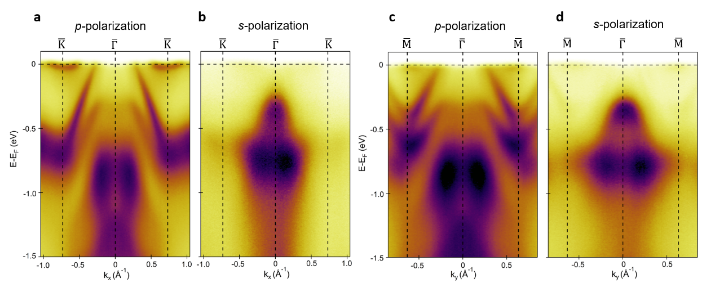
Fig. S8. ARPES spectra taken with different polarized light. a, b ARPES cuts along $\overline{K}-\overline{Γ}-\overline{K}$ direction taken with 80 eV LH (p) and LV (s) polarized light respectively. c, d ARPES cuts along $\overline{M}-\overline{Γ}-\overline{M}$ direction taken with 80 eV p and s polarized light respectively.

S8. Anomalous hall conductivity tensors of bulk and slab CoNb₃S₆
According to symmetry analysis, the magnetic space group of bulk CoNb₃S₆ without/with canting are P_{B}2₁2₁2 (No. 18.22) and $P2_{1}2_{1}^{'}2^{'}$ (No. 18.19), respectively. And the magnetic space group of slab CoNb₃S₆ without/with canting are $P_{S}1$ (No. 1.3) and $P1$ (No. 1.1), respectively. The group elements of these magnetic space groups are listed in table S5. Bulk and slab CoNb₃S₆ without canting are preserved the$Tτ_{\frac{1}{2}\frac{1}{2}0}$. In addition, the main differences between the slab and bulk CoNb₃S₆ are all rotation symmetry is broken for slab.

Table S5. Group elements of the magnetic space group describing bulk and slab CoNb₃S₆ without/with canting.
 | Bulk |  | Slab
 | w/o canting | w/ canting | w/o canting | w/ canting
Magnetic space group | P_{B}2₁2₁2 | $$P2_{1}2_{1}^{'}2^{'}$$ | $$P_{S}1$$ | $$P1$$
w/ SOC | $$E$$  $$TC_{2z}τ_{00\frac{1}{2}}$$  $$TC_{2y}τ_{00\frac{1}{2}}$$  $$C_{2x}$$  $$Tτ_{\frac{1}{2}\frac{1}{2}0}$$  $$C_{2z}τ_{\frac{1}{2}\frac{1}{2}\frac{1}{2}}$$  $$C_{2y}τ_{\frac{1}{2}\frac{1}{2}\frac{1}{2}}$$  $$TC_{2x}τ_{\frac{1}{2}\frac{1}{2}0}$$ | $$E$$  $$TC_{2y}τ_{00\frac{1}{2}}$$  $$C_{2z}τ_{\frac{1}{2}\frac{1}{2}\frac{1}{2}}$$  $$TC_{2x}τ_{\frac{1}{2}\frac{1}{2}0}$$ | $$E$$  $$Tτ_{\frac{1}{2}\frac{1}{2}0}$$ | $$E$$

For bulk CoNb₃S₆ without canting magnetic moment, the magnetic space group is P_{B}2₁2₁2 (No. 18.22). Its form of anomalous hall conductivity tensor is $σ_{ij}=\left(\begin{matrix}σ_{xx} & 0 & 0 \\ 0 & σ_{yy} & 0 \\ 0 & 0 & σ_{zz}\end{matrix}\right)$. Thus the $σ_{xy}=0$ for bulk CoNb₃S₆ w/o canting. However, when a small canting along the z direction, the magnetic space group becomes $P2_{1}2_{1}^{'}2^{'}$ (No. 18.19) and the corresponding form of anomalous hall conductivity tensor $σ_{ij}=\left(\begin{matrix}σ_{xx} & σ_{xy} & 0 \\ {-σ}_{xy} & σ_{yy} & 0 \\ 0 & 0 & σ_{zz}\end{matrix}\right)$, thus $σ_{xy}≠0$.
For slab CoNb₃S₆ w/o canting magnetic moment, the magnetic space group is $P_{S}1$ (No. 1.3). Its form of anomalous hall conductivity tensor is $σ_{ij}=\left(\begin{matrix}σ_{xx} & σ_{xy} & σ_{xz} \\ σ_{xy} & σ_{yy} & σ_{yz} \\ σ_{xz} & σ_{yz} & σ_{zz}\end{matrix}\right)$. The $σ_{xy}=σ_{yx}$ according to the form of anomalous hall conductivity tensor. At the same time, $σ_{xy}$ is an antisymmetric tensor, which lead to $σ_{xy}=-σ_{yx}$. Thus, $σ_{xy}=0$ for slab CoNb₃S₆ w/o canting. However, when a small canting along the z direction, the magnetic space group becomes $P1$ (No. 1.1) and the corresponding form of anomalous hall conductivity tensor $σ_{ij}=\left(\begin{matrix}σ_{xx} & σ_{xy} & σ_{xz} \\ σ_{yx} & σ_{yy} & σ_{yz} \\ σ_{zx} & σ_{zy} & σ_{zz}\end{matrix}\right)$, thus $σ_{xy}≠0$ for slab CoNb₃S₆ with canting.

S9. Electric transport measurements
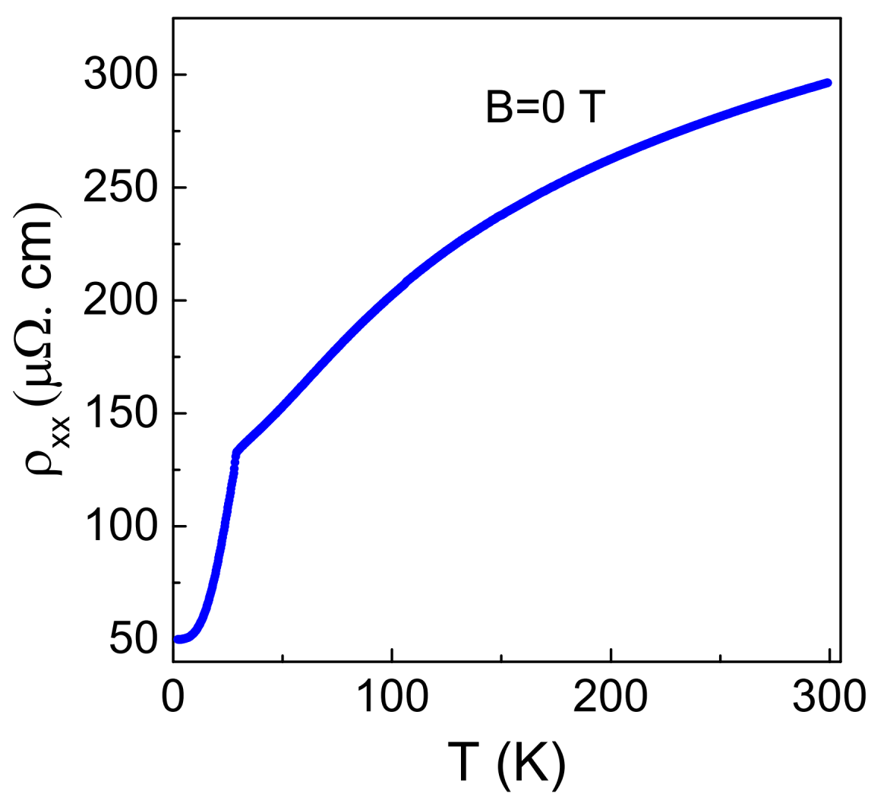
Fig. S9. Temperature dependence of the electrical resistivity with current along the a aixs for CoNb₃S₆.
The zero-field electrical resistivity as a function of temperature measured with current along the a axis is presented in Fig. S9. The anomaly around 28.7 K in $ρ_{xx}(T)$ curve further confirmed the antiferromagnetic transition observed in the magnetization measurements.
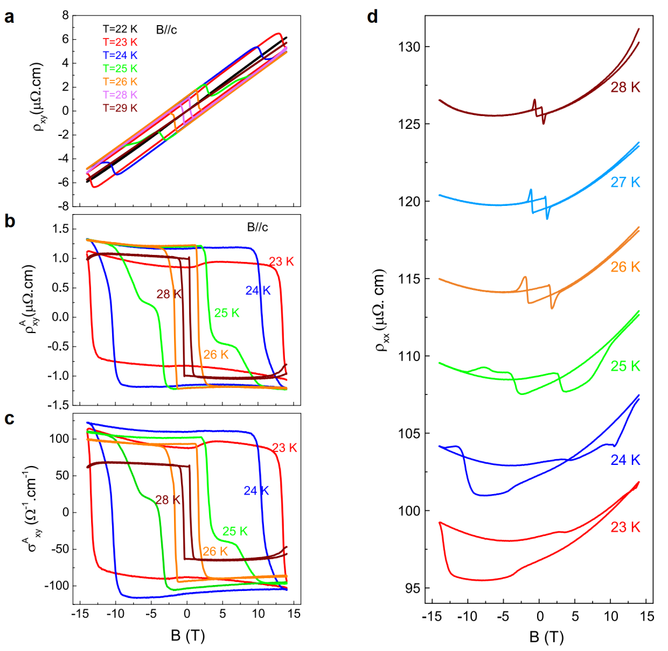
Fig. S10. a, Field evolution of the Hall resistivity measured at different temperatures. b, Field evolution of the anomalous Hall resistivity obtained by subtracting the ordinary Hall resistivity. c, Field evolution of the anomalous Hall conductivity. d, Field evolution of the longitudinal resistivity measured at different temperatures.
Fig. S10 a illustrates the field dependent Hall resistivity measured between 29 K and 22 K with current along the a axis and field along the c axis. By subtracting the linear background, large anomalous Hall resistivity can be obtained for T< T_{N}, as shown in Fig. S10 b. The corresponding anomalous Hall conductivity $σ_{xy}^{A}=ρ_{xy}^{A}/({\left(ρ_{xy}^{A}\right)}^{2}+{\left(ρ_{xx}\right)}^{2})$ at different temperatures are presented in Fig. S10 c. As shown in Fig. S10 d is the field evolution of the longitudinal resistivity $ρ_{xx}$ measured at different temperatures. Only a small magnetoresistance (MR ~5%) is observed below T_{N}. The small jumps observed in the MR curves correspond to the flips of ferromagnetic components.
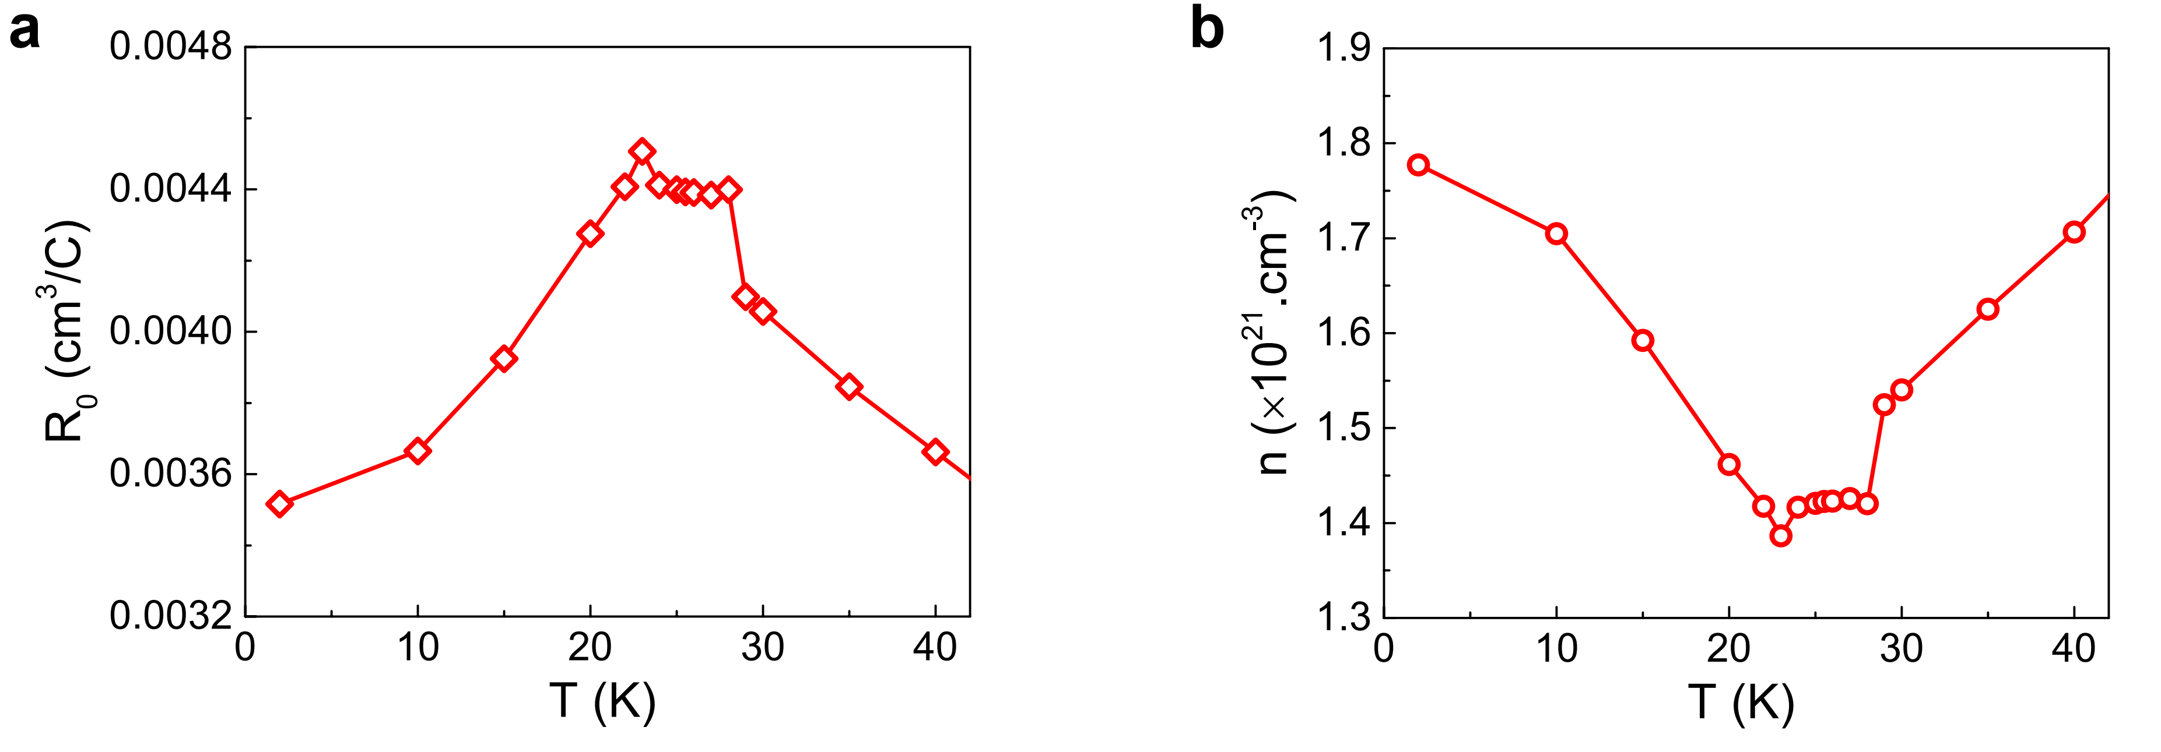Fig. S11. Temperature dependence of a the ordinary Hall coefficient and b carrier concentration.
Fig. S11 a are the ordinary Hall coefficients extracted from the linear fits of the isothermal field dependent Hall effect at different temperatures. If a single band model was assumed, the carrier concentration of the holes can be estimated by n = 1/|eR₀| , and presented in Fig. S11 b. The temperature evolution of the carrier concentration shows a concave-like feature with the minimum around 1.4$×{10}^{21}$cm⁻³ between 23 K and 28 K.

Supplementary reference
1 Coleman, S. & Mandula, J. All Possible Symmetries of the S Matrix. Phys. Rev. 159, 1251-1256 (1967).
2 Heisenberg, W. Über den Bau der Atomkerne. I. Zeitschrift für Physik 77, 1-11 (1932).
3 Weinberg, S. The quantum theory of fields. Vol. 2 (Cambridge university press, 1995).
4 Liu, P., Zhang, A., Han, J. & Liu, Q. Chiral Dirac-like fermion in spin-orbit-free antiferromagnetic semimetals. The Innovation 3, 100343 (2022).

