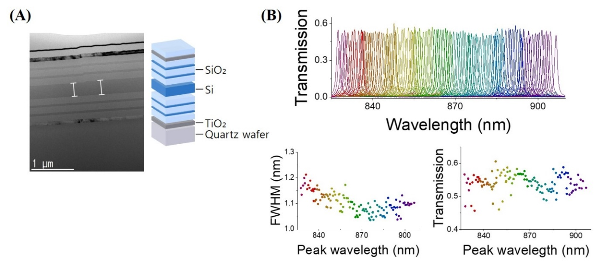

Extended Data Fig. 1 | Structure of DBRs and its optical characterics a, Cross-section of the wavelength-selective band pass filter structure by transmission electron microscopy and schematics of the structure. The band pass filters consisted of a pair of DBRs separated with the Si resonator, and the thickness of the Si resonator tuned the transmission wavelength. The Methods provides more details. b, Series of transmission spectra of 120CH band pass filters (top panel). FWHM (bottom left) and transmission (bottom right) of 120 DBR filters as a function of the peak wavelength.

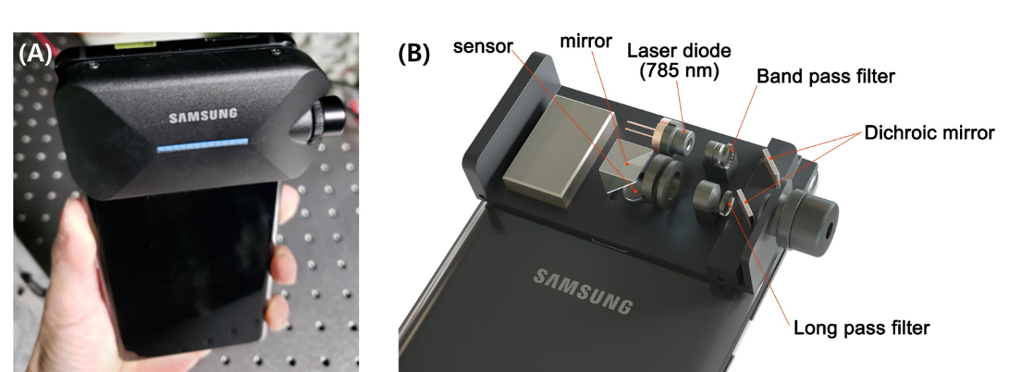
Extended Data Fig. 2 | Photograph and internal optics of the Raman module. a, Photograph of the Raman module attached on the rear camera side of a Samsung Galaxy Note 9. b, Internal optics and laser diode setup of the Raman module.
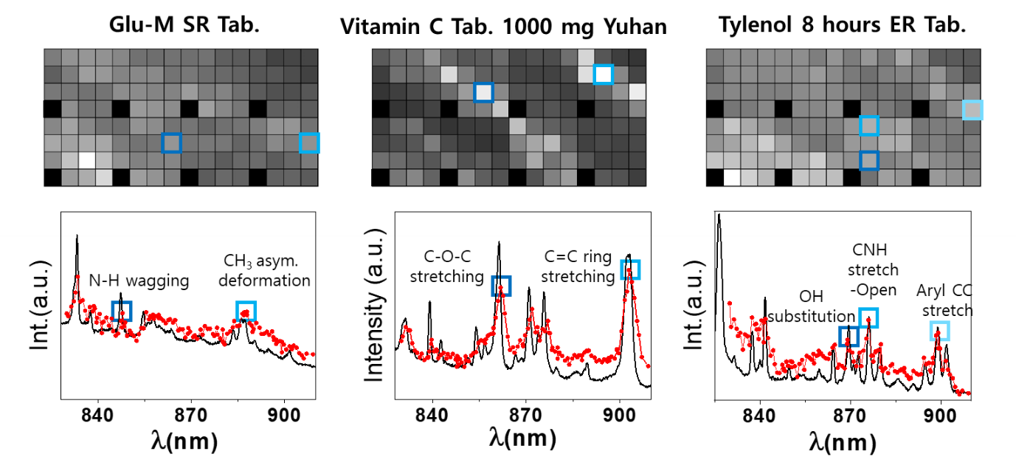
Extended Data Fig. 3 | Unique spectral barcode of drugs from Raman fingerprints. Spectral barcode of Glu-M SR for diabetes, Vitamin C, and Tylenol. Shown below are reference Raman spectra obtained with a commercial Raman spectrometer, and extracted Raman spectra from the spectral barcode, indicated by black solid line and red dots, respectively. Blue squares show two or three representative Raman bands of the spectral barcode and spectrum.

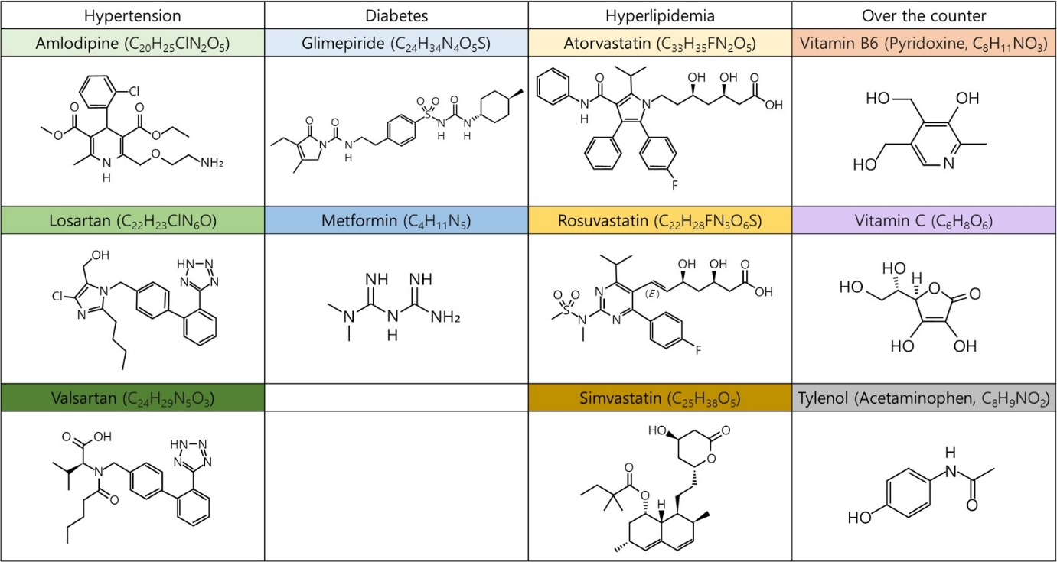

Extended Data Fig. 4 | Molecular structures of 11 categories of drugs. Molecular structure of major component of 11 categories of drugs: hypertension, diabetes, hyperlipidemia, and over the counterover-the-counter drugs.
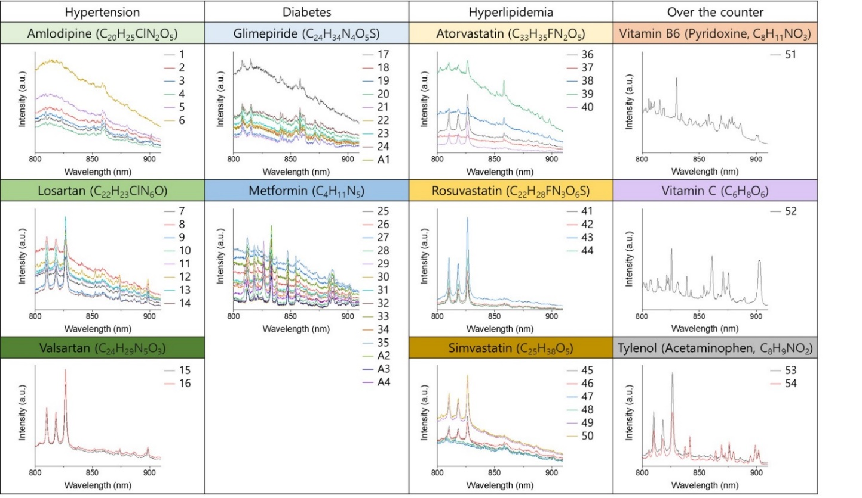
Extended Data Fig. 5 | Reference Raman spectra of 54 drugs in 11 categories. Reference Raman spectra, obtained with a commercial Raman spectrometer, of the drugs used for CNN training of the spectral barcode and the four untrained drugs; labeled as 1–54 and A1–A4, respectively. Spectra were plotted in terms of absolute value. All of the spectra were categorized by each major component. In the same category, the level of the background and additional peaks due to additives were evident.
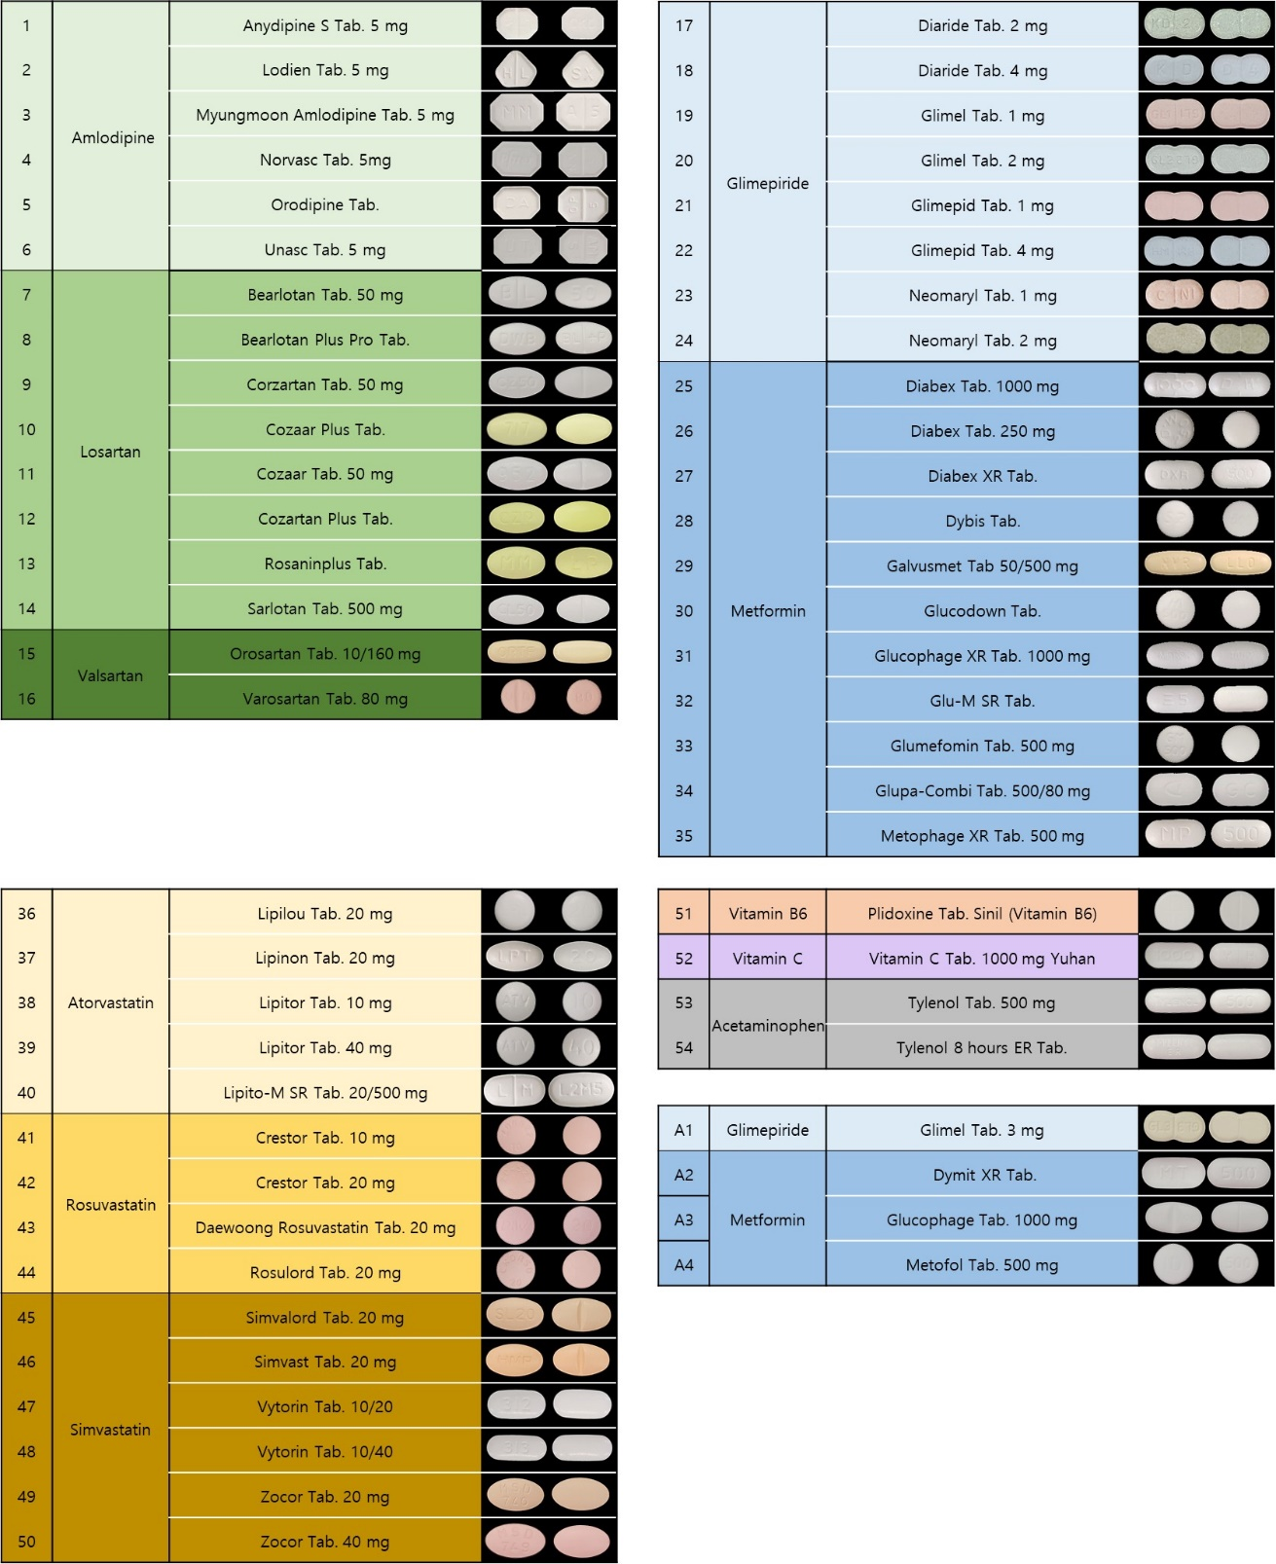

Extended Table 1 | Back and Front RGB images of 54 drugs. Front and back appearance RGB images of 54 drugs obtained with a Galaxy Note 9 used for CNN training for RGB images and four untrained drugs, indicated by 1–54 and A1–A4, respectively. Only shape (snowman, circle, ellipse, and pentagon/octagon) and color (blue, yellow, green, white, and pink) information were used for recognition.

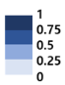
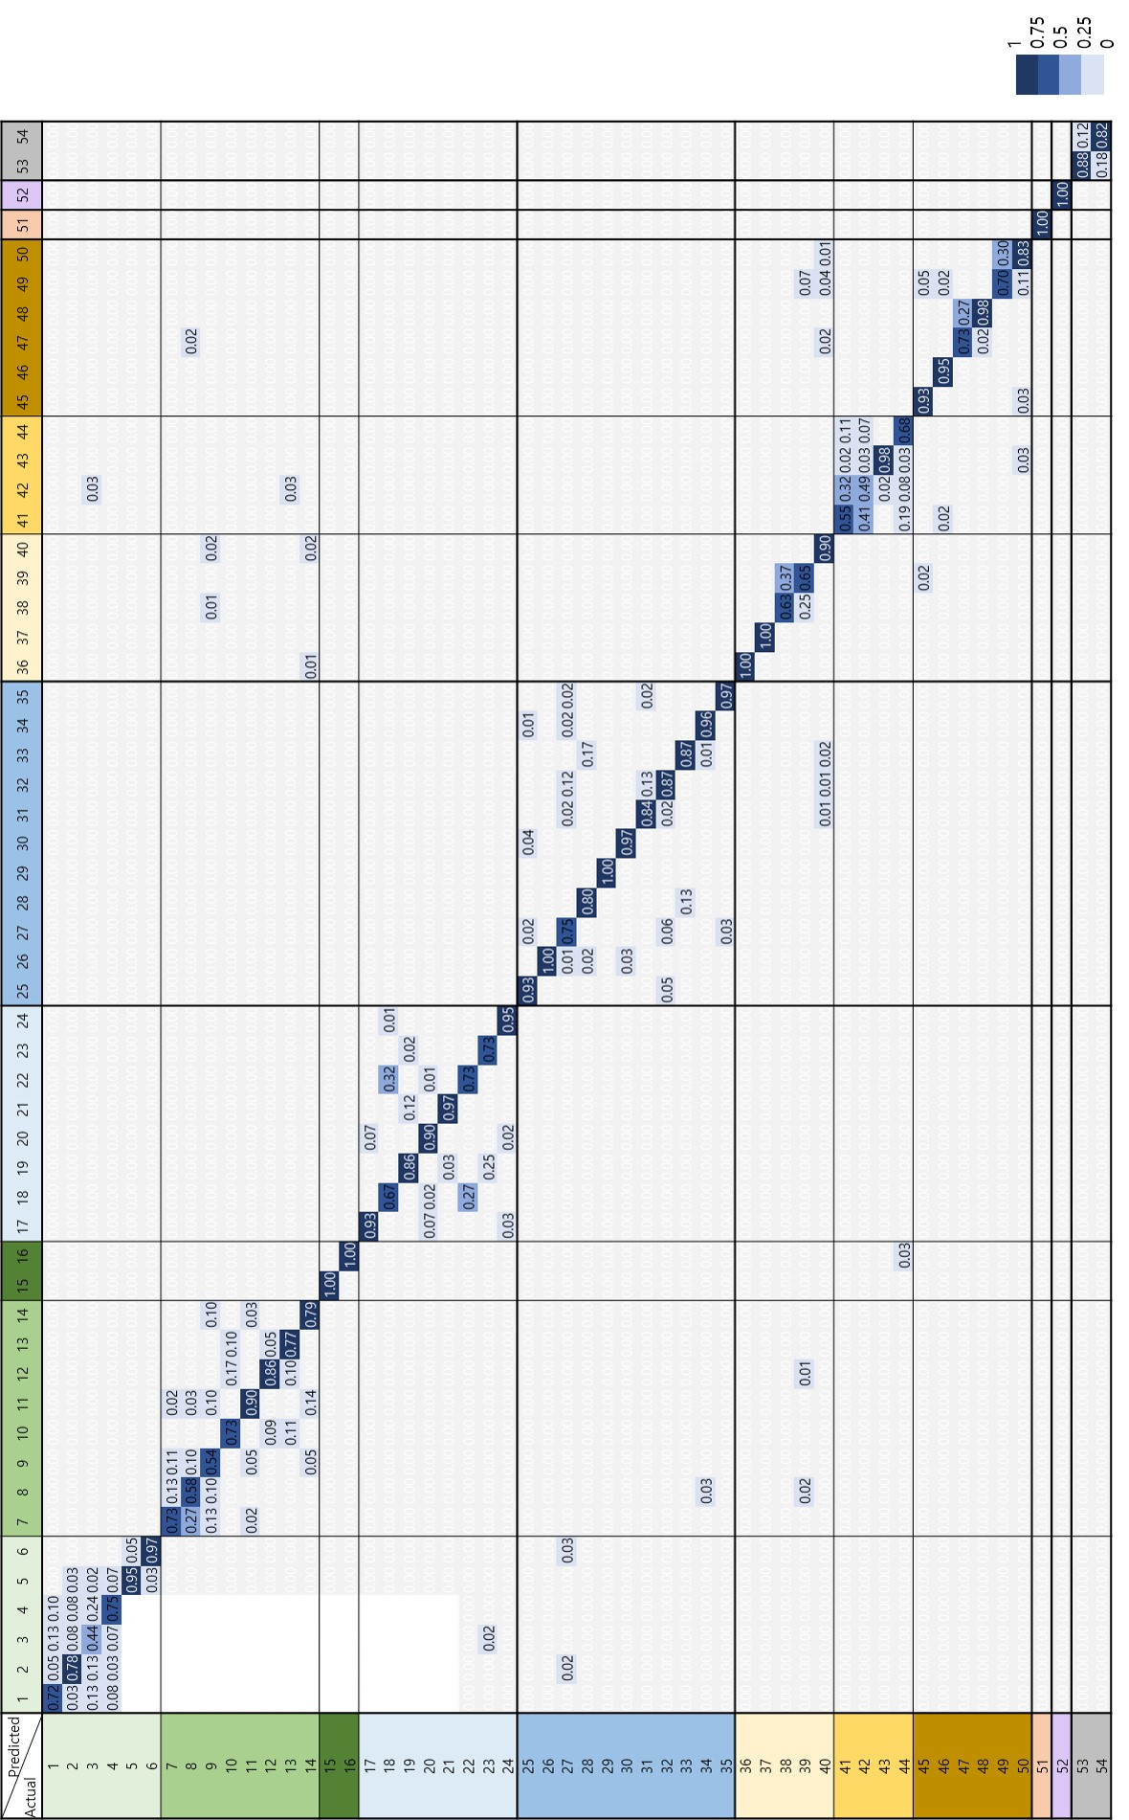
Extended Table 2 | Confusion matrix for the brand name classification. Confusion matrix of the CNN identifying the brand name of the drug from the spectral barcode.
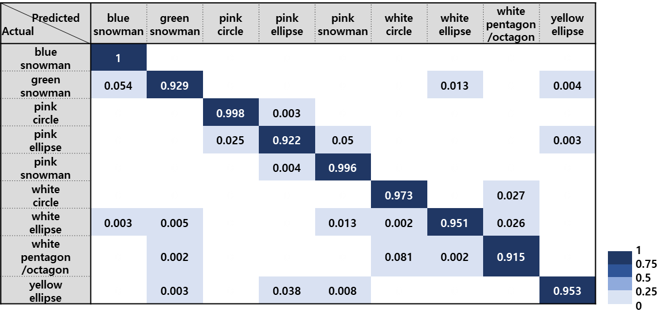
Extended Table 3 | Confusion matrix for RGB matrix. Confusion matrix of the CNN classifying shape and color from the RGB image of the drugs
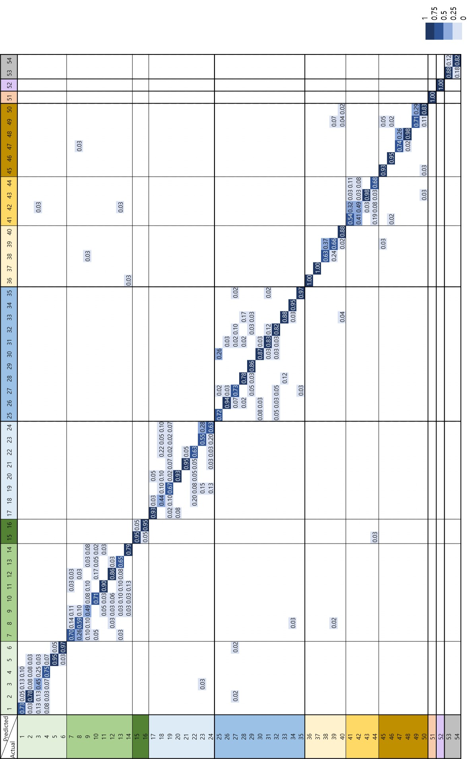
Extended Table 4 | Confusion matrix for spectral barcode and RGB images in combination. Confusion matrix of the combined CNNs identifying the brand name of the drugs from the spectral barcodes and RGB images.

