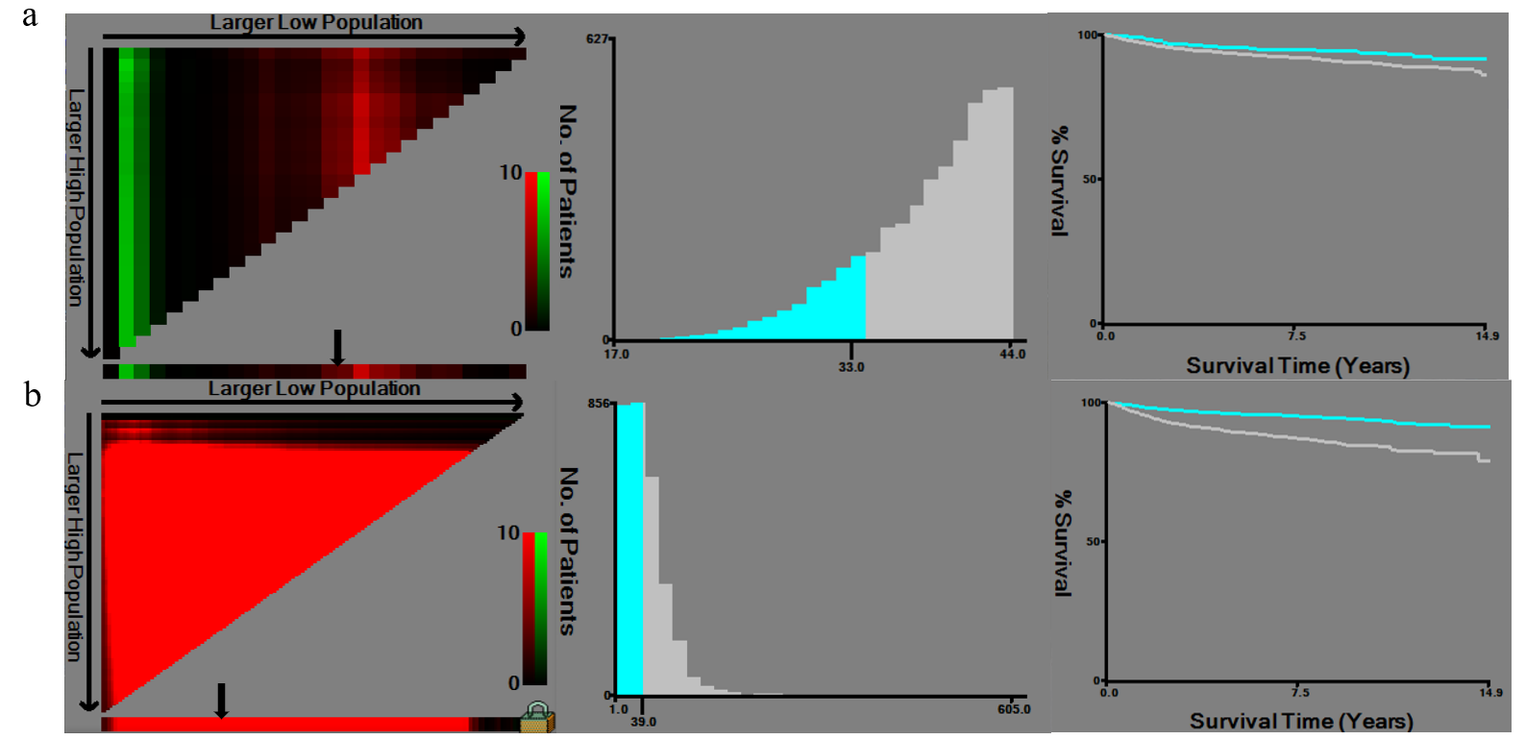 Supplementary Fig. 1 The X-tile analysis was implemented on the survival data of early-onset EC patients to ascertain the optimal threshold for age and tumor size. (a) The optimal cut-off point for age was 33 years; (b) The optimal cut-off point for tumor size was 4cm.
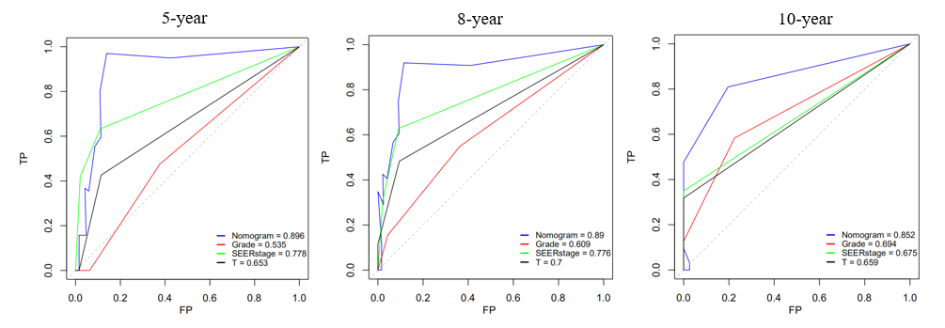 Supplementary Fig. 2 ROC curves for the external validation cohort of 3-, 5- and 8-year (the nomogram, grade, SEER stage and T stage).

