Supplementary Table 1. Performance of parental inbred lines (AKON40A and LM23) with respect to plant height and ear height in spring and kharif, 2021.
 | Akon-40A |  |  |  | LM 23
 | Spring 2021 |  | Kharif 2021 |  | Spring 2021 |  | Kharif 2021
P | PH | EH | PH | EH | PH | EH | PH | EH
P1 | 145 | 110 | 155 | 130 | 117 | 34 | 68 | 42
P2 | 125 | 100 | 140 | 122 | 110 | 33 | 107 | 33
P3 | 140 | 115 | 127 | 107 | 125 | 40 | 95 | 33
P4 | 160 | 130 | 133 | 106 | 123 | 50 | 105 | 45
P5 | 145 | 120 | 122 | 99 | 120 | 50 | 102 | 55
P6 | 160 | 120 | 122 | 100 | 137 | 60 | 103 | 57
P7 | 140 | 110 | 127 | 105 | 127 | 55 | 108 | 42
P8 | 145 | 105 | 120 | 120 | 125 | 50 | 99 | 36
P9 | 126 | 107 | 115 | 105 | 100 | 40 | 107 | 38
P10 | 140 | 100 | 120 | 108 | 75 | 45 | 75 | 40
P11 | 145 | 102 | 125 | 105 | 125 | 60 | 112 | 54
P12 | 125 | 105 | 120 | 100 | 110 | 55 | 108 | 47
P13 | 142 | 110 | 115 | 102 | 115 | 50 | 111 | 46
P14 | 145 | 99 | 125 | 100 | 120 | 45 | 115 | 48
P15 | 154 | 115 | 130 | 100 | 125 | 50 | 109 | 56
Average | 142.47 | 109.87 | 126.4 | 107.27 | 116.93 | 47.8 | 101.6 | 44.8
Mean | 155 | 130 | 124.49 | 105.75 | 68 | 42 | 103.84 | 44.99
Variance | 120 | 122 | 43.79 | 47.834 | 107 | 33 | 90.53 | 65.14

Supplementary Table 2. List of SSR markers applied on parents (AKON40A and LM23) for parental polymorphism survey.
Chro. No. | Marker | Chro. No. | Marker | Chro. No. | Marker | Chro. No. | Marker | Chro. No. | Marker
1 | bnlg1627 | 4 | bnlg1189 | 6 | bnlg1371 | 7 | umc1546 | 10 | umc2067
1 | bnlg1671 | 4 | bnlg1018 | 6 | umc1887 | 7 | umc1642 | 10 | bnlg1712
1 | bnlg1811 | 4 | bnlg2291 | 6 | umc1753 | 7 | umc1036 | 10 | umc1636
1 | umc1748 | 4 | bnlg2333 | 6 | umc1105 | 8 | umc1005 | 10 | bnlg236
1 | bnlg1953 | 4 | umc2290 | 6 | umc1979 | 8 | umc1008 | 10 | umc2126
1 | umc1160 | 4 | umc1849 | 6 | umc1143 | 8 | umc1786 | 10 | umc1054
1 | bnlg1179 | 4 | umc1649 | 6 | umc1480 | 8 | bnlg2046 | 10 | phi062
1 | bnlg1556 | 4 | umc1667 | 6 | umc1625 | 8 | bnlg1823 | 10 | umc1196
1 | phi265454 | 4 | umc1117 | 6 | umc2317 | 8 | umc1304 | 10 | umc1196a
1 | umc1429 | 4 | umc2307 | 6 | umc1082 | 8 | umc1777 | 10 | umc1962
1 | umc 1403 | 5 | bnlg1836 | 6 | umc2055 | 8 | umc1615
1 | umc1924 | 5 | bnlg1346 | 6 | umc1859 | 8 | umc1984
1 | umc1568 | 5 | umc1491 | 6 | mlg 3 | 8 | umc1327
1 | phi039 | 5 | bnlg1922 | 6 | bnlg238 | 8 | phi119
1 | umc1630 | 5 | umc1264 | 6 | umc2320 | 9 | bnlg2122
1 | umc1917 | 5 | umc1705 | 6 | umc1409 | 9 | umc2343
1 | bnlg1643 | 5 | umc1614 | 6 | umc2389 | 9 | bnlg1724
1 | umc1681 | 5 | phi100 | 6 | bnlg1759a | 9 | umc2362
2 | bnlg198 | 5 | phi299852 | 6 | umc1350 | 9 | umc2095
2 | umc1128 | 5 | umc1805 | 6 | umc2065 | 9 | umc1764
2 | bnlg1720 | 5 | umc1114 | 6 | umc2322 | 9 | umc2338
2 | umc1635 | 5 | phi087 | 6 | umc2165 | 9 | bnlg1012
2 | umc1560 | 5 | bnlg118 | 7 | mmc0171 | 9 | umc1366
3 | bnlg1711 | 5 | umc2209 | 7 | bnlg1642 | 9 | umc 123
3 | bnlg1108 | 5 | umc2061 | 7 | bnlg1686 | 9 | umc1231
3 | umc2048 | 6 | bnlg1139 | 7 | bnlg1200 | 9 | bnlg1647
3 | bnlg1144 | 6 | bnlg1702 | 7 | umc1549 | 9 | phi027
3 | bnlg197 | 6 | bnlg2191 | 7 | umc1401 | 9 | umc1137
3 | umc1886 | 6 | dupssr15 | 7 | umc2364 | 10 | bnlg2190
3 | umc1793 | 6 | bnlg1136a | 7 | umc2160 | 10 | mmc0501
3 | bnlg1019 | 6 | umc1248 | 7 | umc1577 | 10 | umc1115
3 | umc2266 | 6 | pl 1-2 | 7 | umc1986 | 10 | umc2067
3 | umc2352 | 6 | bnlg2151 | 7 | umc1695 | 10 | bnlg1712
3 | umc1817 | 6 | umc1462 | 7 | umc2325 | 10 | umc1636
4 | umc1004 | 6 | phi126 | 7 | umc2392 | 10 | bnlg236

Supplementary Figure 1. Plant morphology of the contrasting parents (AKON40A and LM23) under study and their F₁ hybrids and F₂ population generated from this cross.
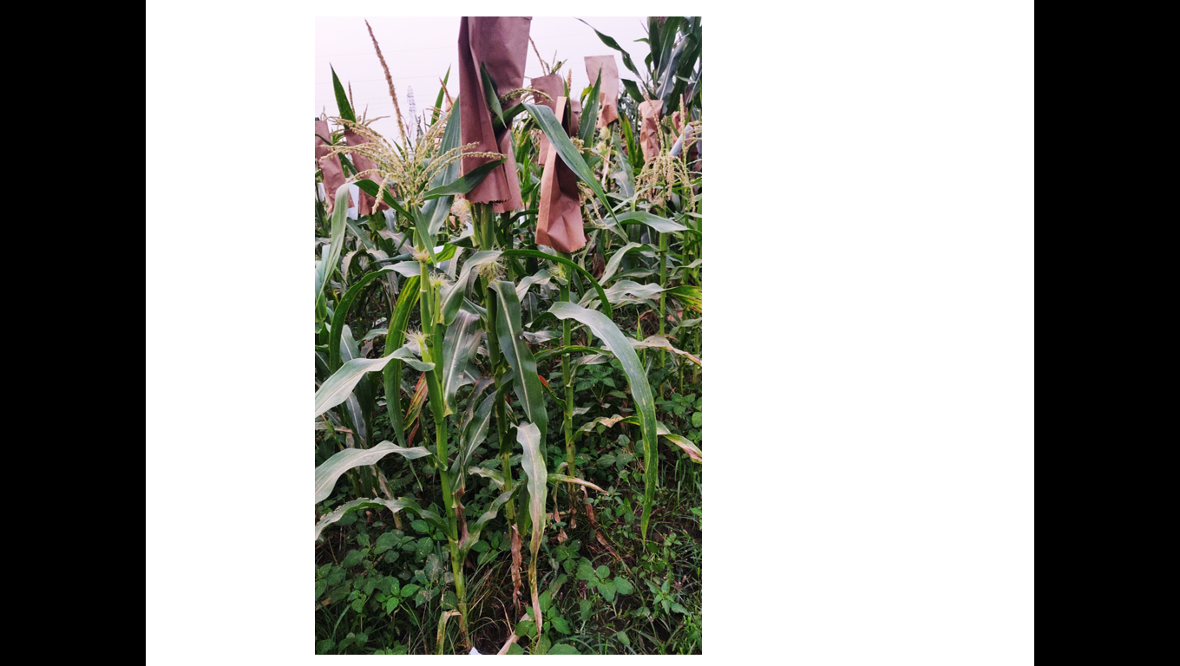  High Ear placement | 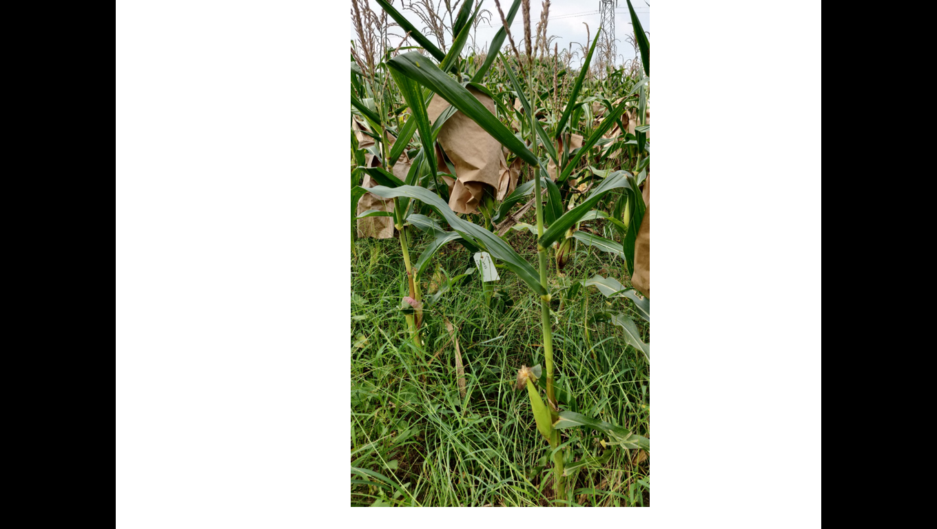  Low Ear placement
AKON40 A (P1) | LM23 (P2)
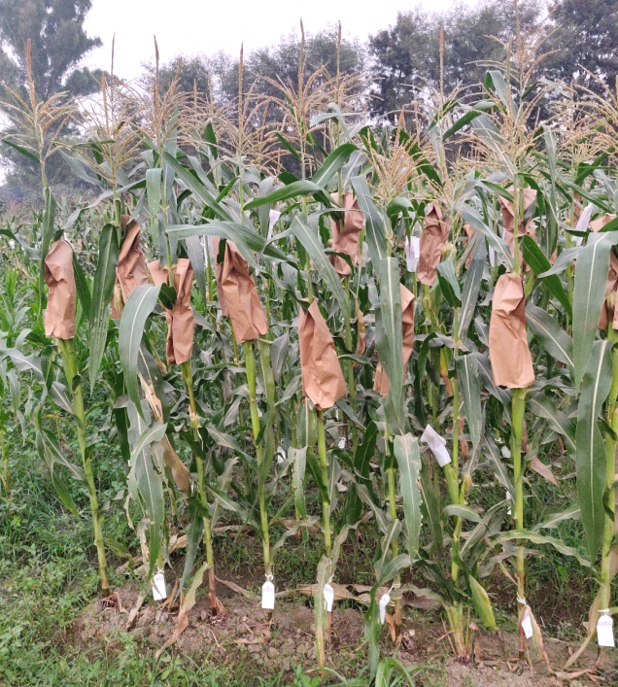 | 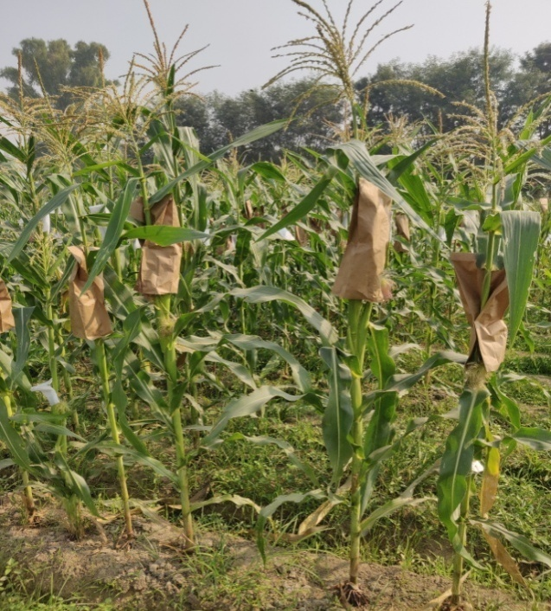
F₁ hybrids | F₂ population

