Divergent responses of biomass accumulation and its allocation to the altered precipitation regimes among different degraded grasslands in China

Tianxue Yang¹, Junda Chen¹, Xiaoyue Zhong¹, Xuechen Yang¹, Gui Wang¹, Yuan Yao¹, Marcelo Sternberg², Wei Sun^{1, *}

¹ Key Laboratory of Vegetation Ecology, Ministry of Education, Institute of Grassland Science, Northeast Normal University, Changchun, Jilin 130024, PR China
² School of Plant Sciences and Food Security, Wise Faculty of Life Sciences, Tel Aviv University, Tel Aviv, Israel

*Corresponding Author: Wei Sun
E-mail: sunwei@nenu.edu.cn
Telephone number: +86 15844006156

ORCID ID
Tianxue Yang https://orcid.org/0000-0002-0305-6873
Marcelo Sternberg http://orcid.org/0000-0001-8710-4141

Wei Sun https://orcid.org/0000-0002-1601-2159

Table S1 Plant functional groups investigated at the end of August in the lightly degraded (LDG), moderately degraded (MDG) and severely degraded grasslands (SDG)
Degraded grasslands | Dominant species | Gramineous species | Forbs
LDG | Leymus chinensis | Hemarthria altissima | Suaeda glauca
LDG | Leymus chinensis | Setaria viridis | Kochia scoparia
LDG | Leymus chinensis | Chloris virgata | Chenopodium glaucum
LDG | Leymus chinensis | Phragmites communis | Carex duriuscula
LDG | Leymus chinensis | Echinochloa crusgalli | Taraxacum mongolicum
LDG | Leymus chinensis | Calamagrostis epigeios | Polygonum aviculare
LDG | Leymus chinensis | Puccinellia tenuiflora | Portulaca oleracea
MDG | P. tenuiflora | L. chinensis | Glaux maritima
MDG | P. tenuiflora | S. viridis | S. glauca
MDG | P. tenuiflora | P. chinampoensis | T. mongolicum
MDG | P. tenuiflora | C. epigeios | P. sibiricum
MDG | P. tenuiflora | C. virgata | Ranunculus japonicus
SDG | C. virgata |  | S. glauca

Table S2 Soil properties (mean ± SD) of the lightly degraded (LDG), moderately degraded (MDG) and severely degraded grasslands (SDG). Different lowercase letters indicate significant differences at 0.05 level among the grasslands differed in degradation level
Variables | Degraded grasslands
Variables | LDG | MDG | SDG
pH value | 9.40 ± 0.16 b | 9.60 ± 0.04 b | 10.17 ± 0.04 a
Electric conductivity (dS cm⁻¹) | 1.51 ± 0.20 ab | 1.15 ± 0.05 b | 1.66 ± 0.09 a
Bulk density (g cm⁻³) | 1.31 ± 0.05 b | 1.42 ± 0.10 ab | 1.62 ± 0.02 a
Total carbon (g kg⁻¹) | 14.12 ± 2.32 a | 11.76 ± 0.98 a | 5.45 ± 0.26 b
Total nitrogen (g kg⁻¹) | 1.38 ± 0.17 a | 1.24 ± 0.10 a | 0.47 ± 0.03 b
Total organic carbon (g kg⁻¹) | 10.65 ± 1.93 a | 8.43 ± 0.95 a | 3.40 ± 0.10 b

Table S3 Soil inorganic nitrogen content (SINC) (mg kg⁻¹) under the four precipitation patterns in the lightly degraded (LDG), moderately degraded (MDG) and severely degraded grasslands (SDG). CPF-control precipitation frequency, DPF-the decreased precipitation frequency treatment, CPA-control precipitation amount, IPA-the increased precipitation amount treatment. Different lowercase letters indicate significant differences at P < 0.05 level among the precipitation patterns in an identical soil layer in each grassland by multicomparison of LSD test. P values of ANOVA results in the univariate GLMs for the effects of degradation level of grassland (DL), the precipitation frequency (PF) and precipitation amount (PA), and their interaction are presented
Variables | Soil layer (cm) | Degraded grasslands | Precipitation patterns |  |  |  | ANOVA results
Variables | Soil layer (cm) | Degraded grasslands | CPF+CPA | DPF+CPA | CPF+IPA | DPF+IPA | ANOVA results
SINC | 0–10 | LDG | 8.88 ± 1.66 bc | 4.38 ± 0.71 c | 15.94 ± 2.38 a | 9.42 ± 1.31 b
  DL: < 0.001 | DL × PF: < 0.001
  PF: 0.036 | DL × PA: 0.012
  PA: < 0.001 | PF × PA: 0.063
   | DL × PF × PA: 0.018
SINC | 0–10 | MDG | 8.30 ± 0.62 b | 6.25 ± 0.60 c | 9.04 ± 0.75 b | 14.77 ± 0.21 a
SINC | 0–10 | SDG | 5.32 ± 0.43 a | 3.98 ± 0.52 b | 5.22 ± 0.42 a | 2.56 ± 0.28 c
SINC | 10–30 | LDG | 15.44 ± 1.66 a | 4.56 ± 0.67 c | 8.79 ± 0.55 b | 6.91 ± 0.72 bc
  DL: < 0.001 | DL × PF: < 0.001
  PF: 0.001 | DL × PA: 0.035
  PA: 0.087 | PF × PA: 0.021
   | DL × PF × PA: <0.001
SINC | 10–30 | MDG | 3.61 ± 0.28 b | 7.12 ± 0.42 a | 6.25 ± 0.72 a | 6.21 ± 1.18 a
SINC | 10–30 | SDG | 4.67 ± 0.69 a | 3.37 ± 0.12 ab | 2.80 ± 0.19 b | 2.85 ± 0.87 b

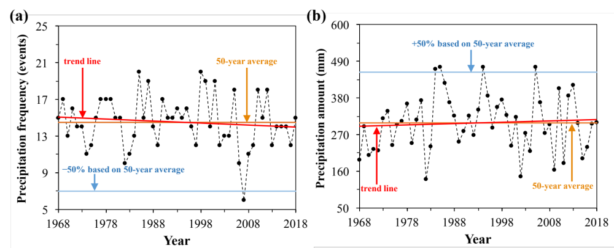
Fig. S1 Historical records of (a) precipitation frequency and (b) precipitation amount records of growing season (May-August) from 1968−2018 of the studied area
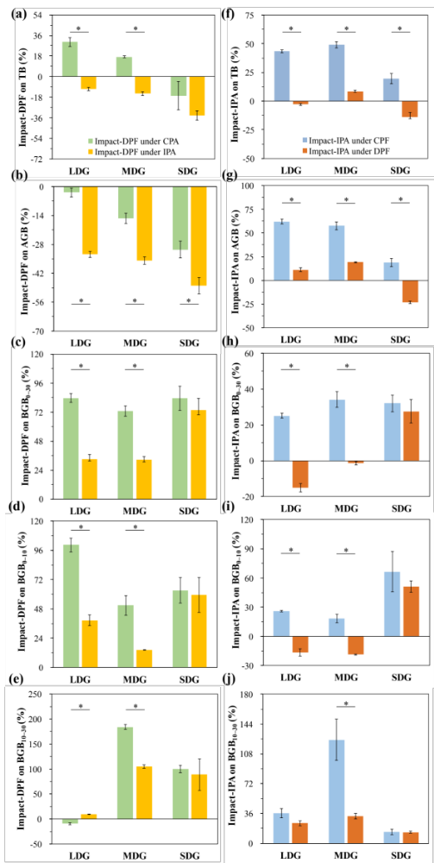
Fig. S2 Impact values of the decreased precipitation frequency treatment (DPF) on (a) total biomass (TB), (b) aboveground biomass (AGB), (c) belowground biomass in the 0–30 cm soil layer (BGB_{0–30}), (d) belowground biomass in the 0–10 cm soil layer (BGB_{0–10}), and (e) belowground biomass in the 10–30 cm soil layer (BGB_{10–30}), and the impact values of the increased precipitation amount treatment (IPA) on (f) total biomass, (g) ABG, (h) BGB_{0–30}, (i) BGB_{0–10}, and (j) BGB_{10–30} in the lightly degraded (LDG), moderately degraded (MDG) and severely degraded grasslands (SDG). CPA-control precipitation amount; CPF-control precipitation frequency. Impact-DPF under CPA = (X_{DPF+CPA} − X_{CPF+CPA}) / X_{CPF+CPA}, where X represents biomass. Impact-DPF under IPA = (X_{DPF+IPA} − X_{CPF+IPA}) / X_{CPF+IPA}. Impact-IPA under CPF = (X_{CPF+IPA} − X_{CPF+CPA}) / X_{CPF+CPA}. Impact-IPA under DPF = (X_{DPF+IPA} − X_{DPF+CPA}) / X_{DPF+CPA}. * indicates Independence Samples T-test results (P < 0.05)

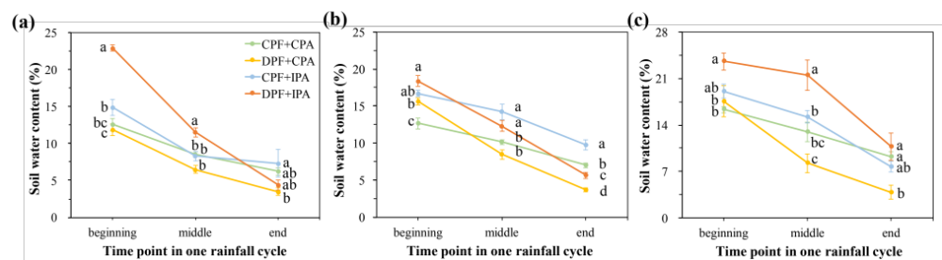
Fig. S3 Soil water content in the surface soil layer (0–10 cm) at the beginning (one day after a rainfall event), the middle and the end (one day before next rainfall event) of one rainfall cycle under the four precipitation patterns in (a) the lightly degraded, (b) moderately degraded, and (c) severely degraded grasslands. CPF-control precipitation frequency, DPF-the decreased precipitation frequency treatment, CPA-control precipitation amount, IPA-the increased precipitation amount treatment. Different lowercase letters-significant differences in soil water content among the precipitation patterns in each time point for each grassland (P < 0.05)

