Supplementary Materials for:

Experimental evidence of climate change extinction risk in tropical plants.

Authors: Emily C. Hollenbeck, Dov F. Sax
Correspondence to: hollenbeck.ec@gmail.com

This PDF file includes:

Supplementary text
Figs. S1 to S12
Tables S1 to S7

Supplementary Text

Acknowledgements
We received research permits from Sistema Nacional de Areas de Conservation (SINAC) in Costa Rica from 2013-17, and the Ministerio de Ambiente in Panama in 2016.
The following individuals and organizations generously granted permission to collect data on their property: The Monteverde Cloud Forest Biological Preserve (Tropical Science Center), Reserva Curi-Cancha, Bosque Eterno de los Niños, the Leitón family, Frank Joyce & Katy van Dusen, Braulio Carrillo National Park (Costa Rica), La Selva Biological Station (Organization for Tropical Studies), La Fortuna Reserve (Smithsonian Tropical Research Institute),Volcán Barú National Park (Panama).
We were aided in logistics by the Monteverde Institute, the Monteverde Cloud Forest Biological Preserve, the Organization for Tropical Studies, and the Smithsonian Tropical Research Institute.
We are grateful for assistance from many individuals in field data collection: Phoebe Hopkins, Cecilia Cerrilla, Yesenia Valverde, Emmaline Suchland, Adam Moreno, Krystal House, Tony Obando, Eladio Cruz, Juan Huertas, David Miranda, Chalo Miranda, Bady Garcia, Fernando Obando, Chico Fuentes, Mino Fuentes, Elier Zuñiga, Jocksan Mata, Marcos Molina, Gilbert Hurtado, and many kind and supportive employees of the Monteverde Cloud Forest Biological Reserve.
We received generous help learning the taxonomy of our study species from Robbin Moran, Fernando Bittencourt Matos, Alexander Rojas, and Guido Mathieu.
The manuscript benefited from helpful discussion over the course of the study with Jon Witman, Erika Edwards, and Sohini Ramachandran.

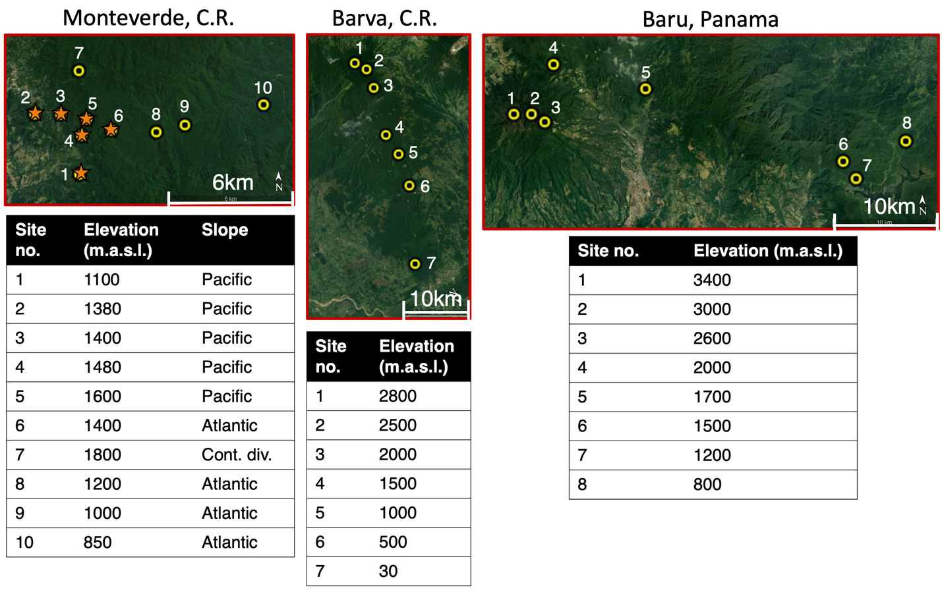Fig. S1. Maps of surveyed elevational gradients. Colored points show the exact locations of survey sites on three mountains in Costa Rica and western Panama, with their elevations listed below. Transplant sites in Monteverde are illustrated with orange stars.

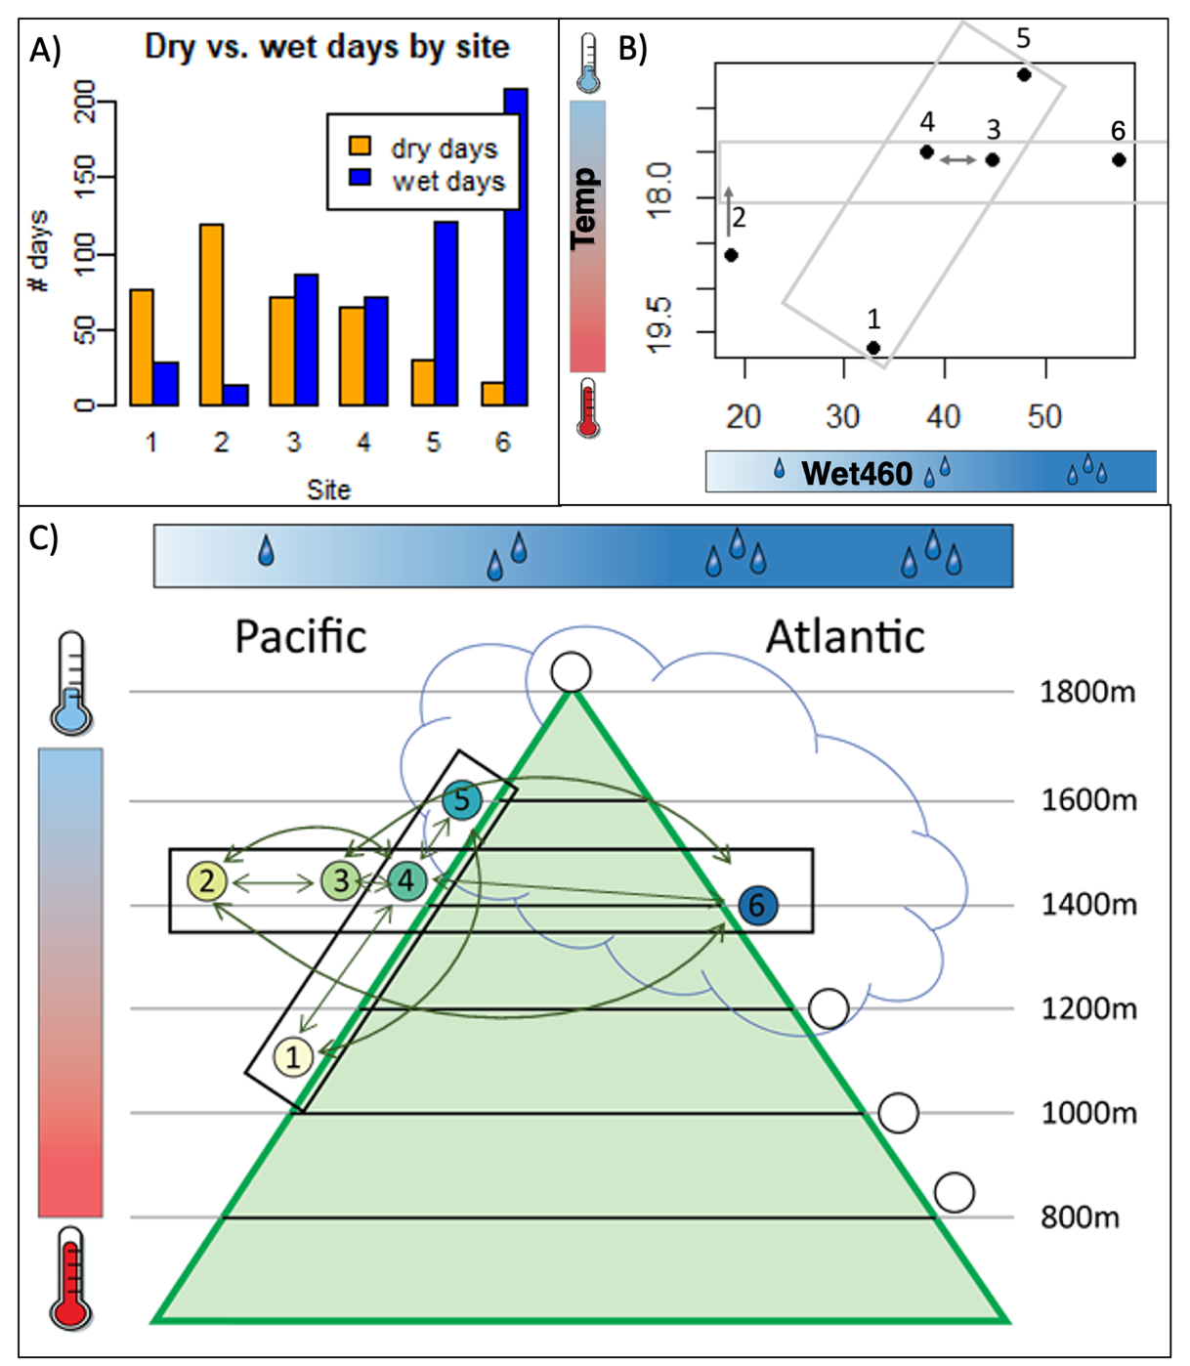Fig. S2. Climatic gradients in Monteverde provided the context for our transplant experiment and range surveys. Sites 1-6 were used for the transplant experiment. White circles represent additional sites included in range surveys (Fig. S1). A) Number of dry and wet days during an 11-month period. B) Temperature (y axis; inverse so cooler temperatures are higher) vs. average leaf wetness (LWS) (x axis, “Wet460”) during an 11-month period. See methods for details on climate data collection and calculations. C) Study sites illustrated along qualitative representations of the climate gradients quantified in A) and B), as well as elevational gradients. Each box (in B and C) shows a transect along which transplants took place: a horizontal “moisture” transect, with four sites (2, 3, 4, and 6) around the same elevation, so they have similar temperature profiles (although site 2 appears to be warmer, B), but vary greatly in their moisture availability. The Pacific elevational transect (sites 1, 4, and 5) crosses gradients of both temperature and moisture availability, but the change in moisture is not as dramatic as that along the horizontal transect. Transplants were moved reciprocally between all sites along each gradient. Each arrow represents a “transplant direction,” where transplants moved between a particular site pair.

We note that sites along our aridity transect (sites 2, 3, 4 and 6) exhibit a pronounced gradient in leaf wetness, but that the relative position of sites 3 and 4 along this gradient is dependent on the specific measure of aridity examined. Based on an index that incorporates temperature and average leaf wetness, site 4 is more arid than site 3 (Panel B). This relative position is swapped when considering the total number of dry days (Panel A). This latter measure is more consistent with our qualitative perception of dryness. This measure is also consistent with species occurrence data, with many mesic species (found in cloud forest) present at site 4 but not site 3, and with survival data, as several species had survival boundaries such that they survived at site 4 and wetter, but not at site 3 and drier. Of course, different species might be sensitive to different aspects of aridity and no single measure is best, particularly when the relative difference between two sites is minimal. We performed our primary analysis of survival versus aridity (Figs. 2, S6, S7) based on the values shown in Panel B, but found that our overall results are robust to the position of these two sites.

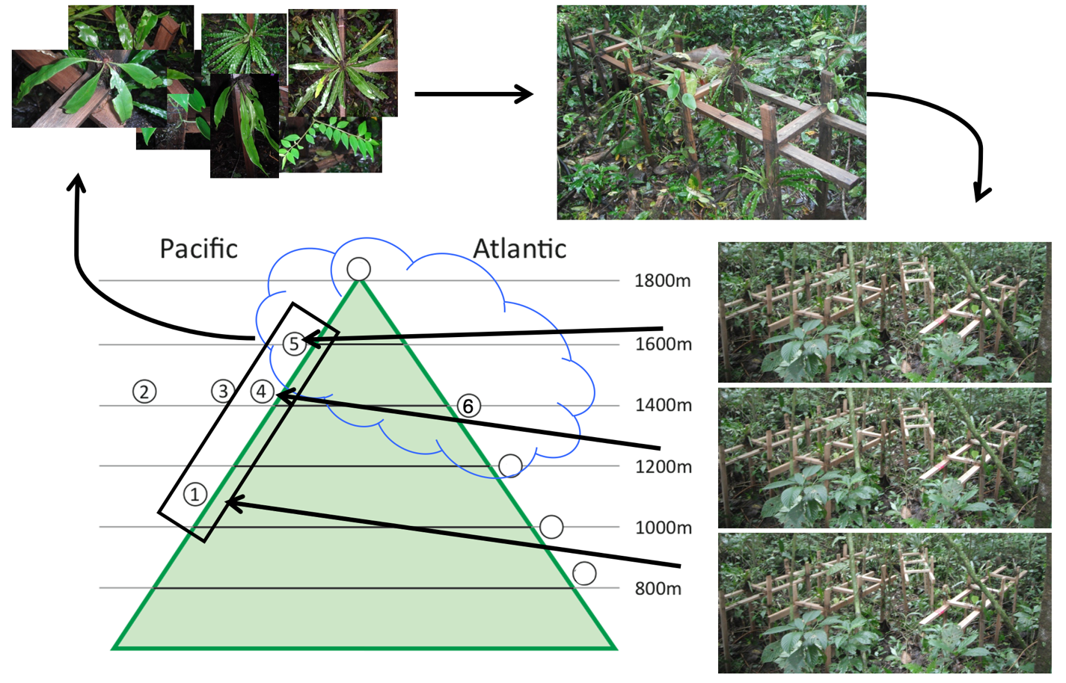

Fig. S3. Illustration of transplant experimental process. Using site 5 as an example, the seven species appropriate for the transplant experiment at this site (see Methods) were collected in the forest understory and attached to wooden scaffolds (actual examples pictured). Four identical replicate scaffolds were created for each destination site along the gradient; in this case, to sites 1, 4, and 5. The scaffolds returned to their native site 5 are the experimental controls.

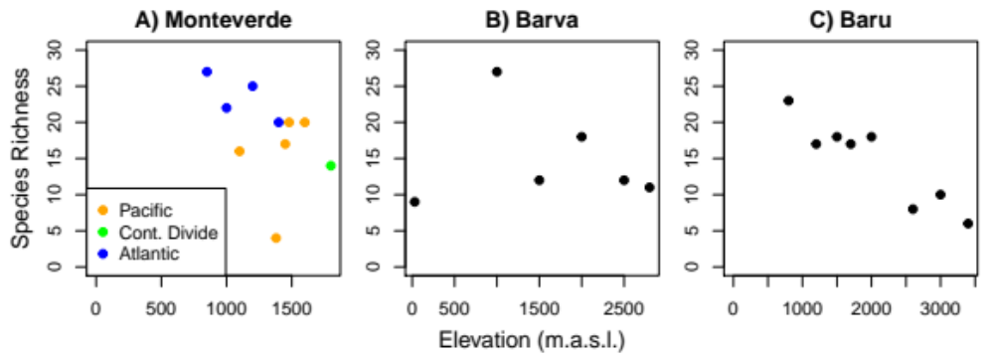
Fig. S4. Epiphyte diversity across elevational transects. Number of species identified in the genera Elaphoglossum and Peperomia, at each survey site along elevational transects on three mountains. Note that the highest elevation differs between mountains. At Monteverde, colors indicate sites on different slopes of the mountain. The Pacific side is (seasonally) drier than the Atlantic slope, and the top of the mountain lies at the continental divide.

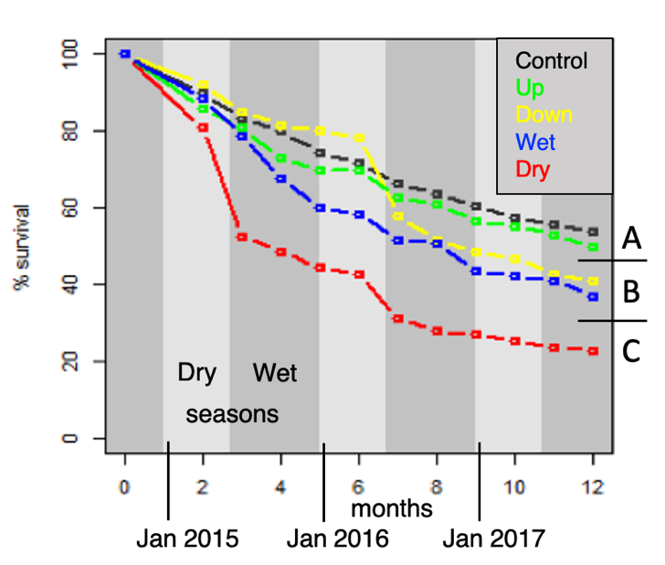
Fig. S5. Survival of epiphyte transplants over time for three years shows that greater mortality occurred during the dry season for transplants moved to warmer or drier sites than their native range. Dotted lines show the overall average survival of all transplants based on the direction they were moved across the climatic gradients from Figure S2: To sites that were higher (Up) or lower (Down) along the elevational transect; to sites with climates wetter (Wet) or drier (Dry) along the moisture transect; and plants that were manipulated but ultimately deposited at their native site (Control). Percent survival was measured every 3 months starting in September 2014. Dark and light grey illustrate the approximate boundaries of the wet (May-December) and dry (January-April) seasons. Statistically significant differences between groups, calculated using Kaplan-Meier curves (see methods), are indicated by the letters A, B, and C.

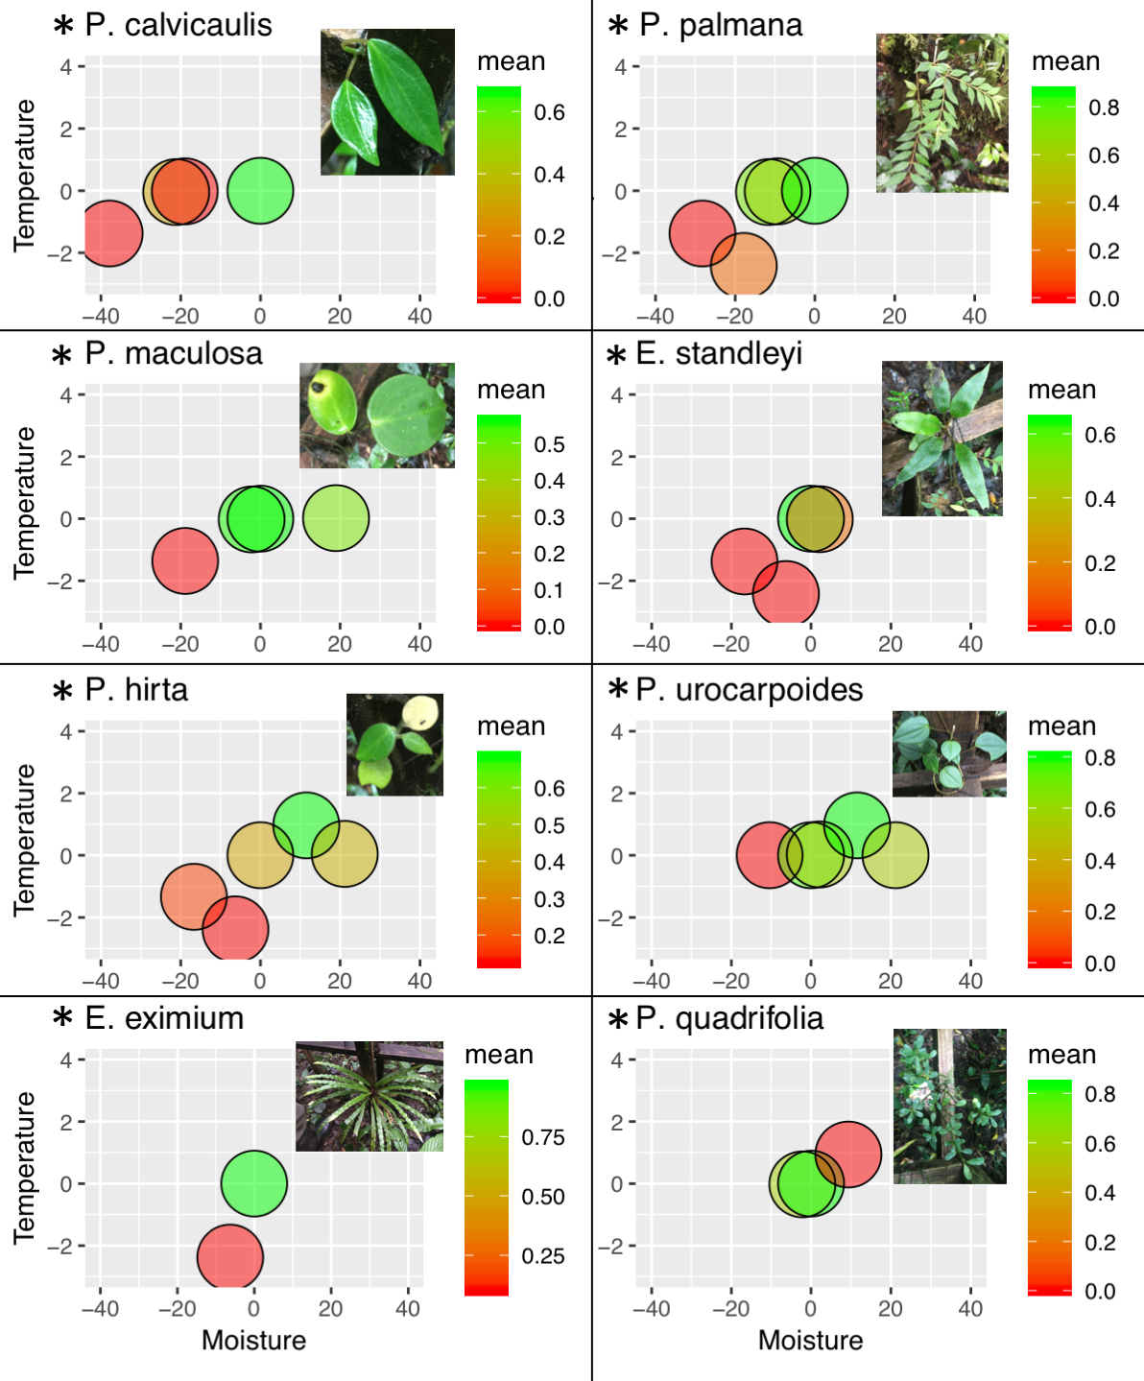
Fig. S6. Individual species’ results from the 3-year transplant experiment. Temperature and moisture axes are plotted as in Figure 2; axes are identical for all species. Circles represent a set of replicates of that species transplanted at a climatic distance from the native range boundary as indicated by position along the x (moisture; LWS) and y (Temperature) axes; all transplants within the native range are at (0,0). Circle color indicates mean percent survival at that site; note that species have different color scales. Asterisks indicate species for which Logrank tests of K-M survival curves indicated a significant effect of destination site on transplant survival with p < 0.05 (Table S1; see Fig S8 for an example).

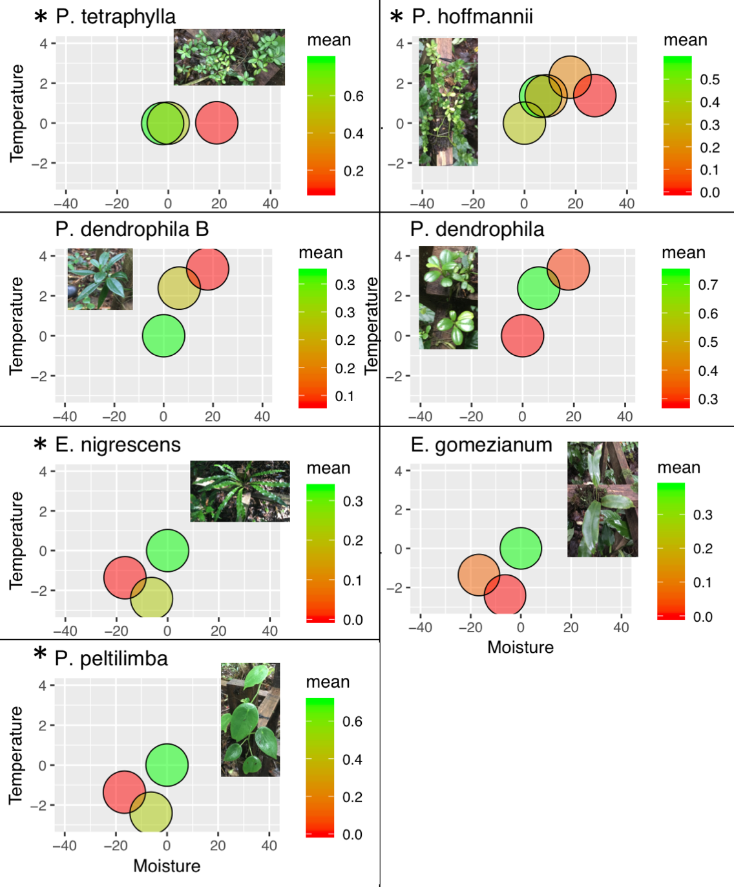
Fig. S7. Individual species’ results from the 3-year transplant experiment (continued). Temperature and moisture axes are plotted as in Figure 2; axes are identical for all species. Circles represent a set of replicates of that species transplanted at a climatic distance from the native range boundary as indicated by position along the x (moisture; LWS) and y (Temperature) axes; all transplants within the native range are at (0,0). Circle color indicates mean percent survival at that site; note that species have different color scales. Asterisks indicate species for which Logrank tests of K-M survival curves indicated a significant effect of destination site on transplant survival with p < 0.05 (Table S1; see Fig S8 for an example).
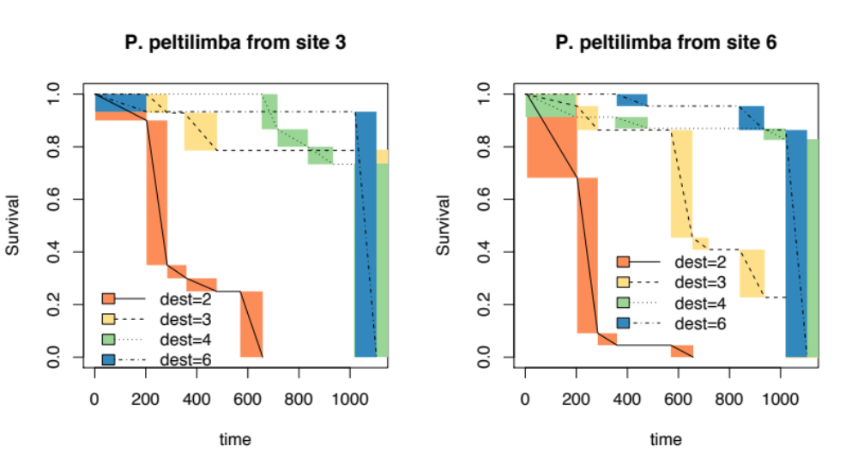
Fig. S8.
Peperomia peltilimba population of origin has an impact on transplant survival at a destination site (3) on the dry periphery of the native range. Kaplan-Meier curves are illustrated over time (x axis shows days after transplant) for each transplant destination (colors) coming from origin sites 3 and 6 (two panels). Transplants from site 3 that went to destination sites 3, 4, and 6 are not statistically different from each other. However, transplants from site 6 suffered significantly lower survival at site 3 than sites 4 and 6 (Table S2). This indicates that the population from site 6, which is wetter, was unable to survive as well in the drier site 3 – even though conspecific populations native to site 3 had equally high survival throughout the range.

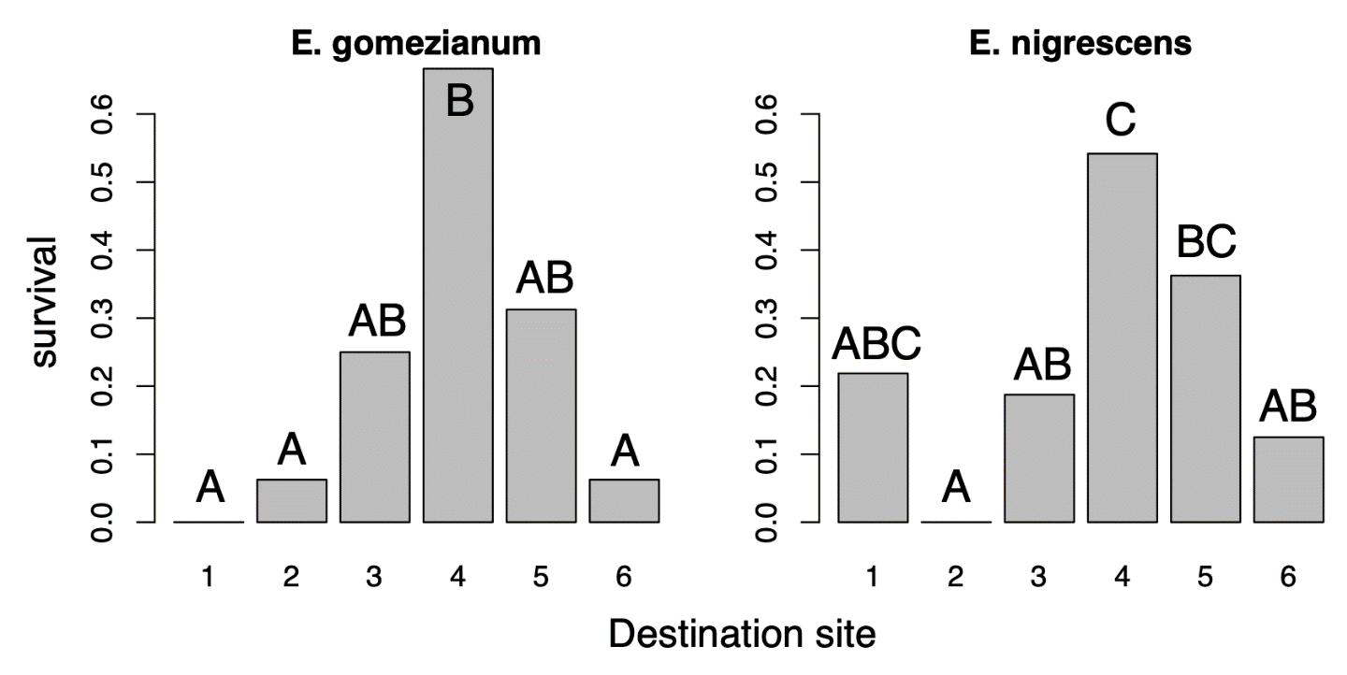
Fig. S9. Elaphoglossum gomezianum and E. nigrescens have reduced survival at both wet and dry peripheries of their native range, compared to the most central part of their range along the studied transects. Bars illustrate the fraction of plants alive (y axis) of all individuals from each species after 3 years post-transplant to each destination site. Both species were found growing naturally at all sites except site 2. For E. gomezianum, survival was significantly higher at site 4 than at sites 1, 2, and 6, while for E. nigrescens, site 4 survival was significantly higher than sites 2, 3, and 6, while survival at site 5 was significantly higher than at site 2. Significance of destination site was determined by a one-way ANOVA, and pairwise significant differences between sites were calculated with a Tukey HSD (Table S3).

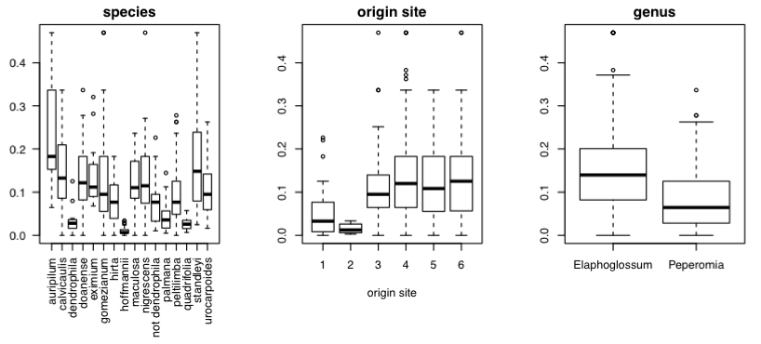
Fig. S10. Baseline herbivory by species, origin site, and genus. All three factors explain significant variation in baseline herbivory according to ANOVA (see Table S3). Each box plot illustrates the herbivory levels at the beginning of the experiment for all plants within each category; the Y axis is log (fraction herbivory + 1). Raw data were transformed with log(+1) prior to visualization and statistical tests.

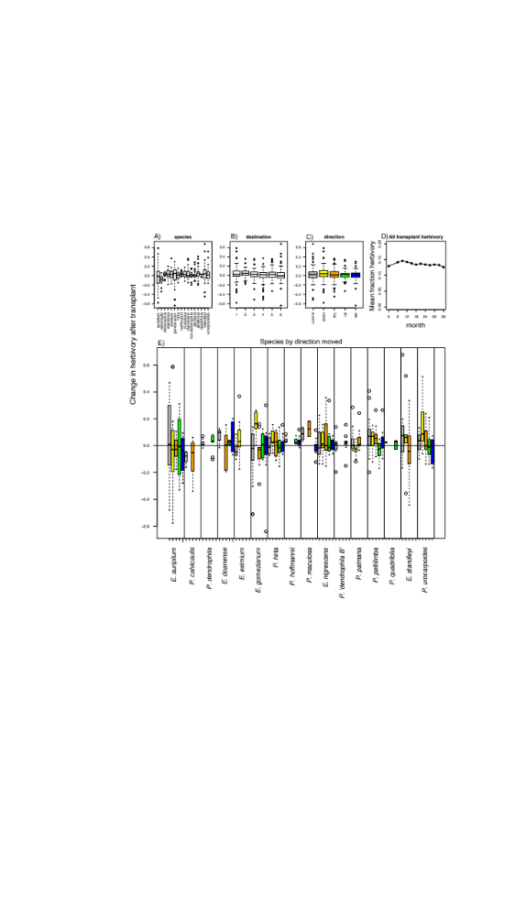

Fig. S11. Change in herbivory after 3 years post-transplant. There was no significant effect of species, destination, direction, or species * direction on the change in herbivory from the beginning to the end of the experiment (Table S3). In panels A-C and E, each box plot illustrates the change in herbivory for all plants within each category that survived to the end of the experiment. Colors in panel E indicate transplant direction as labeled in C. The Y axis is log ((difference in fraction herbivory from first to last timepoint) + 1). Raw data were transformed with log(+1) prior to visualization and statistical tests. Panel D shows mean herbivory (raw fraction herbivory values) in all transplants over time during the experiment.

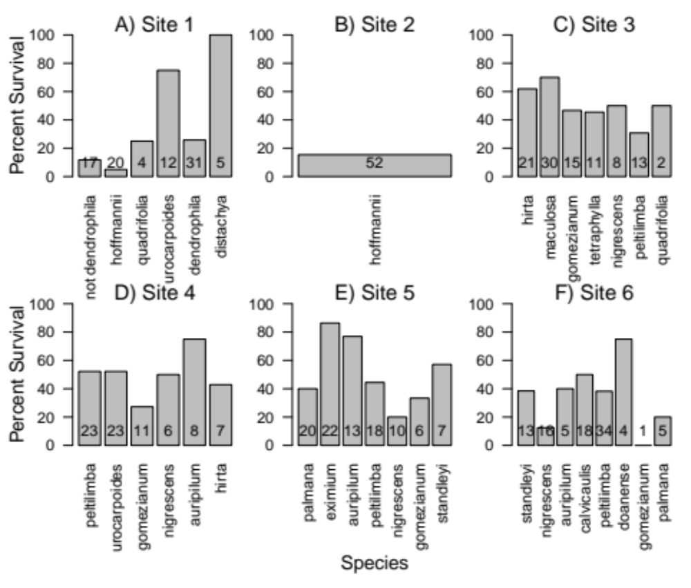
Fig. S12. Survival of unmanipulated forest control plants was low, species-dependent and highly idiosyncratic. Percent survival (y-axis) is shown for each species (x-axis bars) monitored as forest controls at each site (panels). Numbers on bars indicate sample size, e.g. initial number of control plants alive per species at each site at the beginning of the experiment. Error bars are not included because there is no replication; survival values are simply the % of individuals alive at the end of the experiment.

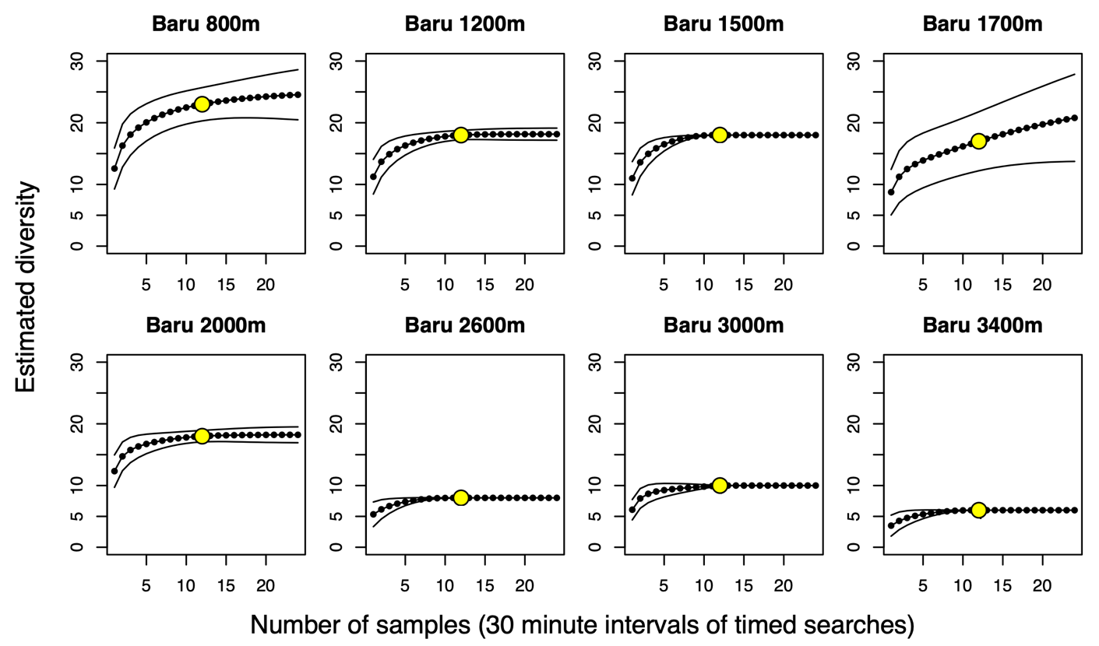
Fig. S13. Species-accumulation curves (SACs) for Baru sites calculated using EstimateS software. Points indicate the estimated diversity after a given number of sampling units; yellow dot is actual sampling effort, and lower sample numbers are interpolated while higher sample numbers are extrapolated. Asymptote is estimated actual diversity. Solid lines indicate 95% confidence interval.

genus | species | p value | Z statistic
P. | calvicaulis | 9.21E-13 | -7.141775258
E. | nigrescens | 2.39E-02 | -2.258707246
P. | peltilimba | 5.96E-22 | -9.630167215
P. | palmana | 9.17E-06 | -4.435922403
E. | standleyi | 3.00E-04 | -3.615024448
E. | eximium | 1.14E-10 | -6.447332908
E. | gomezianum | 8.47E-02 | -1.723985869
P. | urocarpoides | 1.49E-02 | -2.433640519
P. | hirta | 1.01E-02 | -2.573918508
P. | maculosa | 1.40E-02 | -2.456044919
P. | tetraphylla | 1.05E-02 | 2.560280639
P. | hoffmannii | 5.02E-03 | 2.805637173
P. | dendrophila | 2.17E-01 | -1.233548622
P. | "dendrophila B" | 2.03E-01 | 1.271835308
P. | quadrifolia | 1.00E-02 | NA
Table S1.
Logrank test of the impact of destination site on each species’ KM survival curve. Species for which transplant destination had a significant impact on survival with p<0.05 are shown in bold. Marginally significant (E. nigrescens, p=0.0847) shown in italics.

Site of origin: 3
pairs | score statistic | p
2 and 3 | 9.14 | 6.10E-06
2 and 4 | 10.5 | 5.80E-07
2 and 6 | 10.15 | 3.00E-07
3 and 6 | 1.05 | 2.80E-01
3 and 4 | 0.19 | 8.80E-01
4 and 6 | 1.52 | 1.70E-01
Site of origin: 6
pairs | score statistic | p
2 and 3 | 11.2 | 7.90E-06
2 and 4 | 11.96 | 6.80E-08
2 and 6 | 13.02 | 3.30E-09
3 and 6 | 8.66 | 2.60E-05
3 and 4 | 7.89 | 2.50E-04
4 and 6 | 0.54 | 6.80E-01

Table S2.
Pairwise comparisons of Asymptotic Logrank two-sample tests for P. peltilimba transplants to destination sites from different sites of origin. These correspond to the data illustrated in Fig S8. Bold rows indicate significant pairwise differences. The first table shows that for P. peltilimba individuals sourced from site 3 and transplanted to sites 2, 3, 4, and 6, survival was significantly lower at site 2 than at all other sites, but there were no significant differences between survival at destination sites 3, 4, and 6. The bottom table shows that, in contrast, for individuals sourced from site 6 (the wettest site), in addition to reduced survival at site 2, their survival was also significantly lower at site 3 compared to site 6. Survival at site 4 was not significantly different from either site 3 or site 6.

E. gomezianum |  |  |  |  |  | E. nigrescens
One-way ANOVA |  |  |  |  |  | One-way ANOVA
 | Df | Sum of squares | Mean square | F value | p value |  | Df | Sum of squares | Mean square | F value | p value
destination | 5 | 7.827 | 1.5655 | 5.237 | 0.0007 | destination | 5 | 5.316 | 1.0631 | 5.731 | 0.0002
Residuals | 46 | 13.751 | 0.2989 |  |  | Residuals | 62 | 11.5 | 0.1855
Two-way ANOVA |  |  |  |  |  | Two-way ANOVA
 | Df | Sum of squares | Mean square | F value | p value |  | Df | Sum of squares | Mean square | F value | p value
origin | 2 | 0.219 | 0.1097 | 0.36 | 0.6997 | origin | 3 | 1.154 | 0.3848 | 1.98 | 0.1286
destination | 5 | 7.617 | 1.5234 | 5.003 | 0.0012 | destination | 5 | 4.534 | 0.9069 | 4.667 | 0.0014
origin * destination | 5 | 1.867 | 0.3734 | 1.226 | 0.3152 | origin * destination | 8 | 1.217 | 0.1521 | 0.783 | 0.6197
Residuals | 39 | 11.874 | 0.3045 |  |  | Residuals | 51 | 9.91 | 0.1943
Tukey HSD pairwise comparisons |  |  |  |  |  | Tukey HSD pairwise comparisons
site pairs | mean difference | lower bound | upper bound | p value |  | site pairs | mean difference | lower bound | upper bound | p value
2-1 | 0.098 | -0.715 | 0.911 | 0.9992 |  | 2-1 | -0.360 | -0.938 | 0.218 | 0.4538
3-1 | 0.393 | -0.420 | 1.205 | 0.7050 |  | 3-1 | -0.055 | -0.633 | 0.524 | 0.9998
4-1 | 1.047 | 0.305 | 1.789 | 0.0016 |  | 4-1 | 0.452 | -0.096 | 1.001 | 0.1634
5-1 | 0.491 | -0.322 | 1.304 | 0.4785 |  | 5-1 | 0.184 | -0.450 | 0.817 | 0.9560
6-1 | 0.098 | -0.715 | 0.911 | 0.9992 |  | 6-1 | -0.142 | -0.720 | 0.436 | 0.9786
3-2 | 0.295 | -0.518 | 1.107 | 0.8878 |  | 3-2 | 0.305 | -0.212 | 0.822 | 0.5132
4-2 | 0.949 | 0.207 | 1.691 | 0.0053 |  | 4-2 | 0.812 | 0.329 | 1.296 | 0.0001
5-2 | 0.393 | -0.420 | 1.205 | 0.7050 |  | 5-2 | 0.544 | -0.034 | 1.122 | 0.0769
6-2 | 0.000 | -0.813 | 0.813 | 1.0000 |  | 6-2 | 0.218 | -0.299 | 0.735 | 0.8150
4-3 | 0.654 | -0.087 | 1.396 | 0.1122 |  | 4-3 | 0.507 | 0.023 | 0.991 | 0.0347
5-3 | 0.098 | -0.715 | 0.911 | 0.9992 |  | 5-3 | 0.238 | -0.340 | 0.816 | 0.8294
6-3 | -0.295 | -1.107 | 0.518 | 0.8878 |  | 6-3 | -0.087 | -0.604 | 0.430 | 0.9961
5-4 | -0.556 | -1.298 | 0.186 | 0.2445 |  | 5-4 | -0.269 | -0.817 | 0.280 | 0.7023
6-4 | -0.949 | -1.691 | -0.207 | 0.0053 |  | 6-4 | -0.594 | -1.078 | -0.111 | 0.0077
6-5 | -0.393 | -1.205 | 0.420 | 0.7050 |  | 6-5 | -0.326 | -0.904 | 0.253 | 0.5655
Table S3: ANOVA and Tukey HSD results showing impact of destination site on survival of transplants. We found a statistically significant effect of destination site (p=0.001), but not origin site or the interaction of origin * destination, in the survival of both E. gomezianum and E. nigrescens after 3 years post-transplant, using a two-way ANOVA. Arcsin transformation was applied to percentage survival (dependent variable) prior to analysis. Pairwise differences are shown, calculated with Tukey HSD post-hoc test from a one-way ANOVA measuring the impact of destination site on 3-year survival of each species. Significant differences are shown in bold. Data visualized in Figure S9.
Baseline herbivory
 | Impact on baseline herbivory:
 | Independent variable | Df | Sum Sq | Mean Sq | F value | p
1-way ANOVAs | species | 15 | 1.504 | 0.10028 | 16.29 | <2e-16
 | origin site | 5 | 0.532 | 0.10637 | 13.17 | 4.98E-12
 | genus | 1 | 0.76 | 0.7605 | 101 | <2e-16
2-way ANOVAs | species * origin | 11 | 0.0852 | 0.00775 | 1.269 | 0.239
 | genus * origin | 3 | 0.06 | 0.02 | 2.817 | 0.0387

Change in herbivory
 | Impact on change in herbivory:
 | Independent variable | Df | Sum Sq | Mean Sq | F value |  |  | p
1-way ANOVAs | species | 15 | 0.364 | 0.02425 |  | 1.426 |  | 0.129
 | destination | 5 | 0.186 | 0.03713 |  | 2.182 |  | 0.0547
 | direction | 4 | 0.109 | 0.02735 |  | 1.598 |  | 0.173
2-way ANOVAs
 | species * destination | 54 | 1.017 | 0.01884 |  | 1.129 |  | 0.253
 | species * direction | 36 | 0.767 | 0.02129 |  | 1.285 |  | 0.128

Table S4.
ANOVA results for herbivory. Herbivory rates were transformed with log (+1) prior to analysis and visualization. We show that species, origin site, genus, and the interaction of genus * origin significantly impact baseline, natural herbivory rates in this system (p values in table below; significant values of p<0.05 in bold). However, the transplant experiment did not cause any systematic changes in herbivory; no significant effects were detected from species, direction of movement, destination site, or the interactions between species * direction or species * destination on changes in herbivory levels during the experiment (although the effect of destination site was marginally significant with p=0.055). Overall herbivory did not change throughout the 3-year course of the experiment. Thus, we conclude that herbivory pressure did not contribute to differential survival of species moved outside their native range.

genus | species | origin | destination | N
E. | eximium | 5 | 1 | 20
E. | eximium | 5 | 4 | 20
E. | eximium | 5 | 5 | 20
E. | gomezianum | 3 | 2 | 9
E. | gomezianum | 3 | 3 | 9
E. | gomezianum | 3 | 4 | 8
E. | gomezianum | 3 | 6 | 9
E. | gomezianum | 4 | 1 | 4
E. | gomezianum | 4 | 2 | 4
E. | gomezianum | 4 | 3 | 4
E. | gomezianum | 4 | 4 | 4
E. | gomezianum | 4 | 5 | 7
E. | gomezianum | 4 | 6 | 4
E. | gomezianum | 5 | 1 | 4
E. | gomezianum | 5 | 4 | 4
E. | gomezianum | 5 | 5 | 6
E. | nigrescens | 3 | 2 | 7
E. | nigrescens | 3 | 3 | 9
E. | nigrescens | 3 | 4 | 7
E. | nigrescens | 3 | 6 | 8
E. | nigrescens | 4 | 1 | 15
E. | nigrescens | 4 | 2 | 16
E. | nigrescens | 4 | 3 | 16
E. | nigrescens | 4 | 4 | 16
E. | nigrescens | 4 | 5 | 19
E. | nigrescens | 4 | 6 | 16
E. | nigrescens | 5 | 1 | 10
E. | nigrescens | 5 | 4 | 17
E. | nigrescens | 5 | 5 | 12
E. | nigrescens | 6 | 2 | 14
E. | nigrescens | 6 | 3 | 14
E. | nigrescens | 6 | 4 | 15
E. | nigrescens | 6 | 6 | 15
E. | standleyi | 5 | 1 | 4
E. | standleyi | 5 | 4 | 4
E. | standleyi | 5 | 5 | 4
E. | standleyi | 6 | 2 | 6
E. | standleyi | 6 | 3 | 7
E. | standleyi | 6 | 4 | 7
E. | standleyi | 6 | 6 | 7
P. | calvicaulis | 6 | 2 | 20
P. | calvicaulis | 6 | 3 | 20
P. | calvicaulis | 6 | 4 | 24
P. | calvicaulis | 6 | 6 | 18
P. | dendrophila | 1 | 1 | 18
P. | dendrophila | 1 | 4 | 16
P. | dendrophila | 1 | 5 | 16
P. | hirta | 3 | 2 | 13
P. | hirta | 3 | 3 | 12
P. | hirta | 3 | 4 | 13
P. | hirta | 3 | 6 | 12
P. | hirta | 4 | 1 | 8
P. | hirta | 4 | 2 | 9
P. | hirta | 4 | 3 | 8
P. | hirta | 4 | 4 | 9
P. | hirta | 4 | 5 | 11
P. | hirta | 4 | 6 | 10
P. | hoffmannii | 1 | 1 | 16
P. | hoffmannii | 1 | 4 | 11
P. | hoffmannii | 1 | 5 | 14
P. | hoffmannii | 2 | 2 | 20
P. | hoffmannii | 2 | 3 | 21
P. | hoffmannii | 2 | 4 | 19
P. | hoffmannii | 2 | 6 | 21
P. | maculosa | 3 | 2 | 13
P. | maculosa | 3 | 3 | 14
P. | maculosa | 3 | 4 | 15
P. | maculosa | 3 | 6 | 14
P. | "dendrophila B" | 1 | 1 | 16
P. | "dendrophila B" | 1 | 4 | 21
P. | "dendrophila B" | 1 | 5 | 21
P. | palmana | 5 | 1 | 16
P. | palmana | 5 | 4 | 15
P. | palmana | 5 | 5 | 16
P. | palmana | 6 | 2 | 8
P. | palmana | 6 | 3 | 8
P. | palmana | 6 | 4 | 9
P. | palmana | 6 | 6 | 6
P. | peltilimba | 3 | 2 | 20
P. | peltilimba | 3 | 3 | 14
P. | peltilimba | 3 | 4 | 15
P. | peltilimba | 3 | 6 | 16
P. | peltilimba | 4 | 1 | 20
P. | peltilimba | 4 | 2 | 22
P. | peltilimba | 4 | 3 | 20
P. | peltilimba | 4 | 4 | 19
P. | peltilimba | 4 | 5 | 20
P. | peltilimba | 4 | 6 | 20
P. | peltilimba | 5 | 1 | 22
P. | peltilimba | 5 | 4 | 20
P. | peltilimba | 5 | 5 | 21
P. | peltilimba | 6 | 2 | 22
P. | peltilimba | 6 | 3 | 21
P. | peltilimba | 6 | 4 | 22
P. | peltilimba | 6 | 6 | 21
P. | quadrifolia | 1 | 1 | 4
P. | quadrifolia | 1 | 4 | 6
P. | quadrifolia | 1 | 5 | 6
P. | tetraphylla | 3 | 2 | 12
P. | tetraphylla | 3 | 3 | 12
P. | tetraphylla | 3 | 4 | 13
P. | tetraphylla | 3 | 6 | 13
P. | urocarpoides | 1 | 1 | 14
P. | urocarpoides | 1 | 4 | 12
P. | urocarpoides | 1 | 5 | 13
P. | urocarpoides | 4 | 1 | 20
P. | urocarpoides | 4 | 2 | 19
P. | urocarpoides | 4 | 3 | 20
P. | urocarpoides | 4 | 4 | 21
P. | urocarpoides | 4 | 5 | 20
P. | urocarpoides | 4 | 6 | 21
Table S5.
Sample sizes for transplant experiment. N indicates the number of individuals moved of each species from each unique site of origin to site of destination. “Origin” and “destination” refer to site numbers from Monteverde used throughout the study.

 | elevation | 2800 | 2500 | 2000 | 1500 | 1000 | 500 | 30
E. | alfredii | 26.5 | 103.8 | 0 | 0 | 0 | 0 | 0
E. | conspersum | 9.9 | 5.9 | 0 | 0 | 0 | 0 | 0
E. | furfuraceum | 26.3 | 1.3 | 0.1 | 0 | 0 | 0 | 0
E. | papillosum | 24.8 | 0.3 | 0 | 0 | 0 | 0 | 0
E. | squamipes | 4.2 | 0 | 0 | 0 | 0 | 0 | 0
E. | lehmannianum | 0.7 | 0 | 0.1 | 0 | 0 | 0 | 0
P. | galioides | 0.3 | 0 | 0 | 0 | 0 | 0 | 0
E. | moranii | 0.1 | 0.1 | 8.8 | 0.4 | 1.5 | 0 | 0
E. | hammellianum | 0 | 1.6 | 0.3 | 0 | 1 | 0 | 0
E. | peltatum | 0 | 35.2 | 20.4 | 11 | 0.6 | 8.6 | 0.4
E. | subcuspidatum | 0 | 2.8 | 8.7 | 0 | 0 | 0 | 0
E. | eximium | 0 | 0.1 | 89.3 | 4.5 | 0 | 0 | 0
E. | gloeorrhizum | 0 | 2.3 | 4.8 | 0 | 0 | 0 | 0
E. | lingua | 0 | 0 | 1.4 | 0 | 0 | 0 | 0
E. | auripilum | 0 | 0 | 0.6 | 0 | 0 | 0 | 0
E. | proximum | 0 | 0 | 0.5 | 5.8 | 0.25 | 0 | 0
P. | palmana | 0 | 0 | 5.6 | 1.8 | 0.5 | 0 | 0
P. | pittieri | 0 | 0 | 7.4 | 8.3 | 0 | 0 | 0
P. | hernandiifolia | 0 | 0 | 14.3 | 18.4 | 12.4 | 0 | 0
P. | peltilimba | 0 | 0 | 0.6 | 0 | 0 | 0 | 0
E. | decoratum | 0 | 0 | 0 | 0.9 | 0.2 | 0 | 0
E. | doanense | 0 | 0 | 0 | 0.1 | 0 | 4.1 | 0
E. | nigrescens | 0 | 0 | 0 | 0 | 2.8 | 0.4 | 2.1
P. | serpens | 0 | 0 | 0 | 0 | 3.8 | 4.3 | 1.7
P. | urocarpoides | 0 | 0 | 0 | 0 | 0.1 | 0 | 0
E. | mitorrhizum | 0 | 0 | 0 | 0 | 6.0 | 0 | 0
E. | crinitum | 0 | 0 | 0 | 0 | 0.1 | 0.25 | 0
E. | phoras | 0 | 0 | 0 | 0 | 1.0 | 0 | 0
E. | smithii | 0 | 0 | 0 | 0 | 5.4 | 0 | 0
E. | ciliatum | 0 | 0 | 0 | 0 | 0.1 | 0 | 0
P. | montium | 0 | 0 | 0 | 0 | 0.6 | 0.3 | 0
E. | lalitae | 0 | 0 | 0 | 0 | 0.1 | 2.9 | 0
P. | rotundifolia | 0 | 0 | 0 | 0 | 0.1 | 0.1 | 0
E. | boragineum | 0 | 0 | 0 | 0 | 0 | 35.3 | 0
E. | siliquoides | 0 | 0 | 0 | 0 | 0 | 4.3 | 0
E. | backhousianum | 0 | 0 | 0 | 0 | 0 | 0.2 | 0
E. | brenesii | 0 | 0 | 0 | 0 | 0 | 1.0 | 0
E. | heterochroum | 0 | 0 | 0 | 0 | 0 | 2.9 | 0
P. | distachya | 0 | 0 | 0 | 0 | 0 | 0.9 | 0
E. | herminieri | 0 | 0 | 0 | 0 | 0 | 0.8 | 2.2
P. | flexinerva | 0 | 0 | 0 | 0 | 0 | 0.2 | 0.3
E. | productum | 0 | 0 | 0 | 0 | 0 | 0.1 | 0.3

Table S6.
Species by site occurrence matrix for Barva. Each row is a species, each column a survey site, indicated by elevation in m.a.s.l. Numbers in each cell represent the average number of individuals of each species found in each 30-minute interval of timed searches.

slope |  | Pacific |  |  |  |  | Divide | Atlantic
site number |  | 1 | 2 | 3 | 4 | 5 |  | 6
elevation |  | 1100 | 1380 | 1450 | 1480 | 1600 | 1800 | 1400 | 1200 | 1000 | 850
P. | dendrophila | 92 | 0 | 0 | 0 | 0 | 0 | 0 | 0 | 0 | 0
P. | “dendrophila B” | 185 | 0 | 0 | 0 | 0 | 0 | 0 | 0 | 0 | 0
P. | hoffmannii | 139 | 88 | 1 | 0 | 0 | 0 | 0 | 0 | 0 | 0
P. | tetraphylla | 2 | 20 | 65 | 0 | 0 | 0 | 0 | 0 | 0 | 0
E. | glabellum | 10 | 0 | 31 | 0 | 0 | 0 | 0 | 0 | 0 | 0
P. | quadrifolia | 57 | 9 | 43 | 4 | 0 | 0 | 0 | 0 | 0 | 0
P. | rotundifolia | 45 | 0 | 9 | 5 | 0 | 0 | 0 | 0 | 249 | 43
E. | hammelianum | 22 | 0 | 30 | 85 | 17 | 0 | 91 | 36 | 57 | 12
E. | caricifolium | 36 | 0 | 28 | 0.5 | 0 | 0 | 0 | 0.5 | 25 | 32
P. | urocarpoides | 58 | 0 | 0 | 204 | 0 | 0 | 0 | 0 | 169 | 59
P. | distachyos | 0.5 | 0 | 0 | 4 | 7 | 0 | 135 | 82 | 162 | 154
E. | doanense | 0.5 | 0 | 0 | 5 | 0.5 | 0 | 0.5 | 10 | 0 | 0
E. | peltatum | 3 | 0 | 38 | 45 | 52 | 120 | 109 | 20 | 36 | 32
E. | brenesii | 0 | 0 | 17 | 0 | 0 | 0 | 0 | 0 | 0 | 0
E. | bellermannianum | 0 | 0 | 1 | 0 | 0 | 0 | 0.5 | 0 | 0 | 0
E. | siliquoides | 0 | 0 | 0.5 | 0 | 0 | 0 | 0 | 2 | 1 | 14
P. | maculosa | 0 | 0 | 46 | 5 | 0 | 0 | 0 | 0 | 0 | 0
P. | hirta | 0 | 0 | 11 | 59 | 0 | 0 | 2 | 79 | 0 | 19
E. | gomezianum | 0 | 0 | 42 | 57 | 13 | 0 | 2 | 162 | 0 | 0
E. | lingua | 0 | 0 | 12 | 18 | 1 | 0 | 5 | 0 | 1 | 0
E. | moranii | 0 | 0 | 0.5 | 4 | 10 | 8 | 1 | 0 | 4 | 7
E. | nigrescens | 0 | 0 | 4 | 73 | 50 | 1 | 79 | 0.5 | 0.5 | 0.5
P. | peltilimba | 0 | 0 | 16 | 271 | 224 | 0 | 339 | 75 | 89 | 26
P. | pittieri | 0 | 0 | 0 | 2 | 1 | 14 | 0.5 | 0 | 0 | 0
E. | eximium | 0 | 0 | 0 | 0.5 | 305 | 856 | 0.5 | 0 | 0 | 0
E. | auripilum | 0 | 0 | 0 | 14 | 17 | 0.5 | 19 | 0 | 0 | 0
E. | standleyi | 0 | 0 | 0 | 0.5 | 8 | 159 | 30 | 23 | 0 | 0
E. | ciliatum | 0 | 0 | 0 | 10 | 6 | 0 | 48 | 3 | 111 | 171
P. | hernandiifolia | 0 | 0 | 0 | 20 | 122 | 136 | 110 | 39 | 19 | 76
E. | gloeorrhizum | 0 | 0 | 0 | 0 | 0.5 | 9 | 0 | 0 | 0 | 0
E. | decoratum | 0 | 0 | 0 | 0 | 0.5 | 0 | 0 | 1 | 0 | 0
P. | palmana | 0 | 0 | 0 | 0 | 102 | 1 | 50 | 111 | 0 | 0
E. | proximum | 0 | 0 | 0 | 0 | 8 | 47 | 0.5 | 0.5 | 0 | 1
E. | phoras | 0 | 0 | 0 | 0 | 0 | 5 | 0 | 0 | 0 | 0
P. | calvicaulis | 0 | 0 | 0 | 0 | 0 | 0 | 60 | 67 | 107 | 111
E. | micropogon | 0 | 0 | 0 | 0 | 0 | 0 | 0.5 | 1 | 2 | 7
E. | crinitum | 0 | 0 | 0 | 0 | 0 | 0 | 0 | 14 | 0 | 38
E. | lalitae | 0 | 0 | 0 | 0 | 0 | 0 | 0 | 12 | 0 | 22
P. | montium | 0 | 0 | 0 | 0 | 0 | 0 | 0 | 2 | 14 | 1
E. | amygdalifolium | 0 | 0 | 0 | 0 | 0 | 0 | 0 | 0 | 63 | 43
E. | heterochroum | 0 | 0 | 0 | 0 | 0 | 0 | 0 | 0 | 5 | 42
E. | boragineum | 0 | 0 | 0 | 0 | 0 | 0 | 0 | 0 | 0 | 1
E. | latum | 0 | 0 | 0 | 0 | 0 | 0 | 0 | 0 | 0 | 11
E. | smithii | 0 | 0 | 0 | 0 | 0 | 0 | 0 | 0 | 0 | 1

Table S7.
Species by site occurrence matrix for Monteverde. Slope is designated because Monteverde sites fall along more than one elevational and climatic gradient (Fig. 2, Fig S1). Site numbers refer to the transplant experiment. Each row is a species, each column a survey site, indicated by elevation in m.a.s.l. Numbers in each cell represent the average number of individuals of each species found each 30-minute interval of timed searches.

 | species | 3400 | 3000 | 2600 | 2000 | 1700 | 1500 | 1200 | 800
E. | furfuraceum | 161.7 | 39.1 | 1.6 | 0 | 0 | 0 | 0 | 0
E. | gayanum | 160.0 | 2.8 | 0 | 0 | 0 | 0 | 0 | 0
E. | conspersum | 6.1 | 5.1 | 0.6 | 0 | 0 | 0 | 0 | 0
E. | aff brenesii | 5.6 | 0 | 0 | 0 | 0 | 0 | 0 | 0
E. | "blue tear" | 0.4 | 5.5 | 0 | 0 | 0 | 0 | 0 | 0
E. | bellermannianum | 0.2 | 0 | 0 | 2.2 | 0 | 0 | 0 | 0
E. | squamipes | 0 | 8.2 | 0.5 | 0 | 0 | 0 | 0 | 0
E. | brenesii | 0 | 3.8 | 31.2 | 0.6 | 0 | 0 | 0 | 0
E. | setigerum | 0 | 0.1 | 5.1 | 0 | 0 | 0 | 0 | 0
P. | galioides | 0 | 6 | 19.0 | 0 | 0 | 0 | 0 | 0
P. | quadrifolia | 0 | 0 | 30.3 | 0 | 0 | 0 | 0 | 0
E. | subcuspidatum | 0 | 0 | 0 | 7.3 | 2.5 | 0 | 0 | 0
E. | gomezianum | 0 | 0 | 0 | 7.1 | 0.1 | 4.4 | 7.8 | 0
E. | corifolium | 0 | 0 | 0 | 5.3 | 0.1 | 1.8 | 0 | 0
E. | auripilum | 0 | 0 | 0 | 3.5 | 8.3 | 0.5 | 0 | 0
E. | paleaceum | 0 | 0 | 0 | 0.2 | 0 | 0 | 0 | 0
E. | lloense | 0 | 0 | 0 | 0.8 | 0 | 0 | 0 | 0
E. | glabellum | 0 | 0 | 0 | 3.4 | 0 | 0.6 | 0 | 0
E. | lingua | 0 | 0 | 0 | 2.1 | 0.1 | 3.2 | 1.1 | 0.1
E. | gloeorrhizum | 0 | 0 | 0 | 2.1 | 4.3 | 0 | 0 | 0
E. | peltatum | 0 | 0 | 0 | 2.4 | 4.4 | 0.8 | 0.8 | 2.3
E. | hammellianum | 0 | 0 | 0 | 0.8 | 3.7 | 8.7 | 3.5 | 0.8
P. | palmana | 0 | 0 | 0 | 12.5 | 0 | 0 | 0 | 0
P. | hernandifolia | 0 | 0 | 0 | 0.1 | 11.1 | 6.9 | 0 | 1.8
E. | boquetense | 0 | 0 | 0 | 0 | 17.5 | 19.3 | 6.1 | 0
E. | ciliatum | 0 | 0 | 0 | 0 | 0.3 | 27.9 | 2 | 4
E. | proximum | 0 | 0 | 0 | 0 | 0.2 | 0.3 | 0 | 0
E. | eximium | 0 | 0 | 0 | 0 | 0.1 | 6.0 | 0 | 0
E. | doanense | 0 | 0 | 0 | 0 | 5.3 | 5.5 | 27.2 | 5.9
E. | moranii | 0 | 0 | 0 | 0 | 1.8 | 0.3 | 4.9 | 2.0
P. | calvicaulis | 0 | 0 | 0 | 0 | 1.7 | 1.4 | 0 | 3.1
E. | caricifolium | 0 | 0 | 0 | 0 | 0 | 13.9 | 13 | 0.1
E. | decoratum | 0 | 0 | 0 | 0 | 0 | 0.3 | 0 | 0
P. | rotundifolia | 0 | 0 | 0 | 0 | 0 | 0.2 | 0 | 0
E. | productum | 0 | 0 | 0 | 0 | 0 | 0 | 0.4 | 2.8
E. | micropogon | 0 | 0 | 0 | 0 | 0 | 0 | 5.8 | 0
E. | nigrescens | 0 | 0 | 0 | 0 | 0 | 0 | 21.8 | 0.5
E. | phoras | 0 | 0 | 0 | 0 | 0 | 0 | 0.3 | 0
P. | distachya | 0 | 0 | 0 | 0 | 0 | 0 | 0.2 | 3.1
E. | heterochroum | 0 | 0 | 0 | 0 | 0 | 0 | 0 | 2
E. | amygdalifolium | 0 | 0 | 0 | 0 | 0 | 0 | 0 | 9.2
P. | urocarpoides | 0 | 0 | 0 | 0 | 0 | 0 | 0 | 2.8
P. | serpens | 0 | 0 | 0 | 0 | 0 | 0 | 0 | 3.3
E. | siliquoides | 0 | 0 | 0 | 0 | 0 | 0 | 0 | 0.9
P. | flexinerva | 0 | 0 | 0 | 0 | 0 | 0 | 0 | 0.8
E. | lalitae | 0 | 0 | 0 | 0 | 0 | 0 | 0 | 0.5
E. | crinitum | 0 | 0 | 0 | 0 | 0 | 0 | 0 | 0.3
E. | latum | 0 | 0 | 0 | 0 | 0 | 0 | 0 | 0.3

Table S8.
Species by site occurrence matrix for Baru. Each row is a species, each column a survey site, indicated by elevation in m.a.s.l. Numbers in each cell represent the average number of individuals of each species found each 30-minute interval of timed searches.

