Supplementary Figures
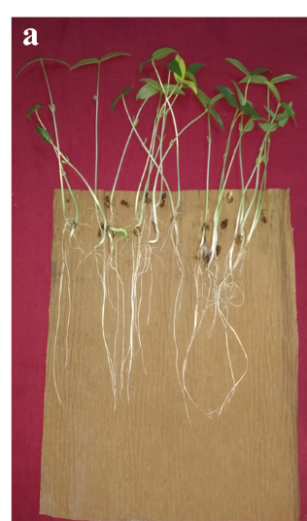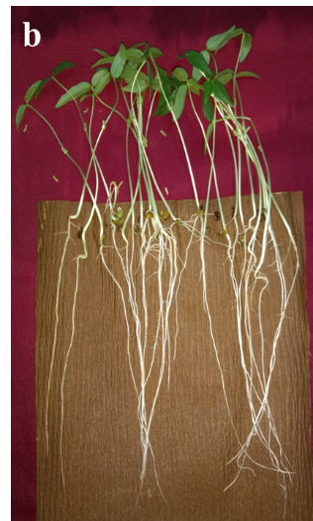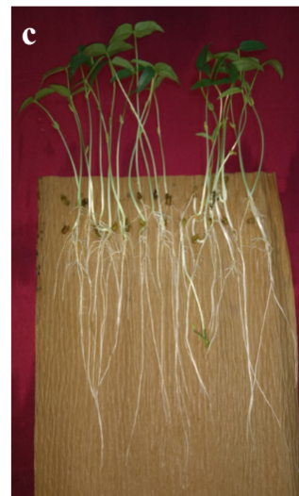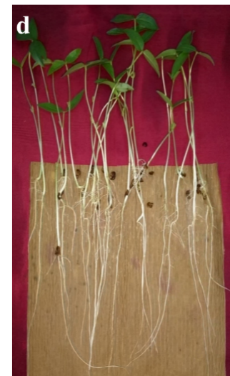
Supplementary fig 1. Green gram seedling vigour due to (a) T₁ - untreated seeds, (b) T₂ - Azotobacter chroococcum inoculated seeds, (c) T₃ - nanofiber coated seeds, and (d) T₄ - Azotobacter chroococcum loaded nanofiber coated seeds.
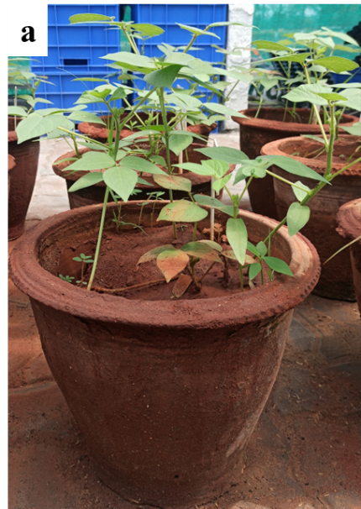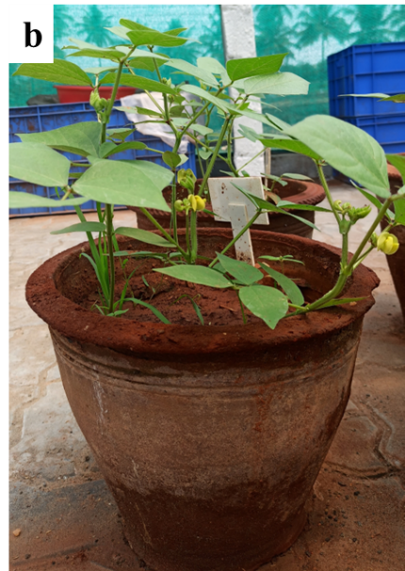
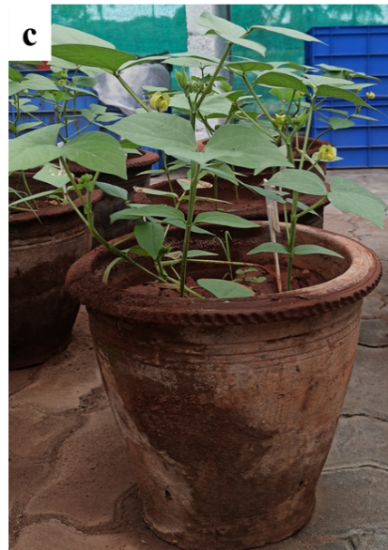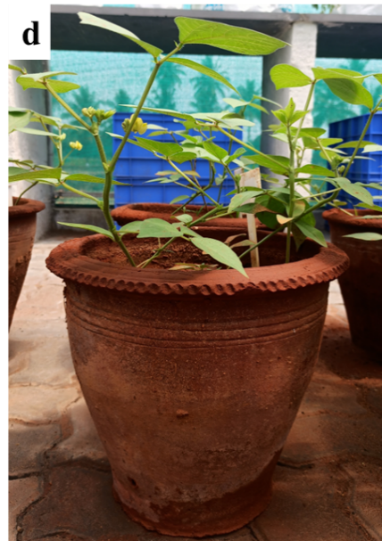
Supplementary fig 2. Green gram plant growth at 25th day (a) T₁ - untreated seeds, (b) T₂ - Azotobacter chroococcum inoculated seeds, (c) T₃ - nanofiber coated seeds, and (d) T₄ - Azotobacter chroococcum loaded nanofiber coated seeds.
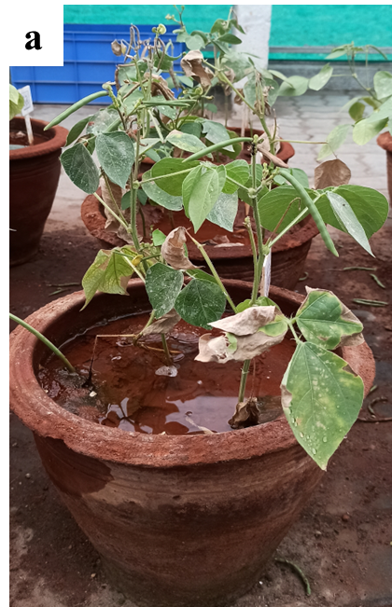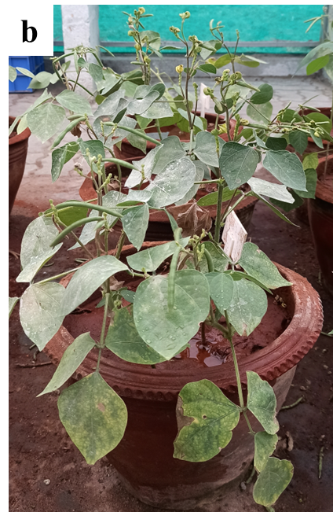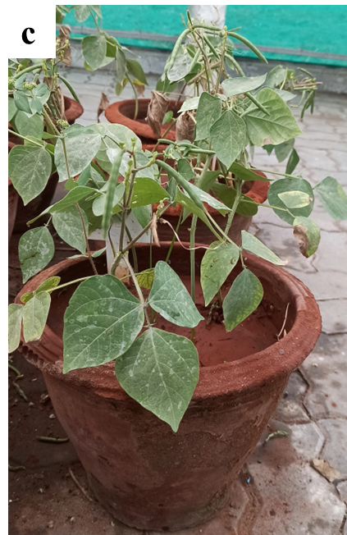
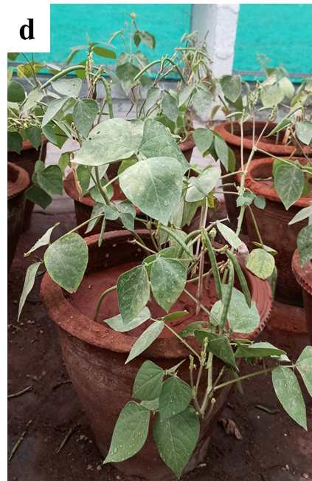
Supplementary fig 3. Green gram plant growth at 45th day (a) T₁ - untreated seeds, (b) T₂ - Azotobacter chroococcum inoculated seeds, (c) T₃ - nanofiber coated seeds, and (d) T₄ - Azotobacter chroococcum loaded nanofiber coated seeds.

