Table 1. Ongoing global, regional, and local monitoring and recording of heritage components in heritage villages.
No. | Name | Classification | Characteristics | Figure
1 | Holloko village, Hungary | It was added to the World Heritage List in 1987. | The village is a striking illustration of rural life prior to the agricultural revolution in the twentieth century, as depicted in Figure (1). | 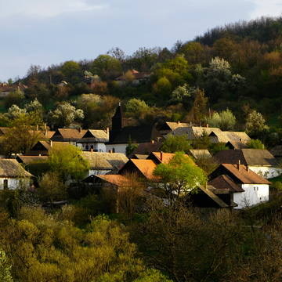  Figure 1: The Hungarian village of Holloko⁽⁹⁾
2 | Hahoe & Yangdong Villages, Korea | They were added to the World Heritage List in 2010. | It stands out for its design and safe setting in the mountains, which faces a river and some farmland. The Confucian study rooms and academies, as well as the old traditional homes, are located in this area, which is the centre of aristocratic culture. | 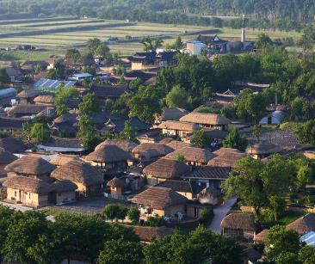  Figure 2: Yangdong and Hahoe Villages⁽¹⁰⁾
3 | Shrinkage and Okayama (Gitarama) villages, Japan | They were listed as a World Heritage Sites | They consist of a number of traditional homes that demonstrate the construction style and serve as excellent examples of the old traditional way of life and the degree to which it has been adapted to the surroundings and the social and economic circumstances of the local community. | 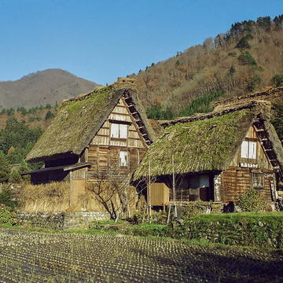  Figure 3: The Japanese villages of Gokayama and Shirakawa-Go⁽¹³⁾
4 | KaipingDaiolou Village, China | It was added to the World Heritage List. In 2007. | Traditional multi-story homes are there, along with a variety of Chinese and Western housing types, as well as towers that served as observatories or places of worship. The homes were constructed of stone, brick, or concrete, and they blend in nicely with the surrounding environment, Figure 4. | 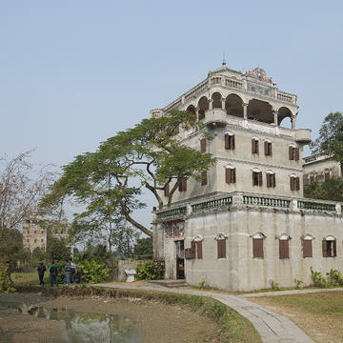  Figure 4: Kaiping Daiolou Village in China⁽¹¹⁾
5 | The ancient villages in southern Anhui are Xidi and Hongcun Villages. | They were added to the World Heritage List in 2000. | They reflect the ancient street layouts that have vanished from most villages and were added to the World Heritage List in the year 2000 AD. These villages exhibit the integration of extensive water systems with conventional structures ⁽⁷⁾. | 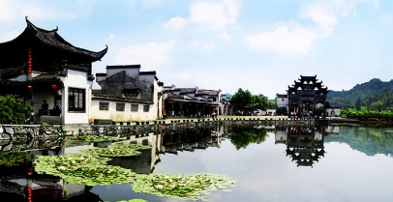  Figure 5: The historic villages of Xidi and Hongcun in southern Anhui
6 | Transylvanian villages, Romania | They were inscribed on the World Heritage List in 1993 | Romania is located with its fortified churches, which are seven villages and were registered in the World Heritage List in 1993 ⁽⁶⁾, Figure 6. | 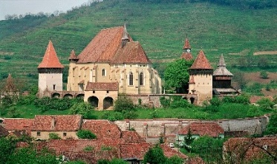  Figure 6: Transylvania villages, Romania⁽¹²⁾ .
7 | M'Zab village, Algeria | it was added to the World and Regional Heritage List in 1983. | The village is recognized by the inhabitants who maintain the customs and traditions in addition to building the village in a way that is in harmony with the environment and the community's life, and it is thought to be an inspiration for the planners, Figure 7. | 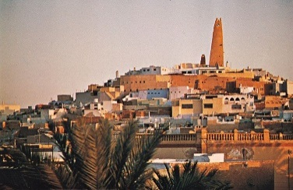  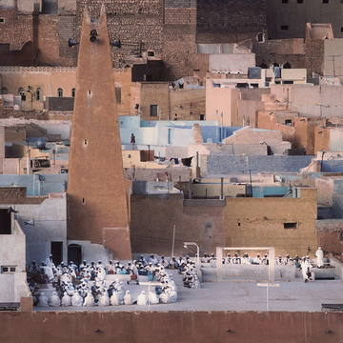  Figure 7: M'zab village, Algeria⁽⁸⁾.
8 | Rijal Alma’ village in the Tuhami part of Asir region in Rijal Alma’ governorate, specifically west of Abha city, Kingdom of Saudi Arabia | It was added to the World Heritage List in 2000 | It is considered as being close to the tourist attractions in Abha and the surrounding areas. The "Al-Soudah Cable Car for Travelers" project, which descends from the high mountains of Al-Soudah to a near proximity from the hamlet, has made it a popular destination for tourists, especially since it opened. | 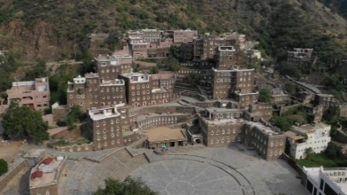  Figure 8: Rijal Almaa village, west of Abha city, Saudi Arabia.
9 | Sos Village was built in 2014 in the city of Tadjoura in the State of Djibouti. | It was registered in the local heritage list in 2014. | The village is highlighted by respect for identity and climate, design elements drawn from traditional Arab architecture, employment of open space, internal courtyards, and winding, crooked roadways, as well as a reliance on solar power. | 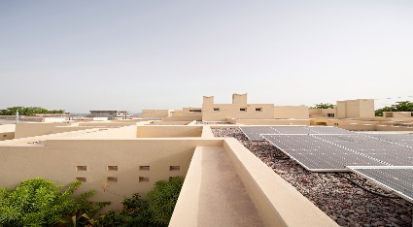  Figure 9: SOS Village A village to house children ⁽¹⁰⁾ .
10 | The Green Village is located on the island of Bali, Indonesia, on an area of 18,700 square meters | Construction has been completed in 2010, the village respects local culture | It was developed and created in compliance with environmental standards to blend into the surroundings. The village's structural framework, ceilings, furnishings, and doors were all constructed from bamboo and bamboo sticks, which were readily available local environmental materials. | 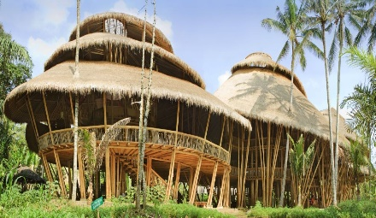  Figure 10: Green Village, Bali Island, Indonesia .
11 | Al Qasr Village, New Valley, Egypt | It has been included in the local heritage list | It contains several traditional homes that highlight the construction style and serves as excellent examples of the old traditional way of life, as well as the extent to which it has been adapted to the environment and the social and economic circumstances of the neighbourhood. | 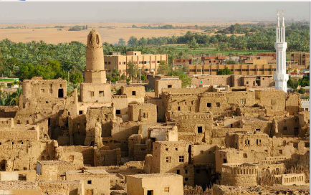  Figure 11: The village of Al-Qasr in the New Valley

Table 2: Criteria for monitoring villages in the Kingdom of Saudi Arabia ⁽²¹⁾
Factor | Village definition in terms of its accessible resources
A description of the villages' location and boundaries | Geographical and administrative location in the villages.
Convenient access to the village | The village's accessibility and the routes that lead there.
Structures and homes with a traditional style | The predominant architectural style, land uses, and kind of urban structure.
Aspects that are social and cultural | Families, social classes, and villages come from tribes with passed-down customs.
A village's tourist attractions | The kind and quantity of ancillary, current, and future tourist amenities

Table 3: The monitoring and recording of the heritage components in the heritage villages of Luxor Governorate, source: the researcher
The village's name |  | Old Karnak Village | The village of the Al-Aqalta | Al-Bairat village | Tod village west | Awamiya village | Al-Dabiya village | Manshiet Al Nuba village
Rating score |  | First | First | Second | Second | Third | Third | Third
Village description |  | Although it is considered as being along the major Luxor tourist route, there are some historic features that should be highlighted in order to support the research goal of Karnak being a historical village. | The village, which is a part of the city of Qurna, is situated close to a mountain, and there are historical and archaeological sites there that can be added to the city's major tourist route. | The village's heritage characteristics might be added to the tourism route of Qurna, the western mainland's heritage city. | Due to its heritage components, which can be employed in accordance with the study purpose, it can be included in the tourist route that runs between Luxor and Aswan. | Due to its heritage elements that serve the purpose of the research, it is an extension of the city of Luxor and can be added to the city's tourism route. | It is an extension of the city of Qurna and can be included in the tourist path for visitors due to its heritage components that achieve the goal of the research | It can be incorporated into the route taken by tourists travelling between Luxor and Aswan, due to its heritage component, which can profit from and further the research's objective.
The village's geographic location and connection to the city's tourist route |  | 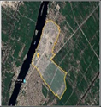 | 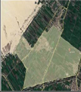 | 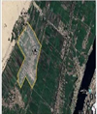 | 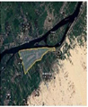 | 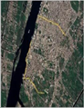 | 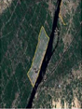 | 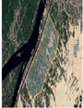
Aspects of monitoring heritage components and capabilities as a heritage village | Economic Aspects | 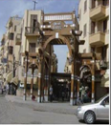  One of the economic resources that the Karnak Heritage Village owns is the artisans’ market, and it needs to be promoted culturally. | 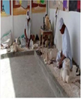  One of the economic resources that Al-Aqalta Heritage Village owns is the alabaster industry, and it needs to be culturally promoted. |   The School of Pottery Industry is one of the economic resources owned by the Al-Bairat Heritage Village, and it needs cultural promotion | 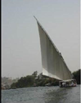  A source of income for the village of Al-Tood, west of the heritage, is the activity of sailing boats. | 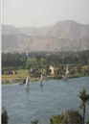  Tourists lodged on the western mainland, and the panoramic view it possesses is one of the economic resources owned by the village of Al-Awamiya | 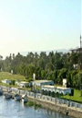  The historical village of Al-Dabiya owns views, restrooms, and a distinctive perspective of the Nile as one of its economic resources. | 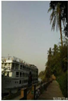  The dock of the "floating hotels" and the Nile view are one of the economic resources owned by the village of Manshiet Al Nuba
 | Architectural and Urban Aspects | 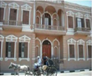  The Yesi Pasha Andraos Palace, which was built in 1921 AD, could be converted into a museum and shrine. | 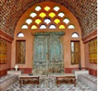  The village is known for its hotel homes, including The Director Hotel, which is one of them. It is a popular destination for travellers because of its distinctively rural nature. | 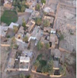  A distinctive urban pattern for some of the old dwellings in the village, which represent the traditional old Qurna dwellings | 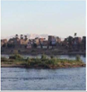  Hassan Fathi, an architect, designed the structures and the tourist inn, which is a dormitory for travellers staying in the village. | 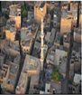  The houses in the village have a distinct urban design. | 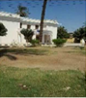  The village owns houses in the style of the old Arab house | 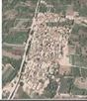  The village has a distinctive urban style of houses

