Supplementary Material

Exploration of biological significance of m6A-related genes in Wilms tumor
Yingquan Zhuo^{1,2†}, Wengqi Zhang^{3†}, Jun Du², Hua jiang², Xu Sun², Youwang Chen², Meilan Nie², Zhongmin Xu² and Huajian Gu^{1,2*}
¹ China School of Clinical Medicine, Guizhou Medical University, Guiyang, Guizhou, China
2 Department of Pediatric Surgery, The Affiliated Hospital of Guizhou Medical University, Guiyang, Guizhou, China
3 Department of anesthesiology, The Affiliated Hospital of Guizhou Medical University, Guiyang, Guizhou, China
† Yingquan Zhuo and Wengqi Zhang have contributed equally
*Correspondence: zhaoyaree@sina.com

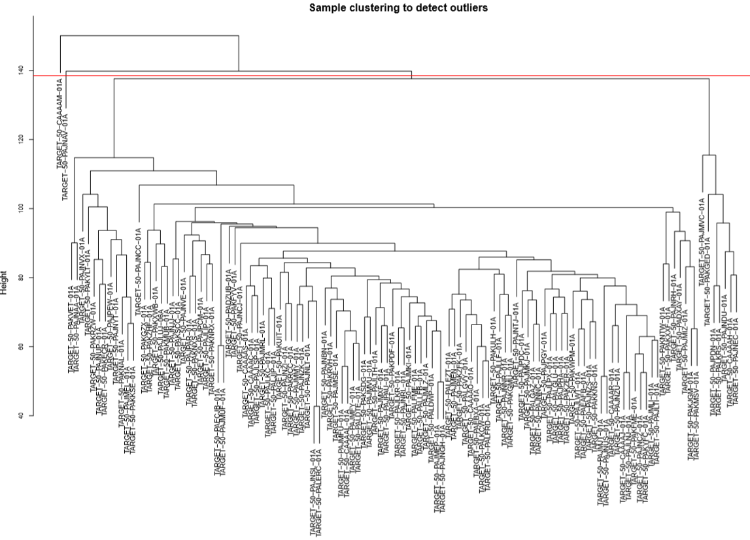
Supplementary Fig. S1 Sample clustering to detect outliers.
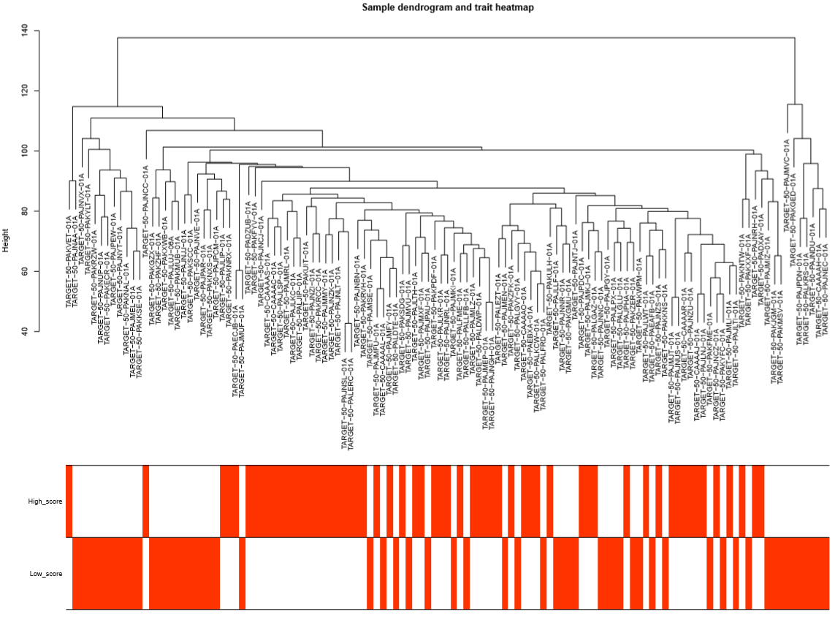

Supplementary Fig. S2 Sample dendrogram and trait heatmap.

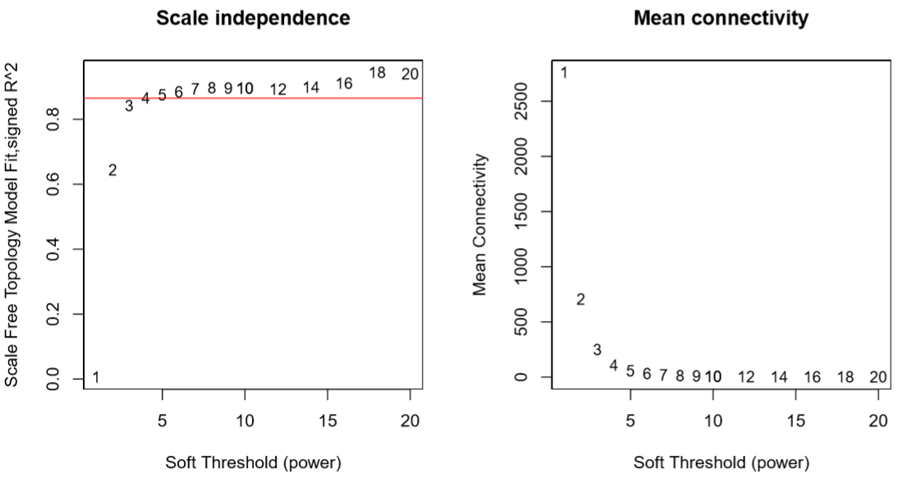

Supplementary Fig. S3 Pick SoftThreshold
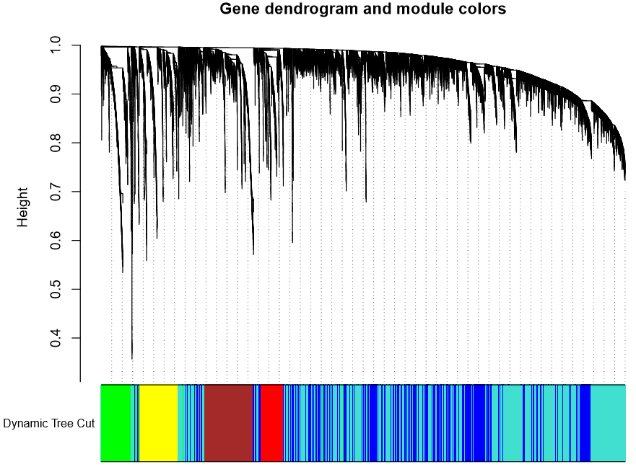

Supplementary Fig. S4 Gene dendrogram and module colors.

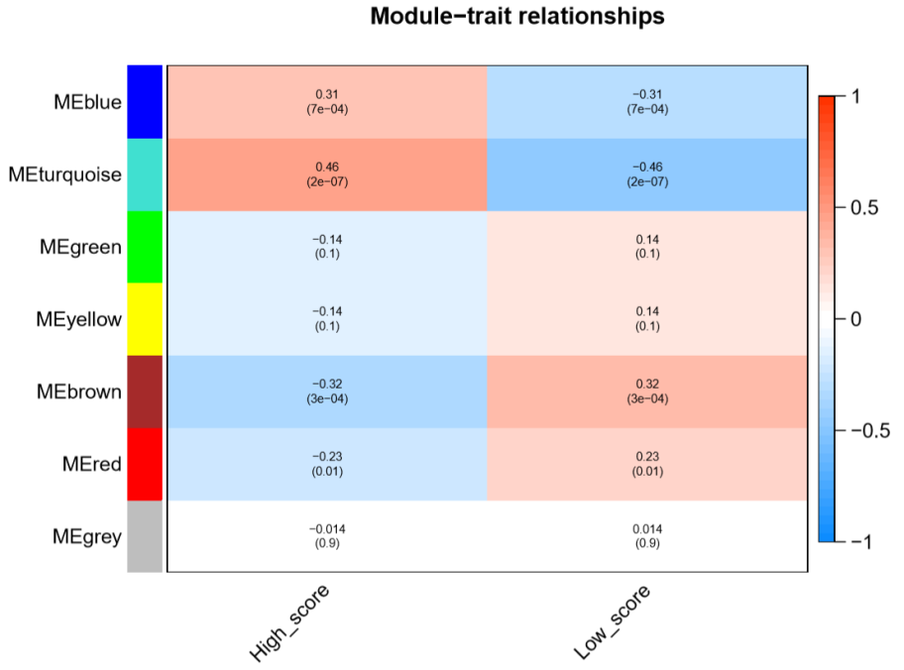

Supplementary Fig. S5 Module-trait relationships.

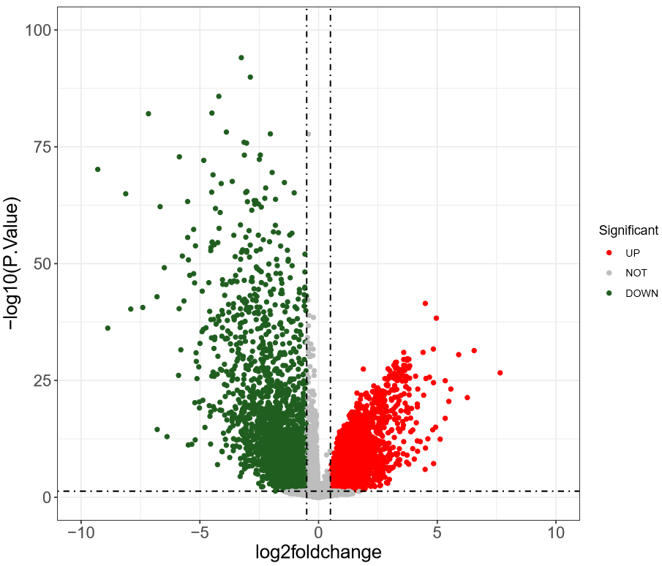

Supplementary Fig. S6 DEGs volcano plot of WT and Normal group.

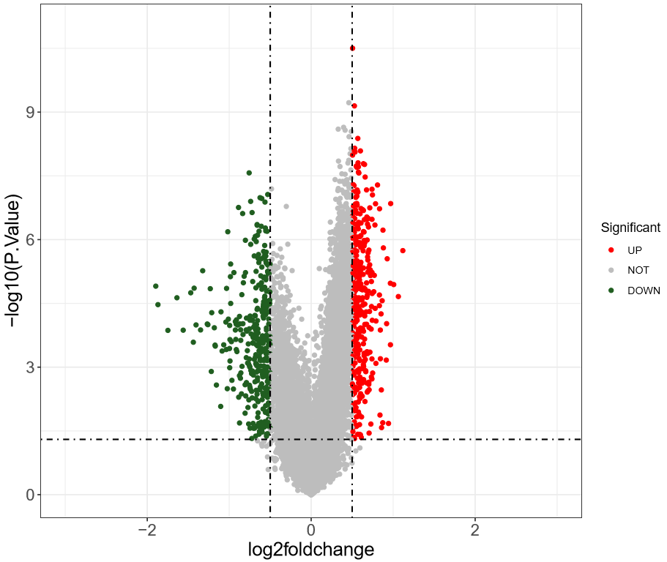

Supplementary Fig. S7 DEGs volcano plot of High_score vs Low _scorel group.

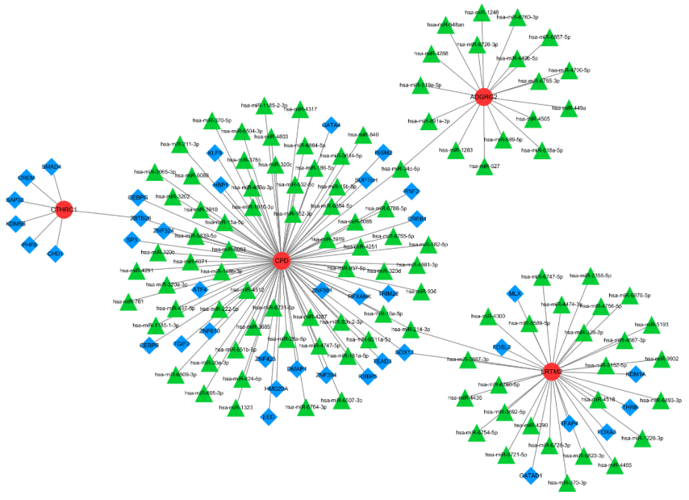

Supplementary Fig. S8 TF-mRNA-miRNA regulatory network.

Supplementary Table S1 The potential therapeutic drugs for WT were predicted by the 4 hub genes.
Hub gene | Chemical Name | Chemical ID | Interaction Count
ADGRG2 | Benzo(a)pyrene | D001564 | 8
ADGRG2 | Aflatoxin B1 | D016604 | 5
ADGRG2 | Tetrachlorodibenzodioxin | D013749 | 5
ADGRG2 | 4-(5-benzo(1,3)dioxol-5-yl-4-pyridin-2-yl-1H-imidazol-2-yl)benzamide | C459179 | 4
ADGRG2 | bisphenol A | C006780 | 4
ADGRG2 | Cisplatin | D002945 | 4
ADGRG2 | Dietary Fats | D004041 | 4
ADGRG2 | dorsomorphin | C516138 | 4
ADGRG2 | Phenobarbital | D010634 | 4
ADGRG2 | Diethylnitrosamine | D004052 | 3
ADGRG2 | Folic Acid | D005492 | 3
ADGRG2 | Valproic Acid | D014635 | 3
ADGRG2 | Choline | D002794 | 2
ADGRG2 | entinostat | C118739 | 2
ADGRG2 | furan | C039281 | 2
ADGRG2 | mercuric bromide | C042720 | 2
ADGRG2 | Methapyrilene | D008701 | 2
ADGRG2 | Methionine | D008715 | 2
ADGRG2 | p-Chloromercuribenzoic Acid | D020245 | 2
ADGRG2 | pentabromodiphenyl ether | C086401 | 2
ADGRG2 | Phenylmercuric Acetate | D010662 | 2
ADGRG2 | Rotenone | D012402 | 2
ADGRG2 | Tobacco Smoke Pollution | D014028 | 2
ADGRG2 | 1,2-Dimethylhydrazine | D019813 | 1
ADGRG2 | 2,2,5,7,8-pentamethyl-1-hydroxychroman | C029141 | 1
ADGRG2 | 2,3',4,4',5-pentachlorobiphenyl | C070055 | 1
ADGRG2 | 3,4,3',4'-tetrachlorobiphenyl | C028451 | 1
ADGRG2 | 3,4,5,3',4'-pentachlorobiphenyl | C023035 | 1
ADGRG2 | 8-Bromo Cyclic Adenosine Monophosphate | D015124 | 1
ADGRG2 | abrine | C496492 | 1
ADGRG2 | acetamide | C030686 | 1
ADGRG2 | Acetaminophen | D000082 | 1
ADGRG2 | Amphetamine | D000661 | 1
ADGRG2 | Antigens, Polyomavirus Transforming | D000952 | 1
ADGRG2 | Antirheumatic Agents | D018501 | 1
ADGRG2 | Arsenic Trioxide | D000077237 | 1
ADGRG2 | benzo(e)pyrene | C026487 | 1
ADGRG2 | Betaine | D001622 | 1
ADGRG2 | beta-Naphthoflavone | D019324 | 1
ADGRG2 | butyraldehyde | C018475 | 1
ADGRG2 | Cadmium | D002104 | 1
ADGRG2 | Chlorodiphenyl (54% Chlorine) | D020111 | 1
ADGRG2 | Cuprizone | D003471 | 1
ADGRG2 | Cyclosporine | D016572 | 1
ADGRG2 | Decitabine | D000077209 | 1
ADGRG2 | Dexamethasone | D003907 | 1
ADGRG2 | Doxorubicin | D004317 | 1
ADGRG2 | Endosulfan | D004726 | 1
ADGRG2 | Estradiol | D004958 | 1
ADGRG2 | Fenretinide | D017313 | 1
ADGRG2 | Formaldehyde | D005557 | 1
ADGRG2 | Gallic Acid | D005707 | 1
ADGRG2 | indole-3-carbinol | C016517 | 1
ADGRG2 | Isotretinoin | D015474 | 1
ADGRG2 | jinfukang | C544151 | 1
ADGRG2 | methylmercuric chloride | C004925 | 1
ADGRG2 | muraglitazar | C500085 | 1
ADGRG2 | Orphenadrine | D009966 | 1
ADGRG2 | Oxygen | D010100 | 1
ADGRG2 | Ozone | D010126 | 1
ADGRG2 | Palm Oil | D000073878 | 1
ADGRG2 | Paraquat | D010269 | 1
ADGRG2 | Particulate Matter | D052638 | 1
ADGRG2 | perfluorooctane sulfonic acid | C076994 | 1
ADGRG2 | Plant Extracts | D010936 | 1
ADGRG2 | Propylthiouracil | D011441 | 1
ADGRG2 | Rosiglitazone | D000077154 | 1
ADGRG2 | Sodium Dodecyl Sulfate | D012967 | 1
ADGRG2 | Sodium Fluoride | D012969 | 1
ADGRG2 | Sunitinib | D000077210 | 1
ADGRG2 | systhane | C446685 | 1
ADGRG2 | Tamoxifen | D013629 | 1
ADGRG2 | tesaglitazar | C501413 | 1
ADGRG2 | Testosterone Propionate | D043343 | 1
ADGRG2 | Thioacetamide | D013853 | 1
ADGRG2 | Triclosan | D014260 | 1
ADGRG2 | trimellitic anhydride | C015559 | 1
ADGRG2 | triphenyl phosphate | C005445 | 1
ADGRG2 | triptonide | C084079 | 1
ADGRG2 | vinylidene chloride | C029297 | 1
ADGRG2 | Vitamin B 12 | D014805 | 1
ADGRG2 | Zinc | D015032 | 1
CPD | bisphenol A | C006780 | 6
CPD | Testosterone | D013739 | 5
CPD | Tetrachlorodibenzodioxin | D013749 | 5
CPD | Gasoline | D005742 | 4
CPD | Particulate Matter | D052638 | 4
CPD | Polycyclic Aromatic Hydrocarbons | D011084 | 4
CPD | Ethanol | D000431 | 3
CPD | Ethinyl Estradiol | D004997 | 3
CPD | Nitric Oxide | D009569 | 3
CPD | Tobacco Smoke Pollution | D014028 | 3
CPD | Valproic Acid | D014635 | 3
CPD | abrine | C496492 | 2
CPD | Aflatoxin B1 | D016604 | 2
CPD | Benzo(a)pyrene | D001564 | 2
CPD | Estradiol | D004958 | 2
CPD | ethylene dichloride | C024565 | 2
CPD | Fluorouracil | D005472 | 2
CPD | Folic Acid | D005492 | 2
CPD | gardiquimod | C546771 | 2
CPD | lipopolysaccharide, E coli O55-B5 | C482199 | 2
CPD | Magnetite Nanoparticles | D058185 | 2
CPD | pirinixic acid | C006253 | 2
CPD | Succimer | D004113 | 2
CPD | trichostatin A | C012589 | 2
CPD | 1,1,1-trichloroethane | C024566 | 1
CPD | 1,2-Dimethylhydrazine | D019813 | 1
CPD | 1-Butanol | D020001 | 1
CPD | 2,3,5-(triglutathion-S-yl)hydroquinone | C078765 | 1
CPD | 4-(5-benzo(1,3)dioxol-5-yl-4-pyridin-2-yl-1H-imidazol-2-yl)benzamide | C459179 | 1
CPD | Ammonium Chloride | D000643 | 1
CPD | Bilirubin | D001663 | 1
CPD | butyraldehyde | C018475 | 1
CPD | Cacodylic Acid | D002101 | 1
CPD | Calcitriol | D002117 | 1
CPD | Cannabidiol | D002185 | 1
CPD | Carbon Tetrachloride | D002251 | 1
CPD | Chlorine | D002713 | 1
CPD | chloropicrin | C100187 | 1
CPD | Chloroprene | D002737 | 1
CPD | Choline | D002794 | 1
CPD | Clorgyline | D003010 | 1
CPD | Copper | D003300 | 1
CPD | Cyclosporine | D016572 | 1
CPD | Dibutyl Phthalate | D003993 | 1
CPD | Dietary Fats | D004041 | 1
CPD | dorsomorphin | C516138 | 1
CPD | Doxorubicin | D004317 | 1
CPD | Endosulfan | D004726 | 1
CPD | Gentamicins | D005839 | 1
CPD | hexabromocyclododecane | C089796 | 1
CPD | Hexachlorocyclohexane | D001556 | 1
CPD | Hydrogen Cyanide | D006856 | 1
CPD | Ionomycin | D015759 | 1
CPD | isobutyl alcohol | C040507 | 1
CPD | Isotretinoin | D015474 | 1
CPD | Ivermectin | D007559 | 1
CPD | jinfukang | C544151 | 1
CPD | Lactic Acid | D019344 | 1
CPD | Methapyrilene | D008701 | 1
CPD | Methionine | D008715 | 1
CPD | methylmercuric chloride | C004925 | 1
CPD | N-(2-(1,1'-bicyclopropyl)-2-ylphenyl)-3-(difluoromethyl)-1-methyl-1H-pyrazole-4-carboxamide | C583365 | 1
CPD | N-Methyl-3,4-methylenedioxyamphetamine | D018817 | 1
CPD | Ozone | D010126 | 1
CPD | perfluorooctanoic acid | C023036 | 1
CPD | Phenobarbital | D010634 | 1
CPD | Plant Extracts | D010936 | 1
CPD | Potassium Cyanide | D011190 | 1
CPD | procymidone | C035988 | 1
CPD | Propylthiouracil | D011441 | 1
CPD | Protein Kinase Inhibitors | D047428 | 1
CPD | sandostatinLAR | C541923 | 1
CPD | Selenium | D012643 | 1
CPD | Silicon Dioxide | D012822 | 1
CPD | sodium arsenate | C009277 | 1
CPD | sulforaphane | C016766 | 1
CPD | T-2 Toxin | D013605 | 1
CPD | Tetrachloroethylene | D013750 | 1
CPD | Tetradecanoylphorbol Acetate | D013755 | 1
CPD | Tretinoin | D014212 | 1
CPD | Trichloroethylene | D014241 | 1
CPD | triptonide | C084079 | 1
CPD | Troglitazone | D000077288 | 1
CPD | Tungsten | D014414 | 1
CPD | Tunicamycin | D014415 | 1
CPD | Urethane | D014520 | 1
CPD | Vehicle Emissions | D001335 | 1
CPD | Venlafaxine Hydrochloride | D000069470 | 1
CPD | vinclozolin | C025643 | 1
CPD | vinylidene chloride | C029297 | 1
CPD | Zoledronic Acid | D000077211 | 1
CTHRC1 | Valproic Acid | D014635 | 12
CTHRC1 | 4-(5-benzo(1,3)dioxol-5-yl-4-pyridin-2-yl-1H-imidazol-2-yl)benzamide | C459179 | 7
CTHRC1 | Benzo(a)pyrene | D001564 | 7
CTHRC1 | dorsomorphin | C516138 | 7
CTHRC1 | Tetrachlorodibenzodioxin | D013749 | 6
CTHRC1 | Cyclosporine | D016572 | 4
CTHRC1 | Aflatoxin B1 | D016604 | 3
CTHRC1 | bisphenol A | C006780 | 3
CTHRC1 | (+)-JQ1 compound | C561695 | 3
CTHRC1 | trichostatin A | C012589 | 3
CTHRC1 | Vorinostat | D000077337 | 3
CTHRC1 | belinostat | C487081 | 2
CTHRC1 | Decitabine | D000077209 | 2
CTHRC1 | entinostat | C118739 | 2
CTHRC1 | furan | C039281 | 2
CTHRC1 | mercuric bromide | C042720 | 2
CTHRC1 | Oxaliplatin | D000077150 | 2
CTHRC1 | Phenylmercuric Acetate | D010662 | 2
CTHRC1 | Tobacco Smoke Pollution | D014028 | 2
CTHRC1 | Topotecan | D019772 | 2
CTHRC1 | Tretinoin | D014212 | 2
CTHRC1 | 1-Naphthylisothiocyanate | D015058 | 1
CTHRC1 | 2',3,3',4',5-pentachloro-4-hydroxybiphenyl | C111118 | 1
CTHRC1 | 2,3-pentanedione | C013186 | 1
CTHRC1 | 4-(4-((5-(4,5-dimethyl-2-nitrophenyl)-2-furanyl)methylene)-4,5-dihydro-3-methyl-5-oxo-1H-pyrazol-1-yl)benzoic acid | C584509 | 1
CTHRC1 | Air Pollutants | D000393 | 1
CTHRC1 | Aluminum | D000535 | 1
CTHRC1 | Ammonium Chloride | D000643 | 1
CTHRC1 | Antirheumatic Agents | D018501 | 1
CTHRC1 | aristolochic acid I | C000228 | 1
CTHRC1 | arsenite | C015001 | 1
CTHRC1 | Atrazine | D001280 | 1
CTHRC1 | bis(4-hydroxyphenyl)sulfone | C543008 | 1
CTHRC1 | bisphenol F | C000611646 | 1
CTHRC1 | butyraldehyde | C018475 | 1
CTHRC1 | Calcitriol | D002117 | 1
CTHRC1 | Calcium Chloride | D002122 | 1
CTHRC1 | Carbon Tetrachloride | D002251 | 1
CTHRC1 | Chloroprene | D002737 | 1
CTHRC1 | Cisplatin | D002945 | 1
CTHRC1 | Copper Sulfate | D019327 | 1
CTHRC1 | deoxynivalenol | C007262 | 1
CTHRC1 | dicrotophos | C000944 | 1
CTHRC1 | Diethylhexyl Phthalate | D004051 | 1
CTHRC1 | Diethylnitrosamine | D004052 | 1
CTHRC1 | Doxorubicin | D004317 | 1
CTHRC1 | Estradiol | D004958 | 1
CTHRC1 | Ethanol | D000431 | 1
CTHRC1 | Ethinyl Estradiol | D004997 | 1
CTHRC1 | ethylene dichloride | C024565 | 1
CTHRC1 | Folic Acid | D005492 | 1
CTHRC1 | gemcitabine | C056507 | 1
CTHRC1 | Genistein | D019833 | 1
CTHRC1 | glycidol | C004312 | 1
CTHRC1 | hexabromocyclododecane | C089796 | 1
CTHRC1 | ICG 001 | C492448 | 1
CTHRC1 | Ionomycin | D015759 | 1
CTHRC1 | Isoproterenol | D007545 | 1
CTHRC1 | Milrinone | D020105 | 1
CTHRC1 | monomethyl phthalate | C517284 | 1
CTHRC1 | MRK 003 | C523799 | 1
CTHRC1 | naphthalene | C031721 | 1
CTHRC1 | n-butoxyethanol | C017096 | 1
CTHRC1 | n-hexane | C026385 | 1
CTHRC1 | Panobinostat | D000077767 | 1
CTHRC1 | Paraquat | D010269 | 1
CTHRC1 | Particulate Matter | D052638 | 1
CTHRC1 | pirinixic acid | C006253 | 1
CTHRC1 | propionaldehyde | C005556 | 1
CTHRC1 | Quercetin | D011794 | 1
CTHRC1 | Resveratrol | D000077185 | 1
CTHRC1 | S-2-pentyl-4-pentynoic hydroxamic acid | C513635 | 1
CTHRC1 | Silver | D012834 | 1
CTHRC1 | Smoke | D012906 | 1
CTHRC1 | Testosterone | D013739 | 1
CTHRC1 | Tetradecanoylphorbol Acetate | D013755 | 1
CTHRC1 | titanium dioxide | C009495 | 1
CTHRC1 | Trichloroethylene | D014241 | 1
CTHRC1 | trimellitic anhydride | C015559 | 1
CTHRC1 | tris(2-butoxyethyl) phosphate | C013320 | 1
CTHRC1 | Tungsten Compounds | D017973 | 1
LRTM2 | Aflatoxin B1 | D016604 | 5
LRTM2 | Benzo(a)pyrene | D001564 | 4
LRTM2 | bisphenol A | C006780 | 3
LRTM2 | benz(a)anthracene | C030935 | 2
LRTM2 | Carbon Tetrachloride | D002251 | 2
LRTM2 | Dietary Fats | D004041 | 2
LRTM2 | Nanotubes, Carbon | D037742 | 2
LRTM2 | Tetrachlorodibenzodioxin | D013749 | 2
LRTM2 | 2,2,5,7,8-pentamethyl-1-hydroxychroman | C029141 | 1
LRTM2 | benzo(b)fluoranthene | C006703 | 1
LRTM2 | benzo(e)pyrene | C026487 | 1
LRTM2 | Cadmium Chloride | D019256 | 1
LRTM2 | Choline | D002794 | 1
LRTM2 | chrysene | C031180 | 1
LRTM2 | diethyl maleate | C014476 | 1
LRTM2 | Doxorubicin | D004317 | 1
LRTM2 | Endosulfan | D004726 | 1
LRTM2 | ethylene dichloride | C024565 | 1
LRTM2 | Folic Acid | D005492 | 1
LRTM2 | furan | C039281 | 1
LRTM2 | Methapyrilene | D008701 | 1
LRTM2 | Methionine | D008715 | 1
LRTM2 | Palm Oil | D000073878 | 1
LRTM2 | Rotenone | D012402 | 1
LRTM2 | sodium bichromate | C016104 | 1
LRTM2 | systhane | C446685 | 1
LRTM2 | Testosterone | D013739 | 1
LRTM2 | Thioacetamide | D013853 | 1
LRTM2 | Tobacco Smoke Pollution | D014028 | 1
LRTM2 | Trichloroethylene | D014241 | 1
LRTM2 | triptonide | C084079 | 1
LRTM2 | tris(1,3-dichloro-2-propyl)phosphate | C016805 | 1
LRTM2 | Valproic Acid | D014635 | 1
LRTM2 | Vehicle Emissions | D001335 | 1
LRTM2 | Zinc Oxide | D015034 | 1

