Boron Nitride-enabled Printing of Highly Sensitive and Flexible Iontronic Pressure Sensing System toward Spatial Mapping
Zekun Yang^{1†}, Qikai Duan^{2†}, Junbin Zang^{1†}, Yunlong Zhao³, Weihao Zheng⁴, Ran Xiao⁵, Zhidong Zhang¹, Liangwei Hu³, Guirong Wu³, Xueli Nan^{2*}, Chenyang Xue^{1,3*} and Libo Gao^{3*}
¹Key Laboratory of Instrumentation Science and Dynamic Measurement Ministry of Education, North University of China, Taiyuan 030051, China
²School of Automation and Software Engineering, Shanxi University, Taiyuan 030006, China
³Department of Mechanical and Electrical Engineering, Xiamen University, Xiamen, 361102, China
⁴School of Mechano-Electronic Engineering, Xidian University, Xi’an 710071, China
⁵Deparment of Mechanical Engineering, City University of Hong Kong, Hong Kong SAR., Kowloon 999077, Hong Kong
*Author to whom correspondence should be addressed:
E-mail: nanxueli@sxu.edu.cn; xuechenyang@nuc.edu.cn; lbgao@xmu.edu.cn;
†These authors contributed equally to this work.
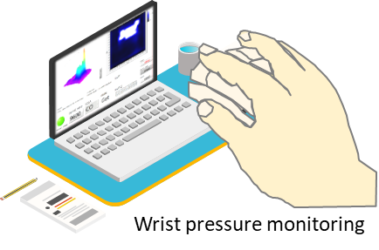
Figure S1. Schematic illustration of the wrist pressure monitoring.

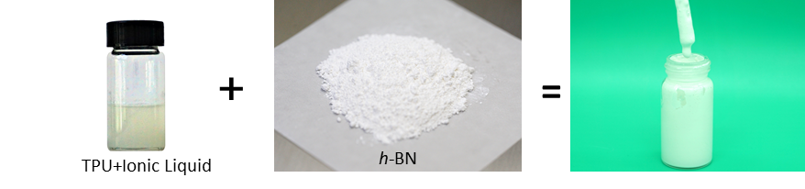
Figure S2. Composition of the thermoplastic polyether urethanes (TPU)/BN ink.

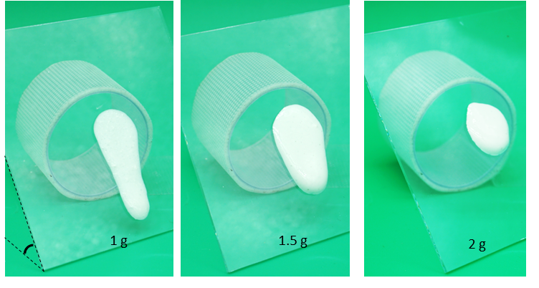
Figure S3. Various doping mass of the BN into the ionic ink.

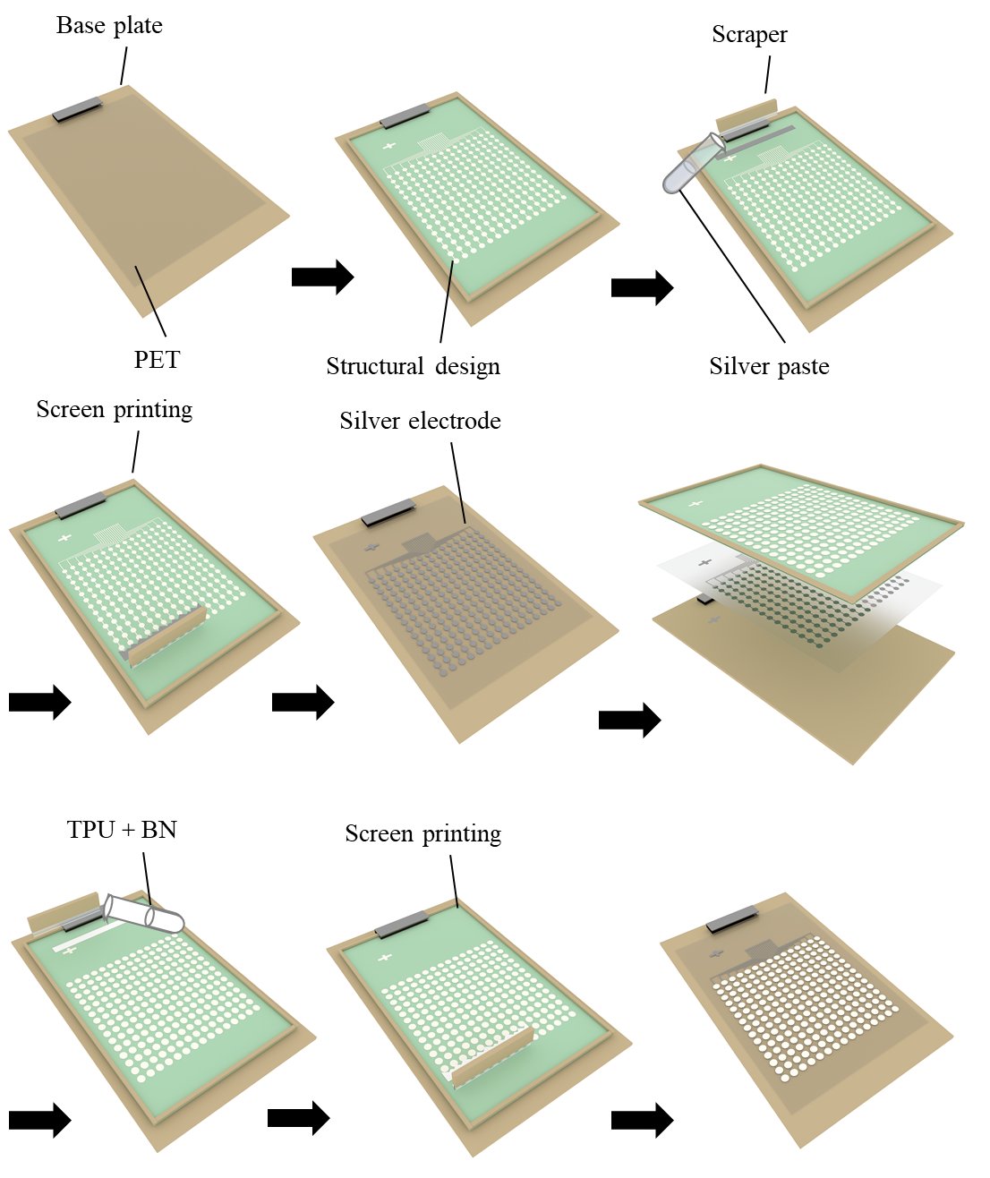
Figure S4. Schematic illustration of the fabrication of the Ag-electrode and ionic film.

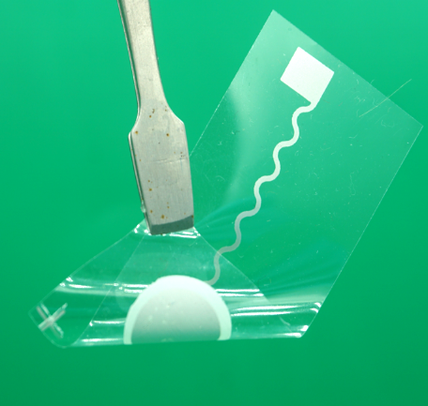
Figure S5 Digital optical image of the Ag/ionic film on polyethylene terephthalate (PET) substrate

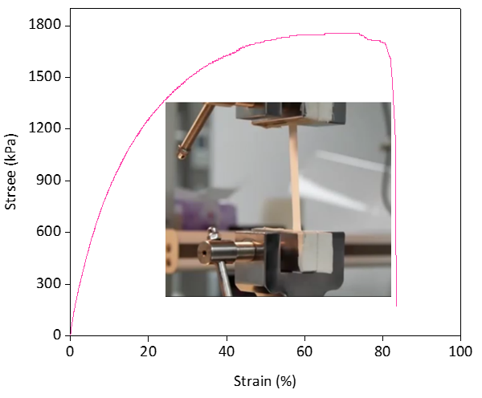
Figure S6. Mechanical tensile test of the ionic film.

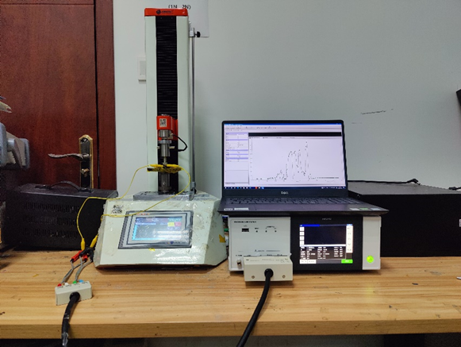
Figure S7. Configuration for the sensor characterization

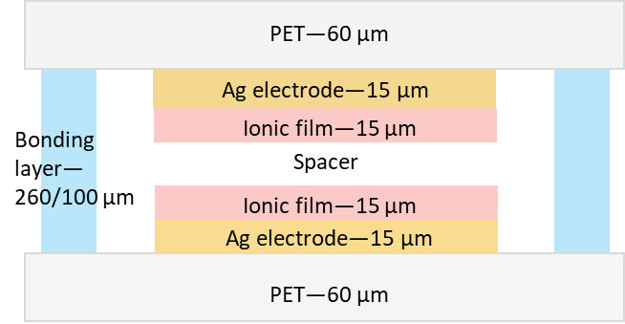
Figure S8. Device configuration of the sensor.

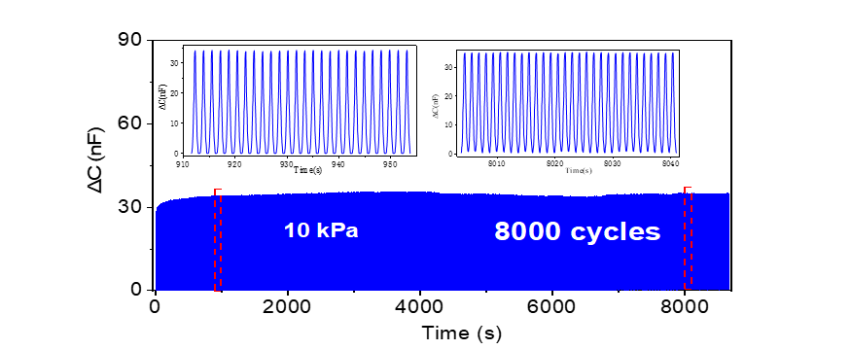
Figure S9. Long-term cycling test of the sensor at 10 kPa for 8000 cycles.

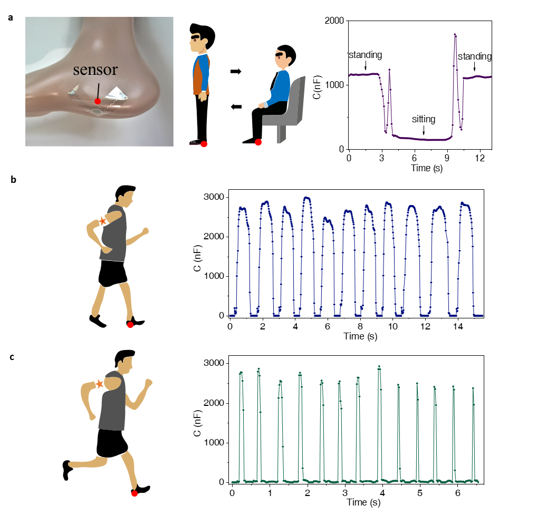
Figure S10. Application of the sensor for planta pressure monitoring. a Planta pressure of the human on sitting state. b-c Planta pressure of human on walking and running state.

