Supporting Information

Top-down fabrication of biodegradable multilayer tunicate cellulose films with controlled mechanical properties

Da Huang^{a,b}, Dong Li^{b}, Kangwei Mo^{b}, Rui Xu^{b}, Yanan Huang^{b}, Yande Cui^{b}, Qunchao Zhang^{a,}*, Chunyu Chang^{b,}*

ª School of Materials Science & Engineering, Hubei University, Wuhan, 430062, China
^{b} College of Chemistry and Molecular Sciences, Engineering Research Center of Natural Polymer-based Medical Materials in Hubei Province, and Laboratory of Biomedical Polymers of Ministry of Education, Wuhan University, Wuhan, 430072, China
Corresponding authors: Prof. Qunchao Zhang
Email: zhangqc1976@hubu.edu.cn

Prof. Chunyu Chang
Email: changcy@whu.edu.cn
ORCID: 0000-0002-3531-5964
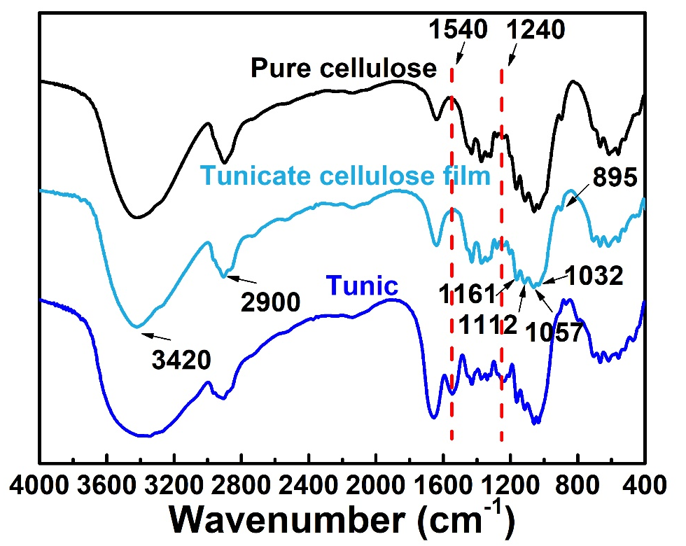
Fig. S1. FTIR spectra of pure cellulose, tunicate cellulose film and tunic.

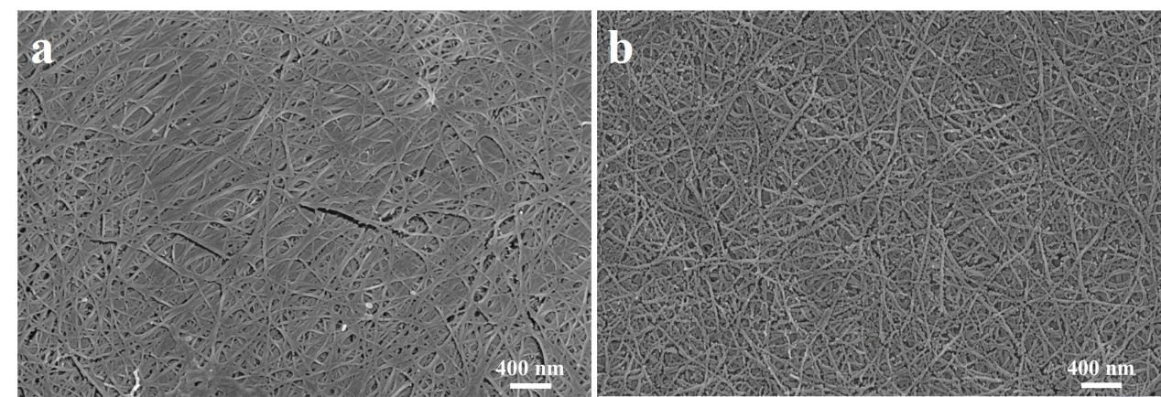
Fig. S2. SEM images for surface (a) and cross section (b) of the tunicate cellulose film.

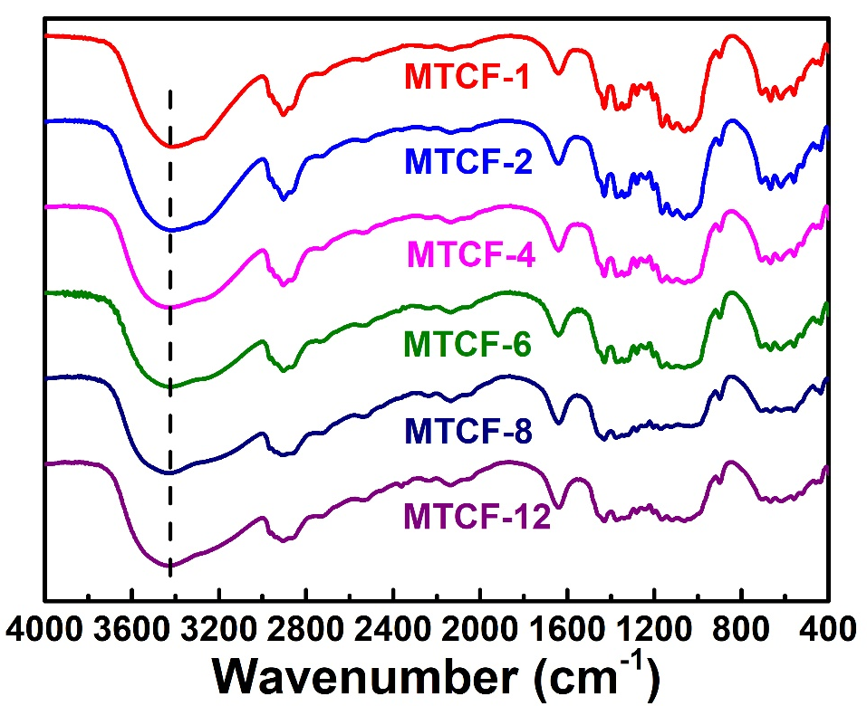
Fig. S3. FTIR spectra of MTCF-1, MTCF-2, MTCF-4, MTCF-6, MTCF-8 and MTCF-12.

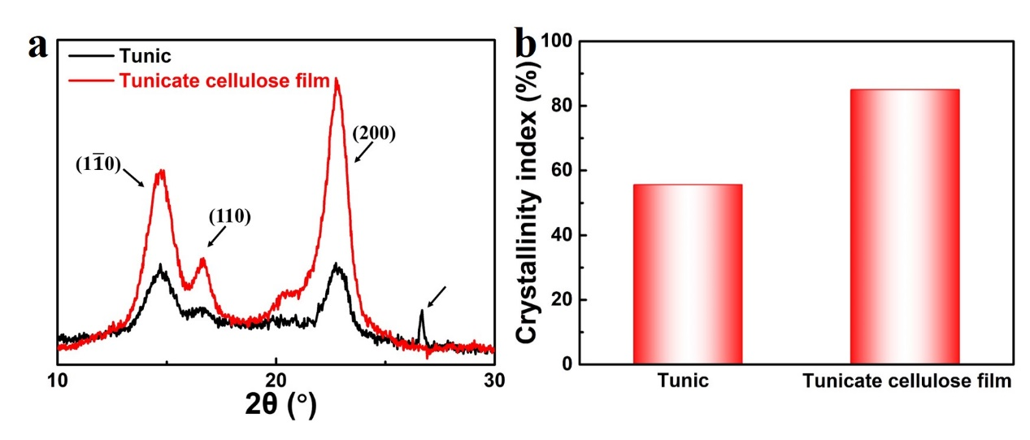
Fig. S4. XRD patterns (a) and crystallinity index (b) of tunic and tunicate cellulose film.

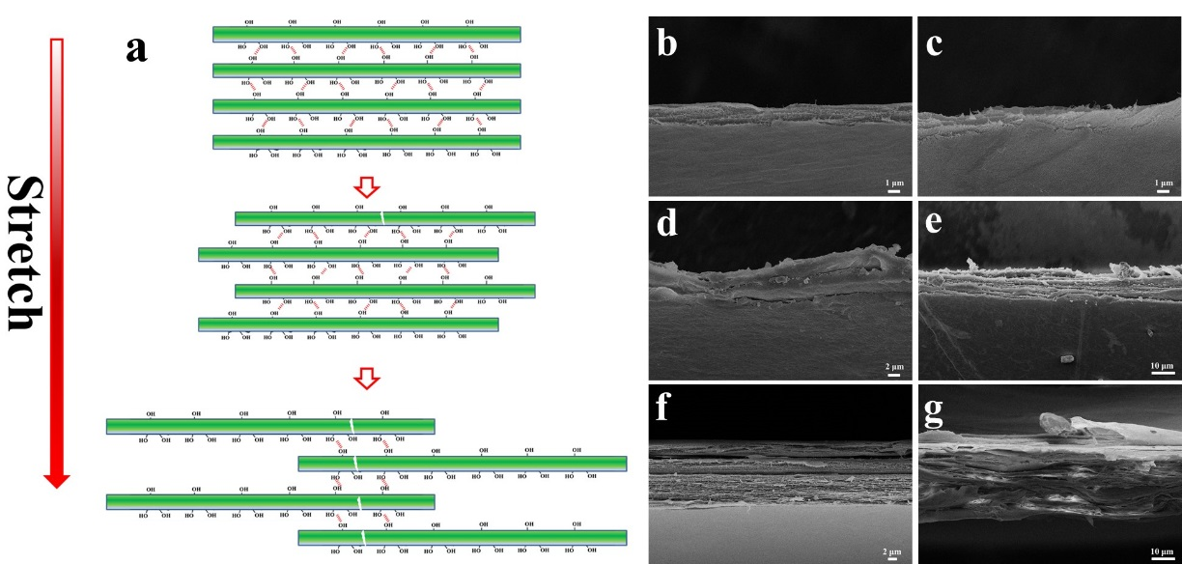
Fig. S5. Mechanism diagram of toughness enhancement (a). SEM images for fracture surface of MTCF-1 (b), MTCF-2 (c), MTCF-4 (d), MTCF-6 (e), MTCF-8 (f) and MTCF-12 (g).

