CMIP6 captures the satellite-era jet slowdown and Arctic amplification - yet projects future jet speedup and tropical amplification

Climate Dynamics

Rachel M. Robinson,,
Jacob Scheff¹ (ORCID 0000-0003-1294-3447)
Nicholas Golden¹

Corresponding author: Jacob Scheff, jscheff@uncc.edu

Supplementary Text

In preliminary work for this study (Golden 2020), analyses paralleling Figs. 1, 2, 3a-b, and 3d (but without observations) were performed using 42 models from the Coupled Model Intercomparison Project phase 5 (CMIP5; Taylor et al. 2012), which was the immediate predecessor of CMIP6. These models are listed in Table S1 below, and the CMIP5 counterparts of Figs. 3b and 3d from the main text are plotted as Figures S1 and S2 below.

The scenario used is CMIP5 historical concatenated to CMIP5 RCP8.5 (Riahi et al. 2011). The satellite-era change (Figure S1) is defined as 1999-2018 minus 1979-1998. The future change (Figure S2) is defined as 2070-2099 minus 1975-2004. The latitude-pressure boxes used to define the subtropical, Arctic and jet-stream domains are the same as in the main text.

References

Golden, N. C., 2020: Robust correlation between northern hemisphere jet response and Arctic-minus-subtropical warming across CMIP5 models. M.S. thesis, Dept. of Geography & Earth Sciences, University of North Carolina Charlotte, 136 pp., https://proquest.com/docview/2471471267.

Riahi, K., and Coauthors, 2011: RCP 8.5—A scenario of comparatively high greenhouse gas emissions. Climatic Change, 109, 33–57, https://doi.org/10.1007/s10584-011-0149-y.

Taylor, K. E., R. J. Stouffer, and G. A. Meehl, 2012: An Overview of CMIP5 and the Experiment Design. Bulletin of the American Meteorological Society, 93, 485–498, https://doi.org/10.1175/BAMS-D-11-00094.1.

Table S1. CMIP5 models used and labeled in Figures S1-S2. Model 42 was only available for the satellite-era analysis (Figure S1).

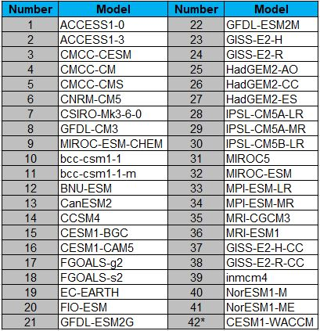

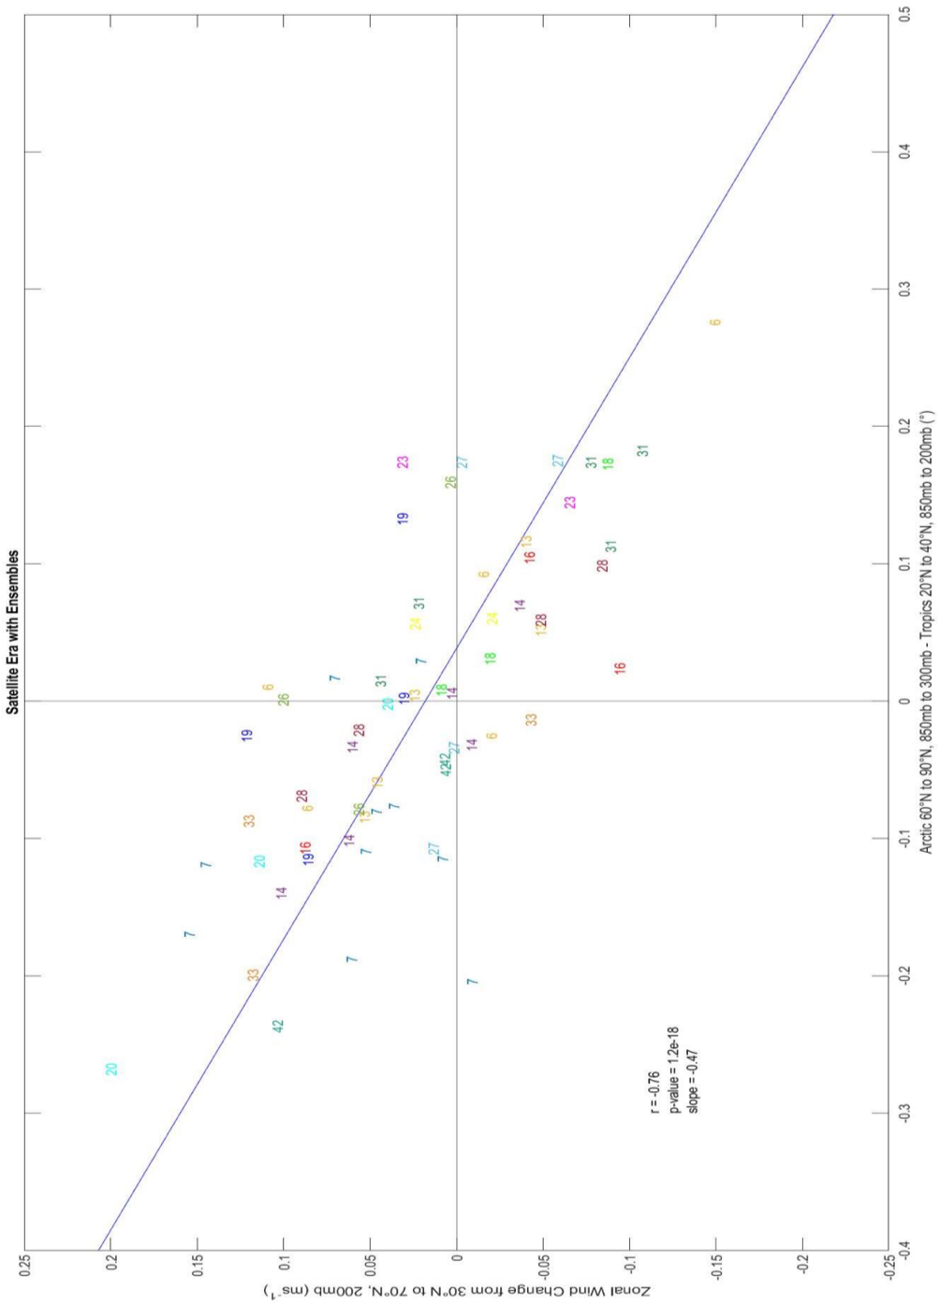
Figure S1: As Figure 3b in the main text, but for CMIP5 (years 1999-2018 of the historical and RCP8.5 experiments minus years 1979-1998 of the historical experiment), and without reanalysis estimates. Model numbers are given in Table S1.

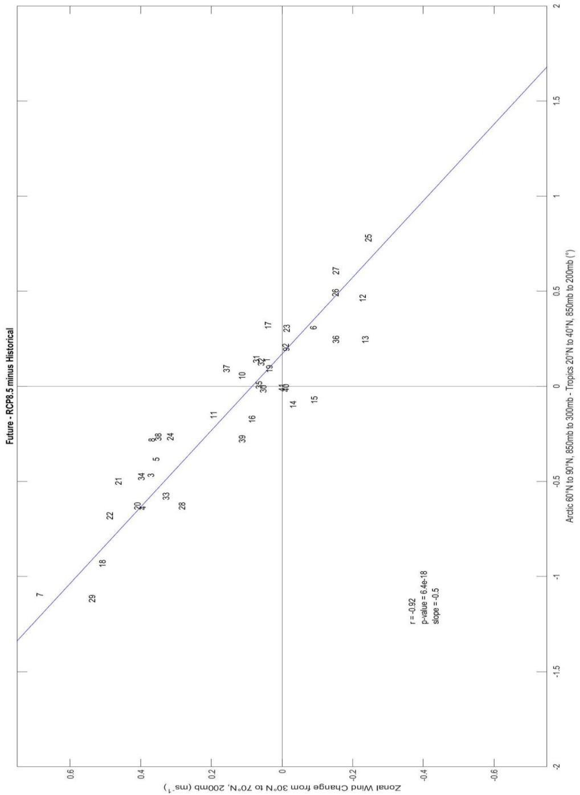
Figure S2: As Figure 3d in the main text, but for CMIP5 (years 2070-2099 of the RCP8.5 experiment minus years 1975-2004 of the historical experiment). Model numbers are given in Table S1.

Dept. of Geography & Earth Sciences, University of North Carolina, Charlotte, NC, USA
Cooperative Institute for Research in Environmental Sciences (CIRES), University of Colorado, Boulder, CO, USA
NOAA Physical Sciences Laboratory, Boulder, CO, USA

