Table 1. Social demographic characteristics of the 81 study participants

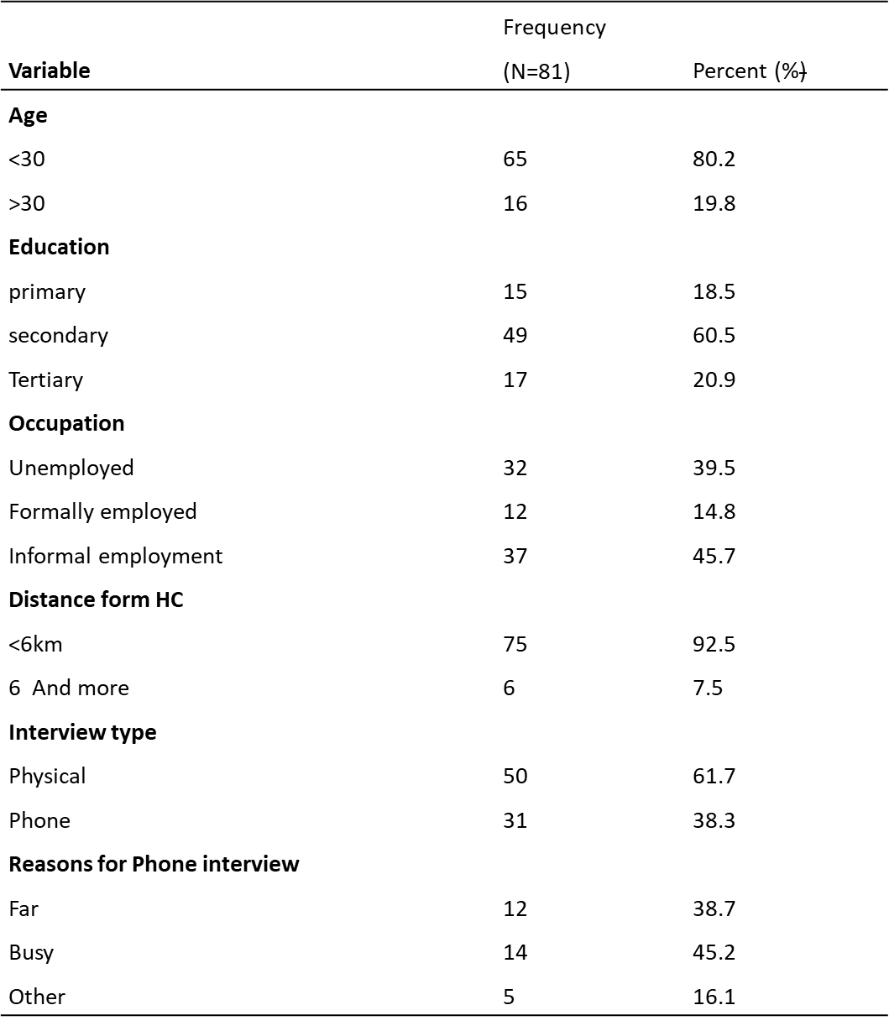

Table 2: Obstetric characteristics of the study participants in the subsequent pregnancy in relation to the mode of delivery in the index pregnancy

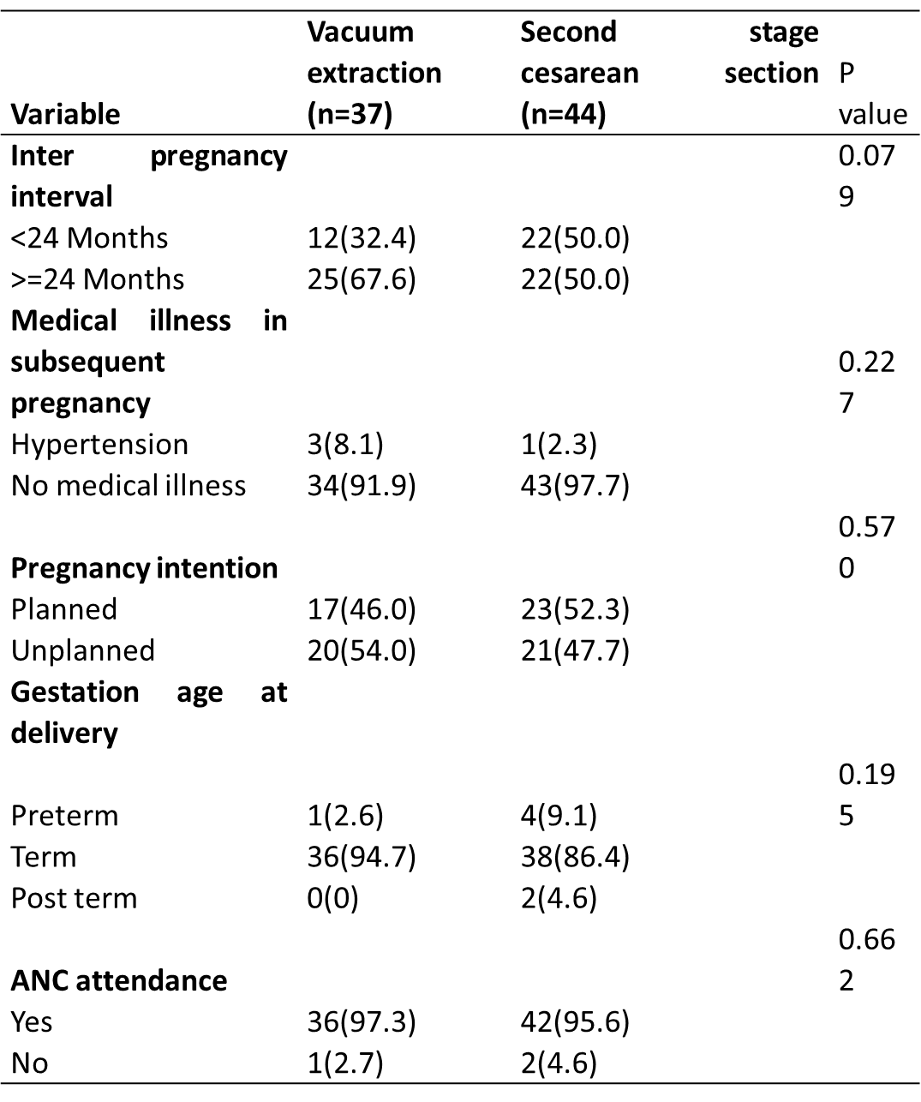

Table 3: Maternal Outcomes of the study participants in their subsequent delivery in relation to the mode of delivery in the index pregnancy.
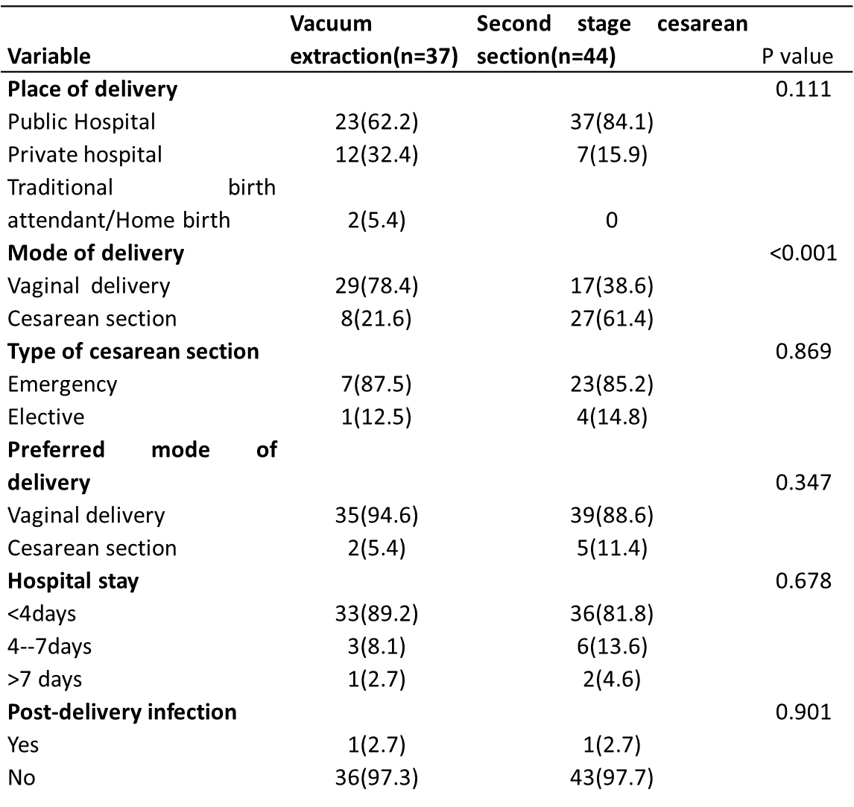

Table 4: Immediate neonatal outcomes of the subsequent delivery in relation to the index mode of delivery
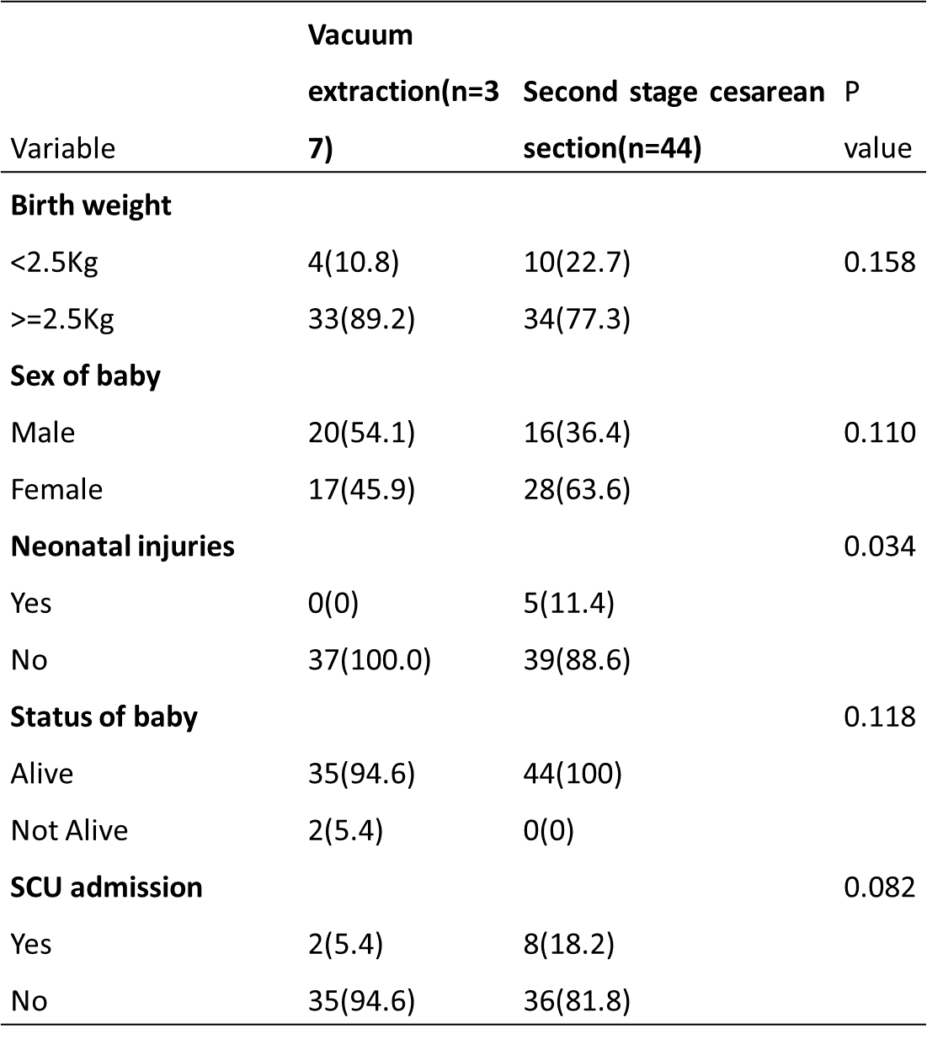
Table 5: Strength of association between mode of index delivery and subsequent mode of delivery.
