Supplementary files
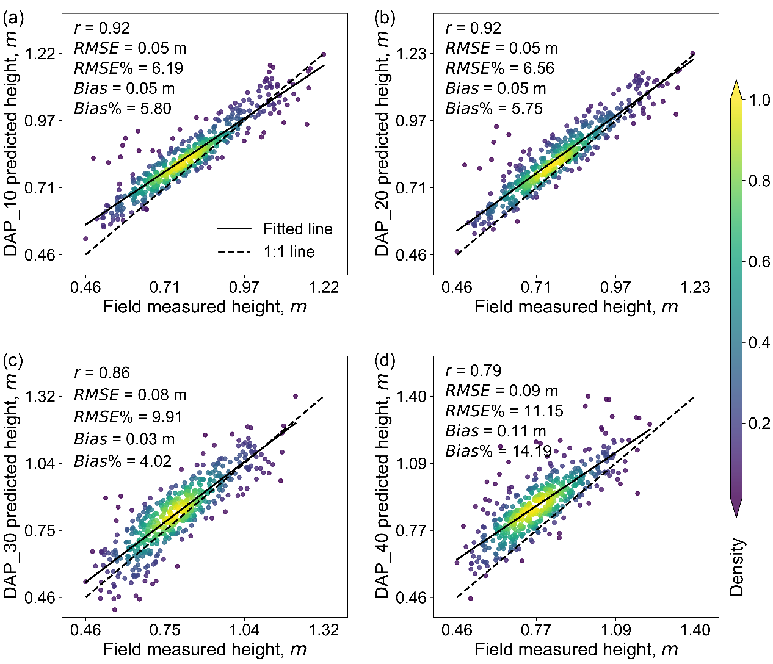

Fig. S1 Canopy height correlations between the field measurement and DAP estimates at different flight heights. (a), (b), (c), and (d) are the results of flight height at 10, 20, 30, and 40m, respectively. The solid line represents the fitted line, and the dashed line represents the 1:1 line. The color bar shows the kernel density value of the point distribution, and the green to yellow represents the increase in kernel density.

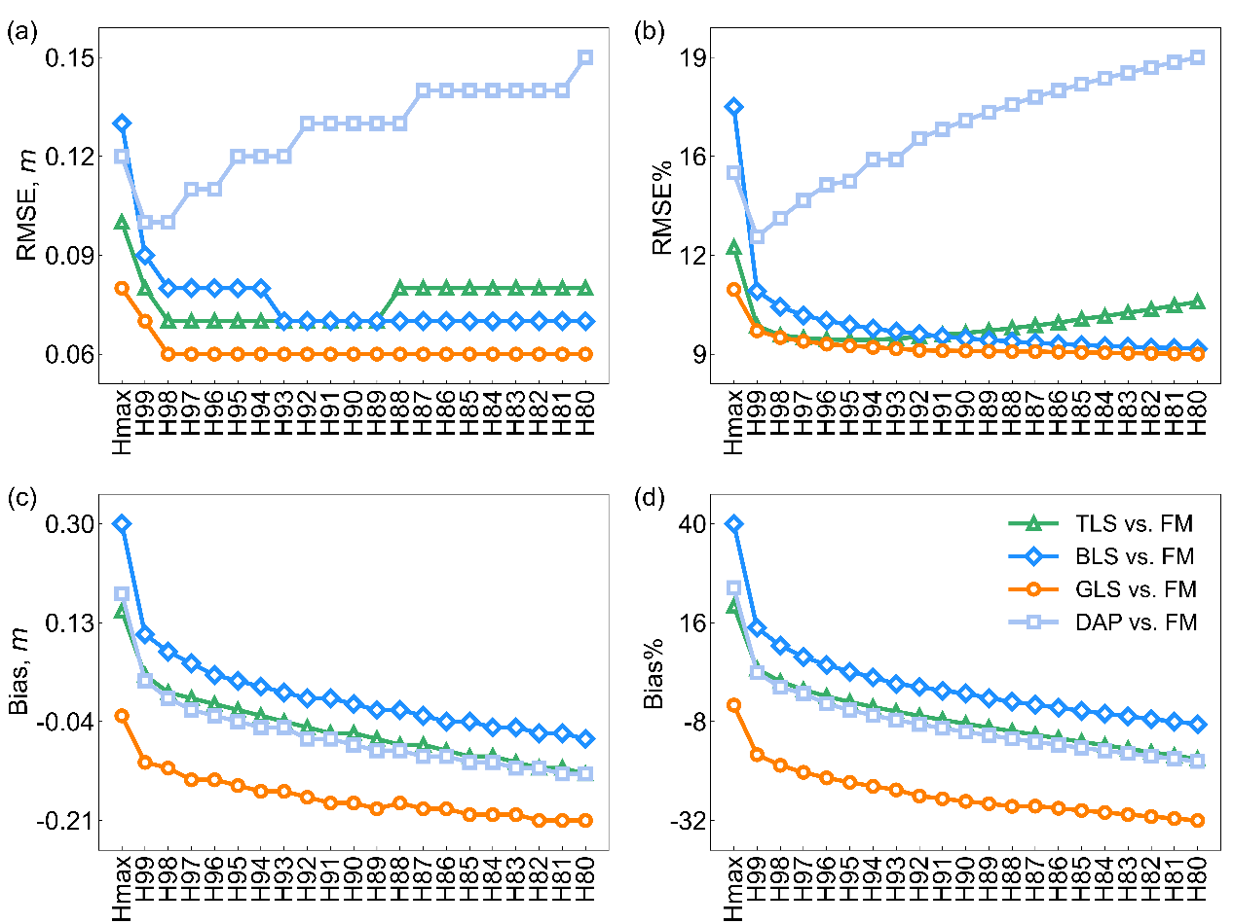

Fig. S2 (a) RMSE, (b) RMSE%, (c) Bias, and (d) Bias% between field measured height (FM) and different height quantiles (Hmax and H99) derived from the different 3D point cloud, including TLS, BLS, GLS, and DAP. The green triangle, blue diamond, dark orange circle, and baby blue square represent TLS vs. FM, BLS vs. FM, GLS vs. FM, and DAP vs. FM, respectively.

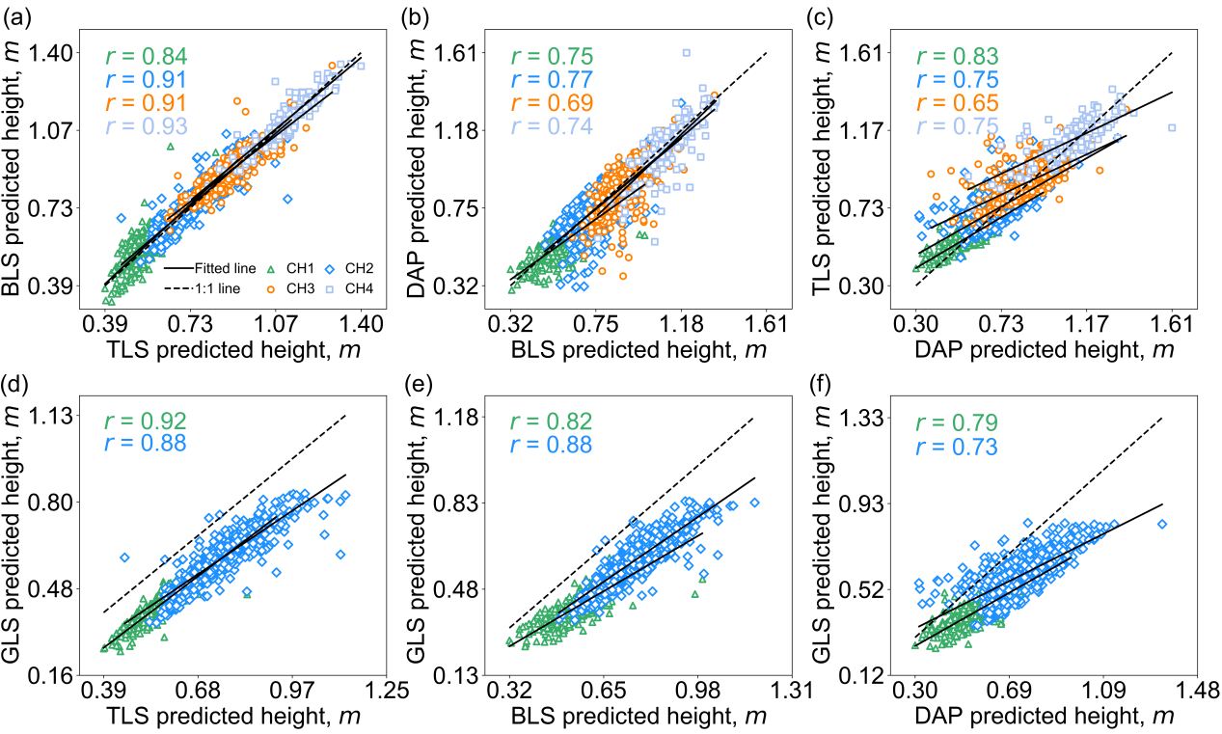

Fig. S3 Correlations of cross-comparisons between different 3D sensing data estimated canopy height (CH) at four CH subgroups. (a), (b), (c), (d), (e), and (f) are comparisons of TLS vs. BLS, BLS vs. DAP, DAP vs. TLS, TLS vs. GLS, BLS vs. GLS, and DAP vs. GLS, respectively. The green triangle, blue diamond, orange circle, and light blue square represent the CH1, CH2, CH3, and CH4 groups, respectively. The solid line represents the fitted line, and the dashed line represents the 1:1 reference.
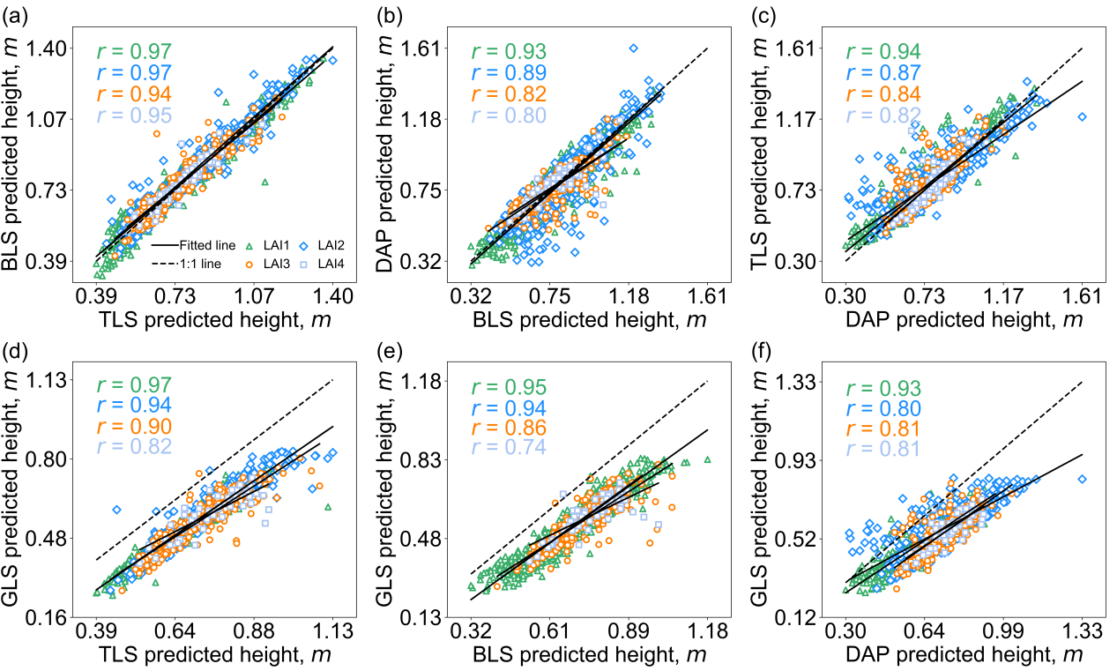

Fig. S4 Correlations of cross-comparisons between different 3D sensing data estimated canopy height (CH) at four leaf area index (LAI) groups. (a), (b), (c), (d), (e), and (f) are comparisons of TLS vs. BLS, BLS vs. DAP, DAP vs. TLS, TLS vs. GLS, BLS vs. GLS, and DAP vs. GLS, respectively. The green triangle, blue diamond, orange circle, and light blue square represent the LAI1, LAI2, LAI3, and LAI4 groups, respectively. The solid line represents the fitted line, and the dashed line represents the 1:1 reference line.
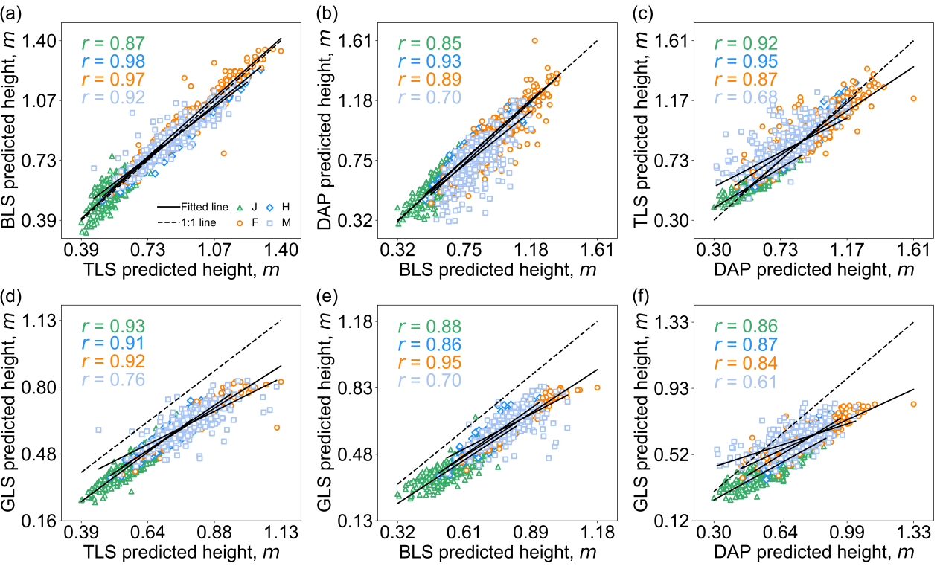

Fig. S5 Correlations of cross-comparisons between different 3D sensing data estimated canopy height (CH) at four growth stages (GS) groups. (a), (b), (c), (d), (e), and (f) are comparisons of TLS vs. BLS, BLS vs. DAP, DAP vs. TLS, TLS vs. GLS, BLS vs. GLS, and DAP vs. GLS, respectively. The green triangle, blue diamond, orange circle, and light blue square represent the jointing, heading, flowering, and maturity stages, respectively. The solid line represents the fitted line, and the dashed line represents the 1:1 reference line.

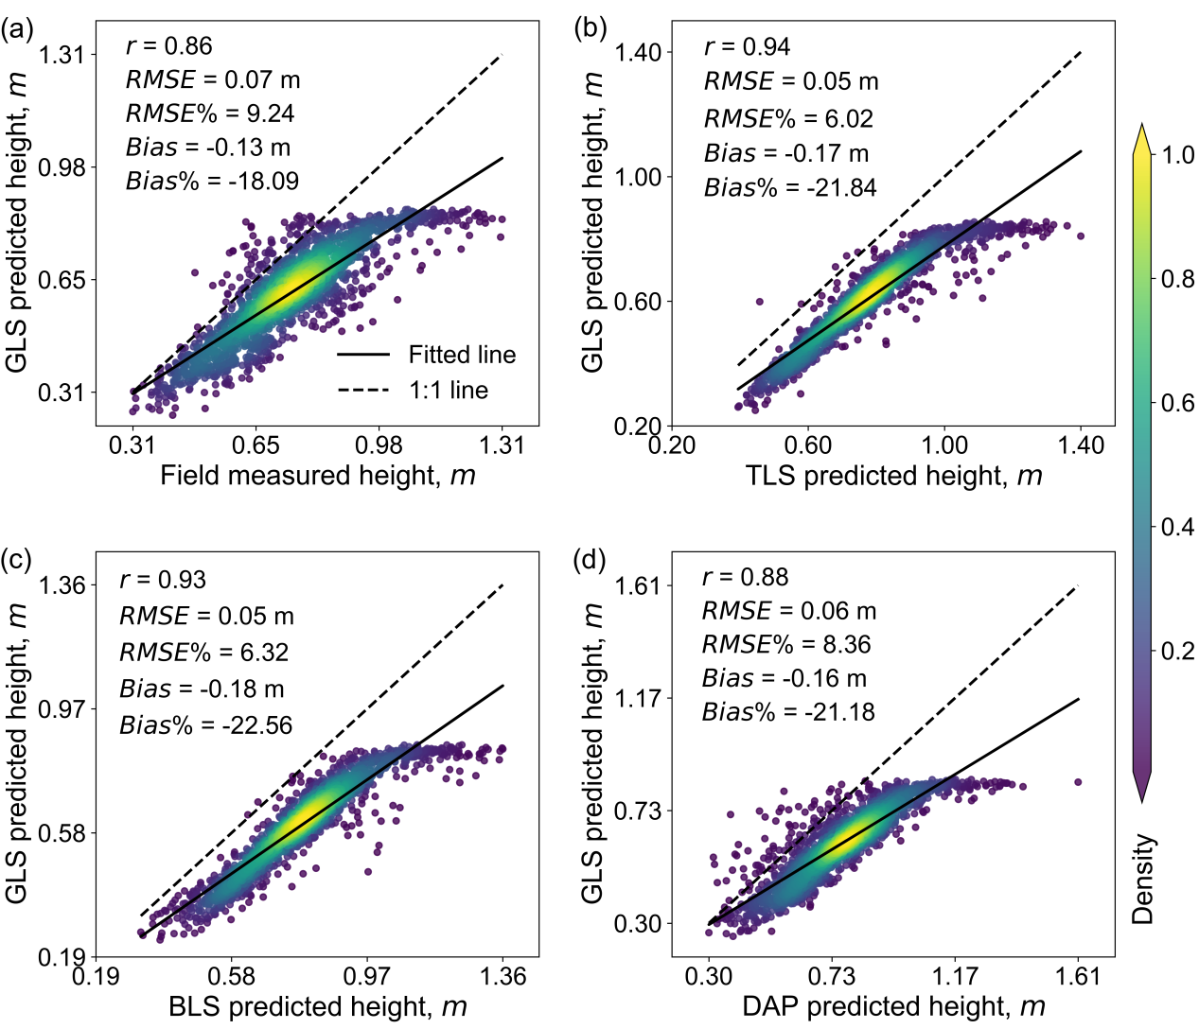

Fig. S6 Correlations between GLS predicted datasets (including the measured canopy height over 0.82m) and other datasets. (a), (b), (c), and (d) respectively represent GLS vs. FM, TLS vs. GLS, BLS vs. GLS, and DAP vs. GLS. The solid line represents the fitted line, and the dashed line represents the 1:1 line. The color bar shows the kernel density value of the point distribution, and the green to yellow represents the increase in kernel density.

