Supplementary material

An environmentally friendly method for extraction of Cobalt and Molybdenum from spent catalysts using deep eutectic solvents (DESs)
Ehsan Ebrahimi¹, Hassan Safari¹, Mohammad Rezaee ¹, Ali Rezaei ¹, Hadi Abdollahi*¹
¹School of Mining Engineering, College of Engineering, University of Tehran, Tehran, Iran
* Corresponding author. Tel./Fax: +98-21-88008838; +98-912-5032335
E-mail address: h_abdollahi@ut.ac.ir (H. Abdollahi).
ORCID: Hadi Abdollahi http://orcid.org/0000-0002-9099-7451

Tables

Table S1 List of kinetic models used in this study and their equations
No | Kinetic mechanisms | Model equations | Reference
1 | Diffusion through the liquid film (constant size cp, sp, pp) | kt = X | (Levenspiel, 1998)
2 | Diffusion through the product layer (constant size pp) | kt = X² | (Levenspiel, 1998)
3 | Diffusion through the product layer (constant size cp) | $$kt= X+(1-X)ln(1-X)$$ | (Levenspiel, 1998)
4 | Diffusion through the product layer (Crank–Ginstling and Brounshtein Model sp) | kt$= 1-{3(1-X)}^{2/3}+2(1-X)$ | (Fogler, 2016)
5 | Diffusion through the product layer (Jander's Equation sp) | $$kt =[1-{\left(1-X\right)}^{\frac{1}{3}}]²$$ | (Fogler, 2016)
6 | Diffusion through the product layer and interfacial transfer | $$kt=\frac{1}{3}\ln\left(1-X\right)–[1-{(1-X)}^{-1/3}]$$ | (Dickinson and Heal, 1999)
7 | chemical reaction on the particle surface (constant size cp) | $$kt= 1-{(1-X)}^{1/2}$$ | (Levenspiel, 1998)
8 | chemical reaction on the particle surface (constant size sp) | $$kt= 1-{(1-X)}^{1/3}$$ | (Levenspiel, 1998)
9 | The surface chemical reaction (shrinking sp) | $$kt= 1-{(1-0.45X)}^{1/3}$$ | (Padilla et al., 2008)
10 | Mixed control model (surface reaction control; and diffusion through product layer) | $$kt =-ln(1-X)$$ | (Sokić et al., 2009)

X is the leaching efficiency of Cobalt/Molybdenum (%), k is the apparent rate constant, and t is the leaching time, h. (sp: spherical particles, pp: prismatic particles, cp: cylindrical particle)
Table S2 List of kinetic models calculated for (DES-1, Cobalt) at different temperatures and their correlation coefficients (R²), (0-48 hour)
No | Kinetic Model equations | Correlation coefficients (R²) of kinetics models
No | Kinetic Model equations | 100°C | 75°C | 50°C
1 | kt = X | 0.0124 | 0.4693 | 0.835
2 | kt = X² | 0.9041 | 0.9339 | 0.9946
3 | $$kt= X+(1-X)ln(1-X)$$ | 0.9645 | 0.9647 | 0.9862
4 | kt$= 1-{3(1-X)}^{2/3}+2(1-X)$ | 0.9808 | 0.9733 | 0.9819
5 | $$kt =[1-{\left(1-X\right)}^{\frac{1}{3}}]²$$ | 0.9964 | 0.9848 | 0.9717
6 | $$kt=\frac{1}{3}\ln\left(1-X\right)–[1-{(1-X)}^{-1/3}]$$ | 0.982 | 0.9907 | 0.9465
7 | $$kt= 1-{(1-X)}^{1/2}$$ | 0.5734 | 0.1741 | 0.008
8 | $$kt= 1-{(1-X)}^{1/3}$$ | 0.7715 | 0.741 | 0.9245
9 | $$kt= 1-{(1-0.45X)}^{1/3}$$ | 0.2578 | 0.5685 | 0.8717
10 | $$kt =-ln(1-X)$$ | 0.948 | 0.1166 | 0.064

Table S3 List of kinetic models calculated for (DES-1, Molybdenum) at different temperatures and their correlation coefficients (R²), (0-48 hour)
No | Kinetic Model equations | Correlation coefficients (R²) of kinetics models
No | Kinetic Model equations | 100°C | 75°C | 50°C
1 | kt = X | 0.361 | 0.5375 | 0.835
2 | kt = X² | 0.9416 | 0.9825 | 0.9946
3 | $$kt= X+(1-X)ln(1-X)$$ | 0.9755 | 0.9859 | 0.9885
4 | kt$= 1-{3(1-X)}^{2/3}+2(1-X)$ | 0.9844 | 0.9839 | 0.9855
5 | $$kt =[1-{\left(1-X\right)}^{\frac{1}{3}}]²$$ | 0.9914 | 0.976 | 0.9785
6 | $$kt=\frac{1}{3}\ln\left(1-X\right)–[1-{(1-X)}^{-1/3}]$$ | 0.9767 | 0.9489 | 0.9614
7 | $$kt= 1-{(1-X)}^{1/2}$$ | 0.01 | 0.07 | 0.05
8 | $$kt= 1-{(1-X)}^{1/3}$$ | 0.8456 | 0.7649 | 0.9091
9 | $$kt= 1-{(1-0.45X)}^{1/3}$$ | 0.5237 | 0.626 | 0.8659
10 | $$kt =-ln(1-X)$$ | 0.9625 | 0.5584 | 0.08

Table S4 List of kinetic models calculated for (DES-2, Cobalt) at different temperatures and their correlation coefficients (R²), (0-48 hour)
No | Kinetic Model equations | Correlation coefficients (R²) of kinetics models
No | Kinetic Model equations | 100°C | 75°C | 50°C
1 | kt = X | 0.7599 | 0.8984 | 0.983
2 | kt = X² | 0.9975 | 0.9894 | 0.8621
3 | $$kt= X+(1-X)ln(1-X)$$ | 0.9825 | 0.9742 | 0.8533
4 | kt$= 1-{3(1-X)}^{2/3}+2(1-X)$ | 0.9679 | 0.967 | 0.8503
5 | $$kt =[1-{\left(1-X\right)}^{\frac{1}{3}}]²$$ | 0.9271 | 0.9513 | 0.8445
6 | $$kt=\frac{1}{3}\ln\left(1-X\right)–[1-{(1-X)}^{-1/3}]$$ | 0.8491 | 0.9162 | 0.8335
7 | $$kt= 1-{(1-X)}^{1/2}$$ | 0.8161 | 0.7046 | 0.8805
8 | $$kt= 1-{(1-X)}^{1/3}$$ | 0.9774 | 0.9661 | 0.9767
9 | $$kt= 1-{(1-0.45X)}^{1/3}$$ | 0.8444 | 0.9266 | 0.9808
10 | $$kt =-ln(1-X)$$ | 0.9861 | 0.9837 | 0.9725

Table S5 List of kinetic models calculated for (DES-2, Molybdenum) at different temperatures and their correlation coefficients (R²), (0-48 hour)
No | Kinetic Model equations | Correlation coefficients (R²) of kinetics models
No | Kinetic Model equations | 100°C | 75°C | 50°C
1 | kt = X | 0.7599 | 0.8984 | 0.983
2 | kt = X² | 0.9975 | 0.9894 | 0.8621
3 | $$kt= X+(1-X)ln(1-X)$$ | 0.9916 | 0.9792 | 0.8555
4 | kt$= 1-{3(1-X)}^{2/3}+2(1-X)$ | 0.9869 | 0.9748 | 0.853
5 | $$kt =[1-{\left(1-X\right)}^{\frac{1}{3}}]²$$ | 0.9724 | 0.9652 | 0.8485
6 | $$kt=\frac{1}{3}\ln\left(1-X\right)–[1-{(1-X)}^{-1/3}]$$ | 0.9395 | 0.9434 | 0.8398
7 | $$kt= 1-{(1-X)}^{1/2}$$ | 0.971 | 0.8887 | 0.9647
8 | $$kt= 1-{(1-X)}^{1/3}$$ | 0.9358 | 0.9512 | 0.9875
9 | $$kt= 1-{(1-0.45X)}^{1/3}$$ | 0.9801 | 0.9893 | 0.9855
10 | $$kt =-ln(1-X)$$ | 0.9701 | 0.9693 | 0.9755

Figures
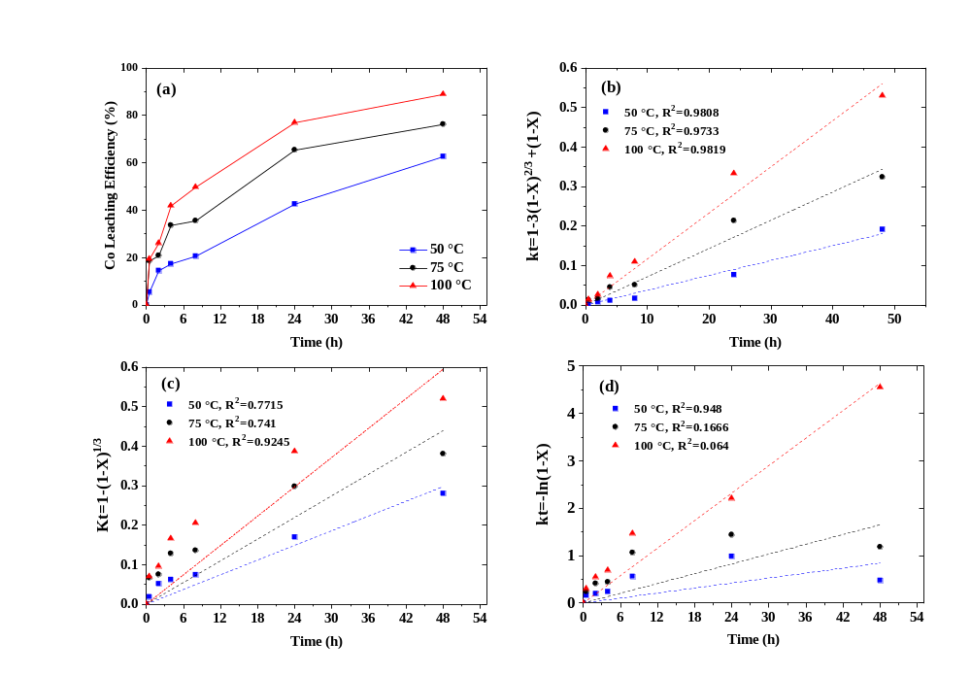
Fig.S1 Plots of (a)Cobalt leaching efficiency at different temperatures for (DES-1), (b) kt$= 1-{3(1-X)}^{2/3}+2(1-X)$ , (c) $kt= 1-{(1-X)}^{1/3}$ , and (d) $kt =-ln\left(1-X\right)$ vs time, (0-48 hours)
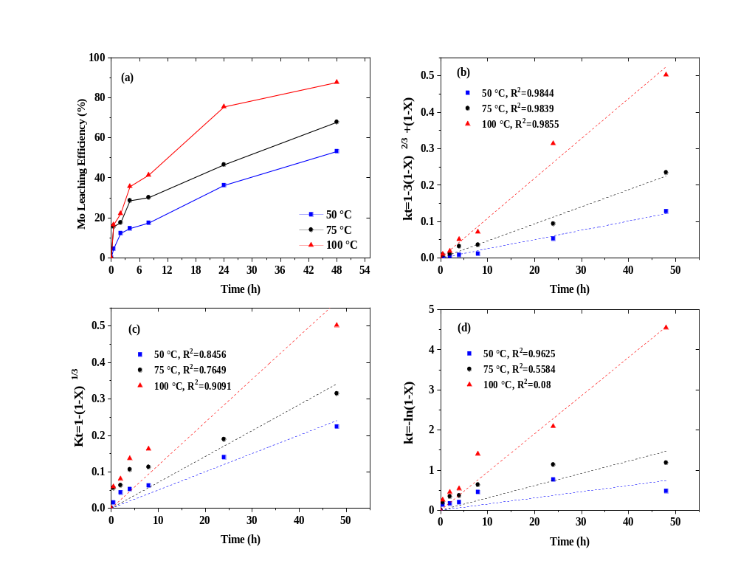
Fig.S2 Plots of (a) Molybdenum leaching efficiency at different temperatures for (DES-1), (b) kt$= 1-{3(1-X)}^{2/3}+2(1-X)$ , (c) $kt= 1-{(1-X)}^{1/3}$ , and (d) $kt =-ln\left(1-X\right)$ vs time, (0-48 hours)
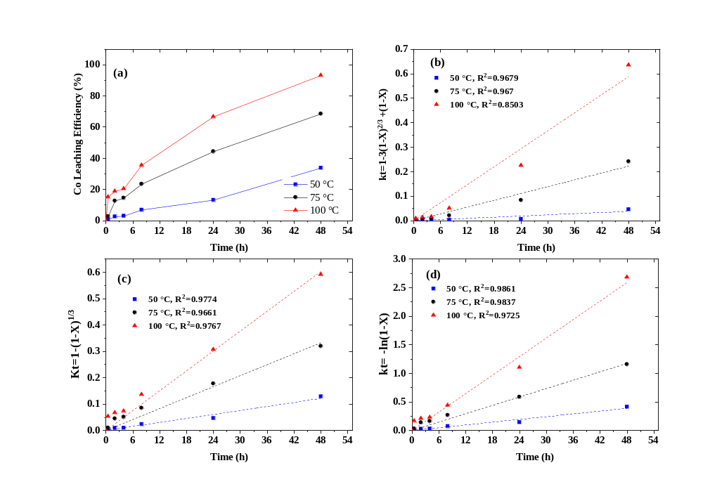
Fig.S3 Plots of (a)Cobalt leaching efficiency at different temperatures for (DES-2), (b) kt$= 1-{3(1-X)}^{2/3}+2(1-X)$ , (c) $kt= 1-{(1-X)}^{1/3}$ , and (d) $kt =-ln\left(1-X\right)$ vs time, (0-48 hours)
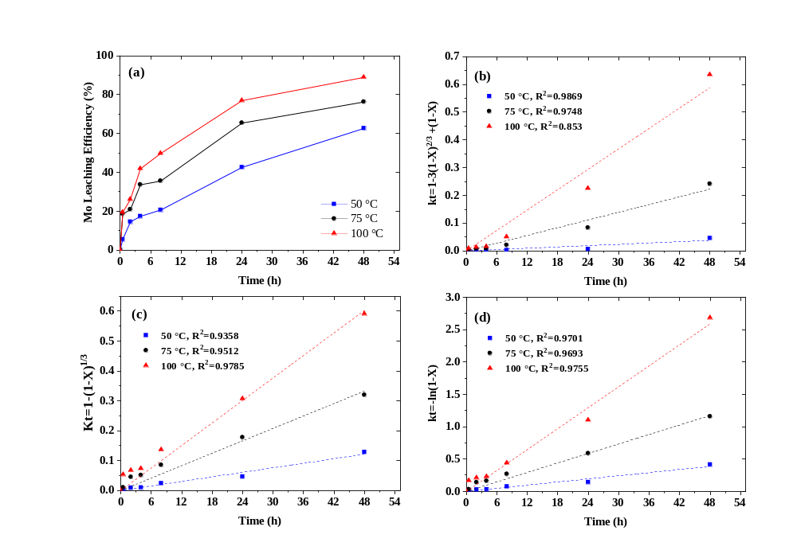
Fig.S4 Plots of (a) Molybdenum leaching efficiency at different temperatures for (DES-2), (b) kt$= 1-{3(1-X)}^{2/3}+2(1-X)$ , (c) $kt= 1-{(1-X)}^{1/3}$ , and (d) $kt =-ln\left(1-X\right)$ vs time, (0-48 hours)

References
Dickinson, C.F., Heal, G.R., 1999. Solid–liquid diffusion controlled rate equations. Thermochim. Acta 340–341, 89–103. https://doi.org/10.1016/S0040-6031(99)00256-7
Fogler, H.S., 2016. Elements of Chemical Reaction Engineering, 5 th. ed, Pearson. Pearson, Philadelphia.
Levenspiel, O., 1998. Chemical reaction engineering, 3rd editio. ed, Wiley. Wiley. https://doi.org/https://doi.org/10.1002/aic.690190143
Padilla, R., Pavez, P., Ruiz, M.C., 2008. Kinetics of copper dissolution from sulfidized chalcopyrite at high pressures in H2SO4–O2. Hydrometallurgy 91, 113–120. https://doi.org/10.1016/j.hydromet.2007.12.003
Sokić, M.D., Marković, B., Živković, D., 2009. Kinetics of chalcopyrite leaching by sodium nitrate in sulphuric acid. Hydrometallurgy 95, 273–279. https://doi.org/10.1016/j.hydromet.2008.06.012

