Supplementary Appendix
Supplementary Table S1 Number and proportion of participants by insulin use and no insulin use in NHANES. 2
Supplementary Table S2 Independent SNPs associated with insulin use in the UKB cohort. 3
Supplementary Table S3 Independent SNPs associated with insulin use in the Finn cohort. 4
Supplementary Table S4 Independent SNPs associated with diabetes. 7
Supplementary Figure S1 Scatter plot and leave-one-out analysis for the association of insulin use with asthma in UKB cohort. 10
Supplementary Figure S2 Scatter plot and leave-one-out analysis for the association of insulin use with asthma in Finn cohort. 11
Supplementary Figure S3 The genetic associations between diabetes and risk of asthma. 13
Supplementary Figure S4 Multivariate mendelian randomization analysis of insulin use and type 1/ type 2 diabetes on asthma. 14

Supplementary Table S1 Number and proportion of participants by insulin use and no insulin use in NHANES.
 | Total | Insulin use | No insulin use | P value
Sex |  |  |  | 0.099
Female | 42,931(50.66) | 876(1.86) | 42,055(98.14)
Male | 42,956(49.34) | 936(2.05) | 42,020(97.95)
Ethnicity |  |  |  | < 0.001
White | 32,131(64.66) | 692(1.95) | 31,439(98.05)
Black | 20,408(12.06) | 539(2.81) | 19,869(97.19)
Mexican | 17,439(9.86) | 293(1.48) | 17,146(98.52)
Age |  |  |  | < 0.001
<18 | 33,498(23.87) | 59(0.24) | 50,636(99.76)
>=18 | 52,389(76.13) | 1,753(2.49) | 33,439(97.51)
Diabetes |  |  |  | < 0.001
Yes | 8,924(9.80) | 1,805(19.89) | 7,119(80.11)
No | 76,963(90.20) | 7(0.01) | 76,956(99.99)
Asthma |  |  |  | < 0.001
Yes | 12,641(14.83) | 362(2.54) | 12,279(97.46)
No | 73,246(85.17) | 1,450(1.85) | 71,796(98.15)
1. Data are presented as n (%). N is the total number of patients with available data.
2. P value < 0.05 was considered statistically significant.

Supplementary Table S2 Independent SNPs associated with insulin use in the UKB cohort.
SNP | EA | OA | EAF | Beta | SE | p | R² | F-statistic
rs6679677 | A | C | 0.100758 | 0.003832 | 0.00034 | 1.50E-29 | 0.000275 | 127.3921
rs4234731 | G | A | 0.593356 | 0.001265 | 0.00021 | 1.70E-09 | 7.85E-05 | 36.33938
rs9637714 | C | T | 0.288066 | -0.00139 | 0.000228 | 1.10E-09 | 8.03E-05 | 37.15791
rs7744001 | A | G | 0.312907 | -0.00252 | 0.00022 | 2.50E-30 | 0.000283 | 131.0205
rs1064173 | A | G | 0.284529 | 0.008117 | 0.000237 | 1.00E-200 | 0.002521 | 1169.777
rs6920323 | C | T | 0.152375 | -0.00201 | 0.000284 | 1.50E-12 | 0.000108 | 50.03324
rs3129883 | C | T | 0.749687 | 0.004101 | 0.000236 | 1.20E-67 | 0.000652 | 302.0201
rs7903146 | T | C | 0.290666 | 0.002265 | 0.000225 | 8.90E-24 | 0.000218 | 101.0549
rs689 | T | A | 0.710792 | 0.002615 | 0.000227 | 1.20E-30 | 0.000286 | 132.4942

SNP, single nucleotide polymorphism; EA, effect allele; OA, other allele; EAF, effect allele frequency; Beta, effect size; SE, standard error for beta; p, p-value; R², phenotype variance explained by genetics.

Supplementary Table S3 Independent SNPs associated with insulin use in the Finn cohort.
SNP | EA | OA | EAF | Beta | SE | p | R2 | F-statistic
rs6679677 | A | C | 0.1472 | 0.1288 | 0.0148 | 3.69E-18 | 0.000399 | 75.73703
rs11688682 | C | G | 0.2507 | -0.0688 | 0.0123 | 2.41E-08 | 0.000165 | 31.2872
rs2943650 | T | C | 0.6392 | 0.0677 | 0.011 | 7.18E-10 | 0.0002 | 37.87843
rs78868334 | A | G | 0.04924 | 0.1665 | 0.0243 | 6.73E-12 | 0.000247 | 46.94787
rs112694524 | A | G | 0.03339 | -0.1684 | 0.0299 | 1.76E-08 | 0.000167 | 31.72063
rs76236532 | A | G | 0.04772 | 0.1625 | 0.0247 | 5.19E-11 | 0.000228 | 43.28255
rs11709077 | A | G | 0.1707 | -0.0984 | 0.0141 | 2.67E-12 | 0.000257 | 48.70258
rs4481184 | T | C | 0.3081 | 0.082 | 0.0114 | 6.30E-13 | 0.000273 | 51.739
rs4858068 | C | A | 0.8459 | -0.0839 | 0.0146 | 9.40E-09 | 0.000174 | 33.02313
rs11720108 | T | C | 0.176 | -0.0842 | 0.0139 | 1.40E-09 | 0.000193 | 36.69396
rs3887925 | T | C | 0.463 | 0.0627 | 0.0106 | 3.30E-09 | 0.000184 | 34.98834
rs12507026 | T | A | 0.4732 | 0.0755 | 0.0106 | 9.68E-13 | 0.000267 | 50.73202
rs1046317 | C | T | 0.6107 | 0.0807 | 0.0109 | 1.04E-13 | 0.000289 | 54.81433
rs76177300 | A | G | 0.05783 | 0.1409 | 0.0226 | 4.76E-10 | 0.000205 | 38.86916
rs3957146 | C | T | 0.1197 | 0.4578 | 0.0164 | 1.40E-170 | 0.00409 | 779.2268
rs73410774 | T | G | 0.05438 | 0.6072 | 0.0235 | 4.48E-147 | 0.003507 | 667.6176
rs4273712 | G | A | 0.2689 | 0.0664 | 0.0118 | 2.08E-08 | 0.000167 | 31.66446
rs9468618 | T | C | 0.05566 | -0.1273 | 0.0233 | 4.54E-08 | 0.000157 | 29.85004
rs62398467 | T | C | 0.2543 | 0.105 | 0.0121 | 5.24E-18 | 0.000397 | 75.30223
rs112511187 | AAAACAAACAAAC | A | 0.04958 | 0.621 | 0.0249 | 2.14E-137 | 0.003268 | 621.9916
rs9348441 | A | T | 0.3289 | 0.1231 | 0.0112 | 3.68E-28 | 0.000636 | 120.8037
rs3131640 | T | A | 0.5721 | 0.1182 | 0.0116 | 2.05E-24 | 0.000547 | 103.8291
rs77655131 | T | C | 0.1836 | 0.0799 | 0.0137 | 5.07E-09 | 0.000179 | 34.01359
rs6977081 | T | G | 0.3593 | 0.061 | 0.011 | 2.89E-08 | 0.000162 | 30.75207
rs11558471 | G | A | 0.3784 | -0.0698 | 0.0109 | 1.46E-10 | 0.000216 | 41.00699
rs34105898 | A | T | 0.1266 | 0.0909 | 0.0159 | 1.03E-08 | 0.000172 | 32.68387
rs62539932 | A | G | 0.06713 | 0.1194 | 0.0213 | 1.99E-08 | 0.000166 | 31.42313
rs28624681 | C | T | 0.7078 | 0.0754 | 0.0117 | 1.05E-10 | 0.000219 | 41.53086
rs10811660 | A | G | 0.1439 | -0.1426 | 0.0151 | 4.24E-21 | 0.00047 | 89.18363
rs11257658 | A | G | 0.2648 | 0.0806 | 0.012 | 1.99E-11 | 0.000238 | 45.11361
rs114322470 | G | T | 0.02355 | -0.2359 | 0.0353 | 2.49E-11 | 0.000235 | 44.65874
rs7910961 | C | T | 0.6783 | 0.0624 | 0.0113 | 3.50E-08 | 0.000161 | 30.49385
rs4745916 | A | T | 0.1956 | 0.0745 | 0.0133 | 2.07E-08 | 0.000165 | 31.37684
rs10882099 | C | T | 0.4766 | -0.0896 | 0.0106 | 2.31E-17 | 0.000376 | 71.45034
rs7903146 | T | C | 0.1996 | 0.2912 | 0.0134 | 1.33E-104 | 0.002483 | 472.2513
rs77464186 | C | A | 0.2376 | -0.0858 | 0.0124 | 5.61E-12 | 0.000252 | 47.87747
rs10830963 | G | C | 0.3567 | 0.0834 | 0.011 | 3.91E-14 | 0.000303 | 57.48397
rs2237897 | T | C | 0.08141 | -0.172 | 0.0196 | 1.61E-18 | 0.000406 | 77.00958
rs1002226 | T | C | 0.5154 | -0.058 | 0.0106 | 3.96E-08 | 0.000158 | 29.93948
rs76895963 | G | T | 0.03114 | -0.4362 | 0.0331 | 1.05E-39 | 0.000915 | 173.6662
rs78470967 | A | T | 0.03942 | -0.2186 | 0.0279 | 4.32E-15 | 0.000323 | 61.38919
rs74862545 | T | C | 0.01951 | -0.261 | 0.0395 | 3.94E-11 | 0.00023 | 43.66031
rs10466811 | A | G | 0.2372 | -0.0704 | 0.0125 | 1.92E-08 | 0.000167 | 31.71942
rs56348580 | C | G | 0.2827 | -0.0645 | 0.0118 | 4.69E-08 | 0.000157 | 29.87827
rs2583921 | C | A | 0.0563 | 0.1315 | 0.023 | 1.06E-08 | 0.000172 | 32.68856
rs112108223 | A | G | 0.02237 | -0.3295 | 0.0371 | 6.17E-19 | 0.000416 | 78.87929
rs7998259 | A | G | 0.3894 | -0.0665 | 0.0109 | 1.01E-09 | 0.000196 | 37.22119
rs34337125 | A | G | 0.4142 | -0.0603 | 0.0107 | 2.01E-08 | 0.000167 | 31.75902
rs9940128 | A | G | 0.4289 | 0.1082 | 0.0106 | 2.98E-24 | 0.000549 | 104.194
rs8073177 | C | T | 0.7454 | -0.0672 | 0.0121 | 2.90E-08 | 0.000163 | 30.84379
rs8100204 | A | G | 0.1599 | 0.1084 | 0.0145 | 8.44E-14 | 0.000294 | 55.88851
rs10408179 | C | T | 0.4465 | -0.0596 | 0.0106 | 2.11E-08 | 0.000167 | 31.6141
rs11668971 | C | T | 0.5284 | -0.0627 | 0.0106 | 2.89E-09 | 0.000184 | 34.98834
rs429358 | C | T | 0.1826 | -0.0931 | 0.0138 | 1.73E-11 | 0.00024 | 45.5136
rs45551238 | T | C | 0.0499 | -0.2126 | 0.0247 | 7.85E-18 | 0.00039 | 74.0854
rs78583263 | G | C | 0.05418 | 0.1425 | 0.0233 | 1.01E-09 | 0.000197 | 37.40399

SNP, single nucleotide polymorphism; EA, effect allele; OA, other allele; EAF, effect allele frequency; Beta, effect size; SE, standard error for beta; p, p-value; R², phenotype variance explained by genetics.

Supplementary Table S4 Independent SNPs associated with diabetes.
SNP | EA | OA | EAF | Beta | SE | p | R2 | F-statistic
rs17513135 | T | C | 0.227468 | 0.002936 | 0.00048 | 9.70E-10 | 8.08E-05 | 37.38992
rs2793829 | T | C | 0.107419 | 0.004347 | 0.00065 | 2.30E-11 | 9.65E-05 | 44.66762
rs6679677 | A | C | 0.100758 | 0.003956 | 0.000668 | 3.10E-09 | 7.59E-05 | 35.12673
rs17712208 | A | T | 0.03521 | 0.007193 | 0.001092 | 4.50E-11 | 9.37E-05 | 43.36249
rs10195252 | C | T | 0.405055 | -0.0026 | 0.00041 | 2.20E-10 | 8.70E-05 | 40.28158
rs2972144 | G | A | 0.647556 | 0.003391 | 0.000421 | 8.10E-16 | 0.00014 | 64.84754
rs1260326 | C | T | 0.604288 | 0.0029 | 0.000411 | 1.70E-12 | 0.000107 | 49.76319
rs77101426 | A | G | 0.073373 | -0.00539 | 0.000775 | 3.60E-12 | 0.000104 | 48.3219
rs13012438 | A | C | 0.372491 | -0.00237 | 0.000417 | 1.20E-08 | 7.01E-05 | 32.4436
rs11712037 | G | C | 0.118751 | -0.00409 | 0.000622 | 5.10E-11 | 9.32E-05 | 43.12977
rs112674299 | T | C | 0.133389 | -0.00349 | 0.000592 | 3.80E-09 | 7.50E-05 | 34.72977
rs11720108 | T | C | 0.24632 | -0.003 | 0.000468 | 1.40E-10 | 8.90E-05 | 41.18844
rs4622883 | G | A | 0.507243 | -0.00222 | 0.000403 | 3.70E-08 | 6.54E-05 | 30.29439
rs1496653 | G | A | 0.203441 | -0.00335 | 0.0005 | 1.90E-11 | 9.73E-05 | 45.02992
rs4686471 | C | T | 0.610082 | 0.002418 | 0.000415 | 5.50E-09 | 7.35E-05 | 34.01441
rs73077175 | A | G | 0.335079 | -0.00235 | 0.000427 | 3.80E-08 | 6.53E-05 | 30.24924
rs7633675 | G | T | 0.315774 | 0.004507 | 0.000433 | 2.30E-25 | 0.000234 | 108.2676
rs4689394 | G | C | 0.600893 | 0.003882 | 0.000412 | 4.20E-21 | 0.000192 | 88.89292
rs7376543 | G | T | 0.68871 | -0.00275 | 0.000484 | 1.30E-08 | 6.99E-05 | 32.33874
rs116782923 | T | A | 0.052499 | 0.006405 | 0.000905 | 1.40E-12 | 0.000108 | 50.13644
rs6885132 | G | C | 0.100069 | -0.00435 | 0.000682 | 1.80E-10 | 8.78E-05 | 40.6674
rs9687832 | A | G | 0.206393 | 0.003012 | 0.000497 | 1.30E-09 | 7.94E-05 | 36.76366
rs506770 | C | G | 0.763369 | 0.003375 | 0.00047 | 6.90E-13 | 0.000111 | 51.58217
rs3798519 | C | A | 0.17993 | 0.002997 | 0.000524 | 1.10E-08 | 7.06E-05 | 32.67907
rs35612982 | C | T | 0.177642 | 0.005522 | 0.000526 | 9.10E-26 | 0.000238 | 110.1576
rs9379084 | A | G | 0.115625 | -0.00495 | 0.000649 | 2.30E-14 | 0.000126 | 58.26844
rs3383 | C | T | 0.634164 | 0.002373 | 0.000419 | 1.50E-08 | 6.93E-05 | 32.09758
rs185774696 | T | C | 0.296706 | 0.005123 | 0.000513 | 1.80E-23 | 0.000215 | 99.64878
rs9273363 | A | C | 0.300675 | 0.006233 | 0.000439 | 1.00E-45 | 0.000435 | 201.4362
rs11759026 | G | A | 0.228427 | 0.003061 | 0.000481 | 2.00E-10 | 8.73E-05 | 40.42522
rs992823 | T | C | 0.462405 | -0.00293 | 0.000405 | 4.70E-13 | 0.000113 | 52.33943
rs11763876 | G | A | 0.103716 | 0.003793 | 0.000661 | 9.70E-09 | 7.11E-05 | 32.90143
rs860262 | A | C | 0.501613 | -0.00355 | 0.000403 | 1.10E-18 | 0.000168 | 77.8669
rs4727554 | A | C | 0.482089 | 0.002251 | 0.000412 | 4.70E-08 | 6.44E-05 | 29.8259
rs10274687 | G | T | 0.349327 | -0.00238 | 0.000422 | 1.80E-08 | 6.85E-05 | 31.71783
rs13262861 | A | C | 0.174772 | -0.00421 | 0.000537 | 4.60E-15 | 0.000133 | 61.42922
rs1320164 | A | G | 0.512108 | -0.00225 | 0.000403 | 2.30E-08 | 6.75E-05 | 31.26017
rs3802177 | A | G | 0.309827 | -0.00388 | 0.000436 | 5.70E-19 | 0.000171 | 79.17026
rs10811660 | A | G | 0.173013 | -0.00587 | 0.000532 | 2.40E-28 | 0.000263 | 121.8924
rs1574285 | T | G | 0.59883 | -0.00234 | 0.000411 | 1.30E-08 | 6.99E-05 | 32.36081
rs2796441 | A | G | 0.418465 | -0.00306 | 0.000407 | 5.60E-14 | 0.000122 | 56.50141
rs34744311 | T | C | 0.377322 | -0.00403 | 0.000416 | 3.30E-22 | 0.000203 | 93.88685
rs7896600 | C | G | 0.239777 | 0.003432 | 0.000472 | 3.40E-13 | 0.000114 | 52.97714
rs697239 | C | T | 0.456974 | -0.00315 | 0.000404 | 6.20E-15 | 0.000131 | 60.8391
rs7903146 | T | C | 0.290666 | 0.012059 | 0.000443 | 3.30E-163 | 0.001599 | 741.2045
rs231361 | A | G | 0.250693 | 0.002858 | 0.000465 | 8.10E-10 | 8.15E-05 | 37.73475
rs5213 | T | C | 0.652911 | -0.00296 | 0.000424 | 3.00E-12 | 0.000105 | 48.66972
rs10830963 | G | C | 0.274974 | 0.003523 | 0.00045 | 5.20E-15 | 0.000132 | 61.19379
rs2237895 | C | A | 0.415681 | 0.003833 | 0.000408 | 5.40E-21 | 0.000191 | 88.38293
rs77464186 | C | A | 0.155746 | -0.00469 | 0.000555 | 2.80E-17 | 0.000154 | 71.48577
rs76895963 | G | T | 0.020691 | -0.01554 | 0.001559 | 2.10E-23 | 0.000215 | 99.35593
rs2258238 | T | A | 0.106678 | 0.004341 | 0.000654 | 3.20E-11 | 9.52E-05 | 44.0754
rs1215468 | G | A | 0.291405 | -0.00334 | 0.000445 | 6.90E-14 | 0.000121 | 56.10367
rs12910361 | G | A | 0.712517 | 0.002808 | 0.000444 | 2.70E-10 | 8.62E-05 | 39.90083
rs34715063 | C | T | 0.128251 | 0.003763 | 0.000605 | 5.10E-10 | 8.35E-05 | 38.65396
rs111852127 | A | T | 0.077953 | -0.0051 | 0.000752 | 1.20E-11 | 9.92E-05 | 45.92228
rs1421085 | C | T | 0.403451 | 0.004285 | 0.00041 | 1.60E-25 | 0.000236 | 109.0577
rs11658063 | G | C | 0.602828 | -0.00317 | 0.000415 | 2.00E-14 | 0.000126 | 58.49019
rs6567160 | C | T | 0.232723 | 0.003046 | 0.000476 | 1.60E-10 | 8.83E-05 | 40.89022
rs12611068 | C | T | 0.599327 | -0.00224 | 0.000411 | 4.90E-08 | 6.43E-05 | 29.75851
rs10421566 | T | C | 0.281269 | 0.003193 | 0.000447 | 9.50E-13 | 0.00011 | 50.94571
rs2303700 | C | T | 0.679202 | -0.00249 | 0.000437 | 1.20E-08 | 7.02E-05 | 32.51735
rs1800961 | T | C | 0.030964 | 0.006448 | 0.001162 | 2.90E-08 | 6.65E-05 | 30.80364

SNP, single nucleotide polymorphism; EA, effect allele; OA, other allele; EAF, effect allele frequency; Beta, effect size; SE, standard error for beta; p, p-value; R², phenotype variance explained by genetics.

Supplementary Figure S1 Scatter plot and leave-one-out analysis for the association of insulin use with asthma in UKB cohort.
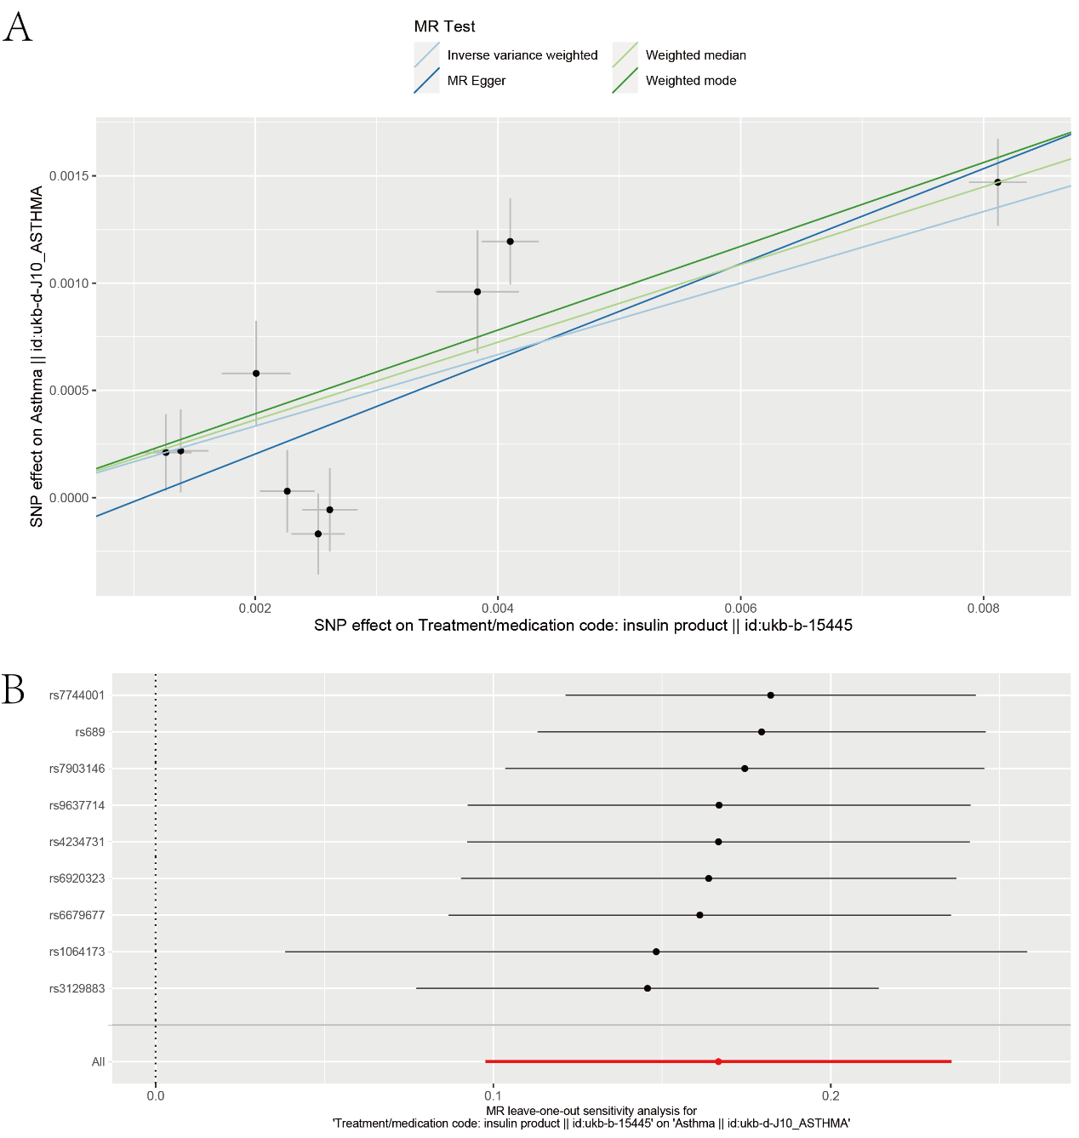
(A) Scatter plots showing robust genetic associations of insulin use with asthma in UKB cohort. Each of the SNPs associated with exposures is represented by a black dot with the error bar depicting the standard error of its association with insulin use (horizontal) and the target asthma (vertical). The slopes of each line represent the causal association for each Mendelian randomization method. (B) Leave-one-out analysis for all significant causal relationships detected in primary analysis. Within each panel, the black points represent the causal estimate of association between a specific exposure and target mental disorder after discarding each SNP in turn. Red points represent the overall causal estimate using the random-effects inverse variance weighted. Horizontal lines denote 95% confidence intervals.

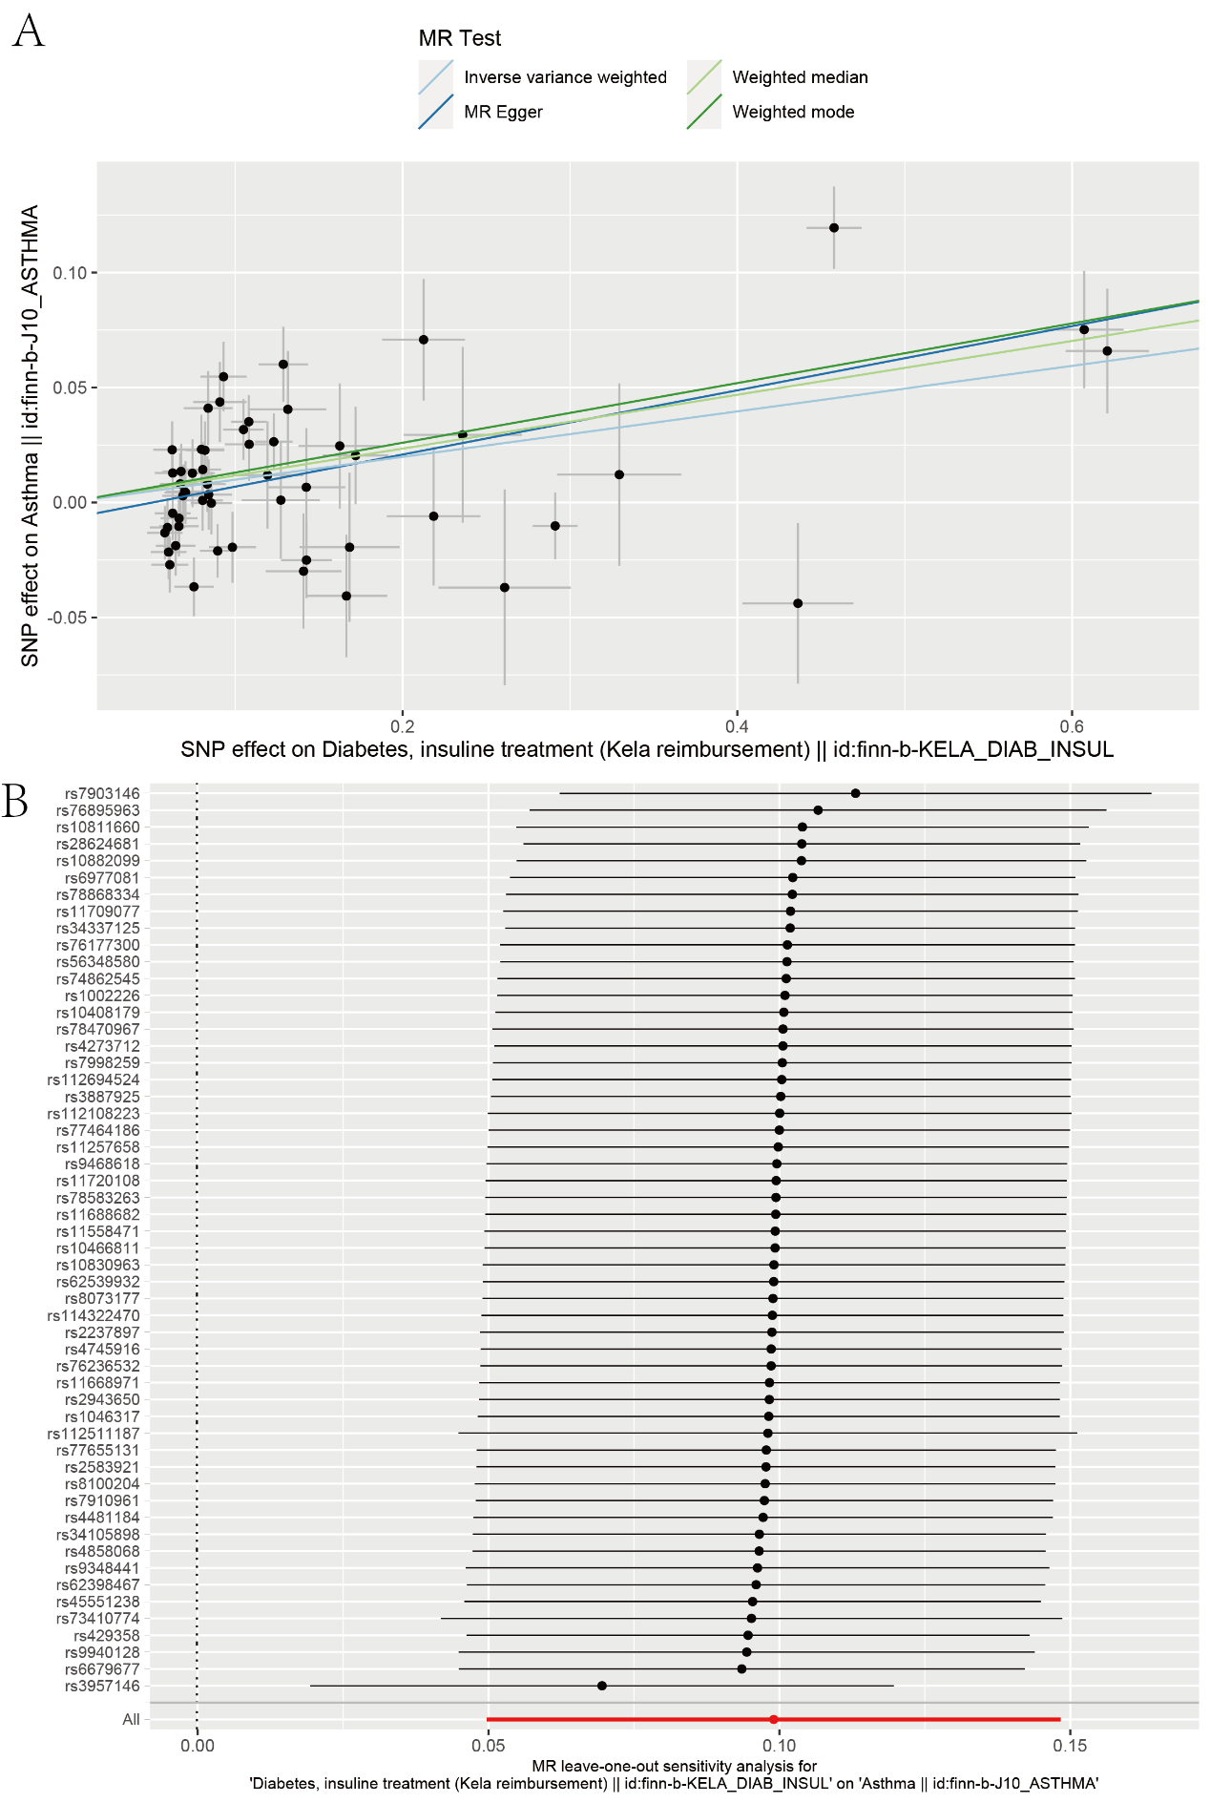
Supplementary Figure S2 Scatter plot and leave-one-out analysis for the association of insulin use with asthma in Finn cohort.
(A) Scatter plots showing robust genetic associations of insulin use with asthma in Finn cohort. Each of the SNPs associated with exposures is represented by a black dot with the error bar depicting the standard error of its association with insulin use (horizontal) and the target asthma (vertical). The slopes of each line represent the causal association for each Mendelian randomization method. (B) Leave-one-out analysis for all significant causal relationships detected in primary analysis. Within each panel, the black points represent the causal estimate of association between a specific exposure and target mental disorder after discarding each SNP in turn. Red points represent the overall causal estimate using the random-effects inverse variance weighted. Horizontal lines denote 95% confidence intervals.

Supplementary Figure S3 The genetic associations between diabetes and risk of asthma.
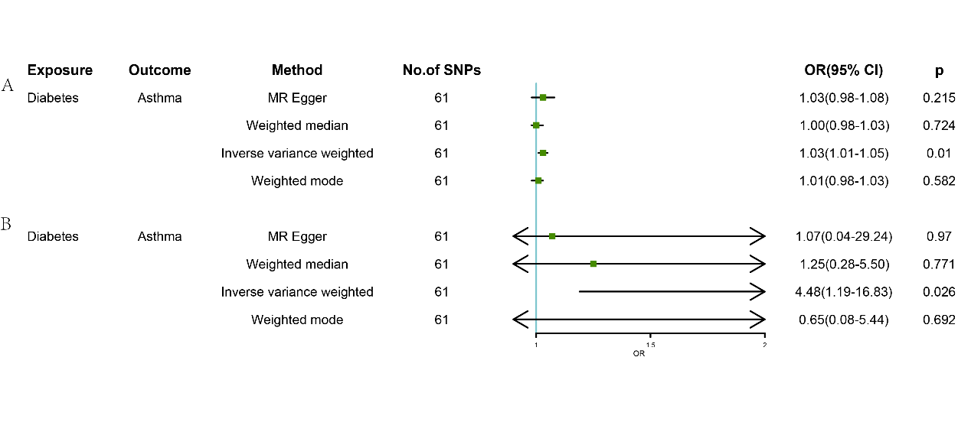
(A) The association between diabetes and asthma in UKB cohort. (B) in Finn cohort. Green squares and their corresponding lines are the point estimates and 95% CI. No statistical difference was observed with the red squares and their corresponding line crossing the line of effect. OR, odds ratio; CI, confidence interval.

Supplementary Figure S4 Multivariate mendelian randomization analysis of insulin use and type 1/ type 2 diabetes on asthma.
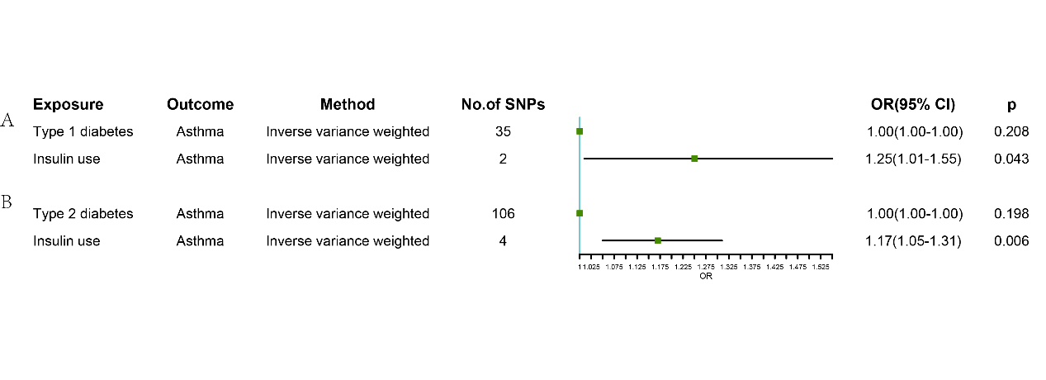
(A) MVMR model with type 1 diabetes and insulin use as exposure and asthma as outcomes. (B) MVMR model with type 2 diabetes and insulin use as exposure and asthma as outcomes. Green squares and their corresponding lines are the point estimates and 95% CI. No statistical difference was observed with the red squares and their corresponding line crossing the line of effect. OR, odds ratio; CI, confidence interval.

