Occurrence of micro-plastics in commercial fish species from the Ethiopian rift valley's, Lake Hawassa
Asrat Fekadu Demsie^{a*}, Girma Tilahun Yimer^{b}
ªHawassa College of Teacher Education, Department of Biology, Hawassa, Ethiopia, P.O.Box115, Hawassa, Ethiopia

^{b}Hawassa University, Department of Aquatic Sciences, Fisheries and Aquaculture, Hawassa, Ethiopia

Supplementary Material

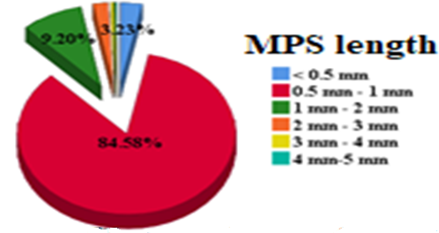
S1Figure. Shapes of Micro plastics per site
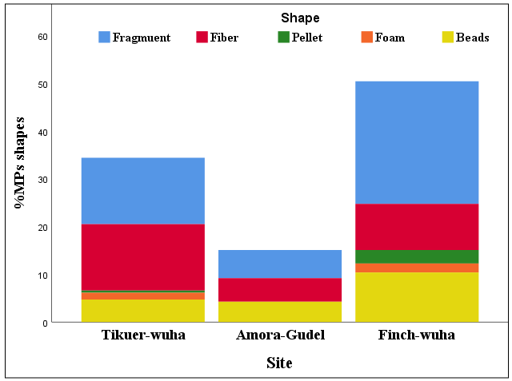
S2 Figure: Size of MPS detected
S3 Table: The site, species, and FTIR characteristic peaks, and confidence in the most abundant polymer types.
Polymer | Species | Charact peaks (cm⁻¹) |  |  | FTIR  Confidence
Polymer | Species | Site1 | Site 2 | Site3 | FTIR  Confidence
PS | Catfish | 1045 | 1639 | 1639 | 0.977-0.983
 | Tilapia | 1639 | 1639 | 1637 | 0.977-0.978
PP | Catfish | 2910 | 1639 | 1639 | 0.888-0.998
 | Tilapia | 662 | 654 | 689 | 0.809-0.853
PET | Catfish | 1045 | 1639 | 1639 | 0.955-0.957
 | Tilapia | 662 | 654 | 689 | 0.908-0.957
HDPE | Catfish | 2910 | 1639 | 2910 | 0.898-0.998
 | Tilapia | 662 | 654 | 689 | 0.912-0.961
LDPE | Catfish | 2910 | 1639 | 2910 | 0.898-0.991
 | Tilapia | 662 | 654 | 689 | 0.912-0.961
PC | Catfish | 2984 | 1639 | 2984 | 0.927-0.994
 | Tilapia | 1638 | 1639 | 1637 | 0.926-0.927
PTFE | Catfish | 1045 | 497 | - | 0.897-0.911
 | Tilapia | 662 | 654 | 689 | 0.926-0.975
PVC | Catfish | 1045 | 1045 | - | 0.951
 | Tilapia | 1637 | 497 | 1637 | 0.807-0.998
Nylon | Catfish | 1637 | 1639 | 1639 | 0.997-0.998
 | Tilapia | 662 | 654 | 662 | 0.952-0.964
Acrylic | Catfish | 2910 | 2910 | 2910 | 0.952-0.987
 | Tilapia | 662 | 1639 | 689 | 0.872-0.918
EVA | Catfish | 2910 | 1639 | 1639 | 0.942-0.998
 | Tilapia | 662 | 654 | 689 | 0.908-0.919
ABS | Catfish | 2910 | 1639 | 1639 | 0.977-0.996
 | Tilapia | 662 | 654 | 689 | 0.937-0.987
CA | Catfish | 877 | 1639 | 1639 | 0.940-0.970
 | Tilapia | 662 | 654 | 689 | 0.871-0.917

