Supplementary Information:

Modest forest and welfare impacts from current REDD+ initiatives

Draft submitted to Nature Sustainability

Sven Wunder, Dario Schulz, Javier G. Montoya-Zumaeta, Jan Börner, Gabriel Frey

December 2022

Literature search

On 22/12/2020, a total of 67,132 records were retrieved from the Web of Knowledge publication database. Yer, in the light of many new studies appearing during our extended period of analysis, we repeated the original search on 11/05/2022 (for entries newer than 01/12/2020). This resulted in 15,686 additional publications. Using the labelled abstracts from studies identified in prior reviews, we applied standard text processing and classified all new records into relevant and non-relevant using a support-vector machine (Boser et al., 1992; Cortes and Vapnik, 1995). After this automated screening process, a priority sample of 508 studies was manually screened for eligibility. A PRISMA diagram in the SI describes the iterative selection process.

We applied the following search string to the Web of Knowledge:

(TS=((conserv* OR deforest* OR emiss* OR "forest* cover*" OR "forest clearing" OR livelihood* OR poverty OR "well-being") AND (match* OR "propens* score*" OR counterfactu* OR "counter-factual" OR "synthet* control*" OR effect* OR impact* OR performance OR randomiz*) AND (payment* OR program* OR project* OR REDD* OR PES))) AND LANGUAGE: (English)
Indexes=SCI-EXPANDED, SSCI, A&HCI, ESCI Timespan=2007-2020

The search resulted in 67,132 hits (22.12.2020)

Fig. S1. PRISMA diagram

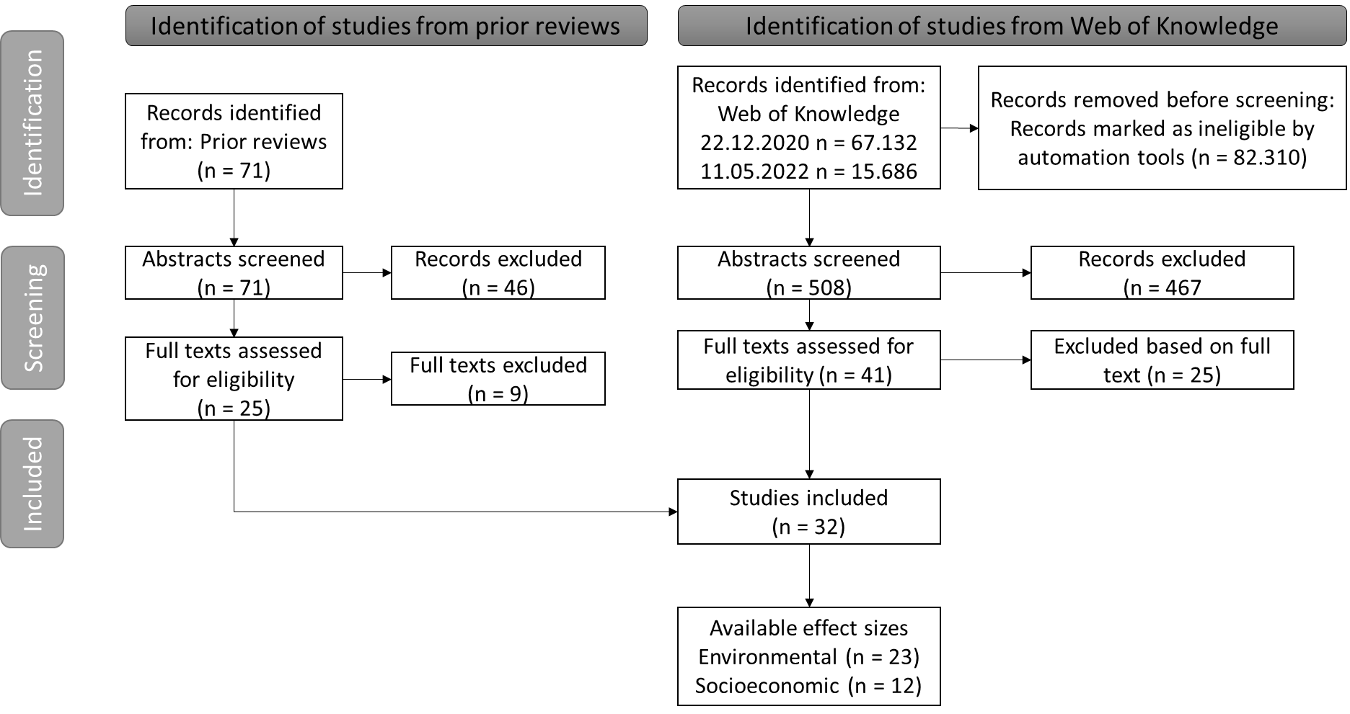

Extracting effect sizes from synthetic control studies
Apparently no method exists to calculate standardized effect sizes for synthetic control studies. The commonly used standard mean difference (also called Cohen’s D) divides the raw mean difference between treatment and control by the pooled standard deviation of both groups. However, synthetic controls often consist of just one treated unit, making the calculation of a standard deviation mathematically impossible. Furthermore, the synthetic control unit is a weighted average of multiple donors, so if the weights sum up to one, it is technically also just one single observation.

Hollingsworth and Wing (2020) proposed a version of Cohen’s D to evaluate the pre-treatment “goodness of fit” of control units, which they calculate as the average mean difference between treated and control units that are standardized by dividing the raw mean difference by the standard deviation of that difference over time. Their formula could be easily extended to estimate post-treatment relative effect sizes. However, while it is useful to evaluate the goodness of fit within a study, it may be less suitable to compare the results of different studies. Any outcome trend that is common to both treatment and control units, but exogenous to the intervention, will increase the standard deviation over time and thus decrease the effect size estimate. Choosing an extended period of analysis and/ or having more data available would in that case deflate the overall effect estimate, compared to the same analysis carried out over a shorter time period.

The lack of reporting standards for synthetic control studies made it impossible for us to apply the same effect size calculation method to all studies. Depending on data availability, we used crosssectional standard deviations of the outcome variable across the donor pool to calculate annual effect sizes for each observed unit and then aggregated these using a meta-regression (e.g. for West et al. 2020). Where possible, we used bootstrapped standard errors from placebo tests to calculate effect size variances; otherwise we use the number of donors multiplied by the timeperiods to get a proxy of sample size. Detailed calculation procedures for replication can be obtained from the authors upon request.

Theory of Change
As described in the Methods section, we use a Theory of Change (ToC) analytical approach tto chcracterize the causal pathway of REDD+ interventions (Fig. S2).
Figure S2: Stylized Theory of Change: the impact of REDD+ interventions on the ground
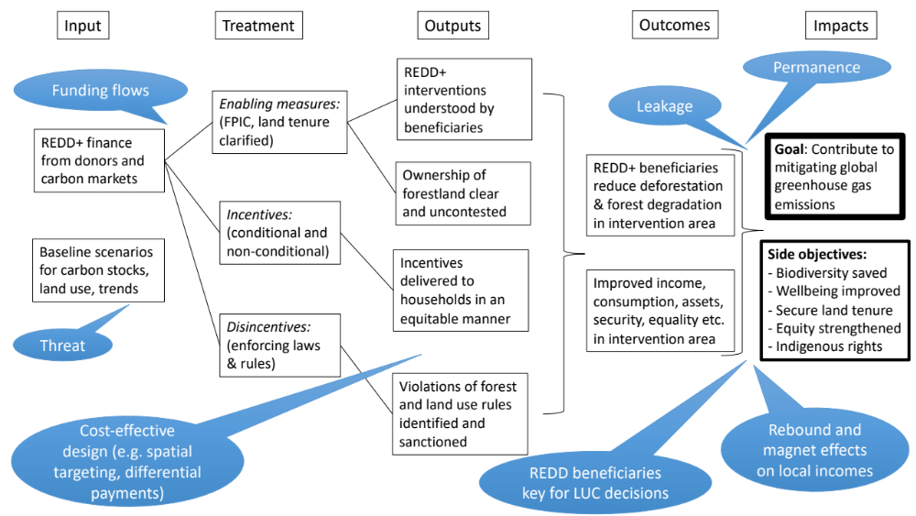
Selection filters
As equally explained in detail in Methods, we use for inclusion in our sample a set of filters related, first, to the intervention criteria, and second, to the study that has been reserching this intervention (Table S1):

Table S1. Filters for selecting interventions (1-4) and studies (A-F)

# | Dimension | Filtering factor | Observation/ justification
1 | REDD+ label | Self-labelled and ‘REDD+ like’ | Incl. multipurpose carbon-focused national PES
2 | Actions | Forest carbon conservation element | Excl. pure A/R projects
3 | Scale | National and subnational REDD+ | No filter: projects and programmes alike
4 | Starting time | Implementation start not before 2007 | COP13 initiated REDD process in 2007
A | Literature | Peer-reviewed + Grey | Filtering instead on evaluation quality
B | Impacts | Forest carbon + human wellbeing | Incl., as main bottom lines for REDD+
C | Outcomes | Forest cover/loss + socio-economic | Incl., as shorter-term bottom lines.
D | Outputs | Excluded | Excl. all middle-part ToC (intermediary)
E | Objectivity | Subjective wellbeing included | Incl., as welfare impact
F | Evaluation | (Quasi-)experimental methods | Counterfactual approach always needed

Secondary outcomes
We collected several effect sizes relating to outcomes that were not directly comparable. Nevertheless, we show these estimates here, but do not aggregate them (Figure S3).

Fig. S3: Secondary environmental effects
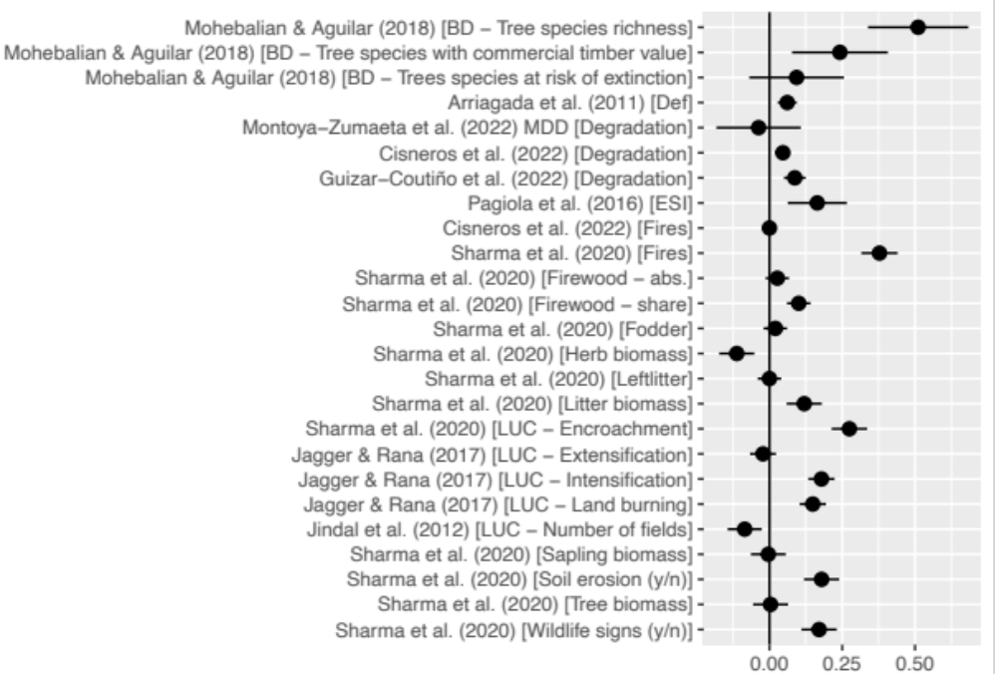
Note: In this graph, effects higher than zero can be interpretet as “positive”, i.e. beneficialm vis-à-vis policy intentions. For example, Sharma et al.’s positive estimate for Fire indicate a redution in Fires, while Jindal et al.’s estimate for the number of fields indicates that the number of fields (as a proxy of extensification) increased.

Figure S4: Secondary socioeconomic effects
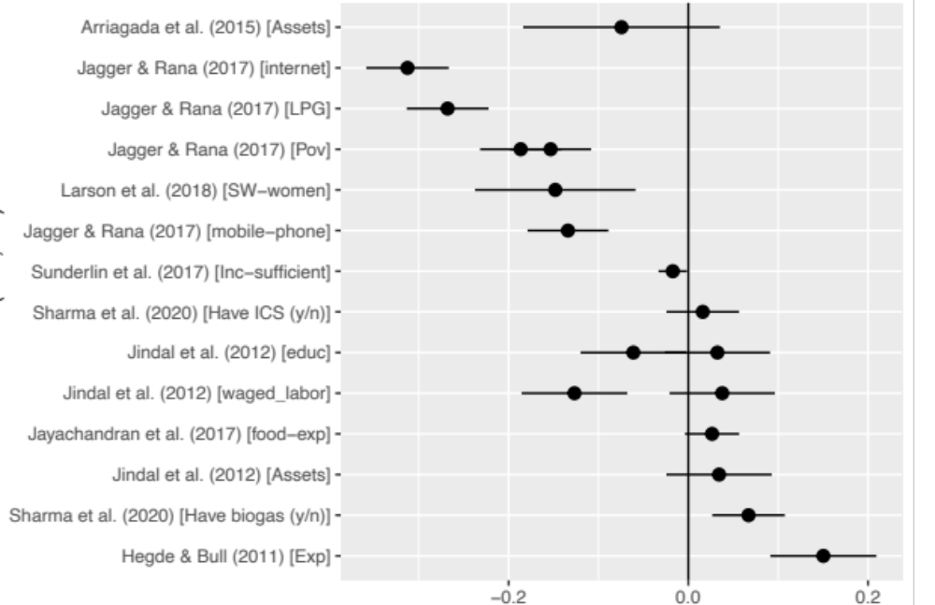

Robustness checks

Outlier & Influential case diagnostics
In the following we present several robustness checks to test how sensitive our findings are to the exclusion of single (or multiple) influential observations. In particular, we conducted the following influential case diagnostics:
- Include a control variable for the exact outcome measure
- Include a control variable for program duration
- Exclude single studies
  - Groom et al. (2022)
  - Guizar-Coutiño et al. (2022)
  - all synthetic control studies
- Exclude influential observations with Cook’s distance > 2 standard deviations
# Check outcome type (Deforestation rate vs. Forest cover)
table(env1$outcome_short)
##
## Carbon Def FC
## 1 16 6
update.rma(m0, mods=~outcome_short-1)
##
## Multivariate Meta-Analysis Model (k = 23; method: REML)
##
## Variance Components:
##
## estim sqrt nlvls fixed factor
## sigma^2.1 0.0011 0.0335 11 no country
## sigma^2.2 0.0005 0.0232 23 no country/study_ID
## sigma^2.3 0.0005 0.0232 23 no country/study_ID/ESID
##
## Test for Residual Heterogeneity:
## QE(df = 20) = 97.5592, p-val < .0001
##
## Test of Moderators (coefficients 1:3):
## QM(df = 3) = 22.4109, p-val < .0001
##
## Model Results:
##
## estimate se zval pval ci.lb ci.ub
## outcome_shortCarbon 0.0149 0.0762 0.1958 0.8447 -0.1344 0.1643
## outcome_shortDef 0.0821 0.0184 4.4679 <.0001 0.0461 0.1181 ***
## outcome_shortFC 0.0794 0.0298 2.6656 0.0077 0.0210 0.1378 **
##
## ---
## Signif. codes: 0 '***' 0.001 '**' 0.01 '*' 0.05 '.' 0.1 ' ' 1
# Check Duration of intervention
update.rma(m0, mods=~duration)
##
## Multivariate Meta-Analysis Model (k = 23; method: REML)
##
## Variance Components:
##
## estim sqrt nlvls fixed factor
## sigma^2.1 0.0019 0.0433 11 no country
## sigma^2.2 0.0003 0.0162 23 no country/study_ID
## sigma^2.3 0.0003 0.0162 23 no country/study_ID/ESID
##
## Test for Residual Heterogeneity:
## QE(df = 21) = 77.6699, p-val < .0001
##
## Test of Moderators (coefficient 2):
## QM(df = 1) = 0.0684, p-val = 0.7937
##
## Model Results:
##
## estimate se zval pval ci.lb ci.ub
## intrcpt 0.0829 0.0288 2.8793 0.0040 0.0265 0.1394 **
## duration -0.0010 0.0040 -0.2615 0.7937 -0.0089 0.0068
##
## ---
## Signif. codes: 0 '***' 0.001 '**' 0.01 '*' 0.05 '.' 0.1 ' ' 1
# check whether results driven by very precise estimates that have high weight
# Remove Groom
update(m0,
data=env1 %>%
filter(!grepl("Groom", study_name)),
mods = ~intervention_type-1)
##
## Multivariate Meta-Analysis Model (k = 22; method: REML)
##
## Variance Components:
##
## estim sqrt nlvls fixed factor
## sigma^2.1 0.0003 0.0185 11 no country
## sigma^2.2 0.0007 0.0256 22 no country/study_ID
## sigma^2.3 0.0007 0.0256 22 no country/study_ID/ESID
##
## Test for Residual Heterogeneity:
## QE(df = 20) = 54.6782, p-val < .0001
##
## Test of Moderators (coefficients 1:2):
## QM(df = 2) = 32.3838, p-val < .0001
##
## Model Results:
##
## estimate se zval pval ci.lb ci.ub
## intervention_typePES 0.0903 0.0224 4.0275 <.0001 0.0464 0.1343 ***
## intervention_typeREDD 0.0808 0.0200 4.0316 <.0001 0.0415 0.1201 ***
##
## ---
## Signif. codes: 0 '***' 0.001 '**' 0.01 '*' 0.05 '.' 0.1 ' ' 1
# remove Guizar
update(m0,
data=env1 %>%
filter(!grepl("Guizar", study_name)),
mods = ~intervention_type-1)
##
## Multivariate Meta-Analysis Model (k = 22; method: REML)
##
## Variance Components:
##
## estim sqrt nlvls fixed factor
## sigma^2.1 0.0020 0.0444 11 no country
## sigma^2.2 0.0003 0.0175 22 no country/study_ID
## sigma^2.3 0.0003 0.0175 22 no country/study_ID/ESID
##
## Test for Residual Heterogeneity:
## QE(df = 20) = 89.6890, p-val < .0001
##
## Test of Moderators (coefficients 1:2):
## QM(df = 2) = 17.2803, p-val = 0.0002
##
## Model Results:
##
## estimate se zval pval ci.lb ci.ub
## intervention_typePES 0.0907 0.0311 2.9140 0.0036 0.0297 0.1516 **
## intervention_typeREDD 0.0732 0.0242 3.0214 0.0025 0.0257 0.1207 **
##
## ---
## Signif. codes: 0 '***' 0.001 '**' 0.01 '*' 0.05 '.' 0.1 ' ' 1
# remove all SCM estimates
update(m0,
data=env1 %>%
filter(!grepl("SCM", method_short)),
mods = ~intervention_type-1)
##
## Multivariate Meta-Analysis Model (k = 20; method: REML)
##
## Variance Components:
##
## estim sqrt nlvls fixed factor
## sigma^2.1 0.0009 0.0295 10 no country
## sigma^2.2 0.0002 0.0141 20 no country/study_ID
## sigma^2.3 0.0002 0.0141 20 no country/study_ID/ESID
##
## Test for Residual Heterogeneity:
## QE(df = 18) = 44.1428, p-val = 0.0006
##
## Test of Moderators (coefficients 1:2):
## QM(df = 2) = 20.9717, p-val < .0001
##
## Model Results:
##
## estimate se zval pval ci.lb ci.ub
## intervention_typePES 0.0874 0.0233 3.7557 0.0002 0.0418 0.1330 ***
## intervention_typeREDD 0.0512 0.0193 2.6531 0.0080 0.0134 0.0891 **
##
## ---
## Signif. codes: 0 '***' 0.001 '**' 0.01 '*' 0.05 '.' 0.1 ' ' 1
# REDD+ effects half in magnitude, but still significant at p<0.01
# identify outliers / potentially influential
# studies via Cooks distance (>2 St.Dev.)
cd <- cooks.distance.rma.mv(m0)
update(m0, data=env1%>%
filter(cd<2*sd(cd)))
##
## Multivariate Meta-Analysis Model (k = 21; method: REML)
##
## Variance Components:
##
## estim sqrt nlvls fixed factor
## sigma^2.1 0.0000 0.0000 10 no country
## sigma^2.2 0.0003 0.0167 21 no country/study_ID
## sigma^2.3 0.0003 0.0167 21 no country/study_ID/ESID
##
## Test for Heterogeneity:
## Q(df = 20) = 34.1257, p-val = 0.0253
##
## Model Results:
##
## estimate se zval pval ci.lb ci.ub
## 0.0726 0.0109 6.6777 <.0001 0.0513 0.0940 ***
##
## ---
## Signif. codes: 0 '***' 0.001 '**' 0.01 '*' 0.05 '.' 0.1 ' ' 1

Figure S3: Sensitivity to effect size calculation method
## Warning in sample_size_control * sample_size_treatment: NAs produced by integer
## overflow
## Warning: Width not defined. Set with `position_dodge(width = ?)`
## Warning: Removed 8 rows containing missing values (geom_pointrange).
## Warning: Removed 3 rows containing missing values (geom_segment).
## Warning: Removed 1 rows containing missing values (geom_segment).

Figure S5. Sensitivity of environmental impacts vis-à-vis changes in methods and assumptions
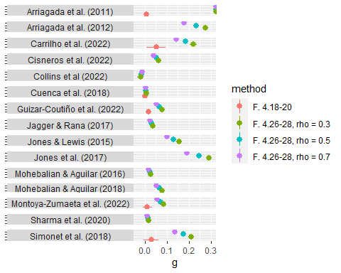
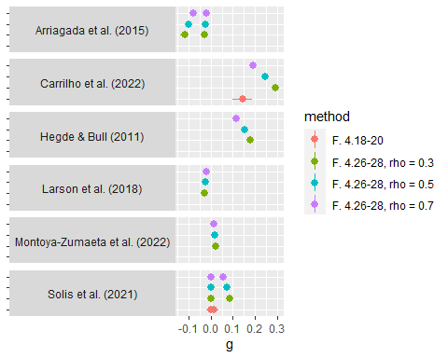

Sensitivity to effect size calculation method
In Figure S.5, we also test whether our results are sensitive to our assumptions regarding effect size calculation. We run the main regression again, but replace the matching estimates by the different estimate available. Note, that we had to exclude Arriagada et al. (2011) due to missing data. We consecutively replaced the effect estimates with their respective lower and upper bounds calculated by changing the correlation parameter from 0.3 to 0.7 (for the main result we used 0.5). The formulas are given by Borenstein et al. (2009) pp. 26. We then run the overall and subgroup models for both environmental and socioeconomic outcomes. The figure shows that some estimates differ substantially depending on method and assumptions used.

##
## Multivariate Meta-Analysis Model (k = 23; method: REML)
##
## Variance Components:
##
## estim sqrt nlvls fixed factor
## sigma^2.1 0.0004 0.0207 11 no country
## sigma^2.2 0.0012 0.0339 23 no country/study_ID
## sigma^2.3 0.0012 0.0339 23 no country/study_ID/ESID
##
## Test for Heterogeneity:
## Q(df = 22) = 150.8385, p-val < .0001
##
## Model Results:
##
## estimate se zval pval ci.lb ci.ub
## 0.0809 0.0168 4.8017 <.0001 0.0479 0.1139 ***
##
## ---
## Signif. codes: 0 '***' 0.001 '**' 0.01 '*' 0.05 '.' 0.1 ' ' 1
##
## Multivariate Meta-Analysis Model (k = 23; method: REML)
##
## Variance Components:
##
## estim sqrt nlvls fixed factor
## sigma^2.1 0.0008 0.0286 11 no country
## sigma^2.2 0.0012 0.0342 23 no country/study_ID
## sigma^2.3 0.0012 0.0342 23 no country/study_ID/ESID
##
## Test for Residual Heterogeneity:
## QE(df = 21) = 118.1210, p-val < .0001
##
## Test of Moderators (coefficients 1:2):
## QM(df = 2) = 20.1914, p-val < .0001
##
## Model Results:
##
## estimate se zval pval ci.lb ci.ub
## intervention_typePES 0.0923 0.0293 3.1531 0.0016 0.0349 0.1496 **
## intervention_typeREDD 0.0753 0.0232 3.2442 0.0012 0.0298 0.1207 **
##
## ---
## Signif. codes: 0 '***' 0.001 '**' 0.01 '*' 0.05 '.' 0.1 ' ' 1
##
## Multivariate Meta-Analysis Model (k = 23; method: REML)
##
## Variance Components:
##
## estim sqrt nlvls fixed factor
## sigma^2.1 0.0012 0.0341 11 no country
## sigma^2.2 0.0006 0.0242 23 no country/study_ID
## sigma^2.3 0.0006 0.0242 23 no country/study_ID/ESID
##
## Test for Heterogeneity:
## Q(df = 22) = 160.7745, p-val < .0001
##
## Model Results:
##
## estimate se zval pval ci.lb ci.ub
## 0.0670 0.0162 4.1379 <.0001 0.0353 0.0988 ***
##
## ---
## Signif. codes: 0 '***' 0.001 '**' 0.01 '*' 0.05 '.' 0.1 ' ' 1
##
## Multivariate Meta-Analysis Model (k = 23; method: REML)
##
## Variance Components:
##
## estim sqrt nlvls fixed factor
## sigma^2.1 0.0014 0.0375 11 no country
## sigma^2.2 0.0006 0.0245 23 no country/study_ID
## sigma^2.3 0.0006 0.0245 23 no country/study_ID/ESID
##
## Test for Residual Heterogeneity:
## QE(df = 21) = 118.4023, p-val < .0001
##
## Test of Moderators (coefficients 1:2):
## QM(df = 2) = 15.8976, p-val = 0.0004
##
## Model Results:
##
## estimate se zval pval ci.lb ci.ub
## intervention_typePES 0.0799 0.0286 2.7985 0.0051 0.0239 0.1359 **
## intervention_typeREDD 0.0611 0.0206 2.9689 0.0030 0.0208 0.1014 **
##
## ---
## Signif. codes: 0 '***' 0.001 '**' 0.01 '*' 0.05 '.' 0.1 ' ' 1
##
## Multivariate Meta-Analysis Model (k = 12; method: REML)
##
## Variance Components:
##
## estim sqrt nlvls fixed factor
## sigma^2.1 0.0066 0.0810 6 no country
## sigma^2.2 0.0000 0.0000 10 no country/study_ID
## sigma^2.3 0.0000 0.0000 12 no country/study_ID/ESID
##
## Test for Heterogeneity:
## Q(df = 11) = 27.7067, p-val = 0.0036
##
## Model Results:
##
## estimate se zval pval ci.lb ci.ub
## 0.0642 0.0402 1.5971 0.1102 -0.0146 0.1429
##
## ---
## Signif. codes: 0 '***' 0.001 '**' 0.01 '*' 0.05 '.' 0.1 ' ' 1
##
## Multivariate Meta-Analysis Model (k = 12; method: REML)
##
## Variance Components:
##
## estim sqrt nlvls fixed factor
## sigma^2.1 0.0062 0.0790 6 no country
## sigma^2.2 0.0000 0.0000 10 no country/study_ID
## sigma^2.3 0.0000 0.0000 12 no country/study_ID/ESID
##
## Test for Residual Heterogeneity:
## QE(df = 10) = 13.3633, p-val = 0.2041
##
## Test of Moderators (coefficients 1:2):
## QM(df = 2) = 3.1732, p-val = 0.2046
##
## Model Results:
##
## estimate se zval pval ci.lb ci.ub
## out_typeImpacts 0.0265 0.0640 0.4137 0.6791 -0.0989 0.1518
## out_typeOutcomes 0.0850 0.0487 1.7467 0.0807 -0.0104 0.1804 .
##
## ---
## Signif. codes: 0 '***' 0.001 '**' 0.01 '*' 0.05 '.' 0.1 ' ' 1
## Warning in sens.env$yi[sens.env$study_name %in% temp.se$study_name] <-
## temp.se$G.2b: number of items to replace is not a multiple of replacement length
## Warning in sens.env$vi[sens.env$study_name %in% temp.se$study_name] <-
## temp.se$vi.2b: number of items to replace is not a multiple of replacement
## length
##
## Multivariate Meta-Analysis Model (k = 12; method: REML)
##
## Variance Components:
##
## estim sqrt nlvls fixed factor
## sigma^2.1 0.0066 0.0810 6 no country
## sigma^2.2 0.0000 0.0000 10 no country/study_ID
## sigma^2.3 0.0000 0.0000 12 no country/study_ID/ESID
##
## Test for Heterogeneity:
## Q(df = 11) = 27.7067, p-val = 0.0036
##
## Model Results:
##
## estimate se zval pval ci.lb ci.ub
## 0.0642 0.0402 1.5971 0.1102 -0.0146 0.1429
##
## ---
## Signif. codes: 0 '***' 0.001 '**' 0.01 '*' 0.05 '.' 0.1 ' ' 1
##
## Multivariate Meta-Analysis Model (k = 12; method: REML)
##
## Variance Components:
##
## estim sqrt nlvls fixed factor
## sigma^2.1 0.0062 0.0790 6 no country
## sigma^2.2 0.0000 0.0000 10 no country/study_ID
## sigma^2.3 0.0000 0.0000 12 no country/study_ID/ESID
##
## Test for Residual Heterogeneity:
## QE(df = 10) = 13.3633, p-val = 0.2041
##
## Test of Moderators (coefficients 1:2):
## QM(df = 2) = 3.1732, p-val = 0.2046
##
## Model Results:
##
## estimate se zval pval ci.lb ci.ub
## out_typeImpacts 0.0265 0.0640 0.4137 0.6791 -0.0989 0.1518
## out_typeOutcomes 0.0850 0.0487 1.7467 0.0807 -0.0104 0.1804 .
##
## ---
## Signif. codes: 0 '***' 0.001 '**' 0.01 '*' 0.05 '.' 0.1 ' ' 1

Publication bias

Figure S6. Funnel plots
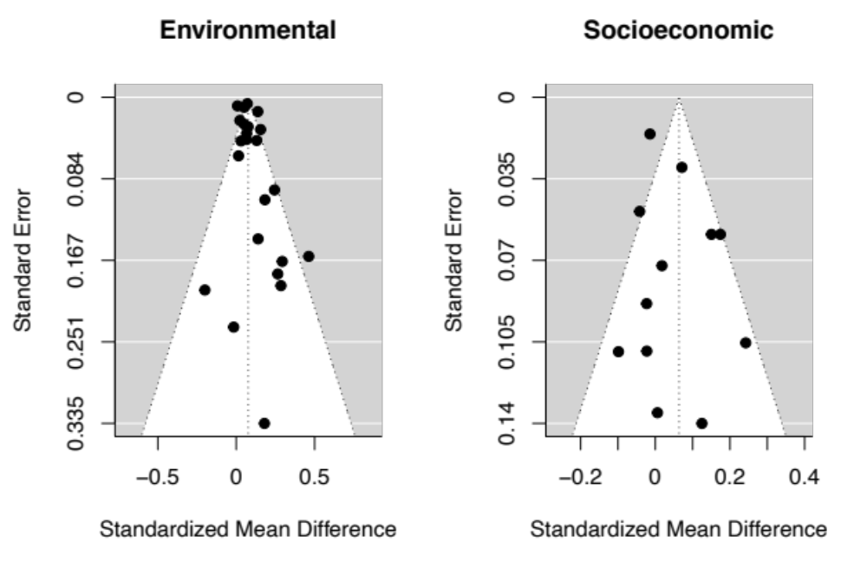

Egger’s regression test
The significant intercept in the regression as well as the visually apparent imbalance in the funnel-plot suggest publication bias: authors are somewhat more likely to publish/ get published positive results, if these are statistically significant.
# check simple rma() model
# e_rma <- rma(yi, vi, data=env1)
# regtest(e_rma)
# -> Significant asymmetry at p = 0.03
# Egger's regression test:
# Check whether intercept is significant
env1$egger <- sqrt(env1$vi)
update(m0, mods=~egger)
## Multivariate Meta-Analysis Model (k = 23; method: REML)
## Variance Components:
## estim sqrt nlvls fixed factor
## sigma^2.1 0.0015 0.0383 11 no country
## sigma^2.2 0.0002 0.0149 23 no country/study_ID
## sigma^2.3 0.0002 0.0149 23 no country/study_ID/ESID
## Test for Residual Heterogeneity:
## QE(df = 21) = 88.8177, p-val < .0001
## Test of Moderators (coefficient 2):
## QM(df = 1) = 5.1832, p-val = 0.0228
##
## Model Results:
##
## estimate se zval pval ci.lb ci.ub
## intrcpt 0.0538 0.0192 2.8068 0.0050 0.0162 0.0913 **
## egger 0.7626 0.3350 2.2767 0.0228 0.1061 1.4191 *
##
## Signif. codes: 0 '***' 0.001 '**' 0.01 '*' 0.05 '.' 0.1 ' ' 1
# Coefficient is significant! Indicates publication bias
# check simple rma() model
#s_rma <- rma(yi, vi, data=sedat1)
#regtest(s_rma)
# -> No significant asymmetry
# Egger's regression test:
# Check whether intercept is significant
sedat1$egger <- sqrt(sedat1$vi)
update(se0, mods=~egger)##
## Multivariate Meta-Analysis Model (k = 12; method: REML)
##
## Variance Components:
##
## estim sqrt nlvls fixed factor
## sigma^2.1 0.0066 0.0814 6 no country
## sigma^2.2 0.0000 0.0000 10 no country/study_ID
## sigma^2.3 0.0000 0.0000 12 no country/study_ID/ESID
##
## Test for Residual Heterogeneity:
## QE(df = 10) = 23.3135, p-val = 0.0096
##
## Test of Moderators (coefficient 2):
## QM(df = 1) = 0.0049, p-val = 0.9444
##
## Model Results:
## estimate se zval pval ci.lb ci.ub
## intrcpt 0.0579 0.0577 1.0042 0.3153 -0.0551 0.1710
## egger 0.0482 0.6917 0.0697 0.9444 -1.3076 1.4040
##
## ---
## Signif. codes: 0 '***' 0.001 '**' 0.01 '*' 0.05 '.' 0.1 ' ' 1
# Intercept is not significant; no indication for publication bias.# overall number of studies included in analyses:
length(unique(pull(d %>% filter(!is.na(use_in_analysis),
!use_in_analysis=="exclude"),
"study_ID"))) # 32
# number of primary environmental effect estimates
nrow(env1)
# number of primary socioeconomic effect estimates
nrow(sedat1)

Table S2: Regional summary statistics

Characteristic | Overall, N = 52¹ | Africa, N = 7¹ | Asia, N = 5¹ | Global, N = 5¹ | LAC, N = 35¹
Outcome type
Environmental | 35 (67%) | 2 (29%) | 3 (60%) | 3 (60%) | 27 (77%)
Socioeconomic | 17 (33%) | 5 (71%) | 2 (40%) | 2 (40%) | 8 (23%)
Intervention type
PES | 11 (21%) | 0 (0%) | 0 (0%) | 0 (0%) | 11 (31%)
REDD | 41 (79%) | 7 (100%) | 5 (100%) | 5 (100%) | 24 (69%)
Payment differentiation
no | 13 (25%) | 3 (43%) | 0 (0%) | 0 (0%) | 10 (29%)
unknown | 24 (46%) | 2 (29%) | 3 (60%) | 5 (100%) | 14 (40%)
yes | 15 (29%) | 2 (29%) | 2 (40%) | 0 (0%) | 11 (31%)
Spatial targeting
no | 11 (21%) | 4 (57%) | 2 (40%) | 0 (0%) | 5 (14%)
unknown | 24 (46%) | 2 (29%) | 3 (60%) | 5 (100%) | 14 (40%)
yes | 17 (33%) | 1 (14%) | 0 (0%) | 0 (0%) | 16 (46%)
Subnational deforestation pressure
high | 29 (66%) | 3 (43%) | 3 (75%) | 1 (50%) | 22 (71%)
low | 15 (34%) | 4 (57%) | 1 (25%) | 1 (50%) | 9 (29%)
Unknown | 8 | 0 | 1 | 3 | 4
National deforestation pressure
high | 28 (55%) | 0 (0%) | 4 (80%) | 2 (40%) | 22 (63%)
low | 23 (45%) | 6 (100%) | 1 (20%) | 3 (60%) | 13 (37%)
Unknown | 1 | 1 | 0 | 0 | 0
¹n (%)

SI Literature references (incl. case-study sample)

Arriagada, R., Sills, E., & Pattanayak, S. (2011). Payments for environmental services and their impact on forest transition in Costa Rica. Paper presented at the 13th annual Biodiversity and Economics for Conservation Conference.
Arriagada, R. A., Ferraro, P. J., Sills, E. O., Pattanayak, S. K., & Cordero-Sancho, S. (2012). Do payments for environmental services affect forest cover? A farm-level evaluation from Costa Rica. Land Economics, 88(2), 382-399. doi:10.3368/le.88.2.382
Arriagada, R. A., Sills, E. O., Ferraro, P. J., & Pattanayak, S. K. (2015). Do Payments Pay Off? Evidence from Participation in Costa Rica’s PES Program. PLoS One, 10(7), e0131544. doi:10.1371/journal.pone.0131544
Borenstein, M. (2009). Effect sizes for continuous data. In H. Cooper, L. V. Hedges, & J. C. Valentine (Eds.), The handbook of research synthesis and meta-analysis (2nd ed., pp. 221–235). New York: Russell Sage Foundation.
Bos, A. B., Duchelle, A., Angelsen, A., Avitabile, V., De Sy, V., Herold, M., . . . Sunderlin, W. (2017). Comparing methods for assessing the effectiveness of subnational REDD+ initiatives. Environmental Research Letters.
Boser, Bernhard E.; Guyon, Isabelle M.; Vapnik, Vladimir N. (1992): A training algorithm for optimal margin classifiers. In David Haussler (Ed.): Proceedings of the fifth annual workshop on Computational learning theory - COLT '92. the fifth annual workshop. Pittsburgh, Pennsylvania, United States, 27/07/1992 - 29/07/1992. New York, New York, USA: ACM Press, pp. 144–152
Carrilho, C. D., Demarchi, G., Duchelle, A. E., Wunder, S., & Morsello, C. (2022). Permanence of avoided deforestation in a Transamazon REDD+ project (Pará, Brazil). Ecological Economics, 201, 107568. doi:https://doi.org/10.1016/j.ecolecon.2022.107568
Cisneros, E., Börner, J., Pagiola, S., & Wunder, S. (2022). Impacts of conservation incentives in protected areas: The case of Bolsa Floresta, Brazil. Journal of Environmental Economics and Management, 111, 102572. doi:https://doi.org/10.1016/j.jeem.2021.102572
Collins, A. C., Grote, M. N., Caro, T., Ghosh, A., Thorne, J., Salerno, J., & Mulder, M. B. (2022). How community forest management performs when REDD+ payments fail. Environmental Research Letters, 17(3), 034019. doi:10.1088/1748-9326/ac4b54
Correa, J., Cisneros, E., Börner, J., Pfaff, A., Costa, M., & Rajão, R. (2020). Evaluating REDD+ at subnational level: Amazon fund impacts in Alta Floresta, Brazil. Forest Policy and Economics, 116. doi:10.1016/j.forpol.2020.102178
Cortes, C., & Vapnik, V. (1995). Support-Vector Networks. Machine Learning, 20, 273–297.
Cuenca, P., Arriagada, R., & Echeverría, C. (2016). How much deforestation do protected areas avoid in tropical Andean landscapes? Environmental Science & Policy, 56, 56-66. doi:10.1016/j.envsci.2015.10.014
Cuenca, P., Robalino, J., Arriagada, R., & Echeverría, C. (2018). Are government incentives effective for avoided deforestation in the tropical Andean forest? PLoS One, 13(9), e0203545. doi:10.1371/journal.pone.0203545
Duchelle, A. E., de Sassi, C., Jagger, P., Cromberg, M., Larson, A. M., Sunderlin, W. D., . . . Pratama, C. D. (2017). Balancing carrots and sticks in REDD+ implications for social safeguards. Ecology and Society, 22(3).
Egger, M., G. Davey Smith, M. Schneider, and C. Minder. 1997. “Bias in Meta-Analysis Detected by a Simple, Graphical Test.” BMJ (Clinical research ed.) 315 (7109): 629–34. doi:10.1136/bmj.315.7109.629
Ellis, E. A., Sierra-Huelsz, J. A., Ceballos, G. C. O., Binnqüist, C. L., & Cerdán, C. R. (2020). Mixed effectiveness of REDD+ subnational initiatives after 10 years of interventions on the Yucatan Peninsula, Mexico. Forests, 11(9), 1005.
Giudice, R., Börner, J., Wunder, S., & Cisneros, E. (2019). Selection biases and spillovers from collective conservation incentives in the Peruvian Amazon. Environmental Research Letters, 14(4). doi:10.1088/1748-9326/aafc83
Grames, E. M., Stillman, A. N., Tingley, M. W., & Elphick, C. S. (2019). An automated approach to identifying search terms for systematic reviews using keyword co‐occurrence networks. Methods in Ecology and Evolution, 10(10), 1645–1654. https://doi.org/10.1111/2041-210x.13268
Groom, B., Palmer, C., & Sileci, L. (2022). Carbon emissions reductions from Indonesia’s moratorium on forest concessions are cost-effective yet contribute little to Paris pledges. Proceedings of the National Academy of Sciences, 119(5), e2102613119. doi:10.1073/pnas.2102613119
Guizar-Coutiño, A., Jones, J. P. G., Balmford, A., Carmenta, R., & Coomes, D. A. (2022). A global evaluation of the effectiveness of voluntary REDD+ projects at reducing deforestation and degradation in the moist tropics. Conservation Biology, n/a(n/a). doi:https://doi.org/10.1111/cobi.13970
Habeck, C.W., and A.K. Schultz. 2015. “Community-Level Impacts of White-Tailed Deer on Understorey Plants in North American Forests: a Meta-Analysis.” AoB PLANTS 7. doi:10.1093/aobpla/plv119
Harrell Jr, Frank E with contributions from Charles Dupont and many others. (2020). Hmisc: Harrell Miscellaneous. R package version 4.4-2. https://CRAN.R-project.org/package=Hmisc
Hedges, L. V. (1981). Distribution theory for Glass's estimator of effect size and related estimators. Journal of Educational Statistics, 6, 107–128.
Hedges, L.V., and I. Olkin. 1985. Statistical Method for Meta-Analysis. Burlington: Elsevier Science. http://gbv.eblib.com/patron/FullRecord.aspx?p=1901162.
Hedges, Larry V.; Tipton, Elizabeth; Johnson, Matthew C. (2010): Robust variance estimation in meta-regression with dependent effect size estimates. In Research synthesis methods, pp. 39–65. DOI: 10.1002/jrsm.5.
Hollingsworth, Alex and Wing, Coady, Tactics for Design and Inference in Synthetic Control Studies: An Applied Example Using High-Dimensional Data (May 3, 2020). Available at SSRN: https://ssrn.com/abstract=3592088 or http://dx.doi.org/10.2139/ssrn.3592088
Hoyt, William T.; Del Re, A. C. (2018): Effect size calculation in meta-analyses of psychotherapy outcome research. In Psychotherapy research : journal of the Society for Psychotherapy Research, pp. 379–388. DOI: 10.1080/10503307.2017.1405171
Jagger, P., & Rana, P. (2017). Using publicly available social and spatial data to evaluate progress on REDD+ social safeguards in Indonesia. Environmental Science & Policy, 76, 59-69. doi:10.1016/j.envsci.2017.06.006
Jayachandran, S., de Laat, J., Lambin, E. F., Stanton, C. Y., Audy, R., & Thomas, N. E. (2017). Cash for carbon: A randomized trial of payments for ecosystem services to reduce deforestation. Science, 357(6348), 267-273. doi:10.1126/science.aan0568
Jindal, R., Kerr, J. M., & Carter, S. (2012). Reducing Poverty Through Carbon Forestry? Impacts of the N’hambita Community Carbon Project in Mozambique. World Development, 40(10), 2123-2135. doi:https://doi.org/10.1016/j.worlddev.2012.05.003
Jones, K. W., Holland, M. B., Naughton-Treves, L., Morales, M., Suarez, L., & Keenan, K. (2016). Forest conservation incentives and deforestation in the Ecuadorian Amazon. Environmental Conservation, 44(1), 56-65. doi:10.1017/S0376892916000308
Jones, K. W., & Lewis, D. J. (2015). Estimating the Counterfactual Impact of Conservation Programs on Land Cover Outcomes: The Role of Matching and Panel Regression Techniques. PLoS One, 10(10), e0141380. doi:10.1371/journal.pone.0141380
Jones, K. W., Muñoz Brenes, C. L., Shinbrot, X. A., López-Báez, W., & Rivera-Castañeda, A. (2018). The influence of cash and technical assistance on household-level outcomes in payments for hydrological services programs in Chiapas, Mexico. Ecosystem Services, 31, 208-218. doi:https://doi.org/10.1016/j.ecoser.2018.04.008
Larson, A. M., Solis, D., Duchelle, A. E., Atmadja, S., Resosudarmo, I. A. P., Dokken, T., & Komalasari, M. (2018). Gender lessons for climate initiatives: A comparative study of REDD+ impacts on subjective wellbeing. World Development, 108, 86-102. doi:https://doi.org/10.1016/j.worlddev.2018.02.027
Mohebalian, P. M., & Aguilar, F. X. (2016). Additionality and design of forest conservation programs: Insights from Ecuador's Socio Bosque Program. Forest Policy and Economics, 71, 103-114. doi:10.1016/j.forpol.2015.08.002
Mohebalian, P. M., & Aguilar, F. X. (2018). Beneath the Canopy: Tropical Forests Enrolled in Conservation Payments Reveal Evidence of Less Degradation. Ecological Economics, 143, 64-73. doi:https://doi.org/10.1016/j.ecolecon.2017.06.038
Montoya-Zumaeta, J. G. (2020). Reconciling conservation and development? Impacts of
incentive-based forest conservation in Peru. (PhD Thesis), Australian
National University (ANU), Canberra, Australia.
Montoya-Zumaeta, J. G., Wunder, S., & Tacconi, L. (2021). Incentive-based conservation in Peru: Assessing the state of six ongoing PES and REDD+ initiatives. Land Use Policy, 108, 105514. doi:https://doi.org/10.1016/j.landusepol.2021.105514
Montoya-Zumaeta, J. G., Wunder, S., Rojas, E., & Duchelle, A. E. (2022). Does REDD+ Complement Law Enforcement? Evaluating Impacts of an Incipient Initiative in Madre de Dios, Peru. Frontiers in Forests and Global Change, 5. doi:10.3389/ffgc.2022.870450
Pagiola, S., Honey-Rosés, J., & Freire-González, J. (2016). Evaluation of the Permanence of Land Use Change Induced by Payments for Environmental Services in Quindío, Colombia. PLoS ONE, 11(3), e0147829. doi:10.1371/journal.pone.0147829
Pustejovsky, James (2020). clubSandwich: Cluster-Robust (Sandwich) Variance Estimators with Small-Sample Corrections. R package version 0.5.2. https://CRAN.R-project.org/package=clubSandwich
R Core Team. (2018). R: A language and environment for statistical computing. Vienna, Austria: R Foundation for Statistical Computing. Retrieved from https://www.R-project.org/
Robalino, J., & Pfaff, A. (2013). Ecopayments and Deforestation in Costa Rica: A Nationwide Analysis of PSA’s Initial Years. Land Economics, 89(3), 432-448. doi:10.3368/le.89.3.432
Roopsind, A., B.Sohngen, and J.Brandt (2019). Evidence That a National REDD+ Program Reduces Tree Cover Loss and Carbon Emissions in a High Forest Cover, Low Deforestation Country. Proceedings of the National Academy of Sciences 116(49) 24492.
Sharma, B. P., Karky, B. S., Nepal, M., Pattanayak, S., Sills, E. O., & Shyamsundar, P. (2020). Making incremental progress: impacts of a REDD+ pilot initiative in Nepal. Environmental Research Letters. Retrieved from http://iopscience.iop.org/10.1088/1748-9326/aba924
Simonet, G., Subervie, J., Ezzine-de-Blas, D., Cromberg, M., & Duchelle, A.E. (2019). Effectiveness of a REDD+ Project in Reducing Deforestation in the Brazilian Amazon. American Journal of Agricultural Economics, 101(1), 211-229. doi:10.1093/ajae/aay028
Solis, D., Cronkleton, P., Sills, E. O., Rodriguez-Ward, D., & Duchelle, A. E. (2021). Evaluating the impact of REDD+ interventions on household forest revenue in Peru. Frontiers in Forests and Global Change, 4, 624724.
Sterne, J.A.C., and M. Egger. 2005. “Regression Methods to Detect Publication and Other Bias in Meta-Analysis.” In Publication Bias in Meta-Analysis, edited by Hannah R. Rothstein, Alexander J. Sutton, and Michael Borenstein, 99–110. Chichester, UK: John Wiley & Sons, Ltd.
Stevens, J.P. 1984. “Outliers and influential data points in regression analysis.” Psychological Bulletin 95 (2): 334–44. doi:10.1037/0033-2909.95.2.334
Sunderlin, W. D., De Sassi, C., Ekaputri, A. D., Light, M., & Pratama, C. D. (2017). REDD+ contribution to well-being and income is marginal: the perspective of local stakeholders. Forests, 8(4), 125.
Viechtbauer, W. (2010). Conducting meta-analyses in R with the metafor package. Journal of Statistical Software, 36(3), 1-48. URL: https://www.jstatsoft.org/v36/i03/
Viechtbauer, W., and M.W.-L. Cheung (2010) “Outlier and Influence Diagnostics for Meta-Analysis.” Research synthesis methods, 112–25. doi:10.1002/jrsm.11
West, T.A.P.; Börner, J.; Sills, Erin O.; Kontoleon, Andreas (2020): Overstated carbon emission reductions from voluntary REDD+ projects in the Brazilian Amazon. In Proceedings of the National Academy of Sciences of the United States of America 117 (39), pp. 24188–24194. DOI: 10.1073/pnas.2004334117.
World Bank. 2018. Evaluating the permanence of forest conservation following the end of payments for environmental services in Uganda. Rep. AUS0000379, World Bank, Washington, DC. https://documents1.worldbank.org/curated/en/867301589223292444/Evaluating-the-permanence-of-forest-conservation-following-the-end-of-payments-for-environmental-services-in-Uganda.docx

