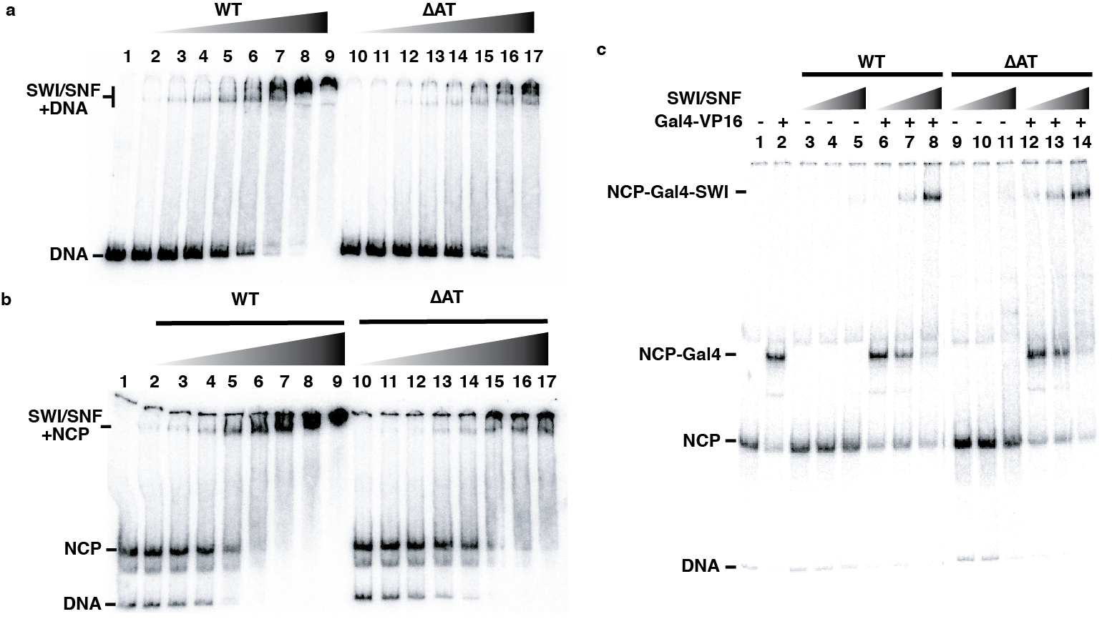
Figure S1. The AT-hooks of Snf2 are not required for recruitment of yeast SWI/SNF.
(a-b) Representative native gel images used in Figures 3a and S3b to measure (a) the relative affinity of WT and ΔAT SWI/SNF for nucleosomes and (b) competition for WT and ΔAT SWI/SNF binding between free DNA and nucleosomes. (c) Recruitment of WT and ΔAT SWI/SNF to nucleosomes, as shown by EMSA, is mediated by the transcription factor Gal4-VP16. SWI/SNF under these conditions in which competitor DNA is present cannot be recruited to nucleosomes without Gal4-VP16 bound to the extranucleosomal DNA (compare lanes 3-5 to 6-8 for WT and lanes 9-11 to 12-14 for ΔAT SWI/SNF. This image is representative of four independent replicates.

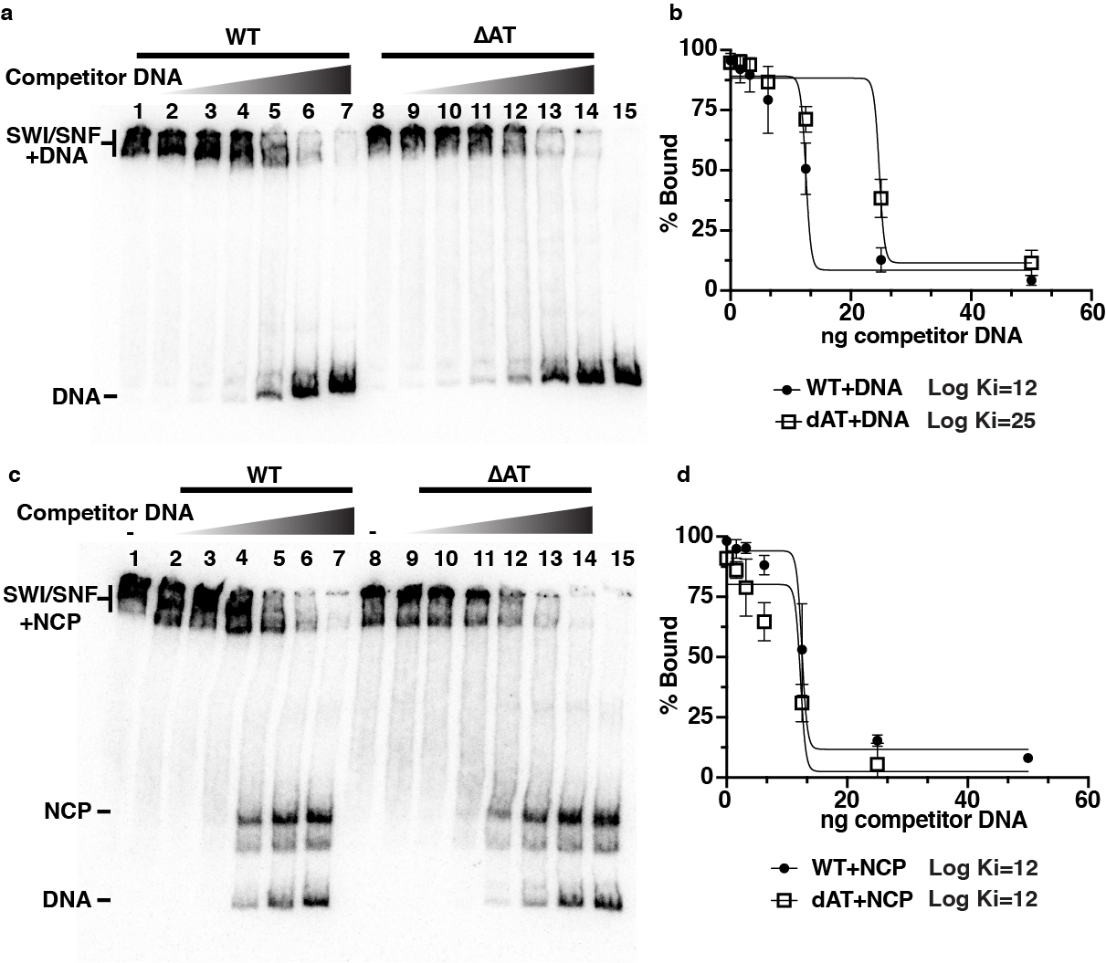
Figure S2. Competition of WT and ΔAT SWI/SNF binding to DNA or nucleosomes.
(a,c) Binding of WT or ΔAT SWI/SNF to either (a) free DNA or (c) nucleosomes was competed with unlabeled pUC19 plasmid DNA and tracked by EMSA. (b,d) A total of 4 replicates were performed for each and the percent bound versus SWI/SNF concentration is plotted and the standard deviation is shown.

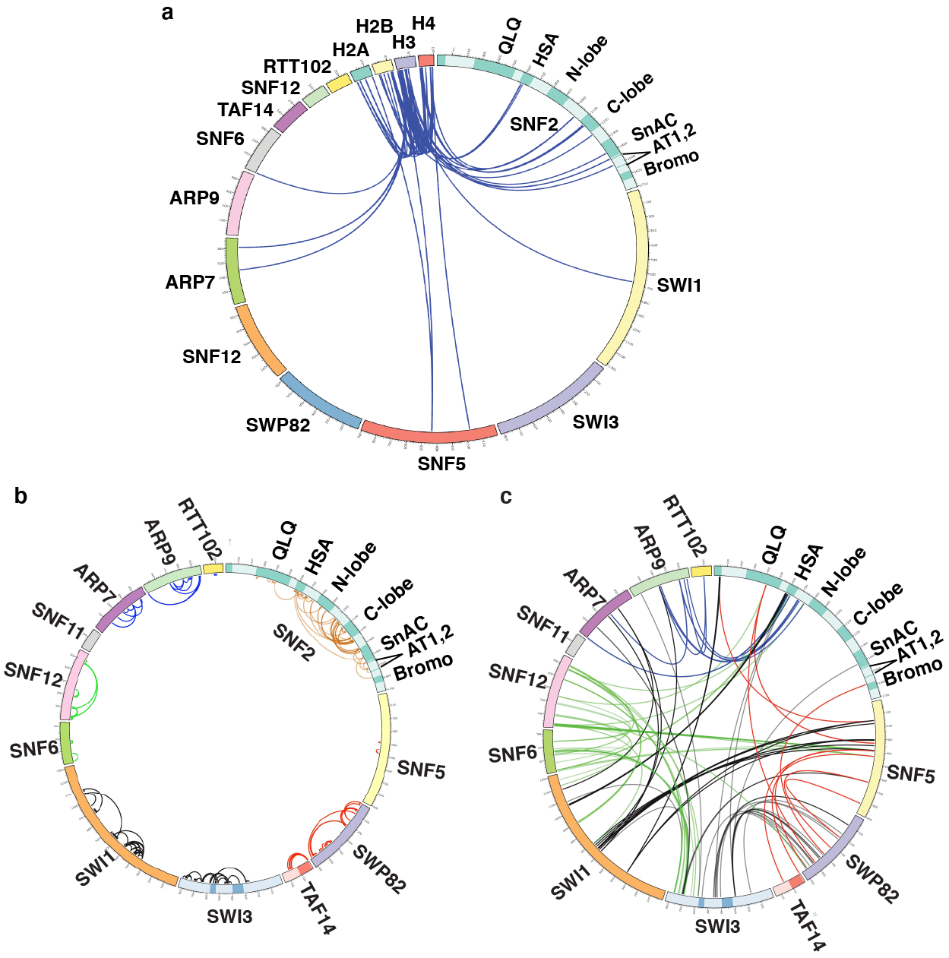
Figure S3. AT-hook switches binding partner(s) upon SWI/SNF binding nucleosomes
(a) The Lys-Lys crosslinking patterns between histones and the SWI/SNF subunits are shown for the nucleosome-bound SWI/SNF complex. (b-c) The SWI/SNF crosslinking pattern is depicted in a Circos format for (b) intra- and (c) inter-subunit crosslinking for WT SWI/SNF. Different colored lines are used to group particular subunits that form submodules within the SWI/SNF complex.

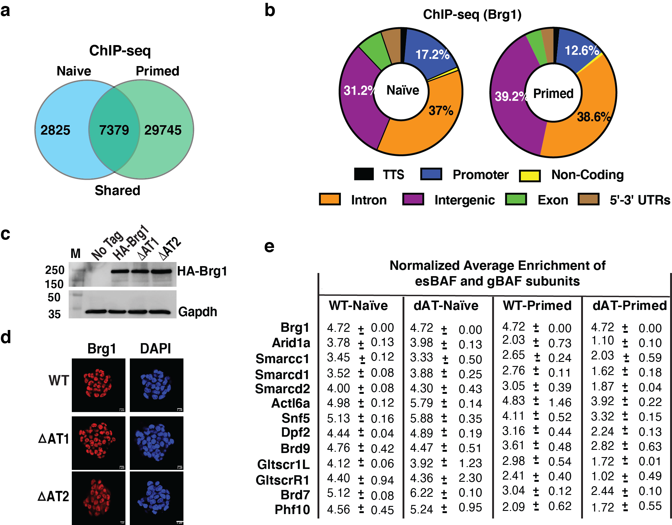

Figure S4. The AT-hook deletion does not affect Brg1 expression and SWI/SNF complex integrity. (a) Venn diagrams show the number of Brg1 peaks detected in naïve and primed cells using ChIP-seq. (b) Pie charts show the genome-wide distribution of Brg1 using ChIP-seq. (c) Western blot for HA-tagged Brg1 expression in WT and dAT mutants mESCs in naïve condition; untagged cells were used as a control, and Gapdh was used as a loading control. (d) The localization and expression of Brg1 in WT and dAT mutants is shown by immunofluorescence in naïve cells. (e) The table shows the average enrichment of es-BAF and gBAF components in WT and AT-hook deleted mutant cells in both naïve and primed states.

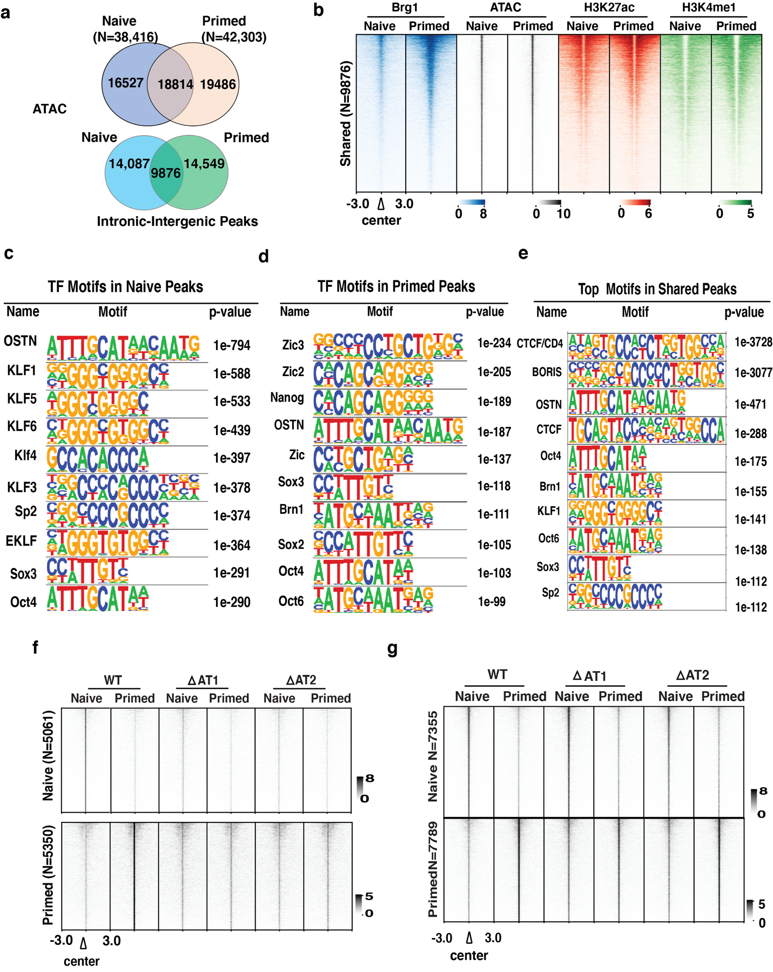
Figure S5. Loss of AT-hook alters accessibility at intronic-intergenic sites. (a) Venn diagrams show cell-type specific and shared ATAC-seq peaks (upper panel) and those only in intergenic and intronic regions (lower panel) in WT and dAT mutants in naïve and primed cells. (b) Brg1 localization (blue), ATAC-signal (grey), and active enhancer histone marks (H3K27ac [red], and H3K4me1 [green]) at shared intronic-intergenic ATAC-seq peaks (TF-dependent). Signals are sorted based on high to low. N represents the total number of ATAC-seq peaks. (c-e) Table showing the top transcription factors motif enriched in naïve (c), primed (d), and shared (e) ATAC-seq intronic-intergenic peaks using HOMER. (f-g) Heatmaps showing ATAC signals in the two independent clones of the AT-hook mutant in naïve (top) and primed (bottom) states versus WT. ATAC signals are sorted based on WT.
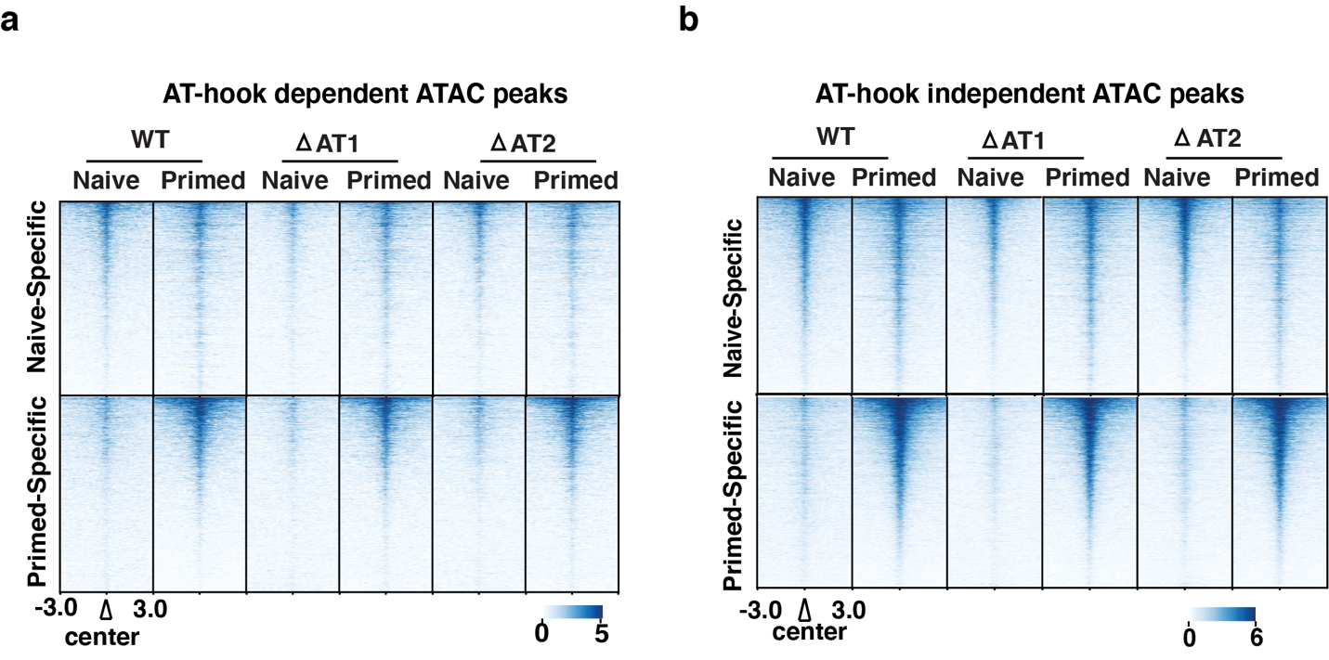

Figure S6. Heatmaps showing Brg1 localization at AT-dependent (a) and AT-independent (b) ATAC intronic-intergenic sites. ChIP signals are sorted based on WT in each group.

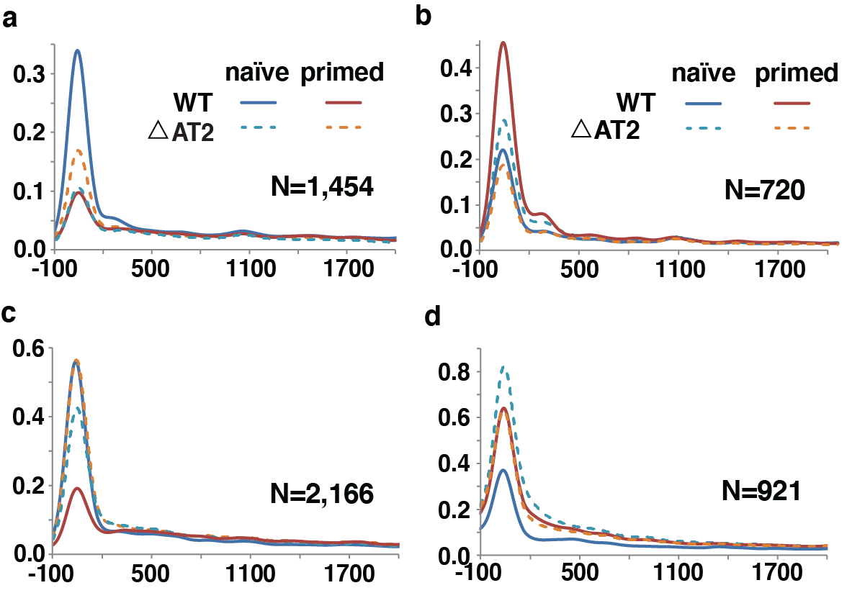

Figure S7. Transcriptional defects due to the loss of the AT-hook. (a-b) Meta-analysis of PRO-seq signals (upstream TSS -100 bp to +300 bp downstream of TSS) for paused genes up-regulated in WT (a) and dAT2 mutant (b) in naïve condition. (c-d) Meta-analysis of PRO-seq signals (upstream TSS -100 bp to +300 bp downstream of TSS) for paused genes up-regulated in WT (c) and dAT2 mutant (d) in Primed condition.

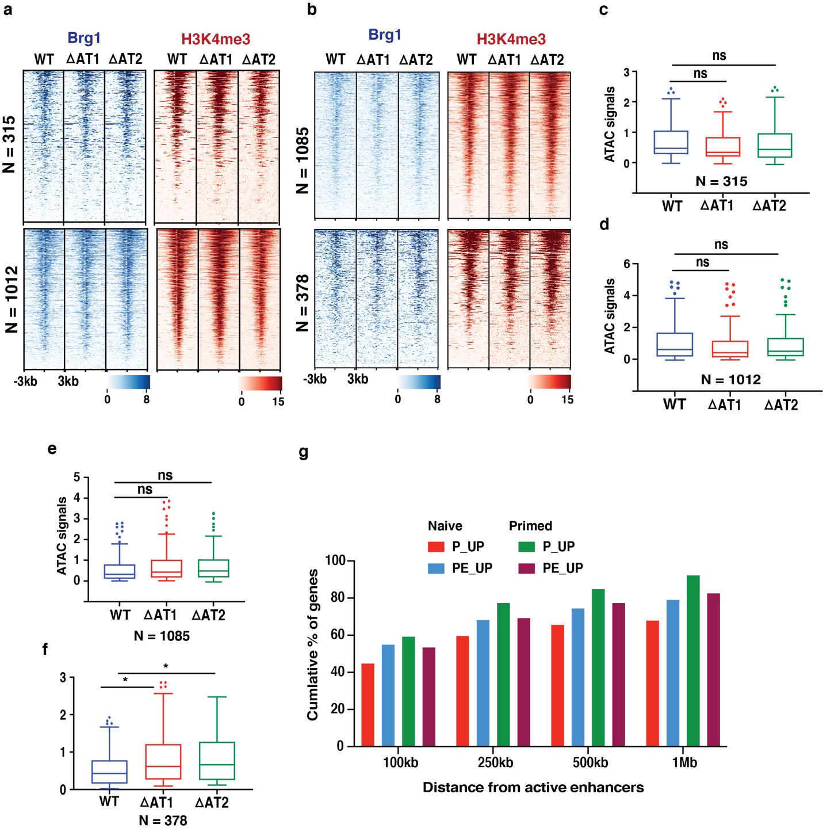
Figure S8. Deletion of AT-hook does not affect Brg1 localization and accessibility at promoter regions. (a-b) Heatmaps show localization of Brg1 (blue) and active histone mark H3K4m3 (red) in WT and AT-hook deletion clones at the promoter regions of differential genes that are being shared between dAT1 and dAT2 clones. ChIP-signals are sorted based on WT Brg1. (c-f) Box plots showing average ATAC-seq signals in WT and dAT mutants at the promoter regions of genes. N represents the number of genes in each group. (g) Bar graph showing the percentage of differential-regulated genes (DE-genes) are located near the state-specific ATAC-seq peaks showing enhancer marks.

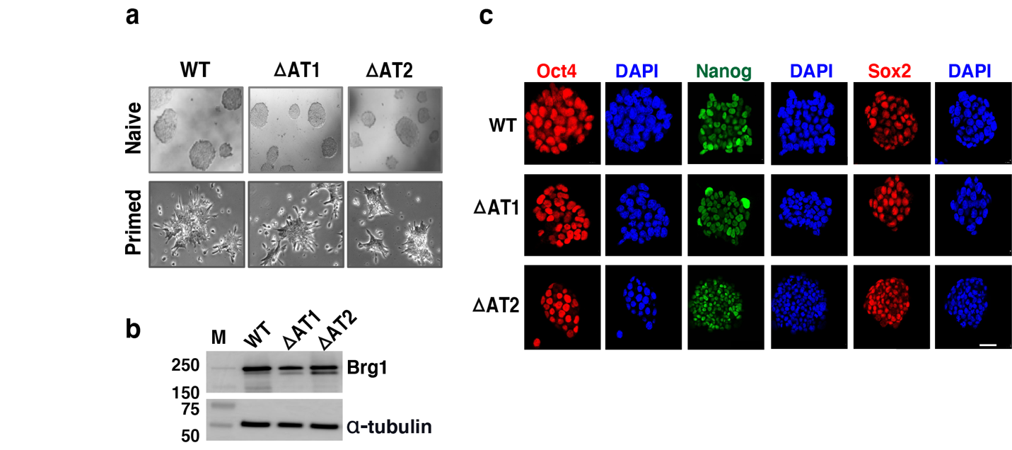

Figure S9. Brg1 AT-hook is dispensable for maintaining pluripotency phenotype. (a) Morphology of wildtype (WT) and AT-hook deletion mutants (dAT1 and dAT2) mESCs grown in naïve [(LIF/2i media supplemented with leukemia inhibitory factor (LIF), MAP/ERK kinase inhibitor (MEKi), glycogen synthase kinase 3 beta inhibitor (GSK3βi)] and primed [(media supplemented activin A, fibroblast growth factor 2 (FGF2)] conditions. (b) Smarca4/Brg1 expression in WT and AT-hook deletion mutants in naïve state is determined by immunoblotting; α-tubulin as a loading control. (c) Immunofluorescence images showing expression and localization of the pluripotency markers Oct4, Nanog, and Sox2 in WT and AT-hook deleted mutant mESCs in naïve cells (scale bar, 20 micron).

