SUPPLEMENTAL DIGITAL CONTENT

Mechanical ventilation after traumatic spinal cord injury –
A retrospective cohort study-based prediction model for weaning success: The BICYCLE score

Annia F Schreiber^{1,2}, Jacopo Garlasco³, Martin Urner^{2,4}, Amanda McFarlan⁵, Andrew Baker^{1,6}, Andrea Rigamonti², Jeffrey M Singh^{2,7}, Demetrios J Kutsogiannis⁸, Laurent J Brochard^{1,2}

- Keenan Research Centre, Li Ka Shing Knowledge Institute, Unity Health Toronto (St. Michael’s Hospital), Toronto, Ontario, Canada
- Interdepartmental Division of Critical Care Medicine, University of Toronto, Toronto, Ontario, Canada
- Department of Diagnostic and Public Health, University of Verona, Verona, Italy
- Institute of Health Policy, Management and Evaluation, University of Toronto, Toronto, Ontario, Canada
- Trauma Division, Unity Health Toronto, (St. Michael’s Hospital), Toronto, Ontario, Canada
- Departments of Anesthesia & Surgery, University of Toronto, Toronto, Ontario, Canada
- Department of Medicine, University Health Network, Toronto, Ontario, Canada
- Department of Critical Care Medicine, Faculty of Medicine and Dentistry, The University of Alberta, Edmonton, Alberta, Canada

Corresponding author: Dr. Laurent Brochard, Li Ka Shing Knowledge Institute - Keenan Research Centre, St. Michael’s Hospital, 209 Victoria Street, 4th Floor, Room 408, Toronto, M5B 1T8, Ontario, Canada
Email: laurent.brochard@unityhealth.to

CONTENT

Methods
Results
References

eTable 1 List of all the comorbidities considered as relevant for each group in the overall cohort

eTable 2 Clinical characteristics of the patients, and characteristics of the lesion at baseline. Overall cohort (St. Michael’s Trauma Registry + RHSCIR) and comparison between the two cohorts considered separately

eTable 3 Outcomes of patients after injury.
Overall cohort (St. Michael’s Trauma Registry + RHSCIR) and comparison between the two cohorts considered separately

eTable 4 Variables selected by the LASSO regression and predictors identified by the multi-variable logistic regression for weaning success at Day 28

eTable 5 Multivariable competing risk regression estimating the cumulative probability of successful weaning at a given time point, accounting for the competing risk of death

eFigure 1 Model building process

eFigure 2 Predictive ability of the BICYCLE score.
(a) AUCROC= 0.689, [95% bootstrapped CI 0.631 – 0.743] and of the Injury severity Score (b) AUCROC= 0.537, [95% bootstrapped CI 0.479 – 0.595, p < 0.0001] to discriminate between weaning success and failure assessed using ROC curve analysis (ROC for the two scores)

eFigure 3 Ability of the derived secondary prediction score
(a) AUCROC= 0.678, [95% bootstrapped CI 0.624 – 0.732] and of the Injury severity Score (b) AUCROC= 0.565, [95% bootstrapped CI 0.499 – 0.619, p < 0.0001] to discriminate between weaning success and failure at Day 28 assessed using ROC curve analysis (ROC for the two scores). The secondary prediction score was computed from the linear combination of the regression beta coefficients of the significant predictors selected by the multivariable logistic regression model at Day 28:
$$- 93 \left[if injury of Blunt type\right]+2*(ISS)+79 \left[if Complete syndrome present\right]+2*age \left[Years\right]$$
eFigure 4 Outcomes in relation to BICYCLE score values.
Predicted odds of weaning success based on BICYCLES score values

eFigure 5 Cumulative probability curves for competing outcomes
METHODS

Data Sources, Ethics, and Data Use
The Rick Hansen Spinal Cord Injury Registry (RHSCIR) included the following Level I trauma centers: Foothills Medical Centre (Calgary, Alberta), Hamilton General Hospital (Hamilton, Ontario), Hôpital de L’Enfant Jesus (Québec City, Québec), Queen Elisabeth II Health Sciences Centre (Halifax, Nova Scotia), Royal Alexandra Hospital (Edmonton, Alberta), and University of Alberta Hospital (Edmonton, Alberta).

Outcomes
Ventilator-free days (VFDs) were calculated as 28 or 60 days minus the number of ventilation days; patients who required more than 28 or 60 days of ventilatory support or who died on or before day 28 or day 60 were assigned zero.
Individual records were manually checked for outcome verification.
Complications potentially influencing the outcome of weaning during the ICU stay were recorded; they were collected in St. Michael’s Trauma Registry since 2012, and for the entire database period (2009-2017) in RHSCIR.

Patient Characteristics and Prognostic Factors

Pre-existing comorbidities were grouped into respiratory, cardiovascular, psychiatric and systemic/others. Comorbidities were considered relevant if potentially affecting the overall patient health status (e.g., chronic obstructive pulmonary disease and previous myocardial infarction); co-morbidities with no plausible systemic impact were excluded (such as gout and prostatic hyperplasia) (eTable 1).
Concerning variable categorization for descriptive purposes, Glasgow Coma Scale (GCS) was categorized into GCS= 15, 9–14 and ≤8. As previously reported, the mechanism of injury was classified into five categories: falls, transport, assault, sports and others [1].
Lesions were classified according to anatomical levels into cervical, thoracic, and lumbar. Within the cervical level a further distinction in C3-or-above and C4-or-below was made, considering the severity of respiratory muscle impairment and diaphragm dysfunction [2].
Completeness/incompleteness of the injury was determined based on the American Spinal Injury Association (ASIA) classification [2]. Traumatic involvement of extra spine districts was derived from the Abbreviated Injury Scale (AIS) and categorized into head/face and/or neck, thoracic and abdominal injury.
In St. Michael’s Hospital Trauma Registry, the AIS 1990 version was used from January 2005 to January 2015, and the AIS 2005 revision from June 2008 to December 2019 [3]; therefore, the Injury Severity Score (ISS) was only available since June 2008; in RHSCIR the ISS was available for the whole set of patients.

Statistical Analysis

Handling of Missing Data
Missing data were assumed to be missing at random and imputed with multiple imputation by chained equations. Considering the performance of multiple imputation, we excluded variables with > 30% missing data from the analysis (GCS, height and weight) and imputed those with ≤ 30% of missing data (smoke, primary injury type, ISS, presence of cervical, thoracic and lumbar spine injuries, presence of complete lesion, presence of extra spine injuries) [4, 5].

Primary Analysis – Prognostic Model Development
As specified in the main manuscript, the LASSO regression model was first performed for the outcome of weaning success at ICU discharge. Subsequently, as ICU discharge may be affected by many factors – such as the availability of intermediate or stepdown units, specialized weaning centres, chronic ventilation beds, or even local discharge policies – we considered setting weaning success at a given time point, rather than at discharge, as primary outcome. Considering that more than 90% of the patients who experienced the outcome (either weaning or death) attained it by the 28th day, the same LASSO regression was performed for weaning success at Day 28. This approach was pursued as it could reasonably ensure sufficient representativeness of the weaning outcome, with also the advantage of a greater uniformity between different ICUs. Among the two sets of variables selected by the LASSO models at ICU discharge and at 28 days, the latter was finally chosen, because it was the most parsimonious model and decreased the potential bias from variable disposition and transfer practices in different ICUs. Variables with coefficients not shrunk toward zero in the LASSO model at Day 28 were then entered in a multivariable logistic regression model, in order to find the most significant predictors of weaning success at Day 28 and at ICU discharge (the usual cut-off of p< 0.05 was chosen) [6]. A primary predictive score was then derived for the outcome of weaning success at ICU discharge through linear combination of significant predictors selected by the final logistic regression model: for each variable, weights were obtained multiplying the respective beta regression coefficients by 100 and rounding them to enhance the ease of application of the derived score [7].
The performance of the score was evaluated via Receiver Operating Characteristic (ROC) curve by computing the Area Under the Curve (AUC), and the value with minimum distance from the (0,1) point was chosen as optimal threshold to discriminate between weaning success likely and unlikely. The score was internally validated via bootstrap (1000 resamples): for each resampling, the ROC curve was elaborated, and the AUC computed, and the bootstrapped 95% CI were built, according to the percentile method. Finally, a pairwise t-test was performed to compare the predictive performance of the derived score, as measured by the AUC, with that of a model including only the ISS as predictor.
Predictive models for weaning success at Day 28 and at discharge were internally validated using 1000 bootstrap samples, drawn from the original dataset with replacement.
Collinearity among the variables of the final logistic models was checked through the analysis of variance inflation factors (VIFs) to detect (and consequently exclude) possible collinear variables.

RESULTS

Prediction model for weaning success after SCI
The sixteen variables considered as clinically relevant and included as candidate predictors for the model were the following: age, gender, smoking status, presence of respiratory, cardiovascular, psychiatric, or systemic/other comorbidities, total number of relevant comorbidities, primary injury type (blunt vs penetrating), ISS, level of the SCI (cervical, thoracic, lumbar injury), extent of the SCI (complete/incomplete), presence of injured extraspinal districts, and presence of TBI.
The probability of weaning success for each score value can be estimated from the following formula (the graphic representation of the function is depicted in eFigure 4).

$$p=\frac{e^{2.409-0.011*BICYCLE score value}}{1+ e^{2.409-0.011*BICYCLE score value}}$$

REFERENCES
1. Rick Hansen Institute (2017) A Look at Traumatic Spinal Cord Injury in Canada: Rick Hansen Spinal Cord Registry (RHSCIR). J Spinal Cord Med 40:870–871. https://doi.org/10.1080/10790268.2017.1387124
2. Berlowitz DJ, Wadsworth B, Ross J (2016) Respiratory problems and management in people with spinal cord injury. Breathe 12:328–340. https://doi.org/10.1183/20734735.012616
3. Gennarelli TA, Wodzin E (2006) AIS 2005: A contemporary injury scale. Injury 37:1083–1091. https://doi.org/10.1016/j.injury.2006.07.009
4. Madley-Dowd P, Hughes R, Tilling K, Heron J (2019) The proportion of missing data should not be used to guide decisions on multiple imputation. J Clin Epidemiol 110:63–73. https://doi.org/10.1016/j.jclinepi.2019.02.016
5. Lodder P (2014) To Impute or Not Impute: That Is the Question ? In: G. J. Mellenbergh, H. J. Adèr (eds) Advising on research methods: Selected topics. Johannes van Kessel, Amsterdam
6. Royston P, Moons KGM, Altman DG, Vergouwe Y (2009) Prognosis and prognostic research: Developing a prognostic model. BMJ 338:1373–1377. https://doi.org/10.1136/bmj.b604
7. Moons KGM, Harrell FE, Steyerberg EW (2002) Should scoring rules be based on odds ratios or regression coefficients? J Clin Epidemiol 55:1054–1055. https://doi.org/10.1016/S0895-4356(02)00453-5

Tables

eTable 1 List of all the comorbidities considered as relevant for each group in the overall cohort.

System | Specific diagnosis
Respiratory | Respiratory failure, chronic obstructive pulmonary disease, chronic lung disease, asthma, sleep apnea
Cardiovascular | Myocardial infarction, hypertension, hypercholesterolemia, transient cerebral ischemic attack, presence of aortocoronary bypass graft, presence of cardiac pacemaker, atrial fibrillation, aortic valve stenosis, congestive heart failure, peripheral vascular disease, occlusion of a cerebral artery
Psychiatric | Psychosis, schizophrenia, depression, behavioral disorder (from opioids/cocaine/other stimulants), dependence syndrome, bipolar affective disorder, anxiety disorder
Systemic/others | Diabetes mellitus, malignant neoplasm, scoliosis, rheumatic fever, chronic renal failure, cirrhosis, chronic hepatitis, ulcer disease, hypothyroidism, Down’s syndrome, autonomic dysreflexia, obesity, fibromyalgia, anemia, aortic aneurysm, osteoporosis, arthrosis, osteoarthritis, connective tissue disease, osteogenesis imperfecta, HIV, bleeding disorder, lymphoid leukemia, monoclonal gammopathy, ankylosing spondylitis, Crohn's disease, cognitive deterioration/dementia, multiple sclerosis, epilepsy, Parkinson’s disease, Alzheimer's disease

eTable 2 Clinical characteristics of the patients, and characteristics of the lesion at baseline. Overall cohort and comparison between the two cohorts.

Characteristics of the patients | All patients  (St. Michael’s + RHSCIR cohorts)  (n= 459) | St. Michael’s cohort  (n= 257) | RHSCIR cohort  (n= 202) | p-value
Age, years | 48 (28 – 65) | 49 (30 – 68) | 46 (26 – 62.7) | 0.087
Sex, males, n (%) | 358/459 (78) | 205/257 (79.8) | 153/202 (75.7) | 0.309
Comorbidities, n (%)
Respiratory | 48/459 (10.5) | 30/257 (11.7) | 18/202 (8.9) | 0.36
Cardiovascular | 77/459 (16.8) | 68/257 (26.5) | 9/202 (4.5) | < 0.001*
Psychiatric | 79/459 (17.2) | 43/257 (16.7) | 26/202 (12.9) | 0.293
Systemic/Others | 167/459 (36.4) | 91/257 (35.4) | 81/202 (40.1) | 0.332
Number of comorbidities, n (%) |  |  |  | 0.016*
None | 214/459 (46.6) | 117/257 (45.5) | 97/202 (48.0)
One | 105/459 (22.9) | 49/257 (19.1) | 56/202 (27.7)
Two | 62/459 (13.5) | 39/257 (15.2) | 23/202 (11.4)
Three | 36/459 (7.8) | 20/257 (7.8) | 16/202 (7.9)
Four or more | 42/459 (9.2) | 32/257 (12.4) | 10/202 (5.0)
Glasgow Coma Scale (GCS), n (%) | (NA: 226) | (NA: 146) | (NA: 80) | 0.546
GCS = 15 | 116/233 (49.8) | 57/111 (51.4) | 59/122 (48.4)
9 ≤ GCS ≤ 14 | 75/233 (32.2) | 32/111 (28.8) | 43/122 (35.2)
GCS ≤ 8 | 42/233 (18) | 22/111 (19.8) | 20/122 (16.4)
Days injury to ICU admission | 1 (0 – 1) | 0 (0 – 1) | 1 (1 – 1) | < 0.001*
Characteristics of the lesion
Mechanism of injury, n (%) |  |  |  | < 0.001*
Fall | 180/459 (39.2) | 111/257 (43.2) | 69/202 (34.1)
Transport | 184/459 (40.1) | 102/257 (39.7) | 82/202 (40.6)
Assault | 26/459 (5.7) | 17/257 (6.6) | 9/202 (4.5)
Sports | 49/459 (10.7) | 14/257 (5.4) | 35/202 (17.3)
Others | 20/459 (4.3) | 13/257 (5.1) | 7/202 (3.5)
Blunt injury type, n (%) | (NA: 28) |  | (NA: 28)
Blunt injury type, n (%) | 404/431 (93.7) | 242/257 (94.2) | 162/174 (93.1) | 0.688
Level of the SCI, n (%)ª | (NA: 36) |  | (NA: 36) | < 0.001*
Cervical spine lesion | 285/423 (67.4) | 152/257 (59.1) | 133/166 (80.1)
C3 or above | 46/285 (16.1) | 10/152 (6.6) | 36/133 (27.1)
C4 or below | 173/285 (60.7) | 76/152 (50) | 97/133 (72.9)
Unknown cervical level | 66/285 (23.2) | 66/152 (43.4) | 0/133 (0)
Thoracic spine lesion | 90/423 (21.3) | 57/257 (22.2) | 33/166 (19.9)
Lumbar spine lesion | 48/423 (11.3) | 48/257 (18.7) | 0/166 (0)
Complete syndrome, n (%) | (NA: 45) |  | (NA: 45)
Complete syndrome, n (%) | 230/414 (55.6) | 138/257 (53.7) | 92/157 (58.6) | 0.476
Traumatic brain injury (TBI), n (%) | 95/459 (20.7) | 68/257 (26.5) | 27/202 (13.4) | 0.001*
Extra spine lesions, n (%) | (NA: 5) |  | (NA: 5)
Extra spine lesions, n (%) | 255/454 (56.2) | 133/257 (51.8) | 122/197 (61.9) | 0.036*
Presence of head/face/neck injury | 175/454 (38.5) | 68/257 (26.5) | 107/197 (54.3) | < 0.001*
Presence of thorax injury | 163/454 (35.9) | 97/257 (37.7) | 66/197 (33.5) | 0.375
Presence of abdominal injury | 56/454 (12.3) | 22/257 (8.6) | 34/197 (17.3) | 0.006*
Injury Severity Score (ISS) | (NA: 61) | (NA: 29) | (NA: 32)
Injury Severity Score (ISS) | 29 (22 – 35) | 29 (25 – 35) | 26 (18 – 34) | 0.176

Fisher’s exact test was used for categorical variables, Wilcoxon Rank Sum test for quantitative variables
* Indicates significant values Table accounts for missing data, NA = not available
a. In the presence of multiple-level lesions, the higher level for considered for classification.

eTable 3 Outcomes of patients after injury.
Overall cohort (St. Michael’s Trauma Registry + RHSCIR) and comparison between the two cohorts

Outcomes after injury | All patients  (St. Michael’s + RHSCIR cohorts)  (n= 459) | St. Michael’s cohort  (n= 257) | RHSCIR cohort  (n= 202) | p-value
Number of complications, n (%) | (NA: 105) | (NA: 105) |  | 0.578
None | 138/354 (39) | 73/152 (48.0) | 65/202 (32.18)
One | 158/354 (44.6) | 40/152 (26.3) | 118/202 (58.42)
Two | 40/354 (11.3) | 26/152 (17.1) | 14/202 (6.93)
Three or more | 18/354 (5.1) | 13/152 (8.6) | 5/202 (2.48)
Respiratory complications, n (%) | (NA: 108) | (NA: 108)
Respiratory complications, n (%) | 207/351 (59) | 72/149 (48.3) | 135/202 (66.8) | 0.001*
Weaning success at Day 14 | 246/459 (53.6) | 125/257 (48.6) | 121/202 (59.9) | 0.018*
Weaning success at Day 28 | 302/459 (65.8) | 159/257 (61.9) | 143/202 (70.8) | 0.048*
Weaning success at ICU discharge | 331/459 (72.1) | 178/257 (69.3) | 153/202 (75.7) | 0.142
Tracheostomy, n (%) | 167/455 (36.7) | 85/257 (33.1) | 82/198 (41.4) | 0.077
Ventilation days | 7 (2 – 17) | 9 (2 – 21) | 6 (2 – 13) | 0.044*
VFDs at 28 days | 15 (0 – 25) | 13 (0 – 26) | 18 (0 – 24) | 0.466
VFDs at 60 days | 47 (0 – 57) | 45 (0 – 58) | 50 (0 – 56) | 0.527
ICU days | 11 (4 – 23) | 11 (4 – 25) | 11 (6 – 21) | 0.675
Hospitalization days | 38 (17 – 79) | 22 (11 – 44) | 67 (38 – 132) | < 0.001*
Mortality, n (%) | 54/459 (11.8) | 40/257 (15.6) | 14/202 (6.9) | 0.005*
Disposition (excluding deaths), n (%) | (NA: 2) | (NA: 1) | (NA: 1) | < 0.001*
Another acute care facility | 104/403 (25.8) | 73/216 (33.8) | 31/187 (16.6)
Special rehabilitation facility | 194/403 (48.1) | 127/216 (58.8) | 67/187 (35.8)
Chronic care facility | 16/403 (4) | 5/216 (2.3) | 11/187 (5.9)
Home (+/- support services) | 89/403 (22.1) | 11/216 (5.1) | 78/187 (41.7)

eTable 4 Variables selected by LASSO and multi-variable logistic regressions for the outcome of weaning success at Day 28

Variables | Coefficient  LASSO regression | Beta Coefficient [95% bootstrapped CI]  Logistic regression | p-value  Logistic regression
Sex | - 0.2138 | - 0.3928 [- 0.9665 – 0.0956] | 0.142
Age | - 0.0161 | - 0.0186 [- 0.0322 – - 0.0060] | 0.006*
Smoking status | 0.0850 | 0.2527 [- 0.3500 – 0.9048] | 0.392
Cardiovascular comorbidities | - 0.0192 | 0.0660 [- 0.6589 – 0.7643] | 0.859
Psychiatric comorbidities | 0.2167 | 0.5383 [- 0.1617 – 1.3327] | 0.129
Number of comorbidities | - 0.0448 | - 0.1441 [- 0.4012 – 0.1140] | 0.269
Blunt as primary injury | 0.5655 | 0.9266 [0.1171 – 1.7490] | 0.024*
Injury Severity Score (ISS) | - 0.0137 | - 0.0206 [- 0.0380 – - 0.0064] | 0.013*
Cervical spine lesion | - 0.1380 | - 0.2662 [- 0.7608 – 0.2334] | 0.250
Complete syndrome | - 0.6762 | - 0.7853 [- 1.3224 – - 0.3684] | < 0.001*
Systemic/other comorbidities | - 0.1523 | - 0.1164 [- 0.7414 – 0.5799] | 0.711

eTable 5 Multivariable competing risk regression estimating the cumulative probability of successful weaning at a given time point, accounting for the competing risk of death

 | Time to weaning |  |  | Time to death
Variables | Beta Coefficient | Sub-distributional  Hazard Ratio [95% CI] | p-value | Beta Coefficient | Sub-distributional  Hazard Ratio [95% CI] | p-value
Age | - 0.011 | 0.989 [0.983 – 0.995] | < 0.001* | 0.044 | 1.045 [1.023 – 1.068] | < 0.001*
Blunt as primary injury | 0.554 | 1.741 [1.110 – 2.729] | 0.016* | - 1.689 | 0.185 [0.070 – 0.487] | < 0.001*
ISS | - 0.017 | 0.983 [0.974 – 0.993] | < 0.001* | 0.033 | 1.033 [1.016 – 1.051] | < 0.001*
Cervical spine lesion | - 0.373 | 0.689 [0.551 – 0.862] | 0.001* | 0.099 | 1.104 [0.577 – 2.115] | 0.765
Complete syndrome | - 0.443 | 0.642 [0.515 – 0.800] | < 0.001* | 0.710 | 2.033 [1.156 – 3.575] | 0.014*
Number of comorbidities | - 0.089 | 0.915 [0.837 – 1] | 0.049* | 0.316 | 1.371 [1.173 – 1.603] | < 0.001*

Multivariable competing risk regression (Fine & Gray model) for the competing outcomes of weaning and death, taking into account patients lost to follow-up. * Indicates significant values

Figures

eFigure 1

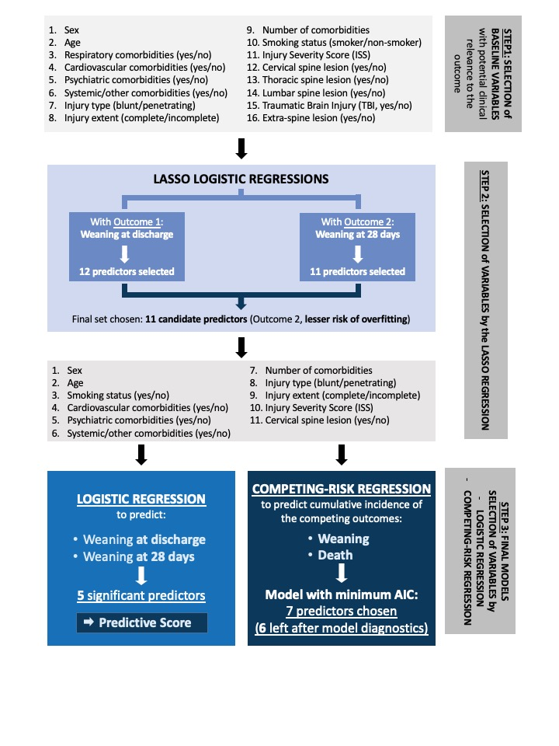
eFigure 2

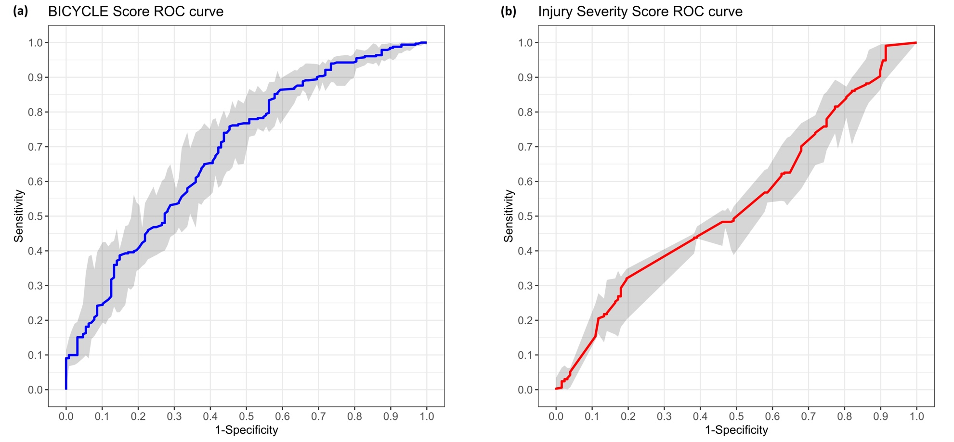

eFigure 3

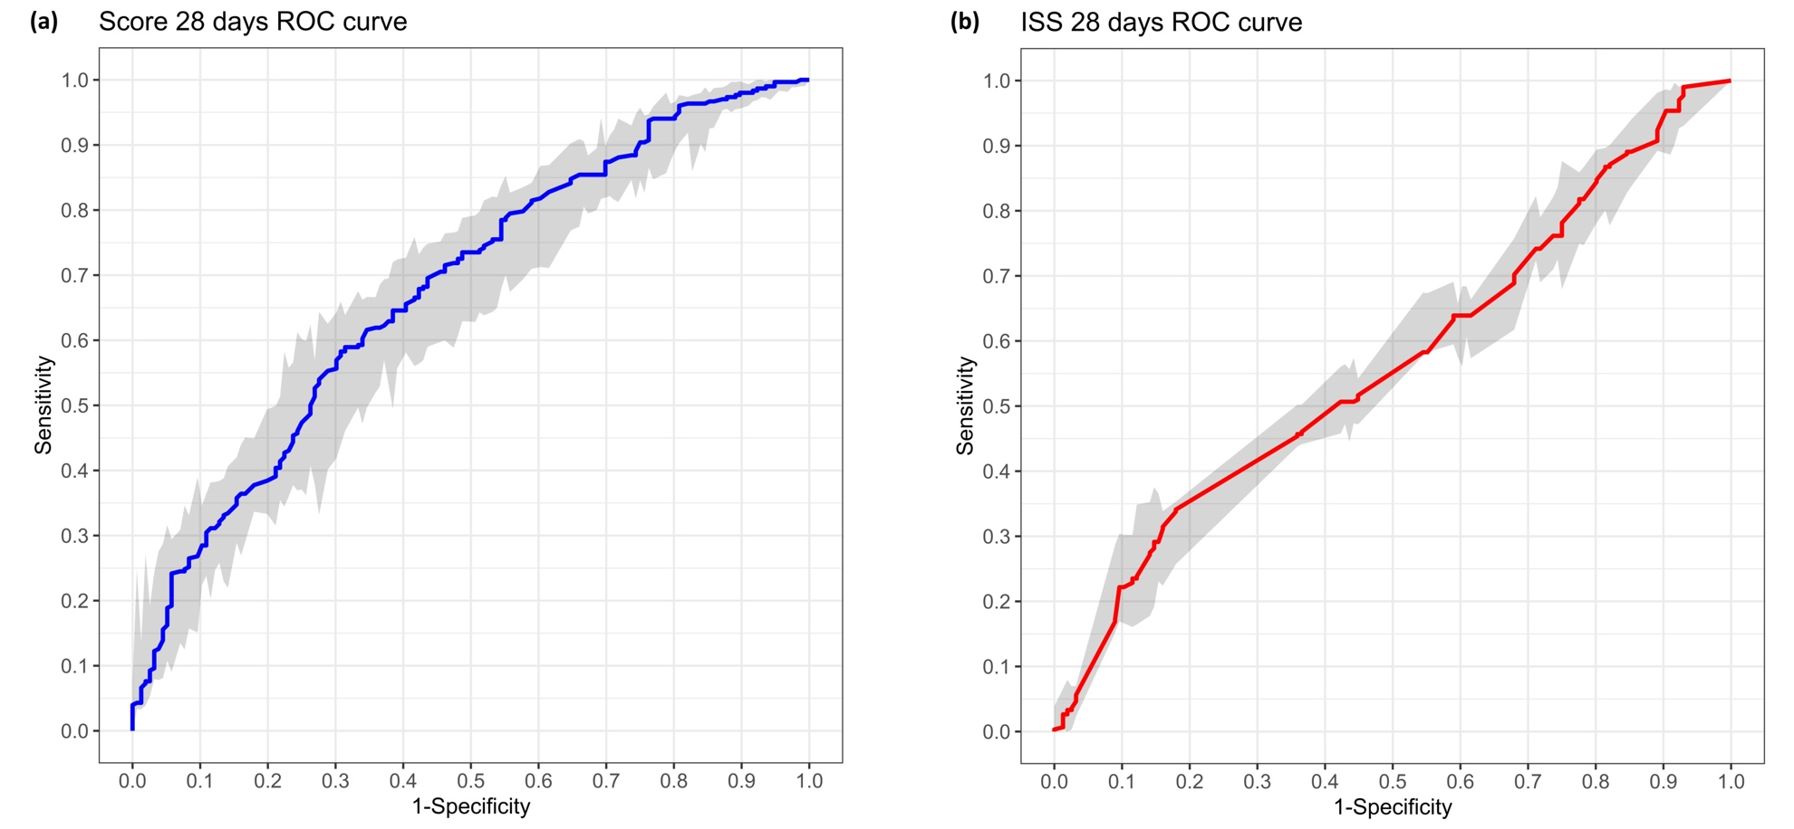

eFigure 4

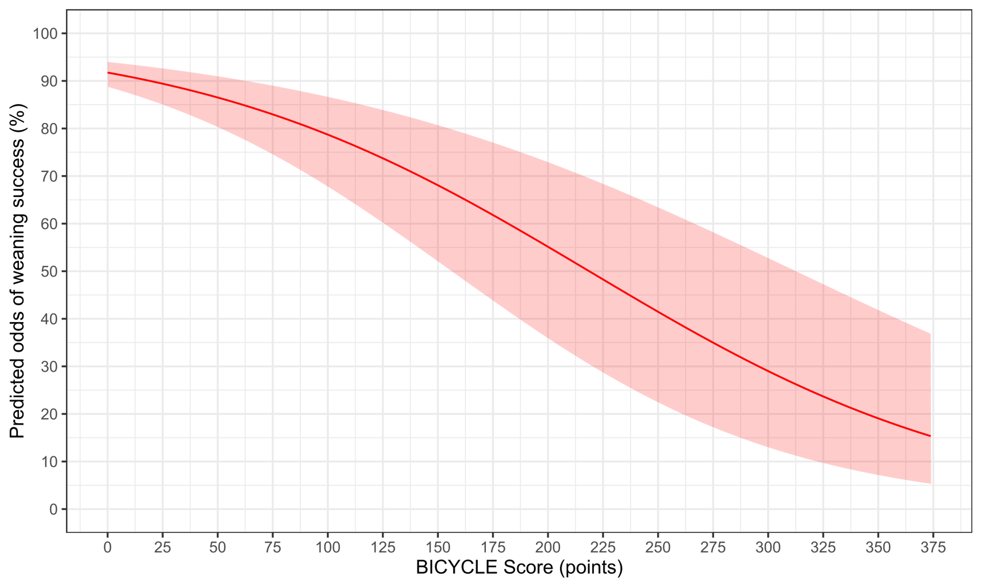

eFigure 5

