Supplemental Material: KKR calculations with multiple-scattering final states

Computational scheme

In the first step of our theoretical investigations, we performed self-consistent electronic structure calculations within the ab-initio framework of the spin-density functional theory in order to generate the self-consistent-field (SCF) potential for further photoemission calculations. The LDA potential of Vosko et al. was used [1]. The electronic structure of semi-infinite crystal was calculated within the relativistic multiple scattering approach using the Green's function Korringa-Kohn-Rostoker (KKR) formalism in the tight binding mode [2]. The experimental lattice constant (a = 4.09 Å) was used. In order to achieve precise description of the most subtle details of the SCF potential, important for photoemission at high excitation energies, the multipole expansion of the Green’s function employed an unusually large angular-momentum cutoff l_{max} of 5. In addition, a large number of k-points (36x36x36) in the first surface BZ was used. The self-consistent calculations have been performed in two modi, within the so-called atomic sphere approximation (ASA) and in the full potential (FP) mode.

The obtained SCF potential was used for the photoemission calculations within the one-step model. The final states (the time-reversed LEED state) were treated using the so-called layer KKR technique [3], allowing accurate description of these states in a wide hv range starting from 6 eV up to several keV. To ensure the convergence of the multiple scattering between the layers, our calculations used a plane-wave basis where the number of the surface reciprocal lattice vectors g was increased to 147 instead of the default value 37 [2]. Another important ingredient of the multiple-scattering calculations is an accurate description of the kinematic and dynamic effects in both initial and final states. For the latter, the dynamic effects are taken into account via the X-matrix [4] which represents the energy-dependent multiple scattering within a single layer. Whereas in VUV-ARPES the kinematic and dynamic effects are comparable, in the soft- and hard-X-ray regime the dynamic effects weaken, whereby the X-matrix approaches zero, leading to the so-called single-site scattering approximation. Another important parameter in the description of multiple scattering is connected with the expansion of all physical quantities in terms of angular momentum l, i.e. using the Bauer’s identity to represent plane waves (scattering between the layers) and spherical waves (inside the layer). These expansions involve a summation over l that must be truncated at a certain value l_{max}. In this context, the increase of l_{max} should be viewed rather as an extension of the basis set for accurate description of the multiple scattering than physically meaningful l-channels in the scattering process. A simple assessment of l_{max} can be obtained from the radial Schrödinger equation where, in order to scatter on the spherical potential, the electron must first overcome the centrifugal barrier l(l+1)/a² (a is the atomic radius). This implies only the partial waves, whose l satisfies the inequality k² > l(l+1)/a², should be included into the l-expansion. The higher E_{k}, the larger l_{max} needs to be used (for the detailed explanation see [5]). For E_{k} in the range 300-1300eV, considered here, l_{max} falls between 4 and 5. The calculations have been performed for a finite temperature of 20K leading to an additional final-state k-broadening, increasing with hv [6].

Effect of various approximations for the multiple-scattering process
We have made an effort to elaborate our ARPES calculations towards their quantitative agreement with the experiment in a few successive steps:

– Fig. S1 shows the results obtained with multiple-scattering final states, as opposed to the FE final states used for the calculations in Figs. 1 and 2 in the main text, under successive refinements of the computational approximations:

– The results in Fig. S1(a) were obtained within the ASA and l_{max} = 3. Due to the non-FE effects described by the multiple-scattering final states, they already show spectral structures due to the MBFSs (such as where marked by magenta arrows) although mostly on the low-energy end of our hv range and not exactly in the same k-space regions compared to the experiment;

– The inclusion of warping of the potential in the interstitial and surface regions within the FP scheme [7], Fig. S1(b), does not result in any significant improvement in our case of Ag. Nevertheless, we anticipate that the accurate FP will be crucial for more open crystal structures, covalent materials, van-der-Waals materials, etc. where the potential modulations are sharper [7]. As we have seen in the present work, their accurate description should be particularly important at high E_{k} where the final states are highly sensitive to the high-frequency modulations of V(r) and thus to the accurate representation of its real-space variations;

– Another step, the inclusion of the full X-matrix compared to the single-site approximation, presented in Fig. S1(c), considerably improves the description of the relative intensity variations in the hv interval between 400 and 500 eV (magenta arrow, for example) but does not notably affect the spectral intensity at higher energies. This observation can be understood from analysis of scattering amplitude f_{k}(θ), giving more insight into the scattering process. The calculations of f_{k}(θ) for Ag by Sébilleau et al. [8], reproduced in Fig. S2, demonstrate that for E_{k} above ~400 eV it is strongly dominated by forward scattering. In practice, this means that for these energies the electrons scatter essentially along the rows of atoms, justifying the single-site approximation for the multiple scattering;

– Finally, at the last step of our computational refinement presented in the Fig. S1(d), we increased l_{max} from 3 to 5. As expected, not only has this returned a vivid pattern of the MBFS-induced replica bands and excessive spectral broadening at low E_{k} (such as where marked by magenta and yellow arrows, respectively) but also pushed these effects to yet higher hv up to 700 eV (magenta arrow). Further increase of l_{max} would inflate the computational time beyond presently realistic.

Although these successive refinements of the computational scheme do move towards a better description of the experiment, the achieved agreement with the experimental results can only be considered as qualitative. We conjecture that the remnant deviation may trace back to quite small sensitivity of the total energy to high-frequency components of the crystal potential. Therefore, the total-energy minimization used to generate the self-consistent potential in the DFT calculations may not ensure sufficient accuracy of its high-frequency components which critically affect the hybridization and thus non-FE effects in the final states at high energies. The accuracy of the final states used in the ARPES calculations can in principle be verified independently from the initial states by calculating the LEED spectra and their fitting to the experiment using the methodology previously developed for very low energies (see [9–11] and the references therein). In any case, including the subtle details of V(r) within the FP approach and the use of sufficiently large l_{max} give the best possible single-particle description of the photoemission final state.
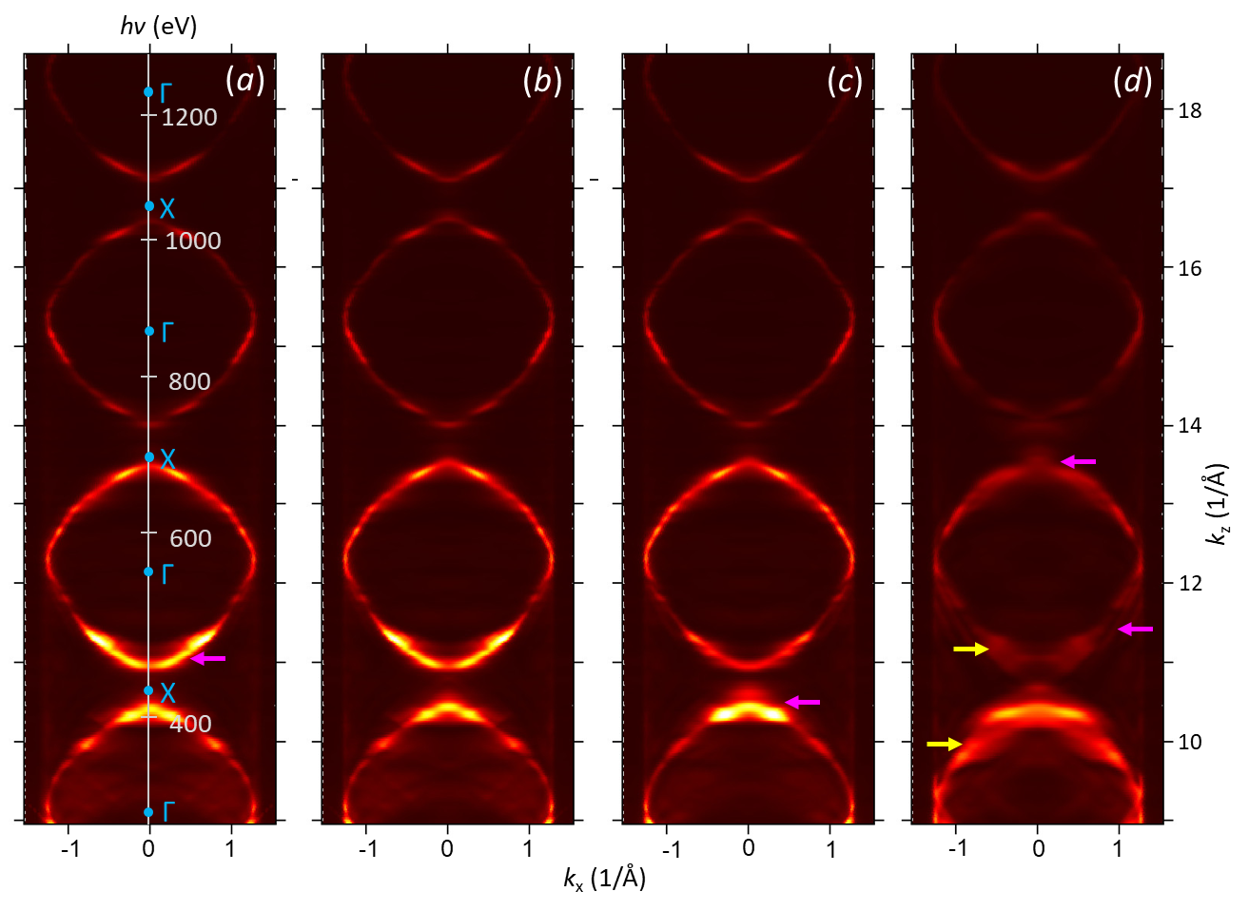
Fig. S1. One-step ARPES calculations as in Fig. 1(d) but using multiple-scattering final states under successive refinements of their treatment: (a) standard spherical-wave expansion and single-site scattering approximation; (b) adding full potential; (c) the full X-matrix beyond the single-site scattering; (d) increasing the angular momentum expansion to l_{max} = 5. The calculations reproduce the multiple spectral peaks (magenta arrows) and the excessive spectral broadening (yellow) induced by the MBFSs.
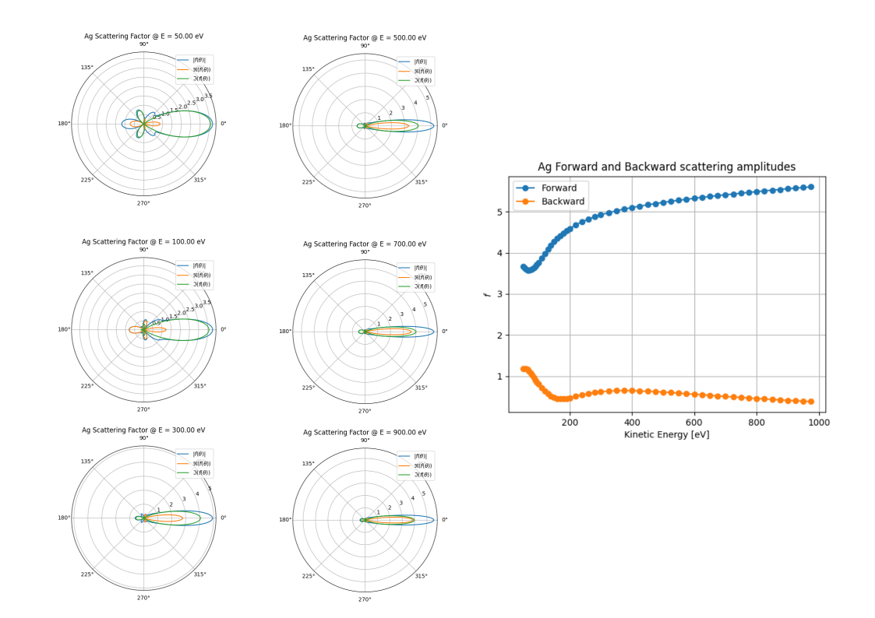
Fig. S2. Scattering amplitude f_{k}(θ) for Ag as a function of E_{k} (left panels) and the total forward and backward scattering contributions (right panel).

References
[1] S. H. Vosko, L. Wilk, and M. Nusair, Accurate Spin-Dependent Electron Liquid Correlation Energies for Local Spin Density Calculations: A Critical Analysis, Canadian J. Phys. 58 (1980) 1200
[2] H. Ebert, D. Ködderitzsch, and J. Minár, Calculating Condensed Matter Properties Using the KKR-Green’s Function Method – Recent Developments and Applications, Rep. Prog. Phys. 74 (2011) 096501.
[3] J. M. MacLaren, S. Crampin, D. D. Vvedensky, and J. B. Pendry, Layer Korringa-Kohn-Rostoker Technique for Surface and Interface Electronic Properties, Phys. Rev. B 40 (1989) 12164
[4] J. Braun, J. Minár, and H. Ebert, Correlation, Temperature and Disorder: Recent Developments in the One-Step Description of Angle-Resolved Photoemission, Phys. Rep. 740 (2018) 1.
[5] Multiple Scattering Theory for Spectroscopies, eds. D. Sébilleau, K. Hatada and H. Ebert. Springer Proc. Phys. 204 (2018).
[6] J. Braun, The theory of angle-resolved ultraviolet photoemission and its applications to ordered materials. Rep. Prog. Phys. 59 (1996) 1267.
[7] J. Braun, J. Minár, S. Mankovsky, V. N. Strocov, N. B. Brookes, L. Plucinski, C. M. Schneider, C. S. Fadley, and H. Ebert, Exploring the XPS Limit in Soft and Hard X-Ray Angle-Resolved Photoemission Using a Temperature-Dependent One-Step Theory, Phys. Rev. B 88 (2013) 205409
[8] D. Sébilleau, S. Tricot, and A. Koide, unpublished (2022).
[9] V. N. Strocov, H. Starnberg & P. O. Nilsson. Excited-state bands of Cu determined by VLEED band fitting & their implications for photoemission, Phys. Rev. B 56 (1997) 1717.
[10] V. N. Strocov, R. Claessen, G. Nicolay, S Hüfner, A Kimura, A. Harasawa, S. Shin, A. Kakizaki, P.O. Nilsson, H.I. Starnberg & P. Blaha. Three-dimensional band mapping by angle-dependent very-low-energy electron diffraction and photoemission: Methodology and application to Cu. Phys. Rev. B 63 (2001) 20510.

[11] V. N. Strocov, E.E. Krasovskii, W. Schattke, N. Barrett, H. Berger, D. Schrupp & R. Claessen. Three-dimensional band structure of layered TiTe₂: Photoemission final-state effects. Phys. Rev. B 74 (2006) 195125.

