SUPPLEMENTAL FIGURES
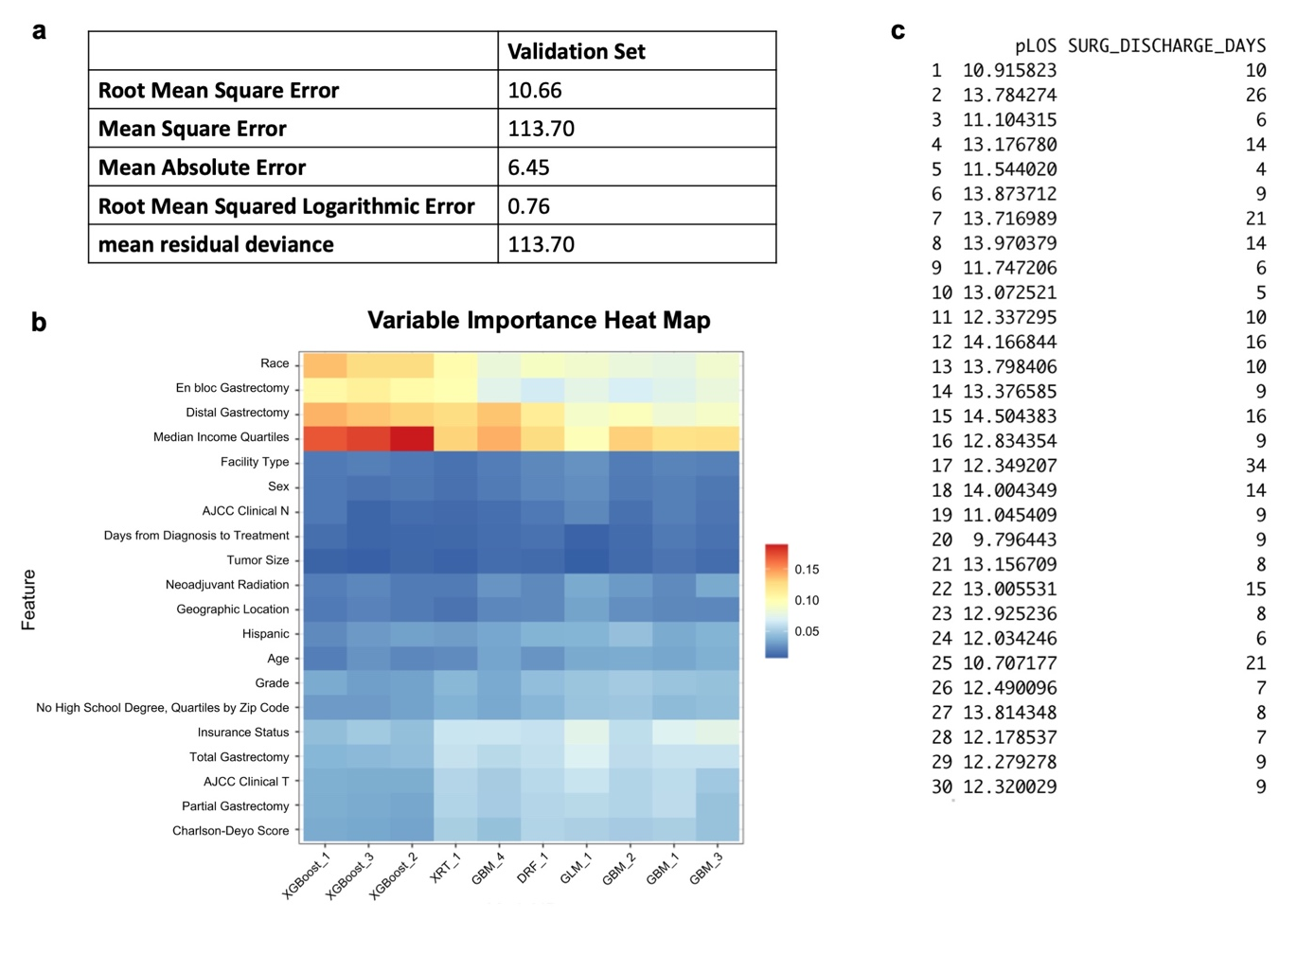
Supplemental Figure 1. AutoML model prediction of inpatient post-operative length of stay. (a) Model performance, (b) variable importance heat map highlighting variables that were most influential for length of stay prediction, and (c) representative predicted length of stay (pLOS) and original values (SURG_DISCHARGE_DAYS).
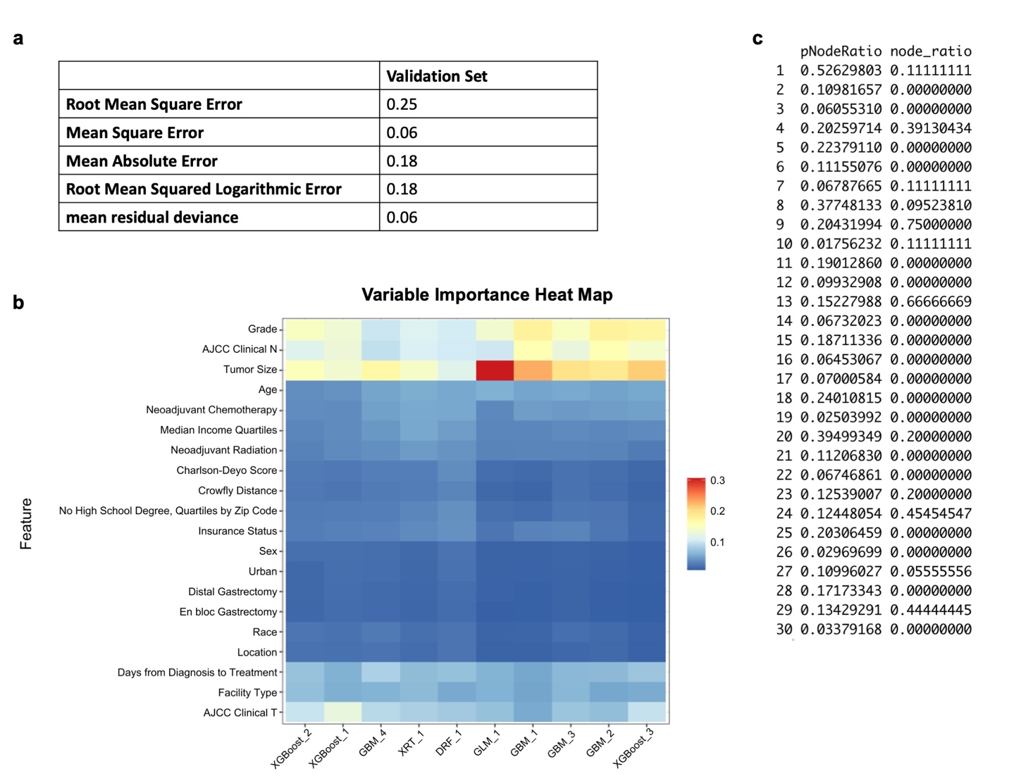
Supplemental Figure 2. AutoML model prediction of nodal ratio. (a) Model performance, (b) variable importance heat map highlighting variables that were most influential for nodal raio prediction, and (c) representative predicted node ratio (pNodeRatio) and original values (node_ratio).

