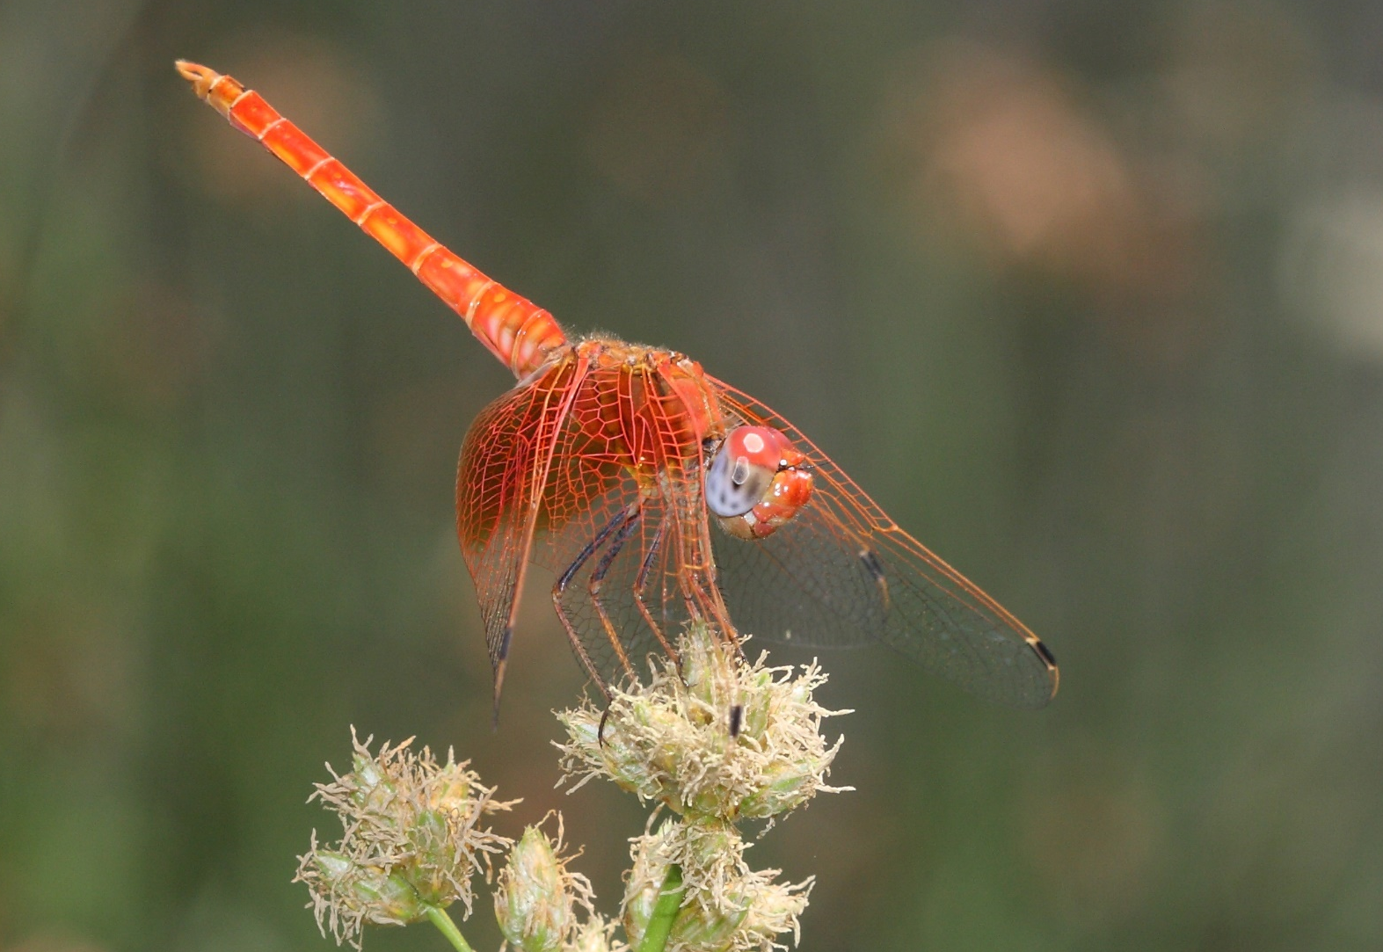
Figure S1. Photograph of a male of Trithemis kirbyi Sélys, 1891, in Madrid (Spain). Photo credit: Jose Ignacio Pascual, with the author’s permission. Photograph hosted on Biodiversidad Virtual: https://www.biodiversidadvirtual.org/insectarium/Trithemis-kirbyi-Selys-1891-img769288.html

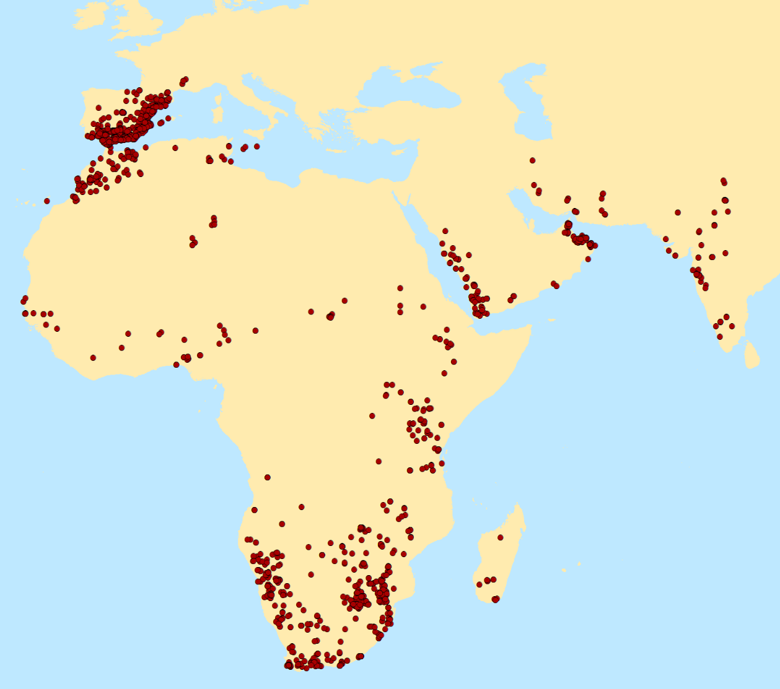
Figure S2. Map showing the location of the occurrence points of Trithemis kirbyi included in the analyses.

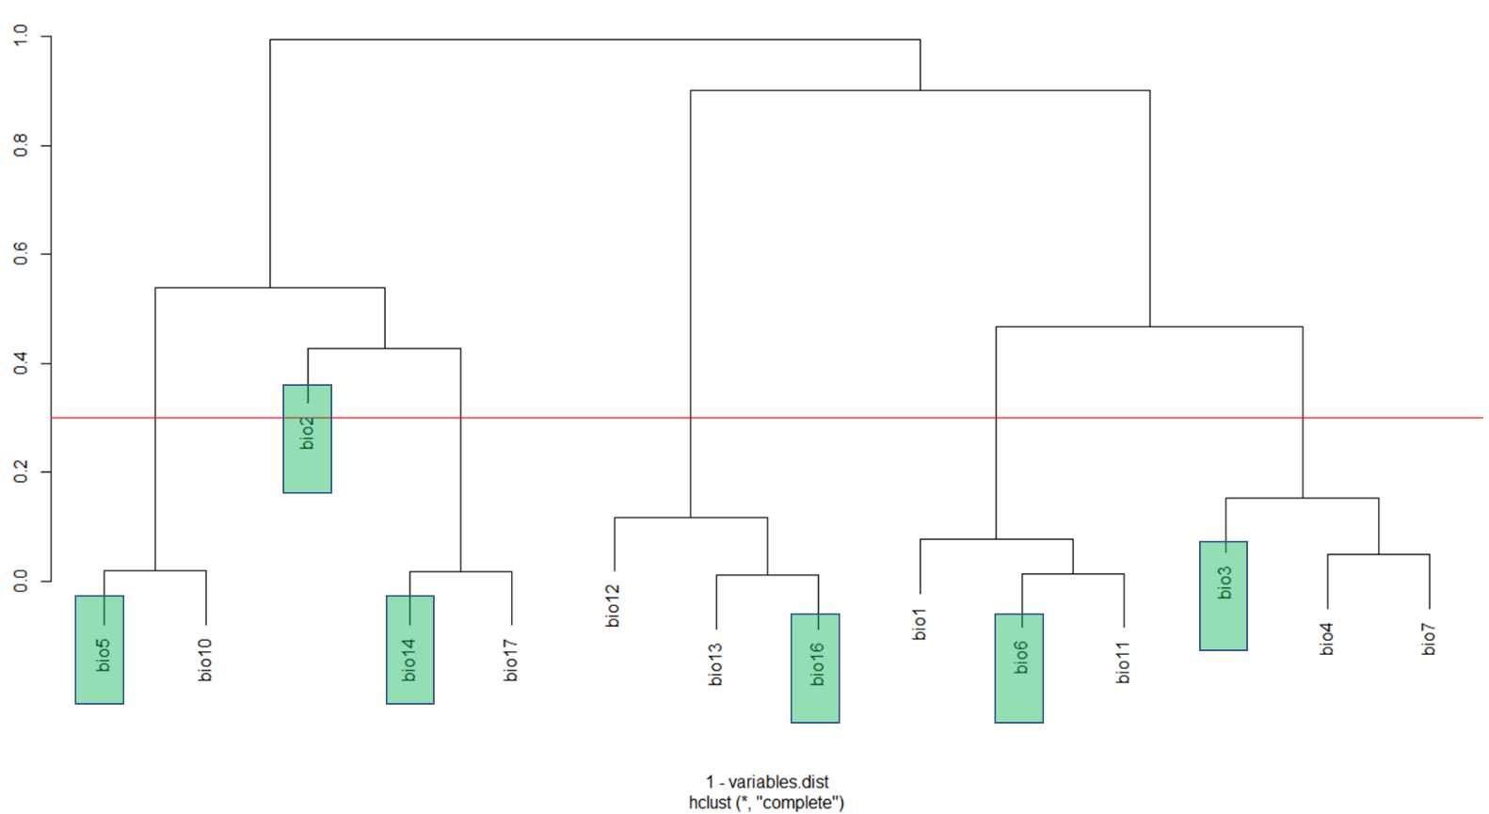

Figure S3. Dendrogram obtained from the cluster analysis used to select the relevant WorldClim variables (in green boxes); the red horizontal line indicates the chosen distance-threshold to form the clusters (i.e., 0.3 or less than 70% correlation).

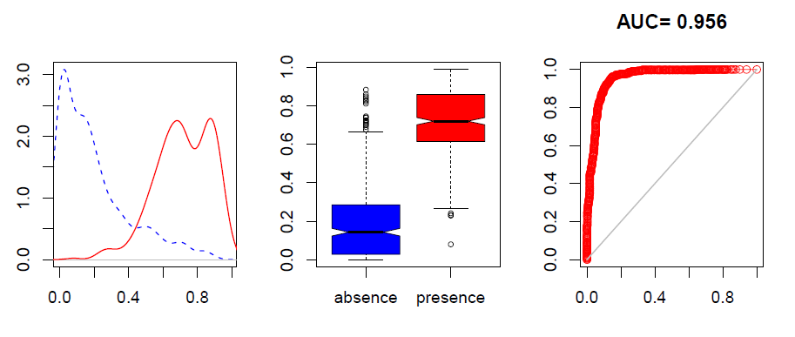

Figure S4. Left: Accumulation of the number of presences (red continuous line) and pseudoabsences (blue dashed line) (in y-axis) considering the suitability of the ensemble model of Trithemis kirbyi without the population density variable (in x-axis). Center: Boxplots of presences (in red) and pseudoabsences (in blue) considering the suitability of the ensemble model of Trithemis kirbyi without the population density variable (in y-axis). Right: Representation of the AUC and AUC value of the Trithemis kirbyi ensemble model without the population density variable.

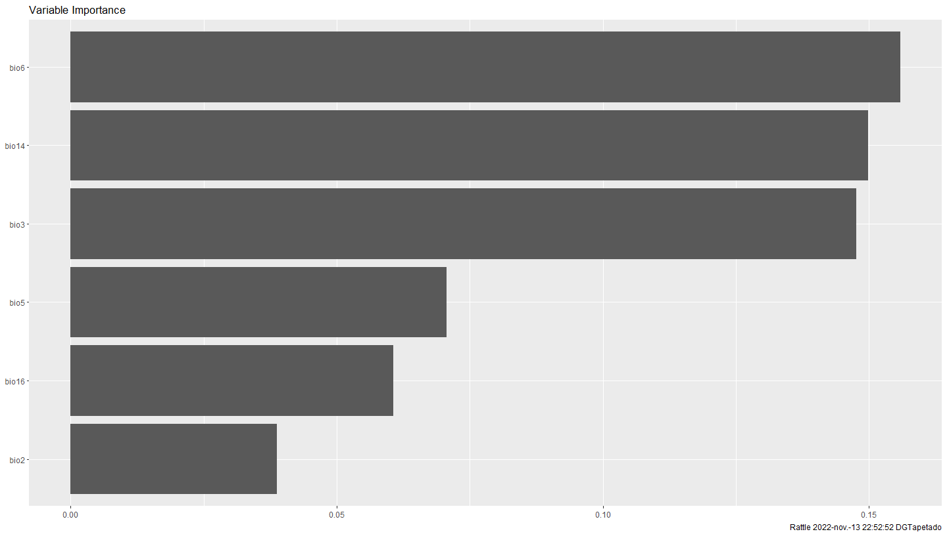
Figure S5. Conditional Random Forest analysis (2500 trees, 4 variables) with presences and absences obtained from an a posteriori test performed to identify the variables most influential on the distribution of Trithemis kirbyi.
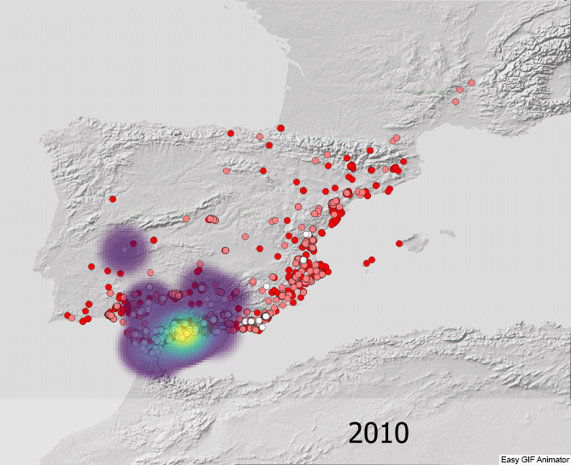
Figure S6. Animated version of Figure 4. Evolution of colonization in the Iberian Peninsula between 2010 and spring 2022. The color of the collection point indicates the relative time since sites were sampled with white dots representing the oldest sites and dark red dots, the most recent ones. The heat map was generated exclusively with the presences of the year represented, and indicates a higher concentration of presences collected in the year in question.

