Supplementary Materials
Supplementary Table S1: Duration of developmental stages in both seasons of S. ricini
Supplementary Table S2: Mean colony-forming units (CFU per ml ± SE) of bacteria isolated across larval instar in both seasons of S. ricini
Supplementary Table S3: Frequency (%) of gut isolates within larval instars from summer and winter.
Supplementary Table S4: Variation of gut bacteria colonization in both seasons.
Table S1.
Developmental stages | Summer (44-48 days) | Winter (85-87 days)
Hatching | 10-11 days | 14-15 days
1st instar (L1) | 3-4 days (SL1) | 6-7 days (WL1)
2nd instar (L2) | 2-3 days (SL2) | 4-5 days (WL2)
3rd instar (L3) | 3-4 days (SL3) | 7-9 days (WL3)
4th instar (L4) | 5-6 days (SL4) | 5-11 days (WL4)
5th instar (L5) | 6-8 days (SL5) | 10-12 days (WL5 )

Table S2.
Media | WL1(Log CFU/ml(x 108)) | WL2(Log CFU/ml(x 108)) | WL3(Log CFU/ml(x 108)) | WL4(Log CFU/ml(x 108)) | WL5(Log CFU/ml(x 108)) | SL1(Log CFU/ml(x 108)) | SL2(Log CFU/ml(x 108)) | SL3(Log CFU/ml(x 108)) | SL4(Log CFU/ml(x 108)) | SL5(Log CFU/ml(x 108))
NA | 4.40 ± 0.26 | 5.43 ± 0.33 | 9.4533 ± 0.295 | 10.383 ± 0.55 | 13.09 ± 0.455 | 6.73 ± 0.54 | 7.78 ± 0.32 | 8.95 ± 0.57 | 11.763 ± 0.69 | 15.20 ± 0.49
TSA | 6.12 ± 0.35 | 6.64 ± 0.40 | 7.1533 ± 0.582 | 7.116 ± 0.22 | 8.5766 ± 0.38 | 6.12 ±0.35 | 6.81 ± 0.12 | 6.82 ± 0.69 | 8.7833 ± 0.39 | 9.42 ± 0.62
BHA+lignin | 2.36 ± 0.18 | 3.456 ± 0.66 | 3.21 ± 0.565 | 5.073 ± 0.61 | 8.5166 ± 0.287 | 2.36 ± 0.18 | 3.46 ± 0.66 | 4.34 ± 0.27 | 4.28 ± 0.49 | 8.18 ± 0.61
BGB | 3.51 ± 1.01 | 5.773 ± 1.23 | 6.5033 ± 0.822 | 8.166 ± 0.39 | 7.34 ± 0.56 | 3.51 ± 1.01 | 5.77 ± 1.23 | 7.17 ± 0.90 | 5.7933 ± 0.89 | 11.00 ± 0.29
LBA | 5.31 ± 0.46 | 6.0933 ± 0.77 | 8.9 ± 0.266 | 8.156 ± 0.466 | 8.59 ± 0.42 | 7.64 ± 1.14 | 6.56 ± 1.29 | 8.92 ± 0.23 | 9.393 ± 0.64 | 8.59 ± 0.42
BHA+CMC | 1.96 ± 0.72 | 4.04 ± 0.168 | 3.0866 ± 1.33 | 4.2133 ± 0.61 | 6.986 ± 0.48 | 2.63 ± 0.96 | 4.266 ± 0.56 | 3.08 ± 1.33 | 4.2133 ± 0.614 | 7.12 ± 0.71

Table S3.

Genera (Nos. of isolates) | Winter |  |  |  |  | Summer
Genera (Nos. of isolates) | 1st instar | 2nd instar | 3rd instar | 4th instar | 5th instar | 1st instar | 2nd instar | 3rd instar | 4th instar | 5th instar
Bacillus (29) | 0 | 10.34 | 10.34 | 17.24 | 13.79 | 3.44 | 10.34 | 0 | 17.24 | 17.24
Acinetobacter (6) | 50 | 0 | 0 | 0 | 33.33 | 0 | 0 | 0 | 0 | 16.66
Pantoea (3) | 0 | 0 | 0 | 33.33 | 0 | 0 | 0 | 0 | 33.33 | 33.33
Paenibacillus (10) | 0 | 10 | 20 | 0 | 0 | 0 | 20 | 30 | 0 | 20
Mammaliicoccus (4) | 0 | 0 | 0 | 0 | 50 | 0 | 0 | 0 | 50 | 0
Leclercia (3) | 0 | 0 | 33.33 | 0 | 0 | 0 | 0 | 66.66 | 0 | 0
Ochrobactrum (3) | 0 | 0 | 0 | 0 | 0 | 0 | 33.33 | 66.66 | 0 | 0
Enterobacter (8) | 0 | 0 | 12.5 | 0 | 12.5 | 0 | 0 | 12.5 | 37.5 | 25
Staphylococcus (13) | 0 | 7.69 | 7.69 | 7.69 | 15.38 | 0 | 0 | 15.38 | 23.07 | 23.07
Microbacterium (1) | 0 | 0 | 0 | 0 | 100 | 0 | 0 | 0 | 0 | 0
Leucobacter (1) | 0 | 0 | 0 | 0 | 0 | 0 | 100 | 0 | 0 | 0
Fictibacillus (1) | 0 | 100 | 0 | 0 | 0 | 0 | 0 | 0 | 0 | 0
Lysinibacillus (4) | 0 | 50 | 0 | 25 | 0 | 0 | 25 | 0 | 0 | 0
Brachybacterium (1) | 0 | 0 | 0 | 0 | 0 | 0 | 0 | 0 | 100 | 0
Pseudomonas (9) | 22.22 | 11.11 | 0 | 0 | 0 | 33.33 | 22.22 | 0 | 11.11 | 0
Klebsiella (2) | 0 | 0 | 0 | 0 | 50 | 0 | 0 | 0 | 50 | 0
Rathayibacter (1) | 0 | 0 | 100 | 0 | 0 | 0 | 0 | 0 | 0 | 0
Serratia (2) | 0 | 0 | 0 | 0 | 0 | 0 | 100 | 0 | 0 | 0
Streptomyces (1) | 0 | 0 | 0 | 0 | 0 | 0 | 0 | 0 | 100 | 0
Enterococcus (4) | 0 | 0 | 0 | 0 | 0 | 0 | 0 | 0 | 0 | 100
Lysobacter (1) | 0 | 0 | 100 | 0 | 0 | 0 | 0 | 0 | 0 | 0
Brevibacillus (1) | 100 | 0 | 0 | 0 | 0 | 0 | 0 | 0 | 0 | 0
Total isolates (108) | 6 | 9 | 10 | 8 | 13 | 4 | 12 | 10 | 18 | 18

Table S4.
Gut bacteria | Winter | Summer
Bacillus sp. | 15 | 14
Acinetobacter sp. | 5 | 1
Pantoea sp. | 1 | 2
Paenibacillus sp. | 3 | 7
Mammaliicoccus sp. | 2 | 2
Leclercia sp. | 1 | 2
Ochrobactrum sp. | 0 | 3
Enterobacter sp. | 2 | 6
Staphylococcus sp. | 5 | 8
Microbacterium sp. | 1 | 0
Leucobacter sp. | 0 | 1
Fictibacillus sp. | 1 | 0
Lysinibacillus sp. | 3 | 1
Brachybacterium sp. | 0 | 1
Pseudomonas sp. | 3 | 6
Klebsiella sp. | 1 | 1
Rathayibacter sp. | 1 | 0
Serratia sp. | 0 | 2
Streptomyces sp. | 0 | 1
Enterococcus sp. | 0 | 3
Lysobacter sp. | 1 | 0
Brevibacillus sp. | 1 | 0

Supplementary figures
Fig. S1. A view of developmental instars of Samia ricini; A. 1st instar, B. 2nd instar, C. 3rd instar, C. 5th instar.
Fig.S2. Whole gut of eri silkworms dissected from IV (A) and V (B) instar stages and10-fold serial dilutions (10⁻², 10⁻³ and10⁻⁴) was done, 1 ml of tissue suspension wasdispersedonto the media.

Fig.S3. Neighbour joining phylogenetic tree of rest 61 gut bacterial strains (black square) on 16S rRNA gene sequence alignments with their closest phylogenetic neighbours. Scale bar indicates 0.02 substitution per nucleotide. Bootstrap values greater than 50% are shown at the nodes and are based on 1,000 replicates.
Fig.S4. Phylogenetic affiliation based on 16SrDNA using UPGMA; a. among the species of Bacillus where Pseudomonas aeruginosa was chosen arbitrarily as the outgroup sequence, b. among the other genera of gut bacteria where Brachybacterium was chosen arbitrarily as the outgroup sequence. Bootstrap values greater than 50% are shown at the nodes and are based on 1,000 replicates. Sequence of type strains and related isolates were retrieved from GenBank, and accession numbers appear in parentheses.
Fig. S5. Screening of cellulolytic and xylanlolytic gut bacteria based on hydrolyzing zones produced by bacterial strains on agar plates containing; a. CMC, b. xylan.
Fig. S6. Variation in genera of summer and winter.
Fig. S1
Fig. S2

Fig.S3
Fig. S4 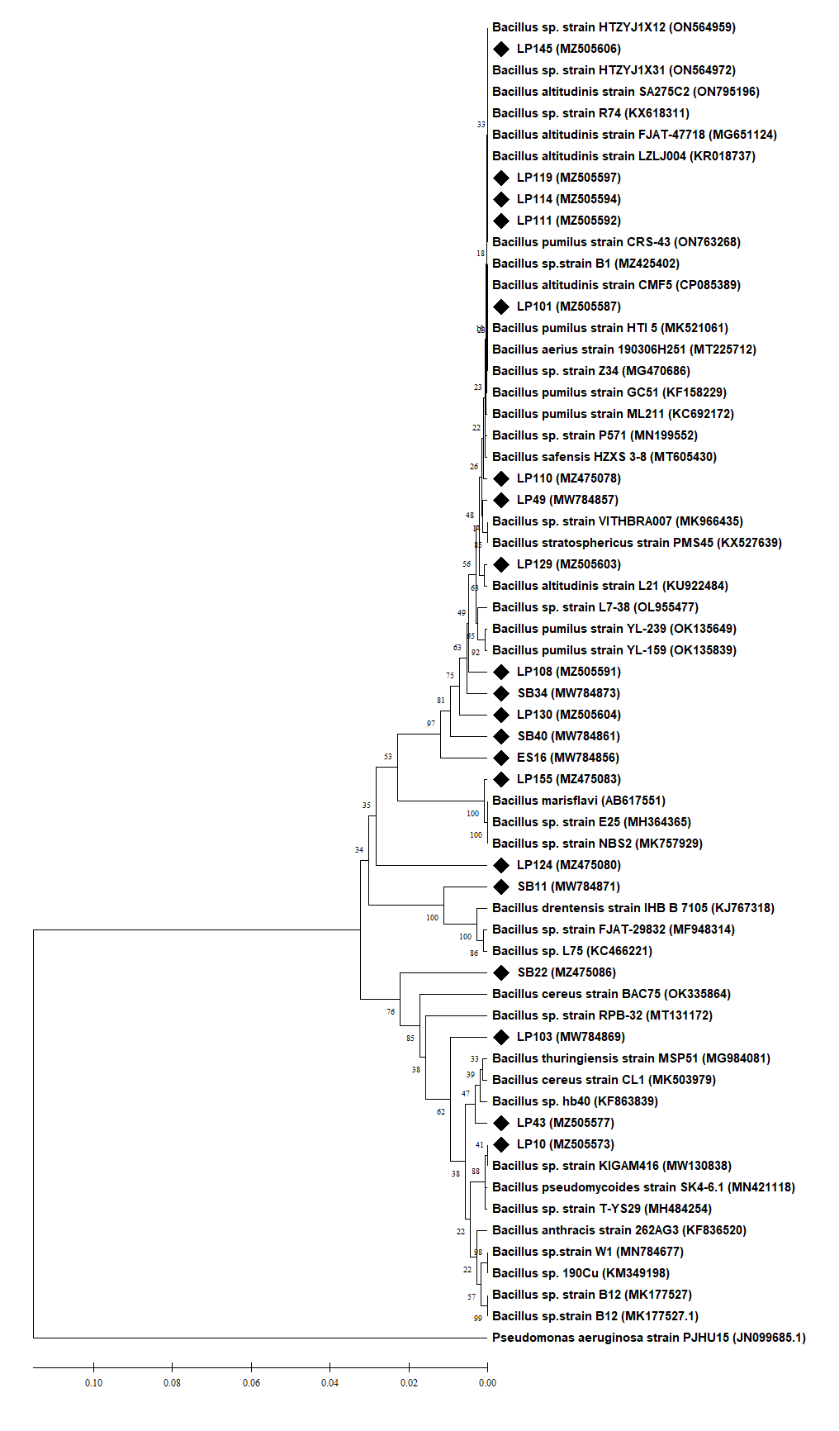
a
Fig. S4

Fig. S5
Fig. S6

