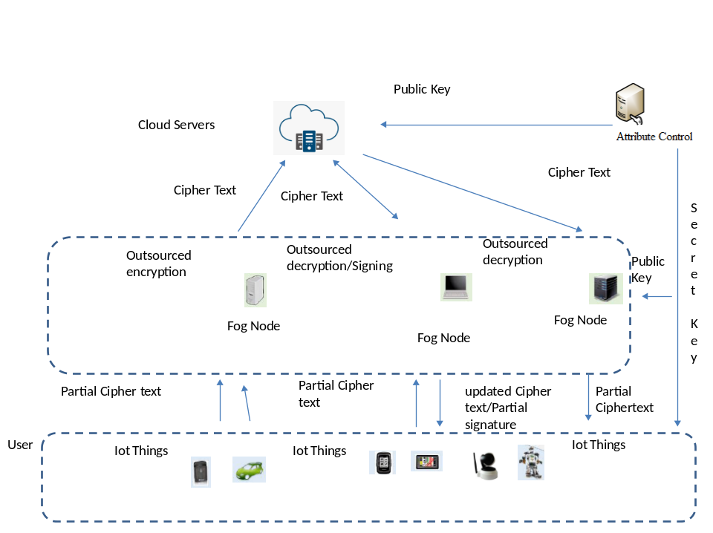
Key Findings/Highlights:
- We identified that there is a need for a highly scalable system with improved efficiency in data security and confidentiality since the existing systems are not much effective.
- We present a novel hybrid Quantum cryptography based Cipher-text policy attribute-based encryption (HQCP-ABE). Though attribute-based encryption ensures data security and fine-grained access control of data, the cost of computation for performing encryption and decryption is narrower to the policy complexity. Further, the conventional CP-ABE methods are constructed from bilinear pairing operation and therefore their decryptions need costly pairing.
- The proposed system effectively overcomes these shortcomings and achieves highly successful results in terms of packet loss, control overheads, computational overheads, throughput, packet delivery ratio, network lifetime, user security and data confidentiality.
- The proposed system can be applied in military applications, disaster management, industrial and consumer applications.

