Computational study of the interaction between azo dye (RR141) and Hematite α-Fe₂O₃(111) Surface: A DFT and MDs Study

M. E. Belghiti, ^{1,2,} K. Mizeb³, M. Salah^{4,}, A. Zeroual⁴, J. Mouldar⁵, A. Moubarik⁶, M. Hochlaf⁷ and M. El idrissi^{6*}
¹Laboratory of Chemistry-Physics of Materials, Faculty of Sciences, Ben M'Sick , Hassan II University of Casablanca, Casablanca, Morocco.
²Laboratory of Nernest Technology, 163 Willington Street, Sherbrook, J1H5C7,
Quebec, Canada.
³Laboratory of organic chemistry, inorganic, Electrochemistry and Environment, Department of Chemistry, Faculty of Sciences, Ibn Tofail University, Kenitra, Morocco

⁴ Molecular Modeling and Spectroscopy Research Team, F. Sc, Chouaïb Doukkali University, El Jadida, Morocco.
⁵Laboratory of Organic Chemistry, Bioorganic and Environment, F. Sc, University Chouaib Doukkali, El Jadida, Morocco
⁶Team of Chemical Processes and Applied Materials, Faculty Polydisciplinary, Sultan Moulay Slimane University, Beni-Mellal, Morocco.
⁷ University of Gustave Eiffel, COSYS/LISIS, 5 Bd Descartes, 77454 Champs sur Marne, France
* Corresponding author: E-mail: m.elidrissi2018@gmail.com

Table of Contents | Pages
Fig.1Sa: the 3D structure of RR141 optimized by B3LYP/6-31G++(d,p) in vacuum  (Black-carbon atoms, white-hydrogen atoms, red-oxygen atoms, blue-nitrogen atoms, yellow-sulphur atoms, and green-sodium atoms). | 2
Fig.1Sb: 3D structure of RR141 optimized by B3LYP/6-31G++(d,p) in water  (Black-carbon atoms, white-hydrogen atoms, red-oxygen atoms, blue-nitrogen atoms, yellow-sulphur atoms, and green-sodium atoms). | 2
Fig.2a : Representation plot for LUMO of RR141 optimized structure in vacuum at B3LYP/6-31++G(d,p) | 3
Fig.2 : Representation plot for HOMO of RR141 optimized structure in vacuum at B3LYP/6-31++G(d,p) | 3
Table.1S Geometries data length (Å) and angles (º) of RR141. | 4
Fig. 3: MPA of RR141 in a vacuum and aqueous media. | 5
Table 2S: Fukui indices for heteroatoms N and O of RR141 in a vacuum and aqueous media | 6

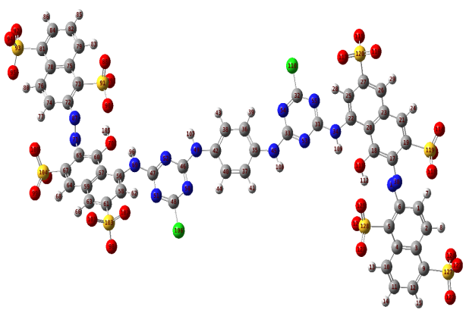

Fig.1Sa: the 3D structure of RR141 optimized by B3LYP/6-31G++(d,p) in vacuum
(Black-carbon atoms, white-hydrogen atoms, red-oxygen atoms, blue-nitrogen atoms, yellow-sulphur atoms, and green-sodium atoms).

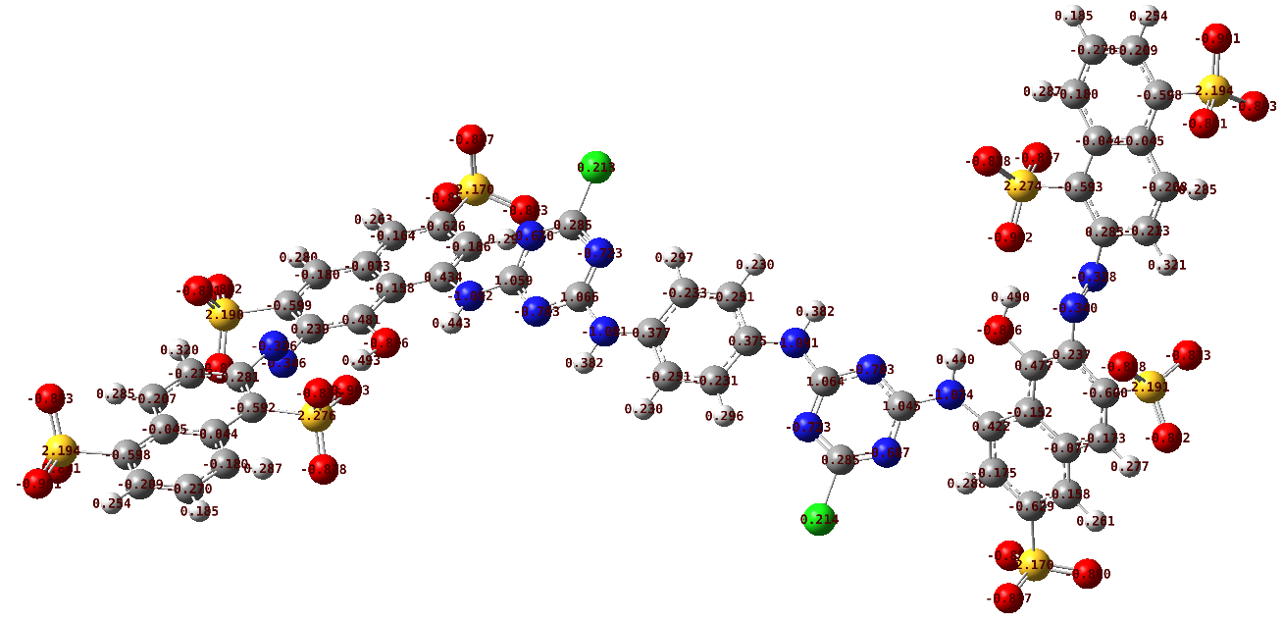

Fig.1Sb: 3D structure of RR141 optimized by B3LYP/6-31G++(d,p) in water
(Black-carbon atoms, white-hydrogen atoms, red-oxygen atoms, blue-nitrogen atoms, yellow-sulphur atoms, and green-sodium atoms).
Fig.2a : Representation plot for LUMO of RR141 optimized structure in vacuum at B3LYP/6-31++G(d,p)

Fig.2 : Representation plot for HOMO of RR141 optimized structure in vacuum at B3LYP/6-31++G(d,p)

Table.1S Geometries data length (Å) and angles (º) of RR141.
Torsional angles | Vacuum | water | X-ray diffraction
C₆-N₁₆=N₃₀-C₁₇ | +174.62 | -171.40 | 171.74
C₆₅-N₇₁=N₈₇-C₇₂ | +174.75 | -175.16 | 174.75
N₃₀-C₁₇-C₁₈-O₁₁₁ | -2.72 | +1.33 | -1.95
N₇₁-C₆₅-C₆₀-O₇₀ | -0.20 | -5.09 | -1.95
N₈₇-C₇₂-C₇₃-S₉₁ | -1.91 | 2.60 | -2.57
N₁₆-C₆-C₅-S₁₂₈ | 7.86 | -8.17 | -8.17
Bond lengths
-N₁₆=N₃₀- | 1.237 | 1.253 | 1.2570
-N₇₁=N₈₇- | 1.237 | 1.258 | 1.2537
-C₁₈-O₁₁₁- | 1.351 | 1.385 | 1.3832
-C₆₀-O₇₀- | 1.352 | 1.383 | 1.3832
-C₁₇-N₃₀= | 1.432 | 1.416 | 1.4199
-C₆-N₁₆= | 1.432 | 1.417 | 1.4197
-C₆₅-N₇₁= | 1.432 | 1.416 | 1.4198
=N₈₇-C₇₂- | 1.435 | 1.420 | 1.4199
Bond angles
C₆-N₁₆=N₃₀ | 116.98 | 111.29 | 111.36
N₁₆=N₃₀-C₁₇ | 117.10 | 110.95 | 112.07
C₁₇-C₁₈-O₁₁₁ | 124.23 | 119.62 | 120.24
C₆₅-C₆₀-O₇₀ | 124.72 | 116.51 | 120.24
C₆₅-N₇₁=N₈₇ | 118.30 | 110.90 | 112.07
N₇₁=N₈₇-C₇₂ | 114.62 | 112.37 | 111.36

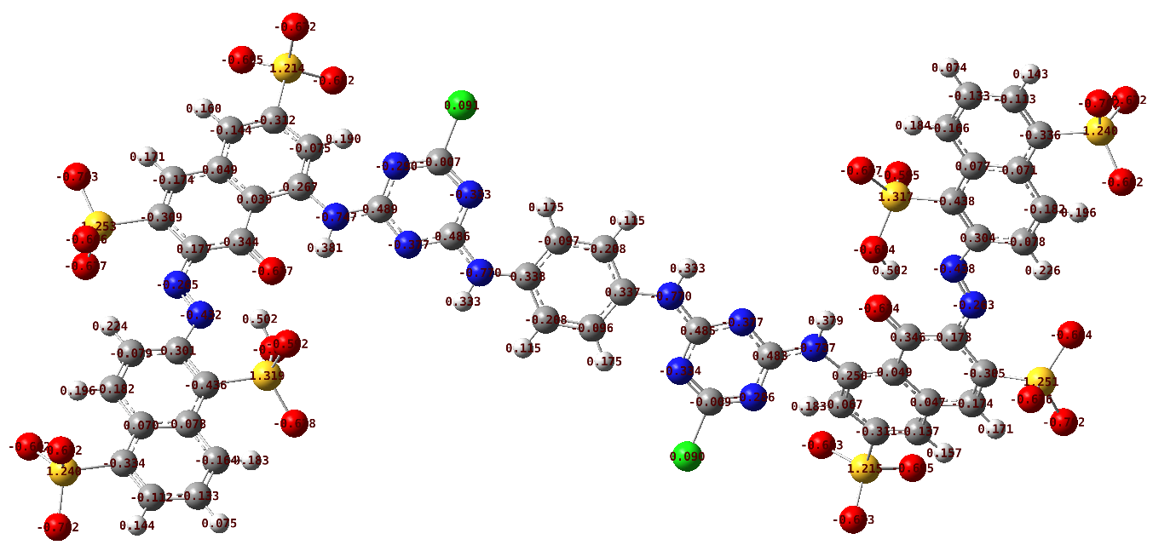
Gas-phase
Aqueous phase
Fig. 3: MPA of RR141 in a vacuum and aqueous media.

Table 2S: Fukui indices for heteroatoms N and O of RR141 in a vacuum and aqueous media.

Atoms | Aqueous phase |  | Gas-phase |  | Atoms | Aqueous phase |  | Gas-phase
Atoms | $$f_{k}^{-}$$ | $$f_{k}^{+}$$ | $$f_{k}^{+}$$ | $$f_{k}^{-}$$ | Atoms | $$f_{k}^{-}$$ | $$f_{k}^{+}$$ | $$f_{k}^{+}$$ | $$f_{k}^{-}$$
N ( 16) | -1.66 | -0.19 | -0.91 | -2.26 | O ( 98) | 0.03 | 0.09 | 0.09 | 0.16
N ( 30) | -1. 37 | 0.45 | -0.81 | -1.67 | O ( 99) | 0.16 | 0.05 | 0.21 | -0.07
N ( 34) | 0.37 | -0.10 | 0.30 | -0.07 | O (100) | 0.15 | 0.11 | 0.11 | 0.19
N ( 45) | 0.37 | 0.16 | 0.25 | -0.01 | O (101) | 0.02 | 0.10 | 0.13 | 0.13
N ( 49) | 0.38 | 0.15 | 0.26 | -0.02 | O (102) | 0.01 | 0.12 | 0.14 | 0.15
N ( 50) | 0.39 | 0.12 | 0.19 | 0.12 | S (103) | 0.03 | 0.01 | 0.15 | -0.09
N ( 51) | -0.15 | 0.24 | 0.17 | -0.24 | S (104) | -0.01 | 0.08 | -0.08 | 0.02
N ( 52) | 0.29 | 0.11 | 0.11 | -0.27 | O (111) | -1.03 | 0.29 | 0.20 | -1.02
N ( 53) | 0.39 | 0.10 | 0.18 | -0.20 | O (113) | 0.13 | 0.18 | 0.18 | 0.19
N ( 54) | 0.29 | 0.11 | 0.21 | 0.20 | O (114) | 0.21 | 0.01 | 0.30 | 0.69
N ( 55) | -0.18 | 0.17 | 0.13 | -0.13 | O (115) | 0.02 | 0.10 | 0.19 | 0.09
N ( 69) | 0.12 | -0.04 | -0.17 | -0.08 | O (116) | 0.06 | 0.04 | 0.12 | 0.15
O ( 70) | -1.25 | 0.08 | -0.16 | -1.20 | O (117) | 0.04 | 0.19 | 0.24 | 1.37
N ( 71) | -2.79 | 0.34 | -0.93 | -2.73 | O (118) | 0.16 | 0.08 | 0.15 | 0.44
N ( 87) | -1.38 | 0.62 | -1.05 | -1.16 | S (119) | -0.08 | 0.04 | -0.21 | 0.17
O ( 88) | 0.13 | 0.10 | 0.27 | 0.07 | S (120) | 0.03 | 0.01 | 0.09 | -0.04
O ( 89) | 0.15 | 0.09 | -0.04 | 0.36 | O (121) | 0.24 | -0.01 | 0.16 | 0.20
O ( 90) | 0.03 | 0.17 | 0.15 | -0.18 | O (122) | 0.04 | 0.03 | 0.21 | 0.07
S ( 91) | 0.05 | 0.02 | -0.04 | 0.04 | O (123) | 0.04 | 0.03 | -0.06 | 0.25
O ( 92) | 0.01 | 0.06 | 0.03 | 0.24 | O (124) | 0.08 | -0.01 | 0.22 | -0.05
S ( 93) | -0.03 | 0.04 | -0.04 | 0.07 | O (125) | -0.10 | 0.21 | -0.26 | 0.53
O ( 94) | 0.03 | 0.05 | 0.13 | 0.04 | O (126) | 0.19 | 0.05 | 0.19 | 0.15
O ( 95) | 0.02 | 0.06 | 0.14 | 0.07 | S (127) | -0.06 | 0.07 | -0.01 | 0.04
O ( 97) | 0.12 | 0.17 | 0.21 | -0.70 | S (128) | 0.05 | -0.05 | -0.02 | -0.06

