Comprehensive treatment strategy for banana inflorescence bract to synthesize biodiesel and bioethanol through fungal biorefinery
Sundaram Deepika Bharathi¹, Samuel Jacob¹*
¹ Department of Biotechnology, School of Bioengineering, College of Engineering and Technology, Faculty of Engineering and Technology, SRM Institute of Science and Technology, SRM Nagar, Chengalpattu Dist., Kattankulathur, 603203, Tamil Nadu, India.
*Corresponding author: samueljb@srmist.edu.in

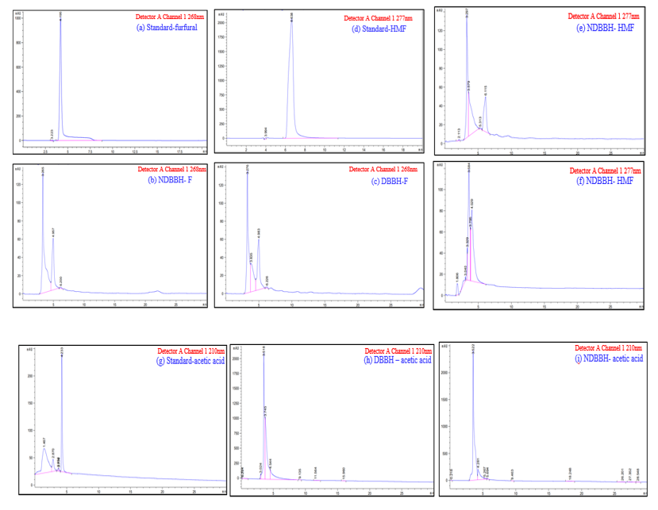
Detector A Channel 1 1277nm
(e) DBBH-HMF

Fig. S1 HPLC chromatogram of inhibitors in BIB liquid hydrolysate (i) Furfural (a)-standard; (b)-NDBBH; (c)-DBBH, (ii) HMF (d)-standard; (e)-DBBH; (f)-NDBBH and Acetic acid (g)-standard; (h)-DBBH; (i)-NDBBH

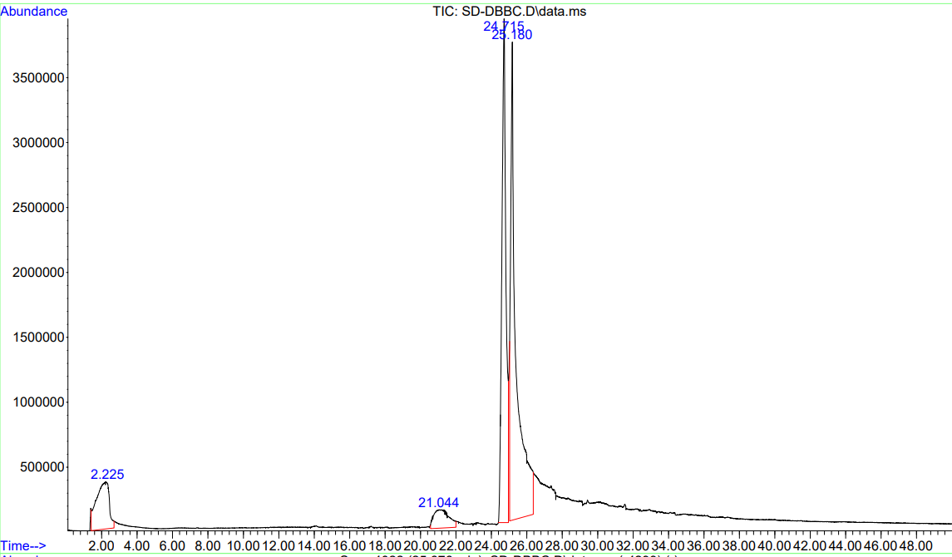
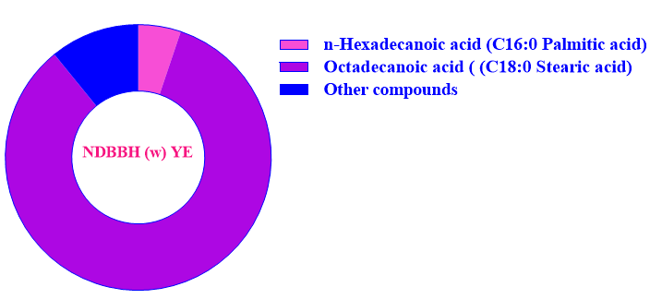

Fig. S2 GC-MS profile of the lipids obtained from NDBBH (w) YE using Rhodosporidium toruloides

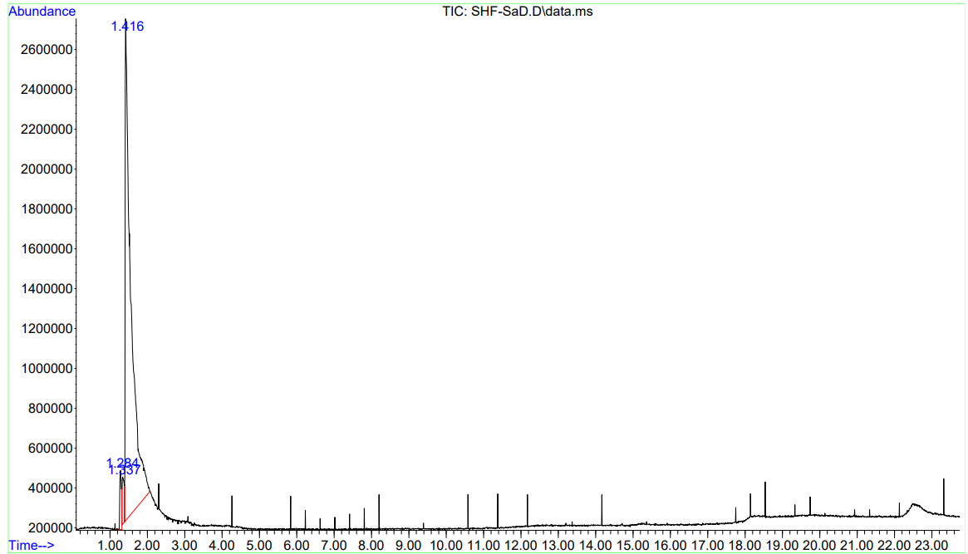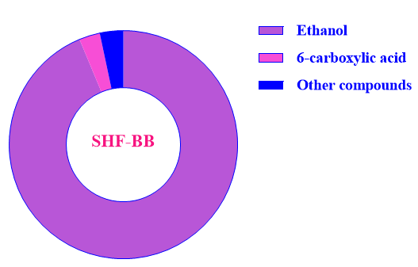
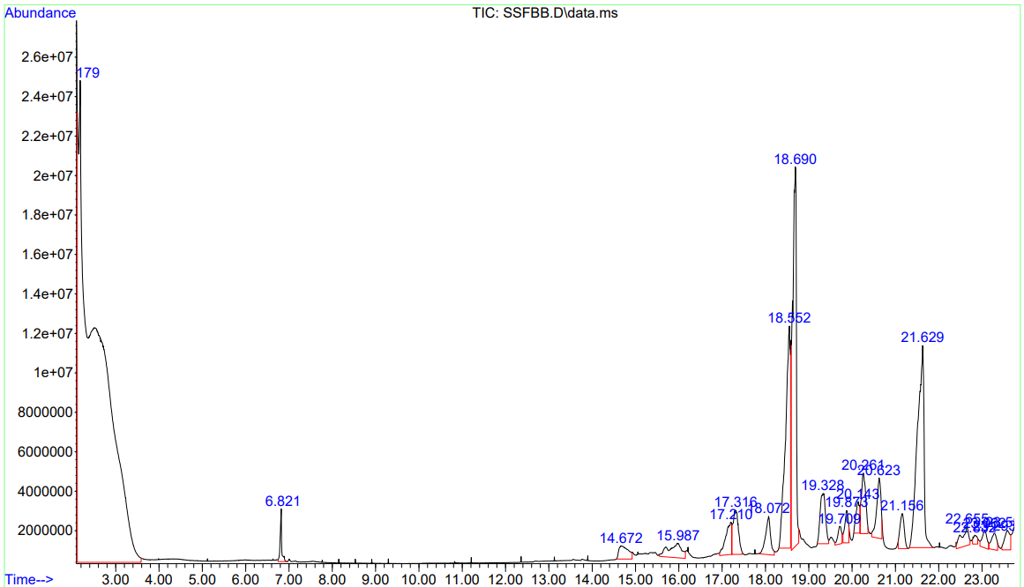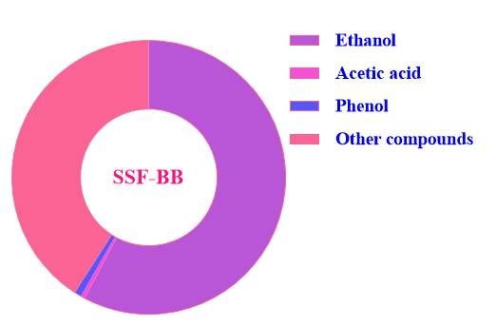

Fig. S3 GC-MS profile of ethanol from BIB substrate using Saccharomyces cerevisiae through SHF&SSF

All values are based on conversion and consumption factors (note: the loss in mass flow has not been represented)
Conversion
Crude cellulolytic enzymes
Residual
11.6 mg of glucose
9.33 mg of xylose
127 mg of ethanol
(12.70 g/L of ethanol content)
384.2 mg of glucose
26.1 mg of xylose
Residual
70.2 mg of cellulose
28.1 mg of hemicellulose
41.4 mg of lignin

Enzymatic hydrolysate
Residual
35.1 mg of glucose
18.2 mg of xylose
38.3 mg of lipid for 92.7 mg of biomass
(41.59 % w/dcw lipid content)

314.8 mg of glucose
104 mg of xylose

Saccharification

Conversion
Residual
210 mg of cellulose
56.1 mg of hemicellulose
43.4 mg of lignin

Solid fraction
(Cellulose components)

355 mg of cellulose
224 mg of hemicellulose
87.8 mg of lignin

Liquid fraction
(Holocellulose components)

Microwave assisted mild acid treatment

BIB biomass
1000 mg

Fig S4. Mass flow of BIB during pretreatment, saccharification (cellulose and hemicellulose) and fermentation for co-production of biodiesel and bioethanol

Table S1. Concentration of inhibitors before and after detoxification of BIB liquid hydrolysate

Compound name | Inhibitor concentration  before detoxification (µg/mL) | Inhibitors concentration after detoxification (µg/mL) | Reduction (%)
Compound name | NDBBH | DBBH | Reduction (%)
Furfural | 0.05 | 0.04 | 20.00
5-HMF | 0.37 | - | -
Acetic acid | 0.36 | 0.26 | 27.80

Table S2. Fatty acid composition analysis from the GC-MS profile of the lipids obtained from
NDBBH (w) YE

S. No | Compound | Retention time | Relative composition by area %
1 | n-hexadecanoic acid (C16:0 Palmitic acid) | 21.04 | 5.12
2 | Octadecanoic acid (C18:0 Stearic acid) | 25.18 | 83.95
3 | Other compounds | 2.22 | 10.93

Table S3. GC-MS profile of ethanol produced from BIB through SSF&SHF

 | Simultaneous saccharification and fermentation (SSF)
S. No | Compound | Retention time | Area (%)
1 | Ethanol | 2.179 | 57.758
2 | Acetic acid | 6.821 | 0.505
3 | Phenol | 14.672 | 0.822
4 | Other compounds | 22.832 | 40.915
Separate hydrolysis and fermentation
1 | Ethanol | 1.416 | 93.726
2 | 6-carboxylic acid | 1.337 | 2.947
3 | Other compounds | 1.284 | 3.327

