Surface metallization of human hair via electroless copper-plating for self-supported nonenzymatic glucose sensor
Kunpeng Qian^{1,2}, Yanfang Xu¹, Miao Miao¹, Dongmei Deng¹, Liqiang Luo^{1,}*, Yuanyuan Li¹, Xin Feng^{1,2}*
1 College of Sciences, Shanghai University, Shanghai 200444, PR China.
2 School of Materials Sciences and Engineering, Shanghai University, Shanghai 200444, P. R. China.
* E-mail: luck@shu.edu.cn (L. Luo), fengxin@shu.edu.cn (X. Feng).

Figure S1. SEM images of the cross section (a) to hair and corresponding EDS mapping.
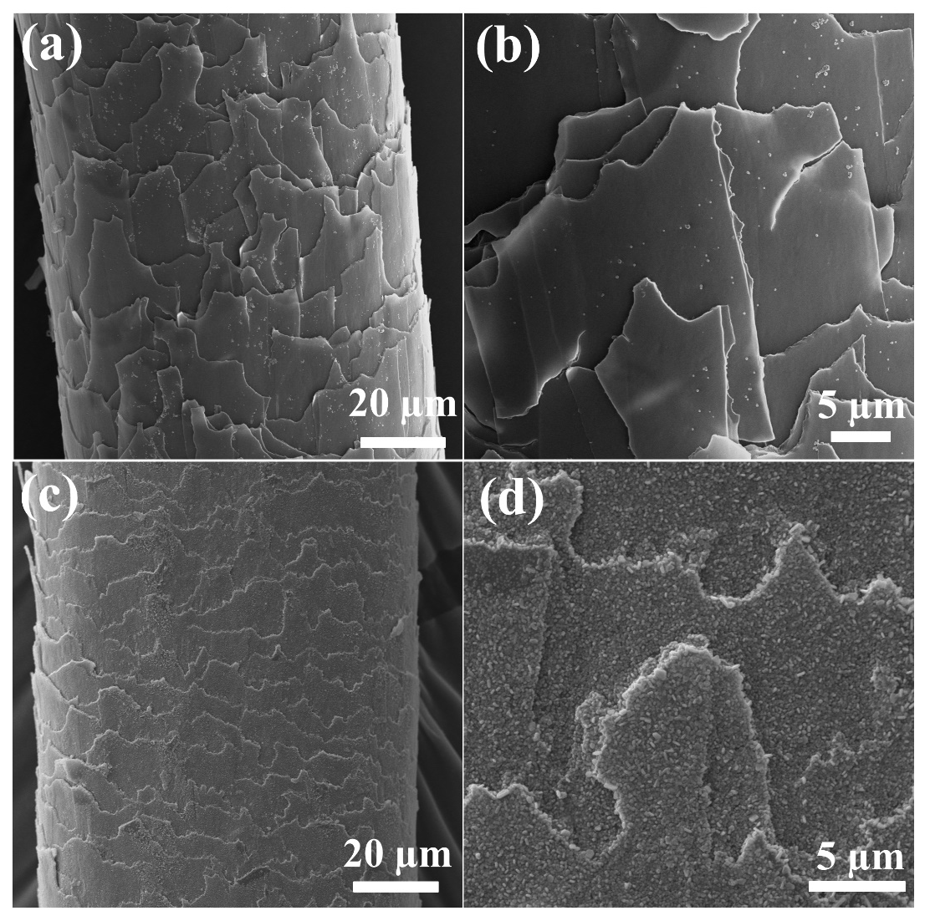
Figure S2. SEM images of the surface to DA functionalized hair surface (a) and magnifying surface (b), Ag site surface (c) and magnifying surface (d).

Figure S3. Element energy spectrum of hair@CuNPs-25.

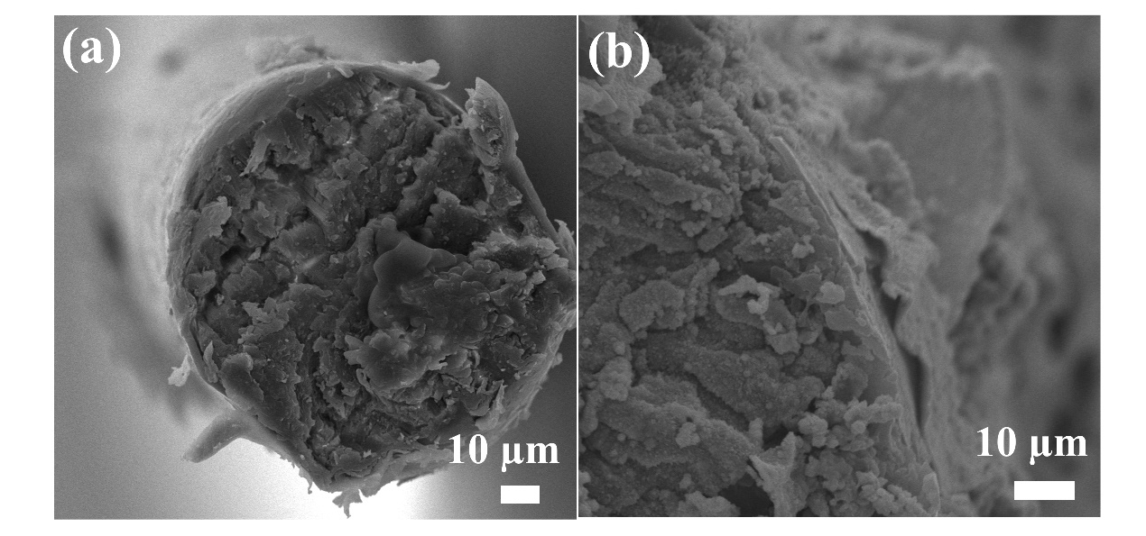
Figure S4. SEM images of the cross section (a) to the hair@CuNPs-25 and corresponding magnify (b).

