Table 2: Comparison between 2D and 3D electrochemical process in tetracycline removal.
Characteristic | 2D electrochemical system | 3D electrochemical system
Electrode | Two Electrode | Two Electrode + granular nZVI as a third electrode
Reaction | - water splitting, to O⁻ + OH⁻  - Oxidation reduction: Oxidation takes place into 1- diffusion of pollutants from the bulk solution 2- oxidation of pollutants at the surface.  - anode surface: a strong oxidizing agent is electro- generated  - Coagulation: generated from the reaction of anode  - corrosion causing to electrode due coagulation as in equation bellow (Abdenacer, 2019)  ( | 1- Absorption: The high surface area of nZVI qualifies it to be a good absorbent material.  2- Fenton- like reaction: the presence of iron in nZFe and the acidic state is the reason for the decomposition of tetracycline  3- The mineralization of organic matter (tetracycline) will be reduced to CO2 and H2O by nZVI.  4- not have corrosion
Process equations | anode  (C (anode)) + H2O → C(●OH) + H+ + e- (1)  C(●OH) + H2O → C + O2 + 3 H+ + 3 e- (2)  2 C(●OH) → 2C + O2 + 2 H+ + 2 e- (3)  C(●OH) → CO + H+ + e- (4)  (Edita , 2015)  Cathode  Fe_{(s)} +Fe³⁺ + 3e⁻ (5)  2H₂O +2e⁻ +H_{2 (g) +}2OH⁻ (6)  Fe_{(s) +} 3H₂O Fe(OH)_{3(S)} +3H⁺ (7)  2Fe³⁺ + 3H₂O Fe₂O_{3(S)} + 6H⁺ (8)  (Adane et al, 2022) | improving The oxidation efficiency of tetracycline (Chi et al., 2018)  Two types of oxidation (direct and indirect)  - direct oxidation  M + H2O → M (OH•) + H⁺ + e ⁻ (9)  M (OH•) → MO + H⁺ + e – (10)  - indirection oxidation (oxidation the electrolyte (Manisha, 2021)  2SO⁻² ₄ → S2O₈ ⁻² + 2e− (11)  3H2O → O₃ + 6H⁺ + 6e− (12)  - Fenton-process  $2Fe^{0}+ O_{2}+2H_{2}O →2Fe^{2+}+4OH^{-}$ (13)  $O_{2}+2H^{+}+2e^{-} → H_{2}O_{2}$ (14)  $Fe^{2+}+ H_{2}O_{2} →‧OH+OH^{-}+Fe^{3+}$ (15)
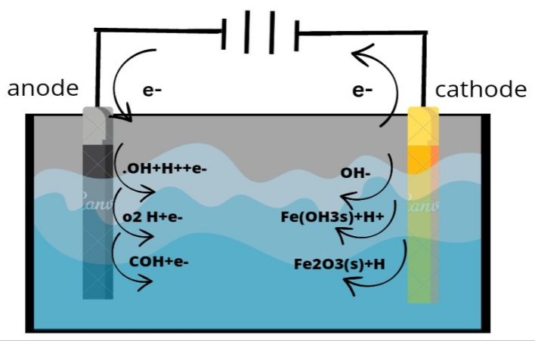 |  | 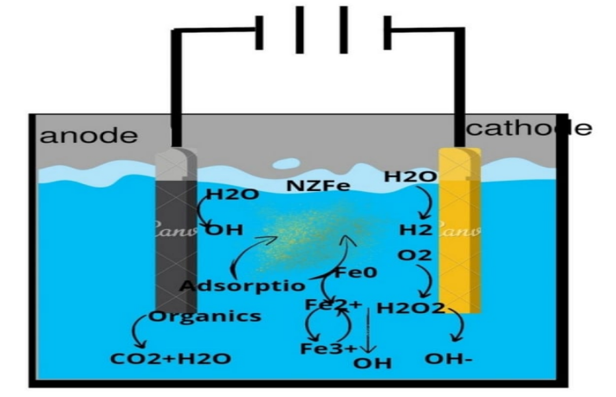
Figure 11: the principle basic of a proposed tow-dimensional electrochemical process for tetracycline removal |  | Figure 12: the principle basic of a proposed three-dimensional electrochemical process for tetracycline removal
From experimental results (In this study )
Operation condition | Contact time: 40min  pH: 5.5  Tetracycline consecrations: 160mg/L  Current density: 50 mA / cm  More energy consumption | Contact time:30min  pH: 4.5  Tetracycline consecrations: 160mg/L  granular nZVI dose: 2g/L  Current density: 40 mA / cm  Less energy consumption
Removal efficiency | 78% | 99%

