Supplementary Figure 1: Risk of severe COVID-19 among adults during BA.2 and BA.4/BA.5 omicron predominance, by vaccination regimens and time since last vaccine dose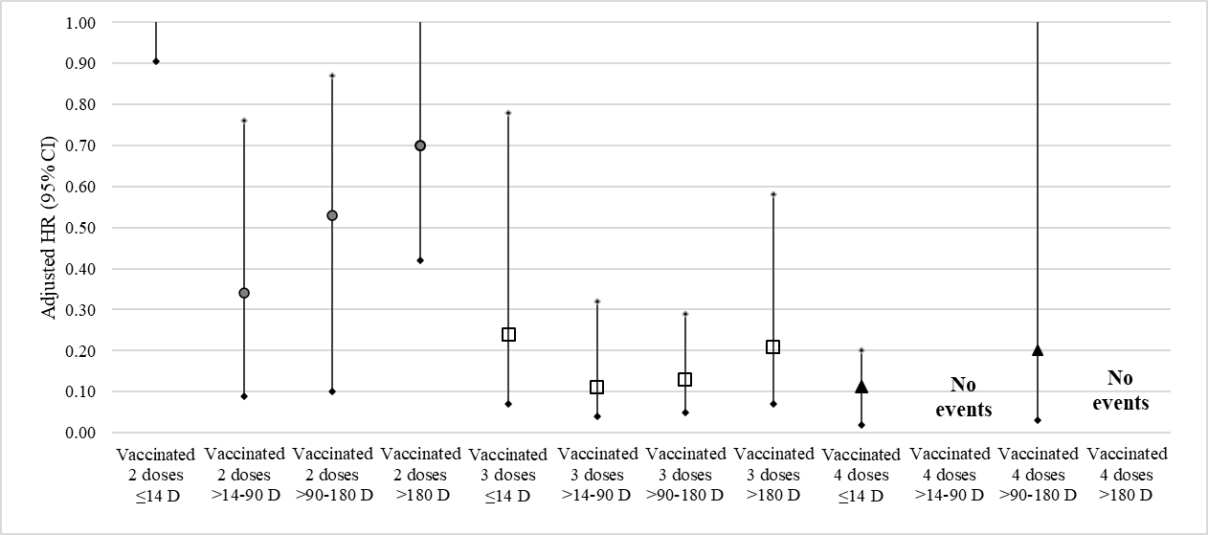
Adjusted for age, gender, type of omicron sub-lineage and calendar time. Reference group: Unvaccinated
Supplementary Figure 2: Risk of severe COVID-19 among adults during BA.2 and BA.4/BA.5 omicron predominance by type of third vaccine
Adjusted for age, gender, type of omicron sub-lineage, calendar time and preceding vaccine series type. Reference group: Unvaccinated
Supplementary Table 1: Association between vaccination regimens and baseline characteristics with severe COVID-19 outcomes and deaths among adult COVID-19 cases during BA.2 and BA.4/BA.5 predominance (1 May 2022- 31 July 2022) in Chiang Mai, Thailand

 | Severe COVID-19 |  |  |  |  |  |  |  | Death
 | Crude HR | 95% CI-lower | 95% CI-upper | p-value | Adjusted HR | 95% CI-lower | 95% CI-upper | p-value | Crude HR | 95% CI-lower | 95% CI-upper | p-value | Adjusted HR | 95% CI-lower | 95% CI-upper | p-value
Age, years | 1.08 | 1.07 | 1.09 | <0.01 | 1.07 | 1.06 | 1.08 | <0.01 | 1.09 | 1.06 | 1.10 | <0.01 | 1.06 | 1.05 | 1.08 | <0.01
Gender
Female | Reference
Male | 1.31 | 0.94 | 1.83 | 0.11 | 1.28 | 0.91 | 1.78 | 0.15 | 1.47 | 0.92 | 2.36 | 0.11 | 1.44 | 0.90 | 2.32 | 0.12
Omicron Sub-lineage
BA.2 | Reference
BA.4/BA.5 | 0.82 | 0.58 | 1.16 | 0.27 | 1.98 | 0.89 | 4.01 | 0.07 | 0.53 | 0.31 | 0.91 | 0.02 | 2.49 | 0.84 | 6.2 | 0.09
Vaccination status¹
Unvaccinated | Reference
Vaccinated One dose | 0.71 | 0.26 | 1.95 | 0.51 | 0.78 | 0.28 | 2.14 | 0.63 | 1.02 | 0.31 | 3.33 | 0.96 | 0.98 | 0.30 | 3.20 | 0.97
Vaccinated two doses | 0.26 | 0.18 | 0.38 | <0.01 | 0.43 | 0.29 | 0.65 | <0.01 | 0.26 | 0.16 | 0.45 | <0.01 | 0.39 | 0.22 | 0.68 | 0.01
Vaccinated three doses | 0.07 | 0.03 | 0.11 | <0.01 | 0.13 | 0.07 | 0.22 | <0.01 | 0.03 | 0.01 | 0.09 | <0.01 | 0.05 | 0.02 | 0.16 | <0.01
Vaccinated four doses | 0.06 | 0.02 | 0.17 | <0.01 | 0.12 | 0.05 | 0.28 | 0.03 | 0.03 | 0.01 | 0.11 | <0.01 | 0.05 | 0.01 | 0.24 | 0.03
Vaccinated five doses | No events
Vaccination status stratified by age group (years)¹
Unvaccinated | Reference
18-59 years
Vaccinated two doses | 0.33 | 0.16 | 0.68 | <0.01 | 0.33 | 0.16 | 0.71 | <0.01
Vaccinated three doses | 0.19 | 0.06 | 0.59 | <0.01 | 0.10 | 0.03 | 0.17 | <0.01
Vaccinated four doses | 0.05 | 0.01 | 0.16 | <0.01 | 0.12 | 0.03 | 0.36 | <0.01
Vaccinated five doses | No events
>=60 years
Vaccinated two doses | 0.35 | 0.22 | 0.55 | <0.01 | 0.48 | 0.30 | 0.77 | <0.01
Vaccinated three doses | 0.11 | 0.06 | 0.21 | <0.01 | 0.20 | 0.10 | 0.38 | <0.01
Vaccinated four doses | No events
Vaccinated five doses | No events

1 Adjusted for age, gender, type of omicron sub-lineage, and calendar time of test

Supplementary Table 2: Association between time since vaccination and type of booster vaccines with severe COVID-19 outcomes among adult COVID-19 cases during BA.2 and BA.4/BA.5 predominance (1 May 2022- 31 Jul 2022) in Chiang Mai, Thailand
Unvaccinated | Reference
Vaccinated One dose | 0.71 | 0.26 | 1.95 | 0.51 | 0.78 | 0.28 | 2.16 | 0.64
Vaccinated two doses ≤14 D | 2.19 | 0.68 | 6.91 | 0.18 | 2.90 | 0.91 | 9.34 | 0.07
Vaccinated two doses >14-90 D | 0.22 | 0.14 | 0.36 | <0.01 | 0.34 | 0.09 | 0.76 | 0.02
Vaccinated two doses >90-180 D | 0.31 | 0.07 | 0.68 | 0.03 | 0.53 | 0.10 | 0.87 | <0.01
Vaccinated two doses >180 D | 0.37 | 0.22 | 0.65 | <0.01 | 0.70 | 0.42 | 1.15 | 0.16
Vaccinated three doses ≤14 D | 0.14 | 0.04 | 0.45 | 0.01 | 0.24 | 0.07 | 0.78 | 0.02
Vaccinated three doses >14-90 D | 0.06 | 0.02 | 0.16 | <0.01 | 0.11 | 0.04 | 0.32 | <0.01
Vaccinated three doses >90-180 D | 0.06 | 0.02 | 0.18 | <0.01 | 0.13 | 0.05 | 0.29 | <0.01
Vaccinated three doses >180 D | 0.07 | 0.03 | 0.18 | <0.01 | 0.21 | 0.07 | 0.58 | <0.01
Vaccinated four doses ≤14 D | 0.06 | 0.01 | 0.47 | 0.01 | 0.11 | 0.02 | 0.20 | <0.01
Vaccinated four doses >14-90 D | No events
Vaccinated four doses >90-180 D | 0.67 | 0.21 | 2.15 | 0.51 | 0.20 | 0.03 | 1.47 | 0.12
Vaccinated four doses >180 D | No events
Third vaccine dose type²
Unvaccinated | Reference
Pfizer-BioNTech | 0.07 | 0.03 | 0.14 | <0.01 | 0.15 | 0.07 | 0.28 | 0.03
ChAdOx1 nCoV-19 | 0.08 | 0.03 | 0.22 | <0.01 | 0.16 | 0.08 | 0.34 | 0.04
Moderna | 0.03 | 0.01 | 0.14 | <0.01 | 0.08 | 0.03 | 0.12 | 0.04
1 Adjusted for age, gender, type of omicron sub-lineage, and calendar time of test
2 Adjusted for age, gender, type of omicron sub-lineage, calendar time and preceding vaccine series type

