Methods Section
- Catalyst reparation
Table S1 The effect of preparation conditions for nanodiamond supported Rh catalysts on the catalytic performance in styrene hydroformylation.
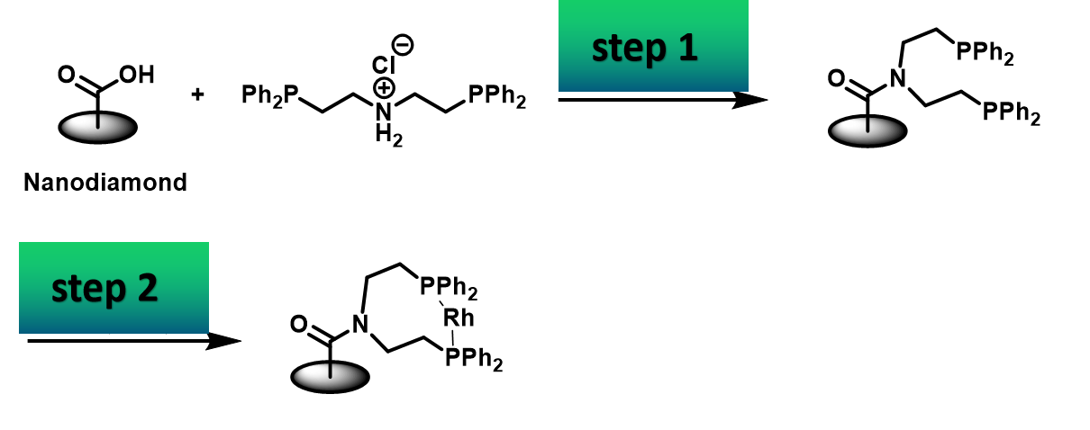

Entry | Reaction conditions for Step 1ª | Solvent in Step 2^{b} | Conv.^{c}/% | Sel.^{d}_{CHO}/% | b/l^{e}
1 | DCC, DMAP, TEA, THF, 30 ℃, 48 h | THF | 34.1 | 98 | 2.4
2 | DCC, DMAP, TEA, DMF, 30 ℃, 48 h | DMF | 48.3 | 99 | 2.9
3 | DCC, DMAP, TEA, DMF, 30℃, 48 h | toluene | 53.0 | 98 | 4.2
4 | NMM, CDMT, DMF, 90℃, 48 h | THF | 99.5 | >99 | 4.1
5 | NMM, CDMT, DMF, 90℃, 48 h | DMF | 97.3 | >99 | 2.0
6 | NMM, CDMT, DMF, 90℃, 48 h | CH₃CN | 90.4 | >99 | 3.1
7 | NMM, CDMT, DMF, 90 ℃, 48 h | toluene | 85.0 | >99 | 3.3
8 | NMM, CDMT, DMF, 70 ℃, 48 h | THF | 31.5 | >99 | 3.6
9 | NMM, CDMT, DMF, 130 ℃, 48 h | THF | 100 | >99 | 2.0
ªIn step 1, 50 mg nanodiamond, 12 mL solvent (THF or DMF), 88 mg diphosphino-amine, 32 mg CDMT (2-Chloro-4,6-dimethoxy-1,3,5-triazine), 65 mg NMM (N-methyl morpholine), DCC (N,N'-dicyclohexylcarbodiimide), DMAP (4-Dimethylaminopyridine), TEA (triethylamine) were used. ^{b}In step 2, 50 mg PNP-ND and 46 mg [Rh(COD)Cl]₂ were added in 10 mL solvent, and then stirred at 30 ℃ for 12 h. ^{c}The hydroformylation was conducted in the presence of 50 mg catalyst at 60 ℃, 3.0 MPa syngas (CO/H₂=1) within 10 h in toluene/H₂O (1:1, 15 mL/15 mL) by using 3 mmol styrene. ^{d}The selectivity for aldehyde products. ^{e}The molar ratio of branched aldehyde/linear aldehyde determined by GC.
2. PNP pincer ligand Bis[2-(diphenylphosphino)ethy]amine.

Under nitrogen atmosphere, diphenylphosphine (14.0 mL, 80 mmol) was added to a solution of tert-butoxide (14 g, 125 mmol) in anhydrous THF (300 ml) at ambient temperature. And then bis(2-chloroethyl)amine hydrochloride (7.15 g, 40 mmol) was added to the solution. The mixture was stirred for 18 h under reflux. After reaction, the reaction mixture was poured into 400 mL hexane, the organic phase was washed with 10% aqueous NaOH, saturated aqueous NaCl solution, and 2 N aqueous HC1 solution to provide a dense white precipitate of 1·HCl. Recrystallization from boiling acetonitrile gave a 90% yield (17.2 g) of 1·HCl of white needles. mp 174-175 °C [lit.^{[1]} 174.5-175.5 °C]. ¹H NMR (400 MHz, CDCl₃) δ 2.3-3.3 (m, 8H), 7.0-7.6 (m, 20H), 9.9 (s, 2H).

[1] Nuzzo, R. et al. Synthesis of functional chelating diphosphines containing the bis[2-(diphenylphosphino)ethyl]amino moiety and the use of these materials in the preparation of water-soluble diphosphine complexes of transition metals. J. Org. Chem., 46, 2861-2867 (1981).

