Pd decorated ZnO nanosheets for enhanced hydrogen sensing performance
Hua-Dong Dong ^{a,c}, Jian-Ping Zhao*^{,a}, Ming-Xing Peng ^{b}, Pei-Yuan Xu^{c} , Xuan-Yu Yang *^{,b}, Yong-Hui Zhang*^{,b}

ªSchool of Mechanical and Power Engineering, Nanjing Tech University, Jiangsu Key Lab of Design and Manufacture of Extreme Pressure Equipment, Nanjing 211816, P. R. China
^{b}College of Materials and Chemical Engineering, Zhengzhou University of Light Industry, Zhengzhou 450002, P. R. China
^{c}School of Energy and Power Engineering, Zhengzhou University of Light Industry, Zhengzhou 450002, P. R. China
*E-mail address: jpzhao_njtech@163.com; kfyxyyfmhp@163.com; yonghui.zhang@zzuli.edu.cn

Sensor fabrication and gas sensing measurement
Gas sensor preparation process: the prepared pure ZnO and PZO composite materials were evenly ground, then, an appropriate amount of terpineol was mixed into a uniform paste. The prepared slurry is evenly coated on the surface of the Al₂O₃ tube with pt electrode with a brush, and the Ni-Cr alloy heating wire is passed through the Al₂O₃ tube to realize the heating of the sensor. The original was annealed at 300 ℃ for 2 h to remove terpineol. After cooling, it was welded to bakelite base to complete the preparation of the sensor. WS-30b system (Wei sheng Instruments Co. Zhengzhou, China) was used to test the H₂ sensing performance of the sensors. Sensitivity is defined as the ratio of the sensor's resistance in air (Ra) to its resistance in hydrogen (Rg). The response-recovery time is defined as the time required to reach 90% of the initial equilibrium value.

Figure S1. WS-30B gas sensitive test system and gas sensitive element.
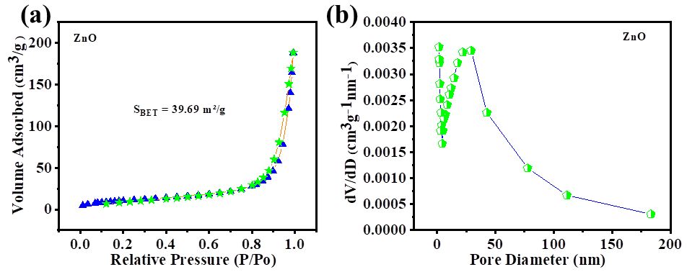
Figure S2. (a) Nitrogen adsorption-desorption isotherm of ZnO; (b) Pore size distribution of ZnO.

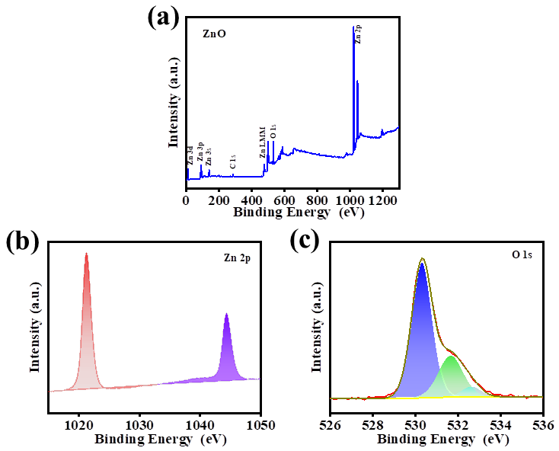
Figure S3. XPS spectra of ZnO: (a) full spectrum; (b) Zn 2p; (c) O 1s.

Table S1
Fitting results of O 1s XPS spectra of ZnO and PZO.
simple | Oxygen species | Binding energy (eV) | Percentage
Pure ZnO  PZO | O_{L}  O_{V}  O_{C}  O_{L}  O_{V}  O_{C} | 530.31  531.63  532.62  530.19  531.54  532.61 | 70.16%  25.11%  4.73%  68.49%  23.17%  8.34%

