Ultra-efficient copper ions adsorption of Chitosan-montmorillonite composite aerogel for wastewater treatment
Xin Ye^{1,2}, Sisi Shang^{1,2},Yifan Zhao^{1,2},Sheng Cui^{1,2*},Ya Zhong^{1,2*},Longjin Huang^{1,2}
1 College of Materials Science and Engineering, Nanjing Tech University, 211800 Nanjing, China
2 Jiangsu Collaborative Innovation Center for Advanced Inorganic Function Composites, Nanjing Tech University, 211800 Nanjing, China
*Corresponding Author
Sheng Cui
E-mail address: cui2002sheng@126.com
Ya Zhong
E-mail address: yzhong@njtech.edu.cn
Contents
Text 1 Detail information of the batch experiments 3
Text 2 Detail information of the solid characterization methods and analysis 5
Text 3 Detail information of Adsorption property of CS-MMTs 8
Figures 9
Tables 13

Supporting Information has 14 pages, including 3 Texts, 4 pictures, and 3 tables.

Text 1 Detail information of the batch experiments
1.1 Materials
Montmorillonite slurry (MMT) was purchased from Jiangsu Haimingsi New Material Technology Co., Ltd, China. Lithium hydroxide (LiOH) and urea were purchased from Shanghai Alighting Chemical Reagent Co., Ltd, China. Chitosan (CS) with the degree of deacetylation (85-95%) was purchased from Sinopac Chemical Reagent Co., Ltd, China. Octadecyl trimethyl ammonium chloride (1831) and sodium dodecyl sulfate (K12) were purchased from Yuanye Biotechnology Co., Ltd, China. Copper chloride (CuCl₂) was obtained from Shanghai chemical reagent Co., Ltd, China. Sodium diethyldithiocarbamate (DDTC) was purchased from Jinshan New Chemical Reagent Factory in Shanghai. Ethylenediaminetetraacetic acid disodium salt (Na₂-EDTA), Carbon tetrachloride (CCl₄), and Ammonium chloride (NH₄Cl) were purchased from Sinoreagent Chemical Reagent Co., Ltd, China. All chemicals used were either AR or GR-grade.
1.2 Fabrication of CS-MMT aerogel
Take a certain quality of montmorillonite slurry, add 1831 and K12. The pH value of the adjusted solution was 7. After heating at 70°C for 2 hours, the mixed solution was taken out and purified by centrifugation. Exfoliated MMT nanosheets were obtained. The stripped MMT nanosheets were re-dispersed in water and configured into diluents of different concentrations (3g/ L, 6g/ L,9/ L,12g/ L, and 15g/ L), named MMT1, MMT2, MMT3, MMT4, MMT5, respectively. 1g CS was dissolved in a 50 mL alkaline/urea system. Regenerated chitosan was prepared by freezing and thawing cycles at -18°C. The chitosan solution was added to the corresponding MMT solution and stirred evenly. CS-MMT aerogel was prepared by the sol-cryogenic method, named CS-MMT1, CS-MMT2, CS-MMT3, CS-MMT4, CS-MMT5, respectively. CS-MMT aerogels prepared had a density between 11.021 mg/cm⁻³ and 15.062mg/cm⁻³. The specific preparation process is shown in Figure S1.
1.3 Adsorption of Cu²⁺ on CS-MMT composite aerogel
Using CuCl₂·H₂O as a heavy metal ion source and sodium diethyldithiocarbamate (DDTC) as a color developing agent, Cu²⁺solutions of different concentrations were prepared. 0.1 mol/L hydrochloric acid was used to adjust the pH to 6. Prepared CS-MMT1, CS-MMT2, CS-MMT3, CS-MMT4, and CS-MMT5 were as adsorbents. For the adsorption kinetics study, 0.05 g of adsorbent was added to 50 mL of solution, and the initial Cu²⁺ concentration was 10mg/L. After the specified time, the adsorbent was centrifuged from the Cu²⁺solution, the supernatant was collected. Analyzed with an ultraviolet spectrophotometer at 460 nm to measure the concentration of Cu²⁺ in the curing solution. In the adsorption isotherm study, 50 mg of adsorbent was added to 50 mL solutions of different concentrations and shaken at 30°C for 150 minutes. Centrifuge the test system after the experiment.

Text 2 Detail information of the solid characterization methods and analysis
2.1 Characterization
CS-MMT composite aerogels were characterized by X-ray diffraction (XRD), X-ray photoelectron spectroscopy (XPS), Fourier transforms infrared spectra (FT-IR), Scanning electron microscopy (SEM), Thermal gravimetric analysis (TGA), Mercury intrusion analysis and N₂ adsorption-desorption measurement, etc. XRD patterns were obtained using a Rigaku Smart Lab 3000 (Cu Kα(target) radiation (λ=1.5418Å)) with a scan rate (2θ) of 10°/min and a scan range from 10° to 80°. XPS was carried out using a Thermo Escalab 250Xi XPS spectrometer equipped with a dual X-ray source using Al Kα. FTIR was implemented by a Nicolet Nexus 670 FTIR instrument in the range from 400 to 4000 cm⁻¹ with a resolution of 4 cm⁻¹. SEM was conducted using an LEO-1530VP ﬁeld emission scanning electron microscope operating at 6 kV. TGA was performed by the NETZSCH STA449C Thermogravimetric analyzer from 30 ℃ to 800 ℃ with a heating rate of 10 ℃/min under the nitrogen atmosphere. SEM was conducted using an LEO-1530VP ﬁeld emission scanning electron microscope operating at 6 kV. Pore structure analysis was carried out by Auto Pore Iv 9510 mercury injecter produced by Mike Company and degassed at 300℃ for 5h before the test. Surface areas, pore-volume, and pore distribution were measured by nitrogen adsorption/desorption porosimetry by using an APPLICATION V-Sorb 2800P surface area and pore distribution analyzer. Samples were degassed in a vacuum at 100 ℃ for 6 h.
2.2 The element mapping images and EDS analysis
To further explore the element composition and distribution of the material, we performed local surface scan mapping and EDS analysis on CS-MMT2 (Figure S2). From the mapping diagram, we can find that Si, C, N, O can be dispersed well and uniformly. From the energy spectrum, we can see that the surface elements of CS-MMT2 are mainly O, C, N, Na, and Si. O and N accounted for 54.38% and 21.82% of the total mass respectively. In this regard, we can infer that CS-MMT2 may contain a large number of oxygen-containing functional groups, oxides, and nitrides, such as siloxy, hydroxyl, carboxyl, acetamido, nitro. This is consistent with the analysis of FT-IR and XPS. These active functional groups will chelate with metal ions in the process of treating heavy metal ion wastewater, to achieve efficient heavy metal ion adsorption applications.
2.3 The TG analysis
By comparing the thermogravimetric curves of CS-MMT composite aerogels of different components (Figure S3), the thermal stability of the material in the application process can be tested, and the composition of the material can also be indirectly characterized. The thermal degradation trends of CS-MMT composite aerogels are consistent, and there is an obvious quality loss in three stages. The first stage is from room temperature to 100°C. The small amount of residual water in CS-MMTs will evaporate at this stage, resulting in quality loss in the first stage. According to our previous FT-IR analysis, the surface of CS-MMT is rich in hydroxyl groups, so it is easy to absorb moisture in the air. As the test temperature rises, the moisture in the CS-MMT will volatilize. CS-MMT composite moisture will evaporate out of the aerogel¹. The second node is around 210°C. Obvious weight loss before 210℃ can be considered as depolymerization and glass transition of CS. After 210℃, obvious weight loss can be considered as CS depolymerization and "vitrification" transformation. However, when the temperature is higher than 210°C, CS will undergo a violent depolymerization reaction, and even vaporization will occur to gas overflow. The third stage starts at about 310℃. The residual carbon and ash in the CS structure are further cracked into char. The organic functional groups on the surface of montmorillonite are violently ablated and a violent carbonization reaction occurs. The residual sample gradually stabilizes after 750℃. The thermogravimetric curve shows that CS-MMT has good stable performance in the medium and low-temperature range, and can adapt to normal temperature conditions. Among the five groups of samples, the thermal stability of CS-MMT2 is significantly higher than other components. We believe that CS can well open and crosslink the lamella structure of montmorillonite under this ratio. The distribution of each component is more uniform so that a fuller and more stable three-dimensional network structure is formed as a whole, thereby improving the overall thermal stability of the material.

Text 3 Detail information of Adsorption property of CS-MMTs
3.1 Adsorption equilibrium time and adsorption kinetics
The adsorption equilibrium time is an important index to measure the adsorbent performance, which directly affects the adsorption efficiency of the adsorbent. Therefore, the effect of adsorption time on adsorption efficiency was studied. We set the oscillation time to 5, 10, 25, 50, 80, 100, 120, and 150 minutes based on experience.
The adsorption of heavy metal ions by the adsorbent mainly depends on the following three aspects: 1) The concentration gradient of the material and the solution. It is mainly reflected in the initial stage of adsorption when the concentration gradient is large. Heavy metal ions diffuse to the material along with the difference in concentration. 2) Adsorption active sites in the material. The adsorption active sites largely determine the adsorption capacity of the material. 3) The pore structure of the material. For porous materials, the pore structure largely determines the adsorption rate but also has a slight impact on the adsorption capacity.
3.2 Adsorption isotherms and adsorption thermodynamics
To further elucidate the adsorption thermodynamic mechanism of CS-MMT composite aerogels, the effect of different initial concentrations of Cu²⁺ on the adsorption performance was investigated. In this experiment, 50 mg of adsorbent was added to 50 ml of Cu²⁺ solution at different initial concentrations, ranging from 10 to 100 mg/L. Dilute hydrochloric acid solution was used to adjust pH=6 at 25 ℃ and the oscillation rate was 200 r/min.

Figures
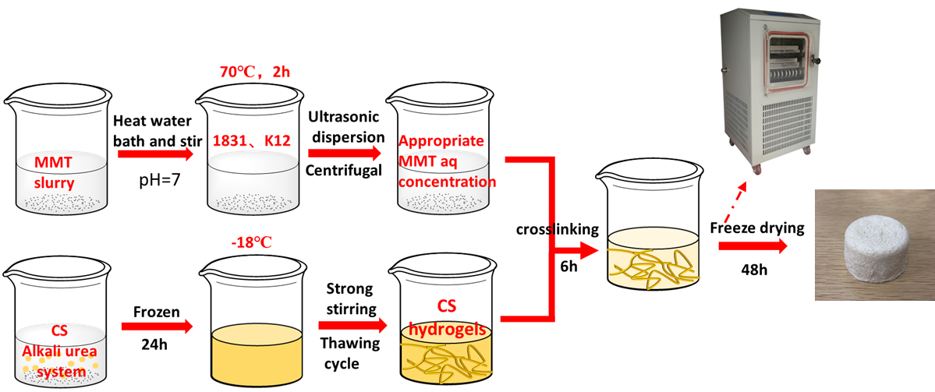
Fig. S1 Schematic illustration for the preparation of CS-MMT aerogel

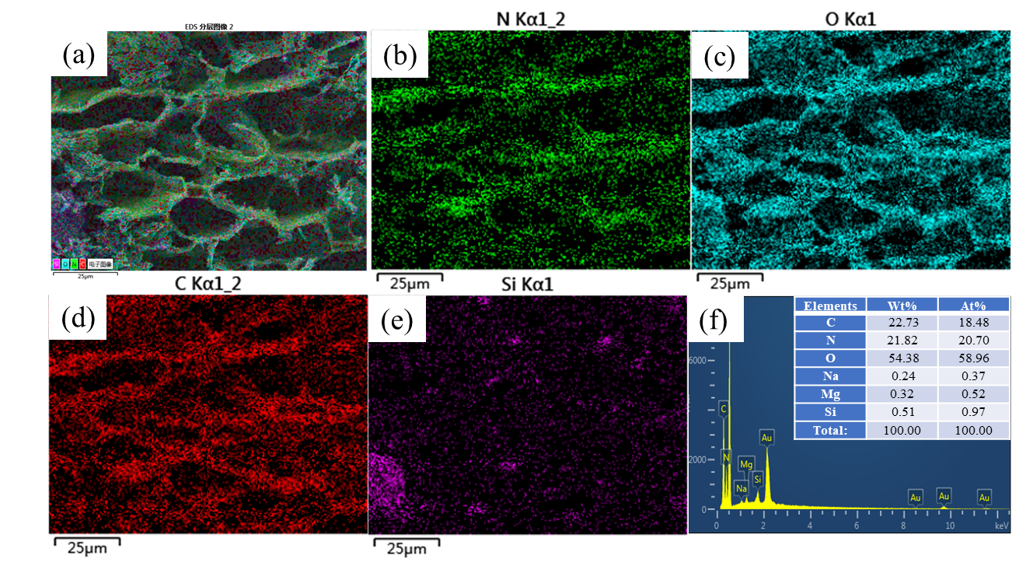
Fig. S2 Element mapping images and EDS analysis of CS-MMT2

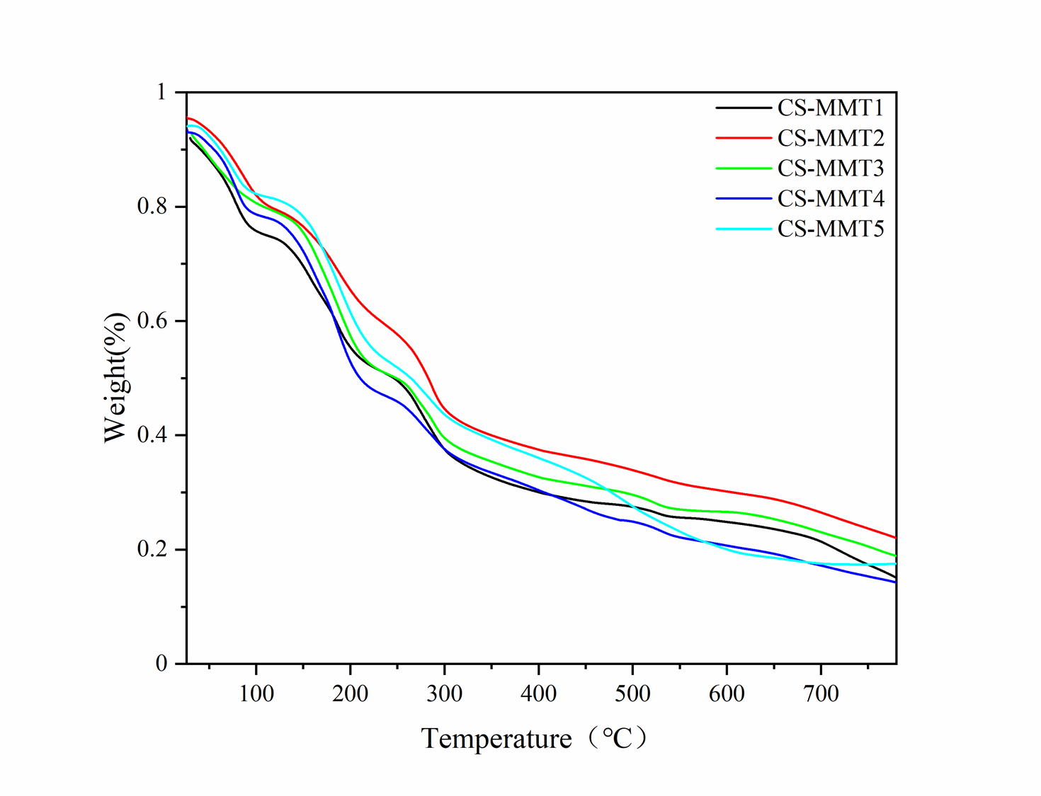
Fig. S3 Thermogravimetric curve of CS-MMT composite aerogels with different components

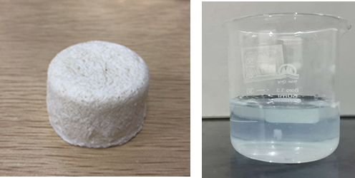
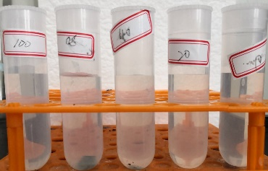
Fig. S4 The digital picture of CS-MMT2 and adsorption effect diagram

Tables
Table S1 Physical property parameters of CS-MMT composite aerogels
Sample | S_{BET}(m²/g） | Pore size(nm) | Pore volume(cm³/g)
CS-MMT1  CS-MMT2  CS-MMT3  CS-MMT4  CS-MMT5 | 10.584763  14.133255  1.21725  6.639328  8.235829 | 0.072761  0.058397  399.363317  0.050182  0.080398 | 27.462614  16.527537  0.071196  30.233445  39.047871
Table S2 Kinetic parameters of the two kinetic equations for adsorption rate
 | Pseudo-first-order-equation |  |  | Pseudo-second-order-equation
 | Q_{e} | K₁ | R² | Q_{e} | K₂ | R²
CS-MMT1 | 8.536 | 0.2603 | 0.97636 | 9.004 | 0.04248 | 0.99664
CS-MMT2 | 9.821 | 0.2122 | 0.98909 | 9.906 | 0.04942 | 0.99937
CS-MMT3 | 7.743 | 0.3460 | 0.9801 | 7.993 | 0.07077 | 0.99894
CS-MMT4 | 7.502 | 0.2844 | 0.95991 | 7.716 | 0.05372 | 0.99894
CS-MMT5 | 6.839 | 0.2823 | 0.98458 | 7.070 | 0.07506 | 0.99642
Table S3 Langmuir and Freundlich parameters for adsorption of Cu²⁺
 | Langmuir isotherm |  |  | Freundlich isotherm
Adsorbent | Q_{e}(mg/g) | K_{L} | R² | K_{F} | 1/n | R²
CS-MMT1 | 80.38 | 0.07596 | 0.97521 | 1.25 | 0.19164 | 0.99804
CS-MMT2 | 86.95 | 0.07997 | 0.98791 | 0.95 | 0.43058 | 0.99588
CS-MMT3 | 76.92 | 0.03990 | 0.98311 | 1.66 | 0.08297 | 0.9838
CS-MMT4 | 69.93 | 0.02747 | 0.98746 | 2.73 | 0.09797 | 0.99559
CS-MMT5 | 60.86 | 0.01339 | 0.98375 | 2.95 | 0.09935 | 0.99900

Ref.
1. Zhang, H.; Omer, A. M.; Hu, Z. H.; Yang, L. Y.; Ji, C.; Ouyang, X. K., Fabrication of magnetic bentonite/carboxymethyl chitosan/sodium alginate hydrogel beads for Cu (II) adsorption. Int J Biol Macromol 2019, 135, 490-500.

